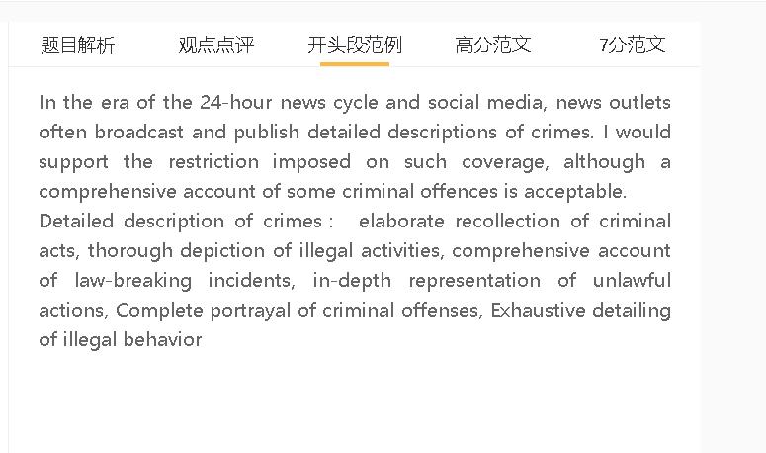

范文

In the era of the 24-hour news cycle and social media, news outlets often broadcast and publish detailed descriptions of crimes. I would support the restriction imposed on such coverage, although a comprehensive account of some criminal offences is acceptable.

A 对违法事件的精心回忆 B 导致模仿犯罪 C 可能会使守法公民面临风险
解释：当媒体对犯罪进行深入报道时，它可以吸引弱势群体的注意力，比如已经感到被边缘化的人或有心理健康问题的人。
解释：他们可能认同施暴者，或者觉得犯罪行为会助力自己，因此试图效仿犯罪人员。
举例：例如，一些人可能会购买武器来模仿那些因大规模枪击而臭名昭著的人，以吸引类似的媒体关注。
Elaborate recollection of law-breaking incidents may put law-abiding citizens at risk as it leads to copycat crimes. When media outlets provide in-depth coverage of a crime, it can capture the attention of vulnerable individuals such as people who are already feeling marginalized or those with mental health issues. They may identify with the perpetrator or feel empowered by their actions and seek to emulate them. For example, some may buy weapons to copy those who gain notoriety for mass shootings, in order to draw similar media attention.
A 详细描述犯罪 B 它会对公众产生强烈的情感影响 C 不利于大众健康
解释：某些犯罪可能涉及身体虐待、性侵犯和其他形式的酷刑，受害者被剥削来满足罪犯的愿望或表达他们的愤怒。
解释：当媒体生动地描述此类暴力事件时，可能会引发严重的焦虑、恐惧和创伤，对观众的幸福感和心理健康产生负面影响。
结果：在某些情况下，它会造成长期的心理伤害，影响他们的生活质量。
Another significant issue with detailed descriptions of crimes is that it can have a strong emotional impact on the public. Certain crimes may involve physical abuse, sexual assault, and other forms of torture, with the victims being exploited to fulfill the offender’s wants or to express their rage. When such violent incidents are graphically depicted in media, it can trigger serious feelings of anxiety, fear, and trauma, leading to negative effects on the well-being and mental health of the viewers. In some cases, it can cause long-lasting psychological damage, affecting their quality of life.
A 对犯罪的深入报道 B提高对潜在风险的认识，并使他们能够在犯罪发生前识别警告信号 C 人们采取预防措施，保护自己免受犯罪活动的影响
解释：它可以为人们提供关键信息，帮助他们避免成为犯罪的受害者，或者帮助他们在成为犯罪目标时做出反应。
举例：对欺诈和骗局的详细报道可以帮助人们识别骗局的迹象，并采取措施保护自己免受经济损失。
举例2：同样，对入室盗窃、抢劫和其他暴力犯罪的报道可以帮助人们识别社区中的问题区域，从而防止此类事件的发生。
On the other hand, in-depth coverage of crime can help people take precautions to protect themselves from criminal activities by raising awareness of the potential risks and enabling them to recognise warning signs before a crime occurs. It can provide people with critical information that can help them avoid becoming victims of crime or help them respond if they are targeted. For example, detailed coverage of frauds and scams can help people recognize the signs of a scam and take steps to protect themselves from financial losses. Similarly, coverage of burglaries, robberies, and other violent crimes can help people identify problem areas in their neighborhoods, thereby preventing such incidents.

In conclusion, I agree that criminal behaviour should not be reported in great detail, not only inspiring potential offenders to commit similar crimes but also inflicting emotional harm on many, although for some criminal offences, the provision of detailed information may have positive effects.

