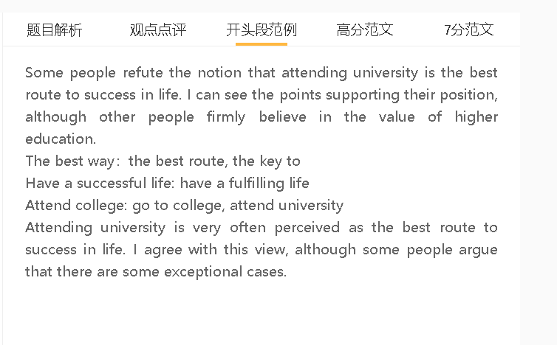

范文

6.5
It is sometimes argued that receiving a university education is the best path to career success. I agree with this view, although the opposite may be true in some cases.
A 上大学 B 获得很多的知识和技能 C 很成功
背景（想不到，可以不写）：This is particularly true for ….where 句子
解释（解释A到B或者B到C的跳跃）： 原因，so 结果
举例 （名词具体化进行替代）：for example, 句子
The main reason why higher education holds the key to a successful life is that people can acquire knowledge and skills at university. This is particularly true in the knowledge economy, where people are expected to use knowledge in the workplace. University students can systematically learn professional knowledge, and high paying professions require a solid theoretical foundation. For example, they need to have a degree in computer science if they want to succeed in artificial intelligence.
A 直接进入职场 B 积累大量实际经验 C 很成功
On the other hand, opponents hold the view that A+C because B
背景（想不到，可以不写）： In some cases, ……
解释（解释A到B或者B到C的跳跃）：结果，because/as/since 原因
On the other hand, opponents hold the view that entering the workforce directly is the best way to achieve success because people can gain a lot of practical experience. In some cases, hands-on experience is very important in some industries. They can have a successful life since they understand the ways to approach different situations.
A 上大学 B 积累人脉 C 很成功
In my view, A+C considering that B
背景（想不到，可以不写）：This is important in ....where 句子
解释（解释A到B或者B到C的跳跃）： 原因; therefore, 结果
举例 （名词具体化进行替代）：for example, 句子
In my view, attending college increases the chance of success considering that people can build a network of contacts. This is important in the modern world, where competition is intense. People can turn to their friends for help; therefore, they can solve problems and achieve success.

In conclusion, I would argue that tertiary education is the most important factor leading to success, even though there are some exceptions.
7.5+
It is sometimes argued that receiving a university education is the best path to career success. I agree with this view, although the opposite may be true in some cases.

The main reason why higher education holds the key to life achievements is that people can acquire knowledge and skills at university. This is particularly true in the knowledge economy, where jobs have become specialised and technology-intensive. Universities provide well-structured courses to impart professional knowledge systematically, which can be applied in solving complex problems, improving efficiency and fostering innovations. Those who have specialised knowledge to perform these functions are economically valuable, thereby having a successful career. This kind of knowledge can hardly be gained outside the university campus, either by self-education or by practice.

On the other hand, opponents hold the view that entering the workforce directly is the best way to achieve success because people can gain a wealth of practical experience. This view is valid in cases where people have intellectual skills to expand their knowledge without formal education. Working immediately after high school can expose them to a variety of problems in the workplace and push them to find solutions. They may develop expertise, discover untapped demands and introduce changes earlier than their peers who study at college. Therefore, they have more competitive advantages, which lead to their success.

In my view, pursuing a college degree increases the chance of success considering that young people can build a network of contacts. This is valuable in the modern world, where competition is intense and few can overcome all challenges or attain objectives alone. University life is ideal for meeting like-minded friends, because they have shared experiences in group assignments and club activities, as well as similar skills and abilities. After they graduate, they can turn to their social connections for support, when they seek new employment, set up a business and encounter thorny problems in their professional lives. They can address all issues and attain their targets with their social network, which contribute to their success. In contrast, young people who start their career early may have limited opportunities to find favourite jobs and meet people of similar backgrounds and levels.

In conclusion, I would argue that tertiary education is the most important factor leading to success, even though there are some exceptions.

