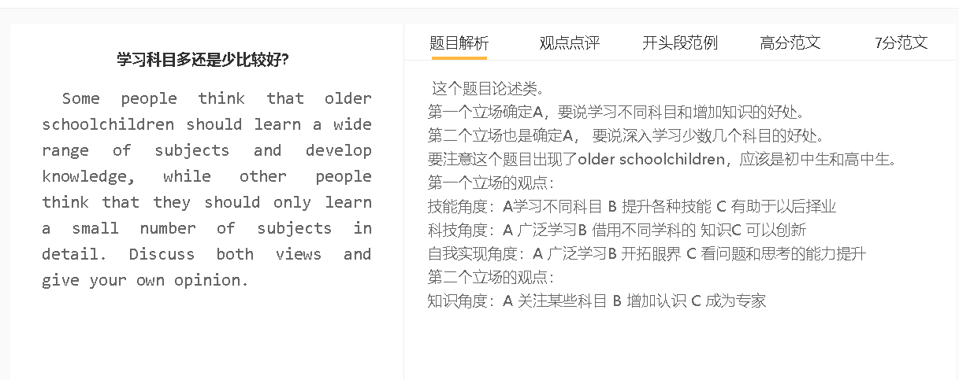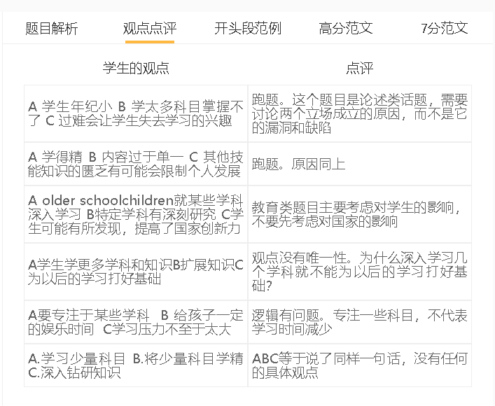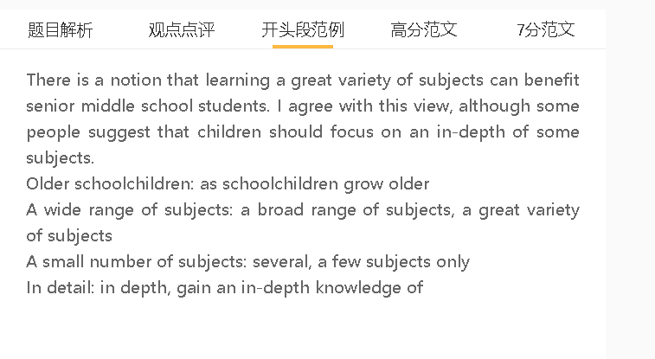

范文

The subjects a student learns at school can have a direct impact on their personal development and job prospects. I believe that children should receive a rounded education, instead of focusing on several subjects only.
A学习不同科目 B 提升各种技能 C 有助于以后择业
背景：现在社会企业压缩成本，需要人们有多项技能，可以处理多种工作
背景：年轻人不知道的职业走向，技能多才可以有不同的选择
举例：数学提高数字能力
举例2：语言提高表达能力
对比：有限科目，以后转业比较难，或者不能multitasking
Acquire, develop skills
Broaden career horizons, find work
Numeracy, mathematical skills,
Financial analysts, engineers, accountants
Learning a variety of subjects can help students develop skills which can meet varied requirements of employers and broaden their career horizons in later life. Cost-conscious companies expect employees to multitask at a time when there is a need to shrink the workforce. A balanced curriculum also benefits teenagers who are unaware of what career path they should follow, and learning different subjects can equip them with skills to seize different employment opportunities. Science subjects, such as maths and biology, and arts subjects, such as literature and psychology, impart diverse skills to younger generations and offer flexibility when they switch jobs and explore talents. A narrow range of courses, by comparison, eliminates some options available for children and reduces the resilience in a changing world of work.
A 关注某些科目 B 增加认识 C 成为专家
背景：学生的时间少，不可能全才
背景：有些学生很早知道自己的天赋所在
解释（how）：做作业，额外的阅读，复习，巩固
解释优点：职业成功
on the other hand, some educationalists may advise students to concentrate on a small number of disciplines only and develop expertise in these subjects. For students who have a good idea where their talent lies, it is reasonable for them to make early decisions and concentrate all their effort into some subjects. Given the tight schedule, they can become competent at one subject more easily if they set clear objectives and stay focused. Some of them may have a facility for learning languages, for instance, so it is better to focus their minds on language acquisition and receive training as potential linguists, language teachers or interpreters. They are more likely to succeed, earn a high salary and become reputable, than those who lack focus.
A 广泛学习B 借用不同学科的 知识C 可以创新
解释：增加知识面，借鉴其他领域的知识，知道不同的工具
举例：搞文学，电脑做一些事情
对比：只熟悉1-2个科目，解决方法比较传统
Draw upon ideas, borrow ideas from…
Promote innovation, show creativity,
Expand knowledge base, tools.
Teach literature, playwright
In my view, having a good understanding of different subjects can fuel imagination. Young people who have expanded knowledge base in different subjects can borrow ideas from whatever fields they know, and employ tools and skills which are unique to some areas of study. For example, even though they may teach literature or a foreign language in the future, they can incorporate computer skills they acquire at middle school into their work to ensure their teaching is more effective and stimulating. These innovations cannot be achieved by those whose thinking is limited to a small number of subjects only.

In conclusion, I would agree with the idea of exposing students to the knowledge of different disciplines, although for some children, the targeted education is possibly a better choice.

