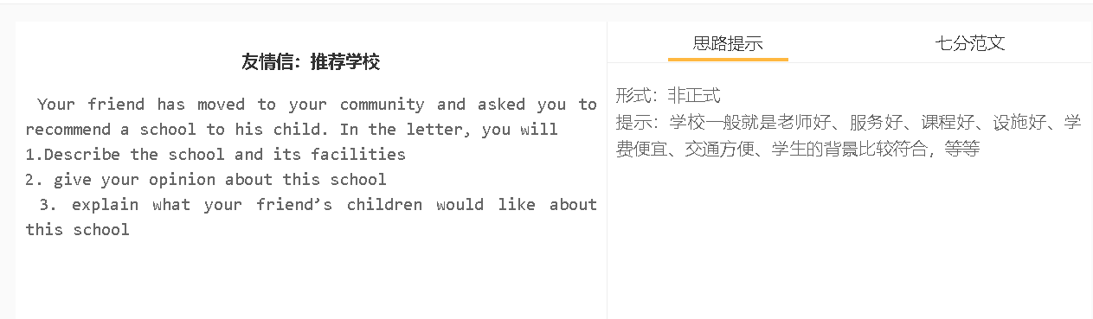
7分范文1
Hi, Alice, I’ve been thrilled about your decision to move to our neighbourhood. We can visit each other more frequently as your home is only two blocks away. I’d recommend Avondale Elementary school, if you ask me what is the best option for Adam. Established in 1950, this school has been serving the community more than seven decades. With the funding received by the city council as well as from alumni, it has gradually been extended with a hot of facilities, including a swimming pool, lab, library and gym, which support a broad range of extracurricular activities. What I like most about the school is its inclusive culture. It has students of different nationalities, half from immigrants’ families. Children can mix with classmates from diverse backgrounds, thereby finding it easy to adapt to this multicultural community. Cultural competence also prepares them for employment in this country.

