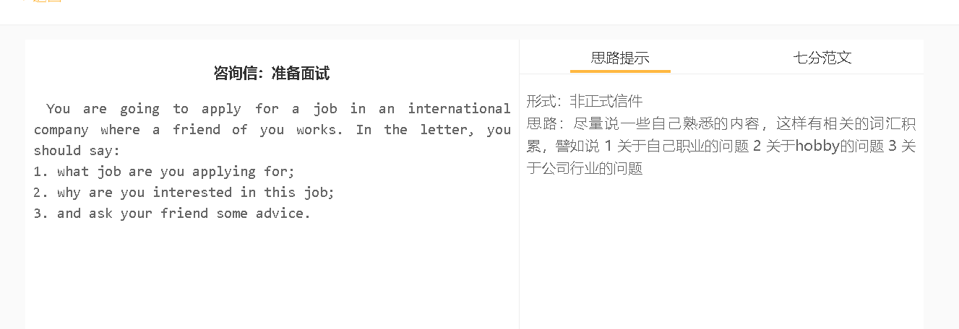
7分范文1
Dear Abby, I’m writing to ask you for advice on my application for a position of your company. I believe your suggestion can make my CV shine and I have to tell you that this job means a lot to me. Your company has been recruiting an architect who has relevant experience of five to eight years, and I have read all the requirements and tasks of the job available. I’m fully confident that I am well-qualified for this vacancy, but what worries me is that the competition for this place is fierce and I really need your support to impress recruiters. I want this job because Arup is a reputable construction company, and it has been my dream to work with talented architects like you. I’ve also been told that your company has made a tremendous effort to create a perfect work environment for staff. This has appealed to me as well since I’ve been fed up with the appaling condition of my current office. I hope you can tell me what qualities and values Arup have been looking for among all candidates, and which part of my job history should be highlighted to give me a competitive edge over other applicants. Do you think it is a great idea if I include the draft of Edison Mansion, the building I designed last year? Anyway, please share with me any tip about winning a job in Arup. Thank you my dear and I’m looking forward to hearing from you. Yours, Florence

