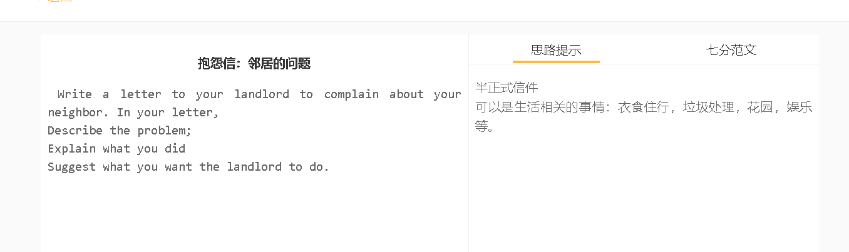7分范文1
Dear Mr. Smith, I am writing to ask for your help in resolving a problem I am experiencing with one neighbor, John Henderson. I am your tenant living at 45, Glanville Terrace. Mr Henderson is using an old air conditioner every day and night, which has created noise disturbing my work and sleep. As you know, I work from home and sometimes, I cannot even hear what my clients say on the phone amidst noise, which has seriously affected my business. I have approached Mr Henderson on this matter, and he has promised to replace it with a new one soon. This promise has not yet been fulfilled, and I tried to talk to him again, but he refused to answer my calls. What has infuriated me is that his son has recently started playing guitar and that loud music has broken my concentration frequently and led to my sleeping problems. I suppose they won’t treat me with respect since they assume that tenants move around a lot, but I believe they cherish their relationship with you. If you intervene to remind the importance to maintaining the quite of this tranquil neighbourhood, they would possibly change their behaviour. I look forward to receiving your response.

