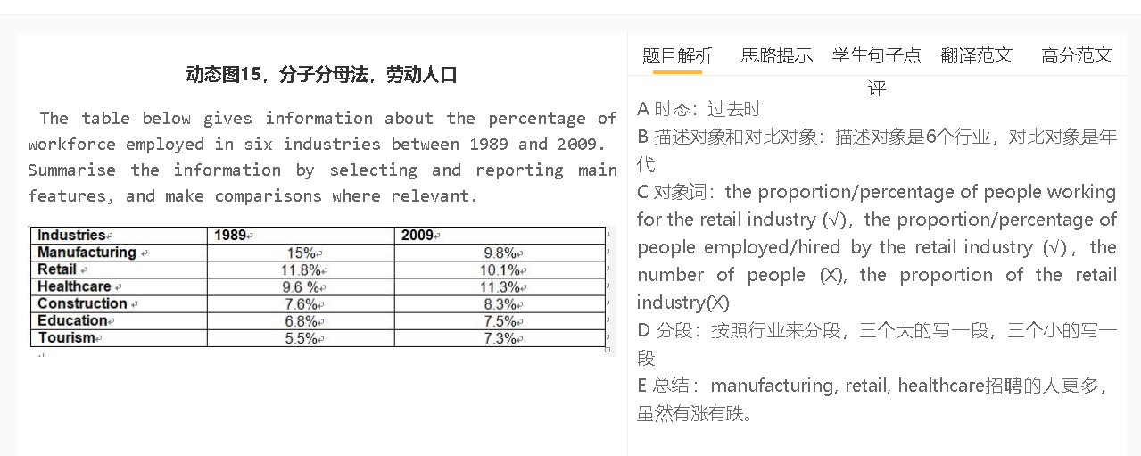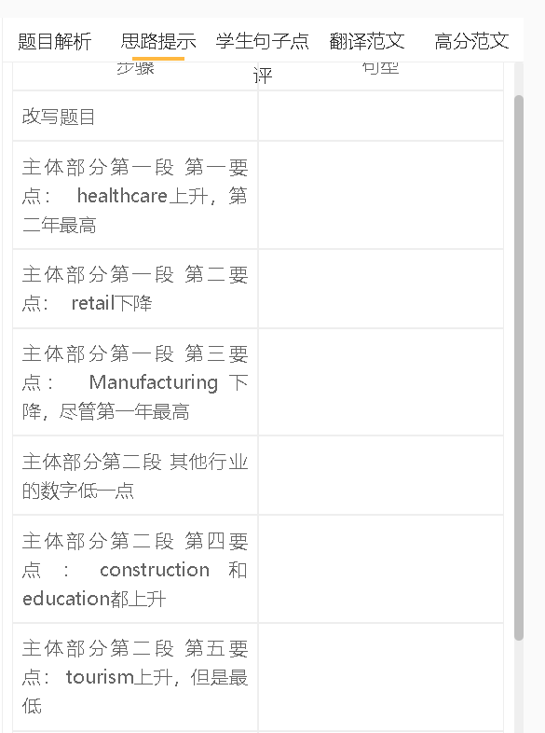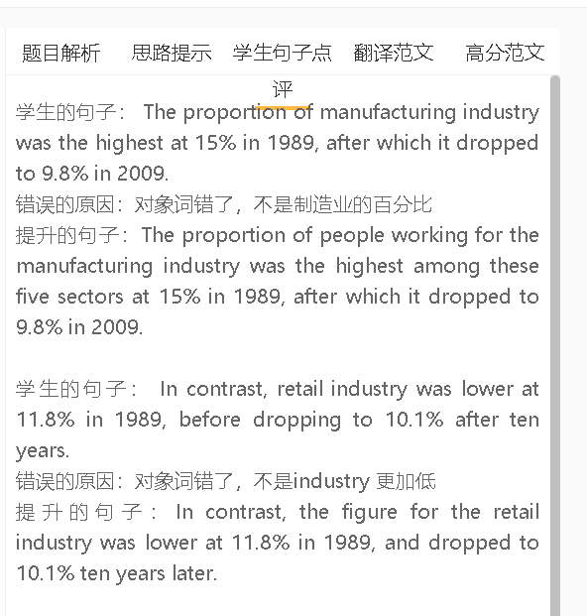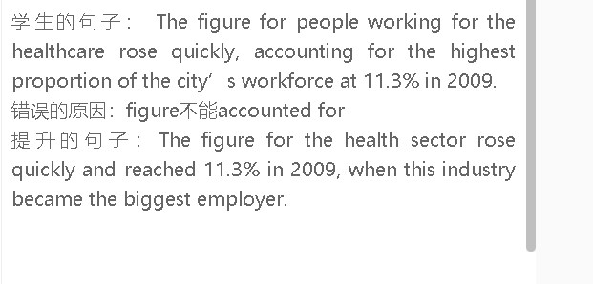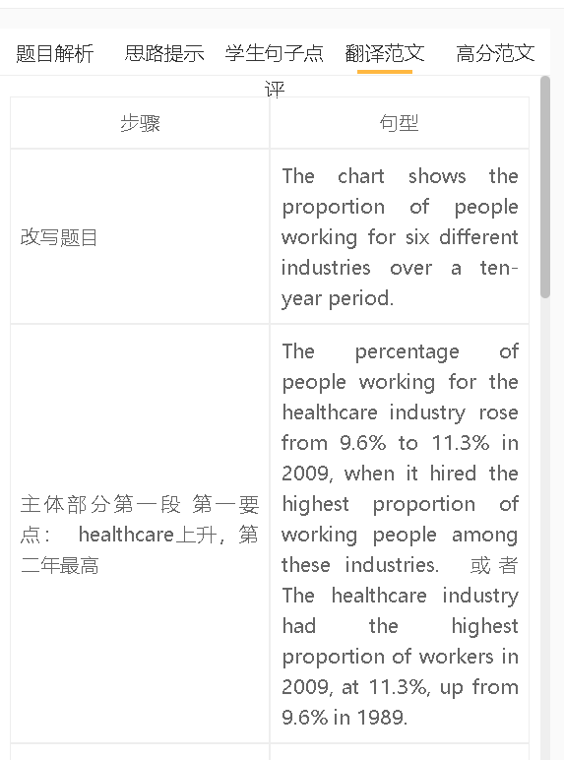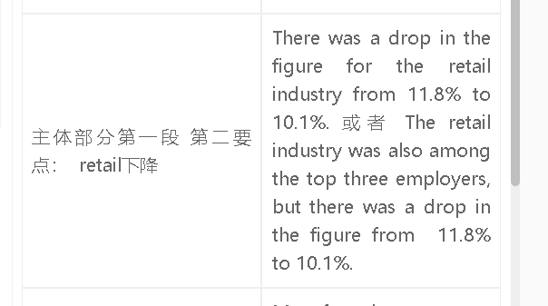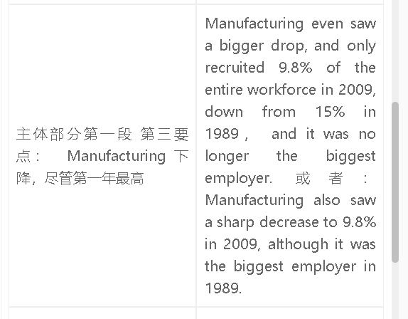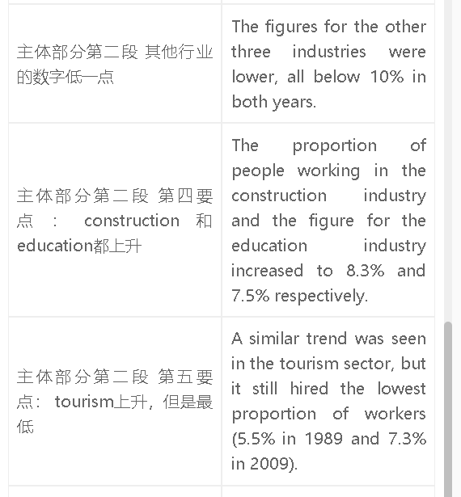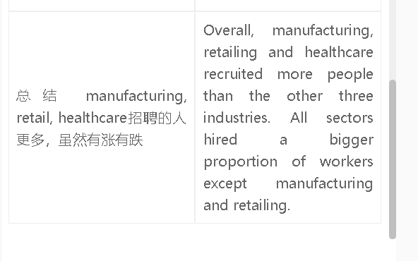

高分范文1
The table compares the proportions of employees working for six industries in the years 1989 and 2009. The percentage of people working for the healthcare industry increased slightly from 9.6% to 11.3% in 2009, when this sector surpassed manufacturing and became the largest employer. The manufacturing sector recruited the highest proportion of people in 1989, at 15%, but the figure dropped sharply to 9.8 % twenty years later. The retail sector was among the top three employers for this country, although the figure dropped slightly from 11.8% to 10.1%. Construction and education employed a smaller proportion of working people, but the figures increased to 8.3% and 7.5% respectively. Tourism employed the smallest proportion of employees in both years, despite an increase to 7.3%. Overall, the healthcare sector played the most important role in the labour market in the second year, and the percentages of working people in all industries, except manufacturing and retailing, increased.

