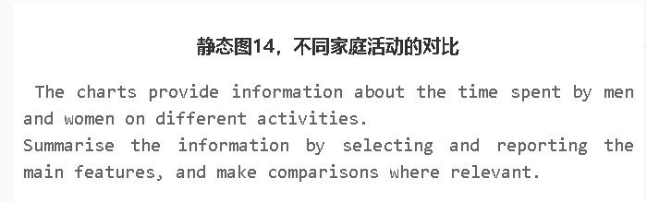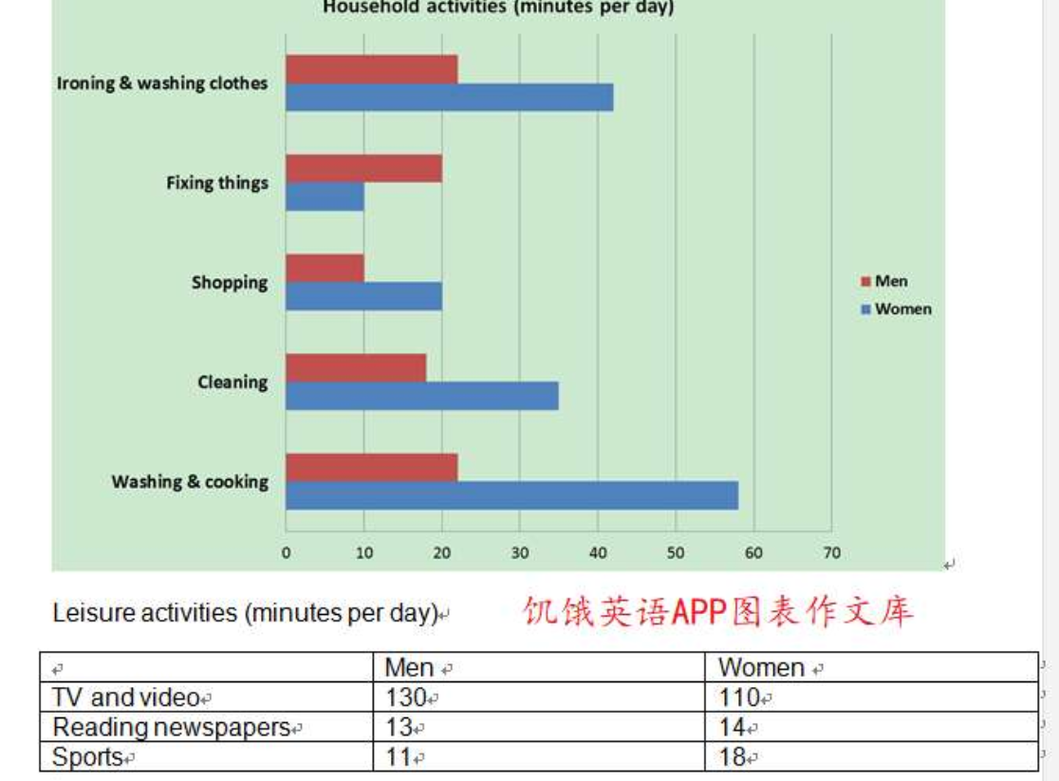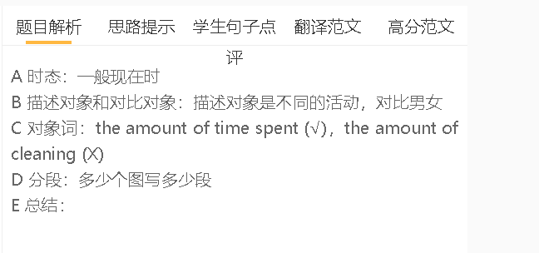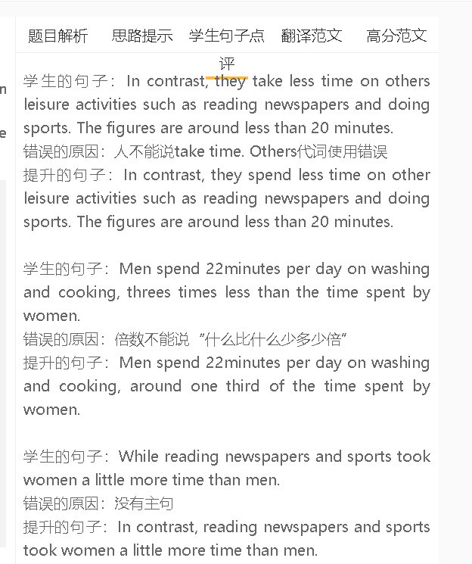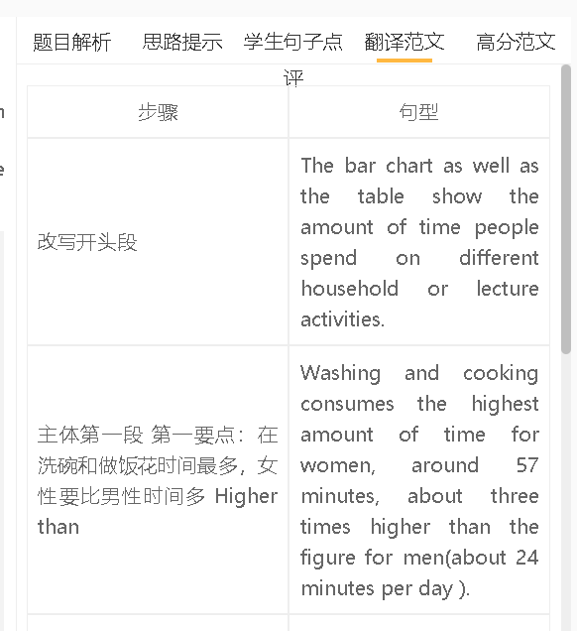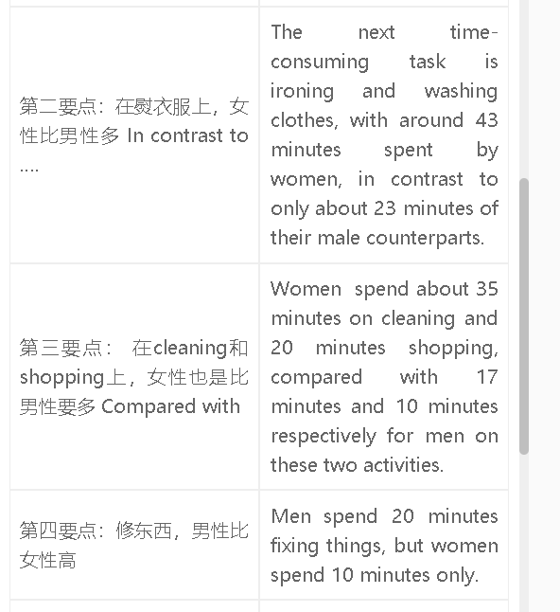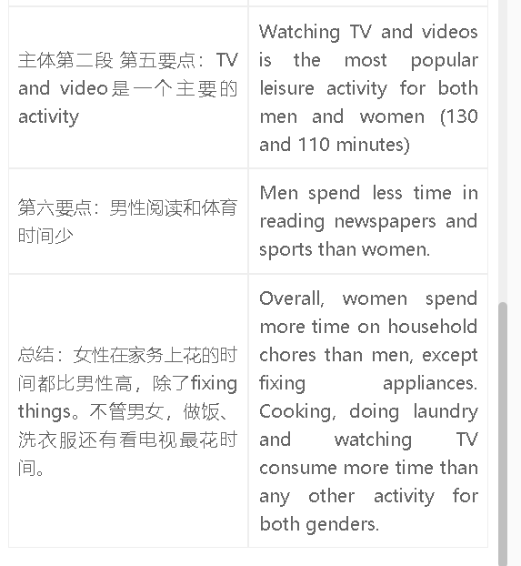

高分范文1
The charts show the amount of time men and women spend on different household and leisure activities every day. Women play a bigger part in domestic work than men do. The biggest gap is in washing and cooking, in which women spend up to 58 minutes on this activity, compared with around 22 minutes for men. Women spend around twice as much time as men on ironing and washing clothes. There are also striking differences in shopping and cleaning, in which women spend 34 and 20 minutes respectively. Fixing things is the only household activity where men spend more time than women (20 minutes versus 10 minutes) . Watching TV and video is the favourite leisure activity for both men and women, using 130 and 110 minutes. The time spent on reading newspapers is similar for both sexes, while women are more interested in sports (spending an average of 18 minutes every day, in contrast to 11 minutes for men). Overall, women assume a bigger role in all domestic activities except fixing things. both men and women prefer to watch TV and videos in their leisure time.

