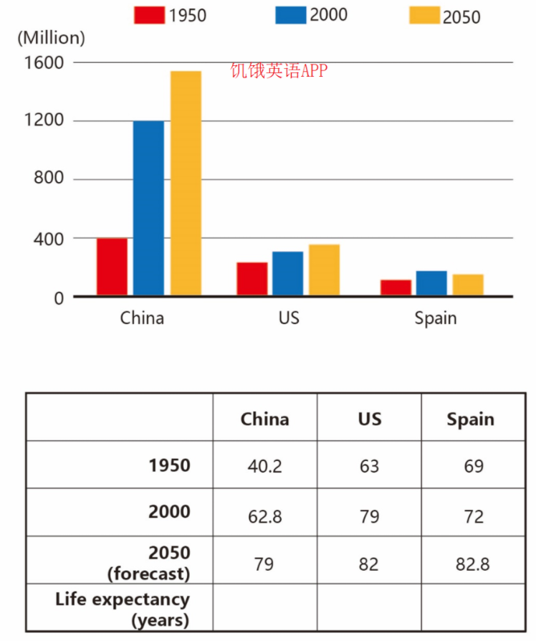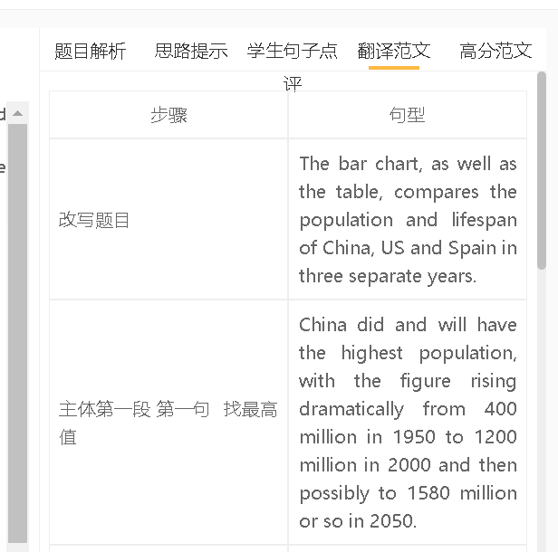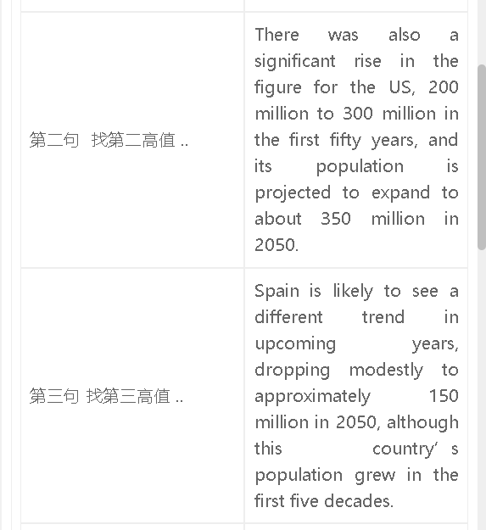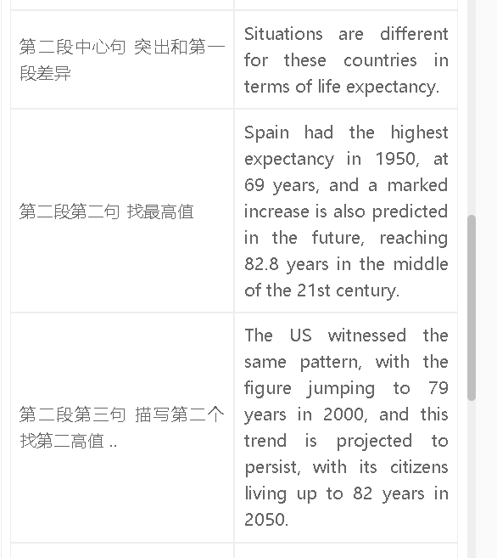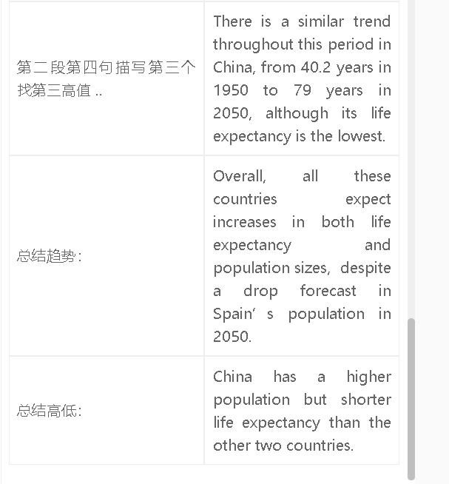

高分范文1
The bar chart and table provide a comparison of the population and lifespan of China, the US, and Spain across three different years. China consistently has the highest population, experiencing a dramatic increase from 400 million in 1950 to 1,200 million in 2000, and potentially reaching around 1,580 million in 2050. The US also saw a significant rise, rising from 200 million to 300 million in the first fifty years, and is projected to expand to approximately 350 million by 2050. In contrast, Spain is expected to follow a different trend, with a modest decline to around 150 million in 2050, despite experiencing population growth in the first five decades. In terms of life expectancy, each country has had distinct situations. Spain had the highest expectancy in 1950, at 69 years, and is predicted to see a notable increase, reaching 82.8 years by the mid-21st century. The US witnessed a similar pattern, with life expectancy jumping to 79 years in 2000, and this trend is projected to continue, with citizens living up to 82 years by 2050. China also experienced a similar trend over this period, with life expectancy increasing from 40.2 years in 1950 to 79 years in 2050, although it still has the lowest figure among the three countries. Overall, all three countries anticipate increases in both life expectancy and population size, despite the projected drop in Spain's population by 2050. China stands out with a higher population but shorter life expectancy compared to the other two countries.

