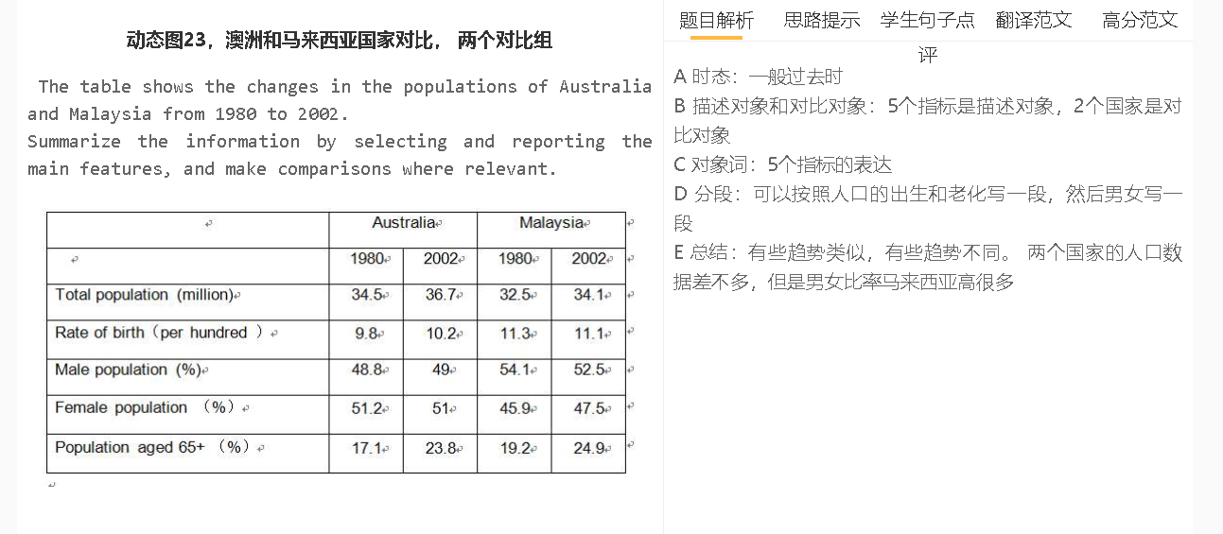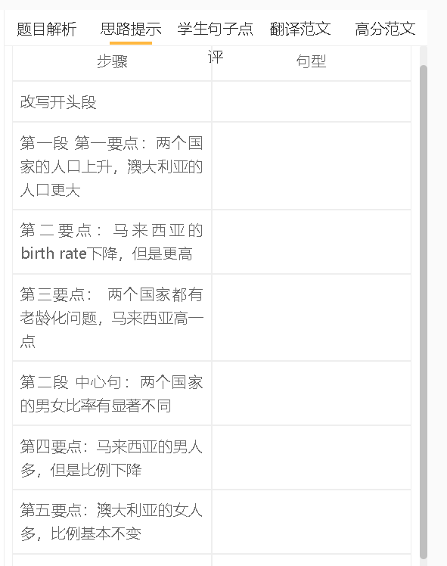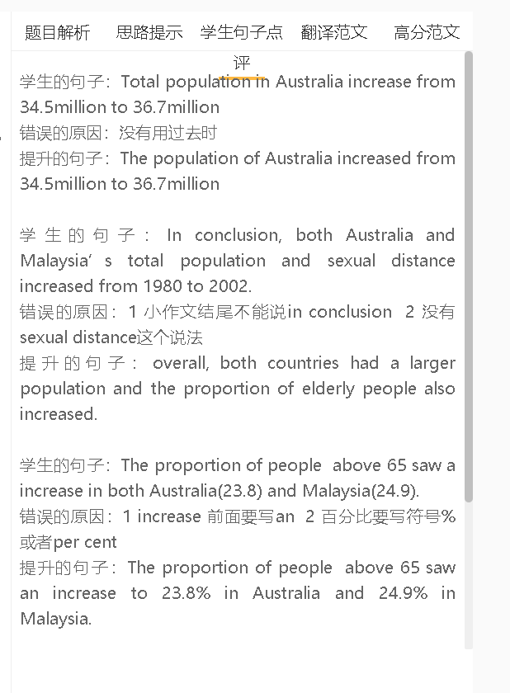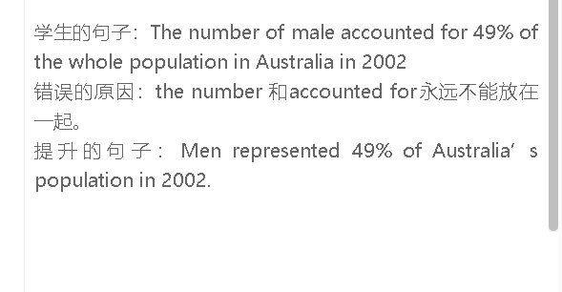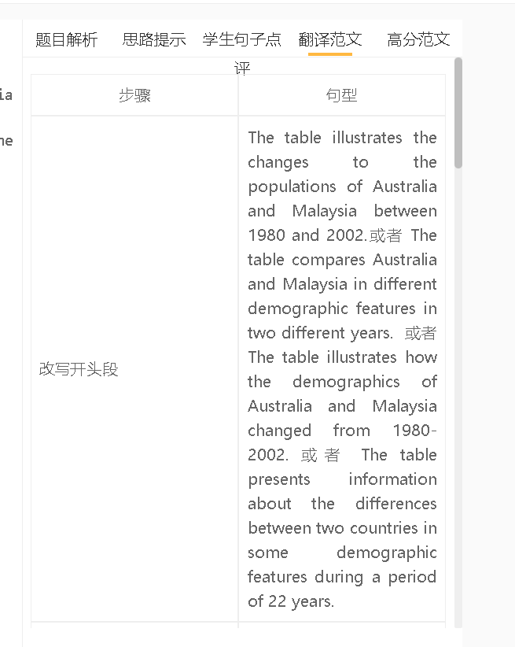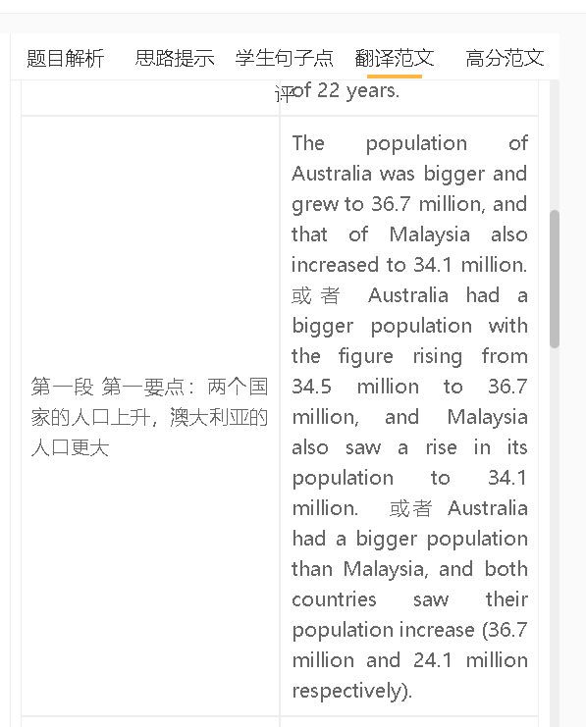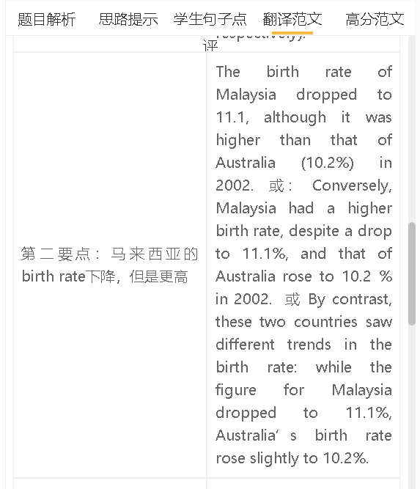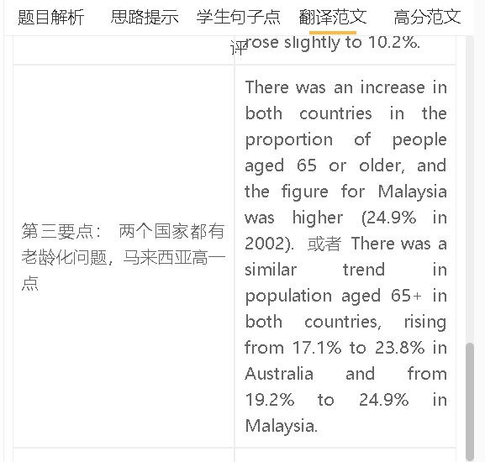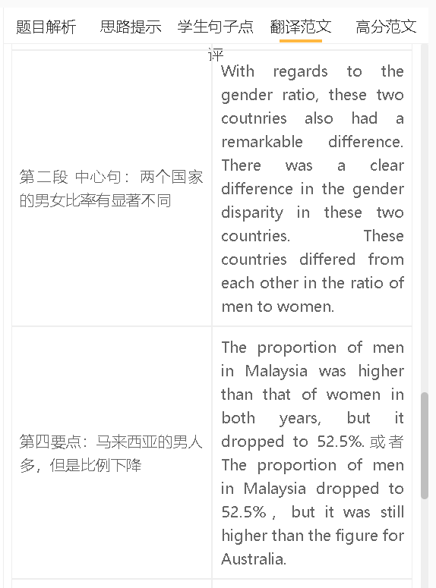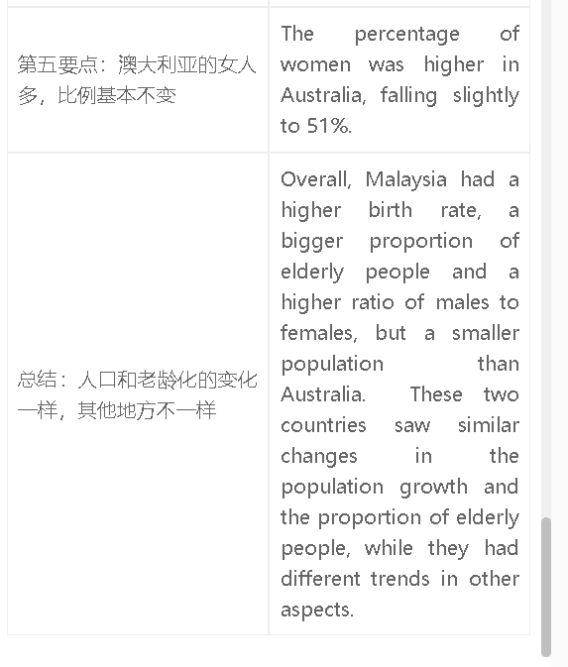

高分范文1
The table provides information about the demographic trends in Australia and Malaysia over a span of 22 years. Australia had a larger population than Malaysia and both populations grew, reaching 36.7 million and 34.1 million respectively in 2002. In contrast, the birth rate in Malaysia was higher than that in Australia, although the gap narrowed (11.1% for Malaysia and 10.2% in Australia in 2002). There were substantial differences between these two countries in the sex ratio. Men accounted for a larger proportion of Malaysia’s population, despite a drop from 54.1% to 52.5 % in 2002. By comparison, women outnumbered men in Australia, but the proportion of women fell slightly to 51%. Both countries saw their population ageing during this period, and Malaysia had a larger proportion of elderly people than Australia (24.9% compared with 23.8% in 2002). Overall, these two countries saw a similar trend in the population growth and the proportion of the elderly, but different patterns in other aspects. Malaysia had higher figures than Australia in all indexes except the population size and the percentage of women.
高分范文2
The chart compares demographic changes of two countries throughout a period from 1980 to 2002. Australia had a higher population, with the figure rising from 34.5 million to 36.7 million, and Malaysia saw a similar trend, with its population growing from 32.6 to 34.1 million. There was also an increase in the proportion of people aged 65 in Australia and Malaysia, rising to 23.8% and 24.9% respectively. In contrast, these two countries saw different trends in the birth rate: the figure for Australia rose to…, while the figure for Malaysia dropped to…. There were clear differences between them in terms of the sex ratio. The proportion of the male population in Australia increased slightly to 49% in 2002. By comparison, men outnumbered women in Malaysia, although the proportion of men decreased to 52.5% in 2002. Overall, two countries saw a rising trend in population expansion and population ageing, but showed different patterns in birth rates as well as the gender gap. Malaysia had higher figures than Australia in nearly all indexes except the population size.

