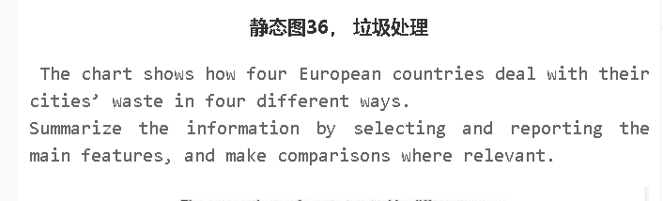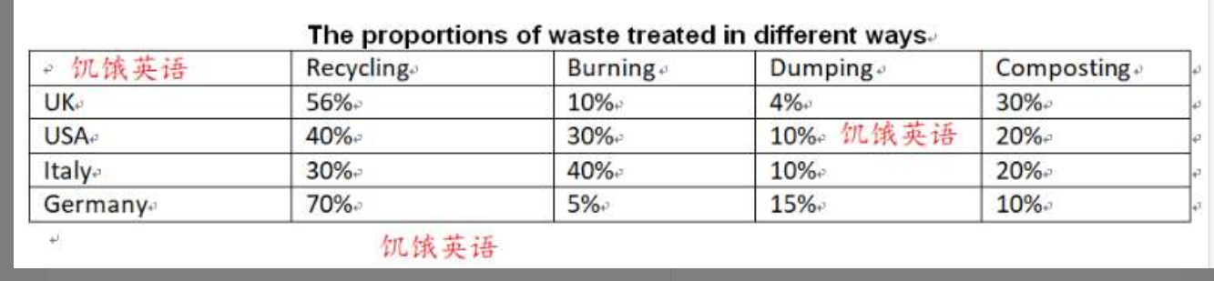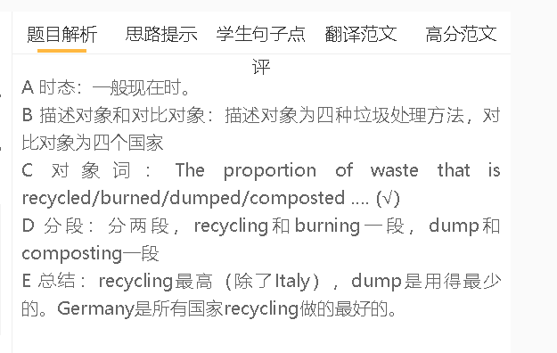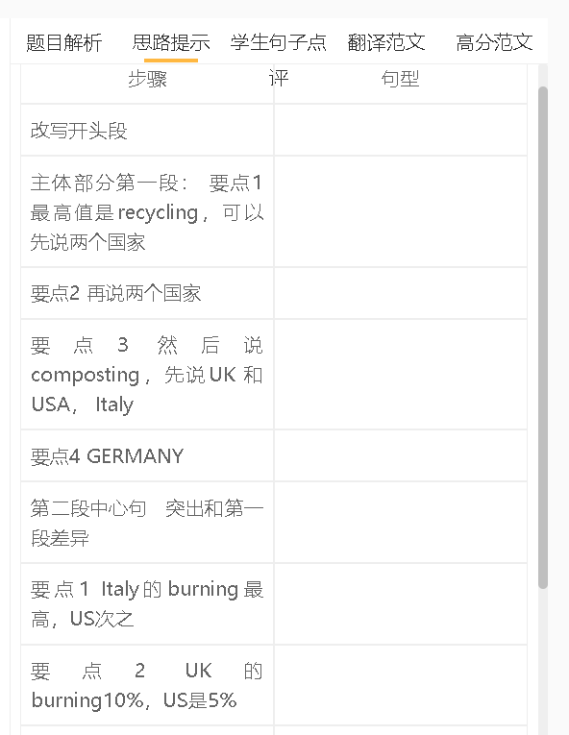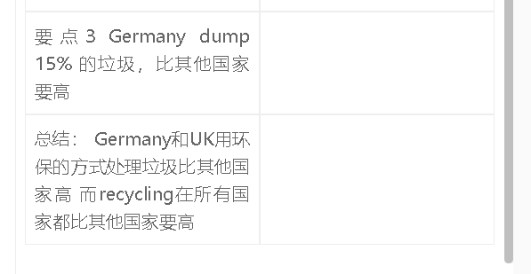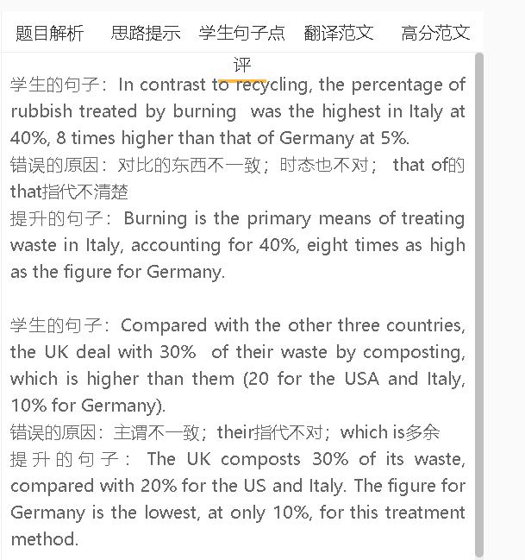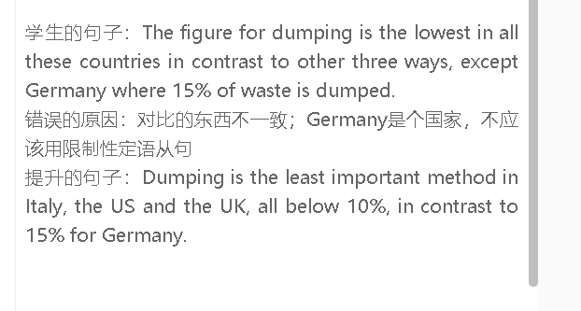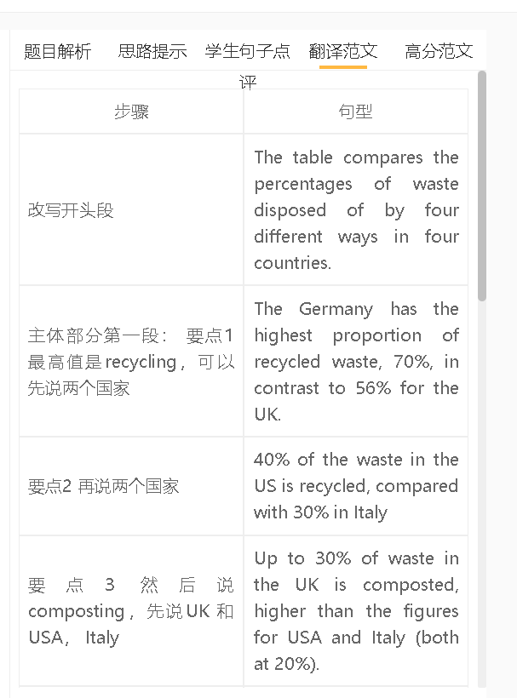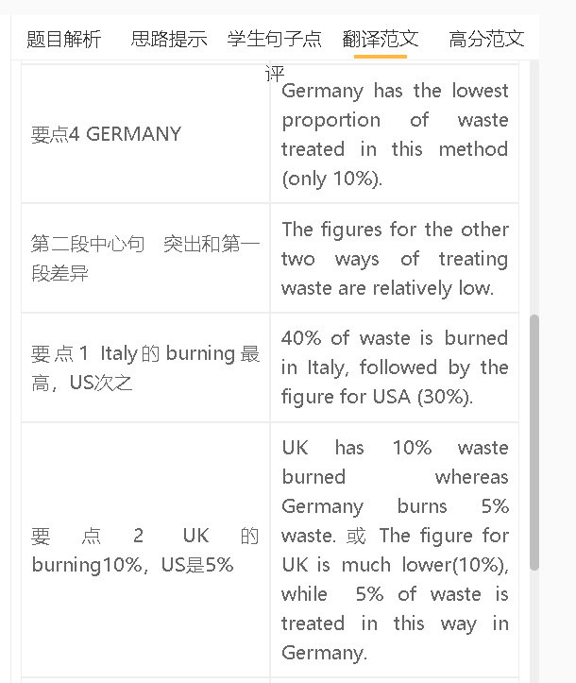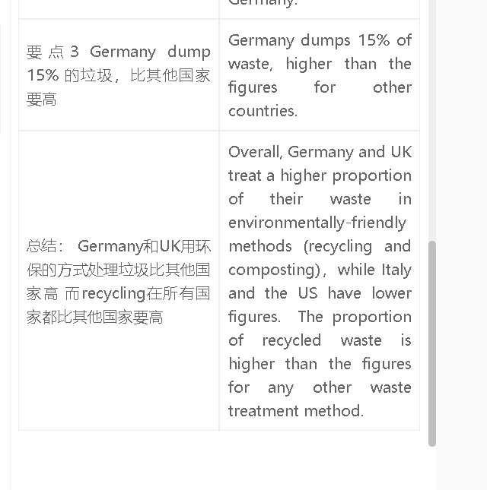

高分范文1
The table gives information about four different means of treating waste chosen by four countries. Germany recycles 70% of its waste, higher than any other country (56% for the UK and 40% for the US). By comparison, only 30% of waste is recycled in Italy. Burning is the primary means of treating waste in Italy, accounting for 40%, eight times as high as the figure for Germany. US burns 30% of its rubbish/garbage, while UK disposes of 10% in this way. The other two waste treatment methods are less important. The UK composts 30% of its waste, compared with 20% for the US and Italy. The figure for Germany is the lowest, at only 10%, for this treatment method. Dumping is the least important method in Italy, the US and the UK, all below 10%, in contrast to 15% for Germany. Overall, recycling is the most common way of treating waste for these countries except Italy, while dump is the last option for all countries with the exception of Germany. Germany recycles more waste than other countries do. 范文2 The table compares the percentages of waste disposed of by four different methods in four countries. Germany has the highest proportion of recycled waste at 70%, in contrast to 56% for the UK. The US recycles 40% of its waste, while Italy recycles 30%. In terms of composting, the UK leads with 30%, followed by the US and Italy, both at 20%. Germany has the lowest proportion of waste treated through composting, with only 10%. The figures for the other two waste treatment methods are relatively low. Italy burns 40% of its waste, followed by the US at 30%. The UK burns 10% of its waste, while Germany burns 5%. Germany also dumps 15% of its waste, which is higher than the figures for the other countries. Overall, Germany and the UK have higher proportions of waste treated through environmentally-friendly methods such as recycling and composting, whereas Italy and the US have lower figures. Recycling is the most common waste treatment method in all these countries.

