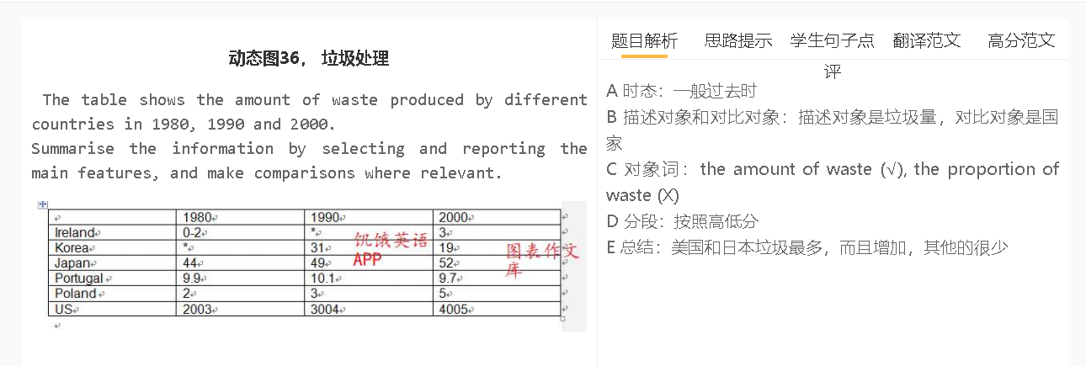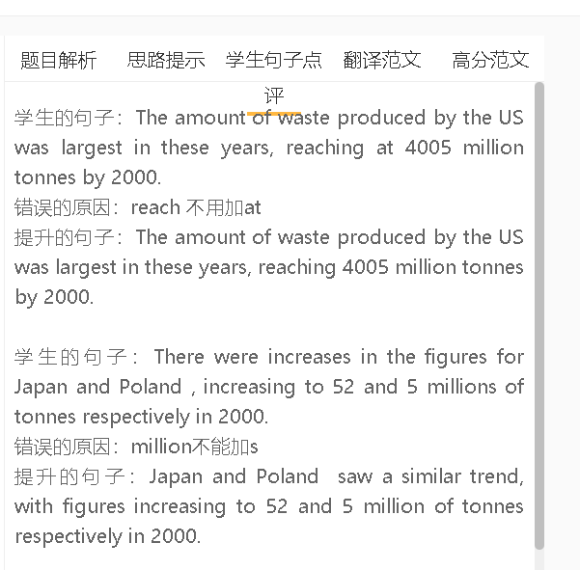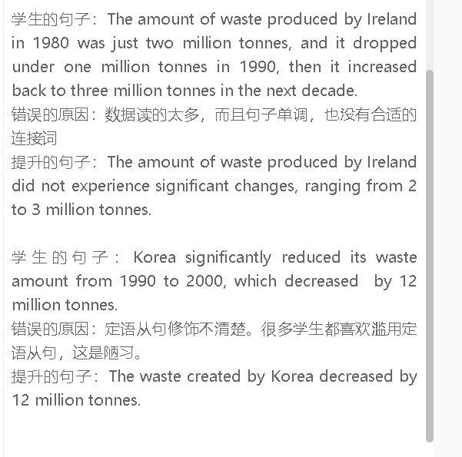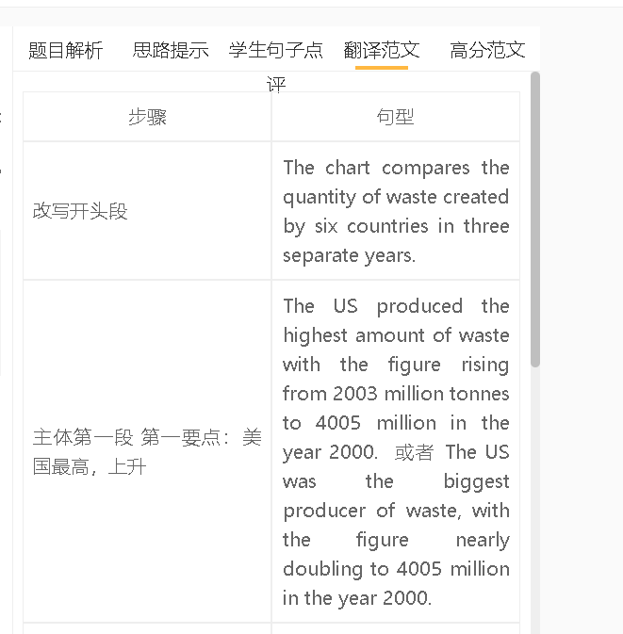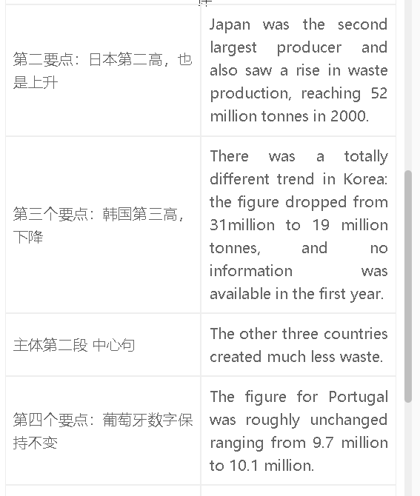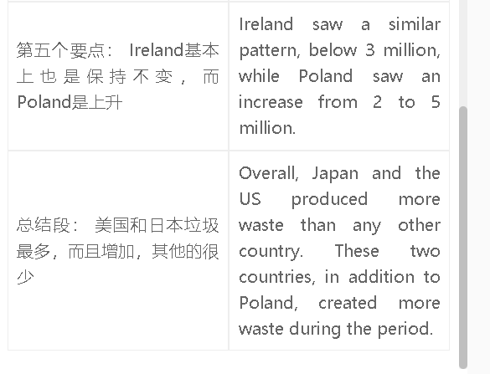

高分范文1
The chart compares the quantity of waste created by six countries in three separate years. The US produced significantly more waste than other countries and there was a two-fold increase in waste production of this country from 2003 million tonnes to 4005 during the period. The rising trend was also seen in Japan, where the waste rose from 44 to 52 million tonnes. The waste output of Korea, in contrast, showed a marked decrease to 19 million in 2000. The waste production was noticeably lower in other countries. While the figures for Ireland and Poland increased slightly to 3 and 5 million tonnes respectively, the waste produced in Portugal remained roughly unchanged at around 10 million. Overall, the US and Japan saw an increase in waste production and these two countries also produced much more waste than other countries did.

