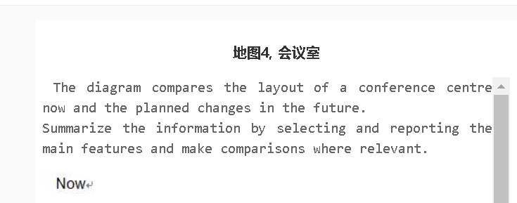

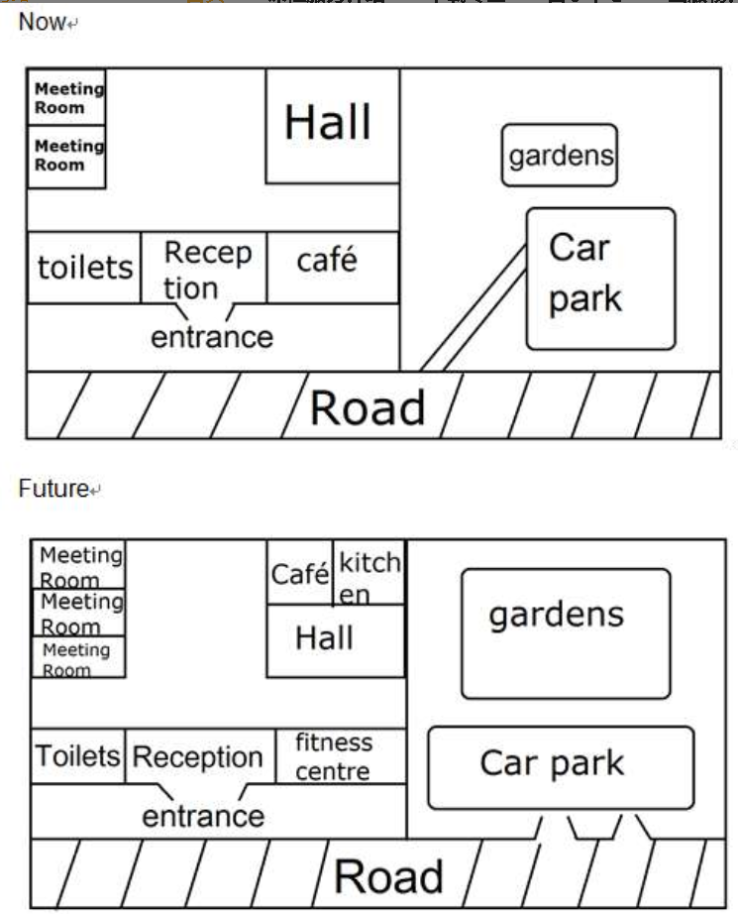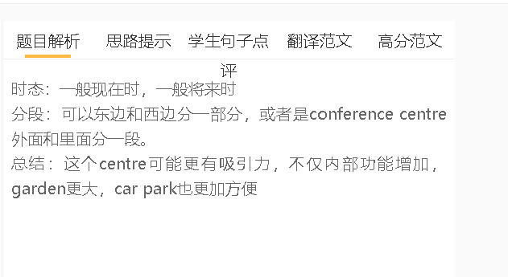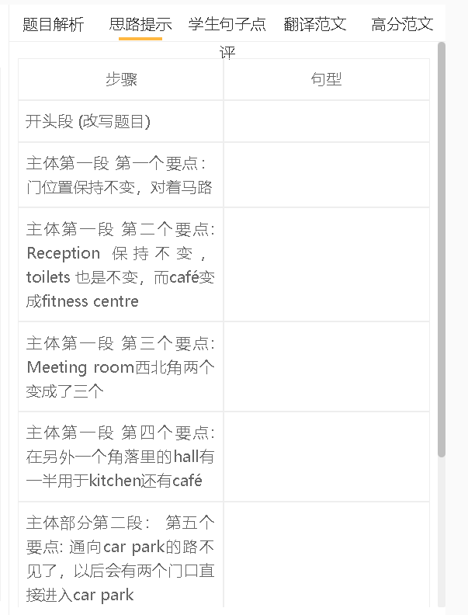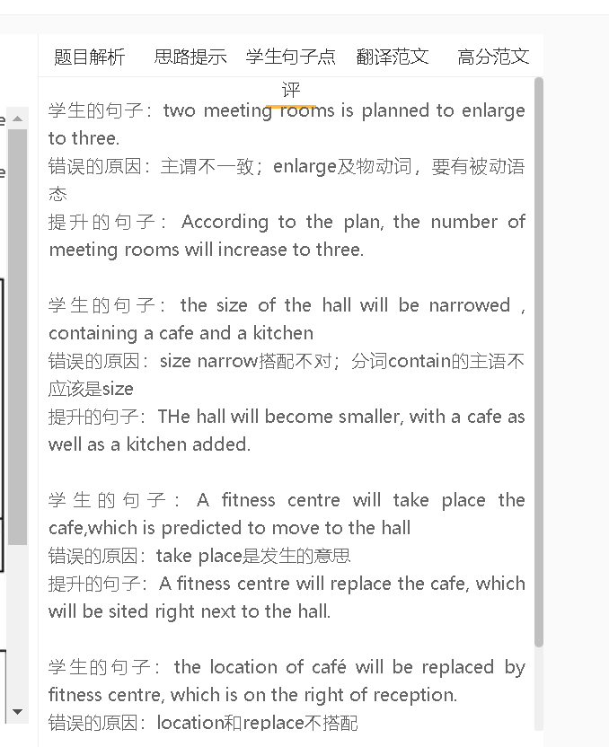

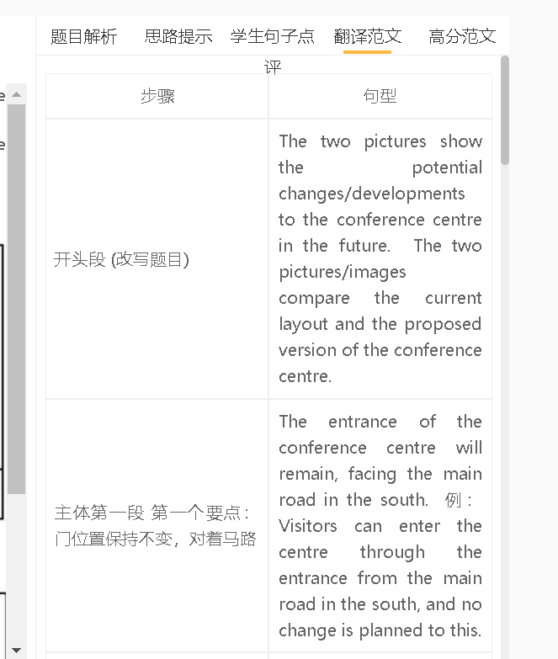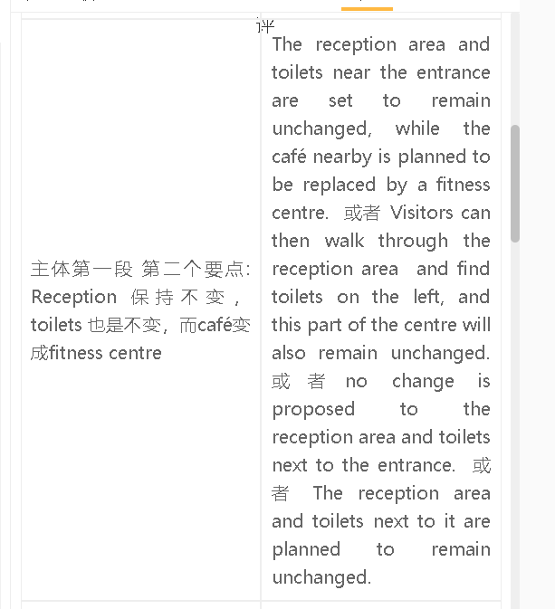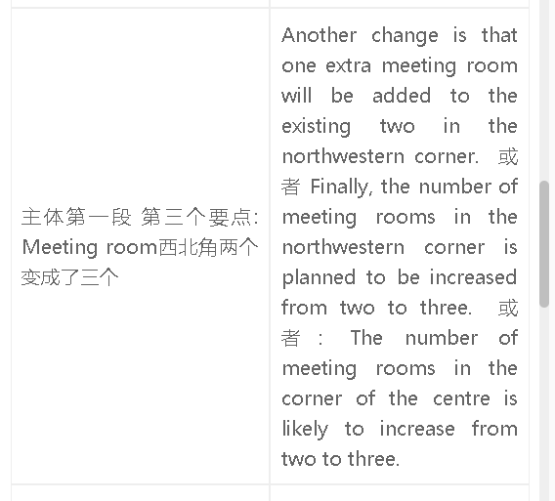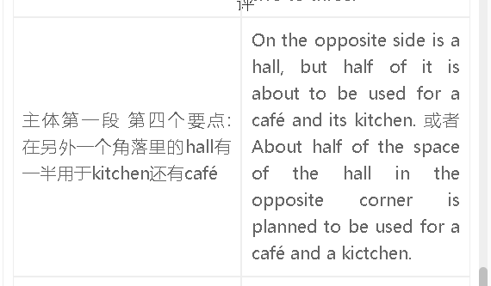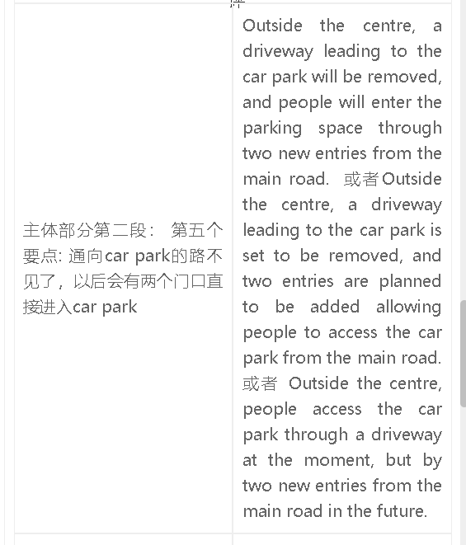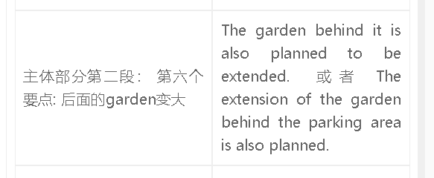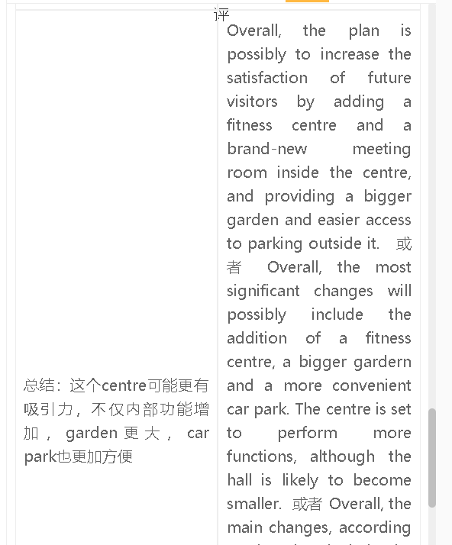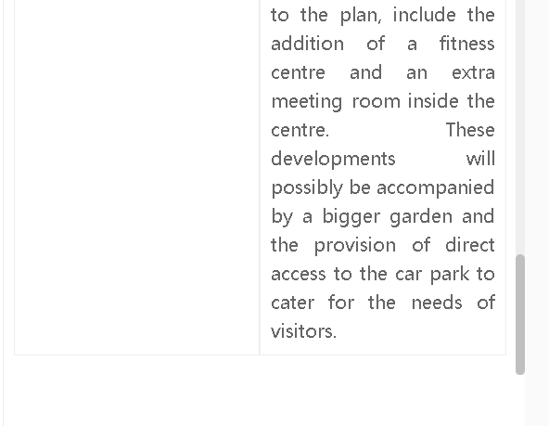

高分范文1
The two maps illustrate the possible changes to the layout of a conference centre and the facilities next to it. Visitors can enter the centre through the entrance facing the road, and then see the reception, which will not be changed in the future. The toilets next to the reception area will remain unchanged as well, while a fitness centre will be built where there is currently a café. There will be significant changes to other facilities inside the centre. One of them is that the number of meeting rooms will increase to three. In addition, the hall on the opposite side will be half as big as it is now, and the other half of the hall will be used for running a café with a kitchen. The future plan will also include remarkable developments outside the centre, including the expansion of the garden. The car park will remain in the same place, but one difference is that people will enter the parking space through two entries from the main road, rather than use the current path leading to it. Overall, the development plan would seek to maximise the use of the conference centre by adding a fitness centre and a brand-new meeting room. The garden, along with the car park, is projected to develop to meet the renewed needs of users.
高分范文2
The two pictures illustrate the possible changes to a conference centre and its facilities. A visitor can see the reception, which remains unchanged in the future plan, when he or she enters the conference centre from the entrance. Toilets will also remain in the same plece, but the café next to the reception area is to be converted into a fitness centre. Another change is the addition of another meeting room to the existing two inside the centre. The hall on the opposite side will become smaller, while part of its space is expected to be used for running a café as well as a kitchen. The garden outside of the centre is likely to be expanded, and there is no driveway leading to the carpark in the proposed development. In the future plan, visitors can get access to the car park from the main road. Overall, the development plan would seek to maximise the use of the conference centre, and the garden, along with the car park, is projected to develop to meet the renewed needs of users.
高分范文3
The two diagrams show the possible changes to a conference hall in the future. One planned change is that gardens in the conference centre will be enlarged. In addition, the path linking the car park and the main road will disappear, and car users will access the car park through two new entrances off the main road. One new meeting room will be added to the original two on the corner of the conference centre, while a café and a new kitchen will be built with part of the origial hall space used. The consequence of this change is that the hall will become smaller. Toilets and the reception will remain in the same positions with visitors entering the centre through the same entrance, but the café next to the reception will be replaced by a fitness centre. Overall, the major changes to the centre include the increase in the number of meeting rooms and a new fitness centre.

