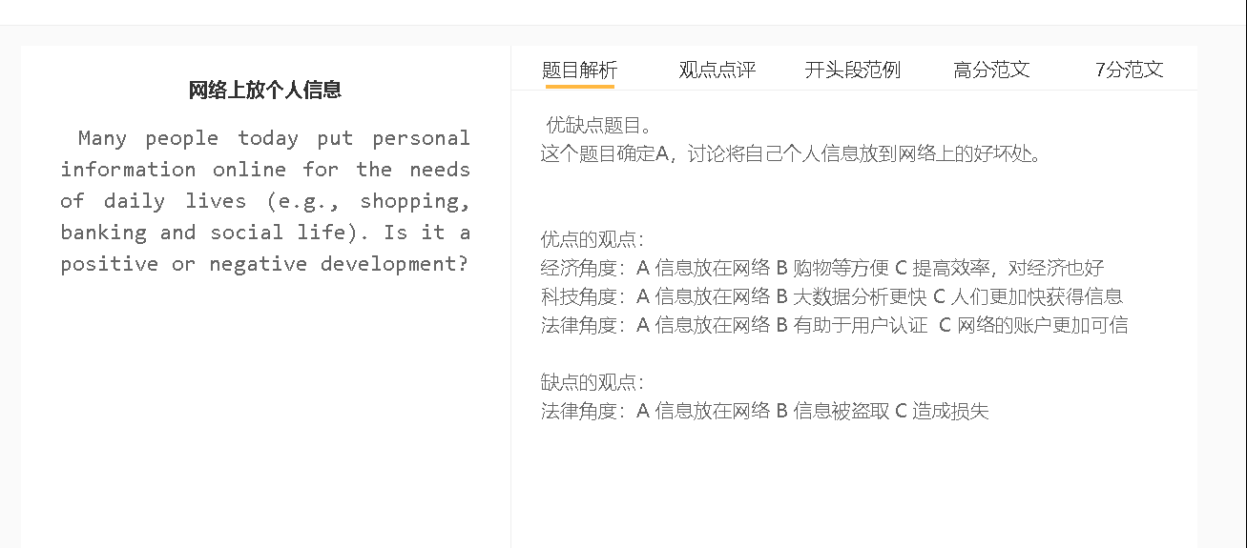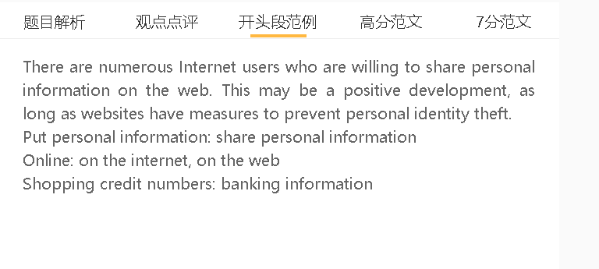

范文

There are numerous Internet users who are willing to share personal information on the web. This may be a positive development, as long as websites have measures to prevent personal identity theft.

A放个人信息在网络上 B 消费容易 C 对经济可能促进
背景：人们现在很忙，购物的时间不一定有
解释（A-B）：输入密码，马上消费
解释（B-C）：网络商铺收入提高
解释（B –C ）: 雇佣更多人
Benefit the economy, help the economy grow
Enter pin numbers, make payment
Online stores/shops, increase revenue
Hire employees
There will be an E-commerce boom if more people choose to provide personal information online. Visiting a shop personally has become a luxury in the modern world, where overworking has become the norm in the workplace. This can be overcome by simplifying the payment process for online shoppers as they enter credit card information beforehand and permit the bank to deduct the payment directly. This can boost the revenue of online retailers as people place an order faster and do it more frequently. Internet-based retailing will become a massive job creator and a key contributor of tax revenue for the economy of a country.

A放个人信息在网络上 B 网站可以认可这个人的身份 C人们可以 利用网络做一下发展自己的事情
背景：现在假信息很多，个人信息用来认证
解释（A-B）：通过检查个人的背景调查，而且一个ID只能注册一个账户
解释（B-C）：开店，做网络商务
解释（B-C）：经营自己的社交媒体账户，提高自己的知名度
False accounts, fake accounts
Run an online business
Social media accounts, increase profile, build a reputation

The trend towards providing personal information online also shows that a growing number of people have seen the potential of tapping into social media and Internet-based businesses. Information such as bank accounts and passport numbers is submitted to social networking websites and online trading platforms to verify their identity, which is valued in the digital age, as people are aware that fake accounts are widespread in the cyber world. Platforms can conduct background check of applicants, and each person can register for one account only, thereby building the public trust in the credit of each account. Some professionals, including freelance writers and scholars, are happy to provide personal information as the first step towards running a popular social media account and building an online reputation.

A放个人信息在网络上B 个人信息被人盗取 C 造成损失
背景：黑客的技术不断发展，寻找各种网站的漏洞
解释（A-B）：网站不能保护用户的隐私，黑客盗取信息
解释（B-C）：盗刷，转账
结果（C）：信用损失，个人生活有困难
Information is stolen, cause a financial loss
Hack into the database, protect privacy
Make unauthorised transfers
Economic difficulties
On the other hand, there is a risk that people can suffer a financial loss if their information is used by cyber criminals. The astounding pace of technological progress has been a double-edge sword as hackers can use advanced tools to discover weak spots of bank systems and mainstream social networking websites. Even the systems of Internet giants like Facebook can be hacked by criminals, and without the consent of account holders, personal information is used for malicious purposes. For example, cyber criminals can make unauthorized withdrawals and transfers when they gain access to account information. Victims can lose money if their personal information falls into wrong hands, and their careers or personal reputation can be damaged if they fail to handle overdraft.

In conclusion, I agree that there are financial gains of sharing personal information on the Internet, as long as people are aware that their personal information can be misused.

7+
There has been a trend towards sharing private information on the Internet for diverse needs, including shopping, making transactions and socialisation. Personally, I would argue that the overall effect of this trend is positive.

A put personal information online B convenience C save time
A put personal information online B information can be misused C unintended consequences
中心句：个人信息放在网络上，很方便，节省时间
背景（可以不写，主要是观点存在的条件和环境）：科技发达，大家可以很多地方上网
解释（A-B的跳跃，B-C的跳跃，也可以写两个并列的解释）：个人信息，含 姓名，地址，电话都有记录，不用反复输入，提高了购物、去银行的效率
解释（A-B的跳跃，B-C的跳跃，也可以写两个并列的解释）：个人信息， 有认证，把个人爱好，照片等等公布，建立互信
举例（写整句话，如果和前面内容雷同比较多，可以具体化名词）：电子支付，信用记录，职业，消费记录，等等，来决定你是否可以借钱消费
拓展结果（拓展C，但是不适用于确认了C的题目）：人们可以把时间省下来去做其它重要的事情，幸福感
为在线平台提供个人信息可以节省时间，因为这种习惯可以给用户带来巨大的便利。对于那些对互联网基础设施的投资导致广泛获得数字服务的国家来说尤其如此。电子商务网站和金融服务提供商允许客户将个人详细信息保存在数据库中，包括姓名、家庭地址、电话号码和银行账户，而无需重复输入这些信息，这可以提高支付和使用银行服务的效率。与此同时，社交网站可以验证每个用户的身份，显示他们的个人资料，并提供对他们照片和个人生活信息的访问，从而帮助迅速建立对社交关系的信任。这些形式的效率使人们能够留出时间用于生活中的其他优先事项，如休闲活动，这可以提高他们的幸福感。
Providing personal information for online platforms can achieve time-saving outcomes because this habit can bring tremendous convenience to users. This is particularly true for countries where the investment on Internet infrastructure has led to wide access to digital services. E-commerce websites as well as financial service providers allow customers to keep personal details in their database, including names, home addresses, telephone numbers and bank accounts, without entering such information repeatedly, which can improve efficiency of making payments and using banking services. Social networking websites, meanwhile, verify each user’ identity, show their profile and provide access to their photos and information about their personal lives, thereby helping build trust for social connections promptly. These forms of efficiency enable people to set aside time for other priorities in lives, such as leisure activities, which can boost their well-being.

A put personal information online B information can be misused C unintended consequences
中心句：
背景（可以不写，主要是观点存在的条件和环境）：网络安全设施不够，国家监管不严格
解释（A-B的跳跃）：想通过此 谋利，把数据卖给其他机构；黑客盗走
解释（B-C的跳跃）：诈骗，银行卡被盗刷
解释（B-C的跳跃）：成为要挟，给钱
拓展结果（拓展C，但是不适用于确认了C的题目）：影响个人的正常学习和工作，缺乏信心，制约着数字经济的发展
另一方面，暴露个人信息有时可能会产生意想不到的后果，因为这些信息可能被一些机构或公司滥用。这种问题最有可能发生在网络安全措施不充分、用户数据泄露不会受到严厉惩罚的情况下。这些数据被黑客窃取，或在未经许可的情况下出售给个人或组织，用于帮助赚取收入的活动。不保护信息安全的人是各种犯罪的受害者，如网络欺诈、电话诈骗、身份盗窃和未经授权的汇款。当他们的信息被他人以其他方式使用时，他们还可能面临其他财务风险，包括对话记录、互联网浏览历史和私人照片。这些问题干扰了学习和工作，动摇了公众的信心，阻碍了数字经济的发展。
On the other hand, exposing personal information may sometimes have unintended consequences as such information may be misused by some institutions or companies. This problem is most likely to occur in cases where online security measures are inadequate and the leaking of user data is not subject to harsh penalties. These data are stolen by hackers, or sold to individuals or organisations without permission for activities that help earn income. People who do not keep their information safe are victims to various crimes such as online frauds, phone scams, identify theft and unauthorised transfer of money. They may also face other financial risks, when their information is used by others in other ways, including conversation records, Internet browse history and private photos. These issues interfere with studies and work and shake public confidence, which hinder the expansion of the digital economy.

In conclusion, leaving personal information online is basically a positive change, although it may have its negative consequences in some cases.

