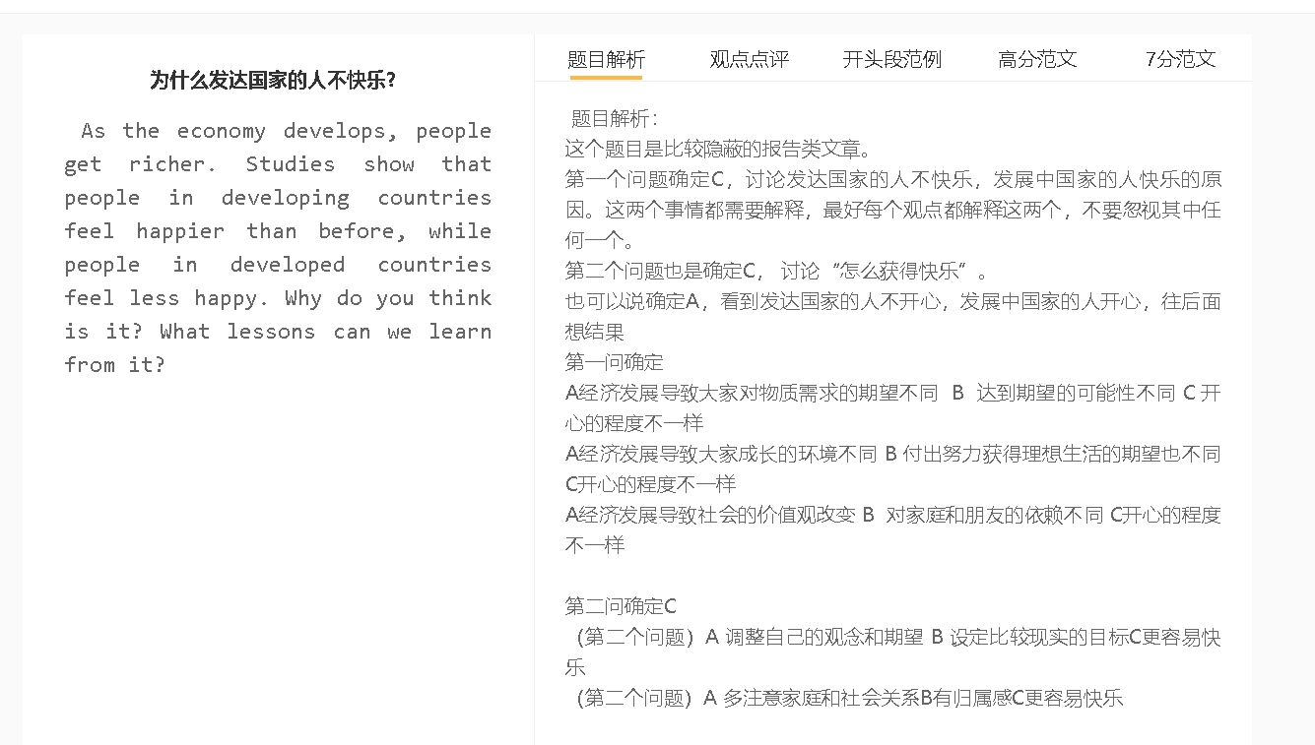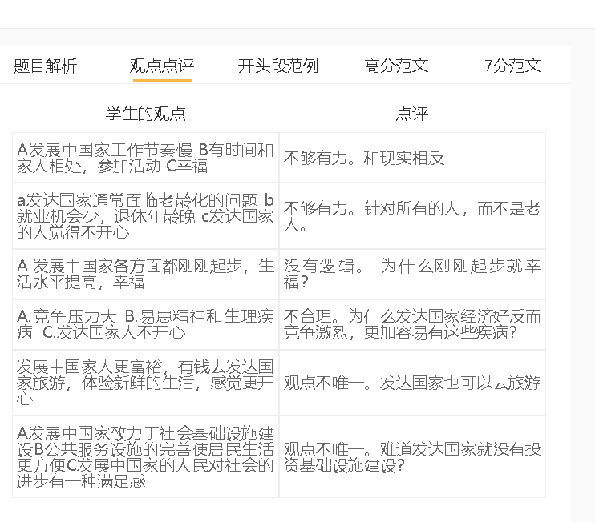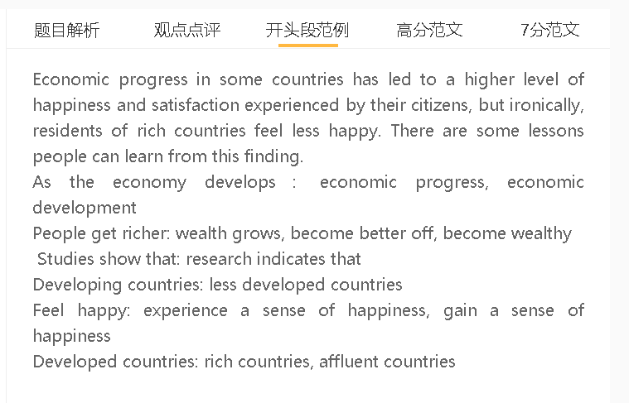

范文

There is evidence that people in different parts of the world experience different levels of happiness in their lives, although the world has become richer than before. Understanding the reasons for this issue can help improve the situation.

A经济发展导致大家对物质需求的期望不同 B 达到期望的可能性不同 C 开心的程度不一样
背景：欲望没有止境，温饱容易满足。
解释（A-B）：发展中国家经济发展，收入提高，满足了基本需求
发达国家经济一直比较富裕，人们物质的需求更高，比较难满足
解释(B-C)：满足不了的时候，会觉得失落，自尊心受到伤害，和别人对比的时候
举例：豪宅，豪车
One possible explanation is that people have varying expectations when their countries are in different stages of economic growth. The gap between objectives and realities can determine whether people feel fulfilled or unfulfilled, which is a key element in happiness. The economic boom in developing countries has raised personal income and satisfied the general expectations of their citizens, namely, to have a reasonable quality of life, thereby elevating their life satisfaction. In contrast, people born in economically developed countries sometimes have undue expectations over material goods they need to possess, such as mansions and prestigious cars. If their needs are unmet, they feel frustrated and their self-esteem is hurt, especially when comparing themselves with rich peers.

Material needs meet expectations/fulfill expectations/satisfy needs
Insatiable basic needs, survival needs, have a reasonable standard of living
Feel disappointed/frustrated, hurt self-esteem,
Grand houses, mansions, luxury cars, prestigious cars

A经济发展导致社会的价值观改变 B 对家庭和朋友的依赖不同 C开心的程度不一样
背景：家人的陪伴，建议，经济帮助都是影响快乐满意度的因素
解释（A-B）：发展中国家虽然经济发展，很多事情还需要相互帮助，所以人仍然相互依赖
而发达国家经济富裕，政府福利好，人对家庭的依赖降低
解释(B-C)：遇到问题的时候，获得家庭的帮助自然不同，承受压力也不同
举例：健康，工作等问题
Social values
Company, companionship, financial support/help/backing/assistance
Mutual support, cooperation, collaboration, interdependent
Social benefits, provide a safety net
Face challenges, experience hardships, come across problems,
Cope with stress,
The level of reliance on family and friends also differs from country to country and accounts for the contentment one experiences in life. The companionship, advice and financial support of family have a direct bearing on happiness. In spite of economic progress, people in developing nations need to maintain an interdependent relationship to handle different matters, while those in advanced economies do not feel this need, because of availability of social benefits. The strength of family bonding can affect the support they receive from family members and the stress they need to cope with alone when facing challenges in lives, such as health issues or work matters. This in turn leads to the substantial differences in feelings of happiness.

A 调整自己的观念和期望 B 设定比较现实的目标C更容易快乐
背景：天赋不同，社会资源有限，不可能每个人都可以满足
解释：更加容易达成，更有成就感
解释：对开心的定义更加多样化
举例：兴趣爱好，家人陪伴

Adjust expectations… change mindset, set realistic/attainable objectives
Reach objectives, attain targets, a sense of achievement
Diverse definition of ..
Approach happiness from different ways
The main lesson we can learn from this finding is that adjusting one’s expectations and setting realistic objectives can make happiness more achievable. It is important to realise that social resources even in affluent countries are scarce and unable to meet every need of every individual. Needless to day, people vary in talents. People who lower expectations can achieve targets more easily and gain a sense of achievement, which can boost their well-being. Meanwhile, instead of focusing on material possessions, they can approach happiness from diverse ways, such as personal hobbies and family life, which can reduce the risk of feeling disappointed when they fail to become as rich as expected.

In conclusion, the disparity in the level of happiness shows the effect of different expectations and the changing perception of family life in different countries. What can be learned from this is the importance of adjusting expectations and taking a broader view of happiness.

7.5
It is concerning to observe a clear trend where people in affluent countries experience a decline in happiness levels, while developing countries witness an increase in life satisfaction. Identifying the underlying cause of this issue is crucial in order to find effective solutions.

A人的期望值不同 B 满足的人快乐，不满足的人不快乐 C
中心句：
背景：人类有一种本能，不断追求更高的目标和标准，从而获得满足感和成就感
解释（A-B的跳跃，B-C的跳跃，也可以写两个并列的解释）： 发展中国家的人收入水平和消费水品更低，决定了他们对于生活或者未来的目标会更低，住房问题和生活问题会很容易实现
解释（A-B的跳跃，B-C的跳跃，也可以写两个并列的解释）：发达国家的人们赚的钱更多，期待值会更高，包括消费欲望和工作职业欲望，譬如购买奢侈品住更大的房子，得到好的发展机会，出国学习或者职位升迁等。更高的目标可能需要更长时间的努力才能得到，会经历更多的挫折与考验，很多人无法承受这些就会变得不快乐。
Frustration, challenges …
The main reason why this has happened is that people differ in expectations and only those who successfully have their needs fulfilled experience feelings of pleasure. It is because human beings have a natural inclination to constantly strive for bolder goals and life standards, which usually leads to a sense of satisfaction and accomplishment. Individuals of previously poor countries have lower income and limited purchasing power, thereby setting more attainable goals in their lives, such as buying a home and affording basic necessities, and finding contentment more easily. In contrast, higher income levels in affluent/wealthy countries result in higher expectations, including the strong desire for material possessions, personal growth and career achievements, so they will encounter more challenges and experience frustrations and unhappiness.

a增加意识 b调整心态 c快乐
背景：在快速发展的社会，强调消费和物质财富，社会价值观改变，人们没有接触到其他信息，知道生活的其他可能
解释：政府告诉人们怎么获得快乐，怎么用不同的角度去看待人生
解释：放低期望，感恩所有的东西，在非物质的东西获得快乐
To address this issue, it is necessary to educate the public about how to adjust their mindset and adopt a comprehensive approach to happiness. Awareness campaigns are important in a rapidly developing society, where people are exposed to messages emphasising consumption and material wealth, rather than information about other possibilities in their lives. The government can disseminate knowledge about how to obtain happiness in diverse ways and how to view life from different perspectives. People will learn to lower expectations, have a sense of gratitude for everything, and derive pleasure from non-material items, such as pursuing hobbies to strike a balance between work and life, and spending quality time with friends and family to enjoy their companionship, which can raise their life satisfaction.
In conclusion, the variance in happiness levels across the world exist in large part because they anticipate different outcomes of life. This situation can be improved if they have diverse perspectives to view happiness.

