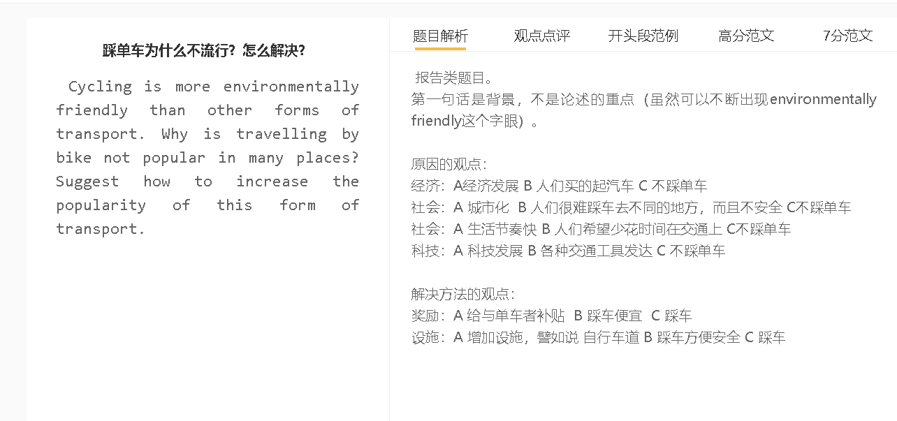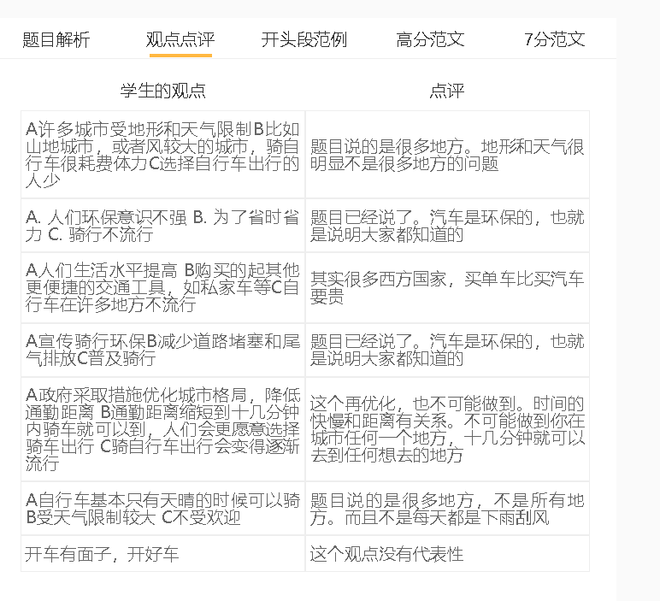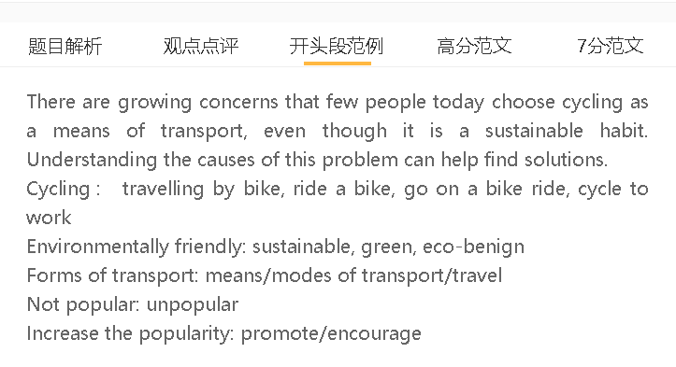

范文

It is widely believed that cycling is the most eco-friendly means of transport since it creates zero emissions. Despite this generally-held belief, riding a bike is not popular in many areas. There are reasons behind this and also methods to promote this mode of travel.
A 城市发展 B 人群住在离市中心很远的地方 C 很少人骑车
解释：很多人住在市郊，房价比较低，骑车每天上班基本不可能
解释2：城市路面交通堵塞 骑车不安全很少人骑车
特定化：有些城市没有单车专用道
City expansion is possibly the main reason why cycling has become unpopular with inhabitants. A growing number of people are now living in outer surburbs, where housing is more affordable, but the downside of this choice is that they have to travel a longer distance to the central office. Cycling to work to them is not practical, as it is slow compared with driving and using public transportation. Meanwhile, as roads are congested with cars, cycling is dangerous. People have to be mindful of the passing traffic while riding a bike. This is particularly the case in cities which do not have bike lanes.

A 城市污染严重 B 要吸入很多废气 C 很少人骑车
背景：人们在意健康
解释：大家觉得踩车吸入尾气，对健康有害
举例：即便是去商场购物等，都尽量开车
对比：即便他们知道开车不环保

The situation has become even worse as air pollution discourages people from travelling by bike. Today’s people are increasingly health-conscious, meaning that they are concerned about the impact of their lifestyles on health. They hardly consider cycling as a means of transport since they know they inhale traffic fumes when riding the bike. They choose to drive cars, whether they go shopping or visit friends, to minimise the risk of breathing in pollutants. This is the safest option even though they are aware that driving is harmful to the environment.

A 提高好的设施和地方B 让骑车变得可行 C 人们骑车
背景：设施的使用直接影响一个人对旅行方式的选择。
解释：如果一个城市有自行车道，给骑自行车的人一些特权使用道路，更多的人会选择骑自行车旅行。他们可以骑自行车，而不用担心被汽车辗过的危险。
解释2：随着自行车的普及，城市的空气污染可以得到缓解。更多的人将会把骑自行车看作是改善健康的体育锻炼，而不仅仅是一种旅行方式。
扣题：这可以进一步促进城市自行车运动。
The best way to deal with these problems is to make cities more cyclist-friendly. The access to facilities has a direct impact on one’s preference for a means of travel. If a city has bike lanes that give cyclists some privileges to use roads, more people will choose to travel by bike. They can go for a bike ride without being worried about the risk of being run over by cars. As cycling gains in popularity, air pollution of cities can be alleviated. More people will see cycling as physical exercise to improve health, rather than a form of travel only. This can further promote cycling in cities.

In conclusion, urban expansion and pollution have deterred people from travelling by bike, and one sound solution to this problem is to increase bike lanes or relevant facilities to make cycling convenient.

7.5+ 范文
The drop in the popularity of cycling Is a phenomenon that has been prevalent in many countries over the last decade. It is necessary to explore the reasons behind this and analyse relevant solutions.
A facilities are suitable for driving B not cycling-friendly C cycling is not popular
许多城市的设施是为容纳驾车者而不是骑自行车的人而设计的。
这在决策者认为开车是最高效的交通方式的城市中很常见，开车可以提高生产力并产生经济效益。
这些城市没有自行车道，这意味着骑自行车是极其危险的，因为骑自行车的人可能会被汽车碾过。尤其是在快速发展的城市，修建自行车道基本上是不可行的。
人们还观察到，城市地区缺乏方便停放自行车的设施，盗窃事件频繁发生。
这些因素导致人们对骑自行车的兴趣下降，尽管人们意识到骑自行车对环境有益。
This can be explained by the fact that facilities in numerous cities are designed to accommodate motorists rather than bikers. It is commonly seen in cities where policymakers perceive driving as the most efficient mode of transport, which can raise productivity and yield economic benefits. These cities do not have bike lanes, meaning that riding a bike is extremely dangerous as cyclists can be run over by cars. This is particularly the case in fast-growing cities where building bike lanes is basically infeasible. It has also been observed that urban areas are devoid of facilities to park bikes easily and incidents of theft happen frequently. These factors account for a drop in the interest in cycling, although people are aware that cycling is beneficial for the environment.
A add facilities, introduce the bike-sharing scheme B cycling is safe and convenient, cost-effective C increase its popularity
为了改善这种情况，政府可以采取多方面的方法，例如增加设施和引入共享单车计划，使骑自行车安全、方便和具有成本效益。
它为前面提到的问题提供了解决方案，因为它解决了打算骑自行车旅行的人的担忧。这可以通过增加自行车专用车道来实现，这可以保护骑自行车的人免受交通堵塞，并使他们更快地到达目的地。
如果人们能够加入共享单车计划，享受更低的骑行成本和便利，那么更好的结果是可以实现的。
自行车通过全球定位系统精确定位，从而显著减少盗窃。
如果这些举措得以实施，踩单车就会越来越受欢迎。
In order to improve this situation, the government can take a multi-faceted approach, such as adding facilities and introducing a bike-sharing scheme to make cycling safe convenient and cost-effective. It offers a solution to the problems mentioned earlier because it addresses the concerns of people who intend to travel by bike. This can be achieved by increasing lanes designated for biking, which can protect cyclists from traffic and enable them to reach destinations faster. A better outcome is achievable if people can join the bike-sharing scheme and enjoy lower costs and convenience of biking. Bicycles are precisely located by GPS, thereby reducing thefts significantly. If these initiatives are implemented, cycling can gain in popularity.

In conclusion, the rarity of cycling is attributed primarily to the fact that cities are less friendly to cyclists nowadays. Some strategies such as providing relevant facilities and launching a bike-sharing scheme can tackle this problem.

