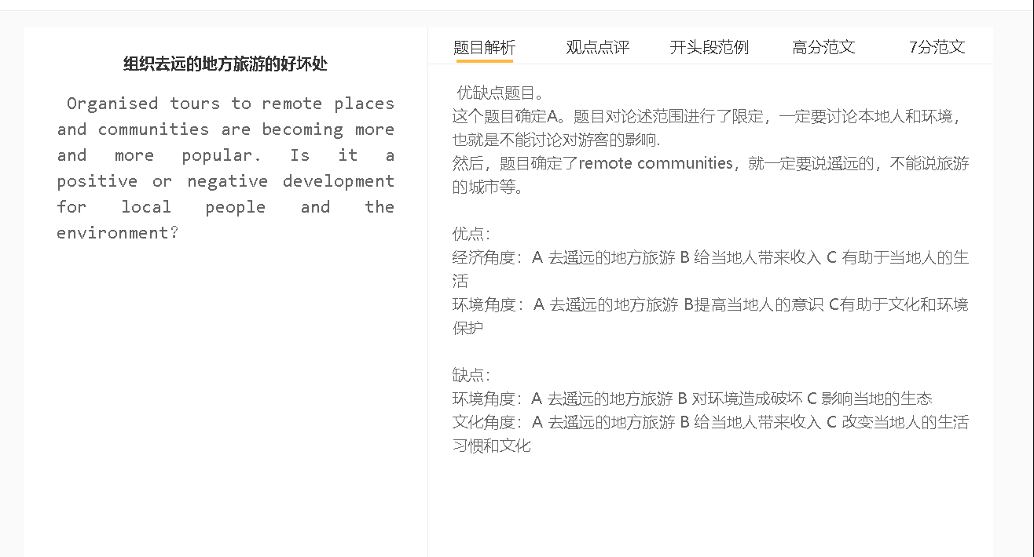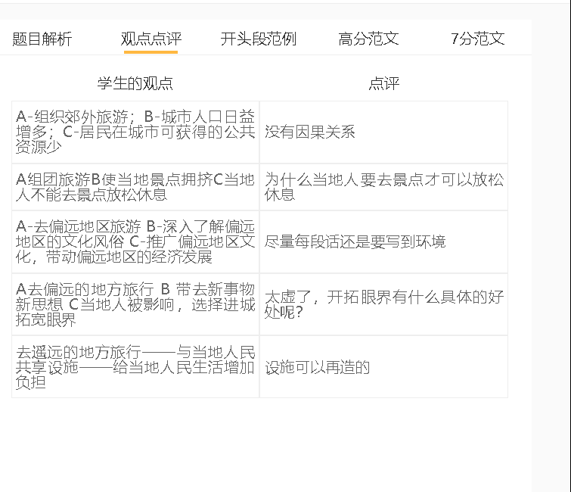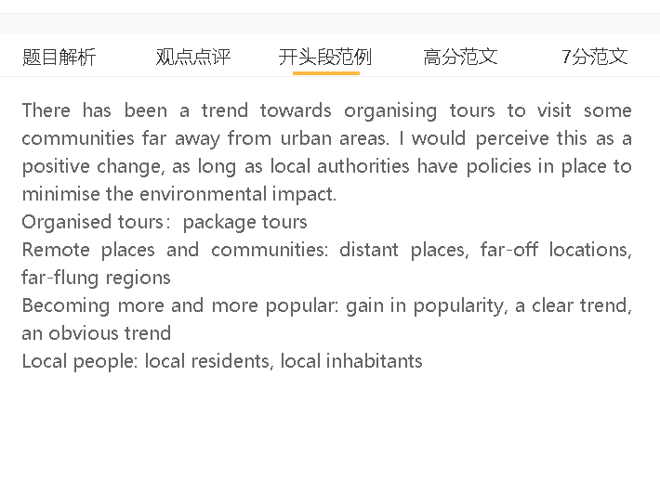

范文

There has been a trend towards organising tours to visit some communities far away from urban areas. I would perceive this as a positive change, as long as local authorities have policies in place to minimise the environmental impact.

经济角度：A 去遥远的地方旅游 B 给当地人带来收入 C 有助于当地人的生活
背景：这些社区可能是经济的死水，当地人从事农业，生活在贫困线以下。
解释（A-B）：游客来这里消费当地的食物、住宿服务和手工艺品
解释（B-c ）:居民生活水平受益，而且他们放弃可能破坏当地环境的传统生计。
Increased tourism, first of all, brings in cash to local inhabitants and boost the quality of life. These communities are possibly economic backwaters, with locals practising farming and living under poverty line due to a lack of infrastructure for manufacturing and other lucractive industries. This situation can be improved significantly if tourists come to spend money on local food, lodging services and handicrafts. Tourism revenue not only benefits inhabitants of these remote areas in the standard of living but also encourages them to give up traditional livelihoods that could damage the local environment, such as logging and farming.

环境角度：A 去遥远的地方旅游 B提高当地人的意识 C有助于文化和环境保护
背景：与外界隔绝，这些地区的原住民可能意识不到他们的环境和文化有多么珍贵。举例：他们有时不顾一切地开发自然资源，却不知道价值。
举例2：由于年轻人没有意识到他们祖先发展的手艺、工艺和习俗的经济价值，一些当地的传统消失了。
解释（B-C）：如果他们想让自己的孩子过上舒适的生活，就应该保护他们从前辈那里继承的东西。
Another benefit is that the influx of tourists can remind locals to preserve their traditions as well as ecological assets as part of sustainable development. Living in isolation from the outside world, people native to these regions may not be aware of how precious their surroundings and cultures are. They sometimes exploit natural resources recklessly without the knowledge that rich holidaymakers are willing to pay to take in local views and explore the nature. Some local traditions die out as young people do not realise the economic value of the trades, craftsmanship and customs that their ancestors developed. They will wake up to the fact that they should protect what they have inherited from older generations, if they want their children to live comfortably.

环境角度：A 去遥远的地方旅游 B 对环境造成破坏 C 影响当地的生态
背景：一些社区可能会支持一些激进的发展计划，以实现旅游收入的最大化，但忽略了长期影响。
举例：兴建康乐设施、酒店、食肆及交通网络，以配合各种旅游活动的需要
拓展结果：如果生态系统被破坏，游客将注意力转移到其他目的地，当地人最终会受到影响。
On the other hand, tourism boom may pose a threat to the local environment if local populace fail to manage their resources effectively. Some communities may endorse some aggressive development plans in order to maximise tourism income but lose sight of the long-term impacts. Recreational facilities, hotels, restaurants and transport links are built to keep pace with the demand for a variety of tourism activities, although these developments can change the face of these previously untouched locations. Local people can be affected ultimately if the ecosystem is ruined and tourists shift their attention to other destinations.

In conclusion, package tours to remote areas could be a welcome change to those living in these regions not only in terms of economic development but also in environmental protection, although unbridled development could cause environmental destruction.

