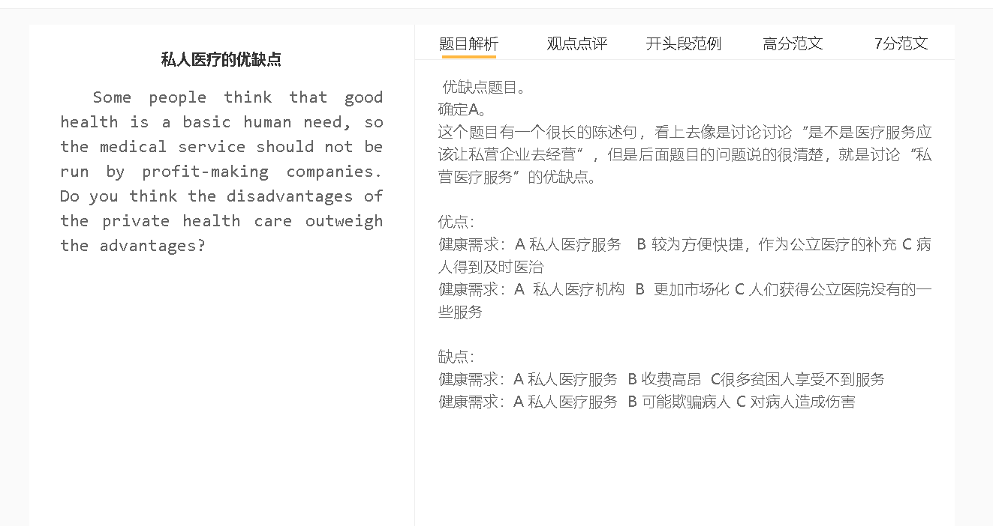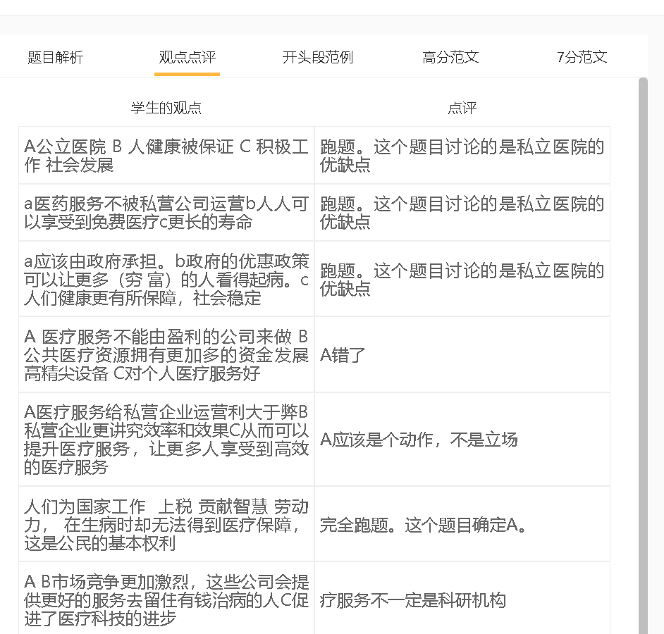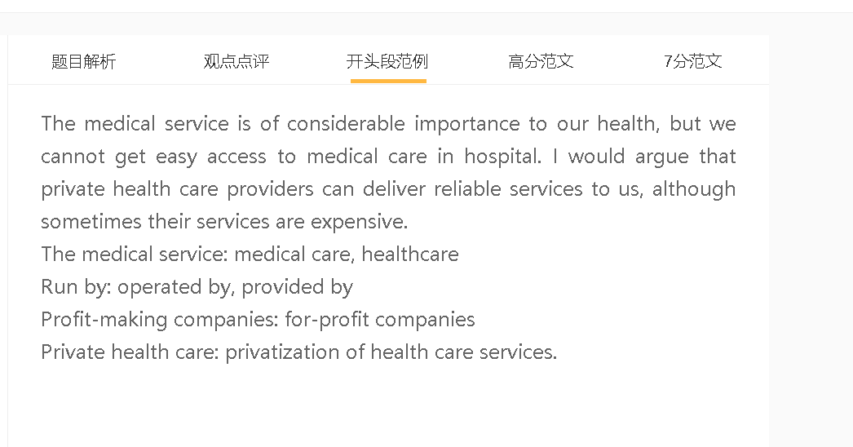

范文

Medical services can be offered by some profit-making companies .This kind of private health care has many advantages while it may have its drawbacks.

A 私人医疗服务 B 较为方便快捷 C 病人得到及时医治
背景：有竞争意识，要通过服务获得市场
背景：费用比较高，看病的人少，不需要排队
举例：急诊 看一些慢性病
拓展结果：更快康复
One obvious advantage of private health care is that private hospitals can provide convenient services to treat each patient promptly. The private sector is responsive to market needs, as providers cannot survive without earning the money of patients. They need to provide timely, premium services to impress very client; otherwise, they are unlikely to rival state hospitals or other private operators. Meanwhile, a relatively high fee charged by private health services deter people from visiting these for-profit businesses, so the waiting list of private clinics is shorter. This is important not only to those who need to undergo emergency treatments but also to those who suffer chronic health problems as Early treatment is the key to fast recovery.

A 私人医疗机构 B 收入更高 C 人们获得公立医院没有的一些服务
背景：私人医疗机构专注细分市场，专注某个特殊的领域
解释：有钱去请更厉害的人，提供更好的设备
拓展结果：很好地弥补公立服务，解决某些方面的疑难杂症
Another advantage is that private service providers may have some services not available in public healthcare facilities. The profit-oriented healthcare operators focus on some niche markets, where they provide specialist services to cater for the needs of some patient groups, instead of going head-to-head with large-sized public hospitals. It follows that some private health organisations acquire a reputation in some domains of medical care and earn sufficient money to hire well-qualified personnel and purchase sophisticated equipment, thereby filling some gaps in the health sector.

A 私人医疗服务 B 收费高昂 C很多贫困人享受不到服务
背景：政府减少公立医院的费用，竞争下跌
背景：私立医院唯利是图
解释：聘用更加多的职员，花费比较高
举例：体检， 开药
拓展： 对社会不满，导致社会动乱

charge high fees, the poor, disadvantaged people
financial support, recruit, hire employees, the running cost
health checks, prescribe expensive drugs
feel resentful, social unrest
On the other hand, the increase in private health care may lead to health inequality because the providers of these services normally charge high fees. Privatisation of the whole sector can lead to the shutdown of some public hospitals, which rely on government funding. Profit-driven hospitals can increase and charge an exorbitant fee for services. Even ordinary health checks can be costly, and doctors tend to prescribe expensive drugs to gain higher commission. Those who cannot afford such services may have resentment against the government’s health policy, which may lead to social unrests.

In conclusion, the presence of private operators in the medical system is important, since it can supplement state-run hospitals. On the negative side, medical expenses will increase.

