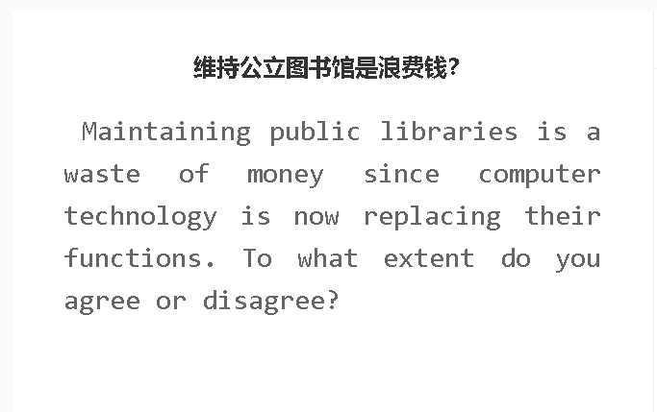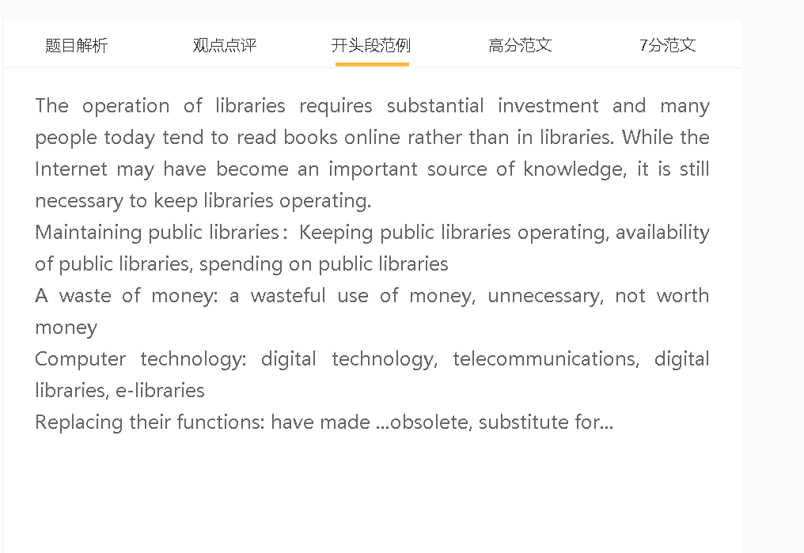

范文

The operation of libraries requires substantial investment and many people today tend to read books online rather than in libraries. While the Internet may have become an important source of knowledge, it is still necessary to keep libraries operating.

A 保留公共图书馆 B 提供读书氛围 C 有利于大家文化程度的提高，喜欢读书
解释（A-B）：图书馆不能大声说话，不能在手机上聊天
解释（B-C）：如果很多人都去图书馆，享受读书，身边的人自然就会模仿，形成这种习惯
对比：用电脑和手机看书，很难专注，会被游戏、信息提示等打断
A quiet atmosphere, environment conducive to reading, improve literacy
keep quiet, switch off the mobile phone, make any noise that breaks concentration
enjoy reading, form this habit
get distracted
The availability of public libraries in communities can promote the love of reading and improve literacy levels since libraries provide an environment conducive for reading. They require all visitors to read books quietly and switch their phones to the silent mode in an attempt to reduce distractions and unwanted noises, thereby preserving a quiet atmosphere. Libraries attract people who find enjoyment in reading, and their passion for reading can influence others, who will in turn form a similar habit. Without libraries, they might have to read books at home by using computers or smartphones, where they are constantly distracted by games, news and notifications.
A 保留图书馆 B 举办各种活动 C 给大家一种社区感，这是科技做不到的
背景：今天的城市居民缺乏社区意识，因为很难找到时间或空间从事社区活动
解释（B-C）：书展、读书会等，大家可以交流，交新的朋友
对比：网络看书都是在家里，缺乏和社区其他成员的交流和活动
Organise activities, foster a sense of community
Book exhibitions, book clubs, connect to others, make new friends
From the comfort of home, members of community
Another reason why libraries are indispensable is that they can foster a sense of community by organising different activities. City dwellers today lack a sense of community due to the difficulty in finding time or space for engaging in community activity. Book exhibitions organised by community libraries bring people together, while reading clubs and seminars provide avid readers with opportunities to share their views about the books they read, and make new friends. This is not attainable if people read books on computer from the comfort of their homes without interacting with other members of community.

电脑科技替代公共图书馆 ，书籍和相关资料更丰富，人们阅读可以有更多选择
背景：一些公共图书馆不受当地居民欢迎的原因有很多，比如藏书少，地理位置不好
解释：网络提供更大的数据库，人们可以阅读更多的书
举例：人们可以看到最新发表的学术类文章
对比：图书馆只能定期购买新的书籍，更新速度慢

On the other hand, it is true that computers have rivaled public libraries as an important source of knowledge since people have wider access to new books on the Internet. Some public libraries are unpopular with local residents for a number of reasons, such as small collections and geographic locations. In contrast, many e-book providers have a powerful database and offer a repertoire of books, newspapers, magazines and other publications that cater for a wide spectrum of readers. For example, they can gain access to the latest versions of international journals related to their areas of study or professions, which are possibly not available in local libraries. As such, closing those underused libraries is a possible choice as it saves precious public money for other community projects.

In conclusion, public libraries perform some functions that digital counterparts fail to fulfill, although the spending on those unpopular libraries is not worth it.

7+ 范文
There are some people holding the view that computers have superseded libraries. From my personal perspective, I would argue that it is worth spending money on public libraries.

A 图书馆 B好的学习氛围 C 学习效果好
我的第一个论点是，图书馆可以保证学习成果，因为它提供了一个有利于阅读的环境。在数字时代尤其如此，人们会在网上分心，比如新闻通知、弹出广告和社交媒体平台的私人信息。图书馆为他们提供了一个安静的氛围，因为用户必须严格遵守协议，例如播放音乐、举行会议和接听电话的限制。他们可以全神贯注地阅读，从而最大限度地利用学习时间。相比之下，当他们在屏幕上阅读时，很难保持注意力集中，这会降低他们的生产力。在这方面，图书馆仍然是不可或缺/不可替代的，因为它们可以执行一些计算机无法完成的功能。
My first argument is that libraries can guarantee learning outcomes because it provides an environment conducive to reading. This is particularly true in the digital age, when people are exposed to numerous online distractions, such as news notifications, pop-up advertisements and private messages from social media platforms. Libraries provide them with a quiet atmosphere, as users have to follow protocols strictly, such as restrictions on playing music, holding meetings and answering phones. They can immerse themselves in reading without distractions, thereby making optimal use of their study time. In contrast, they have difficulty in maintaining concentration when they read on screens, which can reduce their productivity. In this regard, libraries are still indispensable/irreplaceable because they can perform some functions that computers cannot do.
A 图书馆 B 方便某些群体的人阅读 C 减少人和人的不平等
中心句：
另一个原因是，公共图书馆通过为弱势群体和不懂计算机的人提供平等的知识获取机会，缩小了社会或数字鸿沟。在在线阅读成本持续上升的情况下，这具有重要价值，包括电子设备支出、教育网站收取的会员费和出版社征收的版权费。公共图书馆允许游客免费阅读书籍，主要是因为这些机构由国家补贴，也得到社区组织或慈善家的支持。这对缩小经济差距，从而促进社会稳定发挥了重要作用。同时，传统图书馆为老年人等不熟悉数字阅读的人提供便利，可以缓解社会排斥感。
Another reason is that public libraries close the social or digital divide by providing the equal access to knowledge for the disadvantaged and those who are not computer literate. This holds significant value in cases where the cost of online reading has continued to rise, including the spending on electronic devices, the membership fee charged by educational websites and the copyright charges imposed by publishing houses. Public libraries allow visitors to read books for free, primarily because these institutions are subsidised by the state and also supported by community organisations or philanthropists. This plays a significant role in closing the economic divide, thus promoting social stability. Meanwhile, conventional libraries provide convenience for those who are not familiar with digital reading, such as the elderly, which can alleviate the feelings of social exclusion.
In conclusion, it is my personal view that public libraries are still of importance to communities and that they deserve public funding.

