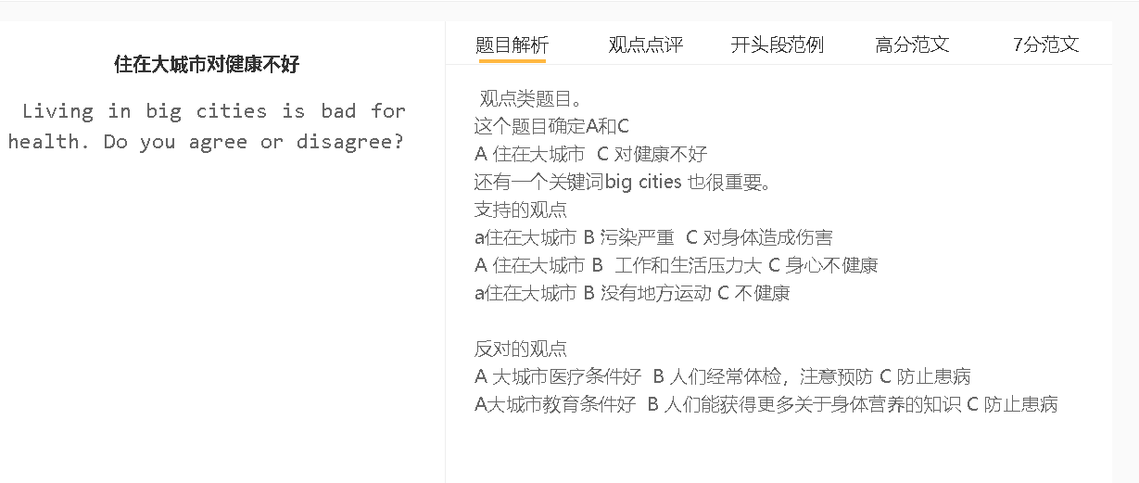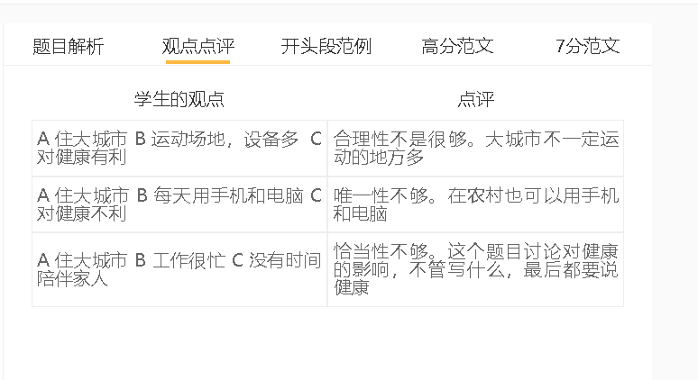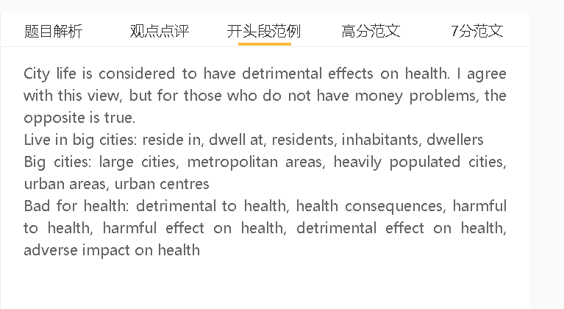

范文

People who live in large cities can benefit from urban life to some extent, but it is true that they are also prone to health problems.
a城市人口集中, 污染严重, 对身体造成伤害
背景：人口密度对基础设施造成了压力
具体化：废物和污水管理、供水和交通
解释1：汽车尾气导致呼吸道疾病
解释2：污水和生活垃圾造成水和土壤污染，导致疾病
对比：而农村人少，污染少，对身体更好
人口密集城市的污染会增加患疾病的风险。人口密度对基础设施造成了压力，如废物和污水管理、供水和交通，因为供应可能跟不上需求的步伐。如果公共交通不方便，人们可能会开车，废气会使城市烟雾弥漫，导致呼吸系统疾病的病例急剧上升。污水和生活垃圾如果不以安全和环保的方式处理，就会造成水和土壤污染，从而污染食物链，传播水传播的疾病。这些健康问题在农村不太常见，那里的人类活动很低，不会对环境造成污染，不会导致健康状况不佳。
Pollution of heavily populated cities can increase the risk of suffering from illnesses. Population density put strains on infrastructure, such as waste and sewage management, water supplies and transportation, as the supply may fail to keep pace with the demand. If public transport is not convenient, people may drive cars and exhaust fumes can make a city smoggy and lead to a sharp rise in instances of respiratory diseases. Sewage and household waste, if not disposed of in safe and green ways, causes water and soil pollution, which can pollute the food chain as well as spread water-borne diseases. These health problems are less common in the countryside, where human activity is so low that it does not pollute the environment to a level that can cause poor health.

A 住在大城市 B 工作和生活压力大 C 身心不健康
背景：竞争特别激烈，为了更好的工作保障而长时间工作
背景2：消费文化，大城市的居民感到有必要赚额外的钱来购买物质品和名牌
结果：牺牲家庭生活和业余爱好，从而使他们面临焦虑、孤独甚至抑郁的风险
对比：农村人比较单纯，对物质的需求不大，生活轻松

由于城市生活压力大，城市居民也容易出现心理健康问题。人口众多会加剧每个职位的竞争，使人们承受压力，为了更好的工作保障而长时间工作。大都市地区也有很强的消费文化，在这些地区，无论大小企业都采用各种营销手段说服消费者购买商品。大城市的居民感到有必要赚额外的钱来购买物质品和名牌;否则，他们会觉得自己不如同龄人。对物质财富的不懈追求取代了他们与家人在一起、从事运动或业余爱好的时间，从而使他们面临焦虑、孤独甚至抑郁的风险。相比之下，在小城镇和乡村，居民的生活相对简单，他们的期望和欲望更容易得到满足，感到轻松自在。
City dwellers are also prone to mental health problems as urban life is stressful. The high population can intensify the competition for each position, putting people under pressure to work long hours for better job security. Metropolitan areas also have a strong consumer culture, in which businesses, small or large, adopt numerous marketing techniques persuading consumers to make a purchase. Inhabitants of large cities feel compelled to earn extra money to afford material goods and famous brands; otherwise, they feel inferior to their peers. The relentless pursuit of material wealth displaces the time they otherwise spend with family or on sport or hobbies, thereby putting them at risk of experiencing anxiety, loneliness and even depression. In small towns and villages, by contrast, residents live a relatively simple life and feel at ease when their expectations and desires are fulfilled more easily.

A 大城市 B 医疗设施好 C 人们保持健康
背景：经济好，有钱建医院和养医疗人员。
解释1：人们可以去医院或医疗中心进行定期体检
解释2：被诊断出患有某些疾病，他们可以立即接受治疗
对比：农村穷，缺少药和医护人员
Medical facilities, stay healthy
Medical checks/ health checks,
Diagnosed with diseases
Medical treatment
另一方面，对于那些没有经济上的担忧的人来说，城市是他们可以保持健康的地方，有医疗设施。城市经济相对强劲，为配备医疗专业人员的医院和诊所提供了资金。人们可以去医院或医疗中心进行定期体检，如果他们被诊断出患有某些疾病，他们可以立即接受治疗。相比之下，农村社区几乎没有预算来建造医院或吸引高素质的工作人员来满足需求，特别是应付一些复杂的疾病。
On the other hand, for those people who do not have financial worries, cities are where they can stay healthy with the access to medical facilities. The urban economy is relatively strong, providing funding for hospitals and clinics equipped with medical professionals. People can go to hospital or visit medical centers for regular medical checks, and if they are diagnosed with some diseases, they can receive medical treatment immediately. Rural communities, by comparison, hardly have the budget to build hospitals or attract well-qualified staff to meet needs, especially dealing with some complex conditions.

In conclusion, inhabitants of cities are at greater risk of suffering from ill leath, but for the middle or upper income class, the access to high-quality medical care can be an advantage.

