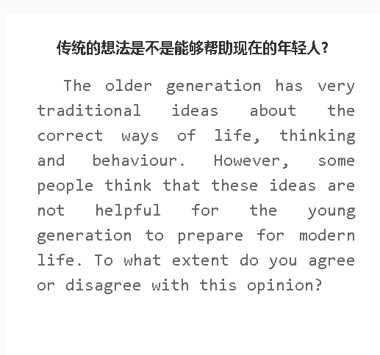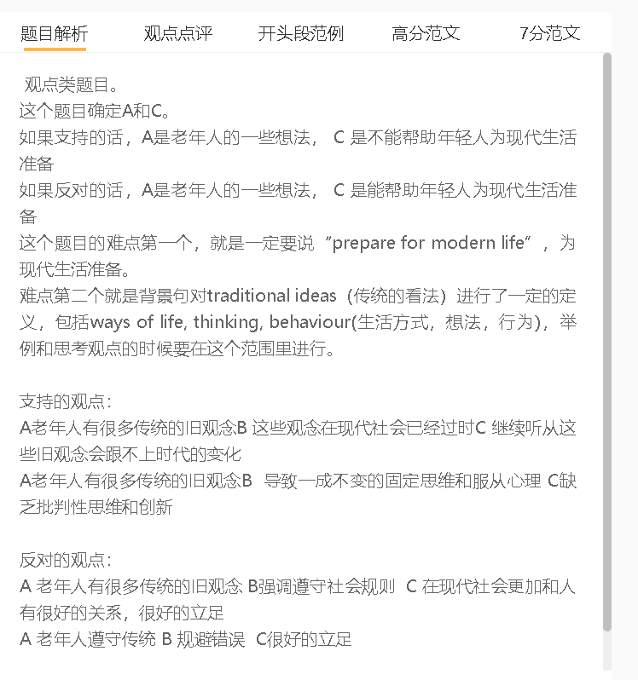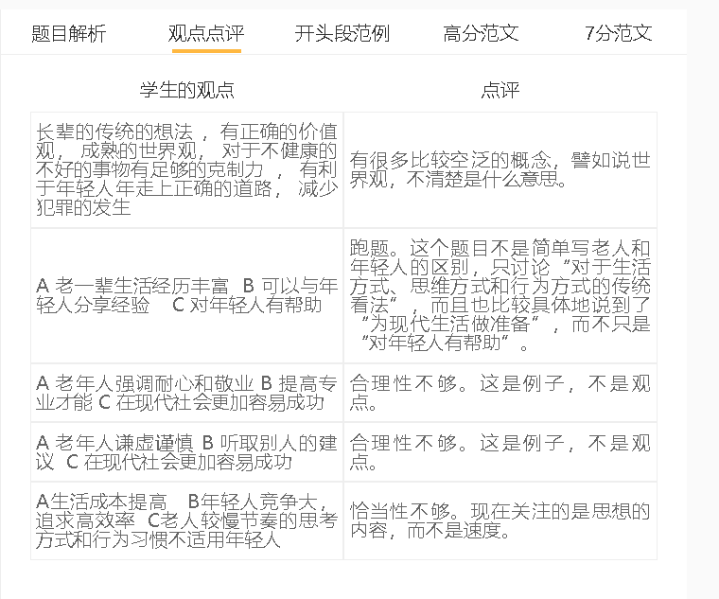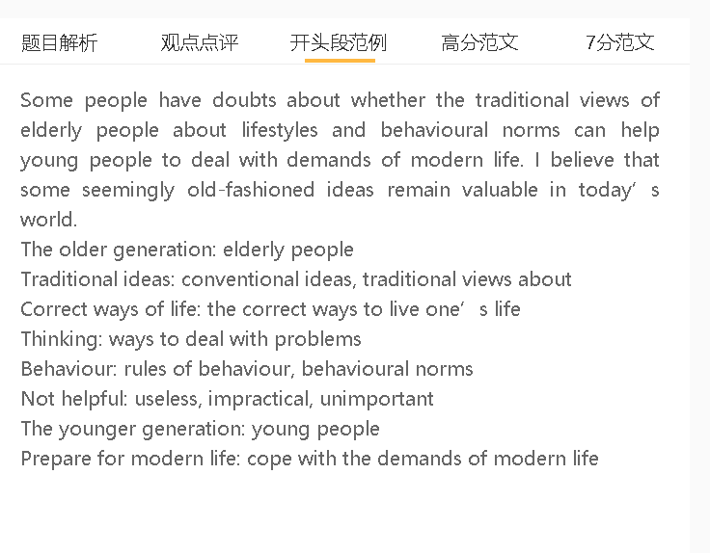

范文
The world is changing fast and older people’s suggestions may not be useful in modern societies. However, I believe that young people can draw upon the experience of the older generation if they want to handle some challenges of modern life.

A 老年人的看法强调遵守规则 B大家认可的行为 C 在现代社会更加和人有很好的关系，很好的立足
背景：不管社会如何变化，社会是由人组成的，人不会生活在真空里，如何管理不同的关系决定了他们可以利用的资源
解释（A-B）：老一辈人对于如何表现或说话来表现耐心、同情、忠诚和尊重他人有具体的想法
举例：比如职场规则，要给同事和主管留下好印象就应该遵守
解释（B-C）：坚持这些想法的年轻人可以与他人建立良好的关系，从而获得解决问题和取得成功的必要支持
Follow traditions, respect social norms, get along well with others
Friendly and respectful behaviour, develop a mutually beneficial relationship
Rules of the workplace, gain recognition, earn respect
Nurture a relationship
Gain support, tackle problems, achieve success
A large proportion of traditional ideas are about how to foster social relationships, which are also valuable in modern times. Whatever changes have taken place, human society consists of individuals who cannot live in a vacuum, and how to manage different relationships determines the resources they can draw upon. Older generations have specific ideas about how to behave or speak to show patience, empathy, loyalty and respect to others, such as the rules of the workplace one should follow to make a favourable impression on colleagues and supervisors. Young people who adhere to these ideas can develop a good relationship with others, thereby receiving necessary support for tackling problems and achieving success.
A 老年人遵守传统 B 规避错误 C很好的立足
背景：社会不管怎么改变，人性不变，包括贪婪、激进、喜欢躺在舒适区等等，因为这是我们遗传祖先的特点
但是这些特点有缺点，譬如说鼓励我们冒险
解释（A-B）：传统可以把上一代的智慧传递给年轻人，确保他们采取正确的行动。
举例：老年人会有意识地进行财务规划，而不是用尽所有的财务资源。追随自己想法的年轻人可能会为生活中不可预见的事件和经受经济危机预留资金。
Avoid risks，minimise risks, manage risks, handle the demands of modern life.
Valuable lessons learn from,,, setbacks and failures
Use money wisely, make plans, handle emergencies
The younger generation can also draw inspiration from the elderly about the time-honoured traditions in avoiding some repeat mistakes that they are prone to make. Human instincts, such as greed, aggression and staying in the comfort zone, are characteristics inherited from distant ancestors, who relied on these qualities to survive in harsh conditions, but these attributes have their downside, for example, prompting us to take risks. Traditions can pass on the wisdom of previous generations to young people, ensuring that they take correct action. Instead of using up all financial resources, for example, older people are conscious of financial planning. Young people who follow their ideas may set aside money for unforeseen events in lives and weather economic crises.

A 传统的想法比较刻板 B 不喜欢改变 , 没有创新 C 很难在现在社会上立足
背景：世界是改变的，很多传统的东西现在已经被人鄙视，因为不符合现在的价值观
解释（A-B）：这些传统起源于古代，当时人们对世界的认识还很有限，所以它们已经过时了。
举例：在一些文化中，体罚被认为是一种可以接受的管教孩子的方式，但随着父母教养的知识积累，父母逐渐放弃了这种传统做法。
解释（B-C）：年轻人要想适应现代，就应该跟上变化的步伐，调整心态。
Resistant to change, adapt to the modern world
Change rapidly
Keep pace with changes, change the mindset

On the other hand, young people may not be able to adapt to the modern world if they follow all traditions strictly and fail to respond to changes. The world is changing rapidly, and some traditions are frowned upon in today’s world for they are at odds with what is currently valued. These traditions originated from ancient times when people’s understanding of the world was limited, so they have been rendered obsolete. In some cultures, for instance, physical punishment was accepted as an acceptable way of disciplining children, but as the knowledge of parenting accumulates, parents have gradually abandoned this traditional practice. Young people should keep pace with changes and adjust the mindset if they intend to adapt to modern times.

In conclusion, I believe that young people should respect traditions, especially the conventional ways of handling relationship issues and managing risks, although some traditions may be outdated.

