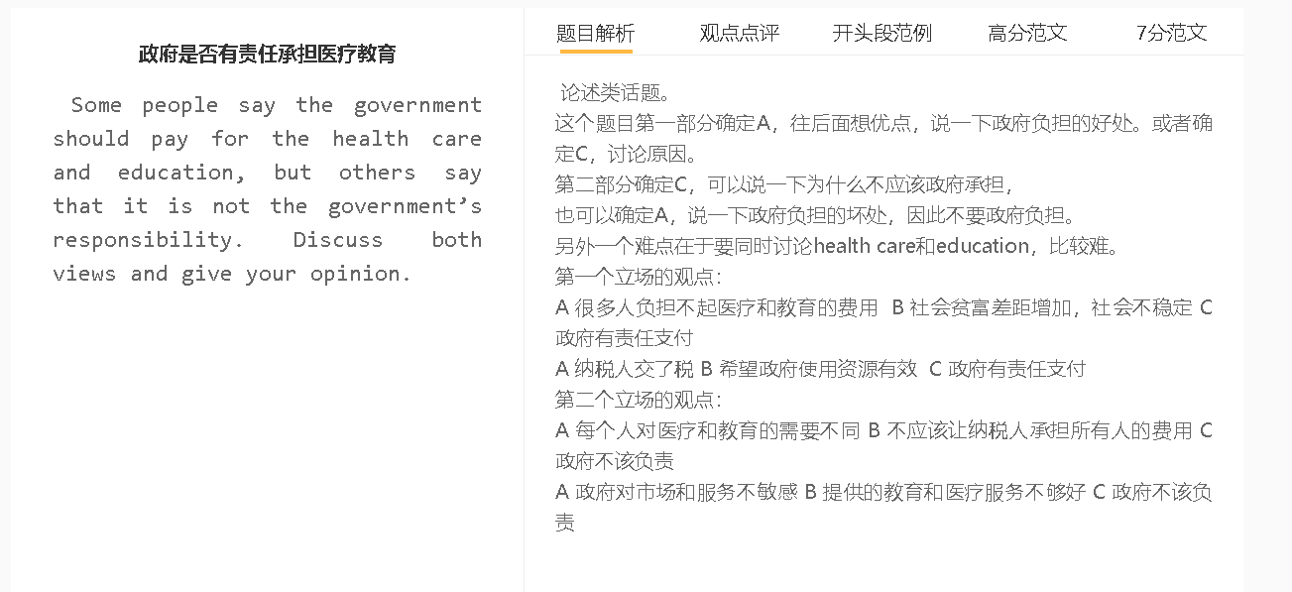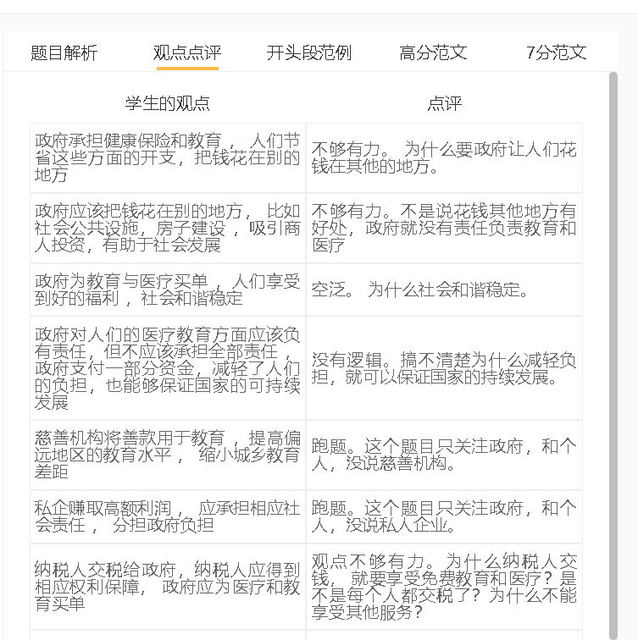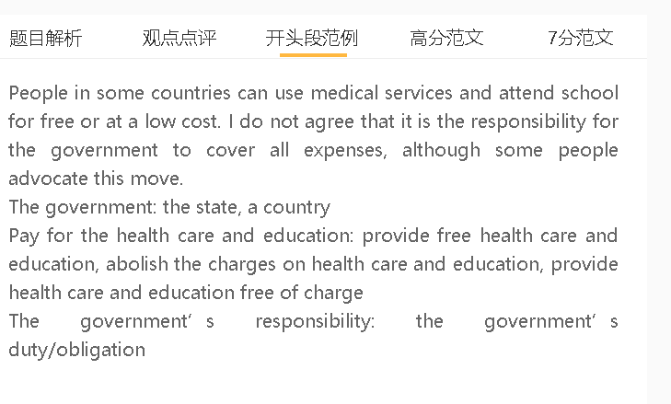

范文

7.5+
It is sometimes argued that health care and education should be subsidised/financed/funded fully by the state. I agree with this view, although the opposite may be true in some cases.
A health care and education are expensive B beyond the power of citizens C government should pay for the cost
中心句：
背景（可以不写，主要是观点存在的条件和环境）：设备都很贵、人员的费用很高
解释（A-B的跳跃，B-C的跳跃，也可以写两个并列的解释）： 工薪阶层收入不高，一些特殊疾病的人
解释：政府收税用于公共服务，有助于社会的稳定
财力
The main reason why the government should cover expenses is that these services are expensive and beyond the financial means of citizens. Tuition and medical fees are sometimes exorbitant for many due to the fact that equipment requires a huge expenditure and the spending on the salaries of staff is enormous. The financial support of the government can make these services affordable for ordinary people, including those with low incomes who struggle to send children to schools, and patients who suffer from complex diseases and face sizable medical bills. This government policy can also gain broad support because taxpayers’ money is used to promote educational and health equality for social stability.
A some people overuse public resources and services B unfair to other taxpayers C it is not the government’s responsibility
中心句：
背景（1 可以不写 2 主要是观点存在的条件和环境 3 确定C的观点，可以是A的解释）：有人比较自私，没有考虑大家的利益
解释（A-B的跳跃，B-C的跳跃，也可以写两个并列的解释）： 一些小病也要去医院，占用资源；读书不认真，一直毕不了业；生活不注意，得到一些生活方式的问题；学校和医疗机构为了利益过度医疗或者购买多余的设备
解释（A-B的跳跃，B-C的跳跃，也可以写两个并列的解释）：对于那些生活规律然后读书认真，或者是用不到这些服务的纳税人不公平
On the other hand, opponents hold the view that the government should not be responsible for these costs because free services risk overuse public resources and are unfair to other taxpayers. Overexploitation of essential services happens when individuals place their personal benefits above shared interests of the whole society. They may seek medical treatment for minor illnesses or hardly attempt to adopt healthy habits to avoid lifestyle-related health issues. Meanwhile, students do not devote their time and energies to studies to cherish educational opportunities, while schools and hospitals may make unnecessary purchases to apply for more funding. It is not reasonable to burden other taxpayers with these expenses, who do not rely on these services.
A health care and education are important to productivity B promote social progress C government should pay for the cost
中心句：
背景（1 可以不写 2 主要是观点存在的条件和环境 3 确定C的观点，可以是A的解释）：精力充沛不生病，所以能够专注学习和工作; 学习各种技能，提升工作效率
解释（A-B的跳跃，B-C的跳跃，也可以写两个并列的解释）：收益增加，经济发展
解释（A-B的跳跃，B-C的跳跃，也可以写两个并列的解释）： 有钱资助，良性循环
In my view, the government should pay for the cost considering that health care and education are important to productivity, which can promote social progress. Government funding can reduce medical costs, such as those related to health checks and vaccination, which can prevent illnesses, raise energy levels and improve performance either at school or in the workplace. Furthermore, government-funded education provides individuals with opportunities to acquire a diverse range of practical skills, which can boost efficiency. It will generate more business revenue, raise the average income of the working population and increase purchasing power, thereby prompting economic growth. Economic expansion forms a virtuous cycle as more funding can be allocated to these vital services.

In conclusion, I would argue that the government should pour money into educational and medical services even though there are some risks.

