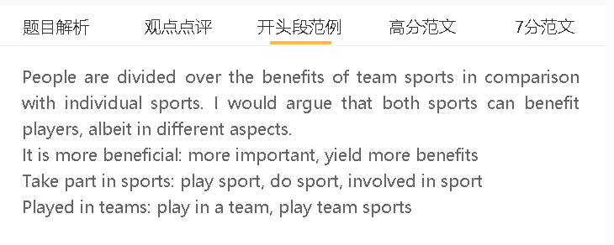

范文

People are divided over the benefits of team sports in comparison with individual sports. I would argue that both sports can benefit players, albeit in different aspects.

A 团队体育 B 懂得合作 C 对以后有帮助
People who consider it important to play team sports argue that they can learn how to act as good team players. In team sports, the strength and talent of individual players hardly override the performance of the whole team. When playing in a team, people should learn how to communicate effectively with teammates about goals and tactics, play respective roles to maximise the chance of beating rivals, and give encouragement to boost team morale whenever necessary. These skills and experiences may give players some advantages in the workplace, where they expect to work closely with others to execute tasks. Individual sports, by comparison, highlight the excellence of contestants themselves to the final outcome and attract people who intend to take the credit for the victory alone rather than share the glory with others. (7+)

A 个人体育 B 需要提升自己的能力 C对以后也有帮助
On the other hand, some people suggest that individual sports are more likely to push themselves to improve their skills. In these sports, the success or failure hinges on the fitness of players themselves, so it is fair to say that they cannot succeed without a sense of self-discipline and the ability to stay focused and show resilience in a game. They need to undergo training alone every day to maintain stamina in the absence of companionship provided by teammates, and also struggle through the low times of a competition without the encouragement and support of the entire team. This kind of sport can make them self-reliant individuals who can face challenges on their own and show exceptional self-management skills in attaining personal targets. These benefits may not be attainable for some participants of team sports, who develop the habit of depending on others, rather than explore their own potential. (7+)
A个人体育和团队体育 B 丰富不同经历 C都有用
In my view, it makes little sense to favour team sports over choices for individual players, or vice versa, as both can yield benefits for participants. In the modern world, one cannot accomplish every feat without the assistance provided by others, nor can they have a rewarding life without showing the skills in solving problems independently. Sports may simulate the difficulties or situations they could encounter in real life, and require them to respond with a mix of skills.

