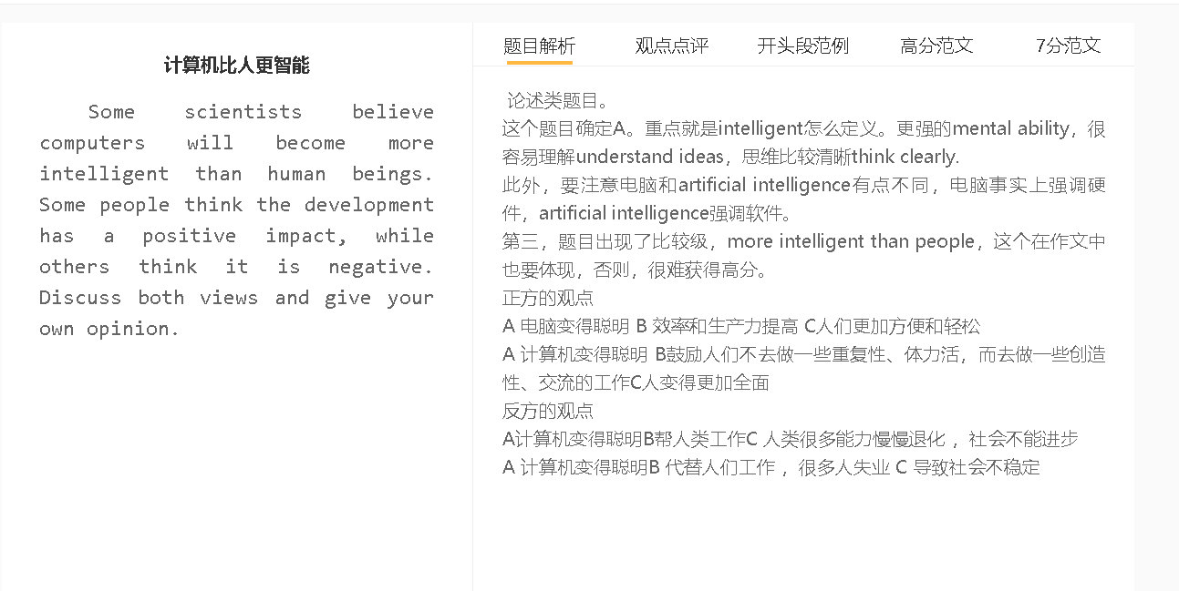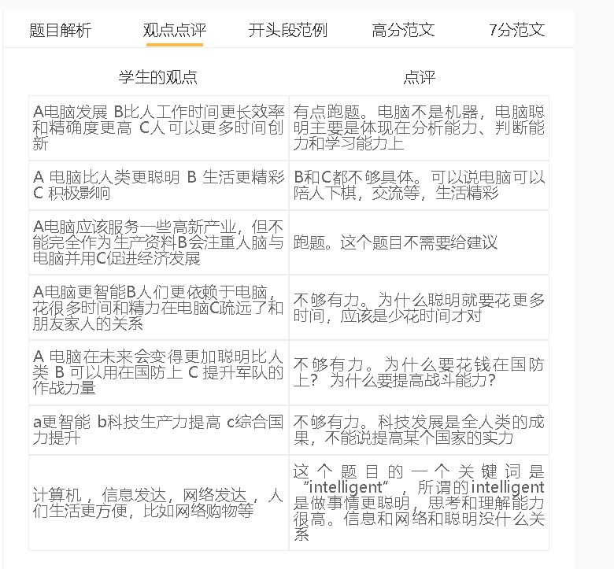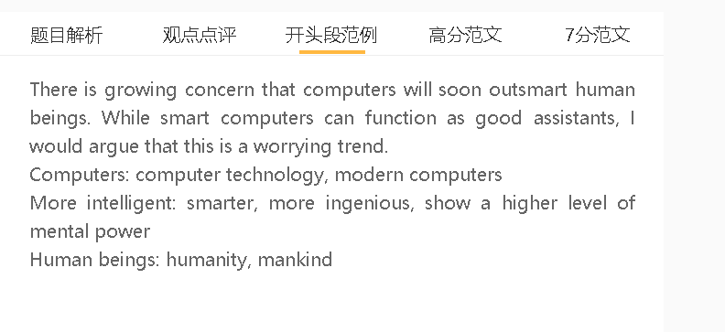

范文
There is growing concern that computers will soon outsmart human beings. While smart computers can function as good assistants, I would argue that this is a worrying trend.
A 电脑变得聪明 C 效率和生产力提高
解释(A -B)：电脑收集信息，处理信息更快
解释(A-B)：电脑学习更快，找到更好的解决方法
举例：有数据库，根据病人的健康数据和情况给诊断，并且根据治疗手段的效果来不断提升。
C的拓展：机构的盈利增加，经济提升
Some people perceive the development of computer technology as a positive change as it can give productivity a boost. Computers will become increasingly intelligent, meaning that these machinese can gather data in smart ways and detectvaluable information which may be ignored by human beings. It is also believed that computers are fast learners that can reflect on mistakes efficiently and discover better solutions to problems. For example, hospitals in the future may have computers which can decide treatments based on the health figures and situations of patients and make improvements by comparing the outcomes of different therapies, while human doctors are not able to make decicisions and adjustments at the same pace. With the widespread use of advanced computer technology, organisations can increase output and yield more revenue, thereby boosting the whole economy.

A 计算机变得聪明 B 代替人们工作 C 很多人失业
解释（A-B）：工作更好，而且比较少犯错
解释（B-C）：为了减少成本，裁员
拓展：人们没有收入去保证自己的生活，社会动荡
Opponents, however, regard the advent of intelligent computers as a threat to social stability because it will lead massive job cuts. It takes time and energy for humans to learn how to perform their duties and acquire new knowledge when their tasks change, but smart computers can fit into new positions by self-study, as long as they are programmed to do so. As machine learning develops at an astounding rate, cost-conscious employers would shift attention from staff training to computerisation. Without sufficient jobs to keep everybody in the workforce, a society would possibly face different challenges such as crime and rioting, when people fail to earn a living.

A 计算机聪明 B 帮人类工作， 人类很多能力慢慢退化 C社会不能进步
解释（前提）：人类比较懒，所有工作交给电脑
解释：大脑很少思考解决问题，去学习
解释（B-C）：不主动分析信息，对数据和趋势缺乏敏感，对新现象反应比较慢，缺乏创新
举例：教师依赖电脑去设计教学材料和设定教学策略，而自己不去思考新的。
In my view, intelligent computers may help us complete work faster, but overreliance on machines can limit our cognitive and intellectual development. With the support of computer technology, we hardly feel the need to increase knowledge on a daily basis and tackle matters with our own intelligence. The consequence is that we would perform poorly in doing calculations, assessing options, memorising new information and responding to unexpected situations. The decline in these skills means that people are not able to innovate to benefit the whole society. For example, if teachers count on computers to design teaching material and strategies, they would hardly form the habit of checking learning outcomes and creating brand-new practices which can assist students making faster progress.

