序号

中文关键词

英文关键词

图例

At night sky, the beach is covered with blue and green

fluorescence, the huge moon, elf light, stars, facula, the sea

with fluorescence, the shining golden beach, the starry sky with

moonlight, Michael james Smith's matte painting, reflection, cg

rendering, volume light, space art, bioluminescence, unreal engine

5, magic of light, unreal engine rendering, super wide angle,

super wide angle, high definition. --ar 9:16

1

A high-definition CG rendering of a dark rose forest, a rose path,

long floating red roses on the ground, fireflies, luminous ovules,

light effects, snowstorm style art trendsmagical light fognight

timelow light volumetric lightingue4 zbrushmarmostt toolbag HD --

ar 9:16

2

3

4

5

6

Blue sky, blue sea, pink beach, many pink roses spread on the

beach, which is very romantic.HD --ar 9:16

Lycoris radiata in the sky is red, and its petals are transparent.

It is as deep as the sea. It can feel loyalty and purity.

Love, mysterious light, soft light。HD --ar 9:16

Red Rose. Petals as deep as sea water, crystal clear grass,

frozen in ice cubes, you can feel the loyalty and purity of love,

high details and bigDepth of Field, 1080 P ,HD, --ar 9:16

There are many round gold coins in the pool, beside which there

are golden lotus flowers,frozen roses, and 4k 7x 1 plant roses at

night make the room full of romantic.HD --ar 9:16



A Panoramic Hanging Garden Rose World in an Alien Transparent

Glass Bottle, Castle, Rose Petals Flying, Romance, Dream, Greg

Ratkowski, Night, Red Rose Pavilion, Art Station Trends, Bright

Lighting, Smoke, Wood Support, UE4, HD, Lighting, Winter AUV,HD, -

-ar 9:16

7

At night,moon,There are several colored flowers nearby. There are

many transparent dew on the transparent petals. They are blooming

on the bank. There is a winding brook river. In the distance, the

valley is shrouded in clouds. The village is dimly seen. The gray

background，8k,HD --ar 9:16

8

A panoramic sky garden rose world in a special-shaped transparent

glass bottle, castle, roses, petals are flying, romance, dream,

Greg lat Kosky, night, red rose Pavilion, art station trend,

bright lights, smoke, wood support, UE4, HD, lighting, winter, AUV

--ar 9:16

9

the most beautiful golden tree, There is a golden rabbit under the

tree 241HD --ar 9:16

10

11

12

On a small mountain peak, there is a golden spring gushing upward.

The spring water gathers into a stream, surrounded by many flowers

and colorful colors lighting effect, CG rendering the dark skyHD -

-ar 9:16 --iw 10

Presented by HD CG, Black Rose Desert Rose Path, Blue Rose,

Firefly, Domino Vule Long Floating, Music Lighting, Rainbow Light

EffectFruitLight Fog Night Time Lightning Roll Lighting Kit of Art

Trends in a Light Style,HD, --ar 9:16



Gorgeous crystal shop white church, red rose, lighting effect,

romance, CG rendering European style, overlooking, fairy tale,

rose surround, lighting effect, party, super detail, 4K, unreal

engine, unreal cloud, HD --ar 9:16

13

14

15

16

17

18

Ancient ship,Many rose,A few roses,clouds, ultra wide shot,

atmospheric, hyper realistic, 8k, epic composition, cinematic,

octane render, artstation landscape vista photography by Carr

Clifton & Galen Rowell, 16K resolution, Landscape veduta photo by

Dustin Lefevre & tdraw, 8k resolution, detailed landscape painting

by Ivan Shishkin, DeviantArt, Flickr, rendered in Enscape,

Miyazaki, Nausicaa Ghibli, Breath of The Wild, 4k detailed post

processing, artstation, rendering by octane, unreal engine --ar

9:16 --iw 1 --test --creative

Palace half immersed in water blue lake, underwater trees, snow,

roses, fairyland, dreamy, unreal engine, ultra clear, 8K, extreme

rendering, high detail, light and shadow effects, epic, wide-angle

--ar 9:16 --q 2

beautiful portrait of realistic Aerith --ar 2:3 --testp --upbeta

Gorgeous crystal shop white church, red rose, lighting effect,

romance, CG rendering European style, overlooking, fairy tale,

rose surround, lighting effect, party, super detail, 4K, unreal

engine, unreal cloud, HD --ar 9:16 --test --creative

beautiful female wizard short blond hair, short beard, full body,

detailed whitish armor, intricate filigree metal design, magic

halo, studio light, opal, silk, mist, photorealistic, octane

render, unreal engine, hyper detailed, volumetric lighting,

romantic pastel colors, hdr, octane render, 4k, 8k --ar 2:3 --

video --testp

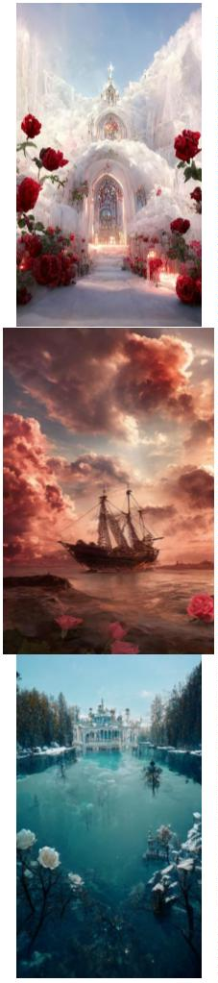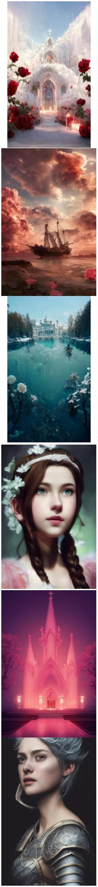

Pixar Style, Tiny cute and adorable cat dressed in raincoat, in

the rain, anthropomorphic, 8k, portrait, --ar 9:16 --s 5000 --

testp

19

20

21

22

23

24

cute anthropomorphic bunny in a kimono under cherry blossoms in

pixar style, octane render --testp --ar 2:3

ultra wide photo, overcast grey sky rainy clouds, Icelandic

landscape, field of moss, octane, photo realism, realistic,

extreme detail --test --creative --ar 2:3

Tiny cute and adorable monkey dressed in large streetwear clothing

, wearing sneakers , anthropomorphic , studio lighting, fashion

photography --ar 9:16 --testp --video

succulent terrarium in a glass jar, photorealistic, HDR, dynamic

lighting, unreal engine, octane render, dynamic composition --

testp --creative --ar 2:3

anthropomorphic cute baby cream Pomeranian as Elvis Presley,

hairstyles like Elvis Presley, standing, singing and dancing like

a rockstar, on the stage, with microphone, anthropomorphic, raving

fans in background, 8k --ar 2:3 --test

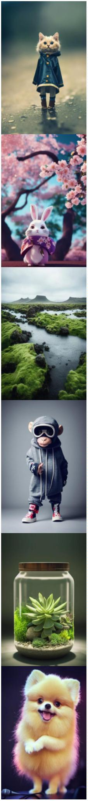

queen of the wind, long hair flying in the wind, cinematic light,

dramatic --ar 2:3 --test --creative

25

26

27

28

29

30

Beautiful Woman dissolving into colorful liquid oil paint, wind,

cinematic lighting, photo realistic, by karol bak --ar 2:3 --testp

--upbeta

beautiful female form with bursting floral head, roses, peonies,

songbirds in flight, morning glories, ethereal wisps of swirling

color --test --ar 2:3 --upbeta

cute baby white fox dressed as snow Queen, Pixar style,

anthropomorphic , Slept in the garden, 4k, trending on artstation,

Gorgeous,ultra wide angle, 4K, --ar 9:16

cute baby white fox dressed as snow Queen, Pixar style,

anthropomorphic , Slept in the garden, 4k, trending on artstation,

Gorgeous,ultra wide angle, 4K, --ar 9:16 --testp --upbeta

一个中国古代美人的红色背影，

一个奇怪的怪物，一个圆形的光 The back of an ancient Chinese beauty in red, a strange monster, a

晕，星空，CG渲染，体积光，太 round halo, a starry sky, CG rendering, volume light, space art,

空艺术，虚幻引擎5，超广角，高 unreal engine 5, ultra wide angle, high definition --ar 9:16

分辨率——ar 9:16

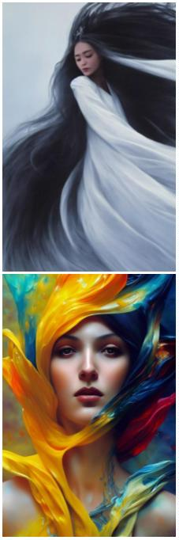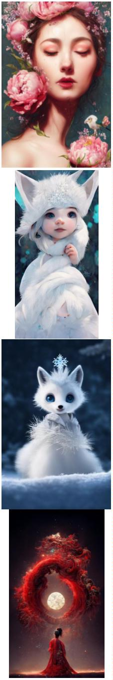

一头中国元素的古龙，龙的颜色

是金色与红色搭配，龙的特征明

显，超细节，CG渲染，星空，空

间艺术，虚幻引擎5，高清晰度，

超广角，8k --ar 9:16

An ancient dragon with Chinese elements. The color of the dragon

is gold and red. The characteristics of the dragon are obvious,

super detail, CG rendering, starry sky, space art, unreal engine

5, high definition, ultra wide angle, 8K --ar 9:16

31

On a windy night in a month, a small yard was planted with peach

blossom trees, a group of butterflies were dancing, and four

people were sitting on the table eating moon cakes. There were

peach blossoms in the moon and cotton clouds in the air. The

picture was very beautiful. The wide-angle view was 8K,HD --ar

9:16

32

This is a beautiful picture, cherry blossom forest, Mid-Autumn

Festival, the white moon slowly rising from the waterfall,dream,

gems, smoke, Movie HD, lots of detail, surrealism, magic, U Unreal

Engine, lighting--hd --ar 9:16 --testp

33

blue sea, blue sky and white beach, scattered pink roses. Spread

beach, a champagne colored broken diamond fine twinkling rose path

leading to Crescent Bay, is surrounded by several colorful colored

stones, panoramic view, ultra wide view, and beach in light blue

and pink sky. Dream engine, epic rendering, Ultra HD, ultra wide

angle, art station,4K.HD --ar 9:16

34

On a summer night, there is a light blue starry sky, and a train

has passed on the ground, surrounded by pink flowers and green

plants, lighting effects, starlight, fairy tales,by Makoto Shinkai

and Claude Monet,trending on behance,8K HD --ar 9:16

35

Super wide angle view, red rose icebulerosegarden + beautiful

paintings in the factory area, tall factory with many iron frames,

iron nets, factory lighting, Greg ratkowski, night, a little red

rose on the iron frame, art station trend, low light, smoke, steel

support, volume lighting, UE4, ZBrush, marmoset Kit HD --ar 9:16 -

-iw 10

36

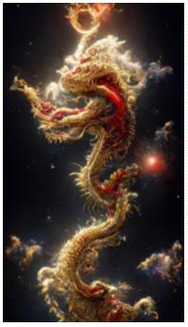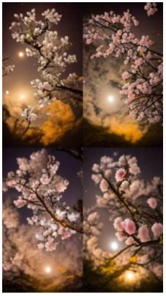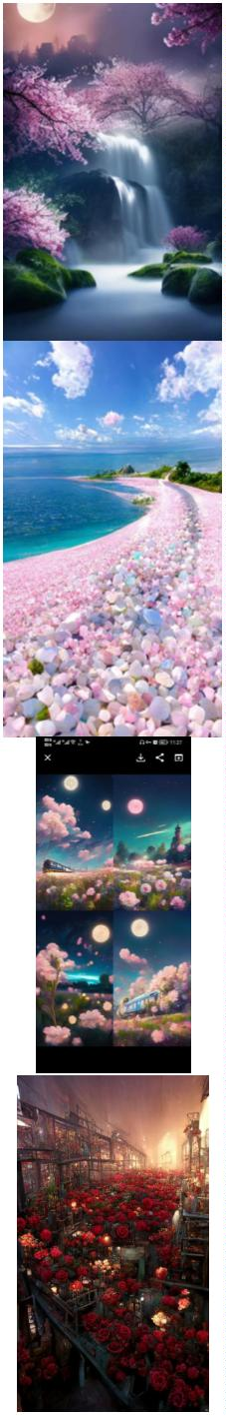

house floating in the air, cotton candy clouds, watermelon clouds,

small flowers, grass, flowers,lake, light green background, dream,

fairy tale,HD --ar 9:16

37

38

39

40

41

42

There are many green pointed tender leaves on the flower branches,

many crystal clear lavender flowers, and translucent petals curled

around its wet flower center. There are crystal dew on the

flowers. The hazy gray blue background is clear, and several

transparent snowflakes are falling,HD --ar 9:16

This is a beautiful picture, cherry blossom forest, Mid-Autumn

Festival, the white moon, slowly rising from the sea, dream，8K

,HD --ar 9:16

cute white lion in black plate armor and long white hair with red

splatter, dark cloud background, symmetrical face, volumetric

lighting, half body, legendary, epic, character design, cover art,

singer sargent, naruto, Diego Velázquez, fantasy, illustration,

highly detailed

Tempest Creation, silver angel of echoes and endless sound, god-

teir, god-level, god-like beauty

constellation echo, god-tier lorn, king of endless sound,

commander of motion, the gatekeeper of time, epic, cinematic

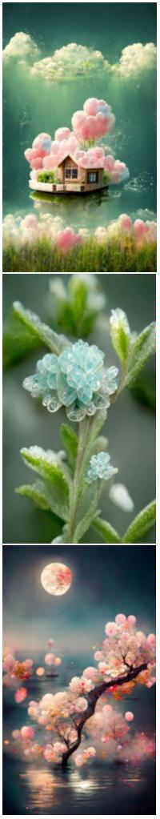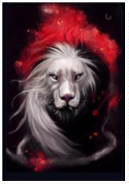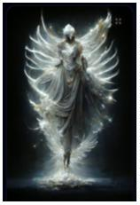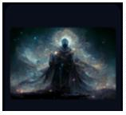

Margot Robby with pink katana, crazy, night light, city, fabric,

4K, realistic, cgi, beautiful, unreal engine, detailed, intricate

details, dramatic, photorealistic, beautiful, cinematic lighting

43

44

45

46

47

48

Oriental myth, Chinese dream Dununhuang Flying sky, super

delicate, crystal noble Gorgeous tulle light clothes, behind a

pair of translucent gorgeous white wings, huge moon,China

Palace,soft light, gold wirvire Flying, white feathers, mystery,

gems, smoke, Movie HD, lots of detail, surrealism, magic, U Unreal

Engine, lighting--hd --ar 9:16

Oriental myth, Chinese dream Dununhuang Flying sky, super

delicate, crystal noble Gorgeous tulle light clothes, behind a

pair of translucent gorgeous white wings, soft light, gold wirvire

Flying, white feathers, mystery, gems, smoke, Movie HD, lots of

detail, surrealism, magic, U Unreal Engine, lighting--hd --ar 9:16

A tree is covered with gold coins. The leaves are gold and the

flowers are gold. There are many beautiful golden wild flowers

under the tree. on an island in the center of a lake, dreamy

mist，It is resplendent, dreamy, light effect, 4K..HD --ar 9:16

Pixar Style, Tiny cute and adorable bunny adventurer dressed in

medieval armour , jean - baptiste monge , anthropomorphic ,

dramatic lighting --ar 2:3 --testp

cyan chinese dragon fantasy, intricate, elegant, highly detailed,

digital painting, artstation, concept art, matte, sharp focus,

illustration by greg rutkowski, john howe, 8k --aspect 9:16 --test

--creative

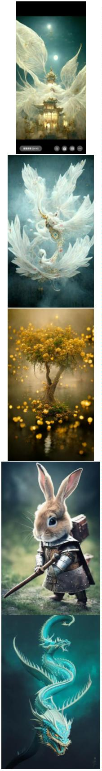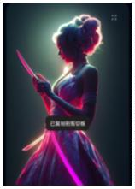

ethereal absinthe fairy with intricate glass wings, magical forest

background, will-o-the-wisp, mystical, eerie, dreamlike, glim

light --ar 2:3 --testp --s 1500

49

50

51

52

53

54

a portrait of an ethereal tulip goddess, sunny light, fresh

feelings, photorealistic, in the style of Tom Bagshaw and Anna

Dittmann and Monia Merlo --test --creative --ar 2:3

adorable border collie laying on a colorful blanket, realistic,

cinematic lighting, award winning photo, 80mm lens --testp --

creative --ar 2:3 --video

a male witch made of sand and foam wearing ocean haute couture,

blue jupiter gas swirls as sand, swirling sand and foam, blue foam

swirling,marble swirls, textured as sand, haute couture, dust and

foam in the background --ar 9:16 --test --creative --upbeta

beautiful female form with bursting floral head, roses, peonies,

songbirds in flight, morning glories, ethereal wisps of swirling

color --test --ar 2:3 --upbeta\*\* - Upscaled (Beta)

beautiful woman, long gray and wavy hair, lacy black dress, silver

jewelery, complex details, very realistic, art by Ben Enwonwu and

karol bak and tom bagshaw --ar 9:16 --test --creative

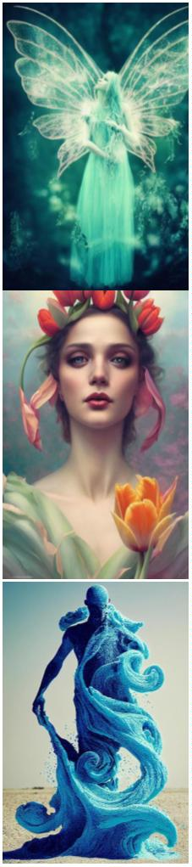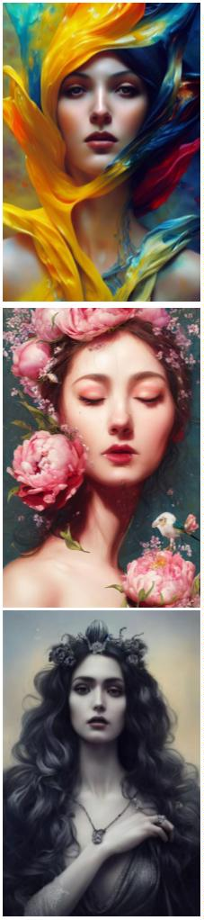

medieval male peasant with asian elder face, working in the

fields, tattered clothing, concentrated expression, tanned skin,

emotive eyes, dynamic pose, Alphonse Mucha, Tom Bagshaw, painted

by artgerm, krenz cushart, digital painting, highly detailed, art

nouveau style, 3, --no hands --ar 2:3 --test --creative

55

56

57

58

59

60

A meta-universe sci-fi game hall, from Ready Player One,

cyberpunk style, in front of the hall with a big screen, service

desk, futuristic, technological, blockchain, HD, rich details --ar

9:16

A beautiful huge cliff, ancient Chinese architecture, rainbow

waterfall, water mist, soft light, crystal texture of clouds,

fairy tale, dream, fluorescent, volume light matte painting, below

the waterfall is a huge lake, green water, Thomas kinkad and

Taylor Edlin, popular on cgsociety, 8K, volume light --ar 9:16

A ultra-realistic CG rendering of Ancient China,Lake, bridge, Plum

blossom,mysterious loneliness, withering, loneliness, a bright

moon, reflected in the water,A ultra-realistic CG rendering--iw 10

--ar 9:16

Fantasy, Black background, HD Mid-Autumn Festival Chinese Elegant

Peony+tranquility aestheticism+high details, soft moonlight, soft

colors, soft lights,8k new happiness, deep details,distinct levels

of detail,high picture quality,high definition and new Huan

renderin,8K HD --ar 9:16

Fantasy, Black background, HD Mid-Autumn Festival Chinese Elegant

Peony+tranquility aestheticism+high details, soft moonlight, soft

colors, soft lights,8k new happiness, deep details,distinct levels

of detail,high picture quality,high definition and new Huan

renderin,8K HD --ar 9:16

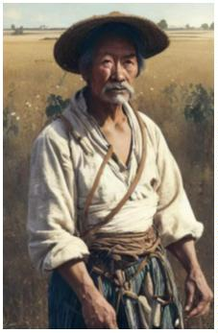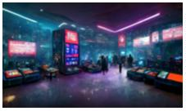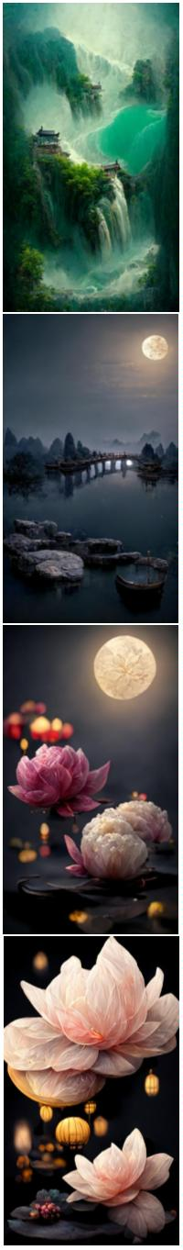

One kind of flower is pink. Its petals are as deep as sea water,

and its heart is like dew. There are many green leaves on the

branches, and there are many crystal white button chrysanthemums.

You can feel its loyalty and purity in comparison with loveHD, --

ar 9:16 --q 2

61

62

63

64

65

66

Surreal CG rendering in Ancient China Jiangnan Water Township

Architecture, Night View Meaning Environment Yellow willows, the

moon except the current water, And the stream is clear and real.

Real. 8K--hd --ar 9:16

Surreal CG rendering in ancient China, artistic conception of

night scene of ancient architecture in Wuzhen Snow . Moon, willow,

except current. water, And the stream is clear and real. Real. 8K-

-hd --ar 9:16

One soda float in a glass with clear blue soda and vanilla ice

cream on top, photorealistic, menu book, forward light, bright

lighting --w 512 --h 1024 --testp

focus post apocalypse floating city :: pastel color hazy clouds ::

cinematic :: galaxy bubbles :: render :: dreamy --ar 3:2

anime wallpaper、movie poster、featuring Hatsune Miku from

Vocaloid、she's in her early 20s、pin-up、nighttime concert、

character illustration in the style of Kimi no Na wa、your name、

Makoto Shinkai、Atelier Rorona、Granblue Fantasy、Atelier Lulua、

Last Exile、Atelier Firis、Guilty Crown、2k、Ghost in the Shell、

Hyper Dimension Neptunia --aspect 16:9

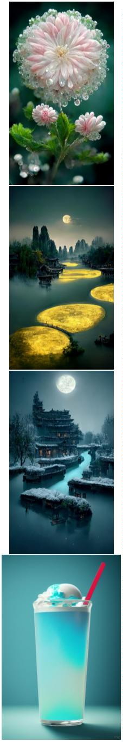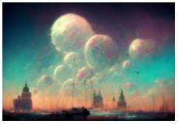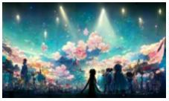

Heavenly wizardpunk city , night , trending on artstation ,

cinematic lighting , hyper detailed , insane details , intricate ,

elite , elegant , luxury , dramatic lighting , CGsociety ,

hypermaximalist , golden ratio , octane render , weta digital ,

micro details , ray trace 4k , --test --ar 16:9

67

68

69

70

71

72

sparkling pastel rainbow dye Maguk waterfall Kakadu , Animation

art , Breath of the wild , studio ghibli style , sun rays ,

fantasy feeling , lush vegetation and fern gorge , plants ,

miyazaki , Shinkai Makoto , hyper detail , octane render , --w

1024 --h 1792

focus post apocalypse floating city :: pastel color hazy clouds ::

cinematic :: galaxy bubbles :: render :: dreamy --ar 3:2

Environment aggressive courtyard chinese city :: people military，

robots people :: background future ruined chinese city ::

Mythology，cinematic，detailed atmospheric，epic，concept art，

very strange things，mid morning，blue dark skies，shafts of

lighting，mist， photorealistic，concept art，volumetric light，

cinematic epic + rule of thirds | 35mm | octane render，8k，corona

render，movie concept art，octane render，cinematic，trending on

artstation，movie concept art，cinematic composition，ultra

detailed，realistic， hiperealistic，volumetric lighting，--ar 3:1

beautiful,stunning,Azure Dragon,breathtaking,mirrors,glass,magic

circle,magic

portal,fantasy,mist,bioluminescence,crystals,gold,nebula,hypeet-

realistic,unreal engine --ar 9:16 --q 2 --s 15000 --chaos 5

beautiful,stunning, A splendid dragon，

breathtaking,mirrors,glass,magic circle,magic

portal,fantasy,mist,bioluminescence,crystals,gold,nebula,hypeet-

realistic,unreal engine --ar 9:16 --q 2 --s 15000 --chaos 5

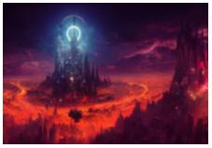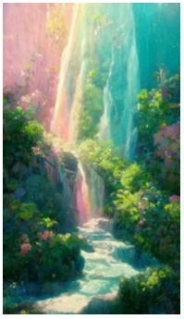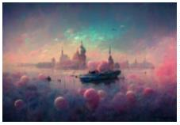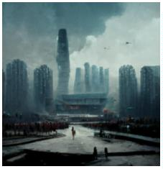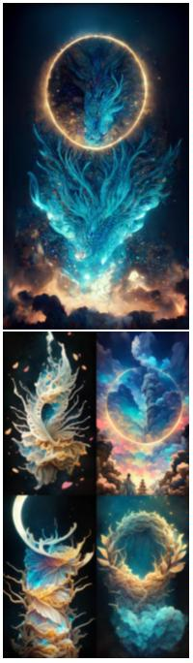

In the night sky, stars shine on silky beach, moon, elf light,

stars, stars shine, golden beach, starry sky, matte painting by

Michael James Smith, CG rendering, volume light, space art,

Bioluminescence, Unreal Engine 5, ultra wide Angle, high

definition --ar 9:16

73

74

75

76

77

78

The child's profile,carving, line art, gothic, multi-fantasy,

absolutely symmetrical,multi-detailed,absolutely clear --ar 9:16

The head of a sheep, the body of a lion, the wings of an

eagle,carving, line art, gothic, multi-fantasy, absolutely

symmetrical,multi-detailed,absolutely clear --ar 9:16

Guan Yu,carving, line art, gothic, multi-fantasy, absolutely

symmetrical,multi-detailed,absolutely clear --ar 9:16

Cat knight, portrait, finely detailed armor, intricate design,

silver, silk, cinematic lighting, 4k

datamosh, Graceful Midnight Angel of God + elegant details +

divine fantasy aesthetic + epic cinematic view + high details +

realism + octane render + volumetric soft light + post processing

+ denoise + 8k + ornate + elegant + Luminous color + Spiritual +

psychedelic --hd --no blur --ar 9:16 --q 2 --s 5000 --uplight

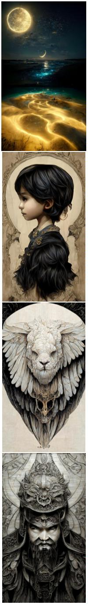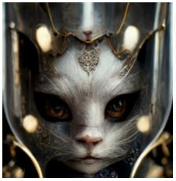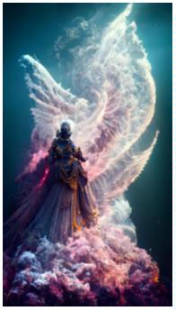

datamosh, Graceful Midnight Angel of God + elegant details +

divine fantasy aesthetic + epic cinematic view + high details +

realism + octane render + volumetric soft light + post processing

+ denoise + 8k + ornate + elegant + Luminous color + Spiritual +

psychedelic --hd --no blur --ar 9:16 --q 2 --s 5000 --uplight

79

80

81

82

83

84

datamosh, Graceful Midnight Angel of God + elegant details +

divine fantasy aesthetic + epic cinematic view + high details +

realism + octane render + volumetric soft light + post processing

+ denoise + 8k + ornate + elegant + Luminous color + Spiritual

Broken photo frames and butterfly specimen glass on the ground,

dappled light shining on the glass diamonds, --ar 16:9 --upbeta -

-q 2

One kind of flower is pink, its petals are transparent, deep as

sea water, crystal like dew, it can feel the loyalty and purity of

love, 8K ,HD --ar 16:9 --upbeta

closeup, mirrored portrait of Kristen McMenamy, covered in broken

mirrors in a low-poly style, detailed, soft background, cinematic,

hd photo, 4k, telephoto lens，--test --creative --ar 9:16

Surreal CG rendering of ancient China, a forest of peach blossoms

with an ancient Chinese pavilion in the woods, water pool, Chinese

fantasy novel scene +ultra wide Angle + detailed + beautiful

fanatasy art + matte painting by a senior matte painter +

cgsociety + masterpiece --ar 9:16 --test --creative

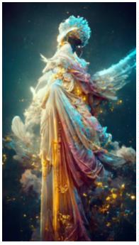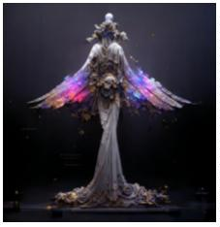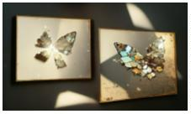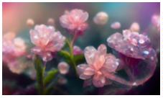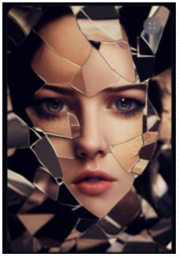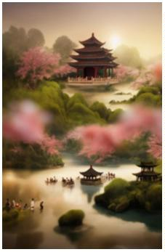

This is a real picture, a lavender garden under the moonlight,

many butterflies flying, studio lighting, octane rendering, film

level post-processing,8k,HD, --ar 9:16

85

86

87

88

89

90

beautiful ethereal cyberpunk girl, full face portrait, low angle,

intricate, highly detailed, digital painting, hyperrealistic,

artstation, concept art, smooth, sharp focus, illustration,

dystopian background, Unreal Engine 5, 8K，--test --creative --ar

9:16

young woman, pink hair, gorgeous, glowing teal eyes, elegant,

intricate, highly detailed, digital painting, artstation, concept

art, sharp focus, illustration, art by Ross tran --test --creative

--ar 9:16

automaton that look like porcelain doll wearing baroque and rococo

style outfit by charlie bowater, WLOP, artgerm and Jason Chan --

test --creative --ar 9:16

futuristic city deep in thick forest with monorail sci-fi ,

hyperdetailed technical precision, cinematic, ultrareal, octane

render, volumetric lighting, 8k ,--test --creative --ar 9:16

Character, Hybrid class, Rogue Wizard, Dungeons&Dragons Style,

Artstation, concept art, Artist Jesper Ejsing, sense of awe,

Octane render, Unreal 5 engine, Godrays, Forrest, daylight, low

mist,--test --creative --ar 9:16

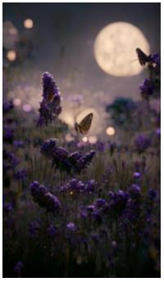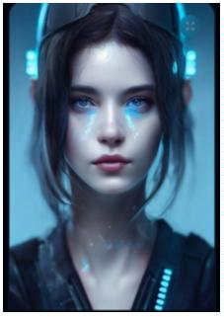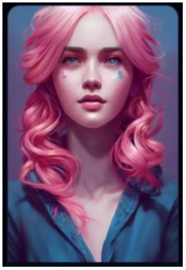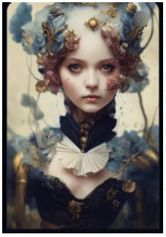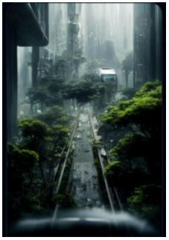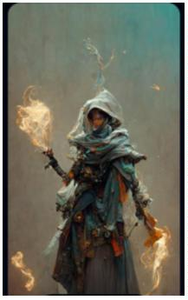

The Moon Knight dissolving into swirling sand, sandman, volumetric

dust, cinematic lighting, close up portrait，--test --creative --

ar 9:16

91

92

93

94

95

96

temperance tarot card featuring an angel, vaporwave color scheme,

ultra detailed, digital art, photo realistic, 4K, Cinematic，--

test --creative --ar 9:16

sunlit surrealist collapse of the galaxy in on itself

metaphorically, a person holding the universe, cinimatic, highly

illustrative rendering, highly detailed by rafał olbiński,

photoreal, Houdini Render，--test --creative --ar 9:16

open interior of a great hall, chrome, violet, sci-fi,

technological, otherworldly, stars in the sky at night, beautiful,

industrial, futuristic, dark fantasy, atmospheric, photorealistic,

highly detailed，--test --creative --ar 9:16

a beautiful fashion doll dressed as a demon, hyper realistic,

photo realistic, extreme detail, cinematic lighting realistic

facial features，--test --creative --ar 9:16

Breathtaking baroque Madelaine Petsch beauty, full head, Oval

baroque frame, acanthus scroll, Painted by artgerm, Alphonse

Mucha, Akihiko yoshida, sakimichan, krenz cushart, low angle shot,

digital painting，--test --creative --ar 9:16

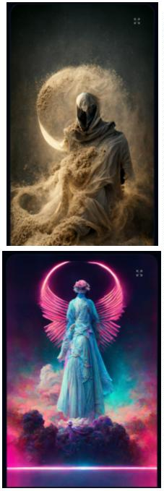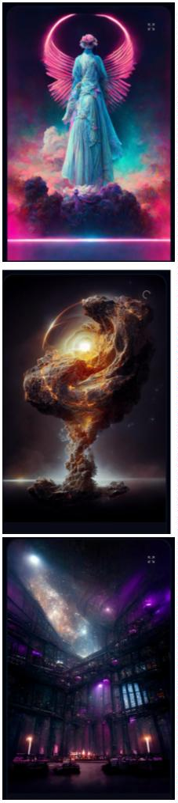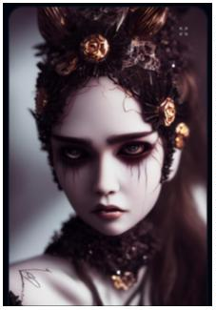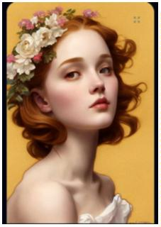

A high-definition CG rendering of a dark rose forest, a rose path,

long floating red roses on the ground, fireflies, luminous ovules,

light effects, snowstorm style art trendsmagical light fognight

timelow light volumetric lightingue4 zbrushmarmostt toolbag HD --

ar 9:16

97

A ultra-realistic CG rendering of Ancient China,Old houses, green

trees, shade, clouds, Trending on artstation --ar 9:16 --test --

upbeta

98

It is a beautiful picture. There are many huge blue roses floating

in the deep sea, the brightness of the moon, magic clouds, several

sailboats, giant sailboats, Klein Blue Dream rendering, surreal,

surreal, super beautiful dream, HD,beautiful ethereal fairyland--

HD --ar 9:16

99

A ultra-realistic CG rendering of Ancient China,Old houses, green

trees, shade, clouds, Trending on artstation --ar 9:16

100

