Case Velocii!

Link GitHub: https://github.com/SeleucusTheGreat/CaseVelocii

User Stories:

Feature: A new User Signs up to the website and gets immediately logged-in

As a new user, I want to be able to sign up and be logged in immediately after so that I can start using the app.

Scenario: Sign up and Check if logged in

Given I am on CaseVelocii homepage
And I’m a new user
When I click on user icon
And I click on Sign up
Then I should be able to fill out the sign-up form
And I enter my full name, email, password, and password confirmation
And I click on Sign up
Then I should be logged in as a registered user

Feature: A registered User Creates a new post regarding one of his houses.

As a logged-in user, I want to create a new post about my house so that other interested users can see it.

Scenario: User create a House Post

Given I am on CaseVelocii homepage
And I am logged in
When I click on the user icon
And I click on My Houses
Then I should see a list of my houses
And I click on "Post a New House"
Then I should be able to fill out the form
And I enter all the information required
And I upload one or more pictures
And I click on Create
Then I should see a confirmation message that the post has been successfully created
When I visit My Houses again
And I should see the House post I’ve just created
Then I click on the house I’ve just created
And I should see all the details about the house
And they should be correct

Feature: A registered User Modifies his profile and add a new profile picture

As a logged-in user, I want to modify my profile attributes and change my profile picture so other users know who I am.

Scenario: User modifies his user profile

Given I am on CaseVelocii homepage
And I am logged in
When I click on the user icon
And I click on “My Profile”
Then I should see my User Profile
Then I click on "Edit Profile"
Then I should be able to fill out the form
And I enter my full name, email, password, and password confirmation
And I upload a picture of myself
And I click on "Save Changes"
Then I visit "My Profile" page again
And I should see the changes on my profile
And I should see my new profile picture

Feature: A registered User Modifies his recent House Post

As a logged-in user, I want to modify one of my recent house posts so that I can provide the correct information regarding my house.

Scenario: User edits one of his House Posts

Given I am on CaseVelocii homepage
And I am logged in
When I click on the “user icon”
And I click on "My Houses"
Then I should see a list of my houses
And I click on “Edit” on one of my House Posts
Then I should be able to fill out the form
And I modify one or more information
And I click on "Update"
Then I should see a confirmation message that the post has been successfully edited
Then I visit "My Houses" again
And I click on “Show” on the House Post I’ve just modified
Then I should be able to see all the correct information.

Feature: A registered User Clicks on a notification and replies to a user with a Message

As a logged-in user, I want to click on a new notification that just arrived regarding someone interested in one of my houses. Then I want to reply to that user’s message with a new message so that we can find a compromise regarding my house.

Scenario: User send message throw notification

Given I am on CaseVelocii homepage
And I am logged in
When I click on the Notification Icond
Then I can see all my recent notifications
When I click on my latest notification
And I should see all the messages I‘ve sent to the user
And I should see all the messages I’ve receive from that user
Then I should be able to write a new message
And I write a new message
And I click on "Send"
Then I should see a confirmation message that the message has been successfully sent
And I should see my new message as the latest message sent to that user

Feature: A registered User Views all his chats from different posts

As a logged-in user, I want to see a list of all my ongoing chats from different posts so that I can easily manage and continue my conversations.

Scenario: User views his chat list

Given I am on CaseVelocii homepage
And I am logged in
When I click on the "My Profile"
Then I should see a list of all my chats
And each chat should display the other user's profile picture and name
And each chat should show the associated post's image and title
And each chat should display the last message exchanged
When I click on a specific chat
Then I should be taken to the full conversation for that chat

Feature: A registered User Starts a new chat about a house post

As a logged-in user, I want to initiate a conversation with the owner of a house post I'm interested in, so that I can inquire about the property.

Scenario: User starts a new chat from a house post

Given I am on CaseVelocii homepage
And I am logged in
When I click on a house post that interests me
Then I should see the details of the house post
And I should see a Send Message and a text box
Then I write a new message
And I click on Send Message
Then A new chat should be created between me and the House owner
When I visit my User Page
Then A new chat should be visible
And it should display the other user's profile picture and name
And it should show the associated post's image and title
And it should display the last message exchanged

Feature: A new user Searches for a house near where he lives
As a logged-in user, I want to search for houses close to where I live so I can find my next house near my current location.

Scenario: User searches for a house using address and radius
Given I am on the CaseVelocii homepage
And I am logged in
When I enter my address and a specific radius of distance in the Search bar
And I enter the name of my city
And I click on Search
Then I should see posts regarding houses in my city
And the posts should be within the specified radius of my address
When I click on one of these posts
Then I should see detailed information about the house
And I should see a map with the address of the house displayed

Feature: a new User Searches for a house in my city within a budget
As a non logged-in user, I want to search for houses in my city that cost less than €500,000 so I can find affordable housing options.

Scenario: User searches for houses in the city within a budget
Given I am on the CaseVelocii homepage
And I am not logged in
When I enter the name of my city in the Search bar
And I set the maximum price to €500,000
And I click on “Search”
Then I should see posts regarding houses in my city
And the posts should only include houses that cost less than €500,000
When I click on one of these posts
Then I should see detailed information about the house
And I should cost less than €500,000
And I shouldn’t be able to send message to the owner of the house

Feature: an Admin searches and deletes a House post with incorrect information
As an admin, I want to access the admin panel and delete posts with incorrect information to maintain the accuracy and quality of the posts on the platform.

Scenario: Admin deletes a post with incorrect information
Given I am on the CaseVelocii homepage
And I am logged in as an admin
When I click on the user icon
And I click on "Admin Panel"
Then I should see the admin dashboard
When I search for the post with incorrect informations
And I find a post with incorrect information
Then I click on the "Delete" button for that post
Then the post should be removed from the platform
And I should see a confirmation message that the post has been successfully deleted

Feature: A registered User Delete a post after selling a house
As a logged-in user, I want to delete my house post once I have sold my house so that it no longer appears on the platform.

Scenario: User deletes a post after selling their house
Given I am on the CaseVelocii homepage
And I am logged in
When I click on the user icon
And I click on "My Houses"
Then I should see a list of my house posts
When I find the post for the house I have sold
And I click on the "Delete" button for that post
Then the post should be removed
And I should see a confirmation message that the post has been successfully deleted

Feature: A new User Sign up with Google OAuth and check profile
As a new user, I want to be able to sign up with Google and check if my name and avatar image are correctly displayed in my profile.

Scenario: Sign up with Google OAuth
Given I am on the CaseVelocii homepage
And I’m a new user
When I click on the user icon
And I click on "Sign Up"
Then I should be able to click on the “Sign Up with Google” button
And I click on that button
Then I should be redirected to the Google OAuth page
And I grant access to CaseVelocii in the Google authorization panel
Then I should be redirected to the CaseVelocii homepage
And I should be logged in with my Google account
When I click on the user icon
And I click on My Profile
Then I should see my profile
And I should see my Google name
And I should see my Google avatar picture

Feature: New User logs in with Google Oauth

As a Google user but not logged-in, I want to be able to log in using my Google Account without being required to insert any email or password

Scenario: Log in with Google Oauth

Given I am on CaseVelocii homepage
And I’m not logged-in
When I click on user icon
And I click on “Log In”
Then I should be able to click on “Log in with Google” button
And I click on that button
Then I should be able redirected to CaseVelocii homepage
And I should see logged-in
And I should see my Google name
And I should see my Google avatar picture

Feature: An Admin searches and edits a post with incorrect information
As an admin, I want to access the admin panel and edit posts with incorrect information to maintain the accuracy and quality of the listings on the platform.

Scenario: Admin edits a post with incorrect information
Given I am on the CaseVelocii homepage
And I am logged in as an admin
When I click on the user icon
And I click on "Admin Panel"
Then I should see the admin dashboard
Then I search for the post with incorrect information
And I find a post with incorrect information
Then I click on the "Edit" button for that post
And I should be able to edit the information of the post
When I update the incorrect information
And I click "Save Changes"
Then the post should be updated with correct information
And I should see a confirmation message that the post has been successfully updated

Piano dei test:

Per l'implementazione dei test, ho utilizzato Cucumber + Capybara. Le User Stories selezionate illustrano chiaramente le diverse funzionalità della webapp.
- Creazione di un Post : La prima User Story descrive il processo di creazione di un post riguardante una proprietà.
- Interazioni tra Utenti: La seconda User Story mostra come gli utenti interagiscono tra loro e come vengono gestite le chat e i messaggi.
- Funzionalità di Ricerca: La terza User Story spiega le funzionalità di ricerca, permettendo agli utenti di trovare varie proprietà inserendo un indirizzo e un raggio di ricerca.
- Moderazione da parte degli Admin: La quarta User Story evidenzia i poteri degli amministratori nella moderazione dei post e nella gestione dei dati relativi ai post stessi.

1) Feature: A registered User Creates a new post regarding one of his houses.

As a logged-in user, I want to create a new post about my house so that other interested users can see it.

2) Feature: A registered User Starts a new chat about a house post

As a logged-in user, I want to initiate a conversation with the owner of a house post I'm interested in, so that I can inquire about the property.

3) Feature: A new user Searches for a house near where he lives
As a logged-in user, I want to search for houses close to where I live so I can find my next house near my current location.

4) Feature: an Admin searches and deletes a House post with incorrect information
As an admin, I want to access the admin panel and delete posts with incorrect information to maintain the accuracy and quality of the posts on the platform.

Struttura Controllo degli Accessi:

Funzionalità | Utente non Registrato | Utente Registrato | Admin
Log In: |  |  | 
Sign Up: | 
See House Posts in the Homepage: |  |  | 
Click on House Posts: |  |  | 
Search for House Posts: |  |  | 
Access My Profile: |  |  | 
Access My Houses: |  |  | 
Access Admin Panel: |  |  | 
Send a Message to an Owner: |  |  | 
Reply to a Message: |  |  | 
Modify my House Posts: |  |  | 
Delete My House Posts: |  |  | 
Modify every House Post: |  |  | 
Delete every House Post: |  |  | 
Change my User Profile: |  |  | 
View conversations of my Post: |  |  | 
Access my Chats: |  |  | 
Make a User an Admin
Receive Notifications |  |  | 
Click on my Notifications |  |  | 
Log Out |  |  | 

Mockups:
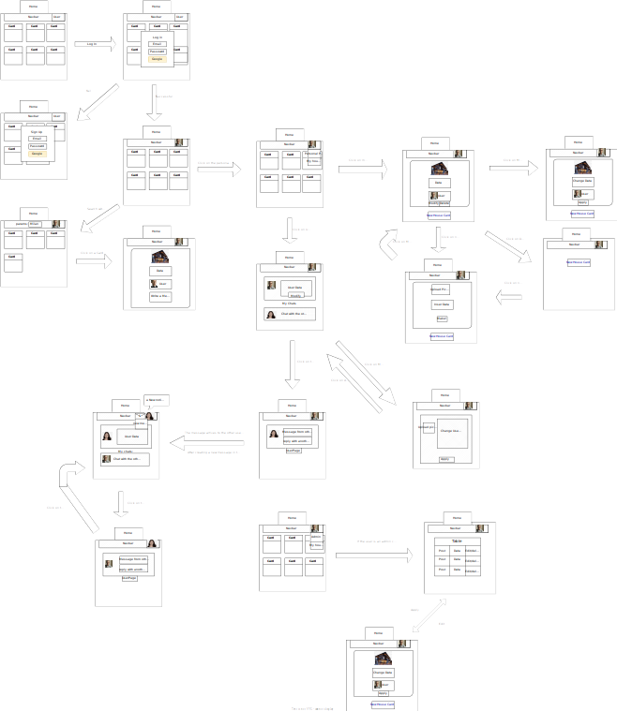

Schema DB:


