>> m=3

m =

3

>> n=2

n =

2

>> zeros(m,n)

ans =

0 0
0 0
0 0

>> ones(n,m)

ans =

1 1 1
1 1 1

>> eye(m,n)

ans =

1 0
0 1
0 0

>> rand(m,n)

ans =

0.8147 0.9134
0.9058 0.6324
0.1270 0.0975

>> randn(n, m)

ans =

-0.4336 3.5784 -1.3499
0.3426 2.7694 3.0349
3

>> a=zeros(m, n)

a =

0 0
0 0
0 0

>> a(1,2)=2

a =

0 2
0 0
0 0

>> a(1,1)=-4

a =

-4 2
0 0
0 0

>> a(4,5)=2

a =

0 0 0 0 0
0 0 0 0 0
0 0 0 0 0
0 0 0 0 2

4

>> a=rand(3,2)

a =

0.8147 0.9134
0.9058 0.6324
0.1270 0.0975

>> a(2,2)=10

a =

0.8147 0.9134
0.9058 10.0000
0.1270 0.0975

>> a(4,2)=-1

a =

0.8147 0.9134
0.9058 10.0000
0.1270 0.0975
0 -1.0000

[2]

>> help elmat
Elementary matrices and matrix manipulation.

Elementary matrices.
zeros - Zeros array.
ones - Ones array.
eye - Identity matrix.
repmat - Replicate and tile array.
repelem - Replicate elements of an array.
linspace - Linearly spaced vector.
logspace - Logarithmically spaced vector.
freqspace - Frequency spacing for frequency response.
meshgrid - X and Y arrays for 3-D plots.
accumarray - Construct an array with accumulation.
: - Regularly spaced vector and index into matrix.

Basic array information.
size - Size of array.
length - Length of vector.
ndims - Number of dimensions.
numel - Number of elements.
disp - Display matrix or text.
isempty - True for empty array.
isequal - True if arrays are numerically equal.
isequaln - True if arrays are numerically equal, treating NaNs as equal.

Matrix manipulation.
cat - Concatenate arrays.
reshape - Reshape array.
diag - Diagonal matrices and diagonals of matrix.
blkdiag - Block diagonal concatenation.
tril - Extract lower triangular part.
triu - Extract upper triangular part.
fliplr - Flip matrix in left/right direction.
flipud - Flip matrix in up/down direction.
flip - Flip the order of elements.
rot90 - Rotate matrix 90 degrees.
: - Regularly spaced vector and index into matrix.
find - Find indices of nonzero elements.
end - Last index.
sub2ind - Linear index from multiple subscripts.
ind2sub - Multiple subscripts from linear index.
bsxfun - Binary singleton expansion function.

Multi-dimensional array functions.
ndgrid - Generate arrays for N-D functions and interpolation.
permute - Permute array dimensions.
ipermute - Inverse permute array dimensions.
shiftdim - Shift dimensions.
circshift - Shift array circularly.
squeeze - Remove singleton dimensions.

Array utility functions.
isscalar - True for scalar.
isvector - True for vector.
isrow - True for row vector.
iscolumn - True for column vector.
ismatrix - True for matrix.

Special variables and constants.
eps - Floating point relative accuracy.
realmax - Largest positive floating point number.
realmin - Smallest positive floating point number.
intmax - Largest positive integer value.
intmin - Smallest integer value.
flintmax - Largest consecutive integer in floating point format.
pi - 3.1415926535897....
i - Imaginary unit.
inf - Infinity.
nan - Not-a-Number.
isnan - True for Not-a-Number.
isinf - True for infinite elements.
isfinite - True for finite elements.
j - Imaginary unit.
true - True array.
false - False array.

Specialized matrices.
compan - Companion matrix.
gallery - Test matrices.
hadamard - Hadamard matrix.
hankel - Hankel matrix.
hilb - Hilbert matrix.
invhilb - Inverse Hilbert matrix.
magic - Magic square.
pascal - Pascal matrix.
rosser - Classic symmetric eigenvalue test problem.
toeplitz - Toeplitz matrix.
vander - Vandermonde matrix.
wilkinson - Wilkinson's eigenvalue test matrix.

>> a=[1 2 3 4 5;6 7 8 9 11]

a =

1 2 3 4 5
6 7 8 9 11

>> b=[0 -1 -2 -3 -4; 5 6 7 8 9]

b =

0 -1 -2 -3 -4
5 6 7 8 9

>> [a,b]

ans =

1 2 3 4 5 0 -1 -2 -3 -4
6 7 8 9 11 5 6 7 8 9

>> [a;b]

ans =

1 2 3 4 5
6 7 8 9 11
0 -1 -2 -3 -4
5 6 7 8 9

>> a+b

ans =

1 1 1 1 1
11 13 15 17 20

>> a-b

ans =

1 3 5 7 9
1 1 1 1 2

>> a*b
Error using *
Inner matrix dimensions must agree.

>> b*a
Error using *
Inner matrix dimensions must agree.

>> a .* b

ans =

0 -2 -6 -12 -20
30 42 56 72 99

>> ta = transpose(a)

ta =

1 6
2 7
3 8
4 9
5 11

>> tb = transpose(b)

tb =

0 5
-1 6
-2 7
-3 8
-4 9

>> c=a*tb

>> oc=inv(c)

oc =

-0.2600 0.1000
-0.0817 0.0348

>> c*oc

ans =

1.0000 0
-0.0000 1.0000

>> det (c)

ans =

-1.1500e+03
[3]

>> p = [1 0 -1 10 0 -1 -20]

p =

1 0 -1 10 0 -1 -20

>> poly2str (p, 'z')

ans =

' z^6 - 1 z^4 + 10 z^3 - 1 z - 20'

>> polyval(p, -0.5)

ans =

-20.7969

>> polyval(p, [-0.5 -0.3 -0.2 0 0.4 0.8])

ans =

-20.7969 -19.9774 -19.8815 -20.0000 -19.7815 -15.8275

>> r = roots(p)

r =

-2.3916 + 0.0000i
1.1898 + 1.8648i
1.1898 - 1.8648i
1.2561 + 0.0000i
-0.6220 + 0.9868i
-0.6220 - 0.9868i

>> poly (r)

ans =

Columns 1 through 6

1.0000 -0.0000 -1.0000 10.0000 -0.0000 -1.0000

Column 7

-20.0000
[4]

>> hndlaxis
Warning: MATLAB has disabled some advanced graphics rendering
features by switching to software OpenGL. For more information,
click here.
>> hndlaxis
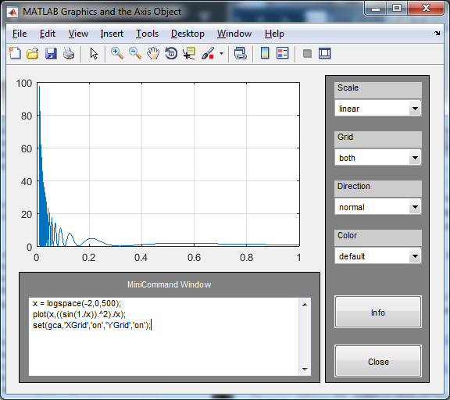
>> hndlgraf
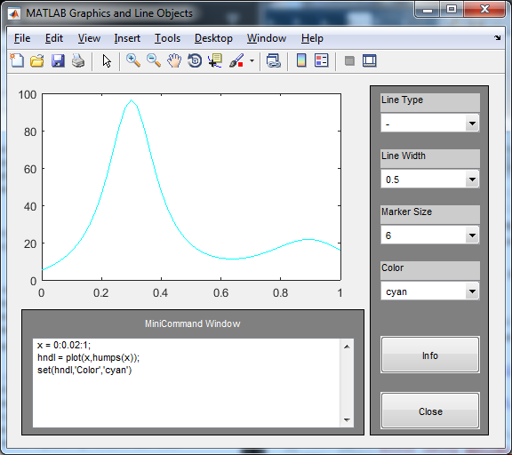

>> v=1.8:0.1:2.8

v =

Columns 1 through 6

1.8000 1.9000 2.0000 2.1000 2.2000 2.3000

Columns 7 through 11

2.4000 2.5000 2.6000 2.7000 2.8000

>> f = (2.718281828+v).*sin(pi*sqrt(v-1))

f =

Columns 1 through 6

1.4712 0.7413 0.0000 -0.7359 -1.4527 -2.1392

Columns 7 through 11

-2.7860 -3.3858 -3.9326 -4.4216 -4.8493
>> subplot (2,1,1); plot (v,f); title('(e+x)(sin(pi*sqrt(x-1)))'); xlabel('Data'); ylabel('Result');
>> subplot (2,1,2); plot (v,1-f); title('1-(e+x)(sin(pi*sqrt(x-1)))'); xlabel('Data'); ylabel('Result2');
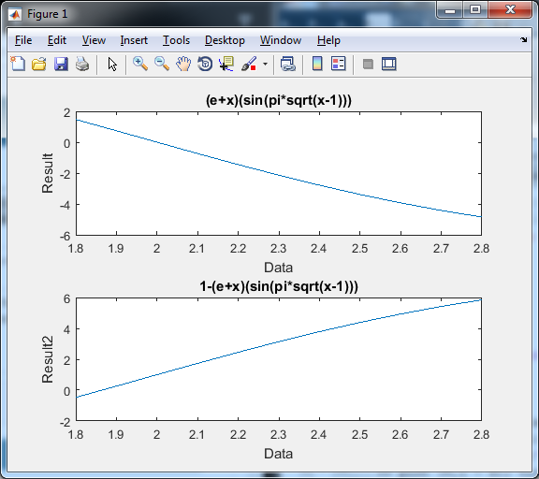

>> help comet
comet Comet-like trajectory.
comet(Y) displays an animated comet plot of the vector Y.
comet(X,Y) displays an animated comet plot of vector Y vs. X.
comet(X,Y,p) uses a comet of length p*length(Y). Default is p = 0.10.

comet(AX,...) plots into AX instead of GCA.

Example:
t = -pi:pi/200:pi;
comet(t,tan(sin(t))-sin(tan(t)))

See also comet3.

Reference page for comet

>> t = -pi:pi/200:pi;
comet(t,tan(sin(t))-sin(tan(t)))
>> help comet3
comet3 3-D Comet-like trajectories.
comet3(Z) displays an animated three dimensional plot of the vector Z.
comet3(X,Y,Z) displays an animated comet plot of the curve through the
points [X(i),Y(i),Z(i)].
comet3(X,Y,Z,p) uses a comet of length p*length(Z). Default is p = 0.1.

comet3(AX,...) plots into AX instead of GCA.

Example:
t = -pi:pi/500:pi;
comet3(sin(5*t),cos(3*t),t)

See also comet.

Reference page for comet3

>> t = -pi:pi/500:pi;
comet3(sin(5*t),cos(3*t),t)
>> comet3(sin(5*t),cos(3*t),t)

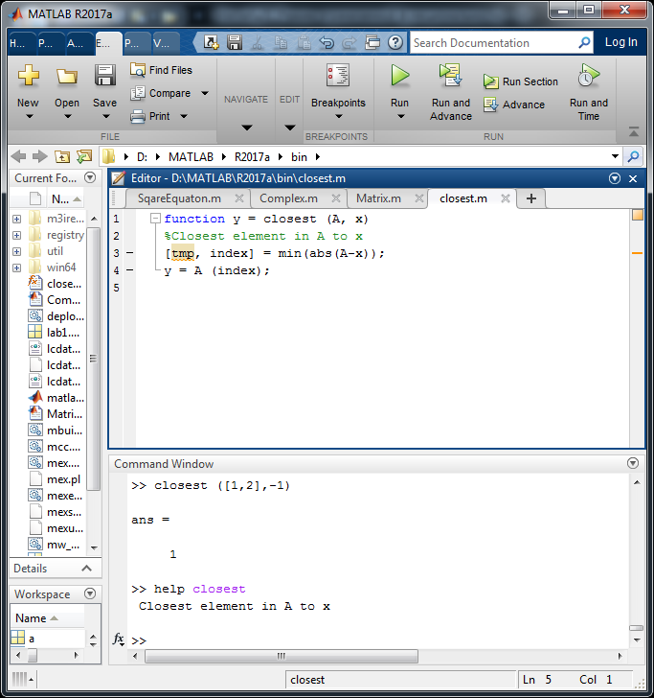

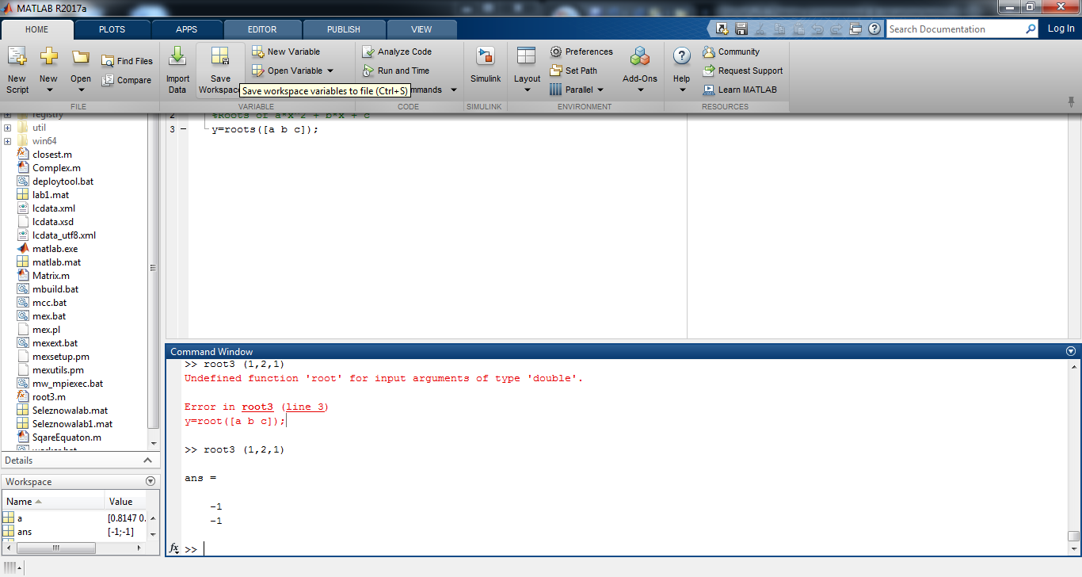
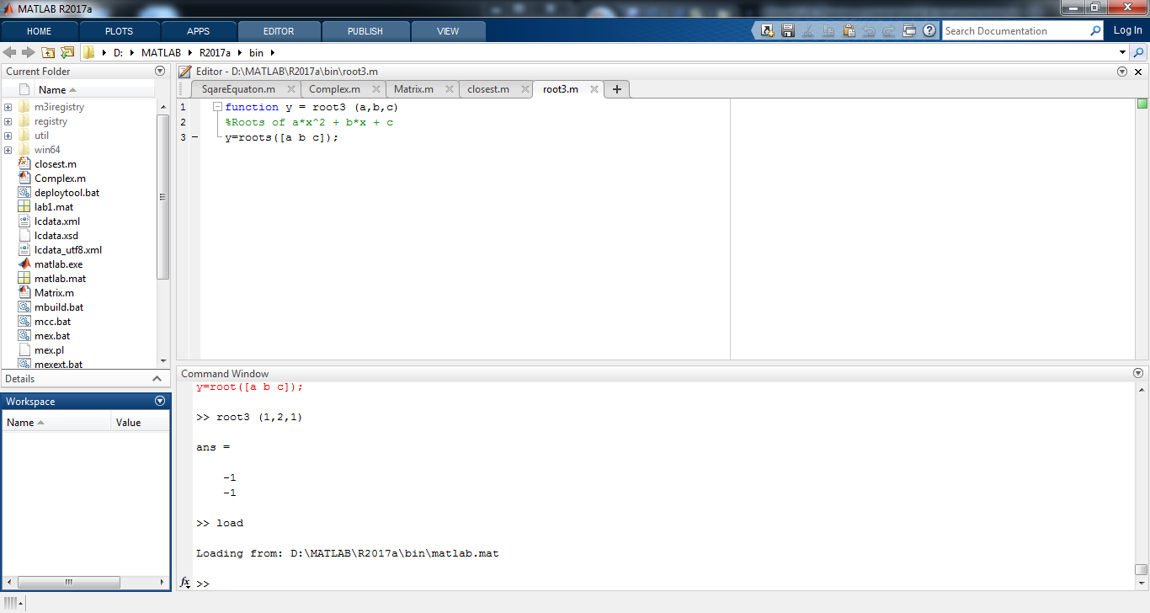
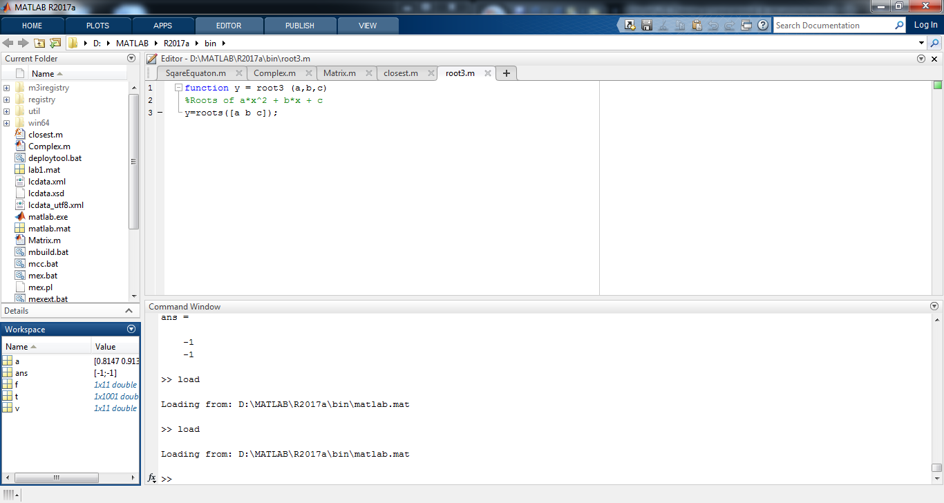
>> a

a =

0.8147 0.9134
0.9058 10.0000
0.1270 0.0975
0 -1.0000

