RentTitan MVP
Hamdi Adam Abouleila Selim, Robert Anaïs

PROJECT IDEA

RentTitan helps tenants create a clear rental dossier and receive a dossier strength score out of 100. The MVP uses manual input fields and labeled document upload slots, then calculates a transparent rule-based score with improvement suggestions.
MVP goal  Google login -> create dossier -> upload dummy documents -> calculate score -> show breakdown. | Core decision  No automatic PDF reading in the MVP. Users choose the document type before uploading.
Architecture  React frontend, Node main backend, Document Service, Scoring Service, PostgreSQL, MongoDB. | Presentation focus  Show authentication, services, databases, REST + GraphQL, and JWT-protected API demo.

React/Vite | Node/Express | PostgreSQL | MongoDB | JWT + Google OAuth

1. MVP Scope Required to Pass
The MVP is intentionally small: build only the features needed to satisfy the full-stack, microservice, database, authentication, API, and presentation requirements.
Requirement | RentTitan MVP implementation
Full-stack JS app | React/Vite frontend + Node.js/Express backend projects.
Main backend + microservices | Main Backend plus two separate microservice projects: Document Service and Scoring Service.
At least 2 databases | PostgreSQL for users/dossiers/scores; MongoDB for document metadata/checklists.
Google login + protected routes | Google OAuth login creates JWT; protected pages redirect to login if unauthenticated.
API as a Service | Protected REST endpoint returns dossier score only when a valid JWT is passed.
JWT demo | Postman call with JWT succeeds; same call without JWT returns access denied.
At least 2 API paradigms | REST for CRUD and protected API demo; GraphQL for dashboard score queries.
External API bonus | Optional LLM API can rewrite advice in natural language; score remains rule-based.
Presentation readiness | Demo app, tech stack, service boundaries, databases, APIs, authentication flow.

In Scope vs. Out of Scope
Build for MVP  • Google login and JWT session  • Dossier profile form  • Labeled upload slots with checklist  • Rule-based score /100  • REST + GraphQL APIs  • Postman JWT/no-JWT demo | Do not build yet  • OCR or automatic PDF extraction  • Real document verification  • Landlord marketplace  • Payment system  • Mobile app  • Cloud deployment unless teacher confirms
2. Architecture Overview
RentTitan will be split into one main backend and two independent microservice projects. The main backend acts as the secure entry point for the frontend and coordinates service calls.
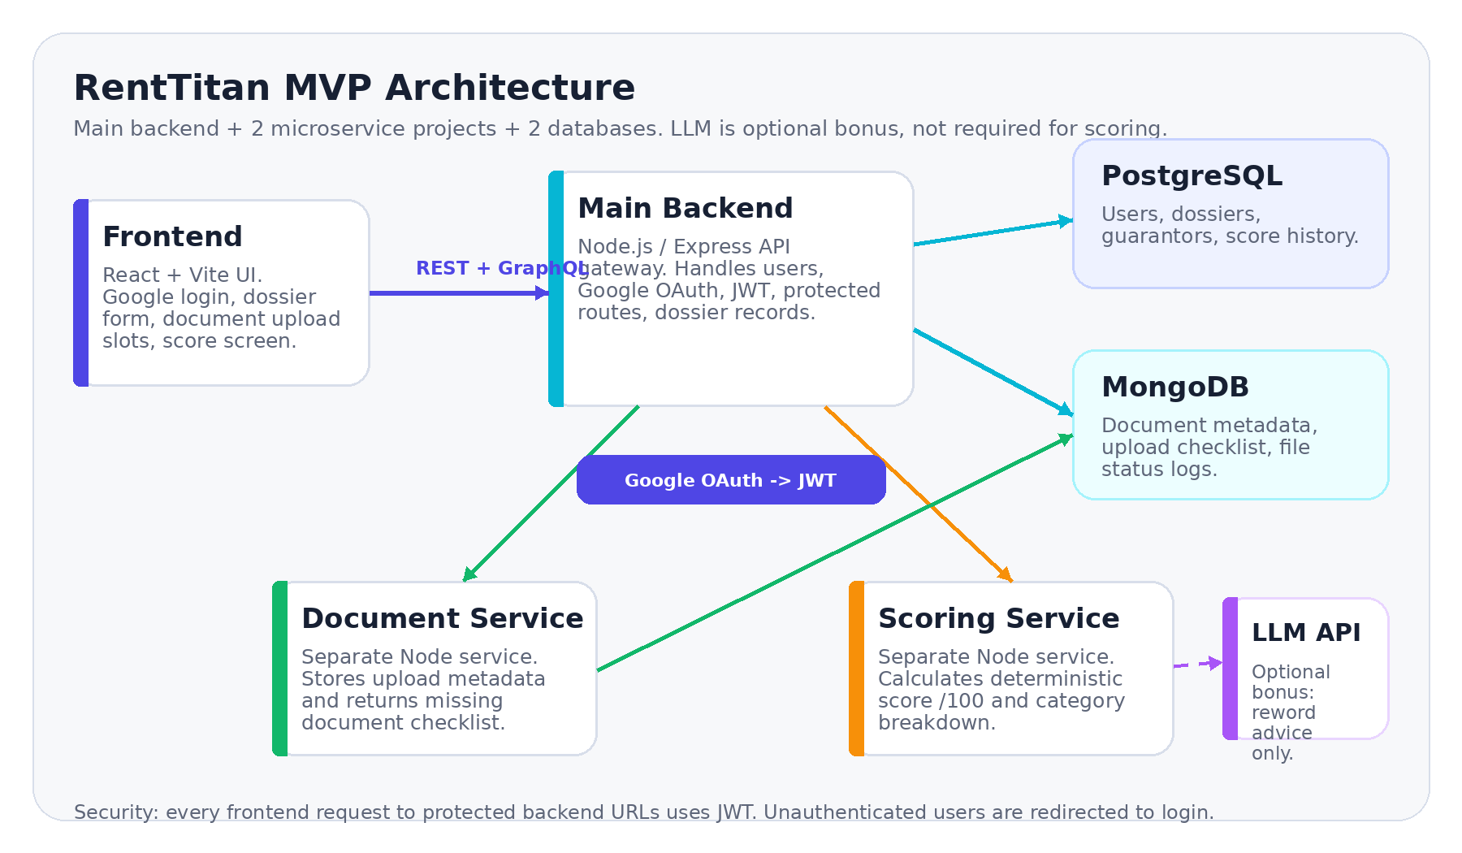
Diagram 1 - Minimal architecture. The LLM API is optional and only improves wording; the score itself is deterministic.
Component | Tech | Responsibility | Data
Frontend | React + Vite | Google login, forms, upload UI, score dashboard | -
Main Backend | Node.js + Express | Auth gateway, dossiers, protected API, GraphQL endpoint | PostgreSQL
Document Service | Node.js + Express | Upload slots, file metadata, missing document checklist | MongoDB
Scoring Service | Node.js + Express | Deterministic score /100, breakdown, improvement flags | PostgreSQL
LLM Advice API | External API / optional | Human-friendly explanation only; not score authority | No app DB

3. Scoring Model and API Design
The score is calculated from structured values entered by the user plus the document checklist returned by the Document Service. This keeps the MVP explainable and easy to defend.
Category | Pts | Rule in MVP
Document completeness | 25 | Required slots uploaded: ID, proof of income/status, proof of address, guarantor ID, guarantor income/tax proof.
Rent affordability | 25 | targetRent / monthlyIncome. Lower ratio earns more points; high ratio creates warning.
Guarantor strength | 25 | Guarantor income relative to rent + guarantor documents present.
Profile stability | 15 | CDI/alternance/student status, income reliability, clear situation.
Profile clarity | 10 | Complete contact fields, consistent inputs, explained income/guarantor relationship.
Total | 100 | Score level: Excellent, Strong, Average, Weak, Very weak.

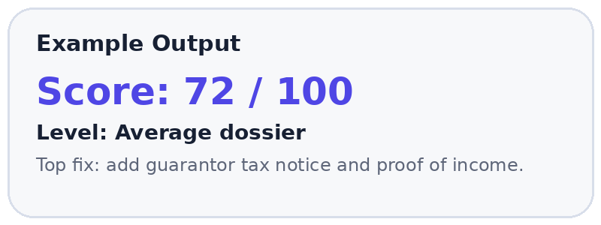 | Important implementation rule  The app does not need to read PDFs. The user enters income/rent/guarantor data manually and uploads files into named slots. The Document Service only checks which slots are filled.

API Paradigms
Paradigm | Endpoint / query | Purpose
REST | POST /dossiers | Create or update dossier input fields.
REST | POST /documents/upload | Upload dummy file into a named document slot.
REST + JWT | GET /api/v1/dossier-score/:id | Public API-as-a-service demo; requires Bearer token.
GraphQL | query myDossier { score missingDocuments suggestions } | Dashboard query showing second API paradigm.
Error case | No JWT / invalid JWT | Return 401 { error: "Access denied" }.

4. Build Order and Demo Plan
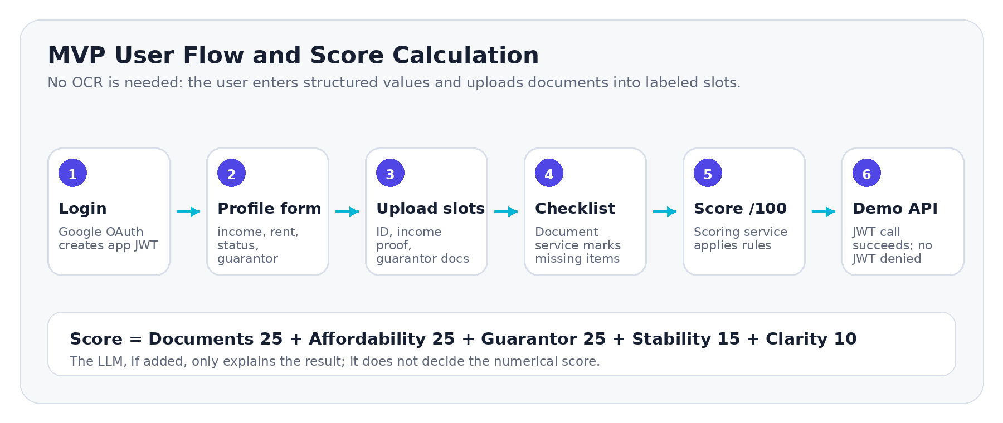
Diagram 2 - End-to-end MVP flow from login to score and JWT-protected API demo.
# | Milestone | Definition of done
1 | Initialize repos | frontend, main-backend, document-service, scoring-service, docker-compose.
2 | Auth first | Google OAuth login, JWT middleware, protected route redirect.
3 | Dossier form | manual inputs: income, rent, status, guarantor data.
4 | Documents | labeled upload slots + missing checklist; no OCR needed.
5 | Score engine | rules, category breakdown, score history, suggestions.
6 | APIs | REST CRUD, protected API-as-service, GraphQL dashboard query.
7 | Demo polish | seed data, dummy PDFs, Postman JWT/no-JWT calls, 12-minute script.

Final Demo Checklist
App demo  □ Login with Google  □ Create dossier with manual fields  □ Upload dummy documents into slots  □ Show score breakdown and suggestions | Technical proof  □ Show service folders/projects  □ Show PostgreSQL and MongoDB data  □ Show REST + GraphQL usage  □ Postman with JWT succeeds; no JWT denied

