Incident Seizures and Epilepsy Following Idiopathic Intracranial Hypertension: A Matched Cohort Study

Selim Tarabeah¹, [Co-author names], Michelle Lin¹

¹ Department of Neurology, Mayo Clinic, Jacksonville, Florida, USA

[Additional author affiliations]

Running title: Seizures after idiopathic intracranial hypertension

Correspondence: [Name, postal address, telephone, email]

Word count: main text 3,258; abstract 299

ABSTRACT
Objective: To estimate the rate of incident seizures and epilepsy after idiopathic intracranial hypertension (IIH) and to examine whether differential healthcare surveillance could account for the association.

Methods: We conducted a retrospective matched cohort study using electronic health records from Mayo Clinic. Adolescents and adults with IIH (aged 13-59 years), identified by an IIH diagnosis code and lumbar puncture, were matched to up to four comparators without IIH on sex, age, body mass index (BMI), and BMI calendar year. Comparators inherited the index date of their matched case. After a 180-day washout to exclude prevalent seizure or epilepsy diagnoses and chronic antiseizure medication use, the primary outcome was a clinically recognized seizure or epilepsy event identified by diagnosis code or sustained antiseizure medication use. Hazard ratios (HRs) were estimated with Cox regression using robust variance clustered by matched set. We evaluated differential detection using negative-control outcomes, empirical calibration, adjustment for pre-index healthcare contact, post-index surveillance rates, and E-values.

Results: The analytic cohort included 2,138 patients with IIH and 5,743 comparators, contributing 13,938 person-years of follow-up. Incident seizure or epilepsy occurred at 14.46 versus 6.72 events per 1,000 person-years (HR 2.28, 95% confidence interval [CI] 1.62--3.22). Three-year cumulative incidence was 3.83% versus 1.71%. The HR was 2.30 (95% CI 1.35--3.92) when restricted to epilepsy-specific codes and 1.93 (95% CI 1.34--2.77) when the medication criterion was removed. Estimates remained similar in landmark analyses and after adjustment for obstructive sleep apnea, hypertension, and polycystic ovary syndrome. Healthcare contact was substantially greater among patients with IIH, and all 11 negative-control outcomes were more prevalent at baseline. Adjustment for pre-index healthcare contact moved negative-control estimates toward the null but did not attenuate the seizure association. Empirical calibration estimated a detection-attributable HR of 1.04, although its interval was wide and included the observed estimate.

Significance: In this electronic health record cohort, IIH was associated with approximately twice the rate of incident seizure or epilepsy, although the absolute excess was modest. Differential surveillance was present and could not be excluded as a partial contributor, but several analyses argue against it explaining the association in full. The findings support further study of seizure phenotypes and potential structural mechanisms, particularly skull-base encephaloceles, in patients with IIH.

Keywords: idiopathic intracranial hypertension; seizures; epilepsy; cohort study; electronic health records; healthcare surveillance

KEY POINTS
• Patients with IIH had approximately twice the rate of incident seizure
or epilepsy as matched comparators.

• The absolute excess was modest: 3-year cumulative incidence was 3.83%
with IIH and 1.71% without it.

• Healthcare contact was substantially greater among patients with IIH,
demonstrating an important risk of differential ascertainment.

• The association persisted across every outcome definition, cohort restriction,
landmark and analytic model (range 1.93-2.79).

• Adjustment for pre-index healthcare contact moved all 66 negative-control
estimates toward the null, while the seizure estimate moved away from it under all six measures.

• Empirical calibration did not exclude detection bias: its interval for a
detection-only effect included the observed estimate.

• Future studies should characterize seizure phenotype and skull-base
encephaloceles prospectively.

1 | INTRODUCTION
[MISSING FROM SCREENSHOTS - OPENING PARAGRAPH(S) REQUIRED] The supplied screenshots begin mid-Introduction, at "This distinction has important diagnostic implications". The opening paragraph or paragraphs, which define IIH and set up the distinction referred to and which carry citations 1-4 (Horton, Markey, Patel, Olaru), are not visible in any screenshot and have not been reconstructed. Please send that text; it has deliberately not been written for you. [END MISSING]

This distinction has important diagnostic implications as IIH remains a diagnosis of exclusion. Among the most important mimics is cerebral venous thrombosis, which can reproduce the headache, papilledema, and sixth-nerve palsy characteristic of IIH but frequently presents with seizures or focal neurologic deficits due to cortical venous involvement.5,6 Consequently, diagnostic paradigms have long distinguished pressure-mediated disease without seizures from structural venous pathology in which seizures are common. This leads to the view that epilepsy represents evidence against rather than a consequence of IIH.

However, an indirect mechanistic link between IIH and epilepsy has been proposed. Chronic intracranial hypertension may lead to skull-base remodeling and osseous erosion, resulting in meningoceles and, most notably, temporal lobe encephaloceles through the middle cranial fossa. These structural abnormalities have been described in patients with IIH, spontaneous skull-base CSF leaks, and drug-resistant temporal lobe epilepsy, suggesting that sustained elevations in intracranial pressure could create a substrate for epileptogenesis over time rather than precipitating seizures acutely.7 Whether this anatomic association translates into an increased population-level risk of incident seizures or epilepsy remains unknown. Current prognostic frameworks for IIH therefore remain focused on visual outcomes, headache burden, and disease recurrence, with little consideration of seizure-related outcomes.8,9

We conducted a matched retrospective cohort study to determine whether IIH is associated with an increased risk of incident seizures or epilepsy compared with matched individuals without IIH. We additionally sought to characterize the magnitude and temporal pattern of any observed association and to evaluate its robustness using a prespecified negative-control framework designed to assess potential differential ascertainment bias.

2 | METHODS

2.1 | Study design, data source, and ethics
This retrospective matched cohort study used the integrated electronic health record of Mayo Clinic (EHR), covering Mayo Clinic sites in Minnesota, Florida, and Arizona. The record contains inpatient, outpatient, emergency, and procedural encounters, together with linked diagnosis codes, problem lists, medication records, flowsheet vital signs, and vital status. Index dates ranged from June 7, 2002, through November 11, 2025, and the data were frozen on September 3, 2026.

This report follows the STROBE and RECORD reporting guidelines.10,11 The study was approved by the Mayo Clinic Institutional Review Board, which waived the requirement for informed consent.

2.2 | Study population
Patients with IIH. Adolescents and adults were identified using an IIH diagnosis code (ICD-9-CM 348.2 or ICD-10-CM G93.2, in any position) together with a lumbar puncture record (CPT 62270 or 62328, or an electronic lumbar puncture procedure entry). The index date was the date of the diagnostic lumbar puncture. IIH diagnoses were not adjudicated against the revised diagnostic criteria; opening pressure was abstracted when available.12 The complete code list is provided in eTable 1.Comparators were patients with no IIH diagnosis code at any time in the available record.

Eligibility criteria. Patients with a history of ischemic stroke, intracerebral or subarachnoid hemorrhage, craniotomy, brain tumor, or traumatic brain injury were excluded from the comparator group, because these conditions are independent risk factors for seizures. This exclusion was applied at the stage of comparator extraction and was not applied to the IIH group, for whom the corresponding diagnosis extract was not available. The asymmetry is therefore a known deviation from the intended design rather than an analytic choice, and its expected direction is to remove seizure-prone individuals from the comparator group only, which would bias the hazard ratio away from the null. It is quantified no further here because the data needed to apply the same exclusion to the IIH group were not obtainable; a symmetric re-analysis is the first priority for any future revision.

Both groups required at least one dated clinical encounter during the 12 months before the index date. Clinical encounters were distinguished from administrative activity (messages, orders, refills, and record maintenance) using an encounter-type list applied identically to both groups; approximately 60% of encounter rows were administrative.

Patients with a qualifying seizure diagnosis or chronic antiseizure medication (ASM) use on or before the end of the 180-day washout were excluded. Patients without follow-up beyond the washout were also excluded. All analyses were repeated using an alternative definition in which every encounter row was treated as a contact.

2.3 | Index date and matching
Each comparator inherited the index date of its matched case. Eligibility, washout, exclusion of prevalent seizures, covariate measurement, and the beginning of follow-up were therefore anchored to the same calendar date within each matched set. Matching was performed without replacement on sex, age, BMI, and BMI calendar year (within 2 years), at a variable ratio of up to 1:4.

Matching used four sequential passes through a randomly ordered case list, with five prespecified tiers of decreasing stringency: (1) race, BMI calendar year, age within 3 years and BMI within 3 kg/m²; (2) the same without race; (3) the same without BMI calendar year; (4) age within 3 years and BMI within 5 kg/m²; and (5) age within 5 years and BMI within 5 kg/m². Race was specified but was unrecorded for every patient with IIH and therefore never constrained the match. BMI was taken from the flowsheet measurement closest in calendar time to the index date.

2.4 | Outcomes
The primary outcome was incident seizure or epilepsy after the 180-day washout, defined by a single rule applied to both groups. The first criterion was a qualifying diagnosis code in the diagnosis record or problem list: ICD-10-CM G40.x or R56.x, or ICD-9-CM 345.x or 780.39. The second criterion was an ASM prescription or medication record indicating treatment continued for at least 180 days.

Febrile, post-traumatic, psychogenic nonepileptic or conversion seizures, family history of seizures, migraine diagnoses, and ASM adverse-effect codes were not considered qualifying outcomes. Topiramate and acetazolamide were not counted as ASMs because they are commonly used to treat IIH and have antiseizure activity. Gabapentin, pregabalin, and benzodiazepines were also excluded because they have common analgesic and procedural indications. The event date was the earlier of the first qualifying diagnosis and the first qualifying medication record.

Because the EHR did not reliably permit classification by seizure type or by provoked versus unprovoked status, the primary outcome represents a clinically recognized seizure or epilepsy event rather than epilepsy as defined by the International League Against Epilepsy (ILAE).13 Epilepsy-specific codes (G40.x/345.x) were analyzed separately as a more specific approximation of epilepsy.

Among patients who experienced a primary outcome, a secondary outcome classified events as recurrent seizure or epilepsy if there was an epilepsy-specific diagnosis code, two or more documented seizure events, or indefinite ASM therapy.

Outcome ascertainment was evaluated by manual chart review of a random sample of 50 patients with IIH and 50 comparators who met the electronic outcome definition. Positive predictive value (PPV) was calculated as the proportion of electronically identified events confirmed as clinical seizures, with exact binomial 95% confidence intervals.

2.5 | Follow-up and covariates
Follow-up began at the end of the 180-day washout and ended at the earliest of the primary outcome, death, the last attended clinical encounter, the data-freeze date, or 3 years. OSA, hypertension, polycystic ovary syndrome (PCOS), and bariatric surgery were identified from diagnosis or procedure codes recorded on or before the index date. Pre-index healthcare contact was measured as the number of clinical encounters during the preceding 12 months.

The use of last attended clinical encounter as a censoring date was intended to avoid attributing person-time to individuals no longer observable in the health system. Because healthcare contact is itself related to the detection process, however, informative censoring is a potential source of bias and was considered in interpretation.

2.6 | Statistical analysis
Incidence rates are reported per 1,000 person-years with exact Poisson 95% confidence intervals. Cause-specific hazard ratios (HRs) were estimated using Cox regression with exposure as the sole model term because age, sex, and BMI were addressed through matching. Variance was estimated using a robust sandwich estimator clustered by matched set.14 Proportional hazards were assessed using scaled Schoenfeld residuals. Cumulative incidence was estimated using the Aalen--Johansen estimator with death as a competing event, and a Fine--Gray model was used to estimate the corresponding subdistribution HR.15 All tests were two-sided.

Prespecified sensitivity analyses included: (1) diagnosis codes without the medication criterion; (2) epilepsy-specific codes only; (3) restriction to IIH cases with opening pressure of at least 25 cm H₂O and their matched comparators; (4) counting all encounter rows as healthcare contact; (5) landmark analyses excluding events occurring during the first 30, 90, or 180 days after the washout; (6) overlap weighting16; and (7) restriction to complete matched sets.

The overlap-weighting propensity model included age, sex, BMI, and the logarithm of pre-index visits. Effect modification by age, BMI, and sex was assessed using Wald tests for interaction. OSA, PCOS, and hypertension remained imbalanced after matching; therefore, a comorbidity-adjusted analysis was performed after the primary analysis. This analysis was prespecified for interpretation after observing the post-matching imbalance and was reported regardless of direction of effect.

A covariate was considered a potential confounder when it was both imbalanced after matching (absolute SMD \>0.10) and associated with the outcome. Analyses were performed in R.

2.7 | Assessment of differential detection
We used five complementary approaches to evaluate differential ascertainment.

First, we examined 11 negative-control outcomes without a plausible direct causal relationship to IIH or seizures, selected to be ascertainable through similar healthcare pathways (eTable 3).17 We did not treat a negative control as evidence of specificity unless its baseline prevalence was reasonably balanced between groups.

Second, we performed an empirical calibration analysis in which the log HR for each negative-control outcome was regressed on its log baseline prevalence ratio. The fitted value at a baseline prevalence ratio of 1 was used to estimate the association expected from the observed pattern of differential detection alone.18

Third, we adjusted each outcome for six prespecified measures of pre-index healthcare contact and examined the direction and magnitude of change. If differential healthcare use were an important source of ascertainment bias, adjustment for these measures would be expected, although not guaranteed, to attenuate the observed associations.

Fourth, we described post-index surveillance rates. We did not adjust the primary outcome for post-index contact because post-exposure healthcare contact may lie on the pathway from IIH to outcome ascertainment and can act as a collider.

Fifth, we calculated E-values to describe the strength of association that an unmeasured confounder would need with both IIH and the outcome, conditional on the measured covariates, to explain the observed HR.19 Because healthcare-contact measures do not directly quantify their association with seizure ascertainment, E-values were interpreted as sensitivity parameters rather than as direct tests of detection bias.

3 | RESULTS

3.1 | Cohort and baseline characteristics
Among 2,520 eligible patients with IIH, 2,490 (98.8%) were matched to 5,743 comparators, yielding a mean of 2.31 comparators per case. Eighty-seven percent of cases were matched at the most stringent tier. After the washout and follow-up eligibility criteria were applied, 2,138 patients with IIH contributed to the primary analysis. The IIH and comparator groups contributed 4,563.0 and 9,375.2 person-years, respectively. Median follow-up was 2.77 years (IQR 1.23--3.00) in the IIH group and 1.51 years (IQR 0.52--3.00) among comparators.

Age, sex, and BMI were well balanced (SMDs −0.065, 0.034, and 0.050, respectively; Table 1). OSA remained more common among patients with IIH (29.5% vs 15.4%; SMD 0.342), as did PCOS (12.3% vs 7.3%; SMD 0.171) and hypertension (22.1% vs 16.4%; SMD 0.146). Pre-index healthcare contact showed the largest imbalance: the median number of clinical visits during the preceding year was 12 in the IIH group versus 4 among comparators (SMD 0.526). Opening pressure was available for 1,585 patients with IIH (74%) and had a mean of 29.5 cm H₂O (SD 9.7).

3.2 | Primary outcome
During follow-up, 66 patients with IIH and 63 comparators experienced a qualifying seizure or epilepsy event. Incidence rates were 14.46 and 6.72 per 1,000 person-years, respectively (95% CIs 11.19--18.40 and 5.16--8.60). The corresponding HR was 2.28 (95% CI 1.62--3.22; p\<0.001), with no evidence of violation of the proportional hazards assumption (p=0.94). Three-year cumulative incidence was 3.83% in the IIH group and 1.71% among comparators, an absolute difference of 2.12 percentage points.

In chart review, 48 of 50 electronically identified events among patients with IIH were confirmed (PPV 96%; 95% CI 86%--100%), compared with 50 of 50 among comparators (PPV 100%; 95% CI 93%--100%).

3.3 | Sensitivity analyses
The association was similar across alternative outcome and cohort definitions (Table 2; eFigure 1). Removing the medication criterion produced an HR of 1.93 (95% CI 1.34--2.77), while restriction to epilepsy-specific codes produced an HR of 2.30 (95% CI 1.35--3.92). Restriction to patients with opening pressure of at least 25 cm H₂O yielded an HR of 2.25 (95% CI 1.41--3.59). Landmark analyses excluding the first 30, 90, and 180 days after the washout yielded HRs of 2.49, 2.29, and 2.22, respectively. The overlap-weighted analysis produced an HR of 2.31 (95% CI 1.56--3.43). Counting all encounter rows as healthcare contact produced an HR of 2.79 (95% CI 1.98--3.93).

Selection of follow-up was asymmetric in one respect: comparators, but not cases, were screened for post-washout follow-up at selection. Consequently, 352 matched sets lost their case but retained 789 comparators, who contributed two events. Restriction to complete matched sets yielded an HR of 2.06 (95% CI 1.46--2.92).

Among the three imbalanced comorbidities, OSA showed the clearest association with the outcome (HR 1.87, 95% CI 1.29--2.71); estimates for hypertension and PCOS were 1.41 (95% CI 0.95--2.08) and 1.14 (95% CI 0.64--2.02), respectively. Adjustment for all three comorbidities reduced the HR to 2.11 (95% CI 1.48--3.01), with the change attributable primarily to OSA. Additional adjustment for pre-index visits yielded an HR of 2.33 (95% CI 1.58--3.45). The cause-specific HR for death was 0.61 (95% CI 0.29--1.29), and the Fine--Gray subdistribution HR for the primary outcome was 2.28 (95% CI 1.62--3.22).

3.4 | Secondary outcome and subgroups
Among patients with a primary event, 41 of 66 patients with IIH (62%; 95% CI 49%--74%) and 32 of 63 comparators (51%; 95% CI 38%--64%) met the definition of recurrent seizure or epilepsy (Fisher exact p=0.22; eFigure 2). No interaction reached statistical significance (eTable 7). HRs were 1.90 among patients younger than 35 years and 2.72 among those aged 35 years or older (p for interaction=0.31). By BMI, HRs were 2.86 for BMI \<35 kg/m² and 1.87 for BMI ≥35 kg/m² (p=0.26). By sex, the HR was 1.98 among women and 5.12 among men (p=0.055); the male estimate was based on 20 events.

3.5 | Differential detection
Healthcare contact after the index date was consistently higher among patients with IIH (eTable 8). Rate ratios were 2.70 (95% CI 2.68--2.73) for all clinical visits, 2.27--2.92 across office, procedural, and hospital encounters, and 5.74 (95% CI 4.96--6.65) for emergency department encounters. Laboratory contact was similar between groups (rate ratio 1.14). Neurology visits, neuroimaging, and EEG could not be compared because these data were not captured comparably in the two source extracts.

All 11 negative-control outcomes were more prevalent at baseline among patients with IIH, with prevalence ratios ranging from 1.6 to 5.0 (all p\<0.01). Thus, none met the prespecified balance criterion for a specificity analysis (Table 3). After the index date, 8 of 11 negative controls had HRs whose 95% CIs excluded 1. The seizure outcome had an unadjusted rate ratio of 2.15, which was lower than the corresponding estimates for 6 of the 11 controls. Across the negative controls, greater baseline imbalance was associated with larger post-index HRs (r=0.66, p=0.026). The empirical calibration model yielded a predicted detection-only HR of 1.04 (95% CI 0.37--2.90); importantly, this interval included the observed seizure HR.

Adjustment for each of six measures of pre-index healthcare contact moved all 66 negative-control estimates toward the null (median change −29%; range −46% to −3%). In contrast, the seizure HR increased under each measure, ranging from 2.46 to 2.93. Because adjustment for healthcare utilization can have complex causal interpretations, these findings are supportive but do not establish that differential detection was absent.

In a separate analysis that adjusted for post-index contact, the seizure HR fell to 1.25 (95% CI 0.85--1.85). The same adjustment produced apparent protective associations for fracture and upper respiratory infection, illustrating the potential for collider bias when conditioning on post-exposure healthcare contact (eTable 6).

The E-value for the primary HR was 3.99, and the E-value for the lower confidence limit was 2.62. Emergency department contact had a rate ratio of 5.74 for IIH versus comparators, exceeding the point-estimate E-value; however, the corresponding association between emergency department contact and seizure ascertainment could not be quantified. The E-value therefore does not exclude detection bias.

4 | DISCUSSION
In this matched electronic health record cohort, patients with IIH had approximately twice the rate of a clinically recognized incident seizure or epilepsy event compared with matched comparators (HR 2.28). The absolute difference was modest: the estimated 3-year cumulative incidence was 3.83% with IIH versus 1.71% without IIH. The association persisted across several alternative outcome definitions, cohort restrictions, follow-up landmarks, and analytic approaches.

The principal challenge in interpreting this association is ascertainment. Patients with IIH had substantially more healthcare contact before and after the index date, and every negative-control outcome was more common at baseline. This makes differential detection a real concern rather than a theoretical limitation.

Three findings argue against differential detection accounting for the association in full. First, adjustment for pre-index healthcare contact moved all negative-control associations toward the null, whereas the seizure estimate did not attenuate. Second, the association persisted when events occurring during the first 30, 90, or 180 days after the washout were excluded, making an explanation based only on the intensive diagnostic workup surrounding IIH less likely. Third, although surveillance was higher in the IIH group in every clinician-initiated setting, it was not higher in laboratory encounters (rate ratio 1.14), the one setting a clinician does not initiate, and the association persisted. The primary estimate was also unchanged by restricting the outcome to epilepsy-specific codes or removing the medication criterion.

These findings should nevertheless be interpreted cautiously. The empirical calibration analysis was inconclusive: its confidence interval for the detection-only HR included the observed estimate. Moreover, the primary outcome could not be compared using the most seizure-specific channels of ascertainment---neurology visits, EEG, and neuroimaging---because those data were not captured equivalently in the two groups. The higher emergency department utilization in the IIH group is particularly relevant because emergency encounters are an important setting for first seizure evaluation. Thus, the data do not allow differential detection to be ruled out.

OSA is another plausible contributor. It is nearly twice as prevalent among patients with IIH, and is itself associated with epilepsy.20 It was associated with the outcome in this cohort. Adjustment for OSA, hypertension, and PCOS reduced the HR from 2.28 to 2.11, suggesting that these measured comorbidities explain only part of the association. Residual confounding is possible, particularly because OSA is frequently underdiagnosed and was identified through electronic health record coding.

Treatment may also have influenced ascertainment. Acetazolamide and topiramate have antiseizure activity, and both are used in IIH.21 Their use could therefore reduce seizure occurrence, alter the decision to initiate a separate ASM, or change the probability that a seizure is captured by the medication-based component of the outcome. If anything, such treatment effects could attenuate the observed association, although the direction and magnitude cannot be established from these data.

Our findings add a population-level perspective to the literature connecting IIH, temporal encephaloceles, and epilepsy. Prior studies have largely approached the question from the epilepsy side. In a presurgical series of 22 patients with drug-resistant temporal lobe epilepsy associated with anterior temporal meningoencephaloceles, Urbach and colleagues reported imaging features suggestive of IIH and obesity in 10 patients.22 Martinez-Poles and colleagues similarly found smaller pituitary height and larger optic nerve sheath diameters among patients with temporal pole encephaloceles compared with controls with other focal epilepsies.23 Case reports have described seizures as a presenting or predominant manifestation of presumed IIH in patients with skull-base encephaloceles.24,25 These studies support a biologically plausible link but cannot estimate seizure risk among patients with IIH.

The mechanism underlying the association remains uncertain. Skull-base encephaloceles are an attractive candidate because they provide a structural pathway linking chronically raised intracranial pressure to focal cortical dysfunction and epilepsy.26--30 Diffuse effects of sustained pressure, as well as shared metabolic and sleep-related risk factors, are other possibilities. Encephalocele status was assessed in only 60 patients with IIH, of whom 43 were positive; it was not extracted for comparators. This precludes meaningful analysis of the structural hypothesis. Future studies should therefore incorporate systematic review of skull-base imaging and detailed seizure phenotyping rather than relying on diagnosis codes alone.

The clinical implications are limited by the modest absolute risk and the uncertainty surrounding ascertainment. These data do not provide a basis for routine EEG screening or prophylactic ASM treatment in patients with IIH. They do support careful evaluation of unexplained paroxysmal events in patients with IIH, particularly when the semiology is compatible with focal seizures. Conversely, when a patient with obesity presents with a new focal seizure, review of brain imaging for subtle signs of raised intracranial pressure and skull-base encephaloceles may be useful.26,27 When both conditions are present, treatment selection may require consideration of weight and IIH management; for example, topiramate may address both seizure risk and weight-related concerns, whereas some ASMs associated with weight gain may be less attractive.31 These clinical considerations require prospective evaluation.

4.1 | Limitations
Several limitations warrant emphasis. First, differential ascertainment could not be excluded. The data elements most specific to seizure evaluation---neurology encounters, neuroimaging, and EEG---were not comparably available in the two groups. The comparator cohort was drawn from the general clinical population rather than from a condition with similar neurologic surveillance. An active-comparator design may reduce this concern, although selecting an appropriate comparator would require careful consideration of how surveillance differs across candidate conditions.

Second, two eligibility steps were applied asymmetrically. Comparators, but not cases, were excluded for a history of ischemic stroke, intracerebral or subarachnoid hemorrhage, craniotomy, brain tumor, or traumatic brain injury, because the corresponding diagnosis extract was unavailable for the IIH group. Because each of these conditions raises seizure risk, removing them from the comparator group alone would be expected to lower the comparator event rate and bias the hazard ratio away from the null; the magnitude cannot be estimated without the corresponding extract for the IIH group, and a symmetric re-analysis is the first priority for any revision. Separately, comparators were screened for post-washout follow-up at selection, whereas cases were not subjected to the same step. Restriction to complete matched sets reduced the HR from 2.28 to 2.06, indicating that this design feature had a measurable effect, although it did not eliminate the association.

Third, IIH was identified using diagnosis codes and lumbar puncture rather than criterion-based adjudication. Although restriction to patients with an opening pressure of at least 25 cm H₂O produced a similar estimate, opening pressure was available for only 74% of cases. The primary outcome was also based on codes and medication records. Seizure type, etiology, and provoked versus unprovoked status were unavailable, so the outcome cannot be mapped directly onto ILAE definitions of epilepsy. The recurrence definition is a proxy rather than a formal epilepsy diagnosis.

Fourth, chart validation was limited to 50 events per group. False-positive outcomes were slightly more common among patients with IIH (4% vs 0%), and correcting for this difference would be expected to attenuate the association modestly, but the small validation sample limits precision. Encephalocele data were too sparse to test the most specific structural mechanism.

Fifth, medication capture differed between the two source extracts: the case extract included inpatient administrations, whereas the comparator extract contained outpatient prescriptions. This difference could bias the medication-based component of the outcome toward the null. Consistent with this possibility, removal of the medication criterion yielded an HR of 1.93.

Finally, race was unavailable for cases, smoking was not comparably recorded, and median follow-up was shorter among comparators. Censoring based on last observed clinical contact may also be informative because healthcare utilization is related to outcome detection. The study was conducted within a single integrated academic health system, and the findings may not generalize to community populations or healthcare systems with different patterns of surveillance.

5 | CONCLUSIONS
In this matched electronic health record cohort, IIH was associated with approximately twice the rate of clinically recognized incident seizure or epilepsy, corresponding to an absolute 3-year excess of about 2 percentage points. Differential healthcare surveillance was present and cannot be excluded as a partial contributor, but the available evidence argues against it explaining the association in full. The findings support further investigation in cohorts with comparable neurologic surveillance, systematic characterization of seizure phenotype, and dedicated assessment of skull-base encephaloceles.

AUTHOR CONTRIBUTIONS
[Author contributions]

ACKNOWLEDGMENTS
[Acknowledgments]

FUNDING
[Funding sources]

CONFLICT OF INTEREST STATEMENT
[Conflict of interest disclosures]

ETHICAL PUBLICATION STATEMENT
We confirm that we have read the Journal's position on issues involved in ethical publication and affirm that this report is consistent with those guidelines.

DATA AVAILABILITY STATEMENT
[Data availability statement]

REFERENCES
1. Horton JC. Idiopathic intracranial hypertension. N Engl J Med. 2025;392(10):995-1008. doi:10.1056/NEJMra2404929
2. Markey KA, Mollan SP, Jensen RH, Sinclair AJ. Understanding idiopathic intracranial hypertension: mechanisms, management, and future directions. Lancet Neurol. 2016;15(1):78-91. doi:10.1016/S1474-4422(15)00298-7

3. Patel P, Ross A, Henretig FM, et al. Clinical reasoning: a 12-year-old girl with headache and change in mental status. Neurology. 2018;90(11):e1000-e1004.
4. Olaru C, Langberg S, McCoin NS. A review of the clinical presentation, causes, and diagnostic evaluation of increased intracranial pressure in the emergency department. West J Emerg Med. 2024;25(6):1046-1057.

5. Saposnik G, Bushnell C, Coutinho JM, et al. Diagnosis and management of cerebral venous thrombosis: a scientific statement from the American Heart Association. Stroke. 2024;55(12):e77-e90. doi:10.1161/STR.0000000000000456

6. Ropper AH, Klein JP. Cerebral venous thrombosis. N Engl J Med. 2021;385(1):59-64. doi:10.1056/NEJMra2106545
7. Chen BS, Britton JOT. Expanding the clinical spectrum of idiopathic intracranial hypertension. Curr Opin Neurol. 2023;36(1):80-86.
8. Toscano S, Lo Fermo S, Reggio E, et al. An update on idiopathic intracranial hypertension in adults: a look at pathophysiology, diagnostic approach and management. J Neurol. 2021;268(9):3249-3268. doi:10.1007/s00415-020-09943-9

9. Molander LD, Hagen SM, Hansen NS, et al. Patterns of retinal damage and visual long-term consequences in patients with idiopathic intracranial hypertension. Neurology. 2025;104(7):e211234.
10. von Elm E, Altman DG, Egger M, et al. The Strengthening the Reporting of Observational Studies in Epidemiology (STROBE) statement: guidelines for reporting observational studies. Lancet. 2007;370(9596):1453--1457.

11. Benchimol EI, Smeeth L, Guttmann A, et al. The REporting of studies Conducted using Observational Routinely-collected health Data (RECORD) statement. PLoS Med. 2015;12(10):e1001885.
12. Friedman DI, Liu GT, Digre KB. Revised diagnostic criteria for the pseudotumor cerebri syndrome in adults and children. Neurology. 2013;81(13):1159--1165.
13. Fisher RS, Acevedo C, Arzimanoglou A, et al. ILAE official report: a practical clinical definition of epilepsy. Epilepsia. 2014;55(4):475--482.
14. Lin DY, Wei LJ. The robust inference for the Cox proportional hazards model. J Am Stat Assoc. 1989;84(408):1074--1078.
15. Fine JP, Gray RJ. A proportional hazards model for the subdistribution of a competing risk. J Am Stat Assoc. 1999;94(446):1074--1081.
16. Li F, Morgan KL, Zaslavsky AM. Balancing covariates via propensity score weighting. J Am Stat Assoc. 2018;113(521):390--400.
17. Lipsitch M, Tchetgen Tchetgen E, Cohen T. Negative controls: a tool for detecting confounding and bias in observational studies. Epidemiology. 2010;21(3):383--388.
18. Schuemie MJ, Ryan PB, DuMouchel W, Suchard MA, Madigan D. Interpreting observational studies: why empirical calibration is needed to correct p-values. Stat Med. 2014;33(2):209--218.
19. VanderWeele TJ, Ding P. Sensitivity analysis in observational research: introducing the E-value. Ann Intern Med. 2017;167(4):268--274.
20. Malow BA, Levy K, Maturen K, Bowes R. Obstructive sleep apnea is common in medically refractory epilepsy patients. Neurology. 2000;55(7):1002--1007.
21. Reiss WG, Oles KS. Acetazolamide in the treatment of seizures. Ann Pharmacother. 1996;30(5):514--519.
22. Urbach H, Jamneala G, Mader I, et al. Temporal lobe epilepsy due to meningoencephaloceles into the greater sphenoid wing: a consequence of idiopathic intracranial hypertension? Neuroradiology. 2018;60(1):51--60.

23. Martinez-Poles J, Toledano R, Jiménez-Huete A, et al. Epilepsy associated with temporal pole encephaloceles: an unrecognized manifestation of idiopathic intracranial hypertension? Clin Neuroradiol. 2021;31(3):575--579.

24. Sayal AP, Vyas M, Micieli JA. Seizure as the presenting sign of idiopathic intracranial hypertension. BMJ Case Rep. 2022;15(1):e246604.
25. Bouthour W, Al-Balushi A, Dattilo M, et al. Seizures as the initial manifestation of idiopathic intracranial hypertension (P2-9.001) [abstract]. Neurology. 2023;100(17 Suppl 2). doi:10.1212/WNL.0000000000202518.

26. Abou-Hamden A, Lau M, Fabinyi G, et al. Small temporal pole encephaloceles: a treatable cause of "lesion negative" temporal lobe epilepsy. Epilepsia. 2010;51(11):2199--2202.
27. Toledano R, Jiménez-Huete A, Campo P, et al. Small temporal pole encephalocele: a hidden cause of "normal" MRI temporal lobe epilepsy. Epilepsia. 2016;57(5):841--851.
28. Panov F, Li Y, Chang EF, et al. Epilepsy with temporal encephalocele: characteristics of electrocorticography and surgical outcome. Epilepsia. 2016;57(2):e33--e38.
29. Tse GT, Frydman AS, O'Shea MF, et al. Anterior temporal encephaloceles: elusive, important, and rewarding to treat. Epilepsia. 2020;61(12):2675--2684.
30. Bidot S, Saindane AM, Peragallo JH, et al. Brain imaging in idiopathic intracranial hypertension. J Neuroophthalmol. 2015;35(4):400--411.
31. Ben-Menachem E. Weight issues for people with epilepsy: a review. Epilepsia. 2007;48(Suppl 9):42--45. # TABLES AND FIGURE LEGENDS Tables 1--3 and Figure legends should be retained from the source manuscript, with the editorial/statistical revisions noted below. The table values were not independently recomputed from raw data in this editorial revision.

TABLES
Table 1. Baseline characteristics of the matched cohort.
Characteristic | IIH (n = 2,138) | Comparator (n = 5,743) | SMD
n | 2,138 | 5,743 | —
Person-years | 4563.0 | 9375.2 | —
Follow-up, years, median (IQR) | 2.77 (1.23-3.00) | 1.51 (0.52-3.00) | —
Age at index, years, mean (SD) | 34.9 (10.2) | 35.5 (9.5) | -0.065
Female | 1875 (87.7%) | 4972 (86.6%) | 0.034
BMI, kg/m2, mean (SD) | 36.5 (7.3) | 36.2 (6.5) | 0.050
Obese (BMI >= 30) | 1712 (80.1%) | 4478 (78.0%) | 0.052
Hypertension | 473 (22.1%) | 940 (16.4%) | 0.146
Obstructive sleep apnea | 630 (29.5%) | 884 (15.4%) | 0.342
Polycystic ovary syndrome | 264 (12.3%) | 418 (7.3%) | 0.171
Bariatric surgery | 74 (3.5%) | 124 (2.2%) | 0.079
Clinical visits, 12 months before index, mean (SD) | 20.6 (26.5) | 9.2 (15.2) | 0.526
Clinical visits, 12 months before index, median (IQR) | 12.00 (5.00-26.00) | 4.00 (1.00-10.00) | —
Current smoker | 16 (0.7%) | 433 (7.5%) | -0.346
Died during follow-up | 38 (1.8%) | 89 (1.5%) | 0.018
SMD, standardized mean difference. Four covariates exceed |SMD| 0.10 and represent residual imbalance: hypertension, obstructive sleep apnea, polycystic ovary syndrome and pre-index clinical visits. Smoking was not comparably recorded between the two source extracts and was not used as a covariate. Opening pressure was available for 1,585 patients with IIH (74%), mean 29.5 cmH2O (SD 9.7), and was not recorded for comparators.
Table 2. Incident seizure or epilepsy: primary analysis and prespecified sensitivity analyses.
Analysis | IIH events / n | Comparator events / n | Hazard ratio (95% CI)
Primary analysis | 66/2138 | 63/5743 | 2.28 (1.62 to 3.22)
Codes only, medication criterion removed | 56/2138 | 63/5743 | 1.93 (1.34 to 2.77)
Epilepsy-specific codes only (G40.x / 345.x) | 26/2138 | 24/5743 | 2.30 (1.35 to 3.92)
Opening pressure 25 cmH2O or higher | 36/1122 | 34/2986 | 2.25 (1.41 to 3.59)
All encounter rows counted as contact | 65/2507 | 67/7905 | 2.79 (1.98 to 3.93)
Complete matched sets only | 66/2138 | 61/4954 | 2.06 (1.46 to 2.92)
Age 18 years or older at index | 64/2076 | 63/5699 | 2.26 (1.59 to 3.20)
Landmark: first 30 days excluded | 62 | 53 | 2.49 (1.73 to 3.58)
Landmark: first 90 days excluded | 49 | 44 | 2.29 (1.54 to 3.41)
Landmark: first 180 days excluded | 39 | 35 | 2.22 (1.40 to 3.51)
Fine-Gray subdistribution hazard | — | — | 2.28 (1.62 to 3.22)
Overlap-weighted | — | — | 2.31 (1.56 to 3.43)
Adjusted for OSA, hypertension and PCOS | — | — | 2.11 (1.48 to 3.01)
All models are Cox proportional-hazards models with a robust variance clustered by matched set. Primary analysis: 14.46 (95% CI 11.19-18.40) versus 6.72 (5.16-8.60) per 1,000 person-years over 4,563.0 and 9,375.2 person-years; 3-year cumulative incidence 3.83% versus 1.71%, absolute difference 2.12 percentage points; proportional-hazards p = 0.94. Cause-specific hazard ratio for death 0.61 (0.29-1.29).
Table 3. Negative-control outcomes: baseline imbalance, post-index association and unadjusted rate ratios.
Outcome | Baseline prevalence ratio | Post-index HR (95% CI) | Unadjusted rate ratio (95% CI)
Herpes zoster | 3.24 | 2.98 (1.41 to 6.32) | 2.92 (1.39 to 6.11)
Renal/ureteric stone | 2.04 | 3.09 (2.09 to 4.56) | 3.00 (2.04 to 4.42)
Gallstones | 1.58 | 2.00 (1.29 to 3.11) | 2.02 (1.30 to 3.14)
Acute appendicitis | 2.27 | 1.06 (0.32 to 3.50) | 1.02 (0.31 to 3.39)
Carpal tunnel | 2.54 | 2.84 (1.77 to 4.57) | 2.90 (1.80 to 4.67)
Upper respiratory infection | 2.03 | 2.02 (1.65 to 2.48) | 2.00 (1.63 to 2.44)
Otitis media or externa | 3.68 | 3.09 (2.15 to 4.43) | 3.06 (2.14 to 4.38)
Sprain or strain | 2.84 | 2.47 (1.67 to 3.67) | 2.44 (1.65 to 3.61)
Laceration or open wound | 4.97 | 4.28 (2.37 to 7.75) | 4.31 (2.37 to 7.83)
Contact dermatitis | 2.55 | 1.85 (0.98 to 3.50) | 1.85 (0.98 to 3.49)
Fracture, excluding skull/face | 1.82 | 1.22 (0.76 to 1.98) | —
Seizure or epilepsy (primary outcome) | — | 2.28 (1.62 to 3.22) | 2.15 (1.52 to 3.04)
All 11 negative-control outcomes were more prevalent in the IIH group before the index date (prevalence ratios 1.6-5.0, all p < 0.01); none met the prespecified balance criterion. Eight of 11 had post-index confidence intervals excluding 1. On unadjusted rate ratios the primary outcome (2.15) was lower than 6 of the 11 controls. Empirical calibration: r = 0.66, p = 0.026; predicted detection-only hazard ratio at baseline balance 1.04 (95% CI 0.37-2.90).

FIGURES
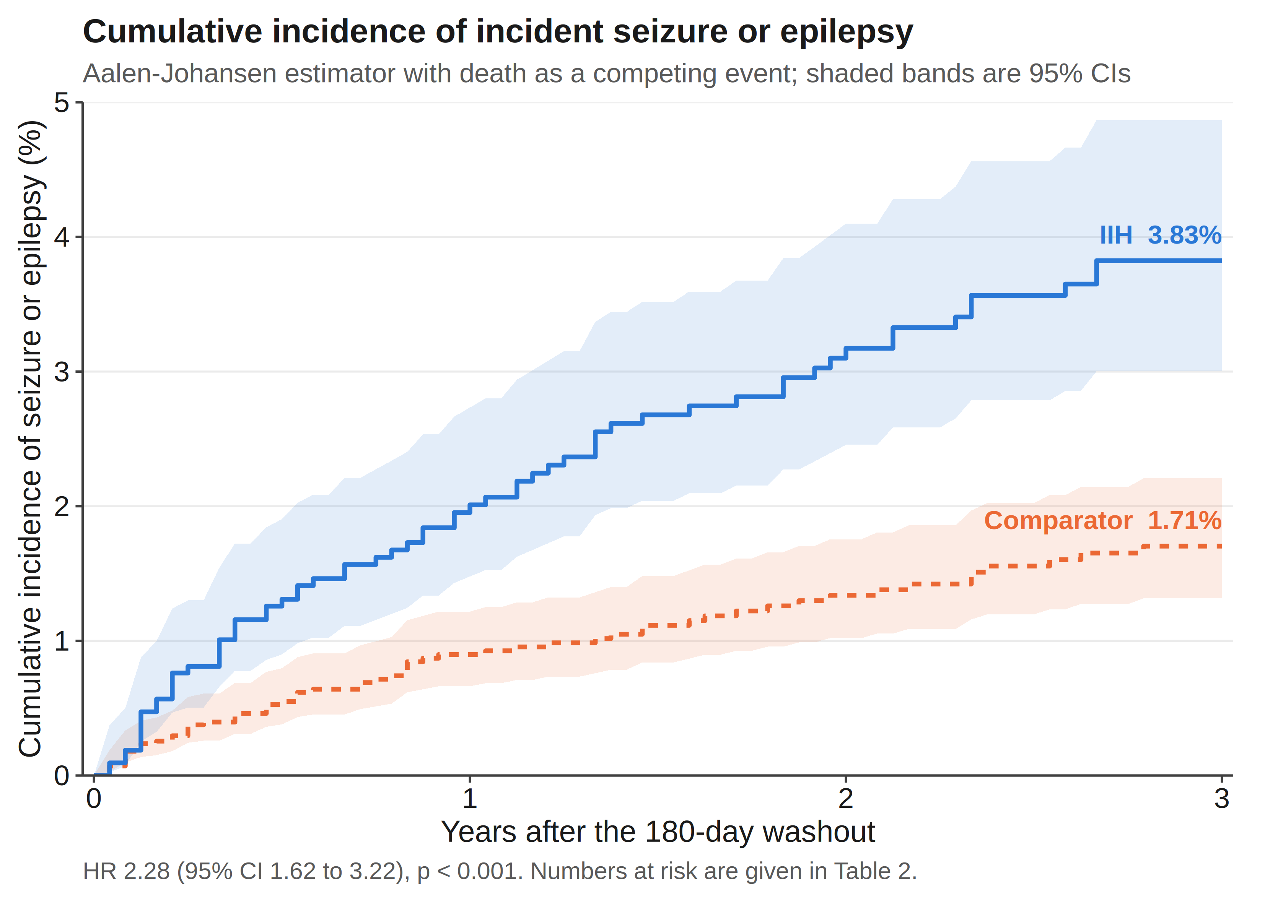
Figure 1. Cumulative incidence of incident seizure or epilepsy after the 180-day washout, by cohort. Estimated with the Aalen-Johansen method treating death as a competing event; shaded bands are 95% confidence intervals. Three-year cumulative incidence was 3.83% in the IIH group and 1.71% among comparators (absolute difference 2.12 percentage points; HR 2.28, 95% CI 1.62-3.22).
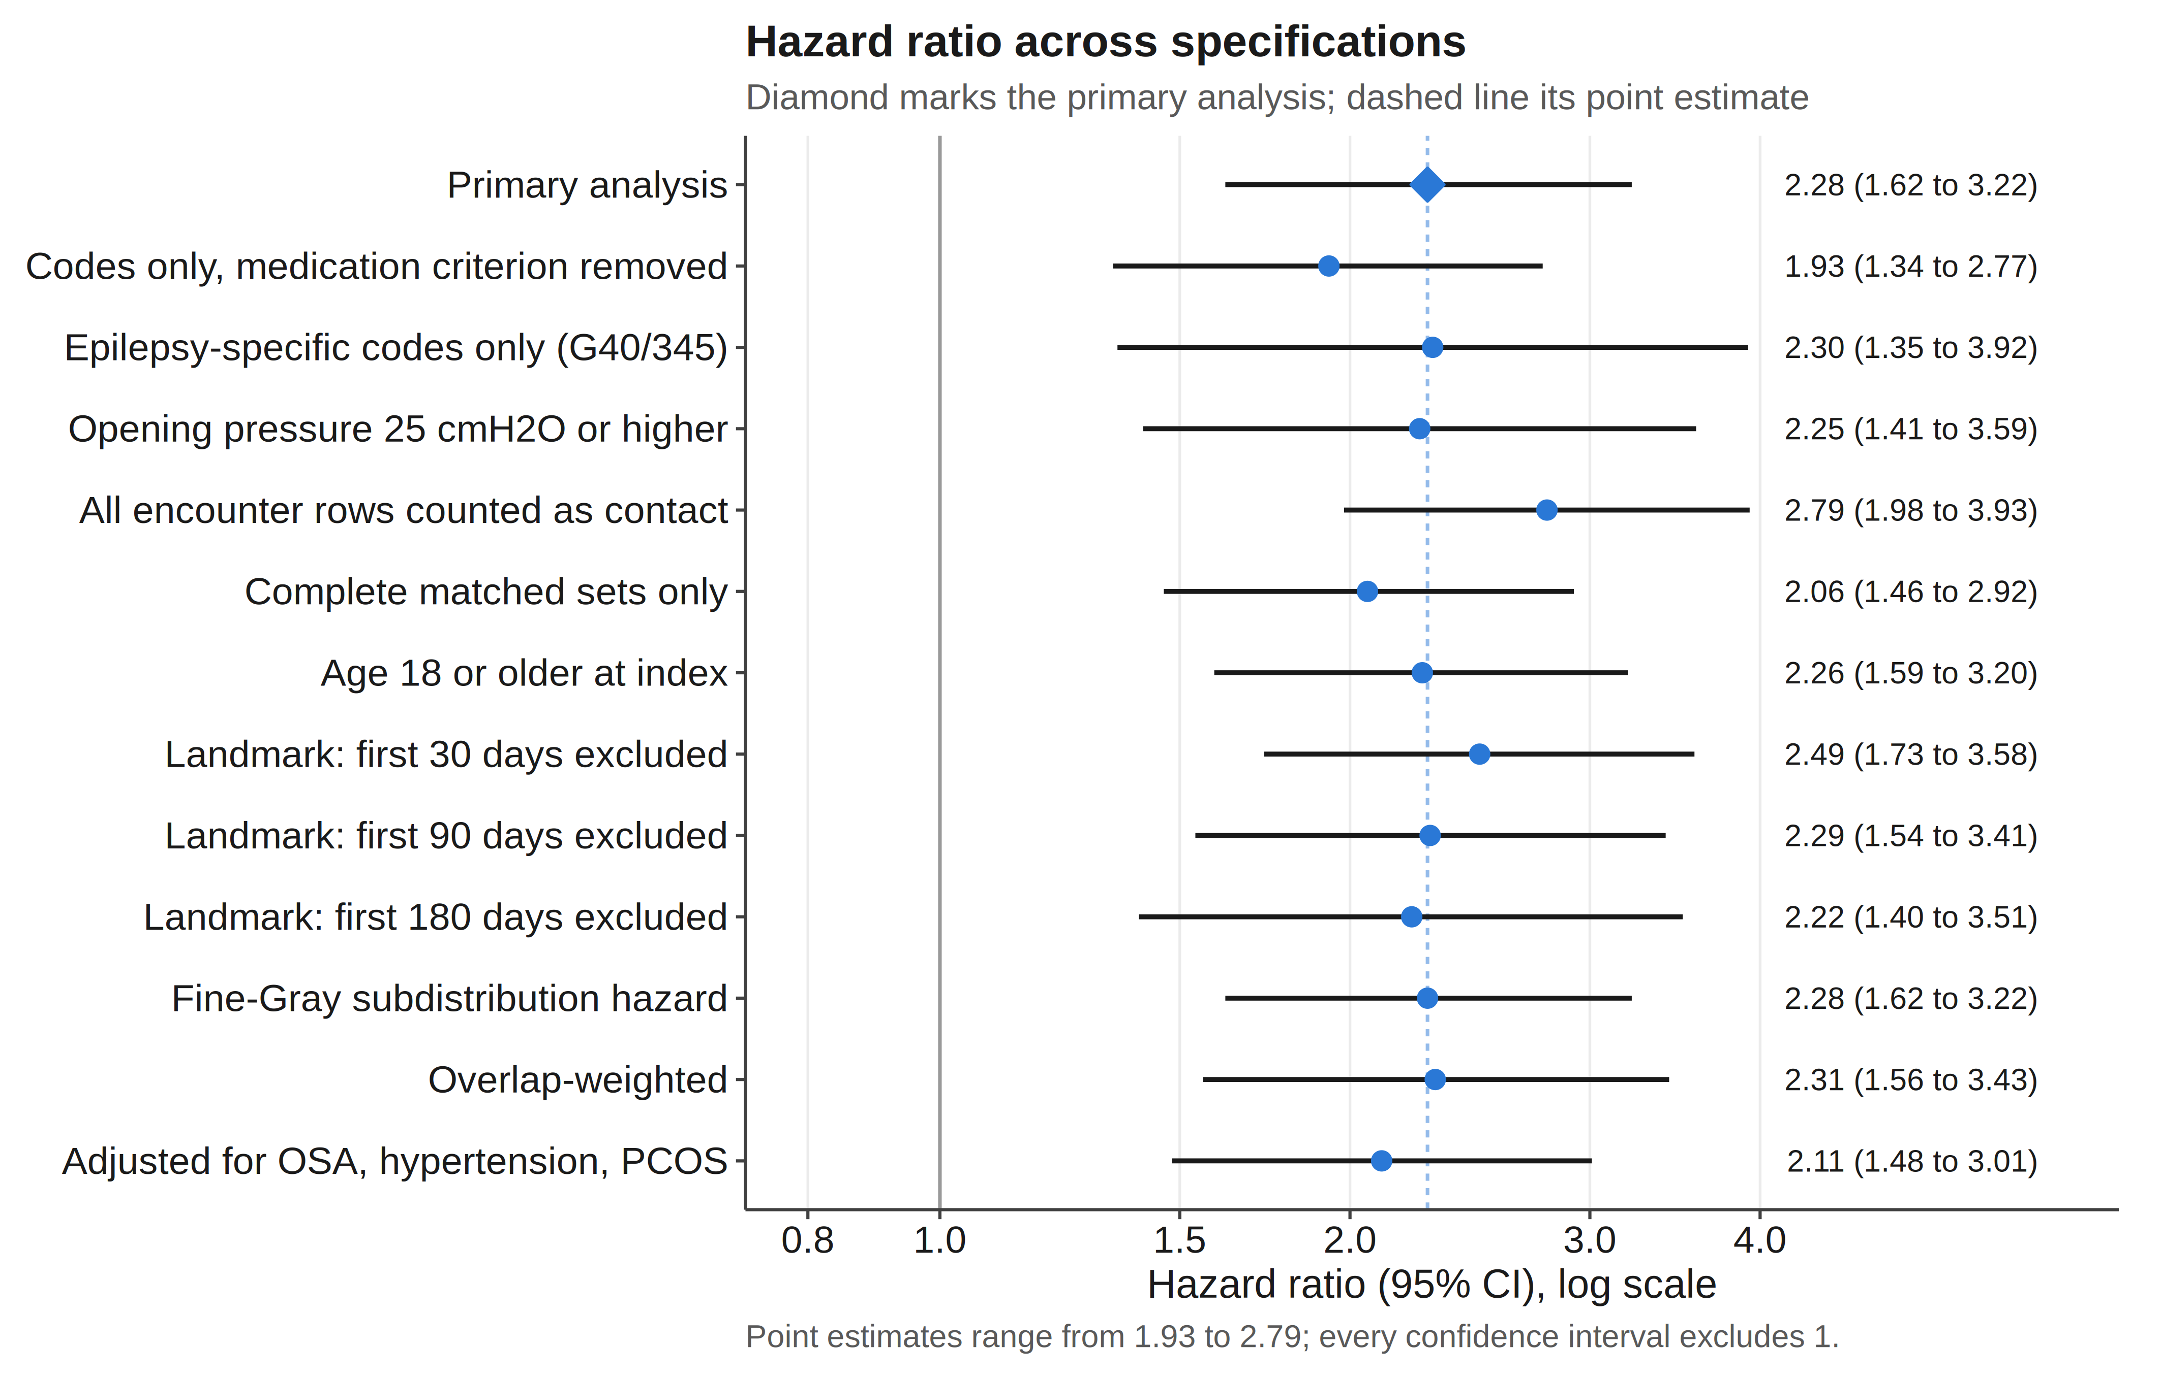
Figure 2. Hazard ratio for incident seizure or epilepsy across outcome definitions, cohort restrictions, follow-up landmarks and analytic models. Points are hazard ratios and horizontal lines 95% confidence intervals, on a logarithmic scale; the diamond marks the primary analysis and the dashed line its point estimate. Point estimates range from 1.93 to 2.79 and every confidence interval excludes 1.
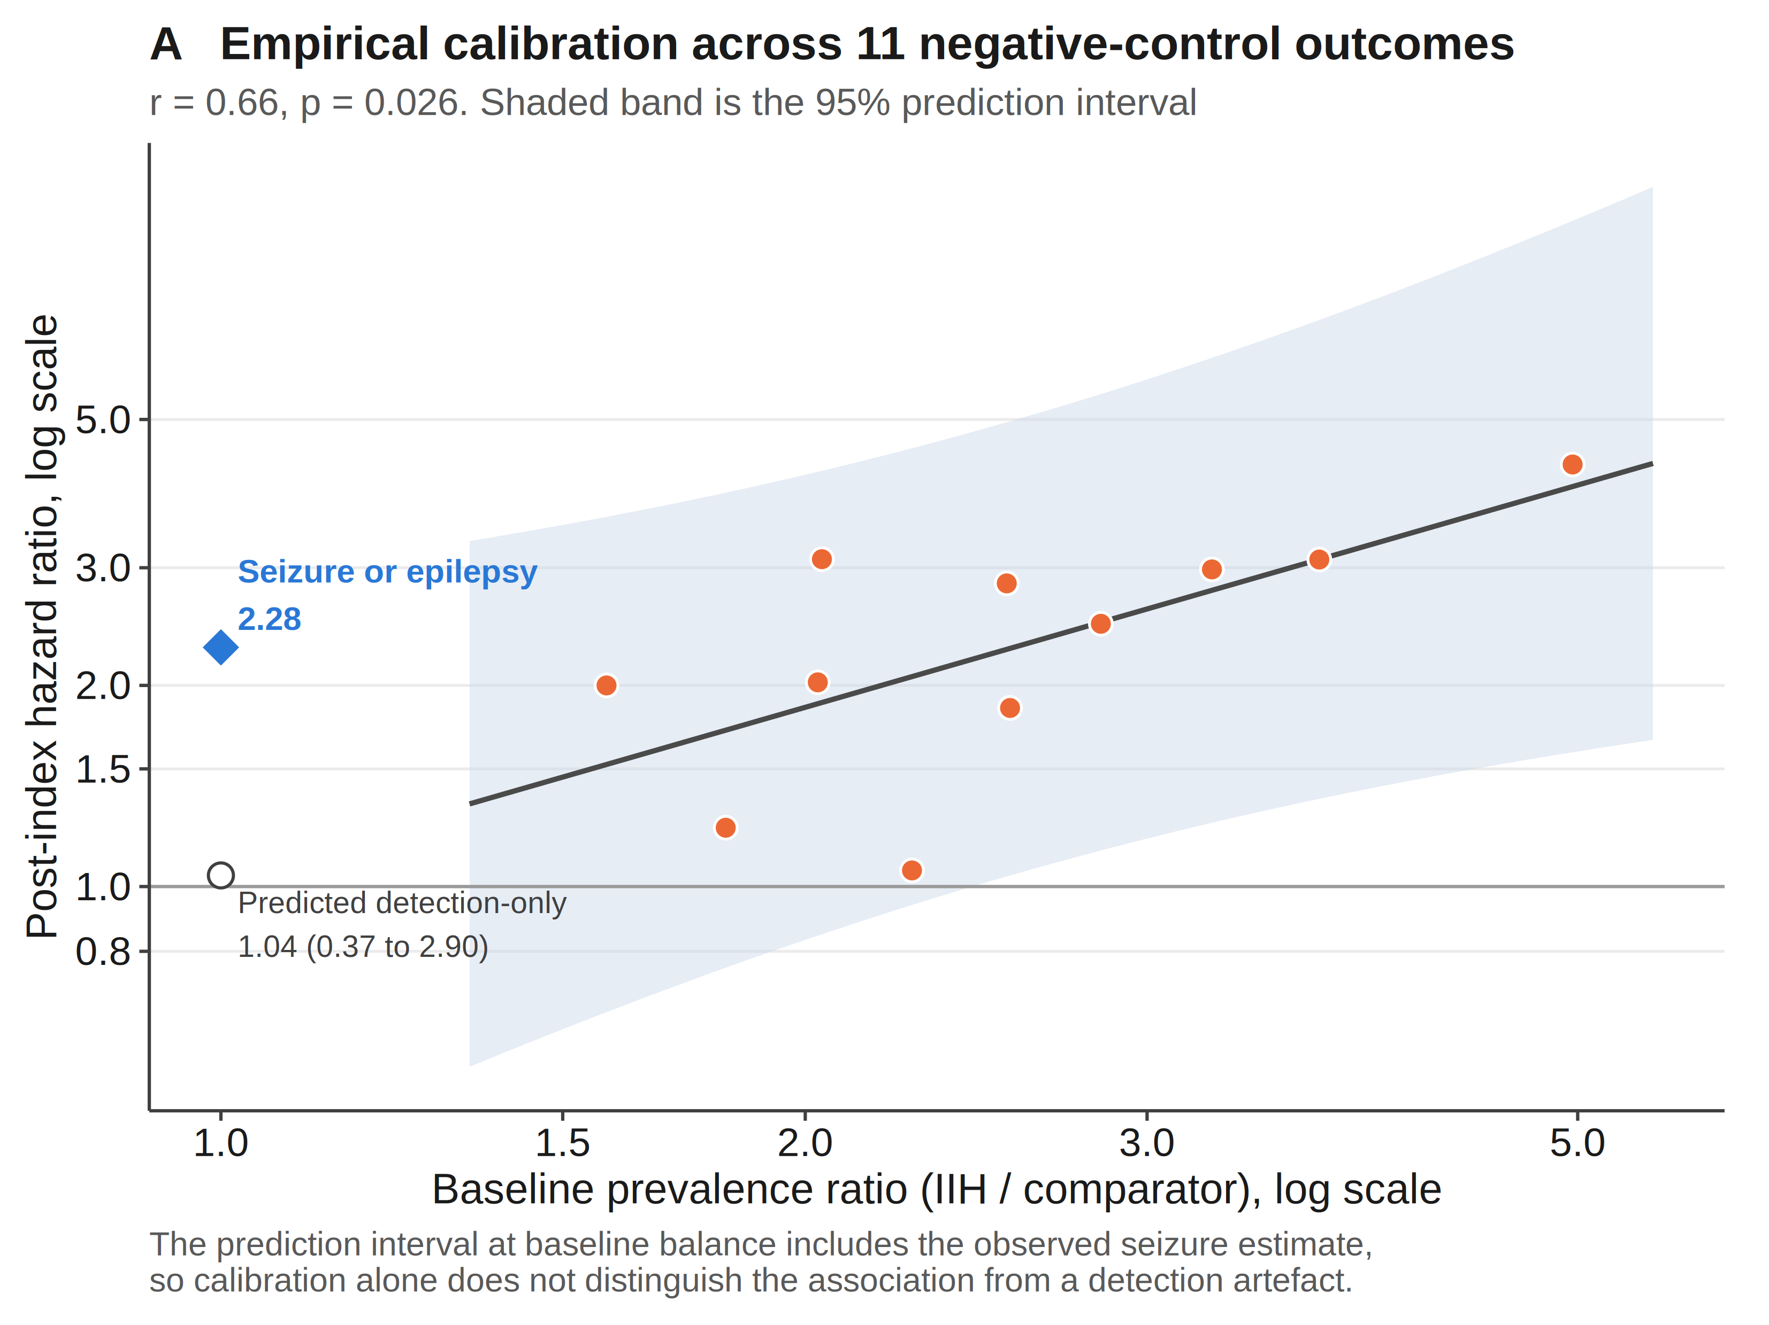
Figure 3A. Empirical calibration across 11 negative-control outcomes. Each orange point is one negative control, plotted by its baseline prevalence ratio and its post-index hazard ratio; the line is the fitted relationship (r = 0.66, p = 0.026) and the shaded band its 95% prediction interval. The open circle is the predicted detection-attributable hazard ratio at baseline balance, 1.04 (95% CI 0.37-2.90). The diamond is the observed seizure estimate, which lies inside that interval.
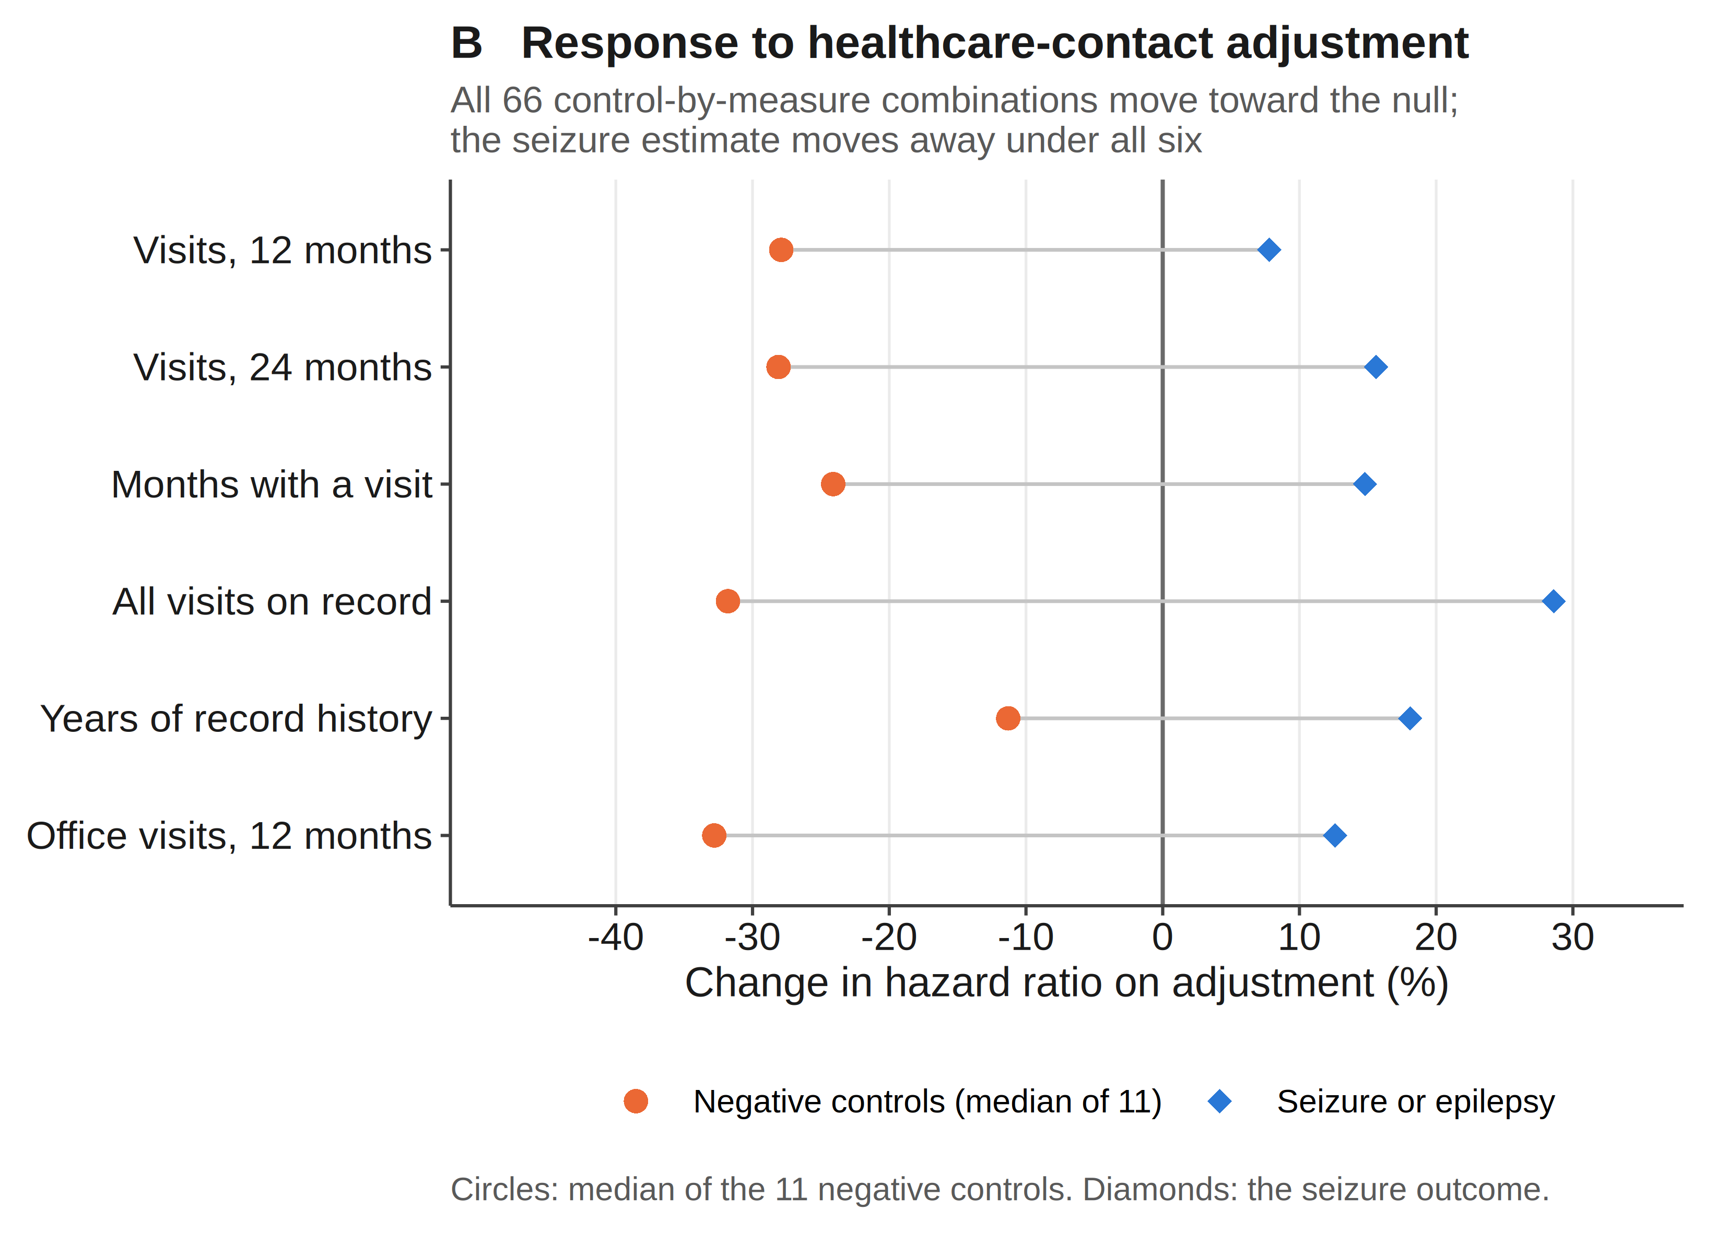
Figure 3B. Direction of movement of each outcome under adjustment for six independent measures of pre-index healthcare contact. Circles show the median change across the 11 negative-control outcomes; diamonds show the seizure outcome. All 66 control-by-measure combinations moved toward the null, whereas the seizure estimate moved away from the null under all six measures.

