EGEBIS
Seyir
Egebis Seyir User Guide
Creating and editing Sprints, Tasks and Sub-Tasks — step by step, with pictures.
Version: October 2026

Contents
Before you start: the basics
1. Creating a Space
2. Creating a Task
3. Editing a Task
4. Creating a Sub-Task
5. Editing a Sub-Task
6. Creating a Sprint
7. Adding work to a sprint
8. Editing and managing a sprint
9. The sprint board (Kanban)
10. Quick tips and FAQ

Before you start: the basics
Seyir is a project management app where a team plans and tracks its work. This guide is written for someone who has never used it: at every step we point at the screen with red numbered markers. The number on the picture matches the list under the picture.
You only need to know a few words first:
Term | What it means | Example
Space | A work area for one product or team. All work items live inside a Space. | Mobile App
Task | One piece of work to do. It has a title, an owner, a date and points. | Design the sign-in screen
Sub-Task | A small part of a Task. It cannot exist alone; it always belongs to a parent item. | Draw the form fields
Sprint | A work period, usually 1–2 weeks, with a goal and dates. The team picks what to do in it. | Sprint 1 (Oct 15–28)
Backlog | The list of work not yet in a sprint, ordered by priority. | —

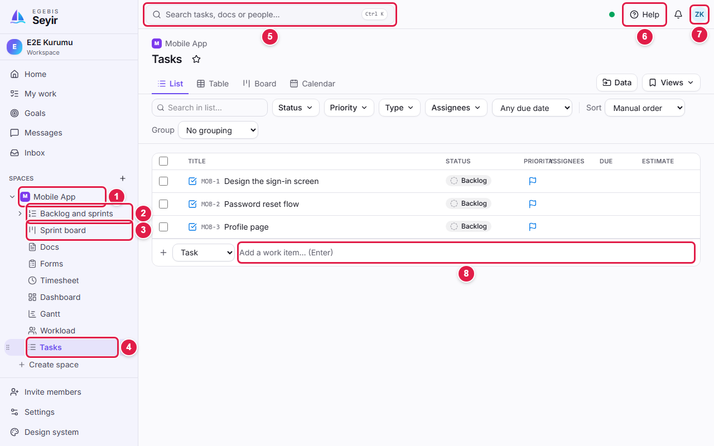
Main screen: use the left menu for the Space and its sections, and the top bar for search, help and your account.
1 | Space: The project area you work in. Click to open the sections below it.
2 | Backlog and sprints: Sprints are created and planned here.
3 | Sprint board: Shows the sprint's work in status columns (Kanban).
4 | Tasks: The Space's work list; Tasks and Sub-Tasks are added here.
5 | Search: Find a task, document or person (shortcut: Ctrl + K).
6 | Help: Open this guide at any time.
7 | Account menu: Profile, language, theme and sign out.
8 | New item row: Type a title and press Enter to add a task.

Tip: When you are stuck, click Help in the top bar. You can also get the Word version with Download as Word at the top right of the page.

1. Creating a Space
Before you create Tasks and Sprints you need a Space to hold them. Your team lead usually prepares it for you, but it helps to know how it is done.
- In the left menu click the + next to SPACES (or the Create space row at the bottom).
- Type the Space's name in Name (e.g. Mobile App).
- Check the Key. It is a short 2–10 letter code; item IDs start with it (MOB-1, MOB-2…). It is suggested automatically.
- Optionally pick a colour and icon. Keep Work mode on Scrum to use Sprints and the Backlog.
- Click Create space.

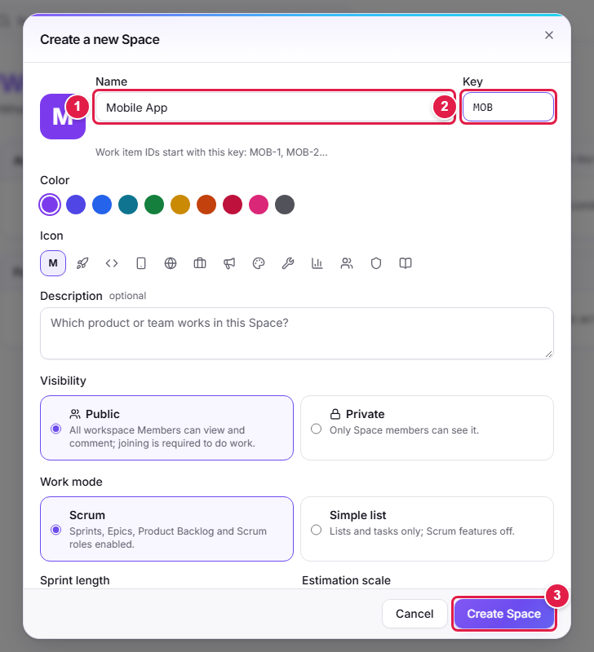
The new Space dialog. Keep the work mode on Scrum if you will use sprints.
1 | Name: The Space's display name.
2 | Key: The short code at the start of item IDs (like MOB-1). It must not be used by another Space; keep it short and clear.
3 | Create space: Saves and opens the Space.

Note: A list called Tasks is created automatically inside the new Space. You will add your first Tasks there.

2. Creating a Task
A Task is one piece of work to do. The fastest way to add one is the add row at the bottom of the list.
- In the left menu open your Space and click the Tasks list.
- In the row at the bottom choose Task in the Type box.
- Type the work's title in the next box (e.g. *Design the sign-in screen*). Keep it short and clear: it should say what must be done.
- Press Enter (or click Add ↵). The task drops into the list and receives its ID (MOB-1).

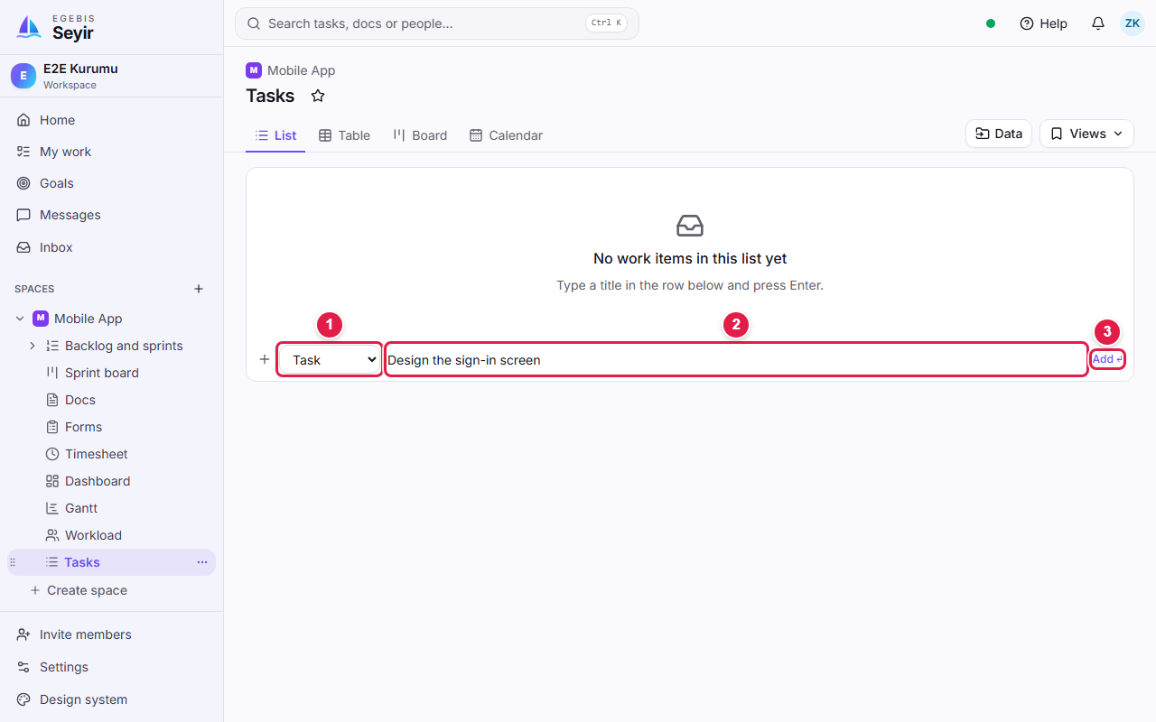
The add row: choose the type, type a title, press Enter.
1 | Type: The kind of record to add. This guide uses Task (others: Epic, Story, Bug).
2 | Title: The name of the work. To add several tasks, just press Enter after each title.
3 | Add ↵: You can click this instead of pressing Enter.

Tip: To add many tasks in a row, type a title, press Enter, type the next, press Enter again. Fill in details (date, person, points) afterwards.

3. Editing a Task
All details of a task are edited in the detail panel that opens from the right when you click its title. The panel has no Save button: a field is saved automatically when you change it.
- In the list click the task's title. The detail panel opens from the right. (Use the expand icon at the top of the panel for a full page.)
- Find the field you want to change (marked in the picture below) and pick or type a value.
- When you are done, close the panel with the X at the top right. Nothing else is needed.

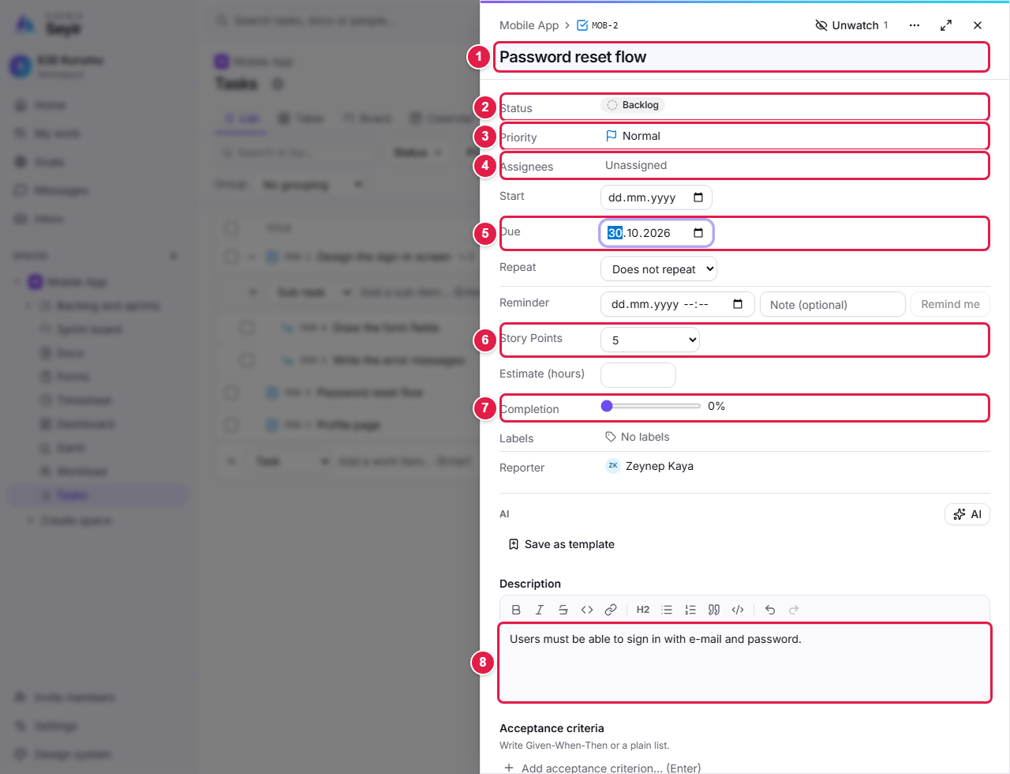
The task detail panel. Every marked row can be clicked and changed.
1 | Title: Click to rename.
2 | Status: Where the work stands (Backlog, To do, In progress, In review…). Click and choose another.
3 | Priority: Urgent, High, Normal or Low. Makes important work stand out.
4 | Assignee: Who does the work. Click and pick one or more people.
5 | Due date: When the work must be finished. Pick from the calendar or type a date.
6 | Story Point: The size of the work. Only 1, 2, 3, 5, 8, 13, 21, 34, 55 can be chosen.
7 | Completion: How much is done? Drag the slider (0–100%, in steps of 5).
8 | Description: The details. Saved automatically as you type.

Field | What it is for | How to change it
Status | Shows the stage of the work; decides which column it sits in on the Kanban board. | Click the status badge in the panel or the list and choose a new status.
Priority | Makes important work stand out. | Click the badge and pick a priority.
Assignee | The responsible person or people. | Click the row and pick one or more people.
Start / Due date | Planned dates. Unfinished work past its due date gets a red warning. | Pick from the date box.
Story Point | A size estimate; sprint totals are calculated from it. | Pick a value from the list (1–55).
Estimate (hours) | An optional time estimate. | Type the number of hours.
Completion | How much is finished; it feeds the sprint progress. | Drag the slider.
Labels | Free labels for grouping (e.g. Design). | Pick from the Labels row or type a new label.

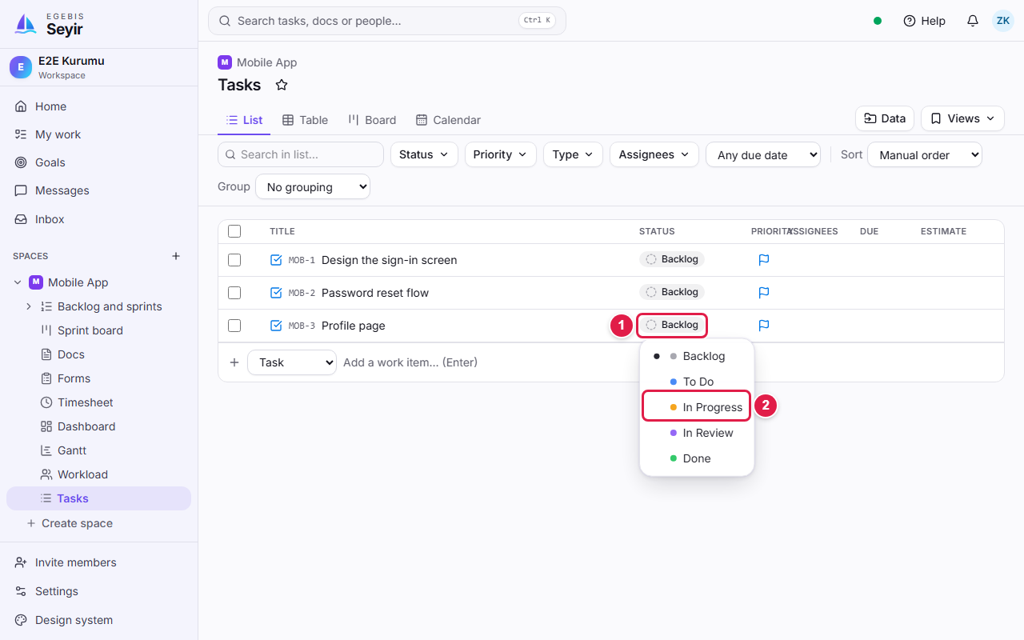
You can also change the status straight from the list without opening the panel.
1 | Status badge: Click to open the status list.
2 | New status: Pick the status you want; the task updates instantly.

- Copy, archive and delete: In the list click the ⋯ button at the right of the task. Copy makes a copy of the task, Archive hides it but keeps it, Delete sends it to the trash.
- If you deleted by mistake: open Settings → Archive and trash, find the task and click Restore. Items in the trash are removed for good after a while.

Warning: Only 1, 2, 3, 5, 8, 13, 21, 34 and 55 are valid Story Points; no other number can be entered. If the task has Sub-Tasks you cannot edit its points by hand, because its points are the sum of its sub-tasks (see Editing a Sub-Task).

4. Creating a Sub-Task
Use a Sub-Task to split a big piece of work into parts. A Sub-Task always belongs to a parent (Task, Story or Bug) and appears under it.
- In the Tasks list click the ⋯ button at the right of the parent task's row.
- Choose Add sub-item from the menu. A new add row opens under the task.
- The type box is already on Sub-task. Type the title (e.g. *Draw the form fields*) and press Enter.
- Keep typing and pressing Enter for more sub-tasks. When you are done, press Esc to close the row.

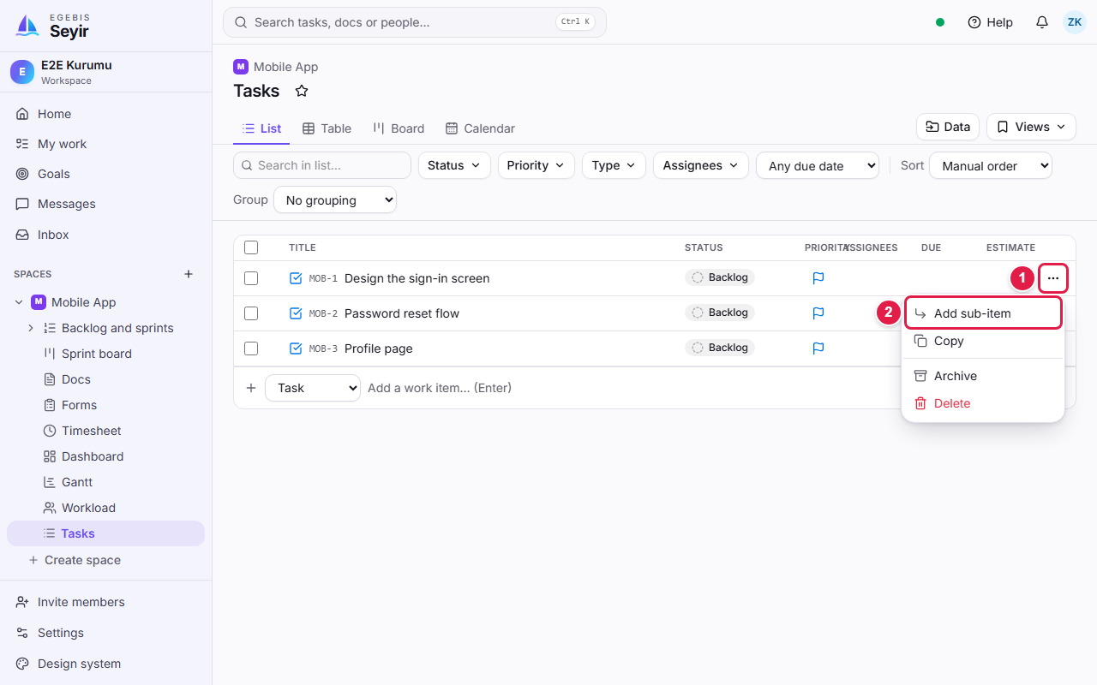
Choose Add sub-item from the parent's ⋯ menu.
1 | ⋯ (actions): Opens the task's menu.
2 | Add sub-item: Lets you add a Sub-Task under this task.

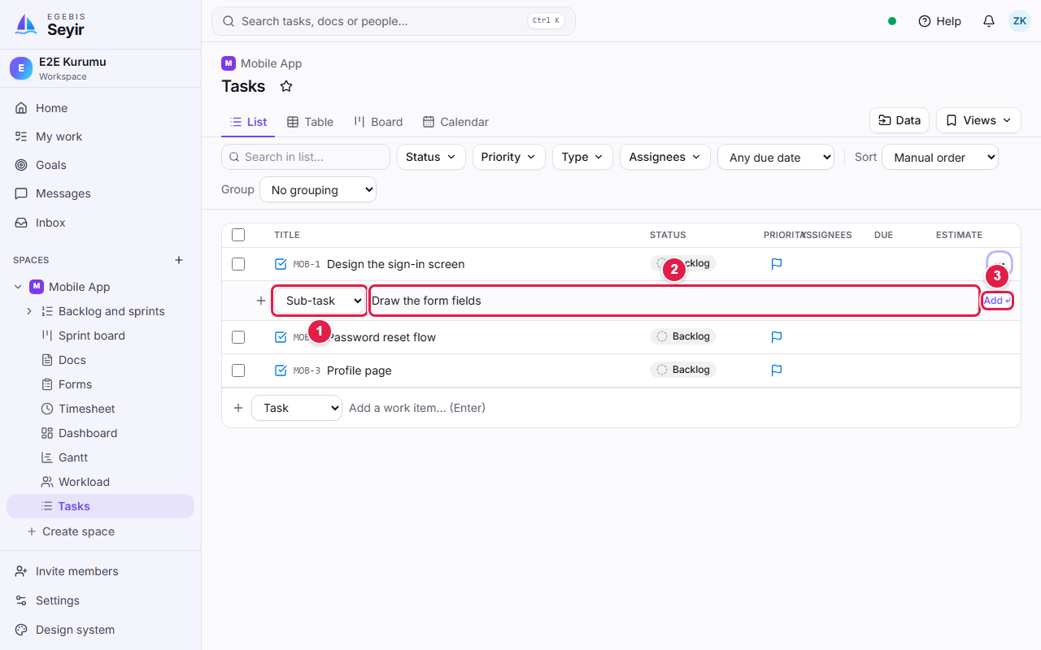
The sub-task add row: type Sub-task, write the title, press Enter.
1 | Type: This should be Sub-task.
2 | Title: The sub-task's name; press Enter to add it.
3 | Add ↵: You can click this instead of pressing Enter.

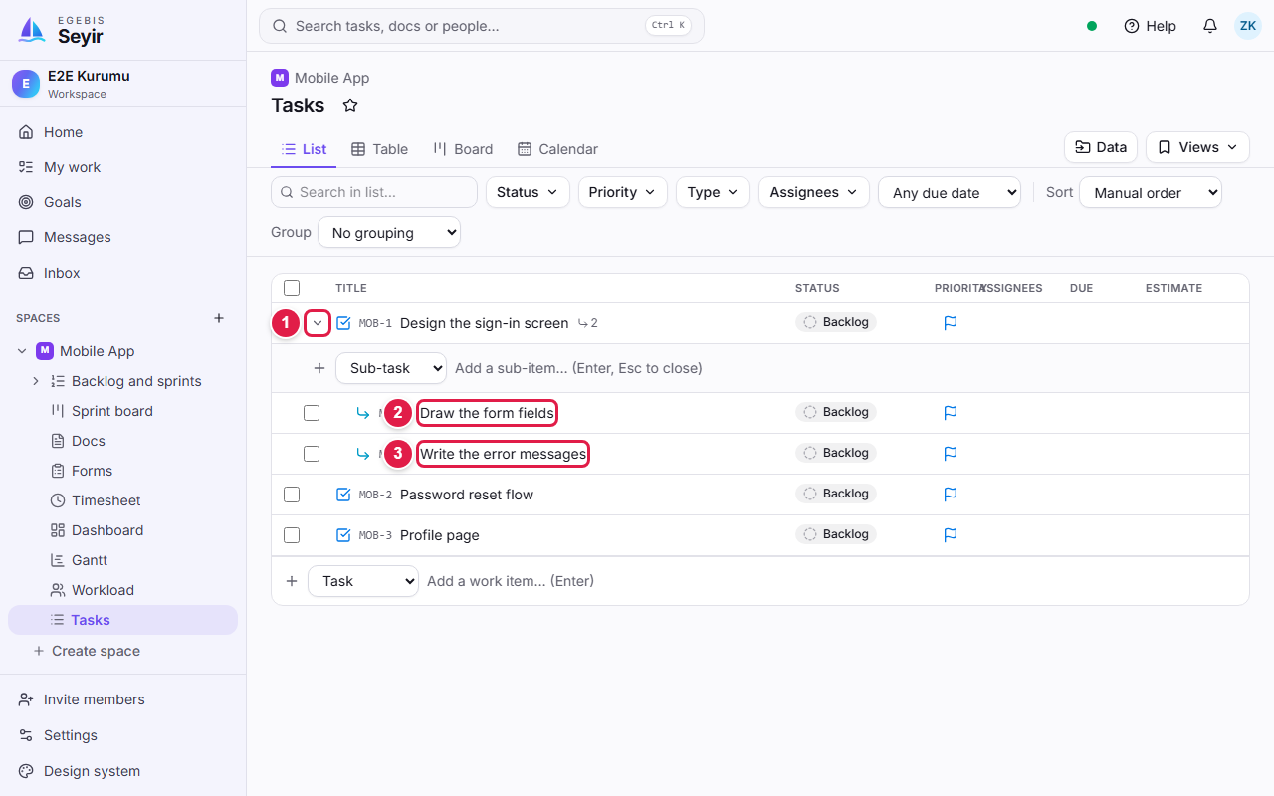
Added sub-tasks appear indented right under the parent.
1 | Expand/collapse arrow: Shows or hides the sub-tasks.
2 | First sub-task (MOB-4).
3 | Second sub-task (MOB-5).

Tip: You can also add sub-tasks from the Sub-items section in the parent's detail panel. On the Backlog page, dragging a row onto another row and dropping it a bit to the right also makes it a sub-task of that row.

Note: Sub-tasks do not enter a sprint on their own; they move together with their parent.

5. Editing a Sub-Task
A sub-task is edited like any task: click its title and change the status, person, date, points and percentage in the detail panel. The difference is that its values flow up to the parent.
- Click the sub-task's title (in the list or in the parent's Sub-items section).
- Choose the Story Point value and, if needed, move the Completion slider.
- To go back to the parent, click the parent link (e.g. MOB-1) above the title.

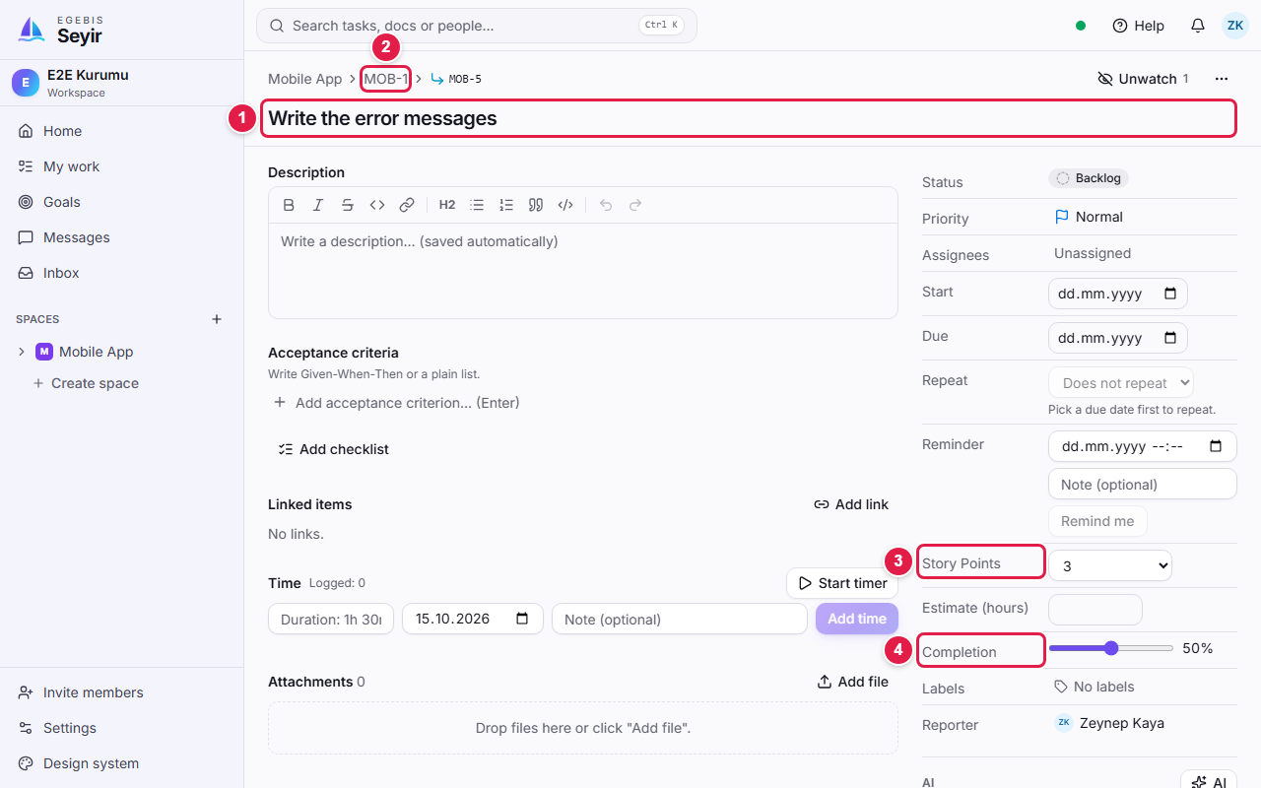
The sub-task page: points and percentage are entered here.
1 | Title: The sub-task's name; click to change.
2 | Parent link: Takes you to the item it belongs to.
3 | Story Point: The sub-task's points (1–55).
4 | Completion: The sub-task's percentage.

When you enter points and percentages on sub-tasks, the parent calculates its own from them:
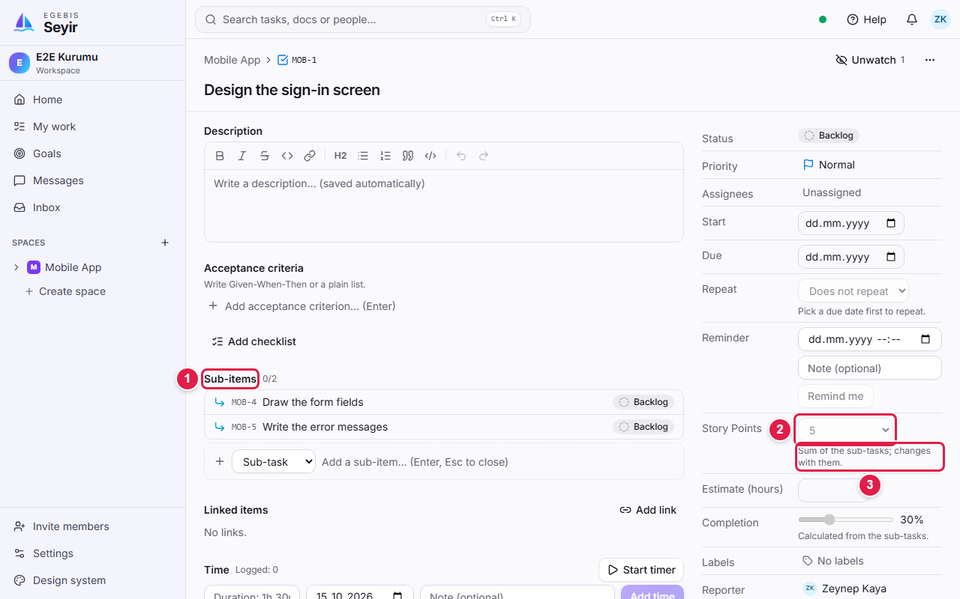
The parent's points are the sum of its sub-tasks (2 + 3 = 5) and cannot be edited by hand.
1 | Sub-items: The task's sub-tasks and their statuses.
2 | Story Point (locked): The sum of the sub-tasks; the list is disabled.
3 | Explanation note: "Sum of the sub-tasks" says this field is calculated automatically.

- Points: The parent's points = the sum of its sub-tasks' points. It updates by itself when you add, change or delete sub-tasks.
- Percentage: The parent's percentage is the point-weighted average of its sub-tasks' percentages. A sub-task in a finished (Done) status counts as 100%.
- If you delete the sub-tasks: the parent keeps its last points and can be edited by hand again.

Warning: To change a parent's points or percentage, change its sub-tasks' values; the field is locked on the parent.

6. Creating a Sprint
A sprint is the package of work the team chooses to do within a fixed time. Sprints are created on the Backlog and sprints page. To open it click Backlog and sprints under your Space in the left menu.
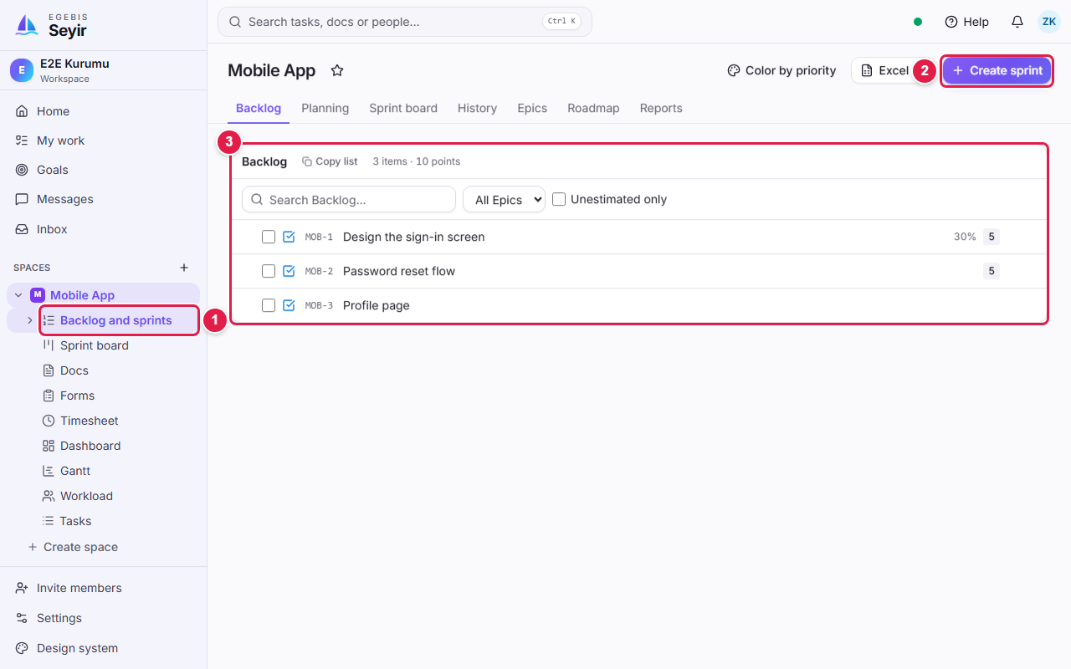
The Backlog page: work not yet in a sprint is listed below.
1 | Backlog and sprints: Open this page from the left menu.
2 | Create sprint: Opens the new sprint dialog.
3 | Backlog section: All tasks not in a sprint, in priority order.

- Click Create sprint at the top right.
- Type the sprint's name in Name (e.g. Sprint 1).
- In Sprint goal write in one sentence what will be achieved. (In some Spaces the goal is required.)
- Pick the Start and End dates. A two-week range is suggested; a sprint can last at most 8 weeks.
- Optionally add a Capacity note (e.g. 3 people, one on leave for 2 days).
- Click Create sprint. The sprint appears above the Backlog with the Planned status.

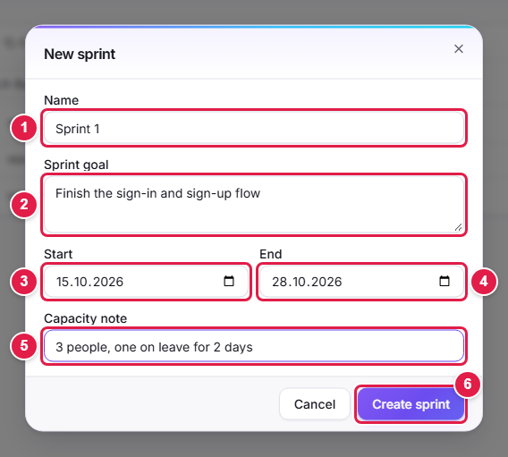
The new sprint dialog and the fields to fill in.
1 | Name: The sprint's name.
2 | Sprint goal: The purpose of this period; everyone sees it on the sprint header.
3 | Start: First day.
4 | End: Last day. It cannot be before the start; 8 weeks at most.
5 | Capacity note: The team's situation in that period (leave, meetings…). Optional.
6 | Create sprint: Saves the sprint.

Field | Required? | Description
Name | Yes | The name shown in lists and boards.
Sprint goal | Depends on the Space setting | The team's shared aim. If left empty you get a warning when starting the sprint.
Start / End | Yes | End cannot be before start; at most 8 weeks.
Capacity note | No | A free note.

7. Adding work to a sprint
The sprint exists but is empty. You plan it by moving work from the Backlog into it. There are three ways; the menu is the easiest.
- In the Backlog section click the ⋯ button at the right of the task you want to move.
- Click "Move to Sprint 1". The task moves under the sprint.
- Repeat for the other tasks.

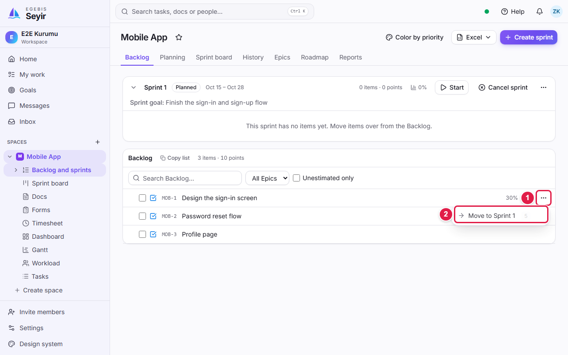
Moving a task into a sprint: choose the sprint from the ⋯ menu.
1 | ⋯ (actions): The task's menu.
2 | Move to sprint: Puts the task into the sprint you choose. To undo it, the same menu has Move back to Backlog.

- By dragging: grab the handle at the left of the row and drop it on a sprint section. Moving between sprints and from a sprint back to the Backlog works the same way.
- Bulk move: tick the boxes at the left of the rows and choose Move to sprint… from the bar that appears.
- Tasks, Stories and Bugs can enter a sprint; Epics cannot. Sub-tasks come with their parent.

Note: Adding or removing work in a sprint that has already started (Active) counts as a "scope change". Seyir asks you and shows it in the reports.

8. Editing and managing a sprint
To change a sprint's name, goal, dates or capacity use the ⋯ menu on the sprint header.
- Click the ⋯ button at the right of the sprint header.
- Choose Edit from the menu. The "Edit sprint" dialog opens.
- Update the field you want to change and click Save.

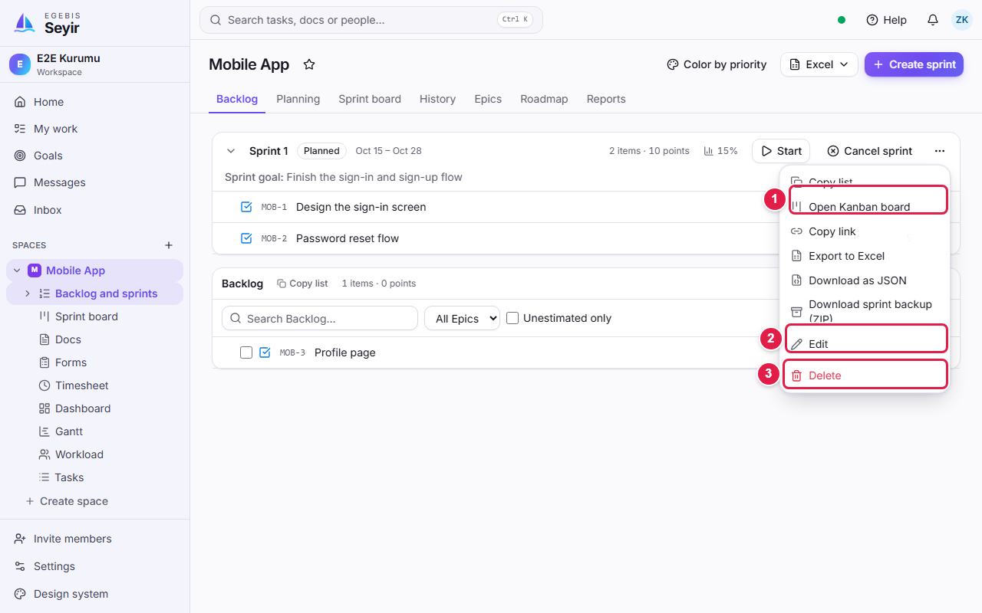
The sprint menu: open the board, edit, export or delete.
1 | Open Kanban board: Shows the sprint's work in status columns.
2 | Edit: Changes the sprint's details.
3 | Delete: Deletes the sprint (only while it is Planned). Its work returns to the Backlog.

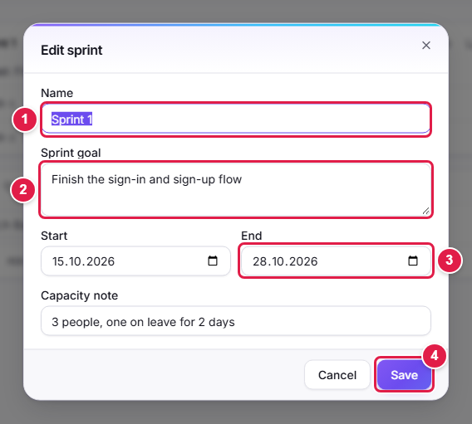
The edit dialog has the same fields as the create dialog.
1 | Name: Changes the name.
2 | Sprint goal: Updates the goal.
3 | End: Extends or shortens the period. Dates are locked in an active sprint.
4 | Save: Applies the changes.

On the sprint header you see its state at a glance and manage its life cycle:
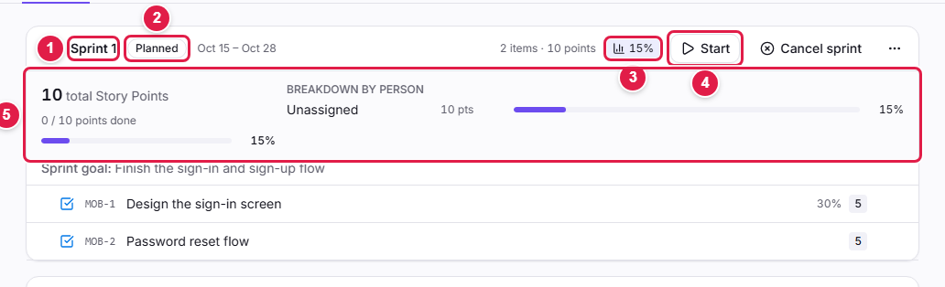
The sprint header: status, total points, percentage and breakdown by person.
1 | Sprint name: The header shows the name, date range and total points.
2 | Status: Planned, Active, Completed or Cancelled.
3 | Percentage button: Click to open or close the summary panel.
4 | Start: Starts a planned sprint. In an active sprint Complete appears instead.
5 | Summary panel: Total Story Points, done points, overall percentage and points/percentage per person.

- Start: makes the sprint active. Seyir warns you if no goal is set or the sprint is empty.
- Complete: asks what to do with unfinished work: carry over to the next sprint or send to the Backlog. Done points are recorded for the team's velocity.
- Cancel: cancels the sprint and returns its work to the Backlog. This cannot be undone.
- Delete: only a Planned sprint can be deleted.

Tip: To share a sprint choose Copy link from the menu; the link opens the sprint board directly. For reports use Export to Excel or Download as JSON.

9. The sprint board (Kanban)
Kanban is a board where work is tracked as cards in status columns. Open it by clicking Sprint board in the left menu or Open Kanban board in the sprint menu. Every sprint has its own board.
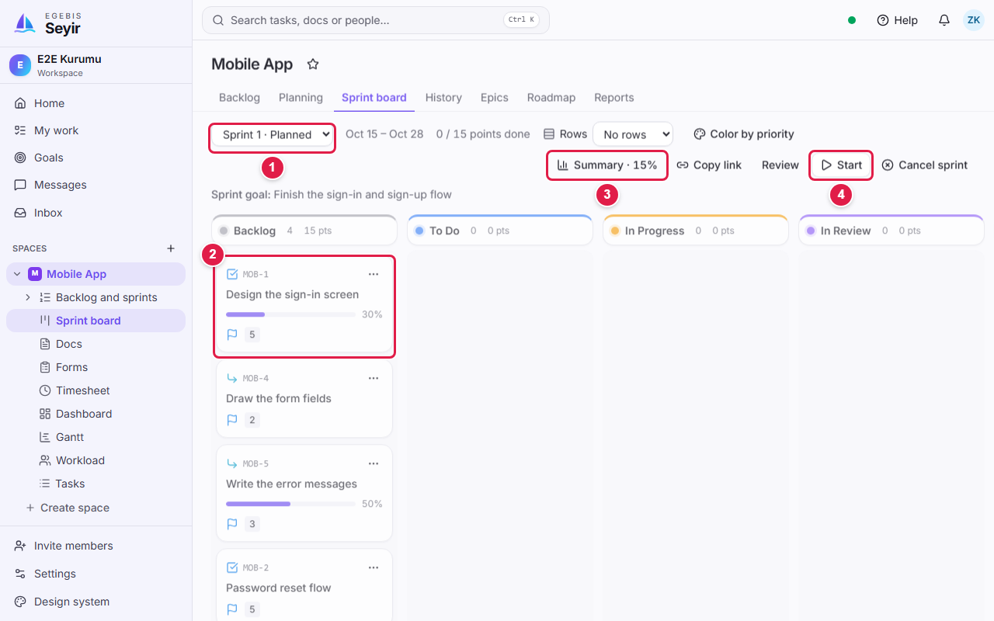
The sprint board: columns are statuses, cards are tasks.
1 | Sprint picker: Choose which sprint's board to see.
2 | Card: Task ID, title, points and percentage. Dragging a card to another column changes its status.
3 | Summary: Opens the total points, percentage and breakdown by person.
4 | Start: Starts a planned sprint.

- To change a status without dragging, use Change status in the card's ⋯ menu.
- The flag on a card is the priority, the number next to it is the Story Point, and the progress bar is the completion percentage.
- The Colour by priority button above the board paints cards by priority (Urgent red, High orange…).

10. Quick tips and FAQ
What do you want to do? | How?
Find a task quickly | Click the search box or press Ctrl + K, then type the task name or ID (MOB-12).
Share a task's link | In the task detail choose Copy link from the ⋯ menu (clicking the task ID in the Backlog also copies it). The address looks like /items/MOB-12.
See only my own work | Click My work in the left menu.
Restore a deleted task | Settings → Archive and trash.
See a sprint's total points | Click the percentage button on the sprint header (Summary panel).
Change the language | Account menu at the top right → Language.

Frequently asked questions
- Why is there no 4 in the Story Point list? Seyir uses the standard Fibonacci scale (1, 2, 3, 5, 8, 13, 21, 34, 55). Choose the nearest value.
- Why can't I change the parent's points? If it has sub-tasks, its points are their sum. Change the sub-tasks' points.
- I created a sprint but cannot see it. Open Backlog and sprints; the sprint sits above the Backlog. You can also expand the arrow in the left menu to list sprints.
- I cannot put a Sub-Task straight into a sprint. Sub-tasks move with their parent; move the parent to the sprint.
- Was my change not saved? Seyir saves automatically; there is no Save button to look for.

Note: If something is still unclear, contact your workspace admin. This guide is updated together with the app.

