

Design Definition and Justification File
WIOT STM32 Node Software
Tracking No.: WIOT-NOD-DDS-07-001-V1.2

Department: | WIOT | Sub-system: | STM32 node software
Created by: |  | Date: | 07/10/2026
Reviewed by: |  | Date:
Approved by: |  | Date:
Date of version: | V1.2 - 7 November 2026
Signature:

Document Control
Engineering review edition, revised 7 November 2026 against the reviewed Arduino STM32 source. Revision 1.2 incorporates independent WOR scheduling, reporting with unavailable sensors, regional gateway subscriptions and selectable diagnostics. The acceptance procedures identify the remaining physical tests.
Table 1. Revision history
Date | Revision | Scope
07/10/2026 | 1.0 | Initial full node-software design document, adapted from the supplied DDS example and grounded in the current final source.
01/11/2026 | 1.1 | Current topics; two counters; UART-RX WOR; SPI sample journal/history commands; expanded schema, tests and flowcharts.
07/11/2026 | 1.2 | Independent WOR scheduling. Offline report priority. Gateway direct and broadcast subscriptions. OFF, LITE and FULL debug. Updated source evidence and diagrams.
Table 2. Baseline and document authority
Item | Definition
Document identifier | WIOT-NOD-DDS-07-001-V1.2. A separate V1.2 filename preserves earlier local editions.
Document example | WIOT-SYS-DDS-07-001-V0.3.docx; layout and design-definition structure only
Software baseline | c604aa6a5a49c61f86bada826a329dc600dac9f6. Reviewed Arduino STM32 release, 4 November 2026. Diagram definitions refreshed 7 November 2026.
Scope | Arduino STM32F401 node software, selectable LoRa gateway role and node/server protocol boundary
Not covered as implementations | ESP32 port, STM32CubeIDE port, server internal design, mechanical qualification and vendor firmware
Review and approval | Administrative signature and approval fields are deliberately unassigned.

How to use this document
Use Section 5 for implementation/configuration, Section 13 and Appendix A for acceptance steps, Appendix B for interfaces and Appendix D for key flowcharts. Source paths are node-relative unless a release-root prefix is stated. The full thirty-chart package covers the gateway, server and simulators in greater detail. Snapshot configuration values must be checked against the actual flashed image.

Table of Contents
Document Control 1
How to use this document 1
Table of Contents 2
1 Introduction 5
1.1 Purpose and objective 5
1.2 Scope and terminology 5
2 Applicable and Reference Documents 6
2.1 Verified toolchain baseline 7
3 Summary of the Project and Technical Requirements 7
3.1 Life cycle and release baseline 7
3.2 Current bench configuration 8
4 Functional Description 9
4.1 Functional architecture and data flow 9
4.2 Startup and main-loop sequencing 9
4.3 Scheduling and responsiveness 10
4.4 Function ownership 11
5 Physical and Software Design Description 11
5.1 Physical interface allocation 11
5.2 Software product tree and module boundaries 12
5.3 Build and configuration contract 13
5.4 RS485 and four-sensor acquisition 15
5.5 RTC and daily/monthly/yearly consumption 17
5.6 Battery-voltage measurement 19
5.7 IP modem, MQTT and command priority 19
5.8 LoRa sensor node and gateway 21
5.9 Protobuf schema and encrypted envelope 22
5.10 Commands, replies and duplicate handling 29
5.11 Latching solenoid valve control 31
5.12 Global watchdog and network recovery 32
5.13 Controller and modem power policies 33
5.14 Persistent and transient storage 37
5.15 External telemetry journal and history 38
5.16 Diagnostic logging 40
6 Technical Budgets, Margins and Deviations 41
6.1 Data and RAM budget 41
6.2 Timing budget 41
6.3 Power and mass budget 41
7 Software Design Constraints 42
7.1 Production and build constraints 42
7.2 Operating and safety constraints 42
7.3 Maintainability and security constraints 42
7.4 Storage, transport and long-term maintenance 43
8 Engineering Data Repository 43
9 Design Justification File Synthesis 44
10 Justification of the Functional Architecture 44
11 Justification of the Physical Architecture 45
12 Development Activities and Results 45
13 Verification Activities and Synthesis of Results 46
13.1 Evidence already recorded 46
13.2 Traceability and acceptance allocation 47
13.3 Repeatable regression and build procedure 47
13.4 Qualification status and release acceptance 48
14 Justification of Technical Budgets and Margins 48
15 Justification of Design Constraints and Open Items 49
16 Constituent Documents 50
Appendix A Individual Test Procedures 51
A01 Configuration and build 51
A02 TUF live and native periods 51
A03 SUPMEA registers and unit conversion 51
A04 HNDA decoding 52
A05 Sondas decoding 52
A06 Zero unavailable values 52
A07 RTC trust and baseline 52
A08 Boundaries, reset and persistence 53
A09 Independent sample/transmit schedules 53
A10 SIM MQTT transport 53
A11 Wi-Fi priority and shared reply path 53
A12 LoRa link/gateway and RSSI 54
A13 Command validation and ACK 54
A14 ACK enable/disable 54
A15 Duplicate and WAKE intent 55
A16 Valve commissioning and polarity 55
A17 Valve faults and retention 55
A18 Global WDT stall 55
A19 WDT count 56
A20 10 + 10 network recovery 56
A21 Normal mode 56
A22 Schedule-driven remote wake 56
A23 Legacy remote option 57
A24 RTC periodic and queued 57
A25 LoRa WOR Stop 57
A26 Battery and power characterization 57
A27 Power and watchdog counters 58
A28 Independent SUPMEA reference 58
A29 Regional MQTT identity 58
A30 UART RX LoRa WOR 58
A31 SPI probe and explicit initialization 59
A32 Sample commit and retention 59
A33 History download and server ACK 59
A34 Storage with each transport and power policy 59
A35 Debug choices and unavailable sensors 59
Appendix B Public Module Interface Reference 60
B.app App modules 60
B.devices Devices modules 61
B.comm Comm modules 63
B.power Power modules 64
B.platform Platform modules 65
B.storage Storage modules 66
B.radio Radio modules 66
Appendix C Troubleshooting Guide 67
Appendix D Node flowcharts 69
F01 Whole system data and control paths 69
D2 Boot and reset initialization 70
D3 Sensor node cooperative main loop 71
D4 Supmea RTC day month and year consumption 72
D5 Watchdog reset causes and two counters 73
D6 Remote wake with normal connected modem 74
D7 LoRa wake on radio with STM32 Stop 75
D8 Capture and commit a flash sample 76
D9 Flash recovery retention and clearing 77
D10 Download retained history with persistence ACK 78

1 Introduction

1.1 Purpose and objective
The WIOT node acquires water-flow and soil measurements, stores complete samples on external SPI flash, publishes the latest retained snapshot, accepts remote operating commands, controls a commissioned latching valve and recovers from network failures or software stalls. This revision defines the current implementation, its operating limits and the procedures needed to verify it.
The target is STM32F401RCT6 using the Arduino STM32 core. The inspected build evidence uses the BLACKPILL_F401CC Arduino board profile. That profile is an integration choice and must be checked against the actual board pinout, clock and flash arrangement; successful compilation alone does not qualify a different PCB.

1.2 Scope and terminology
Sensor node means the application that polls up to four configured RS485 devices. Gateway means an alternative compile-time role that forwards LoRa frames to MQTT and returns MQTT commands over LoRa; it does not poll the four sensors. One firmware image selects a role and uplink, not automatic modem failover.
Status is the routine sensor snapshot. Telemetry is a command response with configuration and the same sensor fields. “Delivered” in local transport logs means the driver accepted a complete write or radio transaction, not that the server stored it. Valve ON/OFF is commanded state, not physical position feedback.
Table 3. Abbreviations
Term | Meaning
ACK | Acknowledgement; distinguish transport acknowledgement from application execution reply
ADC | Analog-to-digital converter
AES / CBC | Advanced Encryption Standard / Cipher Block Chaining
APN / GPRS | Cellular access point / packet-data service
CRC | Cyclic redundancy check; error detection, not authentication
DDS / DJF | Design definition / design justification file
DE / RE | RS485 driver enable / receiver enable
IWDG / WDT | Independent hardware watchdog / watchdog timer
IV | Initialization vector
MQTT | Publish/subscribe application protocol
nanopb | Embedded Protocol Buffers runtime
RTC / UTC | Real-time clock / Coordinated Universal Time
RTU | Modbus binary serial framing
STBY / WOR / WFI | Bridge standby / wake-on-radio / wait-for-interrupt

2 Applicable and Reference Documents
The supplied DDS provides the document organization, not a new source of software requirements. No ECSS certification or formal requirement closure is inferred from that example. The files below provide implementation or previously recorded verification evidence.
Table 4. Source and evidence references
Ref | Artifact | Purpose
R01 | IoT_Node_Encrypted.ino; src/app/ | Entry point, sensor-cycle scheduling and runtime model
R02 | src/config/AppConfig.h; local AppConfig.cpp | Public policy settings and private network/topic configuration
R03 | src/generated/sensor.proto | Authoritative deployed field names, numbers and types
R04 | src/devices/; src/comm/; src/radio/ | Sensor, valve, MQTT, codec and LoRa implementations
R05 | src/power/; src/platform/ | Power coordination, watchdog and reset counter
R06 | FLOW_METER_PROFILES_AND_CONSUMPTION_GUIDE.md; SUPMEA_RTC_RESET_FIX_AND_TEST_GUIDE.md | Meter configuration, calendar accumulation and storage fix
R07 | REMOTE_WAKE_APP_SCHEDULE_GUIDE.md; NEW_POWER_MODES_USER_GUIDE.md | Current remote scheduler and optional additional modes
R08 | LATCHING_VALVE_USER_GUIDE.md; LATCHING_VALVE_VERIFICATION.md | Commissioning, pulse safety and reported software checks
R09 | Release root: RELEASE_GUIDE.md; Documentation/Validation/REMOTE_WAKE_APP_SCHEDULE_VERIFICATION_20261005.md | Integrated release and historical remote-scheduler verification
R10 | Doxyfile; generate_doxygen.ps1; Documentation/Doxygen/html/index.html | Generated API reference (generated output may need local regeneration)
R11 | SPI_FLASH_TELEMETRY_GUIDE.md; SPI_FLASH_TEST_PLAN.md; src/storage/ | Journal geometry, recovery, commands and physical acceptance
R12 | Release Documentation/Flowcharts/README.md; source_manifest.json | 30 source-verified system flows; offline viewer, vector PDF and editable sources

2.1 Verified toolchain baseline
Table 5. Recorded build dependencies
Component | Recorded version / source
STM32 Arduino core | 2.12.0
STM32duino RTC | 1.9.0; compatible pair recorded with core 2.12.0
TinyGSM | 0.12.0
PubSubClient | 2.8
AESLib | 2.3.6
IWatchdog / EEPROM / HAL | From the STM32 core
ModbusMaster / nanopb | Vendored under src/third_party; do not silently substitute installed copies
These versions reproduce earlier build evidence. This documentation task does not install, upgrade, roll back or flash dependencies. An upgrade must repeat protocol, storage, serial and power-mode tests before acceptance.

3 Summary of the Project and Technical Requirements

3.1 Life cycle and release baseline
Development proceeds through configuration, offline regression, ARM compilation, simulator integration, physical-node acceptance and controlled deployment. Maintenance retains the exact firmware image, configuration, schema and logs. Updating a Git source checkout does not automatically update the separate final bench folder or a flashed device.
Table 6. Implemented capability allocation
Design ID | Capability | Owning module
N01 | Independently enable and address TUF, SUPMEA, HNDA and Sondas | AppConfig, SensorPollCycle, device drivers
N02 | Decode meter-specific registers and report validity | TufSensor, SupmeaSensor, HndaSensor, SondasSensor
N03 | Use native TUF periods and RTC-bucketed SUPMEA cumulative differences | FlowMeterManager, SupmeaPeriodAccumulator, RTC
N04 | Zero failed sensor groups without deleting historical baselines | AppState, SensorPayloadMapper
N05 | Publish through selected IP modem or LoRa gateway | MQTT, PacketCodec, LoraLink, GatewayApp
N06 | Prioritize addressed commands and optional correlated replies | CommandHandler, PriorityPublishQueue, CommandReplayCache
N07 | Pulse and safely disable the commissioned valve bridge | ValveController
N08 | Classify and retain independent WDT/power counts; direct verified clear commands | ResetCause, Watchdog, WatchdogResetCounter, PowerResetCounter
N09 | Recover after 10 failed network attempts, then another 10 | NetworkRetryPolicy, MQTT, IoT_Node
N10 | Coordinate supported controller/radio power combinations | PowerManager, RemoteWakeCycle, AppConfig
N11 | Measure divided battery voltage in both message types | BatteryMonitor, SensorPayloadMapper
N12 | Retain complete samples for 24 elapsed hours and download scoped history | TelemetryArchive, TelemetryJournal, S25Fl064L; matching server archive
N01-N12 are local design labels for navigation and test allocation. This revision adds the elapsed 24-hour external sample journal, independent power/WDT counters and acknowledged history download. Authenticated encryption, measured valve position and binary OTA firmware update remain outside the implemented capability set.

3.2 Current bench configuration
Public defaults select node 2, sensor ID 1 and Company_1 / Region_1, with LoRa uplink, UART RX WOR wake, SPI logging, all four sensors and LITE debug. Addresses are TUF 1, SUPMEA 2, HNDA 3 and Sondas 4. Boot SRATE/STRAN are 10,000/15,000 ms. Default WOR schedules them independently and uses a 15-s RTC watchdog heartbeat. The final bench header inspected on 7 November selects node 3, sensor ID 3, all sensor polls disabled and FULL debug. Build the gateway separately in NORMAL and enable APP_LORA_GATEWAY_WOR_TX=1 to wake WOR nodes. Match each device identity and topic scope.

4 Functional Description

4.1 Functional architecture and data flow
The firmware is a cooperative foreground superloop, not an RTOS application. Each enabled sensor driver owns decoding, AppState owns the latest normalized values, the mapper owns the shared wire representation, and transport modules own delivery. Time and safety services are separate from the measurement model.
Table 7. Functional chains
Chain | Sequence | Result / condition
Measurement | SRATE due → one sensor read per pass → validate → replace its state → continue cycle | Routine Status waits for the full cycle, not a mixed unfinished snapshot
Period volume | SUPMEA forward total + trusted UTC RTC → delta checks → local calendar buckets → backup/checkpoint | Independent live, cumulative and period validity
Publication | Latest committed sample -> Status mapper -> encrypted selected route; explicit live fallback | Original sample identity; operational valve/reset/power refreshed
Command | Receive topic/frame → decode → address/range/replay checks → apply → construct reply | Commands and replies precede routine work
Standby | Accepted report → command window → quiesce radio/RS485 → store RTC request → reset → early boot Standby | RTC wake returns through reset; RAM application state restarts
Recovery | Physical network failure counter or missing watchdog progress → modem reset / system reset | Network retry policy and hardware stall deadline are independent
Archive | Complete cycle -> canonical Telemetry -> four-slot queue -> CRC/commit-last -> stored history | CMD14 advances export only after server database persistence

4.2 Startup and main-loop sequencing
1. Apply valve safety pins only when available. Capture RCC/PWR reset flags before early power handling clears them. A valid pending Standby handoff enters Standby before IWDG arming; an invalid or expired request resumes normal startup.
2. Classify the captured cause, load/increment the independent WDT and power counters as appropriate, and arm the global hardware watchdog. Select sensor-node or gateway setup at compile time.
3. For a sensor node, start debug serial, initialize valve state, sensor summary, battery ADC and RTC. Reset/initialize the selected IP modem or initialize LoRa. Attempt the network and configure the MQTT client when present.
4. Initialize RS485 and the enabled drivers, restore SUPMEA accumulator state, then initialize the external telemetry archive and power policy. Journal recovery advances cooperatively; a missing or unformatted chip does not stop existing live reporting.
5. Service commands first and advance one archive step. SensorPollCycle continues one enabled sensor per pass and completes the cycle even after failures. After a completed snapshot, it defers a new acquisition while an overdue Status needs service. Modbus idle callbacks service commands without feeding the watchdog. Capture a canonical archive sample after the full cycle completes.
6. When STRAN/report policy permits and no higher-priority work or pending archive write intervenes, build routine Status from the latest committed sample. Keep original acquisition time/sequence, refresh operational fields and mark explicit live fallback if a stored sample cannot be read. GOSTM uses current runtime measurements.
7. Drain priority replies before routine work. Send at most one ready history packet after commands and routine service, then update power/watchdog state. Flash writes, recovery and active history transfers defer inappropriate sleep; active transfers still permit scheduled sensing.
A log saying “safe mode” after startup network failure is a diagnostic message, not a separate implemented fail-safe operating-mode state. The loop continues recovery; it does not prove the valve is physically safe or the node is reachable.

4.3 Scheduling and responsiveness
NORMAL, scheduled REMOTE_WAKE and default LORA_WOR use independent SRATE and STRAN deadlines. Sampling counts from the previous cycle start and transmission from the previous routine attempt. Stop pauses millis(), so the WOR manager adds elapsed RTC residence to the application task ages. Rate changes preserve each task age. Timed Standby and explicitly selected legacy WOR retain their combined-cycle policies. Runtime rate settings return to compiled defaults after restart.
“Asynchronous publish” is a cooperative state machine, not preemptive I/O. TinyGSM calls, MQTT socket operations and a sensor transaction can still block. Command-first scheduling reduces avoidable delay; it does not guarantee an interrupt can preempt any modem AT call. Measure worst-case command latency under degraded networks.

4.4 Function ownership
Table 8. Function tree
Branch | Sub-functions
Acquisition | RS485 direction; sensor addressing; four decoders; cycle completion; zero/validity handling
State and time | Latest engineering values; sensor mask/count; UTC RTC trust; calendar keys; cumulative baselines
Communication | MQTT connect/subscribe/receive; buffering; reply priority; LoRa framing/reassembly/ACK; gateway routing
Command execution | Identity checks; rate/time validation; duplicate suppression; telemetry reply; valve request; WAKE lease
Recovery and power | Watchdog checkpoints/stage/count; 10+10 modem policy; reachable idle; RTC Standby; LoRa Stop/WOR
Safety and maintenance | Bridge pulse cutoff; boot inhibition; checksummed records; build guards; logs and tests
External storage | Probe/recover; capture/commit; elapsed retention; memory queries; paced acknowledged history

5 Physical and Software Design Description

5.1 Physical interface allocation
All RX/TX entries below are from the controller perspective. Connect controller RX to module TX and controller TX to module RX. Verify the actual compiled constructor, PCB net labels and alternate-function mapping before wiring. A shared common ground is required by the non-isolated valve control arrangement; protect voltage domains and never drive the coil from a GPIO.
Table 9. Source-level pin allocation
Interface | Pins / settings | Design constraint
Debug SerialMon | RX PA3 / TX PA2; 115200 baud | Separate from the three data roles
IP modem SerialAT | RX PA12 / TX PA11; SIM 9600, ESP 115200 | Actual constructor is HardwareSerial(PA12, PA11), arguments RX then TX
RS485 Serial1 | UART1 board mapping; DE/RE control PA8; 9600 8N1 | Confirm Serial1 PA10 RX / PA9 TX board variant; direction returns LOW after TX
LoRa sensor node | RX PA12 / TX PA11 | Exclusive alternative to direct IP; unused SerialAT placeholder PB_11/PB_10 is not a second active uplink
LoRa gateway | RX PA10 / TX PA9 | Uses sensor UART allocation; no sensor polling in gateway role
LoRa controls | M0 PB2 / M1 PB1 / AUX PC13 | PC13 conflicts with valve STBY
ESP controls | EN PB7 / RST PB8 | Active-high enable, active-low reset by default
SIM reset | RST PB0, open-drain active-low | DTR, RI and PWRKEY are not routed for implemented power-down control
Battery ADC | PA0; divided input | Protect ADC range; use actual divider values and calibration
Latching bridge | AIN1 PB9 / AIN2 PB15 / STBY PC13 | Channel A; hardware PWMA high; inhibited on LoRa/gateway builds
External SPI1 flash | CS PA4 / SCK PA5 / MISO PA6 / MOSI PA7; 3.3 V | S25FL064L JEDEC 01 60 17; common GND, local decoupling and inactive control pulls
The reviewed source constructs SerialAT(PA12, PA11), using controller RX then TX. The current LoRa UART-RX wake path reuses LoRa TXD to controller PA12. Verify fitted PCB labels and variant mappings against the compiled role; old documentation with reversed RX/TX descriptions is superseded by the source-level allocation here.

5.2 Software product tree and module boundaries
Table 10. First-party module groups
Folder | Responsibility | Key files
app/ | Startup, shared state, cycle/recovery policies and flow normalization | IoT_Node, AppState, FlowMeterManager, SupmeaPeriodAccumulator, SensorPollCycle, NetworkRetryPolicy, GatewayApp
devices/ | Hardware adapters and engineering-value sensor records | Rs485Bus, TufSensor, SupmeaSensor, HndaSensor, SondasSensor, RTC, BackupDomainAccess, BatteryMonitor, ValveController
comm/ | Serialization, commands and IP transport | PacketCodec, MQTT, CommandHandler, SensorPayloadMapper, TelemetryPayload, CommandReplayCache, PriorityPublishQueue, VerifiedBufferedClient, CachedTinyGsmClient
radio/ | UART LoRa link and module settings | LoraLink, AS32_Config
power/ | Controller sleep FSM and selectable wake input | PowerManager, RemoteWakeCycle, WorWakeInput
platform/ | Captured reset classification, progress WDT and independent counters | Watchdog, ResetCause, WatchdogResetCounter, PowerResetCounter
config/ | Build policy and deployment-local data | AppConfig.h; local AppConfig.cpp; local AppSecrets.h
generated/; third_party/ | Wire descriptors and embedded dependencies | sensor.proto / sensor.pb.*; nanopb; ModbusMaster
storage/ | SPI NOR adapter, commit-last journal and paced archive service | NorFlash, S25Fl064L, TelemetryJournal, TelemetryArchive
Application state is a singleton AppRuntimeState. Sensor blocks, validity, battery, valve state, periods and timestamps are mapped through one common function so SIM, Wi-Fi, LoRa and command replies do not drift into different payload meanings. Drivers return records; they do not publish MQTT themselves.

5.3 Build and configuration contract
Edit the existing macro definition, rebuild and flash. Do not add conflicting second definitions later in a file. AppConfig.h controls public policy; AppConfig.cpp supplies local strings; AppSecrets.h supplies the deployment key. A fresh clone requires copying both corresponding example files locally. Keep secrets out of Git and out of test reports.
Table 11. Core configuration
Setting | Bench value / choice | Effect
USE_SIM800 / USE_ESP8266 | ESP8266 fallback selection in header; inactive in LoRa leaf | Select one for direct/gateway IP images; no automatic failover
APP_ROLE | APP_ROLE_SENSOR_NODE | Alternative APP_ROLE_LORA_GATEWAY disables sensor role
APP_UPLINK | APP_UPLINK_LORA_TO_GATEWAY | LoRa leaf uses no direct IP modem; gateway selects its own uplink
APP_NODE_ID / APP_SENSOR_ID | 2 / 1 | Assign unique node identity; topic builder and payload must agree
APP_ENABLE_COMMAND_ACK_REPLIES | true | Automatic action replies; false does not disable explicit GOSTM or routine Status
APP_ENABLE_*_SENSOR | All four true | Initialize/poll each enabled type independently
APP_*_SENSOR_MODBUS_ADDRESS | TUF 1; SUPMEA 2; HNDA 3; Sondas 4 | Match physical/simulator slave IDs; enabled addresses must be distinct and within 1..247
kDefaultSamplingPeriodMs / kDefaultTransmissionPeriodMs | 10000 / 15000 | Independent in NORMAL, scheduled REMOTE_WAKE and default WOR
APP_ENABLE_BATTERY_MONITOR | 1 | ADC measurement; disabled reports zero
APP_CALENDAR_TIMEZONE | APP_CALENDAR_TIMEZONE_AFRICA_CAIRO | Calendar buckets only; payload timestamps remain UTC
APP_MQTT_COMPANY / APP_MQTT_REGION | Company_1 / Region_1 | Topic path scope; rebuild for a deployment change
Table 12. RTC, recovery and valve settings
Setting | Current value | Meaning / limit
APP_SUPMEA_COUNTER_NOISE_LITERS | 2 | Small downward movement keeps prior high-water reference
APP_SUPMEA_MAX_EXPECTED_FLOW_M3H | 0.0 | Disables the physical-jump envelope; set a credible site limit to enable
APP_SUPMEA_MAX_FLOW_SAFETY_FACTOR | 1.5 | Multiplier for enabled physical-jump envelope
APP_FLOW_FLASH_CHECKPOINT_SECONDS | 86400 | Periodic durable checkpoint; also at baseline/boundaries/events
APP_RESET_SUPMEA_PERIOD_STATE | 0 | Set 1 only for deliberate commissioning reset; return to 0 afterward
APP_ENABLE_HARDWARE_WATCHDOG | 1 | Global IWDG stall detection
APP_WATCHDOG_TIMEOUT_US | 30000000 | Nominal 30 s; microseconds, not milliseconds
APP_NETWORK_RETRIES_PER_STAGE | 10 | Physical connection attempts per recovery stage
APP_WATCHDOG_SELF_TEST_MODE | DISABLED | Controlled setup/main-loop stalls; never leave enabled for normal service
APP_ENABLE_LATCHING_VALVE / APP_VALVE_POLARITY_CONFIRMED | true / true | Bench commissioned; public fresh-clone defaults can intentionally inhibit
APP_VALVE_OPEN_PULSE_MS / CLOSE_PULSE_MS | 50 / 50 | Working bench values; obtain supplier-approved pulse envelope
APP_VALVE_OPEN_AIN1_HIGH / MIN_INTERVAL_MS | true / 1000 | Opening polarity and minimum opposite-motion interval
Company, region, node ID, topic identity and server target must agree. The current topic builder derives scoped strings from public identity configuration; private files hold deployment connection strings and keys. Use distinct MQTT client IDs. Node, gateway and server require matching schemas and the same locally provisioned 16-byte key.

5.4 RS485 and four-sensor acquisition

5.4.1 Shared-bus protocol
All four drivers use Modbus RTU function 03 (read holding registers), 9600 baud, 8 data bits, no parity, one stop bit. Register addresses here are zero-based PDU addresses, not 40001-style labels. Modbus transmits each 16-bit register most-significant byte first and its RTU CRC least-significant byte first. Multi-register word order remains sensor-specific.
Rs485Bus initializes the UART once, asserts PA8 for transmission, applies 50-µs direction guards and restores receive mode afterward. Requests have an inter-request silent gap of at least 4 ms. The vendored response timeout is 2000 ms per transaction. TUF and SUPMEA retry transport errors up to two attempts with a 100-ms gap; valid Modbus exceptions are not blindly retried. HNDA and Sondas use single reads.
Table 13. TUF read map
PDU start / count | Content | Decode / published unit
0x0000 / 6 | Flow registers 0–1; velocity 4–5 | IEEE float; low 16-bit word first; m³/h and m/s
0x007C / 4 | Today 124–125; month 126–127 | IEEE float; low word first; m³
0x0090 / 4 | Year integer 144–145; fraction 146–147 | Signed 32-bit integer + float fraction, low word first; m³
0x0047 / 1 | Meter error/status word 71 | 16-bit alarm diagnostic
For TUF, combine the second register as the high word and the first as the low word before interpreting a float. Changing the bytes inside each register is not the same as swapping the two registers. For example, 12.5 has IEEE bits 0x41480000; TUF words are 0x0000 then 0x4148. Incorrect word order can yield tiny, huge or otherwise meaningless values.
Failure of the live block clears live values and validity. Optional period/year/error failures do not necessarily invalidate a successfully decoded live flow. The published day/month/year group is valid only when both its day/month and year reads pass. This driver does not acquire TUF cumulative forward/reverse/net counters, so its cumulative-valid flag remains false.
Table 14. SUPMEA FMC240 read map
PDU start / count | Content | Decode / meaning
90 (0x005A) / 6 | Forward 90–91; reverse 92–93; net 94–95 | IEEE float; high word first; meter cumulative m³
98 (0x0062) / 10 | Flow 98–99; velocity 100–101; ratio 102–103 | IEEE float; high word first; rate requires unit conversion
104 / included | EPD value | Empty-pipe detection diagnostic percentage
105 / included | Flow unit code | 0..5 volumetric; 6..11 mass units
106–107 / included | EPD alarm; excitation alarm | Combined into alarm_flags: EPD low 16 bits, excitation high 16 bits
For SUPMEA, the first register is the high word. The same 12.5 example is 0x4148 then 0x0000. Overall driver validity requires totals and live reads, but FlowMeterManager retains independent live and cumulative validity so one valid group is not discarded just because the other failed.
Table 15. SUPMEA rate conversion
Code / input unit | Conversion to m³/h | Handling
0 L/h | divide by 1000 | Volumetric supported
1 L/min | multiply by 0.06 | Volumetric supported
2 L/s | multiply by 3.6 | Volumetric supported
3 m³/h | unchanged | Volumetric supported
4 m³/min | multiply by 60 | Volumetric supported
5 m³/s | multiply by 3600 | Volumetric supported
6..11 kg/h, kg/min, kg/s, t/h, t/min, t/s | No assumed density | Live normalized flow invalid; do not call mass rate water volume
Table 16. Soil-sensor map
Sensor / request | Register decoding | Wire fields
HNDA: FC03, 0 / 2 | Temperature signed int16 / 10 °C; moisture uint16 / 10 % | soil_temperature; soil_moisture; soil_moisture_temp_valid
Sondas: FC03, 0 / 3 | Temperature signed int16 / 10 °C; moisture uint16 / 10 %; EC uint16, scale 1 | ec_temperature; ec_moisture; electrical_conductivity; soil_moisture_temp_ec_valid
The physical EC unit must be confirmed against the installed Sondas specification. Firmware applies a factor of one; that alone does not establish a universal µS/cm unit. HNDA is the code name for the sensor called “Honda” in earlier discussions.

5.4.2 Freshness, invalid values and sensor identity
Each unsuccessful read replaces that sensor/group with zeros and a false validity flag. Failed SUPMEA periods are zero on the wire, but retained internal accumulator baselines are not deleted. A real valid zero flow is therefore distinct from unavailable data. Consumers must check validity, not only the numeric value.
If STRAN is faster than SRATE, a valid completed snapshot can legitimately repeat before the next acquisition. Zero-on-failure means a failed acquisition does not republish its previous valid reading; it does not mean every transmission forces a new sensor read. Explicit telemetry replies also use cached measurements.
active_sensor_count counts configured enabled devices, not successful replies. Mask bits are TUF=1, HNDA=2, Sondas=4 and SUPMEA=8. With all four enabled the mask is 15 and the count is 4. This node supports one configured instance per sensor type; the multi-device simulator can model more addresses, but that does not automatically give the firmware multiple instances per type.

5.5 RTC and daily/monthly/yearly consumption

5.5.1 UTC clock trust and local calendar
RTC initializes once per boot. A fallback 2024-01-01 epoch allows startup but is not trusted time. STIME must carry a UTC Unix epoch in the supported interval 2024-01-01 inclusive to 2100-01-01 exclusive. The node rejects values wider than uint32 rather than truncating them, writes date/time, verifies readback within two seconds and only then writes the RTC trust marker in backup register DR14.
Calendar policy can be UTC, a fixed configured offset or the firmware’s offline Africa/Cairo rule. The latter uses UTC+2/UTC+3 with the coded last-Friday-April / end-of-last-Thursday-October transition. This is the implemented rule, not a legal-time certification; maintain it if the site’s time rules change. Do not add a local offset to STIME itself.

5.5.2 SUPMEA calculation algorithm
1. Read the meter forward cumulative volume and convert finite m³ values to integer liters using rounding. Keep reverse and signed net totals as separately reported counters.
2. Require trusted RTC and valid calendar keys. Otherwise publish invalid zero period fields, retaining the internal history for recovery.
3. On the first trusted reading without a valid restored state, record a baseline and zero buckets. Mark quality Partial: earlier consumption in the current day/month/year is unknown, not magically reconstructed.
4. For each subsequent reading, subtract the previous accepted forward total. Add that nonnegative delta to the current day, month and year buckets when their calendar keys are unchanged.
5. At a crossed boundary, estimate the part belonging to the new bucket in proportion to elapsed seconds. Binary-search the current bucket start; do not pretend the exact water-flow timing inside the missing interval was measured.
6. Preserve or roll appropriate buckets; update reference time/total; save the low-wear RTC backup working record and durable flash checkpoints as specified below.
Example: a trusted baseline of 100.000 m³ followed by 100.250 m³ in the same day adds 250 L = 0.250 m³ to each active bucket. Fixed simulator totalizers never produce consumption even if the instantaneous flow display is nonzero. Enable totalizer progression or increase the forward total between samples. The implementation uses cumulative differences, not integration of instantaneous flow times RTC duration.
Table 17. Accumulator edge cases
Condition | Implemented action / interpretation
Downward total ≤2 L noise tolerance | Keep the previous high-water counter so quantization is not counted again
Larger downward total | Rebaseline, preserve/roll buckets without negative consumption; quality CounterReset
Impossible upward jump with enabled envelope | Do not add the jump; rebaseline and flag Anomaly. Envelope disabled when max expected flow is zero
RTC moved backward | Rebaseline time/total, preserve/roll buckets, return invalid for that update and retain conservative Partial quality
Boundary spanning sample gap | Allocate delta by elapsed time; quality Estimated unless existing Partial remains sticky
Initial Partial state | Remains conservative across day/month changes; a year change allows transition out of the initial-year partial state
No communication / invalid total group | Zero that outgoing group; do not erase a previously saved accumulation baseline
Float meter counter precision | Integer-liter storage cannot recover precision already lost in a large float totalizer

5.5.3 Persistence and backup-domain fix
A versioned, checksummed 56-byte flow record occupies RTC backup DR0–DR13. Startup selects the valid newer backup or flash state. The durable copy begins at EEPROM-emulation offset 128. Save at initial baseline, calendar boundaries, counter reset, anomaly, backward-time correction and the configured periodic checkpoint (86400 s in this copy). Magic is committed last in the backup working record.
Flash updates fill the shared emulation buffer, alter the complete record, perform one bounded flush and verify readback. They preserve surrounding logical records but are not atomic under power failure during sector erase. A corrupted record is rejected. If backup power is lost, the last valid flash checkpoint—not every intervening sample—is the recovery reference.
BackupDomainAccess is a nested-safe RAII guard: it enables backup-domain writes and restores the previous write-access state. It does not disable access that an outer RTC operation still needs. This, together with buffered flash writes and explicit WDT stages, addresses the prior SUPMEA RTC-calculation hang/reset path. It is not permission to feed the watchdog inside flash operations.

5.6 Battery-voltage measurement
BatteryMonitor uses PA0, 12-bit ADC counts 0..4095, discards the first conversion and averages 16 conversions. It scales by reference volts, divider ratio and calibration factor. In this copy: reference 3.3 V, upper resistor 21,600 Ω, lower 9,800 Ω, calibration factor 1.0. Voltage is average_count / 4095 × reference × (upper + lower) / lower × calibration.
Battery voltage maps to Status tag 19 and Telemetry tag 5. An archived routine Status retains the voltage from that acquisition; GOSTM refreshes runtime voltage. Disabled measurement reports zero. Compare against a calibrated meter at several safe voltages. Divider tolerance, reference variation, noise and grounding determine practical accuracy; voltage alone does not measure modem current or remaining battery capacity.

5.7 IP modem, MQTT and command priority

5.7.1 Connection and modem ownership
TinyGSM is the single owner of runtime modem AT traffic. Do not add manual AT receive polling that consumes socket unsolicited messages outside it. The IP modem is reset on MCU startup so a separately powered hung modem does not survive a watchdog restart. SIM reset uses PB0 open-drain; ESP uses PB7 enable/PB8 reset.
Wi-Fi attempts firmware-configured credentials first, then a validated saved flash fallback if different, then one bounded operator provisioning prompt per boot. A successful configured connection does not overwrite the independent saved fallback. Operator fallback can be saved with a version/checksum/readback. Prompt timeout is operator inactivity, not a failed physical network attempt.
SIM registration uses waitForNetwork(10000) and then GPRS attachment; each physical failure counts once in the recovery policy. The connection helper performs up to five inner attempts per call with 5-s delays. Wi-Fi performs up to two attempts for each credential source with 5-s delays. These batch sizes are not the global 10-attempt threshold.

5.7.2 MQTT connection contract
The public test configuration uses TCP MQTT on port 1883 without TLS. Keepalive is 45 s, socket timeout 8 s and reconnect backoff 3 s. Direct nodes subscribe to their exact regional cmd and regional broadcast topics; gateways subscribe to the configured regional node-command wildcard and broadcast route.
Table 18. Case-sensitive topic contract
Purpose | Pattern
Routine Status | wiot/{company}/{region}/{node}/status
Telemetry / command reply | wiot/{company}/{region}/{node}/data
Direct command | wiot/{company}/{region}/{node}/cmd
Regional broadcast | wiot/{company}/{region}/broadcast
Gateway command wildcard | wiot/{company}/{region}/+/cmd
Topics are lowercase and case-sensitive. The gateway subscribes to both wiot/{company}/{region}/+/cmd and wiot/{company}/{region}/broadcast. A failed subscription write disconnects MQTT and schedules reconnect. The server waits for successful SUBACK before marking its own subscription ready. Company, region, topic node and decoded payload identity must agree.

5.7.3 Callback, buffering and delivery semantics
The callback validates and applies commands, then queues replies; it does not recursively publish from inside PubSubClient receive parsing. CachedTinyGsmClient avoids repeated socket-status AT queries while TinyGSM still owns read/write/URCs. VerifiedBufferedClient combines the MQTT packet into a checked underlying modem write and flushes keepalive traffic at packet boundaries.
The fixed queue has four reply slots and one periodic Status slot, each bounded by the codec capacity. FIFO replies precede routine Status. A received command can drop an unsent periodic Status so the reply path wins. Intake pauses when reply capacity is full; this is finite backpressure, not unlimited message storage. A full queue or failed write must not be logged as successful server delivery.
The same command-priority correction serves SIM and ESP8266. mqtt.loop guards prevent reentrant modem calls, and Modbus command servicing cannot feed a stalled outer operation indefinitely. QoS-0 write acceptance is not server persistence. The external sample journal now retains measurements, but it is separate from the volatile MQTT packet/reply queue and does not guarantee gap-free sampling during network startup.

5.8 LoRa sensor node and gateway
LoRa-only nodes encode the same Status/Telemetry envelope and send it through LoraLink. Gateway role reassembles the radio payload and forwards unchanged encrypted bytes under the frame source-node topic. It receives MQTT commands, checks direct topic/payload IDs and forwards direct or broadcast radio command types. Sensor work is disabled in the gateway role.
The outer link frame uses EG magic, version, network ID, type, source identity, bounded length and CRC16-CCITT (polynomial 0x1021, initial 0xFFFF). These checks detect framing/corruption and separate networks; they are not cryptographic command authentication.
Table 19. LoRa payload types
Value | Meaning
1 | StatusTelemetry
2 | Command
3 | Ack (link-level classification)
4 | BroadcastCommand
5 | SystemTelemetry / command reply
6 | WakeProbe
0xF0 / 0xF1 | TransportFragment / TransportFragmentAck
Table 20. LoRa transport limits
Parameter | Current value | Meaning
Maximum wire frame | 48 bytes | Large encrypted payloads are fragmented
Fragment ACK timeout / attempts | 12 s / 3 | Bounded link retries; no unlimited loop
Retry backoff / post-ACK guard | 250 ms / 500 ms | Avoid overlapping low-air-rate transmissions
RX frame / fragment assembly expiry | 4 s / 60 s | Incomplete work is discarded on timeout
Reassembly contexts / pending frames | 8 / 4 | Bounded RAM use
UART write / TX-complete timeout | 3 s / 10 s | Detect serial/AUX progress failures
Network ID | 0x4547 | Must match node and gateway
Application payload / fragment data | 640 / 27 bytes | At most 24 fragments; 32-bit received mask
The gateway drains UART before potentially blocking IP work. While a fragment transaction is active, MQTT work is deferred to protect turnaround. A fragment ACK confirms that fragment’s link reception, not command execution, forwarding success or server storage. Capture logs at node, gateway and server separately to locate losses.
Radio settings are in AS32_Config.h. The inspected defaults describe 433 MHz, 9600 8N1 UART, 2.4-kbit/s air rate, transparent mode and 250-ms wake timing. AS32_AUTO_APPLY_CONFIG=0 means editing macros alone does not rewrite an already configured radio. Confirm the exact fitted module and matching readback; E32 and AS32 firmware command families are not interchangeable.
E32-TTL-100 UART RSSI is unsupported; diagnostics report that explicitly. Enable an optional V3 query only on a confirmed compatible module. The 29 October UART-RX WOR bench report records approximately 9 mA for the tested assembly after earlier unsuccessful sleep attempts around 42 mA. It is an initial user-reported current result, not a complete RF/wake or energy qualification.

5.9 Protobuf schema and encrypted envelope
The schema is proto3 with nanopb generated C descriptors. Zero-valued scalar fields can be omitted on the wire and decoded as zero; message structs must be initialized. Never infer a sensor exists from zero fields alone. Field numbers and types are compatibility contracts; add fields without renumbering deployed tags and regenerate node/server bindings together.
With both flow meters enabled, the legacy primary flow fields carry TUF and the optional secondary_flow_meter carries SUPMEA. SUPMEA-only builds use primary fields. HNDA and Sondas always have independent soil fields; enabling both does not overwrite one with the other. flow_rate_per_day/month/year are historical names for consumption volume in m³, not instantaneous rates.
Table 21. Envelope layout
Byte region | Content | Interpretation
0 | Version 1 | Accept only supported version
1..16 | 16-byte packet IV | Sent with packet; not a password
17..end | AES-128-CBC ciphertext | nanopb bytes padded with PKCS#7 to a multiple of 16
The key is provisioned locally through WIOT_AES_KEY_BYTES in AppSecrets.h and must match the server. Outgoing IVs mix timer/counter values; this is not a cryptographically secure random generator. AES-CBC alone does not authenticate a message. Neither CRC, padding checks, request IDs nor matching topics repair that security limitation.
Codec payload buffers are 640 bytes and MQTT packet allocation is 1024 bytes. Generated maximum Status and Telemetry sizes are 333 and 546 plaintext bytes. A maximum Telemetry encrypts to 577 bytes including version/IV/padding. Canonical archive samples have a separate 472-byte payload bound; command/archive metadata is excluded before storing the sample.

5.9.1 Secondary FlowReading field map
Table 22. FlowReading deployed fields
Tag | Name | Type | Unit / meaning
1 | flow_rate | float | m³/h; zero when live invalid
2 | velocity | float | m/s; zero when live invalid
3 | flow_rate_per_day | float | Today’s consumption, m³
4 | flow_rate_per_month | float | Current month consumption, m³
5 | flow_rate_per_year | float | Current year consumption, m³
6 | flow_meter_type | uint32 | 0 none / 1 TUF / 2 SUPMEA
7 | flow_period_source | uint32 | 0 unknown / 1 meter native / 2 node RTC
8 | flow_live_valid | bool | Live group validity
9 | flow_period_totals_valid | bool | Day/month/year group validity
10 | flow_cumulative_totals_valid | bool | Cumulative group validity
11 | rtc_valid | bool | RTC trust indicator
12 | forward_total_liters | uint64 | Unsigned cumulative forward, L
13 | reverse_total_liters | uint64 | Unsigned cumulative reverse, L
14 | net_total_liters | sint64 | Signed cumulative net, L
15 | flow_period_quality | uint32 | 0 invalid / 1 valid / 2 partial / 3 estimated / 4 counter reset / 5 anomaly / 6 time uncertain
16 | flow_meter_alarm_flags | uint32 | Meter-specific alarm bits; not automatic physical diagnosis

5.9.2 Routine Status field map
Table 23. Status_Message deployed fields
Tag | Name | Type | Unit / meaning
1 | node_id | uint32 | Configured node identity
2 | sensor_id | uint32 | Legacy aggregate sensor identity
3 | timestamp | uint64 | UTC Unix seconds
4 | flow_rate | float | m³/h; zero when live invalid
5 | velocity | float | m/s; zero when live invalid
6 | flow_rate_per_day | float | Today’s consumption, m³
7 | flow_rate_per_month | float | Current month consumption, m³
8 | flow_rate_per_year | float | Current year consumption, m³
9 | node_status | uint32 | 0 closed command; 1 open command; 2 unknown; 3 fault
10 | soil_temperature | float | HNDA temperature, °C
11 | soil_moisture | float | HNDA moisture, %
12 | soil_moisture_temp_valid | uint32 | HNDA validity, 0/1
13 | ec_temperature | float | Sondas temperature, °C
14 | ec_moisture | float | Sondas moisture, %
15 | electrical_conductivity | float | Sondas raw scaled EC; confirm physical unit
16 | soil_moisture_temp_ec_valid | uint32 | Sondas validity, 0/1
17 | active_sensor_count | uint32 | Enabled configuration count, not success count
18 | sensor_mask | uint32 | TUF 1 / HNDA 2 / Sondas 4 / SUPMEA 8
19 | battery_voltage | float | Measured divided voltage, V
20 | flow_meter_type | uint32 | 0 none / 1 TUF / 2 SUPMEA
21 | flow_period_source | uint32 | 0 unknown / 1 meter native / 2 node RTC
22 | flow_live_valid | bool | Live group validity
23 | flow_period_totals_valid | bool | Day/month/year group validity
24 | flow_cumulative_totals_valid | bool | Cumulative group validity
25 | rtc_valid | bool | RTC trust indicator
26 | forward_total_liters | uint64 | Unsigned cumulative forward, L
27 | reverse_total_liters | uint64 | Unsigned cumulative reverse, L
28 | net_total_liters | sint64 | Signed cumulative net, L
29 | flow_period_quality | uint32 | 0 invalid / 1 valid / 2 partial / 3 estimated / 4 counter reset / 5 anomaly / 6 time uncertain
30 | flow_meter_alarm_flags | uint32 | Meter-specific alarm bits; not automatic physical diagnosis
31 | secondary_flow_meter | FlowReading | SUPMEA record when both flow meters enabled
32 | power_mode | uint32 | 1 normal / 2 RTC periodic / 3 remote / 4 queued / 5 WOR Stop
33 | power_state | uint32 | 1 active / 2 reachable idle; not live telemetry during Standby
34 | wake_remaining_seconds | uint32 | Remaining active lease, not time asleep
35 | wdt_reset_count | uint32 | Persistent hardware-IWDG reset count
36 | power_reset_count | uint32 | Persistent power-on/brownout count; excludes Standby/software reset
37 | sample_sequence | uint32 | Generation-relative acquisition sequence; gaps may occur
38 | sample_time_valid | bool | Acquisition timestamp was trusted; independent of meter period RTC validity
39 | stored_sample | bool | Measurements read from retained committed storage
40 | live_fallback | bool | Runtime measurements used because stored Status was unavailable

5.9.3 Command field map
Table 24. CMD_Message deployed fields
Tag | Name | Type | Unit / meaning
1 | node_id | uint32 | Configured node identity
2 | cmd_id | uint32 | Command identifier, 1..14; ID14 is internal persistence ACK
3 | cmd_data | uint64 | Unsigned command data; meaning depends on command
4 | request_id | uint32 | Correlation/replay ID; zero is legacy

5.9.4 Command Telemetry field map
Table 25. Telemetry deployed fields
Tag | Name | Type | Unit / meaning
1 | node_id | uint32 | Configured node identity
2 | timestamp | uint64 | UTC Unix seconds
3 | sampling_rate | uint32 | Current sampling period, milliseconds
4 | Transmission_rate | uint32 | Current transmission period, milliseconds
5 | battery_voltage | float | Measured divided voltage, V
6 | reserved2 | uint32 | Unassigned; zero
7 | reserved3 | uint32 | Unassigned; zero
8 | active_sensor_count | uint32 | Enabled configuration count, not success count
9 | sensor_id | uint32 | Legacy aggregate sensor identity
10 | flow_rate | float | m³/h; zero when live invalid
11 | velocity | float | m/s; zero when live invalid
12 | flow_rate_per_day | float | Today’s consumption, m³
13 | flow_rate_per_month | float | Current month consumption, m³
14 | flow_rate_per_year | float | Current year consumption, m³
15 | node_status | uint32 | 0 closed command; 1 open command; 2 unknown; 3 fault
16 | soil_temperature | float | HNDA temperature, °C
17 | soil_moisture | float | HNDA moisture, %
18 | soil_moisture_temp_valid | uint32 | HNDA validity, 0/1
19 | ec_temperature | float | Sondas temperature, °C
20 | ec_moisture | float | Sondas moisture, %
21 | electrical_conductivity | float | Sondas raw scaled EC; confirm physical unit
22 | soil_moisture_temp_ec_valid | uint32 | Sondas validity, 0/1
23 | sensor_mask | uint32 | TUF 1 / HNDA 2 / Sondas 4 / SUPMEA 8
24 | flow_meter_type | uint32 | 0 none / 1 TUF / 2 SUPMEA
25 | flow_period_source | uint32 | 0 unknown / 1 meter native / 2 node RTC
26 | flow_live_valid | bool | Live group validity
27 | flow_period_totals_valid | bool | Day/month/year group validity
28 | flow_cumulative_totals_valid | bool | Cumulative group validity
29 | rtc_valid | bool | RTC trust indicator
30 | forward_total_liters | uint64 | Unsigned cumulative forward, L
31 | reverse_total_liters | uint64 | Unsigned cumulative reverse, L
32 | net_total_liters | sint64 | Signed cumulative net, L
33 | flow_period_quality | uint32 | 0 invalid / 1 valid / 2 partial / 3 estimated / 4 counter reset / 5 anomaly / 6 time uncertain
34 | flow_meter_alarm_flags | uint32 | Meter-specific alarm bits; not automatic physical diagnosis
35 | secondary_flow_meter | FlowReading | SUPMEA record when both flow meters enabled
36 | power_mode | uint32 | 1 normal / 2 RTC periodic / 3 remote / 4 queued / 5 WOR Stop
37 | power_state | uint32 | 1 active / 2 reachable idle; not live telemetry during Standby
38 | wake_remaining_seconds | uint32 | Remaining active lease, not time asleep
39 | wake_command_ack | bool | Accepted explicit WAKE reply
40 | wake_request_id | uint32 | WAKE correlation ID
41 | command_ack_request_id | uint32 | Nonzero correlated action/request ID
42 | command_ack_cmd_id | uint32 | Command ID being replied to
43 | command_ack_success | bool | True applied / false rejected; interpret with request ID
44 | wdt_reset_count | uint32 | Persistent hardware-IWDG reset count
45 | power_reset_count | uint32 | Persistent power-on/brownout count; excludes Standby/software reset
46 | flash_log | FlashLogInfo | Optional FlashLogInfo memory status record
47 | history | HistoryInfo | Optional HistoryInfo transfer identity, progress and result
48 | sample_sequence | uint32 | Generation-relative acquisition sequence; gaps may occur
49 | sample_time_valid | bool | Acquisition timestamp was trusted; independent of meter period RTC validity
50 | stored_sample | bool | Measurements read from retained committed storage
51 | live_fallback | bool | Runtime measurements used because stored Status was unavailable

5.9.5 Memory and history metadata
Table 26. FlashLogInfo deployed fields
Tag | Name | Type | Unit / meaning
1 | state | uint32 | 0 disabled / 1 missing / 2 unformatted / 3 recovering / 4 ready / 5 full / 6 fault
2 | jedec_id | uint32 | JEDEC manufacturer/device ID
3 | capacity_bytes | uint32 | Physical bytes
4 | usable_bytes | uint32 | Data capacity after reserved metadata
5 | used_bytes | uint32 | Occupied slot bytes, including unusable/torn slots
6 | free_bytes | uint32 | Remaining slot bytes
7 | record_count | uint32 | Valid committed current-generation records
8 | maximum_records | uint32 | Maximum sample slots
9 | generation | uint32 | Retained batch identity
10 | latest_sequence | uint32 | Newest committed sample sequence
11 | retention_started_epoch | uint32 | Persisted UTC batch start
12 | next_clear_epoch | uint32 | Batch start + 86400 s
13 | clear_sectors_remaining | uint32 | Old sectors remaining to reclaim
14 | dropped_samples | uint32 | Skipped/failed appends since runtime accounting
15 | corrupt_records | uint32 | Rejected corrupt records
16 | busy | bool | Archive work is pending
17 | rtc_trusted | bool | Clock may drive capture and retention

Table 27. HistoryInfo deployed fields
Tag | Name | Type | Unit / meaning
1 | request_id | uint32 | Original server command/transfer ID
2 | generation | uint32 | Retained batch identity
3 | sequence | uint32 | Original sample sequence
4 | index | uint32 | Transfer row index
5 | total | uint32 | Frozen matching record count
6 | day_key | uint32 | Node calendar YYYYMMDD at acceptance
7 | kind | uint32 | 1 last / 2 today
8 | phase | uint32 | 1 preparing / 2 record / 3 end
9 | result | uint32 | 0 OK / 1 empty / 2 not ready / 3 untrusted / 4 cancelled / 5 retention changed / 6 ACK timeout / 7 read-encode failure / 8 busy
10 | ack_required | bool | Server must commit before sending CMD14

5.10 Commands, replies and duplicate handling
Table 28. Command execution contract
ID / server label | Data | Action / rejection
1 / SRATE | 10..86400 seconds | Set samplingPeriodMs = seconds × 1000; RAM only
2 / STRAN | 10..86400 seconds | Set transmissionPeriodMs = seconds × 1000; RAM only
3 / STIME | UTC Unix seconds | Verify supported 2024..2099 RTC date/time and trust marker
4 / GOSTM | No action data required | Always return cached Telemetry, even with automatic ACK disabled
5 / OPEN_CLOSE_NODE | 0=OFF / closed; 1=ON / open | Commissioned bridge pulse; reject other values, conflict, unavailability or unsafe interval
6 / WAKE | 0=default or 1..86400 active seconds | Supported remote/queued/WOR modes only; defer low-power entry, not a deep-sleep interruption
7 / CLEAR_POWER_RESETS | 0 + nonzero request ID | Direct node only; persist/read back power count zero; WDT unchanged
8 / CLEAR_WDT_RESETS | 0 + nonzero request ID | Direct node only; persist/read back WDT zero; power unchanged
9 / CLEAR_FLASH | 0 + nonzero request ID | Direct + trusted RTC; accept new durable batch; reclaim old sectors asynchronously
10 / FLASH_STATUS | 0 | Explicit memory state/capacity/count/progress response
11 / FLASH_LAST | 0 | Original last retained sample; no new sensor poll
12 / FLASH_TODAY | 0 or packed generation/sequence | Frozen retained current calendar day; paced records plus explicit terminal result
13 / FLASH_CANCEL | 0 | Cancel active export; retain samples
14 / HISTORY_ACK | (phase << 32) | index | Internal same-request persistence ACK; direct only; no automatic response
Direct commands require the configured node ID; broadcast handling is explicitly identified by its topic/frame type. Decryption and protobuf decode precede dispatch. Unsupported IDs or out-of-range values are rejected without applying the requested setting. The server may allow 5–9 s rate entry, but this firmware rejects anything below 10 s.
For nonzero ordinary request IDs, an eight-entry RAM replay cache stores the full intent and result. An exact duplicate reuses its original outcome without repeating the side effect. Reusing an ID with changed intent is rejected. Zero ID is legacy, without that suppression. Reboot loses the cache; this is not durable or cryptographically authenticated replay protection.
WAKE uses separate active-lease duplicate protection: an identical active request is re-acknowledged without extending its deadline or forcing another fresh cycle. Changed or expired repeats with that ID are rejected. A new valid WAKE schedules fresh work; expiry waits for pending work/transport completion.
APP_ENABLE_COMMAND_ACK_REPLIES controls automatic action replies for SIM, Wi-Fi and LoRa. GOSTM and explicit FLASH_STATUS/LAST/TODAY data requests still respond when it is false. Internal HISTORY_ACK never creates a response-to-ACK loop. Use nonzero request IDs for correlated results; execution and server confirmation remain separate when automatic replies are disabled.
A matched Telemetry reply reports command_ack_request_id, command_ack_cmd_id and command_ack_success. A success bit without matching correlation is not sufficient evidence. Broker receipt means the broker accepted publication; it does not mean the node executed the action. Valve success confirms the software pulse procedure, never measured hydraulic movement.

5.11 Latching solenoid valve control
The installed device is a two-wire Uflow 12-V DC latching solenoid controlled by TB6612FNG channel A. Latching operation uses a brief pulse of one polarity to open and the opposite polarity to close. The bridge is OFF after the pulse; do not replace this with continuous DC drive or a single unidirectional GPIO.
Table 29. Bridge and software state
Item | Implemented meaning
Direction | PB9→AIN1, PB15→AIN2; APP_VALVE_OPEN_AIN1_HIGH selects opening polarity
Enable | PC13→STBY; hardware PWMA high; bridge disabled outside pulse
Available role | Sensor node direct IP only on current pin assignment; LoRa AUX uses PC13
Boot | Safety pins first; no automatic coil pulse; restore valid commanded state or Unknown
Normal motion | Persist Unknown before energizing → arm cutoff → apply polarity → pulse → bridge OFF → persist target
Cutoff | TIM10 priority-1 interrupt plus foreground deadline fallback; no modem work/watchdog feed while energized
Idempotence | Request same known target returns success without another pulse
Too-fast reverse request | Opposite command inside configured 1000-ms interval rejected
Telemetry | 0 commanded closed/OFF; 1 commanded open/ON; 2 unknown; 3 fault
Actuation requires enabled and available hardware, confirmed polarity and nonzero commissioned pulse durations. Defaults in a development clone may inhibit motion intentionally, while this final bench copy has enabled 50-ms pulses. A rejected command is not fixed by bypassing the commissioning checks: verify the flashed configuration, GPIO conflicts and pulse settings.
Persisting Unknown before motion prevents a reset mid-pulse from restoring a falsely certain old position. Failure of that pre-pulse storage operation prevents energization. If the final target record cannot be saved after an executed pulse, RAM can report the applied target and the log warns; the next boot can restore Unknown. Physical state may also be unknown after power loss or manual intervention.
Electrical acceptance must check common ground, 3.3-V logic compatibility, bridge supply, coil supply, polarity and peak current against supplier limits. The 30-s WDT is not a coil-energy safety timer. TIM10/foreground cutoffs cannot protect every CPU/interrupt fault; use an independent hardware pulse/energy limiter where failure consequences demand it. Add position/flow feedback if measured valve status is required.

5.12 Global watchdog and network recovery

5.12.1 Stall detection and reset diagnostics
IWatchdog arms before normal modem setup and runs independently of the main application. The nominal timeout is 30,000,000 µs. Verified foreground progress checkpoints reload it before/after bounded operations; a function that never returns cannot reach its next checkpoint. No interrupt periodically feeds the watchdog, so an active SysTick or UART interrupt cannot keep a hung foreground alive forever.
HardwareWatchdogServicePause nests around Modbus idle command servicing. It temporarily prevents reloads and stage overwrite inside the callback, preserving the outer operation’s deadline and diagnosis. watchdogDelay divides intentional bounded waits into approximately 100-ms foreground checkpoints. A delay designed to make progress is not treated like an unknown stuck operation.
The 30-s interval is a longest unserviced-path budget, not the total setup or loop duration. LoRa retries and network batches can exceed 30 s overall if bounded checkpoints occur between progress steps. Clock tolerance and reset/boot latency mean “30 s” is nominal, not a precision wall-clock guarantee. New blocking code must fit the budget or expose genuine bounded foreground progress; never feed unconditionally to conceal it.
Warm-reset no-init state stores a stage marker and inverse/magic validation. On reboot, logs show hardware-IWDG cause and last trustworthy stage such as modem registration, MQTT service, Modbus read, SUPMEA calculation, backup access, flash storage or RTC synchronization. Stage indicates where progress last stopped, not proof of the exact failed line. Cold power-up can lose that stage.

5.12.2 Persistent reset counters
The existing 20-byte WDT record occupies EEPROM offsets 192..211. A separate 20-byte power record occupies 232..251; the valve record remains 212..231. Both use version/magic/checksum/inverted-count validation, saturate at UINT32_MAX and verify buffered commits. Only the classified cause increments once per boot. A failed commit can leave a RAM count with an unhealthy-storage warning.
IWDG resets, including deliberate network-recovery IWDG resets, increment WDT count. Genuine POR/BOR increments power count. NRST-only, software reset, planned Standby handoff/wake, Stop and light Sleep wake increment neither. Mixed flags honor Standby/warm-reset exclusions; POR+PIN may be a genuine power event. Status tags 35/36 and Telemetry tags 44/45 carry WDT/power counts. Direct CMD7/CMD8 clear and verify only the selected counter; they do not reset the MCU or meter totals.

5.12.3 Two-stage physical network recovery
1. Start stage 1 at zero failures. Count one failed Wi-Fi join or SIM registration/GPRS attempt; broker-only MQTT failure does not consume that physical network budget.
2. At failure 10, disconnect/reset transport, discard unsent routine Status, pulse the selected modem RST and resume in stage 2 with zero failures. Modem reset does not erase the stage-2 policy.
3. At another 10 failures, reset the selected modem and force controller reset through the short IWDG path (nominal 250 ms). New boot resets the modem again and begins a fresh recovery cycle.
4. A successful physical connection clears both stages and the failure count. A stuck call can trigger the global 30-s watchdog before either threshold.
Operator provisioning timeout is not a failed join. MQTT broker unavailability has its own reconnect/backoff handling; it is not “10 network failures” unless a physical reconnection attempt itself fails. Consequently, this policy does not guarantee a controller reset after ten arbitrary MQTT publish errors.

5.13 Controller and modem power policies
The controller policy coordinates the chosen transport. Per-component macros are not independent electrical switches: the compiler rejects combinations the hardware/software cannot safely support. Leave inactive module policies NORMAL; their physical supply is not automatically removed.
Table 30. Implemented modes and effects
Profile / wire code | Controller and radio | Wake and retained state
NORMAL / 1 | Controller awake; selected radio NORMAL | Continuous foreground schedules; commands require connectivity
RTC_PERIODIC / 2 | Reset-to-Standby; ESP deep sleep or LoRa Mode 3 | RTC alarm resets controller; command cannot interrupt Standby; RAM lost
REMOTE_WAKE / 3 | Light CPU Sleep WFI; selected SIM/ESP/LoRa NORMAL | UART/poll/keepalive maintenance; commands or independent SRATE/STRAN work; RAM retained
RTC_QUEUED / 4 | As Standby above, with longer active command window | Server keeps bounded/expiring intent until next awake window; no immediate deep-sleep command wake
LORA_WOR_STOP / 5 | STM32 Stop + E32 Mode 2 | UART RX falling edge. Independent sample/send, expiry and heartbeat alarms. RAM retained.
Table 31. All supported active-role combinations
Role / route | Controller macro suffix | Active radio policy | Special setting
Node / SIM direct | NORMAL | SIM NORMAL | —
Node / SIM direct | REMOTE_WAKE | SIM NORMAL | Application-schedule true or legacy false
Node / ESP direct | NORMAL | Wi-Fi NORMAL | —
Node / ESP direct | REMOTE_WAKE | Wi-Fi NORMAL | Application-schedule true or legacy false
Node / ESP direct | POWER_DOWN | Wi-Fi POWER_DOWN | RTC periodic
Node / ESP direct | QUEUED | Wi-Fi POWER_DOWN | RTC queued
Node / LoRa | NORMAL | LoRa NORMAL | —
Node / LoRa | REMOTE_WAKE | LoRa NORMAL | Application-schedule true or legacy false
Node / LoRa | POWER_DOWN | LoRa POWER_DOWN | RTC periodic
Node / LoRa | QUEUED | LoRa POWER_DOWN | RTC queued
Node / LoRa | LORA_WOR | LoRa WAKE_ON_RADIO | Gateway WOR TX=1 required
Gateway / SIM or ESP | NORMAL | IP NORMAL; LoRa NORMAL | WOR TX 0 for ordinary nodes; 1 for WOR wake probing
Use APP_COMPONENT_MODE_ before each suffix above. Use APP_CONTROLLER_POWER_MODE for the controller, APP_SIM_POWER_MODE / APP_WIFI_POWER_MODE / APP_LORA_POWER_MODE for devices. Wire power-mode numbers differ from component macro numbers; do not send macro values as telemetry enum values.
Table 32. Rejected or unsupported combinations
Combination | Reason / alternative
SIM POWER_DOWN / RTC Standby with SIM | Current PCB lacks wired modem sleep/wake controls. RESET is not DTR or power isolation; choose REMOTE_WAKE + SIM NORMAL
Gateway controller low-power profile | Gateway must remain available to route commands and uplinks; controller NORMAL is required
Controller NORMAL with active radio POWER_DOWN | No supported coordination to keep a sleeping active radio available continuously
Controller REMOTE_WAKE with active modem POWER_DOWN | Always-connected command intake requires active selected radio NORMAL
Standby controller with active radio NORMAL | Not a supported periodic profile; use REMOTE_WAKE for controller light sleep and normal radio
LORA_WOR with SIM/ESP route or LoRa NORMAL | Stop wake policy requires the matching LoRa WOR hardware/protocol pairing
Latching valve plus LoRa AUX on PC13 | Shared pin conflict; valve unavailable in current LoRa build

5.13.1 Remote wake: current schedule-driven behaviour
Set controller REMOTE_WAKE, selected radio NORMAL and APP_REMOTE_WAKE_USE_APP_SCHEDULE=true. Initial fresh work is due at boot. Thereafter SRATE triggers acquisition only, STRAN triggers Status only, and routine Status waits for a completed cycle. Ordinary commands execute and receive configured replies, then the node idles when no work remains. An explicit WAKE is an active lease, not a requested sleep interval.
APP_POWER_SLEEP_SECONDS and APP_POWER_COMMAND_WINDOW_MS do not schedule work in this true policy. They remain valid configuration values for other modes and the preserved false policy. false restores the old fixed reachable-idle interval and post-success command window. Pending replies, transmissions and an unfinished multi-sensor cycle prevent premature idle.
This is not literal wake-only-on-three-events operation. UART and 1-ms SysTick remain active, MQTT maintenance/polling normally runs at 100 ms, and foreground watchdog checkpoints continue. The controller briefly wakes for that maintenance even without a server command, sample or report. Incoming commands cannot arrive over an unavailable network.

5.13.2 RTC periodic and queued Standby
After locally accepted reporting, keep a 5-s command window (20 s queued default), wait for transport work to finish, quiesce RS485 and prepare the active radio. ESP uses AT+GSLP=0 and is re-enabled/reset through PB7/PB8 after wake. LoRa uses Mode 3; M0/M1 need hardware pull-ups and DE needs a pull-down while MCU pins are released.
Store a checksummed sleep request in DR15–DR19 and perform NVIC reset. Early boot validates timing and programs RTC Alarm A before IWDG is armed, then enters Standby. The independent watchdog cannot simply be stopped after normal runtime; this reset-before-arm handoff avoids repeated watchdog wakeups during intended Standby. RTC alarm wake starts a fresh boot and fresh acquisition/report.
APP_POWER_SLEEP_SECONDS defaults to 120 s publicly and is 20 s in the inspected bench header. It controls periodic and queued Standby, legacy remote cycles, and WOR only when APP_LORA_WOR_USE_APP_SCHEDULE=false. Default WOR uses SRATE and STRAN instead. Trusted STIME is required for WOR and queued Standby. Flash work, history transfer and active leases can defer sleep. Retention expiry can request an earlier maintenance wake.

5.13.3 LoRa Stop and wake-on-radio
LORA_WOR requires trusted RTC, a NORMAL gateway with APP_LORA_GATEWAY_WOR_TX=1 and matching radio timing. The leaf enters E32 Mode 2 with M0 LOW/M1 HIGH and STM32 Stop. The default falling-edge wake input is LoRa TXD to controller UART RX PA12, selected by APP_LORA_WOR_WAKE_SOURCE_UART_RX. AUX PC13 remains a readiness input; the older AUX wake option is explicitly selectable. A gateway Mode-1 probe precedes the actual command.
RTC Alarm A selects the earliest sample, send, watchdog heartbeat or retained-log expiry deadline. The 15-s heartbeat services IWDG in foreground and returns to Stop when no application work is due. A sample-only wake captures data, and a send-only wake uses the stored snapshot. The 30-s IWDG resets stalled execution. Stop exit restores clocks before UART and flash work, preserves received bytes and opens a command window for radio activity. Pending activity or failed setup keeps the controller awake.
Table 33. Power timing controls
Macro | Bench value | Use
APP_POWER_SLEEP_SECONDS | 120 s public / 20 s local | Standby and legacy cycles. Default WOR uses SRATE and STRAN.
APP_POWER_COMMAND_WINDOW_MS | 5000 ms | RTC periodic and legacy remote
APP_QUEUED_COMMAND_WINDOW_MS | 20000 ms | Queue-draining awake window
APP_POWER_SLEEP_ENTRY_TIMEOUT_MS | 1000 ms | Bounded radio preparation
APP_REMOTE_WAKE_DEFAULT_SECONDS | 60 s | WAKE data=0 active lease
APP_REMOTE_WAKE_POLL_INTERVAL_MS | 100 ms | Reachable-idle foreground poll; UART data can cause earlier service
APP_LORA_WOR_WATCHDOG_WAKE_SECONDS | 15 s; accepted range 2..15 | Foreground WDT maintenance; compile guard also requires timeout margin
APP_LORA_WOR_COMMAND_WINDOW_MS | 5000 ms | Radio wake/report listening window
APP_LORA_WOR_WAKE_SOURCE | UART_RX | AUX remains readiness input; legacy AUX is an explicit alternative
APP_LORA_WOR_USE_APP_SCHEDULE | true | Independent WOR sample/send deadlines. false selects the legacy combined cycle.

5.14 Persistent and transient storage
Table 34. Storage allocation
Location | Owner / record | Retention / limitation
EEPROM emulation offset 0 | Versioned saved Wi-Fi credentials | Fallback provisioning only; private data; check CRC-style checksum
Offset 128..183 | SUPMEA flow checkpoint, 56 bytes | Daily/event durable fallback; RTC backup is the low-wear working copy
Offset 192..211 | WDT count, 20 bytes | Write on counted watchdog reboot; saturating counter
Offset 212..231 | Valve command record, 20 bytes | Unknown before pulse; target after completion; checksummed
RTC DR0..DR13 | SUPMEA flow state | Retained with backup-domain power
RTC DR14 | Trusted-clock marker | Successful RTC synchronization only
RTC DR15..DR19 | Sleep request/deadline/checksum | Standby handoff; invalid state cleared safely
RAM / no-init | Sensor snapshot, reply/replay queues, lease; last WDT stage | Most RAM lost across reset/Standby; no-init diagnostics only valid with markers
Offset 232..251 | Power-on/brownout counter, 20 bytes | Verified clear/count commits; distinct from WDT and valve records
External SPI flash | 2 metadata sectors + 2,046 data sectors | 8 MiB; 14,322 slots; elapsed 24-hour retained batches
Internal flash EEPROM emulation shares a reserved sector. Nonoverlapping logical offsets do not give power-fail isolation between records: sector erase/program interruption may damage more than one. Buffered record updates reduce flash write amplification in the flow/counter/valve paths. Older Wi-Fi EEPROM.put writes remain a separate implementation path. High-cycle valve use needs a wear/endurance assessment or a journal/FRAM design before field-scale qualification.
The external S25FL064L now holds complete canonical samples in a commit-last journal. Internal EEPROM records, external sample storage and the transient MQTT queue have different failure/retention properties. Ordinary replay cache and changed sample/transmit periods remain volatile. The node does not persist every outgoing MQTT packet, and unchanged connection loops may still delay acquisition.

5.15 External telemetry journal and history

5.15.1 Device and sample format
The node uses S25FL064L, 64 Mbit or 8 MiB, JEDEC 01 60 17. SPI1 is dedicated at 4 MHz initially: PA4 CS, PA5 SCK, PA6 MISO and PA7 MOSI. Use 3.3-V supply/logic and required inactive pulls/decoupling. The driver refuses writes to an unexpected identity; it does not guess a compatible geometry or issue whole-chip erase.

5.15.2 Capture and publication
After every complete sensor cycle, capture canonical Telemetry with the original trusted UTC acquisition time and node calendar day. Remove command/history metadata, check the 472-byte bound and copy into one of four RAM queue entries. A successful append means queued, not durable. Poll program/erase progress in step(), verify the body/CRC, then write the commit marker last. Full/queue/unready/I/O failures count drops instead of overwriting retained records.

5.15.3 Boot recovery and elapsed retention
Two alternating metadata sectors carry generation/identity/geometry/CRC/commit state. Recovery selects the newest valid copy and scans bounded data steps. Torn slots are consumed rather than reused. Blank/unknown format requires direct CLEAR_FLASH with trusted RTC. Every batch expires after 86400 elapsed UTC seconds from its persisted start, not at midnight or after each reboot. Untrusted/backward time prevents automatic time-based erase. A generation change hides old records before background physical reclamation; every sweep rechecks sector ownership so it cannot erase newly allocated samples.

5.15.4 Memory requests and acknowledged export
FLASH_STATUS returns geometry, records, free/used and erase progress. FLASH_LAST returns the most recent retained committed acquisition. FLASH_TODAY freezes node calendar day, generation and final sequence, then sends one row at a time after higher-priority work. It covers only the currently retained part of today. The server stores each scoped row in a separate SQLite archive transaction before CMD14; matching request/phase/index advances the node. Retries include the first send and are bounded by the configured attempts and timeout. Completion requires all declared records and a successful End; empty, cancel, expiry, busy, read failure and ACK timeout have explicit outcomes.

5.15.5 Power coordination and limits
Archive recovery/write/clear/transfer guards defer sleep. A download keeps the node active while permitting new acquisition; its frozen set excludes later samples. Idle flash enters deep power-down and resumes after clocks return. RTC sleep planning includes retained-log expiry. Clearing the sample log leaves reset counters, valve state and SUPMEA period records intact; server archives already persisted are separate. Missing/faulted/disabled flash allows marked live fallback. Internal EEPROM remains shared and vulnerable to interruption; external NOR is not encrypted at rest, and connectivity startup may still leave acquisition gaps.
Table 35. External journal geometry
Item | Value | Interpretation
Physical capacity | 8,388,608 bytes | 2 x 4096-byte metadata sectors plus 2046 data sectors
Data sector | 512-byte header area + 7 x 512-byte slots | 14,322 maximum records; fixed stable layout
Canonical sample | At most 472 protobuf bytes | Record CRC and commit metadata occupy the remainder
Queue | 4 samples | RAM-only until commit-last completes
Retention | 86,400 elapsed seconds | Calendar TODAY filtering is a different operation
Media policy | Stop appending when full | Expose drops; no overwrite of unexpired records

Table 36. SPI logging controls
Macro | Current value | Bounds / meaning
APP_ENABLE_SPI_FLASH | true | false preserves live-only reporting; disabled path does not open SPI
APP_FLASH_SPI_HZ | 4000000 | 100000..12000000 Hz
APP_FLASH_HISTORY_ACK_TIMEOUT_MS | 60000 | 10000..300000 ms; tune for low-rate LoRa
APP_FLASH_HISTORY_MAX_ATTEMPTS | 3 | 1..5 total attempts, including first send

5.16 Diagnostic logging
APP_ENABLE_DEBUG is the master build switch. With it enabled, APP_DEBUG_LITE selects compact boot, command, telemetry and critical-error events. FULL adds sensor, radio-fragment, power and storage details. APP_DEBUG_RAW_FRAMES adds byte dumps in FULL. OFF removes diagnostic calls and their argument evaluation. Compile and flash after changing the macros.
The debug UART uses PA2 TX and PA3 RX at 115200 baud, 8N1. LITE and OFF skip the interactive Wi-Fi credential prompt and optional AT+GMR query. Configured Wi-Fi takes priority over the saved fallback. Protocol UART traffic continues in every debug mode. APP_ENABLE_COMMAND_ACK_REPLIES independently controls automatic action replies.
Each line carries active tick_ms, severity and module. Match node and request IDs across command_rx, command_forwarded and reply_tx events. Use explicit RTC epoch fields across Stop because tick_ms pauses. FULL is useful for locating RF fragment or sleep-entry failures. Routine launch monitoring can use LITE.
Table 37. Diagnostic build choices
Choice | Macros | Output
OFF | APP_ENABLE_DEBUG=false | No diagnostic UART output
LITE | APP_ENABLE_DEBUG=true, APP_DEBUG_LITE=true | Boot identity, commands, report outcomes and critical errors
FULL | APP_ENABLE_DEBUG=true, APP_DEBUG_LITE=false | Detailed sensor, power, flash and link diagnostics
Raw bytes | FULL plus APP_DEBUG_RAW_FRAMES=true | Detailed packet byte dumps

6 Technical Budgets, Margins and Deviations

6.1 Data and RAM budget
Table 38. Recorded limits and build evidence
Item | Value / evidence | Qualification limit
Codec / MQTT / TinyGSM RX | 640 / 1024 / 1024 bytes | Maximum Telemetry 546 plaintext / 577 encrypted bytes
Priority replies | 4 × bounded codec payload plus one Status slot | Fixed finite RAM; not a durable queue
Largest recorded ARM load endpoint | 0x08019908, WOR LoRa | 30 October report; below 0x08020000 EEPROM sector
Recorded flash margin before EEPROM | 26,360 bytes at that endpoint | Recompute after runtime/library/configuration changes
Largest recorded static RAM | 36,036 bytes; nominal 29,500 bytes remain | ELF data+BSS; runtime stack/heap peak is not measured
Recorded compilation | 8 current SPI-release ARM profiles | Prior 16-profile remote report remains historical evidence
External log capacity | 14,322 samples; 472-byte canonical payload per slot | Full stops append/drop count; no overwrite of unexpired data

6.2 Timing budget
A silent four-sensor cycle can include approximately TUF 4 blocks × 2 attempts × 2 s = 16 s, SUPMEA 2 × 2 × 2 s = 8 s, plus HNDA 2 s and Sondas 2 s, before guards, retry gaps and transport servicing. This roughly 28-s sum spans separate cooperative sensor operations and watchdog checkpoints; it is not one unserviced 28-s block. Optional early exits and modem delays change the observed path. Measure cycle and command latency on the deployed configuration.
A 10-s sampling target is therefore not a guarantee that all four disconnected devices finish within 10 s. Under repeated timeouts, sampling can stay due and the controller may have little idle time. Record realistic production timing and network recovery latency rather than increasing retry counts without considering the WDT budget.

6.3 Power and mass budget
The power record covers controller + converters + selected SIM or Wi-Fi, not necessarily sensors or an energized valve. Existing handwritten observations and the comparison workbook are provisional engineering measurements. They do not specify calibrated instrument, input voltage, averaging window or all duty cycles; they cannot support a certified battery-life calculation.
The Wi-Fi deep-sleep entry written as 7 retains an unresolved microamp/milliamp interpretation. SIM deep sleep remains unsupported on the present wiring. LoRa now has an initial 29 October observation around 9 mA with UART-RX WOR wake, compared with about 42 mA during an earlier failed sleep attempt; the measurement point, supply and averaging method were not fully recorded. A calibrated whole-node duty-cycle and command-wake study remains open.

7 Software Design Constraints

7.1 Production and build constraints
Use the recorded compatible toolchain and reserve EEPROM flash so the program image cannot overlap its sector. Keep AppConfig.h included before transport headers that depend on modem and MQTT-size macros. Maintain private local configuration files from their examples; a missing AppConfig.cpp or AppSecrets.h is a setup issue, not permission to publish a key in the source repository.
The board profile, Serial1 default mapping, oscillator choices and reset-cause handling must match the target assembly. Preserve generated protobuf consistency across node/server. A firmware release must record commit/build identifier, binary digest, configuration and dependency versions; the present code is not assumed to publish all such provenance fields automatically.

7.2 Operating and safety constraints
Only one active IP modem implementation is compiled. Minimum command rate is 10 s, maximum 86400 s. Shared-bus devices require unique enabled addresses. Non-isolated interfaces need appropriate reference/grounding and protection. Battery input must remain inside ADC electrical limits. SIM supply droop can cause resets that software retries cannot cure.
Power policy does not switch off externally powered sensors, regulators, indicator LEDs or unselected modems. SIM DTR/RI sleep cannot be enabled merely by changing a macro. Latching bridge pulses require manufacturer-approved ratings; no physical-position sensor exists in this software. The valve is inhibited in a conflicting LoRa pin configuration.

7.3 Maintainability and security constraints
Payload AES-CBC and public unencrypted MQTT are not authenticated, production-grade command protection. Provision keys safely, restrict the network and do not treat company-topic filtering as access control. Plan authenticated encryption/secure transport, secure key rotation and reboot-durable replay protection as a coordinated node/server upgrade, not as a claim of this release.
Binary OTA firmware replacement, remote switching of sensor enables/addresses and automatic SIM/Wi-Fi/LoRa failover are not current command features. Rebuild and reflash for those compile-time changes. Transport logs can expose deployment topology and plaintext decoded data; review logging policy before distribution.

7.4 Storage, transport and long-term maintenance
Avoid uncontrolled full-chip erase if RTC history, reset counts or commissioned state must be retained; back up and validate logical records during maintenance. A flash checkpoint is not atomic or wear-free. Preserve the private configuration when synchronizing final-folder updates. Mechanical storage/shipping requirements must come from the hardware design, not software assumptions.

8 Engineering Data Repository
Table 39. Artifact locations
Artifact | Node-relative or release-root location
Entry point | IoT_Node_Encrypted.ino
First-party source | src/app, devices, comm, power, platform, radio, storage, config
Schema | src/generated/sensor.proto; generated sensor.pb.c / sensor.pb.h
Private templates | src/config/AppConfig.cpp.example; AppSecrets.example.h
Build / linker constraints | build.opt; tests/remote_wake/run_build_matrix.ps1; build/link verification scripts
Node host tests | tests/ including command, remote-wake, watchdog, valve and transport fixtures
Integrated regression | Release root: Validate-Release.ps1; tests/release_audit
Multi-device simulator | Release root: SENSORS/Multi Sensor RS485 Simulator/
Current feature guides | Node *_GUIDE.md; release Documentation/Validation/
Generated Doxygen | Documentation/Doxygen/html/index.html; generated locally by generate_doxygen.ps1
Current software review | Release Documentation/Validation/WIOT_SYSTEM_REVIEW_20261104.md
Power measurements | Release outputs: power_measurements_20261006/WIOT_Node_Power_Mode_Comparison.xlsx (engineering record; ambiguous units flagged)
Whole-project flowcharts | Release Documentation/Flowcharts/; offline HTML, 34-page PDF, editable DOT/Mermaid/SVG
The final folder is a working standalone snapshot; the release guide distinguishes it from the development Git worktree. Do not upload the whole bench folder, runtime databases, secrets or generated binaries as an undifferentiated source release. Include controlled public documentation and source changes through the project’s review workflow.

9 Design Justification File Synthesis
Table 40. Decisions and remaining risk
Decision | Reason | Residual limitation
Cooperative superloop | Small embedded footprint; explicit foreground progress | Blocking drivers still bound responsiveness
One state mapper | Consistent fields plus sample sequence/time provenance across routes | No independent acquisition timestamp for each individual sensor
Cumulative SUPMEA differences | Less sensitive to missing instantaneous samples | Counter float precision, lost history and time-boundary estimation remain
Four independent sensor switches | Avoid artificial fixed two-sensor project pairs | One instance/type in node; simulator has more flexible populations
Reply-priority queue | Avoid callback reentrant publish and unnecessary Status delay | Finite capacity; no preemption of a blocked modem operation
Global foreground IWDG | Recover from stalls outside network-connect code | No root-cause proof; timeout tolerance and reset safety require bench checks
Reset-before-Standby | Avoid armed IWDG repeatedly waking intended Standby | Reconnection/boot overhead and RAM loss
Light remote sleep | Keep normal radio reachable without new PCB wiring | More current than modem sleep; tick/poll maintenance wakes
Unknown-before-valve-motion | Avoid falsely certain persistent state after interruption | No physical feedback; shared flash wear and energy safety remain
External commit-last journal | Retain samples across resets and recover torn writes | Finite RAM queue, no at-rest encryption and possible network-startup sampling gaps
This synthesis is an implementation review, not a formal declaration of requirement closure. Critical outstanding acceptance items are electrical valve protection, physical sensor accuracy, command latency under degraded links, storage interruption/endurance and full-board power measurement.

10 Justification of the Functional Architecture
Separating acquisition from publication allows independent measurement resolution and network duty cycle. Completing a cooperative cycle before routine Status avoids an unfinished mixed snapshot. Command ingress runs before ordinary acquisition and replies run before Status; the Modbus idle hook offers additional bounded receive opportunities without undermining watchdog stall coverage.
Separating byte/word decoding from normalization prevents the TUF low-word order from being wrongly generalized to SUPMEA high-word order. Separate validity groups preserve useful data while clearly reporting unavailable fields. The configured count/mask describes population; validity describes measurement availability.
RTC-bucketed cumulative totals provide an auditable water-consumption basis when a SUPMEA meter does not supply the required calendar registers. Quality codes expose partial initialization, boundary estimates, reset/anomaly and uncertain time rather than claiming exact historical consumption. Native TUF periods remain meter-derived and are not silently replaced by a different calculation.
Command correlation distinguishes broker publication from node action. RAM duplicate suppression reduces repeat side effects during retries, while explicit limitations prevent describing it as durable replay security. Shared ACK configuration respects the operator’s choice to suppress replies, and explicit GOSTM remains available for diagnosis.

11 Justification of the Physical Architecture
UART roles are allocated to RS485, debugging and either IP/LoRa sensor uplink. In gateway role, the RS485 UART allocation is reused for LoRa because sensor polling is disabled. Role checks and pin-conflict inhibition prevent pretending all mutually exclusive uses can operate simultaneously.
TinyGSM allows common IP transport logic for SIM800 and ESP8266. Cached socket-state and packet buffering correct performance and ownership problems without replacing the modem abstraction. PubSubClient keeps the client small; nanopb uses caller-provided bounded buffers. These trade-offs retain blocking-call and QoS-0 limitations.
TB6612FNG supplies reversible polarity needed by a latching coil. Retaining PC13 as STBY reuses the original valve-enable control while PB9/PB15 select direction. Availability guards are necessary because the same PC13 is LoRa AUX in another role. Supplier electrical suitability is a hardware acceptance issue, not guaranteed by software pin names.
RTC backup offers retained low-wear working state, while internal flash checkpoints survive backup loss within their checkpoint limits. Those records still share an erase sector. The separate 8-MiB external journal provides commit-last sample/metadata recovery and rotating 24-hour generations; it does not remove internal EEPROM wear or power-fail risks, nor does it provide encryption at rest.

12 Development Activities and Results
Table 41. Implemented evolution represented in this baseline
Area | Current result
Sensors | TUF and HNDA expanded with SUPMEA and Sondas; independent enables and addresses; separate wire data
Modbus correctness | Sensor-specific word order and register maps; bounded reads/retries; simulator-driven diagnostics
Consumption | Trusted RTC, calendar buckets, reset/anomaly handling and backup/flash persistence
Transport | LoRa sensor/gateway routing, fragmentation and optional WOR; unsupported RSSI made explicit
Node health | Battery voltage, global 30-s IWDG, independent WDT/power counters and verified clear commands
Recovery | 10 + 10 physical network-attempt policy with modem RST then controller recovery
Command responsiveness | Shared SIM/Wi-Fi callback ownership and reply priority; correlated ACKs and RAM duplicates
Power | Normal, RTC periodic, remote reachable idle, RTC queued and LoRa WOR Stop
Remote scheduling | Independent SRATE/STRAN work by default, preserved legacy fixed-cycle switch
Valve | Bipolar latching pulse, commissioning guards, timed cutoff and persistent commanded state
Documentation and verification | Doxygen, feature guides, host suites, ARM matrix and cross-component schema contracts
Scoped routing | Lowercase company/region/node status/data/cmd and regional broadcast; strict identity checks
Stored history | S25FL064L retained samples, 24-hour generations, memory commands and server-persistence ACK
The release contains existing ESP32/CubeIDE ports as separate projects; their presence is not evidence that every feature above has been ported. This Word document focuses on the active Arduino STM32 implementation and leaves all software unchanged.

13 Verification Activities and Synthesis of Results

13.1 Evidence already recorded
WIOT_SYSTEM_REVIEW_20261104.md records the current integrated evidence. All ten node host suites, Python server and three simulator suites, eight dashboard scripts and ten cross-component contracts passed in the development checkout and final bench folder. Gateway tests exercise both subscriptions, direct and broadcast routing, invalid scope and reconnect after a subscription failure. The commissioned valve settings require -UseFactoryConfigurationFixture for the factory guard cases.
The 4 November matrix compiled gateway WOR, node WOR, direct SIM and direct Wi-Fi, with load sections below EEPROM sector 0x08020000. The node 3 bench profile also compiled. Doxygen generated with zero warnings. Earlier SPI verification retains journal recovery, 13 interrupted-write cases, storage-driver scenarios and 17/22/24-fragment tests. Section 6 labels historical resource measurements by date. This document refresh checks source, schema and layout. Physical acceptance uses Appendix A.
Host fixtures fake hardware while compiling actual policy modules. They validate logic and bounds, not full modem timing, electrical power, physical register behaviour or valve motion. The commissioned bench copy uses -UseFactoryConfigurationFixture for the factory-default valve guard assumption without changing its working configuration.

13.2 Traceability and acceptance allocation
Table 42. Node design verification matrix
Design ID | Test family (Appendix A) | Evidence to retain
N01 / N02 | A02–A06 sensor isolation/map/faults | Request/response hex, decoded values, validity
N03 | A07-A08 RTC and consumption; A28 independent reference | UTC/local keys, baseline deltas, period quality, reboot logs
N04 | A06 missing sensor and A09 scheduling | Before/after numeric values plus invalid flags
N05 | A10-A12 transport/LoRa; A29 regional routing | Node/gateway/server logs with identities and packet lengths
N06 | A13–A15 commands/replies/replay | Request ID, command data, node outcome and matched reply
N07 | A16–A17 valve | Polarity/pulse scope traces, bridge-off proof, commanded vs observed state
N08 / N09 | A18-A20 recovery; A27 counters and clear | Reset cause/stage/count, physical attempt count and RST waveform
N10 | A21-A25 power modes; A30 UART RX WOR | Wake source, deadlines, lease expiry, current trace and reconnect logs
N11 | A26 battery | Meter comparison and decoded voltage at both message types
N12 | A31-A34 flash and history | JEDEC/status, generation/sequence, acquisition time, commit/ACK and power-cut logs

13.3 Repeatable regression and build procedure
1. Archive the current public source digest and private configuration securely. Select the exact target role, transport, sensors and power policy. Keep physical valve outputs disconnected for compile-only tests.
2. Run release-root Validate-Release.ps1 with installed Python, g++ and Node.js paths. On the commissioned final copy use -UseFactoryConfigurationFixture for factory valve guard tests; do not edit actual bench macros to satisfy a fixture.
3. Run tests/remote_wake/run_build_matrix.ps1 for the required ARM profiles, including legacy remote if it is to remain supported. Confirm every load section is below reserved EEPROM sector 0x08020000.
4. Regenerate Doxygen with generate_doxygen.ps1 and review warnings. Confirm schema agreement and packet capacity tests, not only syntax compilation.
5. Use the multi-sensor simulator for independent valid values, totalizer changes, silence, latency, exceptions and CRC errors. Then repeat critical paths with physical devices.
6. Flash only after offline checks; capture the complete boot configuration and execute the acceptance cases below. Record actual hardware revisions, instrument, supply and test date.

13.4 Qualification status and release acceptance
No formal qualification certificate, signed review, complete production requirement closure or no-open-NCR statement is supplied by this file. Software regression/build evidence exists; physical acceptance remains configuration-dependent. A release is ready for deployment only when its controlled test record resolves critical limitations and identifies accepted residual risks.
Minimum acceptance covers identity/topic scope, four-sensor values and validity, RTC totals, Status/GOSTM, rate/time commands, valve commissioning, reset cause and both counters, 10+10 recovery, intended power wakes and ADC calibration. With SPI enabled also verify JEDEC, explicit format, sample commit/readback, elapsed retention, recovery from real power cuts and a complete acknowledged history download. Broker receipt alone cannot close these tests.

14 Justification of Technical Budgets and Margins
Compile-time generated-message sizing prevents a protobuf/AES envelope from silently exceeding the codec buffer. MQTT allocation is larger because it also carries a header and topic. The LoRa wire-frame limit is smaller for the low-air-rate serial radio, so application packets are fragmented rather than truncated.
Static linker RAM and flash margins are useful regression gates, but stack usage, simultaneous codec temporaries, reassembly contexts and modem buffers still require runtime/high-water testing. The reported load endpoint must be recomputed whenever libraries, flags or payload size change. EEPROM sector preservation is a functional requirement for state records, not optional free flash.
Watchdog timeout covers a bounded unserviced operation, while the network-retry threshold covers repeated completed failures. Distinguishing these budgets prevents a live retry loop from feeding forever without eventual staged recovery, and prevents a stalled modem call from waiting for a failure counter that it will never reach.
Power savings depend on active duration, reconnection cost, supply conversion loss and modem state. The existing current tables are observations, not a full energy model. Capture duty-cycle traces at a known input voltage before calculating daily mAh or battery lifetime; qualify LoRa separately.

15 Justification of Design Constraints and Open Items
Table 43. Open engineering items (not implemented by this document)
Priority | Item | Reason / verification need
High | Authenticated command channel and robust nonce/replay design | CBC + public TCP MQTT lacks authenticity; coordinated node/server protocol and key management needed
High | Independent valve energy limit and physical position confirmation | Software pulse cutoff/ACK cannot prove actual movement or all fault safety
High | Resolve contradictory IP UART prose | Sketch RX PA12/TX PA11 differs from old guides; reconcile board net labels without breaking working hardware
High | Production latency and stall-budget measurement | Degraded modem/sensor paths can block; measure worst unserviced and command paths
Medium | Flash endurance and power-fail record recovery | Shared emulation sector; repeated valve and recovery writes; qualify or journal storage
Medium | Per-sensor freshness | Sample sequence/time validity now exists; each individual sensor still lacks its own acquisition timestamp
Medium | Calibrated whole-node energy study | Retain initial LoRa 9-mA observation; measure inputs, powered population and duty-cycle traces
Medium | External-log endurance/soak and future binary OTA | SPI sample storage is implemented; qualify retention/wear/real interruption. OTA remains future work
Medium | Deployment observability | Build identity, reset-cause detail, long-term diagnostics may warrant future compatible fields
These are recommendations and remaining verification needs, not modifications authorized or performed during documentation. Reuse the project’s controlled branch/review/release workflow for future updates and keep the final working copy synchronized deliberately.

16 Constituent Documents
Table 44. Current user and developer guides
Subject | Node-relative file
Four sensors and periods | FLOW_METER_PROFILES_AND_CONSUMPTION_GUIDE.md
Unavailable values | SENSOR_UNAVAILABLE_ZERO_GUIDE.md
SUPMEA RTC/storage fix | SUPMEA_RTC_RESET_FIX_AND_TEST_GUIDE.md
SIM/Wi-Fi command transport | SIM_MQTT_COMMAND_PRIORITY_FIX_GUIDE.md
Watchdog / count / retry | WATCHDOG_RECOVERY_AND_TEST_GUIDE.md; WDT_RESET_COUNTER_GUIDE.md; NETWORK_RECOVERY_USER_GUIDE.md
Power profiles | POWER_DOWN_MODE_USER_GUIDE.md; NEW_POWER_MODES_USER_GUIDE.md
Remote schedules and legacy behaviour | REMOTE_WAKE_APP_SCHEDULE_GUIDE.md; REMOTE_WAKE_USER_GUIDE.md
ACK option | COMMAND_ACK_CONFIG_USER_GUIDE.md
Valve commissioning | LATCHING_VALVE_USER_GUIDE.md; LATCHING_VALVE_VERIFICATION.md
Radio and battery (pin erratum above) | RADIO_AND_VOLTAGE_GUIDE.md
API generation | DOXYGEN_MAINPAGE.md; Doxyfile; generate_doxygen.ps1
Two reset counters and independent simulator reference | RESET_COUNTERS_AND_SUPMEA_REFERENCE_GUIDE.md
Regional MQTT routes | REGIONAL_MQTT_TOPICS_GUIDE.md
UART-RX WOR wake | LORA_WOR_RX_WAKE_GUIDE.md; release Documentation/Validation/LORA_WOR_9MA_BENCH_RESULT_20261029.md
External journal and acceptance | SPI_FLASH_TELEMETRY_GUIDE.md; SPI_FLASH_TEST_PLAN.md
Complete system flows | Release Documentation/Flowcharts/README.md
Independent WOR schedule | LORA_WOR_APP_SCHEDULE_GUIDE.md
Diagnostics and offline reporting | DEBUG_LOGGING_GUIDE.md. SENSOR_UNAVAILABLE_ZERO_GUIDE.md
Use the current WOR application-schedule, debug, unavailable-sensor, reset-counter, regional-topic and SPI guides with this edition. Revision 1.2 uses a separate filename to preserve locally edited earlier editions. Vendor electrical ratings and controlled hardware acceptance remain applicable.

Appendix A Individual Test Procedures
Run one feature at a time. Record hardware/firmware identity, dependency versions, active macros, supply voltage, instruments, UTC time, simulator profile, request IDs and raw logs. Restore production settings after fault injection. Do not connect a coil or flash a deliberately stalled firmware without a controlled safe bench arrangement.

A01 Configuration and build
Precondition: All outputs safe; private files provisioned locally.
1. Select one role/uplink and verify each sensor enable/address macro.
2. Compile the actual image and confirm no reserved-flash overlap; compare boot log with intended settings.
3. Try a duplicate enabled slave ID in a separate compile-only fixture.
Expected result: Valid build succeeds; duplicate enabled IDs are rejected. Disabled types create no Modbus traffic.

A02 TUF live and native periods
Precondition: Only TUF enabled initially; simulator matches address and 9600 8N1.
1. Set flow 12.5 m³/h, velocity 1.25 m/s and distinct day/month/year values.
2. Capture FC03 starts 0,124,144,71 and inspect low-word-first replies.
3. Compare serial and decoded Status/Telemetry values.
Expected result: Correct finite engineering values and meter-native period source. Cumulative-valid stays false.

A03 SUPMEA registers and unit conversion
Precondition: Only SUPMEA enabled; trusted RTC not yet required for live flow.
1. Set distinct totals/live values; verify starts 90 and 98 and high-word-first replies.
2. Select each volumetric unit code with equivalent expected m³/h.
3. Select a mass unit and inspect independent validity.
Expected result: Volumetric conversions match; mass rate is not assumed to be volume; valid totals can remain usable.

A04 HNDA decoding
Precondition: HNDA only, matched address.
1. Set negative temperature, known moisture and read FC03 0/count2.
2. Verify signed /10 temperature and unsigned /10 moisture.
3. Disable HNDA and repeat traffic capture.
Expected result: Correct units/validity when enabled; no requests and no active mask bit when disabled.

A05 Sondas decoding
Precondition: Sondas only, matched address and physical EC-unit reference.
1. Set negative temperature, moisture and distinct EC raw value.
2. Verify FC03 0/count3 and separate Sondas wire fields.
3. Compare physical unit to installed sensor documentation.
Expected result: Temperature/moisture scales match; EC scale one is recorded with confirmed physical unit.

A06 Zero unavailable values
Precondition: All four enabled and initially valid.
1. Record a valid snapshot, then make one address silent; wait for its next failed acquisition.
2. Verify only that sensor/group is zero and invalid, others remain valid.
3. Repeat with CRC fault, delayed timeout and Modbus exception; restore normal replies.
Expected result: No stale valid sensor value is republished after failed acquisition. Configured count/mask stay population-based; restored readings become valid again.

A07 RTC trust and baseline
Precondition: SUPMEA totalizer available; accumulator reset only if deliberate.
1. Observe seeded RTC without STIME: period validity is false.
2. Send a valid UTC STIME and verify matched success/trust.
3. Hold forward total fixed, then increase it by 0.250 m³; allow a completed sample after each change.
Expected result: First trusted baseline gives zero Partial; fixed totals stay zero; next increase adds 250 L / 0.250 m³ to active buckets.

A08 Boundaries, reset and persistence
Precondition: Controlled simulator/RTC, no real billing consequence.
1. Create deltas across local midnight/month/year and inspect estimated/partial quality.
2. Move counter backward beyond noise, then test ≤2-L noise; enable credible maximum flow and inject a jump.
3. Reboot with backup retained; separately test cold backup loss and durable restore; record checkpoint logs.
4. Apply backward STIME and inspect invalid/time-uncertain result and conservative rebaseline.
Expected result: Buckets roll correctly; noise is not double-counted; resets/jumps are not added; only validated records restore. Missing pre-baseline history is not invented.

A09 Independent sample/transmit schedules
Precondition: Normal or schedule-driven remote; stable four-sensor bus.
1. Use SRATE=10, STRAN=30 and count cycles vs routine Status.
2. Use SRATE=30, STRAN=10 and verify repeated valid cached snapshots are allowed.
3. Inject slow sensor replies and send a command mid-cycle.
Expected result: Routine Status waits for full cycle; command priority survives; no unnecessary read forced by every report.

A10 SIM MQTT transport
Precondition: SIM build; unique client ID, aligned key/company/node/topics.
1. Observe hardware modem reset and network/GPRS startup.
2. Receive several routine Status packets and issue GOSTM while idle and during sampling.
3. Capture node accepted-write log and independently confirm server RX/decode/storage.
Expected result: No recursive callback publish; responsive queued reply; server reception verified separately from local send.

A11 Wi-Fi priority and shared reply path
Precondition: ESP build with separate configured and stored fallback networks.
1. Make configured network available; verify it is tried first and stored fallback unchanged.
2. Remove it; verify validated different fallback is attempted.
3. Repeat GOSTM/action reply tests; test provisioning timeout without treating it as failed join.
Expected result: Priority firmware→flash→operator; SIM/Wi-Fi share command-priority logic; no false counted attempt on empty prompt.

A12 LoRa link/gateway and RSSI
Precondition: Matched ordinary radio settings; valve unavailable due to AUX pin role.
1. Publish all-four-sensor payload through gateway and inspect fragmentation/ACK/reassembly.
2. Send direct and broadcast commands, plus a topic/payload mismatch.
3. Disconnect receiver or suppress ACK; observe bounded retry and recovery.
4. Leave unsupported RSSI flag zero and inspect diagnostics.
Expected result: Identities/routes/payload preserved, bad IDs rejected, no fake RSSI. Link ACK is not treated as server application success.

A13 Command validation and ACK
Precondition: Stable connection; nonzero fresh request IDs.
1. Send SRATE/STRAN within 10..86400 s, invalid 5 s and above maximum.
2. Send valid STIME then out-of-range epoch; send unsupported command ID.
3. Send valve values outside 0/1 with coil safe/disconnected.
Expected result: Valid actions apply; invalid values reject without change; correlate each reply by ID/cmd/result.

A14 ACK enable/disable
Precondition: Two separately compiled profiles.
1. With automatic ACK true, issue correlated actions and GOSTM on SIM then Wi-Fi/LoRa as relevant.
2. With false, issue the same actions and separately verify resulting periods/status.
3. Request GOSTM and observe routine Status with false.
Expected result: false suppresses automatic action replies only. Explicit Telemetry and scheduled Status still work; silent action cannot be marked confirmed by broker receipt.

A15 Duplicate and WAKE intent
Precondition: Nonzero IDs, selected supported WAKE profile.
1. Repeat an identical ordinary request ID and compare application side effects.
2. Reuse that ID with changed data; then restart and document RAM-cache loss.
3. Repeat identical active WAKE without extending its timer; retry with changed or expired lease.
Expected result: Ordinary duplicates reuse original outcome; changed ID intent rejects; active WAKE retries do not extend deadline. No durable replay-security claim.

A16 Valve commissioning and polarity
Precondition: Supplier ratings confirmed; bridge wired; current-limited safe supply; common ground.
1. Verify PB9/PB15/STBY wiring and PWMA hardware high; capture boot STBY LOW.
2. Use approved pulses; command 1 then 0 and scope coil polarity/pulse/bridge disable.
3. Compare commanded telemetry with independently observed movement.
Expected result: Correct bipolar pulses, bridge OFF afterward, no boot pulse. Physical movement is separately verified; software ACK alone is insufficient.

A17 Valve faults and retention
Precondition: Safe disconnected coil or controlled fixture for reset injection.
1. Request same known target; then request opposite before minimum interval.
2. Inject pre-pulse storage failure; verify no energization.
3. Reset during motion and inspect next boot Unknown; simulate final-record failure.
4. Compile LoRa role and attempt valve command safely.
Expected result: Idempotent request no pulse; unsafe interval/conflicting role rejects; interrupted/invalid record does not become false known physical state.

A18 Global WDT stall
Precondition: Valve safe; controlled self-test mode; capture full reboot log.
1. Inject setup then foreground-loop stall in separate tests; leave interrupts active.
2. Measure nominal deadline from last valid checkpoint to reset, allowing tolerance/boot time.
3. Verify last-stage diagnostics and restore disabled self-test setting.
Expected result: Foreground stall resets even though interrupts run. Next boot reports IWDG cause; no continuous ISR/idle callback hides the hang.

A19 WDT count
Precondition: Known baseline counter, intact reserved flash.
1. Trigger one hardware-watchdog reset and inspect both protobuf count fields.
2. Reboot normally and exercise planned Standby handoff.
3. Test corrupted record/readback failure in an isolated fixture, not by erasing production records.
Expected result: One increment per counted IWDG boot; no ordinary/Standby increment; corrupt/storage failure logs warning.

A20 10 + 10 network recovery
Precondition: Separate SIM and ESP profiles, inaccessible physical network.
1. Count completed failed physical joins/registration/GPRS attempts, not batch calls.
2. Scope selected modem RST at the first ten, then again with system reset at next ten.
3. Restore connection before threshold and verify both stages clear.
4. Make only broker unavailable and distinguish physical network count from MQTT backoff.
Expected result: First threshold modem reset; second modem+controller; success clears. A stuck call can be interrupted earlier by global WDT.

A21 Normal mode
Precondition: All active component policies NORMAL.
1. Boot and inspect continuous scheduling.
2. Send commands between cycles and monitor keepalive/reconnect.
3. Confirm no configured periodic Standby is entered.
Expected result: Continuous foreground operation; network availability still bounds command reception.

A22 Schedule-driven remote wake
Precondition: REMOTE_WAKE + active radio NORMAL + app schedule true.
1. Set SRATE=60/STRAN=120 and a valid sleep macro=5; inspect absence of forced 5-s cycles.
2. Send ordinary command/GOSTM while idle, then WAKE=15 and identical retry.
3. Capture partial-cycle/pending-reply completion before idle and maintenance wake activity.
Expected result: Independent deadlines; commands promptly serviced when connected; WAKE active lease; tick/poll maintenance expected, not literal uninterrupted sleep.

A23 Legacy remote option
Precondition: REMOTE_WAKE with app schedule false.
1. Set a valid idle interval and command window.
2. Observe fresh sample/report after fixed idle interval.
3. Compare accepted-report window and explicit WAKE behaviour.
Expected result: Legacy fixed-cycle policy remains available without changing other modes.

A24 RTC periodic and queued
Precondition: ESP or LoRa PowerDown pairing; required pulls; queued has trusted RTC.
1. Observe initial sample/report, command window, persistent request and reset-to-Standby.
2. Verify RTC wake returns through setup and reconnects before fresh reporting.
3. Send command while asleep: periodic cannot immediately wake; queued delivery waits for next reachable window.
4. Inject invalid sleep request/preparation failure and record awake fallback.
Expected result: No forced 30-s WDT wake loop in intended Standby; RAM restarts; no false immediate server wake. Current/energy measured at known supply.

A25 LoRa WOR Stop
Precondition: WOR node + gateway WOR TX=1 + trusted RTC.
1. Enter Mode2/Stop; send gateway wake probe and actual command.
2. Verify default UART RX falling-edge wake, clock restore, Mode 0 and matching command reply. AUX remains the ready/busy signal.
3. Set SRATE=100 and STRAN=300 with the legacy sleep value at 20 s. Verify separate acquisitions and routine reports while 15-s RTC heartbeats continue. Then swap the rates, send GOSTM during Stop and inject pending UART activity and a radio restoration failure.
Expected result: Retained RAM, radio or RTC wakes with safe fallback. ISR flags do not feed watchdog; not a SIM DTR test.

A26 Battery and power characterization
Precondition: Calibrated meter and known safe input supply; all components explicitly listed.
1. Measure ADC voltage at several safe levels and tune documented calibration only if needed.
2. Compare both Status and GOSTM battery fields at server.
3. Measure normal/remote/deep phases with instrument range, input voltage and powered components. Retest LoRa heartbeat/report/command wakes and extended current traces beyond the initial 9-mA observation.
Expected result: Voltage agrees within recorded acceptance tolerance. mA/µA and included loads unambiguous; no unmeasured battery-life assertion.

A27 Power and watchdog counters
Record both counts and cause. Press NRST or use software reset: neither increments. Remove/reapply power: only power increments. Inject a controlled IWDG stall: only WDT increments. Send direct CMD7 then CMD8 with data 0 and fresh IDs; verify durable zero and the unaffected other count. Repeat rejected broadcast/nonzero-data/duplicate cases. Expected: verified selected clear, no MCU reset and no change to meter or valve records.

A28 Independent SUPMEA reference
Use NORMAL first, auto-totalizers enabled, volumetric unit 3 and real-time x1. Synchronize node UTC and the simulator calendar/session, establish the node baseline, then compare deltas after a known interval. At 36 m3/h, 60 s corresponds to 0.600 m3 before display/float rounding. The simulator integrates flow independently; the node subtracts cumulative forward totals. Export reference and node results. No new day/month/year registers may appear on the bus.

A29 Regional MQTT identity
Use Company_1 / Region_1 with nodes 2 and 3. Send direct GOSTM to each node and match command and reply request IDs. Send a regional GOSTM broadcast and verify each node separately. Try a mismatched payload ID and another region. Expected results are scoped replies, rejection of invalid identity and isolated history records. Inspect the gateway subscriptions if direct commands succeed while broadcasts do not.

A30 UART RX LoRa WOR
Build the leaf with LORA_WOR, radio WAKE_ON_RADIO, UART_RX wake and application schedule true. Use gateway NORMAL with WOR TX=1 and matching RF settings. Establish trusted STIME. Set SRATE=100, STRAN=300 and the legacy sleep value to 20 s. Verify sample-only wakes, send-only wakes after swapping rates, 15-s maintenance heartbeats and a GOSTM wake during Stop. Record low idle current, command latency and reset counters. Clock restoration precedes UART work.

A31 SPI probe and explicit initialization
Fit the documented 3.3-V S25FL064L. Check JEDEC 01 60 17 and FLASH_STATUS. Blank media is Unformatted without silent erase. Set trusted STIME, send direct CLEAR_FLASH data 0, then wait for Ready and completed clear progress. Repeat with wrong ID/missing/protected media in controlled fixtures. Expected: no unknown-device writes and explicit live fallback when storage cannot be used.

A32 Sample commit and retention
Run distinct samples and verify record count/sequence and FLASH_LAST acquisition time. Compare routine Status stored_sample to the last committed record while current operational counters remain fresh. Exercise queue/full/time-untrusted and elapsed 24-hour expiry, including reboot and backward-time cases. Keep old-batch allocation/reclamation interleaved. Expected: drops exposed, no premature midnight clear or new-sector erasure, retained valid commits recovered after real bench power cuts.

A33 History download and server ACK
Download TODAY using a fresh request ID; compare frozen total and every indexed scoped server row. Add new samples during transfer, drop/delay one ACK, duplicate a row and confirm bounded resend/dedup. Cancel and separately expire the batch. Expected: no missing/duplicate stored rows, later samples excluded from that job, explicit terminal result and no injection into live charts/consumption.

A34 Storage with each transport and power policy
Repeat STATUS/LAST/TODAY over SIM, Wi-Fi and updated LoRa gateway, then normal/remote/periodic/queued/WOR supported combinations. Test automatic action ACK disabled: explicit storage data queries still respond and ACK14 never loops. Expected: commands precede bulk traffic, sampling remains possible during export, pending archive work prevents premature sleep and retention maintenance does not reset sensor totals.

A35 Debug choices and unavailable sensors
Compare OFF, LITE and FULL using the same acquisition and GOSTM sequence. Expect identical protocol values and fewer diagnostic lines in LITE, with no diagnostic output in OFF. Enable Supmea and Sondas, then stop their simulator replies. Wait for a completed poll, any pending flash commit and an overdue Status. Verify zero values with invalid quality and continuing reports. Repeat with all four polling flags disabled and expect a zero sensor mask. Commands and archive queries must still respond.

Appendix B Public Module Interface Reference
This compact reference lists the public declarations and responsibilities from first-party headers. It complements the design chapters; the generated Doxygen HTML remains the function-by-function detail source. Third-party implementation and private secrets are not reproduced.

B.app App modules

AppState.h
Shared runtime snapshot, sensor summary, normalized flow and soil update functions; invalid inputs replace outgoing measurement groups.
AppRuntimeState& appState();
void updateTufFlowMetrics(const FlowMeterMetrics& metrics);
void updateSupmeaFlowMetrics(const FlowMeterMetrics& metrics);
void updateHndaMetrics(const HndaSensorData& data);
void updateSondasMetrics(const SondasSensorData& data);
void refreshBatteryVoltage();
void refreshEnabledSensorSummary();

FlowMeterManager.h
Initialize/read configured meters, normalize units and select the corresponding state block.
void initializeConfiguredFlowMeter();
void sampleConfiguredFlowMeter();
void sampleTufFlowMeter();
void sampleSupmeaFlowMeter();

GatewayApp.h
Gateway startup and loop; LoRa-to-MQTT forwarding without sensor polling.
void gatewaySetup();
void gatewayLoop();

IoT_Node.h
Startup, selected physical network connection, diagnostics and common module integration.
void setup_Init();

NetworkRetryPolicy.h
Two-stage completed-physical-failure policy; success clears state.
Class/template or configuration-header API: use its Doxygen type/method reference for member declarations.

SensorPollCycle.h
Hardware-independent cooperative enabled-sensor sequence; completion ownership for a full snapshot.
Class/template or configuration-header API: use its Doxygen type/method reference for member declarations.

SupmeaPeriodAccumulator.h
Restore persisted baseline and update RTC-calendar consumption from a cumulative forward total.
void initializeSupmeaPeriodAccumulator();
SupmeaPeriodResult updateSupmeaPeriodAccumulator( uint64_t forwardTotalLiters, uint32_t sampleEpoch, bool rtcTrusted);

B.devices Devices modules

BackupDomainAccess.h
Nested-safe backup write-access guard; restore entry state.
Class/template or configuration-header API: use its Doxygen type/method reference for member declarations.

BatteryMonitor.h
ADC initialization, averaged divided input and runtime voltage refresh.
void initializeBatteryMonitor();
float readBatteryVoltage();

HndaSensor.h
Two-register temperature/moisture input record and one-shot acquisition.
void initializeHndaSensor();
HndaSensorData readHndaSensor();
void printHndaSensorData(const HndaSensorData& data);

Rs485Bus.h
Initialize shared UART, attach direction/idle callbacks and serialize read transactions with silent gaps.
void initializeRs485Bus();
void rs485PreTransmission();
void rs485PostTransmission();
void setRs485CommandService(void (*service)());
void rs485ServiceCommands();

RTC.h
UTC epoch/calendar conversion, validated synchronization/trust, alarm control and local period keys.
void initializeRtc();
bool isRtcTimeSet();
bool isRtcTrusted();
void setRtcEpoch(uint32_t epoch);
void printRtcDateTime();
bool syncRTCFromEpoch(uint32_t epoch);
bool scheduleRtcWakeAlarm(uint32_t epoch);
void cancelRtcWakeAlarm();
uint32_t dateToEpoch( uint16_t year, uint8_t month, uint8_t day, uint8_t hour, uint8_t minute, uint8_t second);
uint32_t getEpochTime();
int16_t getCalendarUtcOffsetMinutes(uint32_t epoch);
bool getCalendarPeriodKeys(uint32_t epoch, CalendarPeriodKeys& keys);

SondasSensor.h
Three-register temperature/moisture/EC input record and one-shot acquisition.
void initializeSondasSensor();
SondasSensorData readSondasSensor();
void printSondasSensorData(const SondasSensorData& data);

SupmeaSensor.h
High-word-first FMC240 totals/live diagnostics and rate-unit decoder.
void initializeSupmeaSensor();
SupmeaSensorData readSupmeaSensor();
void printSupmeaSensorData(const SupmeaSensorData& data);
const char* supmeaFlowUnitName(uint16_t unitCode);

TufSensor.h
Low-word-first TUF live/native-period/error-register decoder; output record and validity.
void initializeTufSensor();
TufSensorData readTufSensor();
void printTufSensorData(const TufSensorData& data);

ValveController.h
Early boot safety, initialization, pulse command acceptance and commanded-state persistence.
void initializeValveSafetyPins();
void initializeValveController();
bool commandValve(bool open);

B.comm Comm modules

CachedTinyGsmClient.h
Return TinyGSM-maintained socket state; avoid repeated blocking status AT queries.
Class/template or configuration-header API: use its Doxygen type/method reference for member declarations.

CommandHandler.h
Command IDs, address/range/replay validation, shared automatic-reply rule, cached Telemetry construction.
bool handleCommand(const CMD_Message& cmd, bool isBroadcastTopic);
bool handleRemoteWakeCommand(const CMD_Message& cmd, bool isBroadcastTopic);
bool handleGetTelemetryCommand(const CMD_Message* cmd, uint8_t* payload, size_t& payloadLength, bool commandApplied = true);

CommandReplayCache.h
Bounded RAM ordinary-command intent/result cache; not durable security.
Class/template or configuration-header API: use its Doxygen type/method reference for member declarations.

MQTT.h
Transport/client setup, checked receive/publish, async result and command-priority service. Transport success does not prove server receipt.
void initializeMqttTransport();
void resetMqttTransportForNetworkRecovery();
[[noreturn]] void resetModemAndControllerForNetworkFailure();
bool prepareMqttTransportForPowerDown(uint32_t timeoutMs);
void restoreMqttTransportAfterPowerDownAbort();
void initializeMqttClient();
bool ensureMqttConnection();
void mqttLoop();
bool connectNetwork();
bool checkNetworkStatus();
void publishTelemetry();
bool publishMqttPayload(const char* topic, const uint8_t* payload, size_t payloadLength);
void mqttCallback(char* topic, byte* payload, unsigned int length);
bool triggerAsyncPublish();
void asyncPublishStep();
bool isAsyncPublishBusy();
void beginMqttCommandPriorityPass();
void serviceMqttPriorityCommands();
bool mqttCommandWorkPending();
AsyncPublishResult takeAsyncPublishResult();

PacketCodec.h
Bounded nanopb encode/AES envelope and command decode. No authenticated-encryption guarantee.
bool encodeEncryptedMessage( const pb_msgdesc_t* fields, const void* srcStruct, uint8_t* output, size_t outputSize, size_t& outputLength);
bool decodeEncryptedCommandPayload( const uint8_t* payload, size_t payloadLength, CMD_Message& command);

PriorityPublishQueue.h
Fixed FIFO replies before one periodic Status; explicit full/pending checks.
Class/template or configuration-header API: use its Doxygen type/method reference for member declarations.

SensorPayloadMapper.h
Common mapping for primary/secondary flow, independent soil data, battery, both reset counters, power and sample provenance; failed groups remain zero/invalid.
Class/template or configuration-header API: use its Doxygen type/method reference for member declarations.

TelemetryPayload.h
Build routine Status with common sensor mapping, time and configuration.
bool buildEncryptedStatusPayload(uint8_t* payload, size_t payloadCapacity, size_t& payloadLength);

VerifiedBufferedClient.h
Aggregate/check underlying modem packet write and close/reset transport on incomplete delivery.
Class/template or configuration-header API: use its Doxygen type/method reference for member declarations.

B.power Power modules

PowerManager.h
Early Standby handoff, runtime scheduling/transport notifications, leases, idle CPU and wire state queries.
void powerManagerEarlyBoot();
void initializePowerManagerAfterSetup();
bool powerManagerAllowsSensorWork();
void notifyPowerManagerSensorCycle(bool active);
void notifyPowerManagerTelemetryResult(bool delivered);
void servicePowerManager();
bool requestRemoteWake(uint64_t seconds, uint32_t requestId = 0U);
bool powerManagerShouldRunApplication();
void powerManagerIdleCpu();
uint32_t powerManagerMode();
uint32_t powerManagerState();
uint32_t powerManagerWakeRemainingSeconds();
uint32_t powerManagerWakeRequestId();

WorWakeInput.h
Attach/detach UART RX or optional AUX wake without discarding the first serial byte. Snapshot and validate selected EXTI pending state before Stop; restore the normal UART configuration after clock recovery.

RemoteWakeCycle.h
Rollover-safe legacy/schedule-driven idle and timed lease policy, independent of hardware.
Class/template or configuration-header API: use its Doxygen type/method reference for member declarations.

B.platform Platform modules

Watchdog.h
Global IWDG arming/service/stage/report/delay/reset and nested feed-pause guard.
void initializeHardwareWatchdog();
void reportHardwareWatchdogStatus();
void serviceHardwareWatchdog();
void serviceHardwareWatchdog(WatchdogStage stage);
void markHardwareWatchdogStage(WatchdogStage stage);
void watchdogDelay(uint32_t durationMs);
[[noreturn]] void forceHardwareWatchdogReset(const char* reason);
void runHardwareWatchdogSelfTest(WatchdogSelfTestPoint point);
bool previousResetWasHardwareWatchdog();
uint32_t hardwareWatchdogResetCount();

WatchdogResetCounter.h
Initialize once with reset cause; expose saturating count and storage diagnostics.
void initialize(bool watchdogReset);
bool clear(); // Persist/read back WDT zero without resetting the MCU
uint32_t value();
bool storageHealthy();
bool recoveredInvalidRecord();

PowerResetCounter.h
Independent saturating POR/BOR counter. initialize(bool), value(), clear(), storageHealthy() and recoveredInvalidRecord() follow the same verified-storage contract as the WDT counter.

ResetCause.h
Capture RCC/PWR flags before clearing them; classify IWDG, genuine power and excluded warm/Standby events. The snapshot is consumed by both counters and early power handoff.

B.storage Storage modules

NorFlash and S25Fl064L
Bounded SPI NOR operations, known JEDEC guard, explicit 4-byte-address read/program/erase, status polling, timeouts and deep power-down/resume.

TelemetryJournal
begin(), step(epoch,trusted), append(), requestClear(), readRecord(), latest(), info(), busy(), ready(), expiry() and occupiedSlots() implement fixed-memory queueing, recovery, generation changes and commit-last record access.

TelemetryArchive
begin(), step(), capture(), storedStatus(), handle(), reply(), packet() and published() connect sampling and commands to the journal. blocking(), transferring(), writePending(), maintenanceDue(), expiry(), prepareSleep() and resume() coordinate application priorities and sleep.

B.radio Radio modules

AS32_Config.h
Compile-time module command/settings encoding and guarded optional diagnostics.
Class/template or configuration-header API: use its Doxygen type/method reference for member declarations.

LoraLink.h
Frame types, send/receive/service/reassembly, power preparation and WOR wake-probe control.
void initializeLoraLink();
void serviceLoraInput();
bool isLoraReceiveTransactionActive();
bool isLoraIdleForPowerDown();
bool prepareLoraForPowerDown(uint32_t timeoutMs);
bool prepareLoraForWakeOnRadio(uint32_t timeoutMs);
bool resumeLoraFromWakeOnRadio(uint32_t timeoutMs);
bool sendLoraWakeCommand(LoraPayloadType type, const uint8_t* payload, size_t length);
void forceLoraPowerDownPins();
bool sendLoraFrame(LoraPayloadType type, uint16_t sourceNodeId, const uint8_t* payload, size_t payloadLength);
bool receiveLoraFrame(LoraFrame& frame);
void printLoraFrameSummary(const LoraFrame& frame, const char* prefix);
void printLoraDiagnostics();

Appendix C Troubleshooting Guide
Table 45. Diagnostic decision guide
Symptom | Check first | Interpretation / safe next step
No Modbus reply | Power, slave ID, 9600 8N1, TX/RX and A/B labels, DE/RE, common reference | One master only; test sensor individually; do not swap word order to cure no bytes
Incorrect TUF/SUPMEA float | Correct zero-based registers, block length and word order | TUF low word first; SUPMEA high word first; both registers transmit high byte first
SUPMEA day/month/year zero | Trusted STIME, fixed vs advancing totalizer, first baseline, group validity | Initial/fixed counters can legitimately be zero; do not integrate a fake rate to conceal it
SUPMEA calculation resets | Last WDT stage, current backup-domain guard and buffered storage code | Verify flashed final version; retain flash/readback timing logs; never add idle watchdog feeds
Node sends but server has no row | Broker/company/topic/node/key/schema; server decrypt/validation log | Local QoS0 driver acceptance is not server RX/storage
Topic node mismatch | APP_NODE_ID and all topic strings vs server target | Identity configuration issue, not little/big endian
Command no reply | Connection, subscribed case-sensitive topic, ACK flag, nonzero ID, queue saturation | Use GOSTM; correlate node result; silent ACK-disabled action is unconfirmed at server
Valve rejected | Commissioning flags, pulse times, direct-IP role, interval and storage health | Do not bypass safety guards; LoRa PC13 AUX makes valve unavailable
Valve ACK but no movement | Common ground, PWMA/STBY, logic/supply, polarity, current and pulse rating | ACK only proves software procedure; observe coil waveform and physical action
Old Wi-Fi still connects | Boot configured-first attempt followed by flash fallback; actual flashed strings | A fallback connection can be intentional after configured join failed
No reset while retries progress | Physical attempt counts vs batch/broker errors; first and second stages | Returning bounded retries feed WDT; 10+10 policy causes eventual staged reset
Unexpected sleep interval | Controller mode and APP_REMOTE_WAKE_USE_APP_SCHEDULE | true uses SRATE/STRAN; false retains fixed cycle; WAKE seconds are active lease
Cannot command a deeply sleeping node | RTC periodic/queued profile; modem disconnected | Queue until next active window; use reachable remote mode for immediate connected command intake
RTC library compile error | Core/RTC compatible pair and selected library path | Reproduce recorded versions; do not remove compatibility guard or change all dependencies blindly
Repeated AUX wake before Stop | Selected wake source, pending IRQs, UART RX idle HIGH and correct pin | Use current UART_RX path; AUX remains ready/busy. Retest commands and RTC separately
Power count unchanged after RESET | Captured RCC/PWR flags and actual reset method | NRST/ST-Link/software reset is not power-on; remove/reapply supply for a power-count test
Flash empty or no stored sample | JEDEC, trusted STIME, explicit CLEAR_FLASH, Ready and full-cycle capture | Check drops/queue and stored_sample/live_fallback; do not assume accepted append is durable
History stalls or appears incomplete | Same scope/request ID, server commit/ACK14, timeout, terminal result | A successful download needs all frozen records plus successful End; live ingestion stays separate

Appendix D Node flowcharts

F01 Whole system data and control paths
One sensing architecture supports direct IP nodes and LoRa nodes behind a gateway. Commands travel back through the selected route.
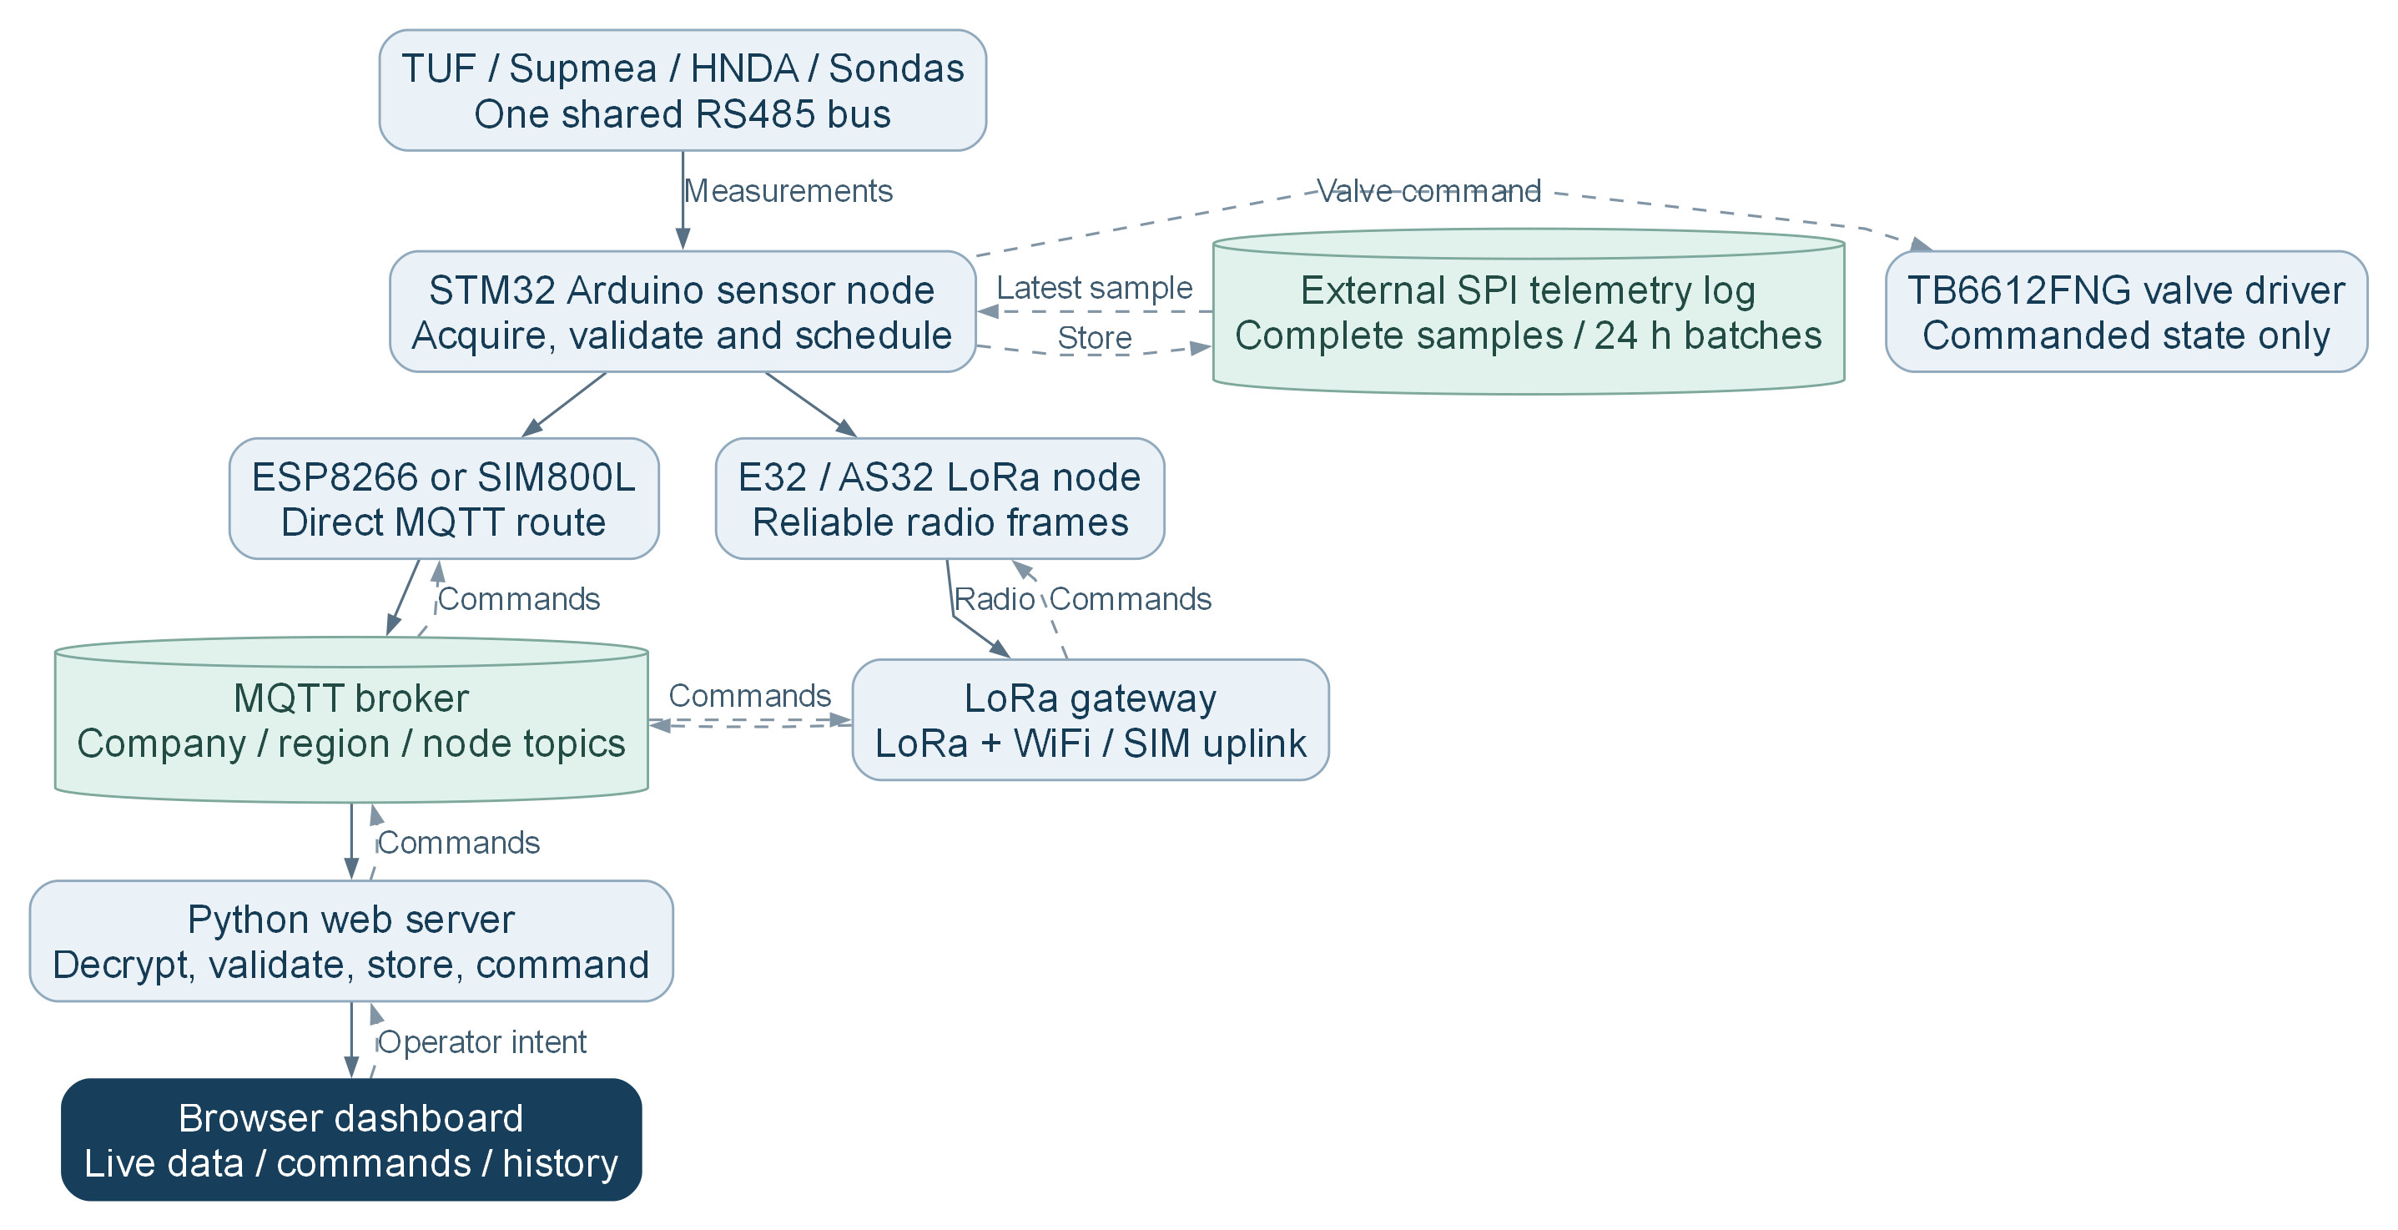
The gateway forwards the encrypted node payload; the server decodes it. LoRa-only nodes do not use their IP-modem path.
Solid arrows show functional data/control direction. All subsequent charts describe software behavior, not a new hardware wiring diagram.
Source chart F01; full verified paths and editable sources in Documentation/Flowcharts.

D2 Boot and reset initialization
Safety and the Standby handoff run before the IWDG; normal active initialization then selects the node or gateway path.
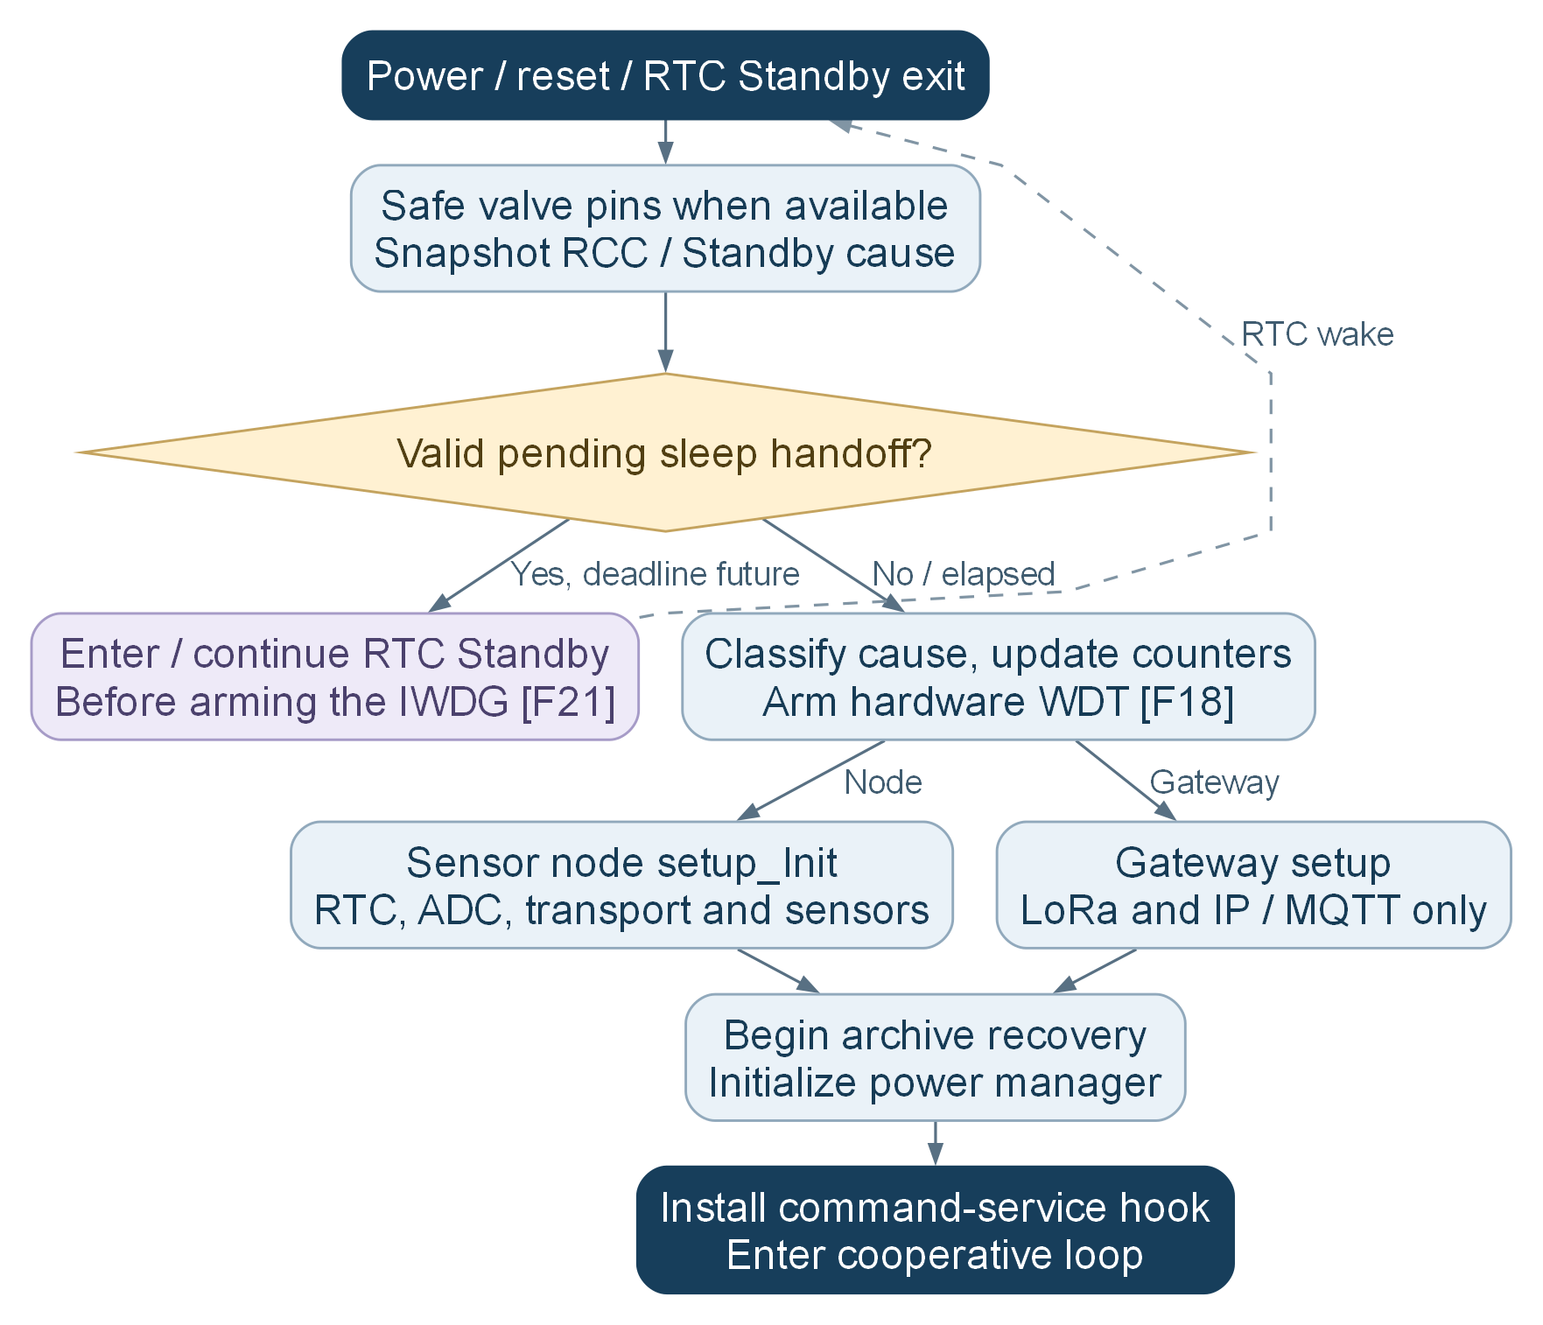
The default RTC date is not proof of trusted time. STIME establishes validated UTC time for calendar totals and flash retention.
The IWDG protects active startup calls as well as loop execution. A valid long Standby handoff deliberately occurs before it starts.
Source chart F03; full verified paths and editable sources in Documentation/Flowcharts.

D3 Sensor node cooperative main loop
Commands and replies precede sampling, routine uploads and bulk history. One enabled sensor is serviced per application pass.
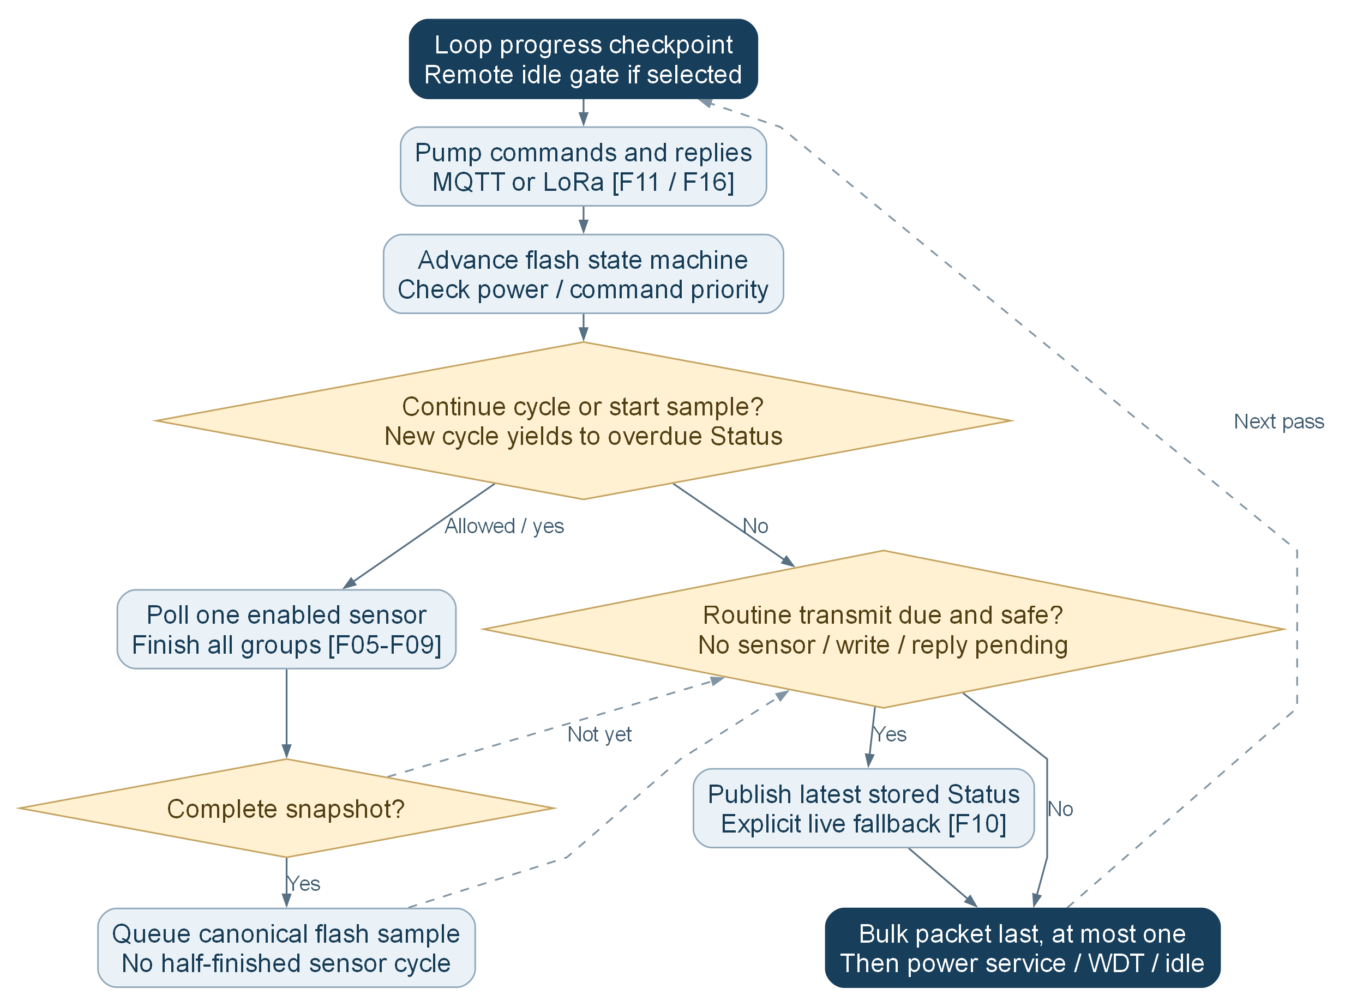
Priority is cooperative: an in-flight modem, sensor or logical LoRa send cannot be preempted instantly.
NORMAL, scheduled REMOTE_WAKE and default LORA_WOR use independent SRATE and STRAN deadlines. Legacy WOR and timed Standby retain combined-cycle policies [F20-F22].
SensorPollCycle finishes an active cycle, then gives an overdue Status an opportunity before another cycle starts. Failed or disabled sensors can still produce zero/invalid samples and reports. Pending command or flash write work can defer the report.
Source chart F04; full verified paths and editable sources in Documentation/Flowcharts.

D4 Supmea RTC day month and year consumption
Consumption comes from the accepted change in cumulative forward liters. RTC calendar keys decide the current day/month/year buckets.
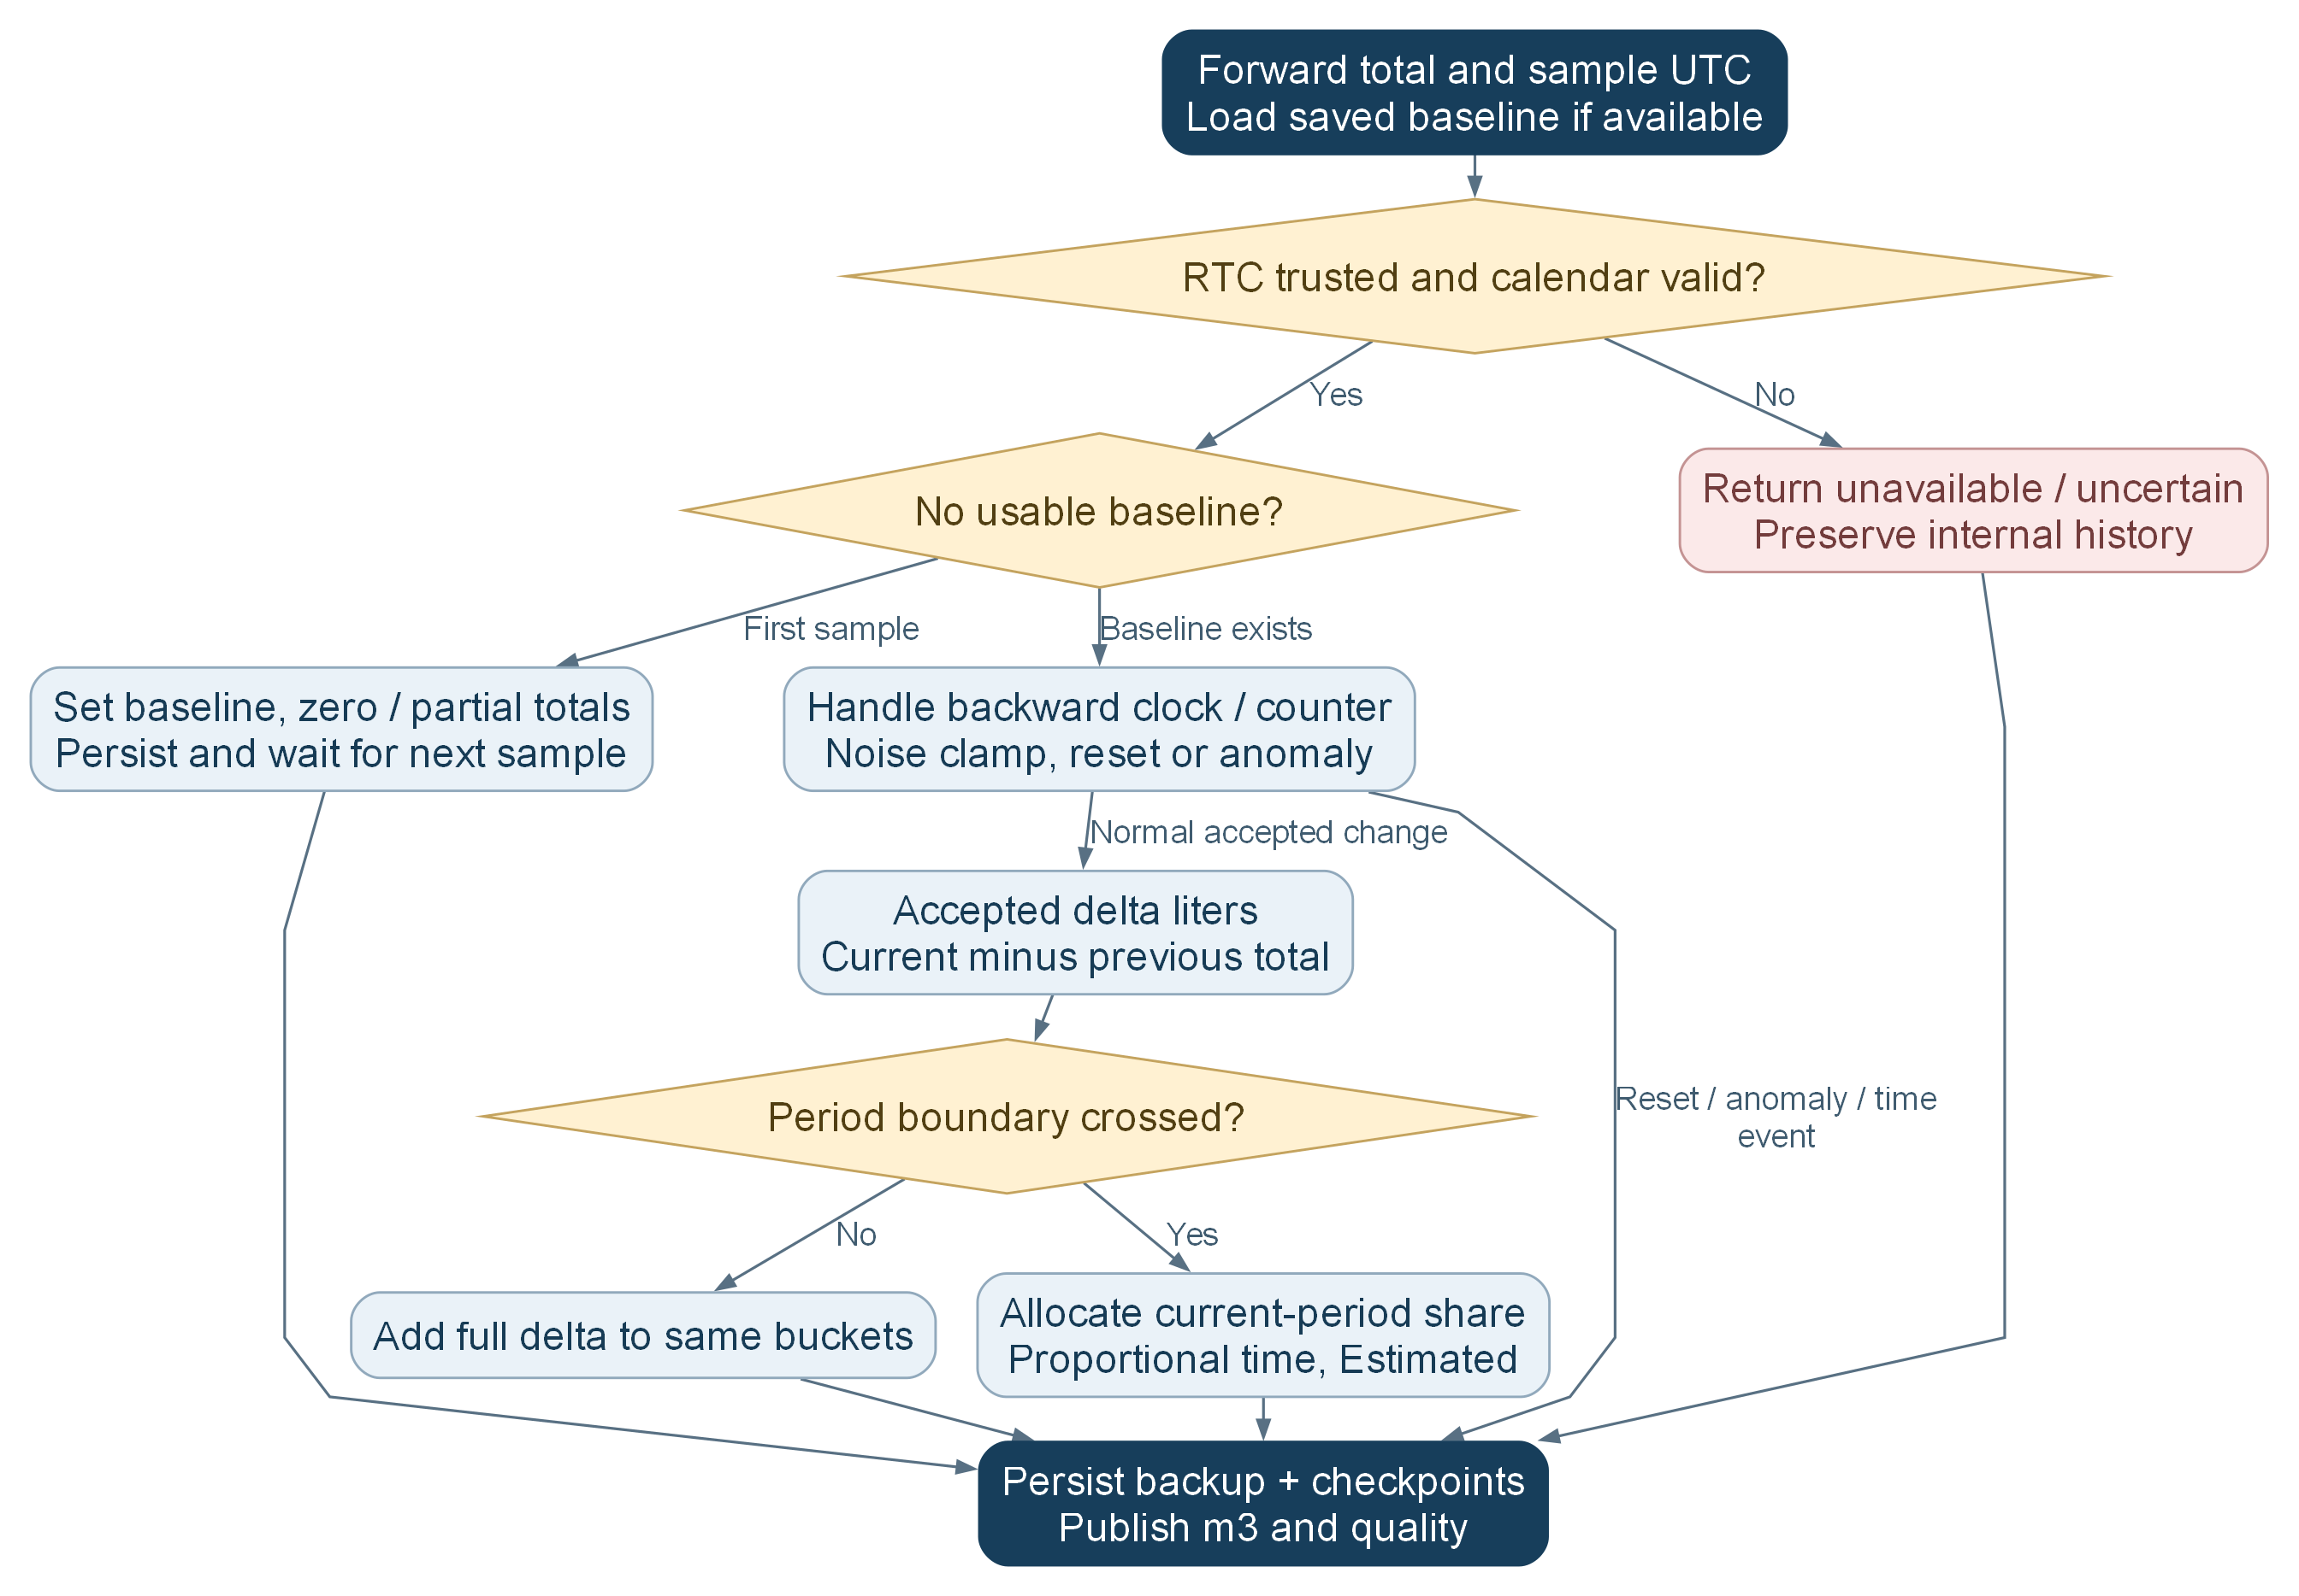
UTC RTC is converted using the configured UTC, fixed-offset or Africa/Cairo calendar policy. Cross-boundary allocation is an estimate, not a meter-provided daily register.
The first partial period cannot recover water consumed before its baseline. Backup state and durable checkpoints reduce loss but do not invent missing history.
Source chart F09; full verified paths and editable sources in Documentation/Flowcharts.

D5 Watchdog reset causes and two counters
The hardware IWDG resets stalled active code. Only genuine power-on/brownout and IWDG causes increment their corresponding persistent counters.
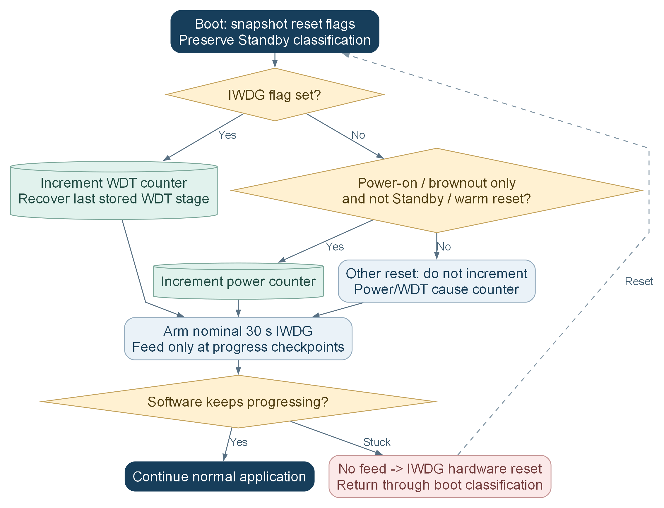
RESET-button / ST-Link software reset / planned Standby wake do not count as power resets. Deliberate WDT-based network recovery still counts as an IWDG reset.
Direct CMD7 clears the power count; CMD8 clears the WDT count. Readback verification, duplicate checks and ACK result expose storage failure. RTC alarms, not the WDT, schedule normal wakeups.
Source chart F18; full verified paths and editable sources in Documentation/Flowcharts.

D6 Remote wake with normal connected modem
The reachable-idle controller uses light CPU Sleep while the radio remains connected. The default policy responds to independent sampling and send deadlines.
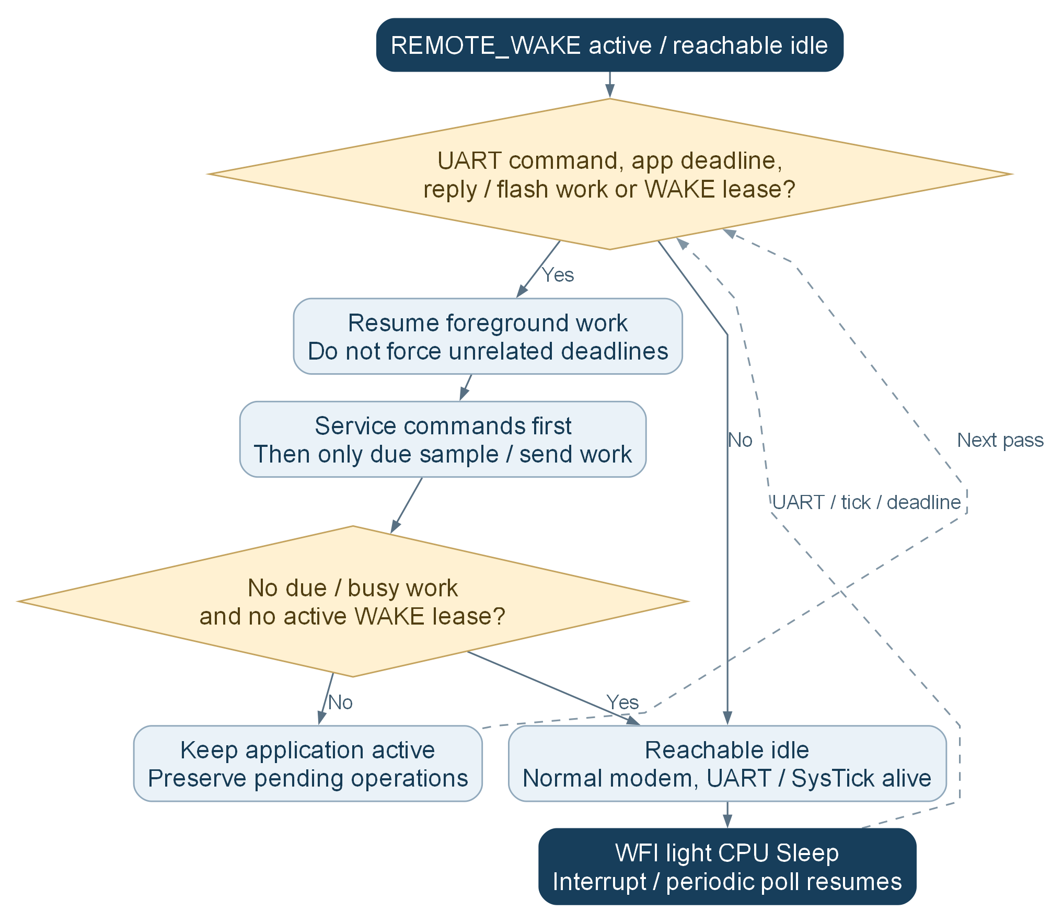
Default APP_REMOTE_WAKE_USE_APP_SCHEDULE=true uses SRATE and STRAN separately. false retains the older fixed-cycle remote policy.
WAKE requests an active lease of 1..86400 s; data 0 uses the configured default. Flash work/transfer guards prevent inappropriate idling; this is not RTC Standby or a modem DTR sleep implementation.
Source chart F20; full verified paths and editable sources in Documentation/Flowcharts.

D7 LoRa wake on radio with STM32 Stop
The leaf listens in Mode 2 while STM32 retains RAM in Stop. UART RX wakes for radio traffic and RTC alarms schedule due work.
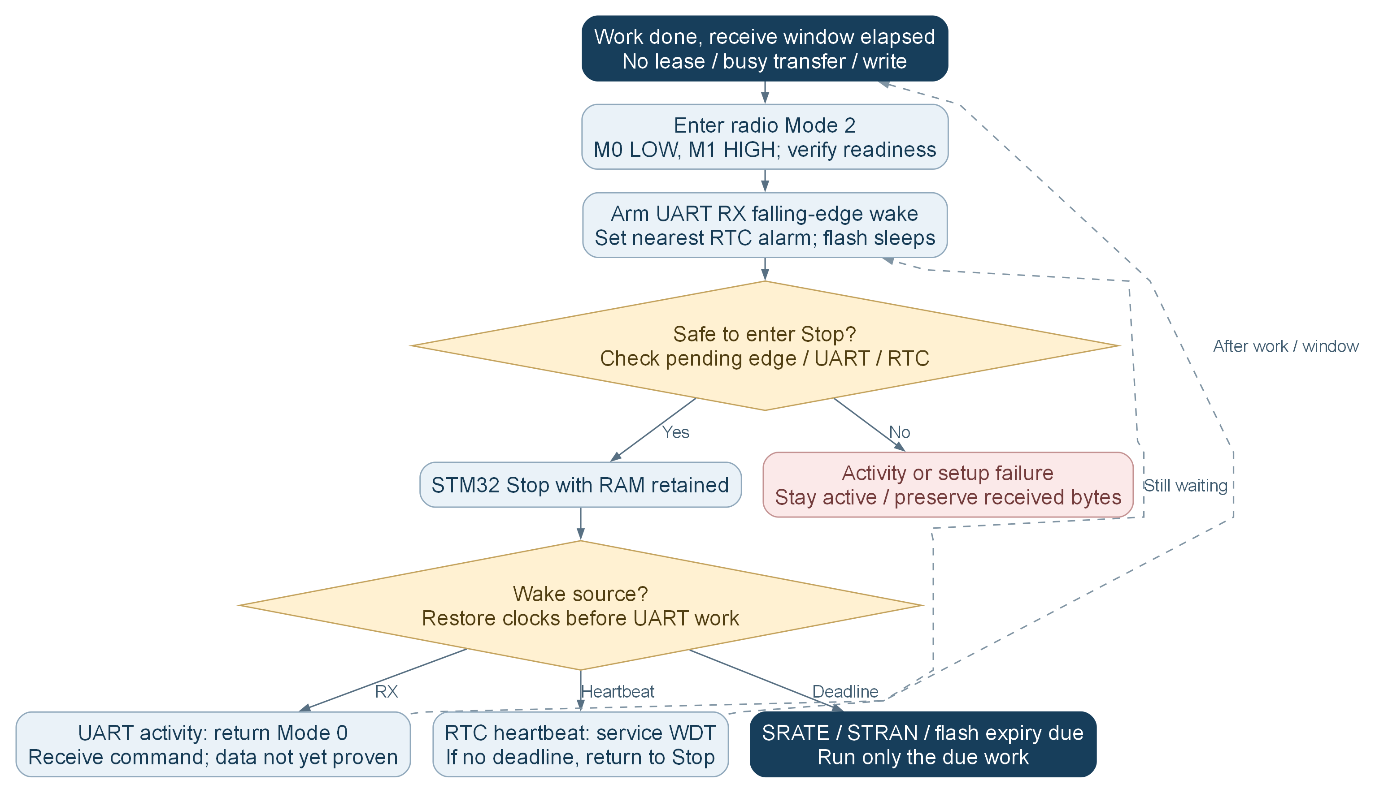
Gateway WOR TX sends a Mode-1 probe before the command. AUX remains a readiness signal; the optional legacy AUX wake selector is separate from the default UART RX path.
APP_LORA_WOR_USE_APP_SCHEDULE=true selects independent sampling and transmission deadlines. APP_POWER_SLEEP_SECONDS controls the legacy combined WOR cycle only when that switch is false. STIME must establish trusted RTC before Stop.
The default 15 s RTC heartbeat services the nominal 30 s IWDG in foreground. It does not force a sensor read or routine Status. Stop residence ages the application deadlines using coherent RTC time because millis pauses. WDT expiry resets the controller.
Source chart F22; full verified paths and editable sources in Documentation/Flowcharts.

D8 Capture and commit a flash sample
The external S25FL064L stores one canonical complete sample per accepted acquisition, with CRC and commit-last recovery.
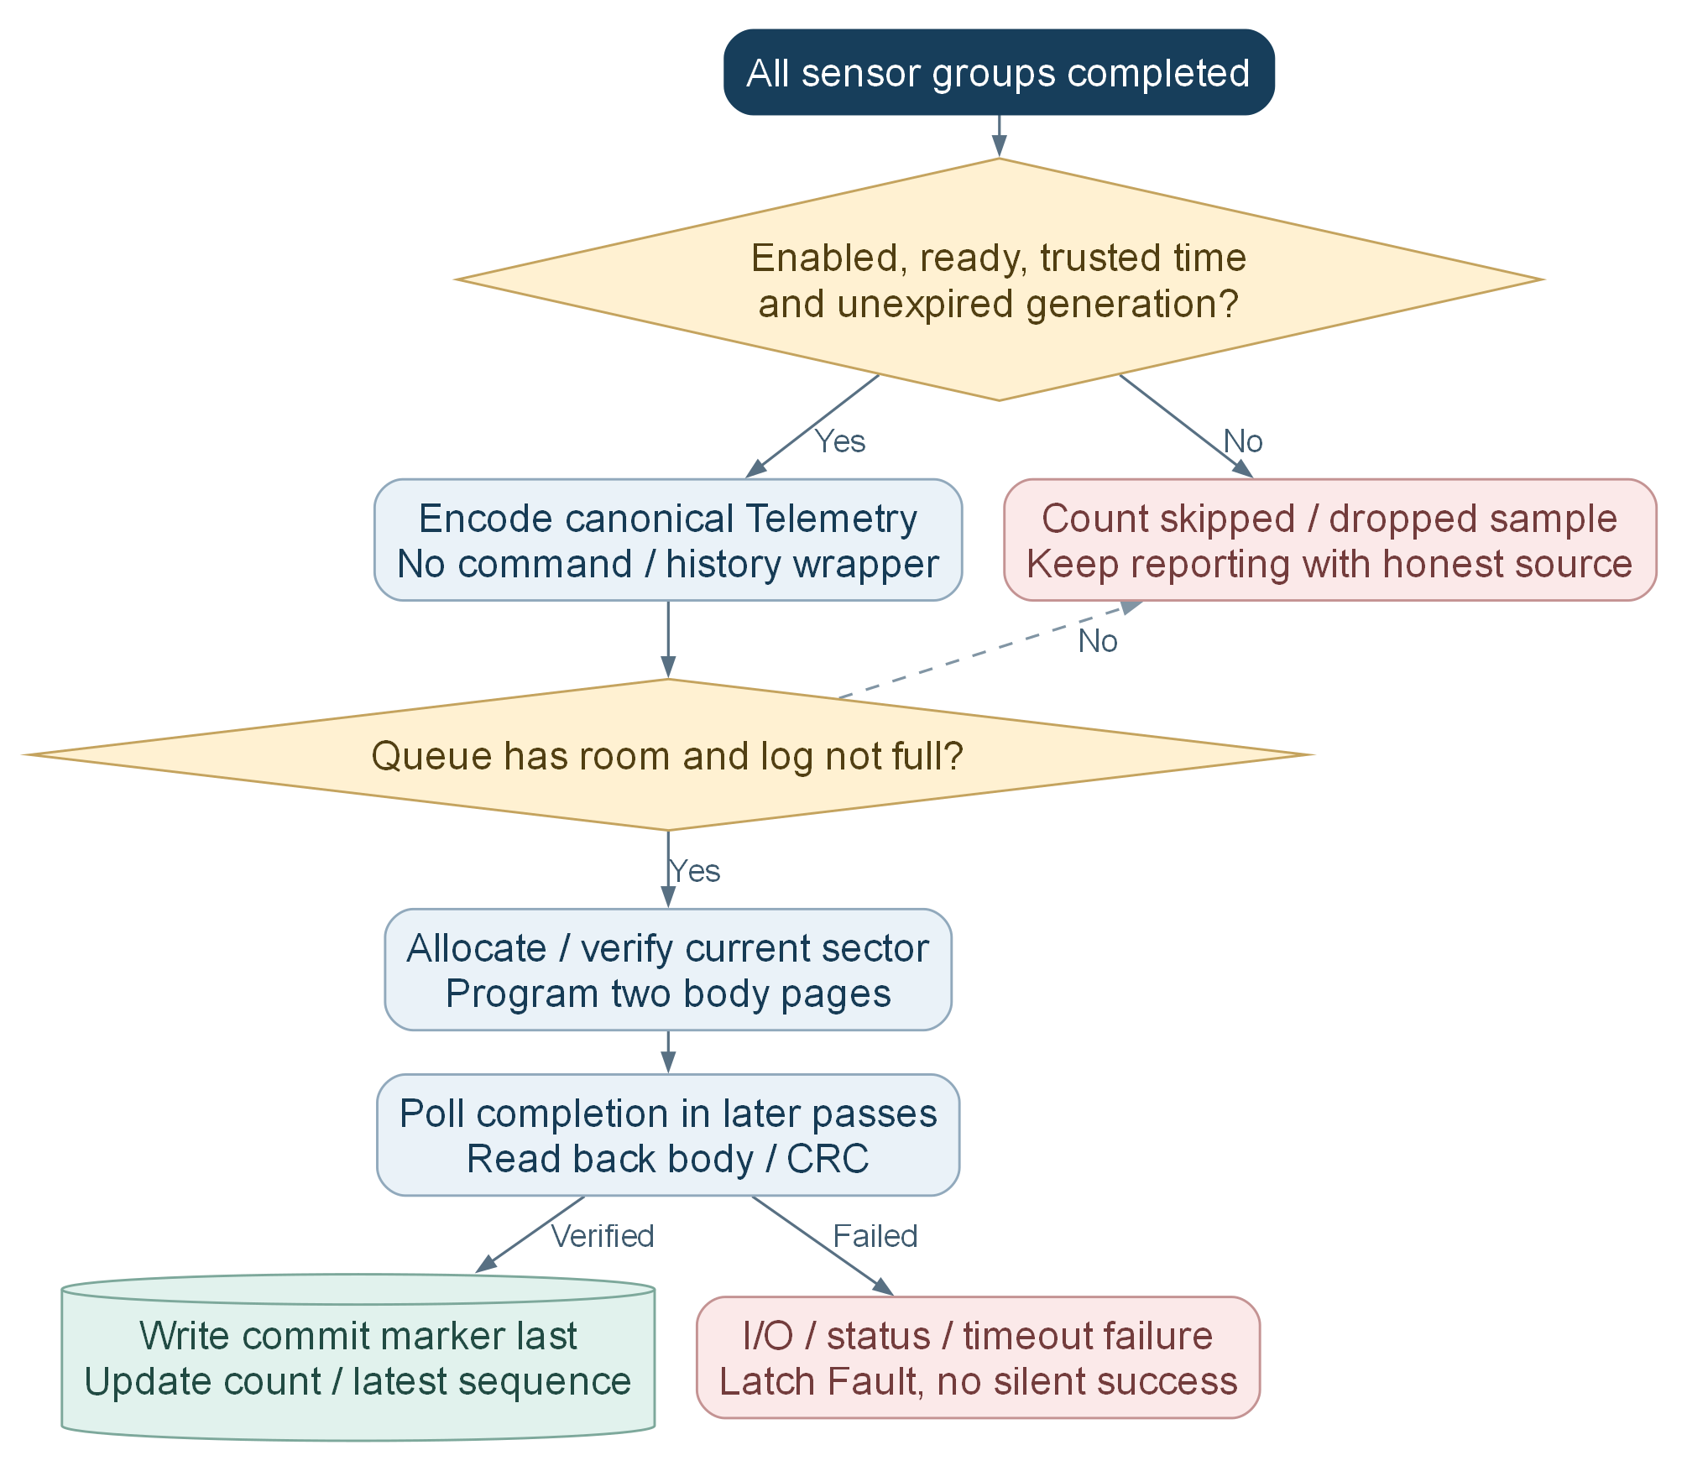
JEDEC 01 60 17 identifies the configured 8 MiB chip. Four RAM queue entries feed 512-byte slots with at most 472 canonical protobuf bytes each.
Capacity is 14,322 records. Full means stop appending and count drops, not overwrite unexpired records. A return from append means queued, not yet durable.
Source chart F23; full verified paths and editable sources in Documentation/Flowcharts.

D9 Flash recovery retention and clearing
Two metadata copies choose a durable generation. Records recover cooperatively; retention changes the generation before background physical reclamation.
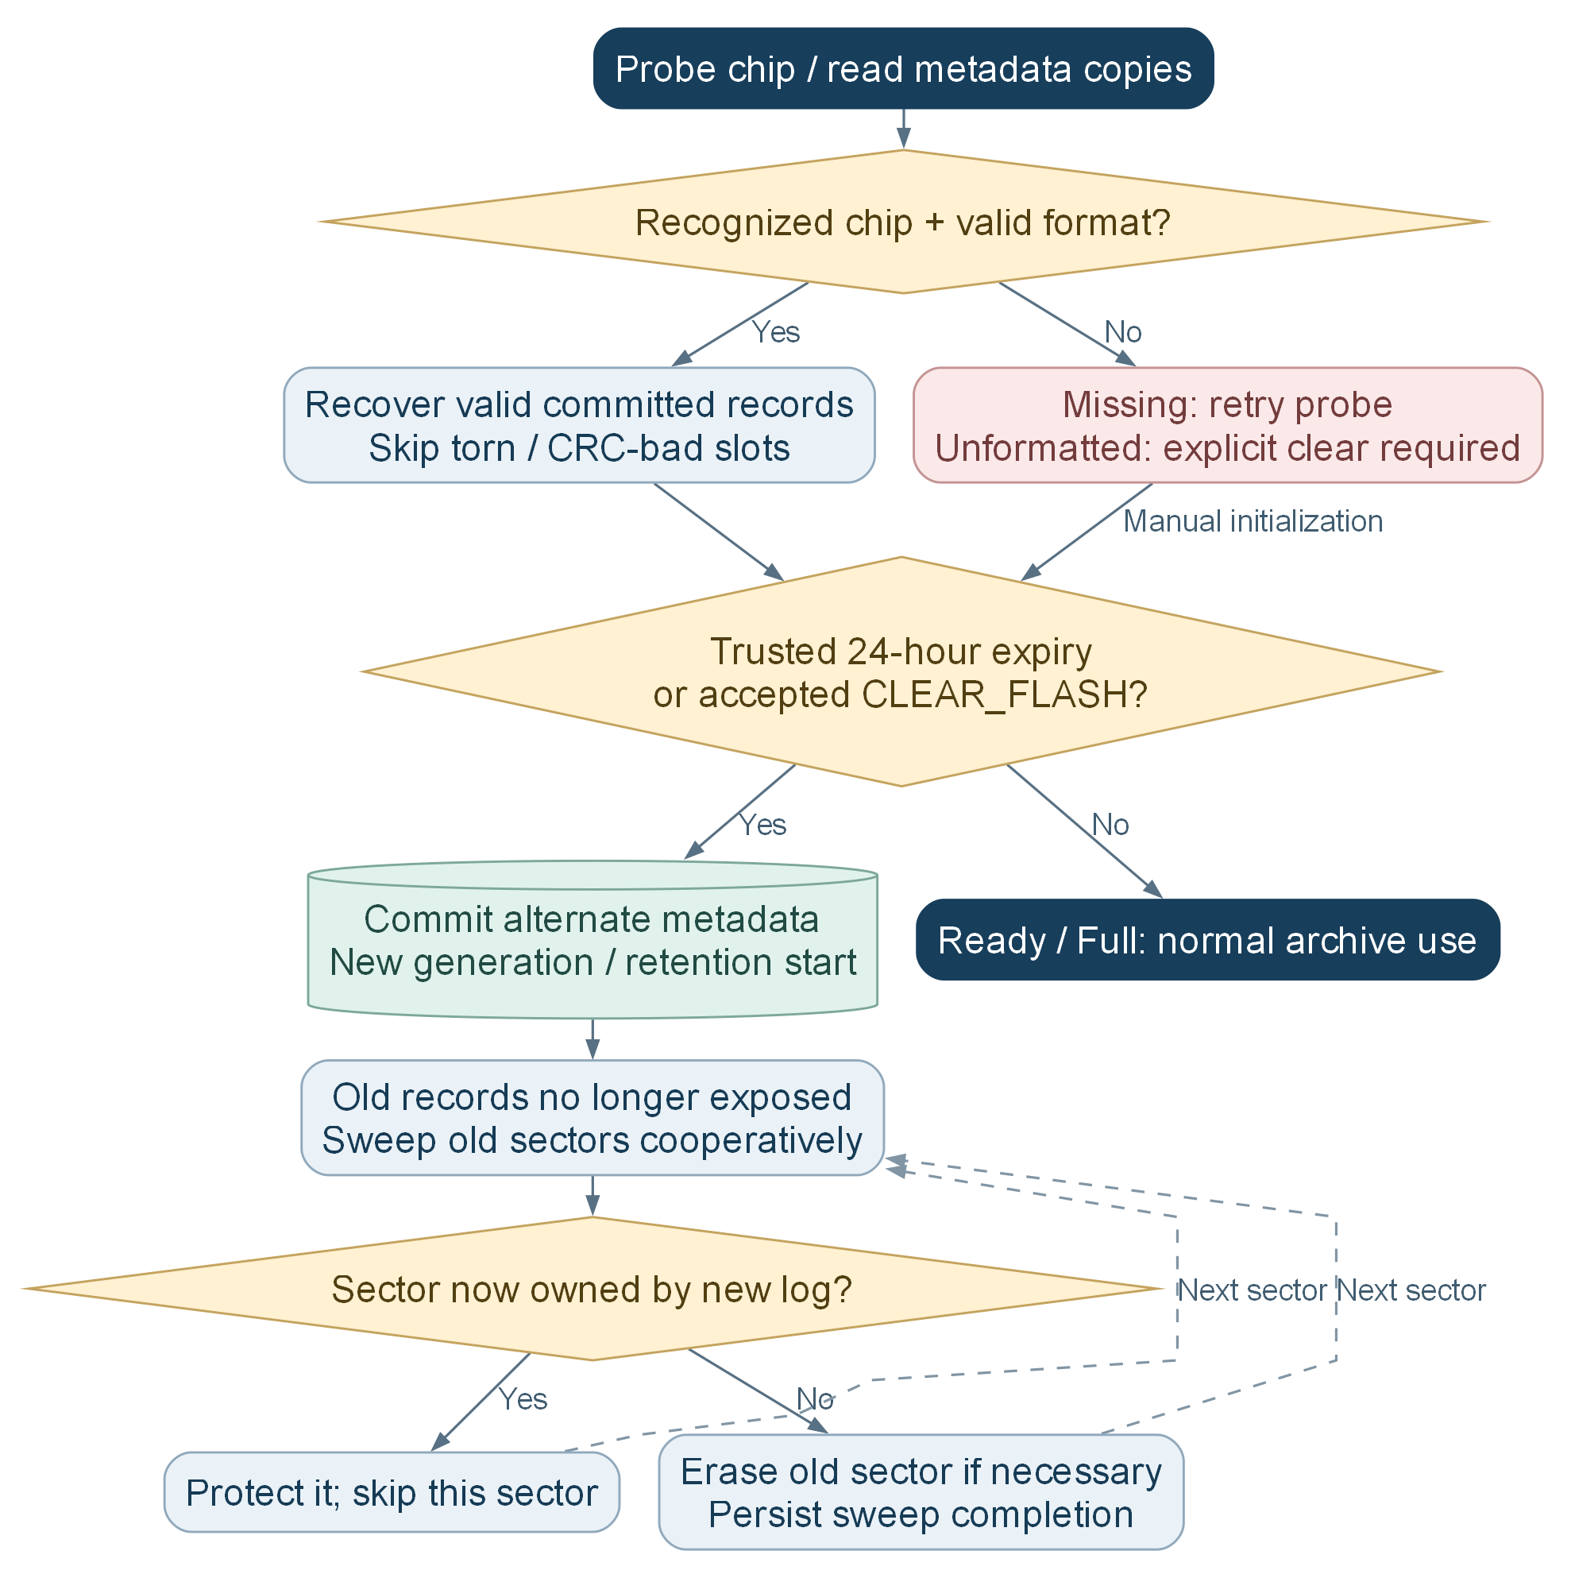
Retention is 24 elapsed hours from the persisted batch start, not local midnight. Untrusted/backward time cannot trigger automatic erase.
Ownership is rechecked on every sweep pass so newly allocated samples cannot be erased. Clear ACK is acceptance; physical erase progress may continue across active windows.
Source chart F24; full verified paths and editable sources in Documentation/Flowcharts.

D10 Download retained history with persistence ACK
FLASH_TODAY freezes the node day and final sequence. The node sends one indexed row at a time and advances only after server storage acknowledgment.
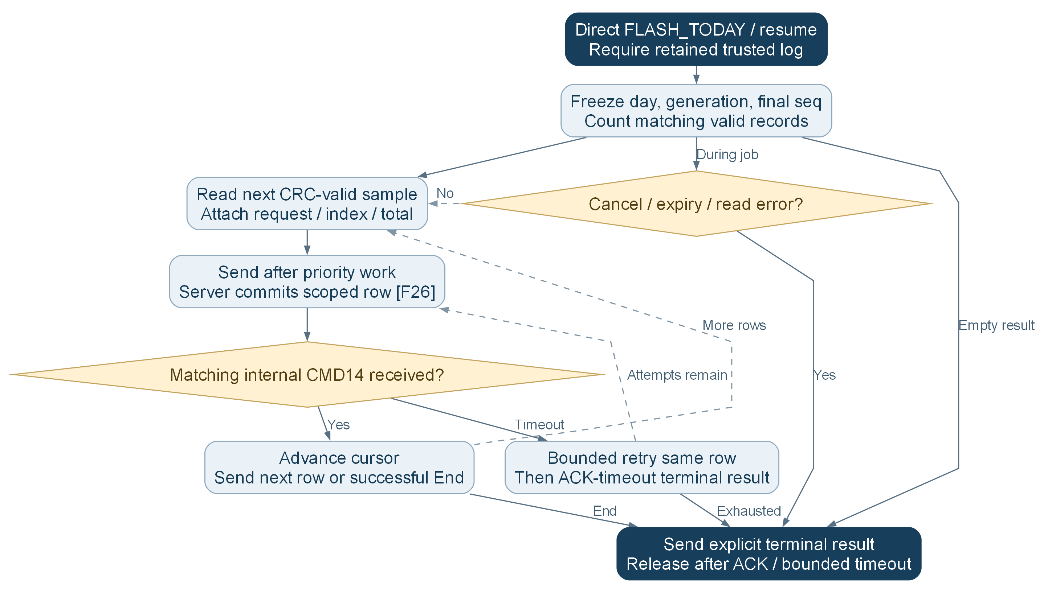
FLASH_LAST is a single original sample, not a new sensor poll. TODAY covers only the retained batch portion of the current node calendar day, not necessarily a complete day.
New acquisition remains allowed while download keeps the controller awake; later records are excluded from the frozen job. Server history does not feed live charts or consumption.
Source chart F25; full verified paths and editable sources in Documentation/Flowcharts.

