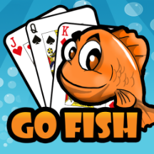**CME1212 Algorithms and Programming II**

**Homework 4**

Upload your program from *Google Classroom* until **24 April 2019, 23:55.**

Write a Java program for a simple version of ***Go Fish*** game.

<https://cardgames.io/gofish/>

The game is played with 24-card deck (4 times numbered from 1 to 6).

The game is played by 2 players (human vs computer).

**Objective**

The objective of the game is to collect as many "books" as possible. A *book* is four cards of the same rank. The player with the most books at the end of the game wins.

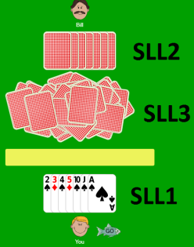

**Dealing and setup**

First, cards are dealt to the players, each player gets 7 cards. Once the dealing is done, the rest of the deck is put in a random pile on the table.

There are three single-linked lists (SLL):

1- SLL1 to hold the cards of the first player (human)

2- SLL2 to hold the cards of the second player (computer)

3- SLL3 to hold the cards on the table

**Asking and fishing**

You opened the game. You asks the computer for a particular rank. For example, you might ask if it has any sixes. You may only ask for ranks that you already have at least one card of. For instance, if you don't have any sixes yourself you can't ask for them.

- If the computer has any sixes, then it must give them to you, and you get another turn and can ask again.

- If the computer doesn't have any sixes then it will tell you to "Go Fish" which means that you will draw one card from the pile on the table. If you get a six, then you get a book.

When the computer plays, it randomly selects and asks a rank that it already has at least one card of. The rest of the game is the same.

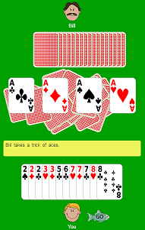

**Scoring**

If you have 4 of the same rank then you show the cards to the other player, and then place the four cards in a pile next to you. This is called a *book*. The player with the most books at the end of the game wins.

**End of the game**

If one of the players (human or computer) finishes all the cards in his hand, the game is over.

The winner should be displayed, if exists. The game may be ended without any winner (in the case of tie).

The program must display all steps until the game is over.

In your program, you can use single-linked list as you want, but you must use only single-linked list, don’t use other data structures such as array, stack and queue.

The user only must enter numbers highlighted in yellow.

Don’t use array.

Don’t use stack or queue.

Don’t use linked list class embedded in Java. Write your own single-linked list class.

**Sample output:**

**Turn: 1 Table**

You: 1 2 2 2556 book: 0 11635 434 4 3

Computer: 1 2 345 66 book: 0

You ask: 2

2 2 22

---------------------------------------------------------------------------------------

**Turn: 2 Table**

You: 1 556 book: 1 11635 434 4 3

Computer: 1 345 66 book: 0

You ask: 1

---------------------------------------------------------------------------------------

**Turn: 3 Table**

You: 11 556 book: 1 11635 434 4 3

Computer: 345 66 book: 0

You ask: 5

---------------------------------------------------------------------------------------

**Turn: 4 Table**

You: 11 555 6 book: 1 11635 434 4 3

Computer: 3466 book: 0

You ask: 6

---------------------------------------------------------------------------------------

**Turn: 5 Table**

You: 11 555 666 book: 1 11635 434 4 3

Computer: 34 book: 0

You ask: 1

Computer says “Go Fish”

---------------------------------------------------------------------------------------

**Turn: 6 Table**

You: 11 1555 666 book: 1 1635 434 4 3

Computer: 34 book: 0

Computer asks: 3

You say “Go Fish”

---------------------------------------------------------------------------------------

**Turn: 7 Table**

You: 11 1555 666 book: 1 635 434 4 3

Computer: 134 book: 0

You ask: 1

11 11

---------------------------------------------------------------------------------------

**Turn: 8 Table**

You: 555 666 book: 2 635 434 4 3

Computer: 34 book: 0

You ask: 5

Computer says “Go Fish”

---------------------------------------------------------------------------------------

**Turn: 9 Table**

You: 555 6666 book: 2 35 434 4 3

Computer: 34 book: 0

6666

Computer asks: 3

You say “Go Fish”

---------------------------------------------------------------------------------------

**Turn: 10 Table**

You: 555  book: 3 5 434 4 3

Computer: 334 book: 0

You ask: 5

Computer says “Go Fish”

---------------------------------------------------------------------------------------

**Turn: 11 Table**

You: 5555  book: 3 434 4 3

Computer: 334 book: 0

5555

---------------------------------------------------------------------------------------

Game is over.

You win the game !!

**Notes**

**1-** Upload format

**Step1:** Create a new folder, named by your student number and name (without any space)

For example: 2015510012_Ali_Tas



**Step2:** Copy all java files into this folder

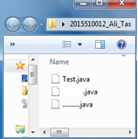

**Step3:** Compress the folder **2015510012_Ali_Tas.zip**

**Step4:** Upload the file **2015510012_Ali_Tas.zip** from *google.classroom.com*

**2-** Don’t use ENIGMA or any other extra library.

**3.**If you are late, your grade will be decreased 10 points for each day. After five days, your assignment will not be accepted.

**4-** Assignment must be your individual work.

**Cheating** is strictly prohibited.

All source codes will be automatically compared with each other by using a program.

If any cheating occurs, your assignment will be graded with **zero (0)**.