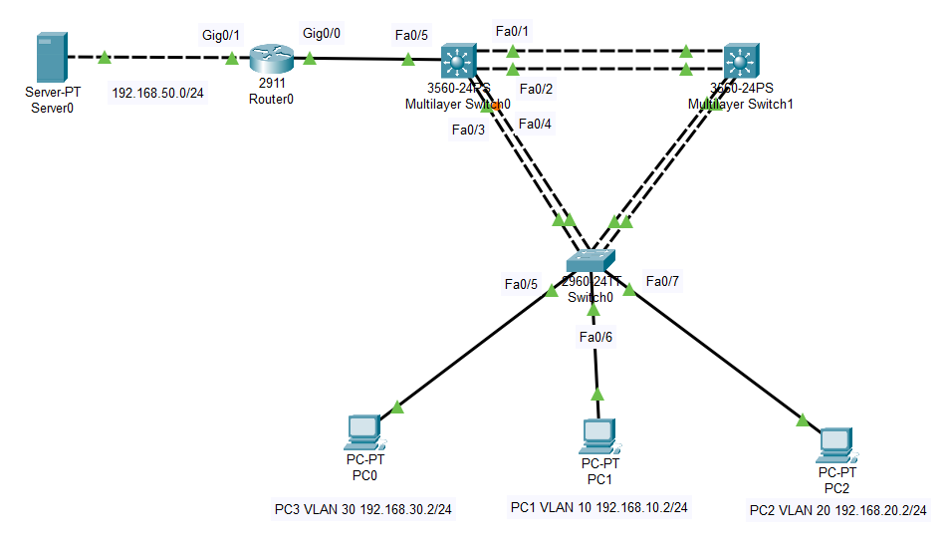

---Switch 0---

en

conf t

vlan 10

name pc1

int fa0/6

switchport mode access

switchport access vlan 10

exit

vlan 20

name pc2

int fa0/7

switchport mode access

switchport access vlan 20

exit

vlan 30

name pc3

int fa0/5

switchport mode access

switchport access vlan 30

int range fa0/1-4

switchport mode trunk

---Multilayer Switch 0---

vlan 10

name pc1

vlan 20

name pc2

vlan 30

name pc3

int range fa0/1-5

switchport trunk encapsulation dot1q

switchport mode trunk

---ROUTER---

en

conf t

int gig0/0

no shutdown

int gig0/0.10

encapsulation dot1Q 10

ip address 192.168.10.1 255.255.255.0

int gig0/0.20

encapsulation dot1Q 20

ip address 192.168.20.1 255.255.255.0

int gig0/0.30

encapsulation dot1Q 30

ip address 192.168.30.1 255.255.255.0

// dhcp tanımlama

exit

ip dhcp pool pc1

network 192.168.10.0 255.255.255.0

default-router 192.168.10.1

exit

ip dhcp pool pc2

network 192.168.20.0 255.255.255.0

default-router 192.168.20.1

exit

ip dhcp pool pc3

network 192.168.30.0 255.255.255.0

default-router 192.168.30.1

// VLAN 20 VE 30 ERİŞEBİLSİN 10 ERİŞEMESİN.FTP İLE

exit

int gig0/1

ip address 192.168.50.1

no shutdown

exit

access-list 100 permit tcp 192.168.20.0 0.0.0.255 host 192.168.50.254 eq 21

access-list 100 permit tcp 192.168.30.0 0.0.0.255 host 192.168.50.254 eq 21

int gig0/1

ip access-group 100 out

