**REPORT: Mobile App Development-ELC001**

**By: Selina Varshney**

**Roll No: 102103496**

**Batch: 1CO18**

**Objective:** To create an app on android studio, learn about different types of platforms like android, iOS and build its apk file.

**Problem Statement:** To create a menu app for a restaurant.

**App description:**

App name: frenchoven

The App uses flutter and is created on android studio. It is a menu card for a restaurant called-The French Oven. It is a Material, scaffold app with basic design features and a list view.

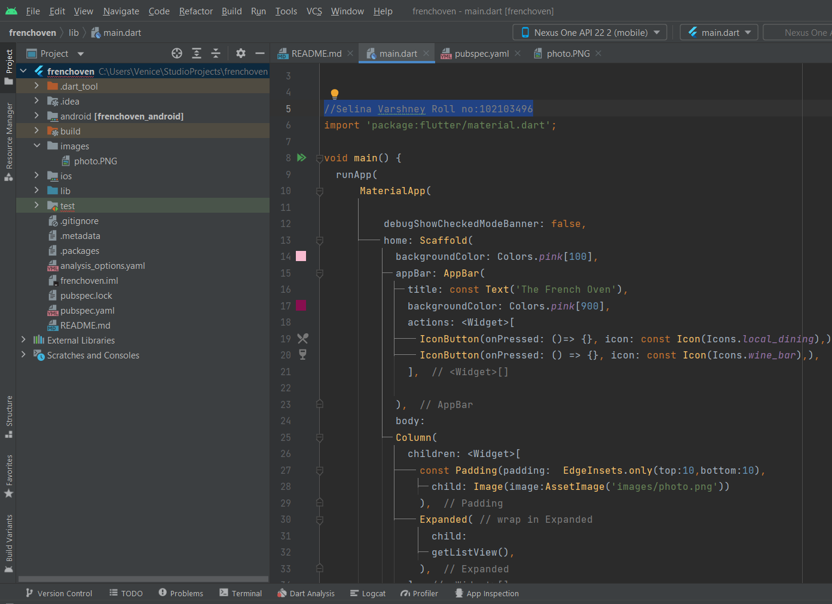

Running Application:

