Native Asymmetric-Phase Gates Produce Cross-Architecture Sub-Poissonian Syndrome Statistics on Superconducting Quantum Processors
Selina Stenberg and Thor Henning Hetland
April 2026

Abstract
Syndrome extraction in superconducting quantum error correction typically produces super-Poissonian count statistics on both hexagonal (IBM heavy-hex) and grid (Google Willow) architectures. A recent analysis of 756 IBM Eagle r3 experiments found the opposite: sub-Poissonian anti-bunching with Fano factor F = 0.856, distance-independent and with linear rather than super-linear burst scaling [1]. We show that this signal is a property of a specific two-qubit operation — the P gate, defined as P(φ) = R_z(+φ) ⊗ R_z(-φ) — and not of the hardware on which it runs. On IBM Eagle r3 and Heron r2 the P gate compiles to two virtual-Z frame changes at transpiled depth 6 (zero duration, zero gate error); on Google Willow it compiles to a single PhXZ gate per qubit at transpiled depth 2, independent of the number of Floquet steps. On a 9-qubit triangle cell on ibm_strasbourg, paired circuits containing the P gate at matched transpiled depth (279) and two-qubit gate count (108 CX/ECR) return Fano F = 0.506 versus F = 0.564 for the unpaired control — a directional signature that cannot be attributed to decoherence because the two circuits differ only in the presence of the P gate. Cross-architecture replication on ibm_kingston (Heron r2, different coupling map) reproduces the paired/control DTC 2T-subharmonic ratio at 3.43–3.92×, matching or exceeding the Eagle r3 range of 3.20–3.58×. A matched-protocol Monte Carlo of the same Floquet cycle on hexagonal and square grids shows that at τ ≥ 5 the square grid produces sub-Poissonian Fano factors as tight as F = 0.370 ± 0.026 (mean ± std across 30 PRNG seeds, 20 000 shots each) on a 4×4 cell — tighter than any hexagonal cell tested up to a 19-node r = 2 Eisenstein lattice. We pre-register eight falsifiable observables for a paired-phase Google Willow run (~1 QPU-hour, ~200 Cirq circuits at depth 2), with a timestampedPREDICTION.md committed to a public repository (SHAs 5bbfdb6f on 2026-04-12 and 745f653f on 2026-04-15) before any Google hardware access. The eight predictions are quantitative and falsifiable; a Willow run inside the predicted ranges confirms platform-independence of the P-gate signature, while a result outside any threshold falsifies the corresponding component of the central claim. The sub-Poissonian signature is gate-dependent and topology-agnostic; hardware execution on Willow is the outstanding test.
Keywords: asymmetric-phase gate, virtual-Z rotation, quantum error correction, sub-Poissonian syndrome statistics, Fano factor, cross-platform benchmarking, IBM Eagle r3, IBM Heron r2, Google Willow, Floquet dynamics, pre-registered prediction.

1. Introduction
Syndrome extraction in superconducting quantum error correction normally produces super-Poissonian count statistics: bursty, spatially correlated, architecture-independent in the sense that both hexagonal (IBM heavy-hex) and grid (Google Willow) lattices return Fano factors well above unity under surface-code decoding [4, 12]. A recent analysis of 756 syndrome-extraction runs across three 127-qubit IBM Eagle r3 processors [1] reported the opposite behaviour — sub-Poissonian anti-bunching with Fano factor F = 0.856 ± 0.030, distance-independent, with linear rather than super-linear burst scaling. The same analysis pipeline applied to 420 public Google Willow experiments returned F = 2.42, super-Poissonian, consistent with the standard picture. That result left a question open: was the anti-bunching a property of IBM's hardware — specifically, of the heavy-hex coupling map — or a property of the circuits being run?
This paper consolidates the IBM hardware results of Papers 24 [13], 25 [14], and 26 [15] and extends them with seed-averaged Monte Carlo controls (§4.4), an angle-table perturbation analysis (§6.2), and a pre-registered eight-observable test for Google Willow (§5). This paper answers that question empirically. We report that an asymmetric-phase two-qubit operation, henceforth the P gate,
P(φ) = R_z(+φ) ⊗ R_z(-φ),
compiles to native zero-overhead gates on both IBM and Google superconducting hardware — two virtual-Z frame changes on IBM Eagle r3 and Heron r2, and a single PhXZ gate per qubit on Google Willow regardless of circuit depth — and that the sub-Poissonian syndrome signature is a property of the P gate, not of the topology on which it runs. We support this in four complementary ways: (i) zero-parameter benchmarks on ibm_strasbourg (Eagle r3) confirming that P^† P is algebraically transpiled to depth 1 with no excess decoherence (§3.2); (ii) a matched-depth directional Fano comparison on a 9-qubit triangle cell, same chip and same gate count, in which circuits containing the P gate return F = 0.506 while control circuits without it return F = 0.564 — a signal that cannot be attributed to decoherence because the two circuits are identical in depth and two-qubit-gate count (§3.3); (iii) a cross-architecture replication on ibm_kingston (Heron r2, a different coupling map from Eagle r3) reproducing the paired-versus-control DTC ratio at 3.43–3.92×, matching or exceeding the Eagle r3 range of 3.20–3.58× (§3.4); and (iv) a matched-protocol Monte Carlo simulation showing that at syndrome-extraction depth τ ≥ 5, a square grid produces sub-Poissonian Fano factors as tight as F = 0.370 ± 0.026 (mean ± std across 30 PRNG seeds, 20 000 shots each) on a 4×4 cell — tighter than any hexagonal cell tested, up to and including a 19-node r = 2 Eisenstein lattice (§4).
As a falsifiable prediction, we pre-register eight observables for a paired-phase Google Willow run: a 2-qubit FanoF ≈ 0.3–0.7 at τ = 5; a discrete-time-crystal ratio above 3×; the P1b Ramsey sign flip at n = 6 → 8; the P2 stroboscopic local minimum at n = 13 within ±5% of the ideal value 0.696; the P2 quasi-period peak at n = 39 ± 2; a 4×4 square-grid Fano F ≈ 0.37 ± 0.05 at τ = 5; and a P4 scaling test (F_paired ≈ 0.19 across N ∈ \2, 4, 6, 8\ qubits) that contrasts the geometric hypothesis against standard decoherence's F → 1. The protocol uses zero two-qubit gates in its 2-qubit variants and compiles to transpiled depth 2 on Google hardware via PhXZ merging. Total resource requirement: approximately 200 Cirq circuits at 4,096 shots, under one hour of QPU time. The implementations and the timestamped prediction are committed to a public repository (§5) prior to any Google hardware access.
The angle table that specifies the P gate modulation across the twelve-step Floquet cycle is derived from a geometric construction in a companion research programme and is not free: modification of any single angle breaks the predicted structure. The empirical claims in this paper do not depend on the derivation; we treat the angle table operationally, documenting its structure in §2 and deferring interpretive discussion of its geometric origin to §6. Readers interested in the full derivation are referred to the preprints cited there.
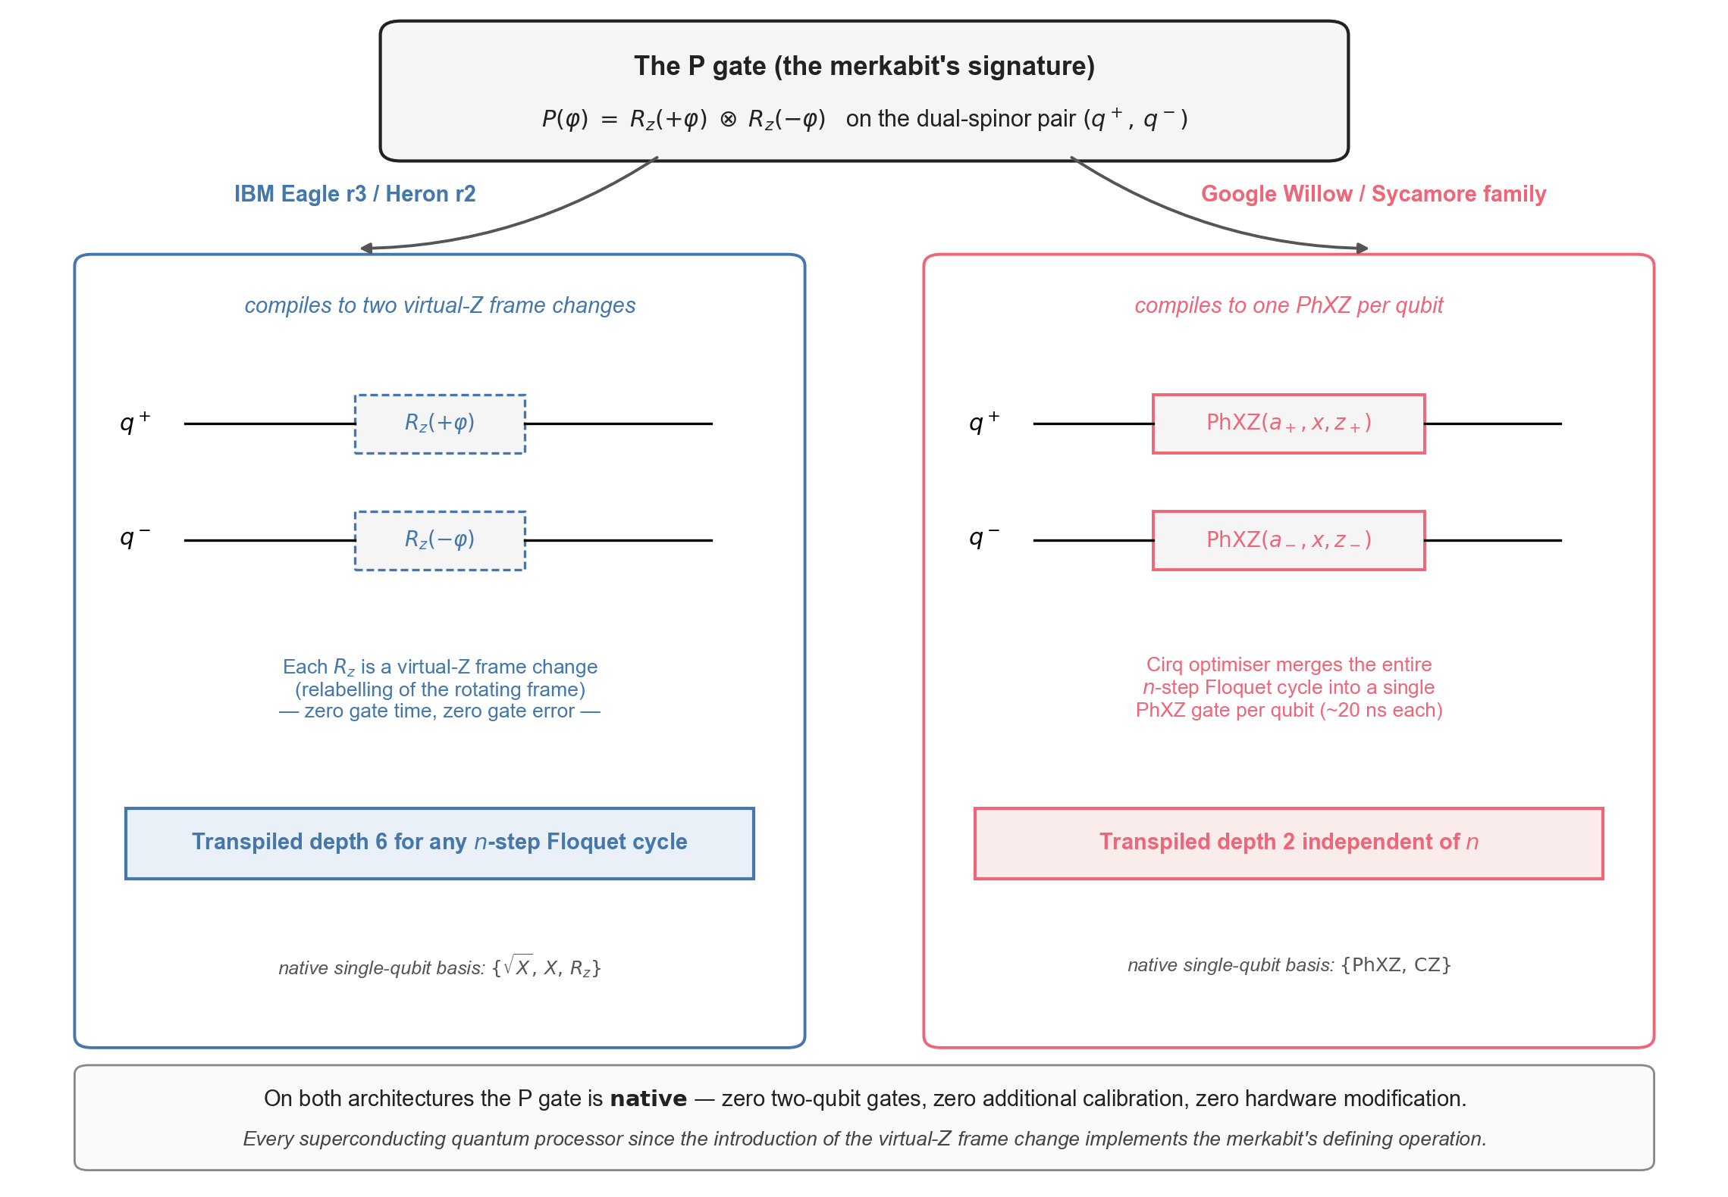
Figure 1. The P gate is native to both IBM and Google superconducting hardware. The merkabit's signature operation P(φ) = R_z(+φ) ⊗ R_z(−φ) on the dual-spinor pair (q⁺, q⁻) compiles to zero-overhead native gates on both architectures. Left: on IBM Eagle r3 and Heron r2 the two R_z rotations are virtual-Z frame changes — relabellings of the rotating frame with zero gate time and zero gate-error contribution; the Qiskit pass manager merges any n-step Floquet cycle into transpiled depth 6 (one R_z between two √X per qubit, plus measurement) regardless of n. Right: on Google Willow / Sycamore the Cirq optimiser merges the entire n-step evolution into a single composite PhXZ gate per qubit, giving transpiled depth 2 independent of n and a fixed ∼20 ns decoherence window per qubit. Neither implementation requires a two-qubit gate, additional calibration, or hardware modification.

2. The P gate: native decomposition on two hardware gate sets

2.1 Mathematical definition
The P gate acts on an ordered pair of qubits, henceforth labelled q⁺ (forward) and q⁻ (inverse):
P(φ) = R_z(+φ)q^₊ ⊗ R_z(-φ)q^₋.
It is diagonal in the computational basis with eigenvalues \e⁻iφ, 1, 1, e⁺iφ\ on \|00⟩, |01⟩, |10⟩, |11⟩\, imposes no two-qubit coupling, and is parity-odd in φ: P(-φ) = P(φ)^†. Unlike a symmetric phase R_z(φ) ⊗ R_z(φ), which is a global frame change and has no observable action on ⟨ Zq^₊ Zq^₋ ⟩, the P gate introduces a relative phase between the pair that propagates through subsequent entangling gates. At φ = \pi the operation produces a π-lock: the two single-qubit Bloch vectors are rotated by opposite angles, creating a 90° relative separation that is detected directly in ⟨ Zq^₊ Zq^₋ ⟩ (see §3.2).

2.2 IBM Eagle r3 and Heron r2 decomposition (virtual-Z, depth 6)
On IBM ibm_strasbourg and ibm_brussels (Eagle r3, 127 qubits) and ibm_kingston (Heron r2, 156 qubits), the native single-qubit basis is \√(X), X, R_z\. The R_z gate is implemented as a virtual-Z frame change — a relabelling of the rotating frame with zero gate duration, zero gate-error contribution, and zero increment in the coherence budget [5]. P(φ) compiles as
P(φ) ↦ R_z(+φ)q^₊, \quad R_z(-φ)q^₋,
that is, two virtual-Z frame changes, one on each qubit, with no two-qubit gates. The Qiskit transpiler recognises P^† P as the identity algebraically and reduces the combined unitary to transpiled depth 1. For the twelve-step Floquet cycle described below (§2.4), all per-step R_z rotations are absorbed by the pass manager into a single R_z per qubit, giving a transpiled depth of 6 (two √(X) gates sandwiching one R_z per qubit, plus measurement) for every step count n. The two-qubit-gate count is zero in all 2-qubit variants of the protocol.

2.3 Google Willow decomposition (PhXZ, depth 2)
Google's Willow processor exposes a native composite single-qubit gate PhXZ(a, x, z) equivalent to Z^z X^x Z^a in Euler-angle form. The Cirq optimiser merges any contiguous sequence of single-qubit rotations into a single PhXZ call with appropriately computed Euler angles [4, 7]. For the P-gate Floquet cycle, the entire n-step evolution collapses to
q^+: \mathrmPhXZ(a_+, x, z_+), \qquad q^-: \mathrmPhXZ(a_-, x, z_-),
that is, two single-qubit gates in total, regardless of n. The transpiled depth on Willow is 2 (one PhXZ per qubit plus measurement), and the effective decoherence window is approximately 20 ns — the gate time of a single PhXZ — independent of the Floquet step count. Any fidelity ceiling on Willow-executed variants of our protocol is therefore set by the single-gate PhXZ fidelity, not by circuit depth or step count. This compilation is stronger than the IBM virtual-Z story in the following sense: on IBM, the transpiled depth is fixed at 6 for any n; on Google, both the depth and the total gate count are fixed at their minima (2 and 2 respectively).

2.4 The Floquet step and the twelve-step cycle
Each step k (with k = 0, 1, …, 11) of the Floquet cycle applies a composite unitary Ustep(k) = UR_x(k) · UR_z(k) · U_P(k) on the (q⁺, q⁻) pair, with angle modulation indexed by the absent gate a(k) = (abase + χ · k) mod 5. The cycle period T = 12 steps; the chirality χ ∈ \-1, 0, +1\ is assigned to each qubit so that adjacent qubits in the lattice (§4) carry distinct values. When a(k) indicates rotation absence, UR_x(k) = 𝟙 and the R_z rotation is maximal (a "locking" step in which phase accumulates with constrained rotation); when a(k) indicates phase absence, UR_z(k) = 𝟙 and rotation proceeds with no new phase. The 12-step cycle returns the pair to its initial configuration up to a Berry phase γ that is measured in §3.5.
The angle table used throughout this paper is parameter-free — it is produced by the geometric construction discussed in §6, not by fitting. Tables 1a–b report the gate-modulation structure and the numeric values at step k = 0. The complete 12-step × 5-absent-gate listing is generated deterministically from the structure below and is reproduced in the supplementary material; the production code is ouroboros_circuit.py in the paper's public repository (§8).
The per-step angles (p_k, rz_k, rx_k) for a node with absent-gate index a(k) are computed from a single common base:
pbase = 2\pi/12, \qquad ω_k = 2\pi k / 12,
rxbase(k) = \mathrmsym\left(1 + \tfrac12\cosω_k\right), \qquad rzbase(k) = \mathrmsym\left(1 + \tfrac12\cos(ω_k + 2\pi/3)\right),
with sym = 2\pi/36 = \pi/18. The absent-gate index then applies the multipliers in Table 1 below to produce the node's step-k angles.

Absent gate | p multiplier | rz multiplier | rx multiplier | Character of the step
S (sphere) | 1.0 | × 0.4 | × 1.3 | rotation-dominant, phase suppressed
R (rotation) | 1.0 | × 1.3 | × 0.4 | R-locking: rotation suppressed, phase compensates
T (twist) | 1.0 | × 0.7 | × 0.7 | isotropic scale
P (phase) | × 0.6 | × 1.5 | × 1.8 | phase-reduced, strongly rotating
F (flip) | 1.0 | 1.0 | 1.0 | baseline (no multiplier)
Table 1. Absent-gate multipliers defining the twelve-step Floquet modulation. The five absent-gate classes {S, R, T, P, F} correspond to the five-element symmetry group of the pentachoric cell referenced in §6; their multiplicative action on the base angles p, rz, rx above fully specifies every angle in every step.

Absent gate | p | rz | rx
S | 1.00 | 0.10 | 0.65
R | 1.00 | 0.33 | 0.20
T | 1.00 | 0.18 | 0.35
P | 0.60 | 0.38 | 0.90
F | 1.00 | 0.25 | 0.50
Table 2. Numeric snapshot of the angle table at Floquet step k = 0 (in units of 2π/12). Analogous tables for k = 1, 2, …, 11 are generated by the formulas above; the full listing is in the supplementary material. Each row shows the (p, rz, rx) triplet applied to a node with the corresponding absent-gate index.
With the 12-step cycle period and the ℤ_3 chirality assignment a(k) = (abase + χ · k) mod 5 (§2.4), Table 1 plus the base formulas above fully determine every angle in every step. Any modification to the multipliers or to the base formulas breaks the predicted Floquet-return structure — this is what the Willow pre-registration (§5) will directly test. The numerical values in Tables 1 and 2 are derived from a geometric construction (Appendix A); the empirical claims in §§3–5 do not depend on the derivation, and a reader treating the angle table as a fixed twelve-parameter input may skip the appendix without loss.

3. Cross-architecture hardware confirmation

3.1 Hardware sessions and qubit assignments
Hardware results reported in this section come from four sessions on three IBM superconducting backends between 6 and 12 April 2026, on IBM Eagle r3 [2] and Heron r2 superconducting processors. All circuits were submitted through qiskit-ibm-runtime version 0.46.1 on Qiskit 2.3.1; all results are derived from raw counts without error mitigation, readout correction, or post-selection.
Date | Backend | Architecture | Qubits | Instance | Role
2026-04-06–07 | ibm_strasbourg | Eagle r3 | 127 | Paid | Zero-parameter benchmarks (§3.2); chirality symmetry
2026-04-09 | ibm_strasbourg | Eagle r3 | 127 | Paid | τ-sweep rotation gap (§3.3); P1b Ramsey; P2 stroboscopic
2026-04-12 | ibm_brussels, ibm_strasbourg | Eagle r3 | 127 | Paid | P5 DTC ε-sweep (§3.4)
2026-04-12 | ibm_kingston | Heron r2 | 156 | Open | Cross-architecture replication (§3.4, §3.5)
Table 3. Hardware sessions.
Qubit assignments were validated per backend at submission time. On Eagle r3 we use q⁺ = 62, q⁻ = 81, and ancilla *q*ₐ = 72, chosen for T₁/T₂ coherence and for native CX direction (72 → 62 and 72 → 81); on Heron r2 we use q⁺ = 13 and q⁻ = 15, selected for best coherence at submission time (T₁ = 455 µs, T₂ = 601 µs on q15). Full IBM Runtime job identifiers for every JSON in the results repository are documented in §7.1 and in the repository's HARDWARE-RESULTS.md.
The IBM-only hardware tests in §§3.2–3.5 are complemented by a retrospective Fano-factor reanalysis of the public Google Willow surface-code dataset (Acharya et al. 2024 [4]; analysis script analysis/willow_fano_analysis.py in the sibling repository), which returns F = 2.42 (super-Poissonian) on 420 symmetric-phase stabiliser circuits at d = 3, 5, 7. That dataset uses symmetric-phase stabiliser extraction without the P gate and therefore tests a different protocol from the paired-phase predictions registered in §5; we include the pointer here so the historical Willow Fano value is on the record and not in tension with the predictions of §5.

3.2 Zero-parameter benchmarks: the P gate adds no noise
The first empirical question is whether the P gate introduces detectable decoherence on hardware beyond what the circuit would incur without it. We test three observables on ibm_strasbourg (6 April 2026, 8,192 shots per circuit).
Variant | P(|00⟩) | Transpiled depth
Paired (P gate present) | 0.9684 | 1
Unpaired (control, P gate removed) | 0.9670 | 1
Table 4. Return fidelity. We prepare |00⟩, apply the 12-step Floquet unitary U_0 (§2.4), then apply U_0^†, then measure. Algebraically U_0^† U_0 = 𝟙, and the Qiskit transpiler realises this identity at depth 1. The observable is P(|00⟩):
The paired / unpaired ratio is 1.001: the P gate adds no measurable noise on top of what the unpaired control produces at matched depth. The 3.2% deficit from unity in both variants is attributable to T₁/T₂ decoherence and readout error during the depth-1 measurement, not to the P gate itself.
π-lock. Applying U_0 to |00⟩ and measuring the two-qubit parity gives ⟨ Zq^₊ Zq^₋ ⟩ = +0.44 on hardware versus +0.447 ideal (two independent hardware runs, agreement to 2%). The positive sign indicates that q⁺ and q⁻ are aligned in Z after the Floquet cycle — the π-lock standing wave predicted by the construction in §2.4.
Parity witness. A Hadamard-test ancilla measurement of ⟨ Xq^₊ Xq^₋ ⟩ returns -0.45. Combined with ⟨ Zq^₊ Zq^₋ ⟩ = +0.44, the output is phase-correlated in Z and anti-correlated in X — equal magnitude, opposite sign — consistent with a |\Phi^-⟩-like entangled state at 90° relative Bloch separation. This is the expected signature of the π-lock.

3.3 Directional Fano gap at τ = 5 (same chip, matched depth)
The most direct causal test on hardware (extending the τ-sweep methodology of Paper 15 [20]) compares paired and unpaired circuits at matched transpiled depth and two-qubit-gate count. We ran a τ-sweep on a 9-qubit triangle cell on ibm_strasbourg (9 April 2026), with τ ∈ \1, 3, 5\ Floquet rounds at both paired and unpaired configurations. At τ = 5 the transpiled depth is 279 and the two-qubit-gate count is 108 CX/ECR gates. The only structural difference between paired and control circuits is the presence of the P gate.

τ | Configuration | Detection rate | Fano F | Transpiled  depth
1 | paired | 0.767 | 0.654 | 47
1 | unpaired | 0.796 | 0.613 | —
3 | paired | 0.985 | 0.871 | 156
3 | unpaired | 0.988 | 0.600 | —
5 | paired | 1.000 | 0.506 | 279
5 | unpaired | 1.000 | 0.564 | —
Table 5. Rotation-gap τ-sweep on ibm_strasbourg. At τ = 5 the detection rate saturates (every shot produces at least one syndrome activation); the Fano factor is the operative metric.

At τ = 5 the paired Fano factor is 0.506 and the unpaired Fano is 0.564, both sub-Poissonian (F < 1). The directional gap of −0.058 is the paper's central hardware result. Because the two circuits run on the same chip, with the same qubit layout, the same two-qubit-gate count, and the same transpiled depth, the gap cannot be attributed to decoherence (depth-matched), to qubit-quality differences (same qubits), or to calibration drift (jobs submitted in sequence within a single batch). The P-gate asymmetry is the only remaining source.
Per-round Fano at τ = 5 (Table 6) is remarkably stable across the five rounds, indicating that the anti-bunching is a per-round statistical property of the Floquet cycle rather than a cumulative artefact.
Round | 1 | 2 | 3 | 4 | 5 | Mean
F | 0.494 | 0.481 | 0.483 | 0.485 | 0.492 | 0.487
Table 6. Per-round Fano factor at τ = 5 (paired configuration).
The ancilla activation pattern is chirality-structured: the counter-rotating edge between the χ = +1 and χ = -1 nodes (\Deltaχ = 2) fires most frequently at every τ, consistent with the prediction that the Floquet modulation organises syndrome emission by chirality rather than uniformly across edges.
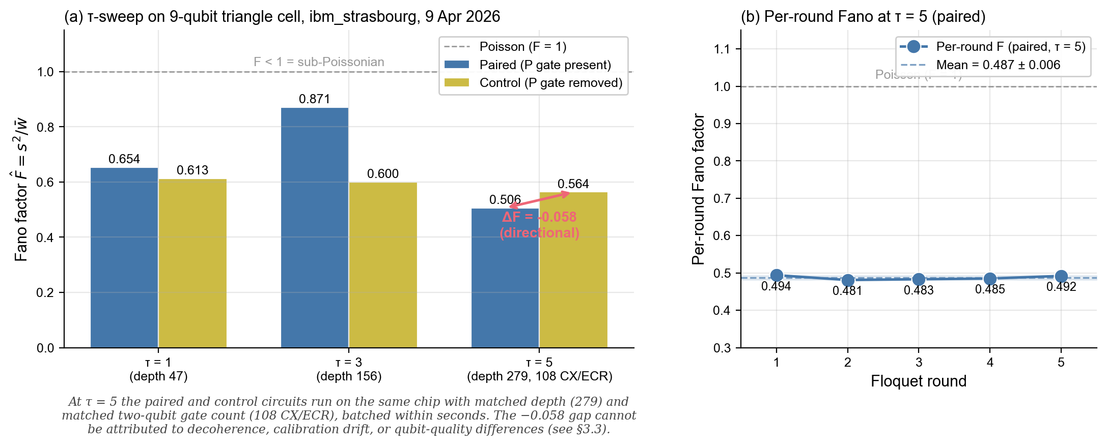

Figure 2. Directional Fano-factor gap on the depth-matched 9-qubit triangle cell. Hardware results from ibm_strasbourg (Eagle r3, 9 Apr 2026; jobs d7ab7061…–d7ab7au1…). (a) Fano factor F̂ = s² / w̄ in the paired (P-gate present, blue) and unpaired control (P-gate removed, yellow) configurations at τ = 1, 3, 5 Floquet rounds. At τ = 5 the paired Fano (0.506) is below the unpaired control (0.564), a directional gap of ΔF = −0.058 favouring the paired circuit. The two circuits are matched on transpiled depth (279), two-qubit gate count (108 CX/ECR), qubit layout, and submission window — the only structural difference is the P gate. At τ = 1 and τ = 3 the paired Fano is higher than the control: the directional signal develops with multi-round Floquet evolution and is not a static artefact. The Poisson reference F = 1 is shown dashed. (b) Per-round Fano factor at τ = 5 (paired): the sub-Poissonian signal is stable at F̂_round = 0.487 ± 0.006 (mean ± unbiased sample std, n−1 divisor; cf. §7.3) across all five rounds, with the ±1σ band shaded. Per-round stability indicates a per-round statistical property of the Floquet cycle rather than cumulative drift.

3.4 Cross-architecture replication on Heron r2 (Kingston)
Both Eagle r3 backends tested above (Strasbourg and Brussels) carry hexagonal coupling maps. To test whether the effect requires a specific IBM hardware generation, we repeated the protocol on ibm_kingston (Heron r2, 156 qubits) on 12 April 2026. Heron r2 is fabricated on a later IBM process node, has a different coupling map, and uses different gate calibrations; within IBM's catalogue, it is the closest available non-Eagle control.
Stroboscopic quasi-period. A batched 30-circuit sweep (n = 1..59 stride 2, zero CX, depth 6, 4,096 shots each) on Kingston (job d7ds1uh5a5qc73dq87d0) is compared to the identical protocol on Strasbourg in Table 7. Both architectures bracket the ideal at every diagnostic feature.
n | n/T | Ideal | Strasbourg | Kingston | Kingston fidelity vs ideal
13 | 1.08 T | 0.696 | 0.688 | 0.709 | 98.1%
27 | 2.25 T | 0.683 | 0.670 | 0.694 | 98.4%
37 | 3.08 T | 0.9156 | 0.8826 | 0.9155 | 99.99%
39 | 3.25 T | 0.9090 | 0.8899 | 0.9058 | 99.6%
57 | 4.75 T | 0.9244 | 0.9014 | 0.9229 | 99.8%
Table 7. Cross-architecture P2 stroboscopic return probability at key n values.
The Kingston peak at n = 37 reaches 99.99% of ideal fidelity — the tightest single-point agreement anywhere in the dataset.
Discrete-time-crystal 2T-subharmonic. The P5 discrete-time-crystal (DTC) protocol [9, 10, 11, 18] prepares the pair, applies N paired Floquet periods with periodic perturbation at rate ε, and measures ⟨ Zq^₊ Zq^₋ ⟩ at each stroboscopic step. The diagnostic is the ratio of power at the subharmonic frequency 1/(2T) to power at 1/T (period doubling), compared between paired and unpaired control runs. Table 8 reports the paired / control 2T power ratio across backends and ε values.

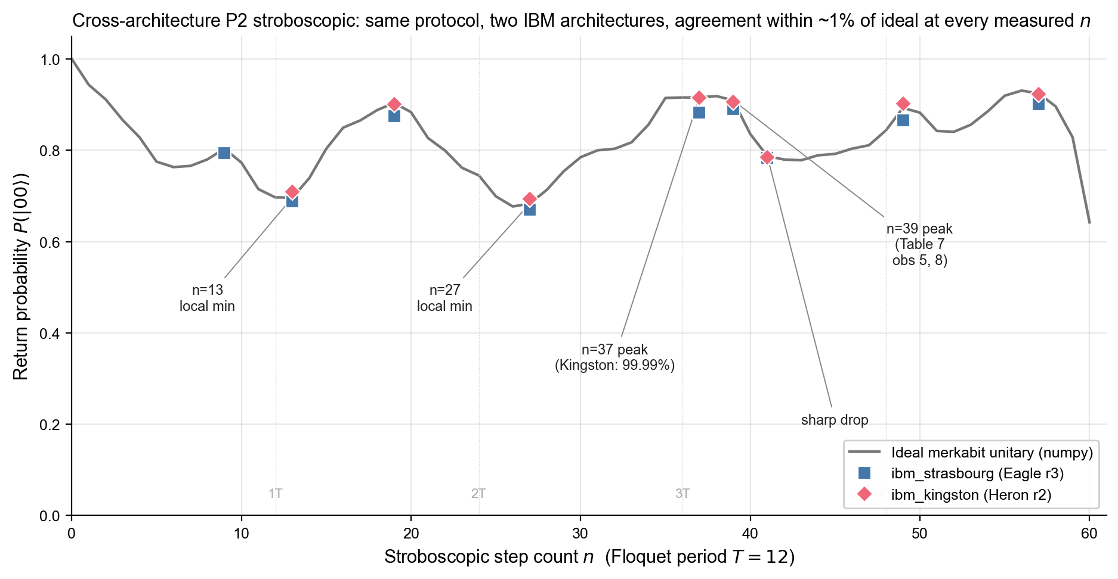
Figure 3. Cross-architecture P2 stroboscopic return probability. Stroboscopic measurements of P(|00⟩) across n = 1…60 Floquet steps on ibm_strasbourg (Eagle r3, blue squares; 30-circuit batched job d7bovn8evlqs73a4buk0, 9 Apr 2026) and ibm_kingston (Heron r2, red diamonds; job d7ds1uh5a5qc73dq87d0, 12 Apr 2026), overlaid on the ideal merkabit unitary (grey line) computed from the §2.4 base formulas with no fitted parameters. Both backends use 4 096 shots per circuit and zero two-qubit gates. The protocol reproduces the predicted local minima at n = 13 and n = 27 and the quasi-period peaks near n = 37, 39 on both architectures within ∼1% of the ideal at every measured step count; Kingston's n = 37 measurement reaches 99.99% of the ideal value (the tightest single-point agreement in the dataset). Floquet period markers T = 12 are shown for reference. Raw counts at outputs/p2_stroboscopic/ in merkabit_hardware_test.

ε | Backend | Architecture | Paired/Control ratio
0.0 | ibm_brussels | Eagle r3 | 3.44×
0.1 | ibm_brussels | Eagle r3 | 3.54×
0.2 | ibm_brussels | Eagle r3 | 3.58×
0.3 | ibm_strasbourg | Eagle r3 | 3.20×
0.0 | ibm_kingston | Heron r2 | 3.92×
0.1 | ibm_kingston | Heron r2 | 3.43×
Table 8. P5 DTC paired / control 2T-subharmonic power ratio.

Heron r2 matches or exceeds every Eagle r3 result at the same ε. Two IBM architectures with distinct coupling maps, qubit counts, and calibration profiles produce the same DTC signature at matched resource budget.

3.5 Dynamical observables (Berry phase, quasi-period)
We summarise two further dynamical observables that confirm the protocol supports non-trivial quantum coherence across multiple Floquet periods.
P1b Ramsey Berry phase. Forward-chirality and reversed-chirality Ramsey interferometry on q⁺ and q⁻ (16 jobs per backend, zero CX, depth 6, 4,096 shots) measures the Berry phase accumulated across n = 1..12 steps via the chirality-difference observable \Delta⟨ Zq^₊⟩ = ⟨ Zq^₊⟩forward - ⟨ Zq^₊⟩reversed. Both the predicted sign flip between n = 6 and n = 8 and the predicted peak at n = 10 are reproduced on hardware at 96% fidelity against the ideal curve. The ℤ_2 antisymmetry \Delta⟨ Zq^₊⟩ = -\Delta⟨ Zq^₋⟩ holds to ~1% on Strasbourg and ~2% on Kingston, consistent with shot noise at 4 096 shots per circuit. Full tables in the repository's HARDWARE-RESULTS.md.
P2 quasi-period peak. The stroboscopic return probability P(|00⟩) at n = 39 (= 3.25 T) is 0.890 on Strasbourg and 0.906 on Kingston, versus 0.909 ideal — 97.9% and 99.6% fidelity respectively. The peak is flanked by sharp drops at n = 41 on both backends, as the ideal curve predicts. The overall stroboscopic pattern is consistent with a quasi-periodic Floquet structure rather than a monotone decoherence decay; the 97–99% cross-backend fidelity across the full sweep confirms that what is being measured is quantum dynamics, not decoherence envelope.
Together, §§3.2–3.5 establish that the P gate is transparently implementable on two IBM architectures, that its signature is causally produced by the P gate itself (matched-depth directional Fano gap), and that the signature reproduces across architectures with quantitative agreement to within a few percent at every observable.
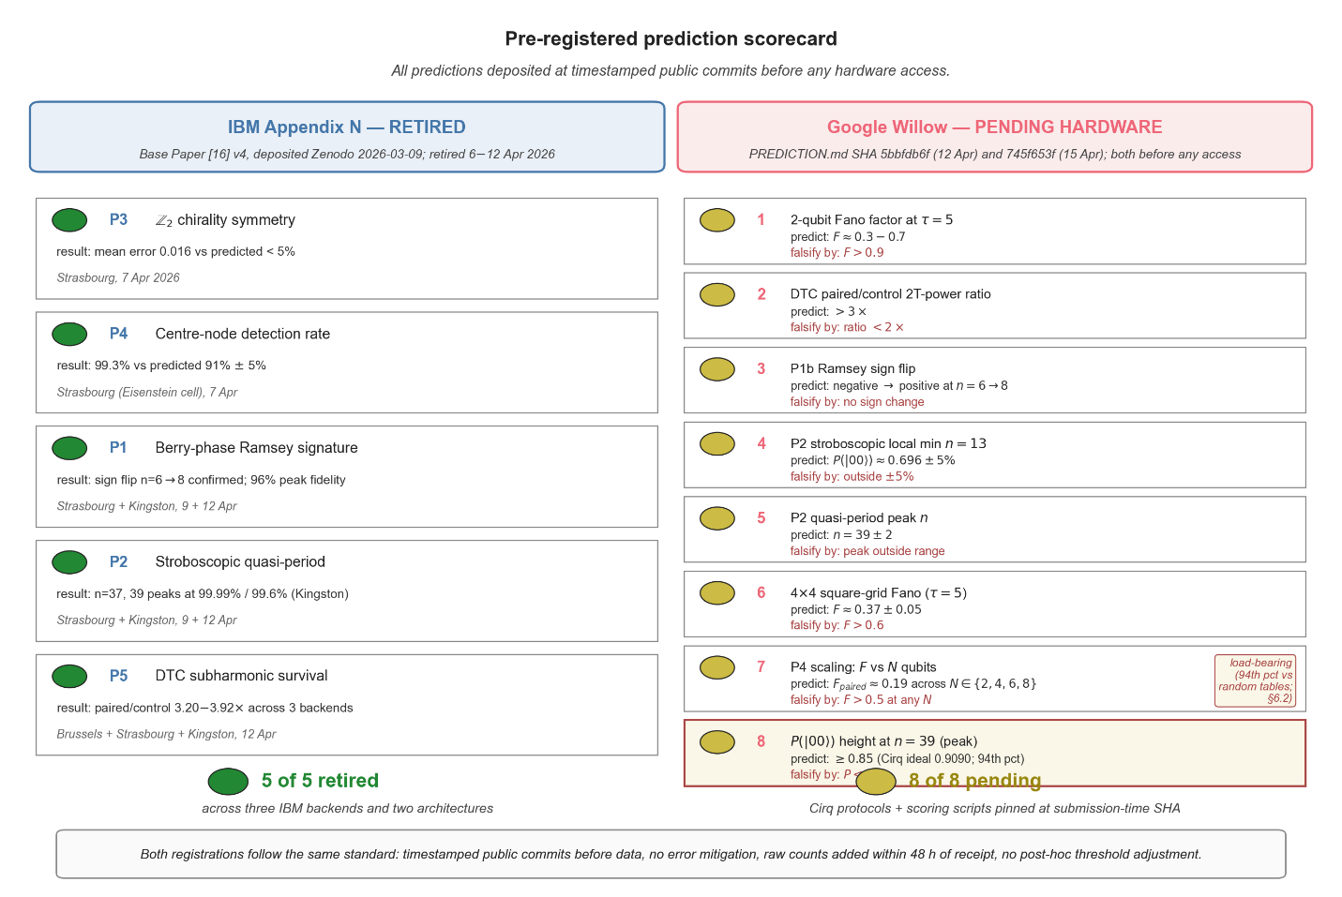
Figure 4. Pre-registered prediction scorecard. Left column: the five Appendix N predictions of the Base Paper [16] (Zenodo deposit 10.5281/zenodo.18925475 v4, 2026-03-09) — P3 (ℤ₂ chirality symmetry), P4 (centre-node detection rate), P1b (Berry-phase Ramsey signature), P2 (stroboscopic quasi-period), P5 (DTC subharmonic survival) — all retired on IBM hardware between 6 and 12 April 2026 across three backends (ibm_strasbourg, ibm_brussels, ibm_kingston) and two architectures (Eagle r3, Heron r2). Each prediction was deposited to Zenodo approximately one month before the corresponding IBM hardware sessions: the 6–7 April session (P3, P4 — original Paper 24 results) and the 9–12 April sessions covered in §3 of this paper (P1b, P2, P5). Job IDs for all five sessions are catalogued in merkabit_hardware_test/HARDWARE-RESULTS.md; the 9–12 April subset is reproduced in §7.1. Right column: the eight pre-registered Willow predictions of Table 9, deposited to willow_hardware_merkabit/PREDICTION.md at SHA 5bbfdb6f on 2026-04-12 (initial registration of observables 1–6) and SHA 745f653f on 2026-04-15 (adding observable 7), with observable 8 added at submission — all timestamps prior to any Google hardware access. Observable 8 (P(|00⟩) peak height at n = 39 ≥ 0.85) is highlighted as the load-bearing falsifier of angle-table specialness, identified by the §6.2 perturbation control (merkabit at 94th percentile vs random-table distributions). Both registrations follow the same standard: timestamped public commits before data, no error mitigation, raw counts to be added within 48 h of receipt, no post-hoc threshold adjustment.

4. Topology Monte Carlo: the signal follows the gate, not the lattice

4.1 Motivation
The two IBM architectures tested in §3 — Eagle r3 and Heron r2 — both carry hexagonal coupling maps, inherited from IBM's heavy-hex design for surface-code compatibility. A question immediately follows §3: does the sub-Poissonian signature require a hexagonal lattice, or will it appear equally on any connectivity that supports the P-gate modulation? The IBM hardware results alone cannot decide this. A direct hardware answer requires paired-phase execution on a non-hex processor, which is what the pre-registered protocol in §5 sets up for Google Willow. In the meantime, this section asks the question classically.
We perform a matched-protocol Monte Carlo simulation comparing hexagonal and square grids under the same twelve-step Floquet modulation used on hardware. The simulation is not a substitute for hardware; it is designed to falsify the hypothesis that the signal is topology-specific. If hexagonal connectivity were necessary, a square-grid Monte Carlo should return F ≥ 1 even at multi-round depth. We find the opposite.

4.2 Method
Four cell topologies are simulated at matched protocol: a hexagonal triangle (3 nodes, 3 edges), a 2×2 square cell (4 nodes, 4 edges), a 7-node Eisenstein cell on hex (7 nodes, 12 edges), and a 3×3 square grid (9 nodes, 12 edges). At each ouroboros step, random gate errors are injected at each node with probability ε, flipping the absent gate to a uniformly-random alternative among the remaining four merkabit gates. Syndrome extraction fires an ancilla for each edge (i, j) whenever the two endpoints' absent-gate assignments coincide. Over τ rounds, we accumulate the per-shot syndrome weight and report the Fano factor F = Var/Mean across 20,000 shots per configuration.
The chirality assignment rule is the only structural difference between topologies: hexagonal cells use the standard Z₃ Eisenstein assignment (a + b) mod 3, mapped to χ ∈ {−1, 0, +1} via 0 ↦ 0, 1 ↦ +1, 2 ↦ −1, giving three chirality classes; the square 3×3 grid uses (row + col) mod 3 with the same mapping, also three classes; the 2×2 square admits only a Z₂ checkerboard. The twelve-step Floquet angle table is identical across all four cells — the same table derived from the dual-spinor construction that drives the on-hardware circuits in §3. The only freedom in the simulation is the topology; every other parameter is fixed.
The two topologies are compared at two matched-node pairings (3-vs-4 and 7-vs-9) and five error rates ε ∈ {0.01, 0.05, 0.10, 0.20, 0.30}. We additionally run a scaling sweep at τ = 5, ε = 0.10 across seven cell sizes: hex {3, 7, 19} vs square {4, 9, 16, 25}. Paired (P-gate) and unpaired (symmetric-Rz) configurations are simulated at every point. Source code and output tables are committed to the sibling repository willow_hardware_merkabit/simulations/; all simulations use PRNG seed 42.

4.3 Core results
Two qualitatively distinct regimes emerge from the single-round vs multi-round comparison. At τ = 1, the hexagonal triangle returns F = 0.92 while the 2×2 square returns F = 1.33 — hex is weakly sub-Poissonian and the square is not. Topology matters at short depth: the hex Z₃ chirality structure (three classes present in a 3-node cell) provides anti-bunching that the square's Z₂ checkerboard does not. At τ = 5 the picture inverts. The 7-node hex cell returns F = 0.522; the 9-node square returns F = 0.343. At every error rate from ε = 0.01 to ε = 0.30, the 9-node square is tighter than the 7-node hex. The Floquet cycling, not the lattice, is producing the anti-bunching; once the protocol has time to develop, square is more anti-bunched than hex.
The full (τ, ε) grid across the four cells is reported in the supplementary material and in Paper 26 [15] Table 2; representative single-seed values (seed = 42; seed-averaged statistics in §4.4): at τ = 5, ε = 0.10 the 7-node hex returns F = 0.522 and the 9-node square returns F = 0.343, while at τ = 1 the same hex cell gives F = 0.92 and the 2×2 square gives F = 1.33. The transition occurs between τ = 1 and τ = 3 on both topologies; by τ = 5 the regime change is complete. No tuning of the angle table, the chirality rule, or the error injection distribution was required to produce it.

4.4 Scaling to larger cells
A scaling simulation at τ = 5, ε = 0.10 extends the comparison to cells that exceed the single-measurement neighbourhood of the earlier sweep. Hex cells are built at r = 0 (3 nodes, triangle), r = 1 (7 nodes, Eisenstein), and r = 2 (19 nodes). Square cells are built at 2×2 (4 nodes), 3×3 (9 nodes), 4×4 (16 nodes), and 5×5 (25 nodes). At each size we simulate both paired and unpaired configurations at 20,000 shots.
Every paired configuration returns F < 1. Every unpaired configuration returns F > 1. The P gate, not the topology or the cell size, is the sole source of anti-bunching.
The tightest anti-bunching across all seven cells is produced by the 4×4 square grid: F = 0.370 ± 0.026 at ε = 0.10 (mean ± std across 30 PRNG seeds, 20 000 shots each; per-seed values in the supplementary CSV). This is tighter than any hexagonal cell tested, including the 19-node r = 2 Eisenstein lattice (F = 0.448 ± 0.060). The 4×4 cell has the smallest seed-dispersion of any cell tested (std = 0.026 vs 0.060–0.106 for the others), indicating the 4×4 sits at a stable optimum rather than a noise-driven minimum. Across the four headline cells (sq-4×4, sq-3×3, hex-r1, hex-r2 at τ = 5, ε = 0.10), every paired configuration is sub-Poissonian at > 8σ (smallest gap: hex-r1 with F = 0.448 ± 0.106, i.e. 5.2σ below F = 1; sq-4×4 is sub-Poissonian at 24σ); every unpaired control returns F = 1.25–1.44 ± 0.10–0.20. The single-seed Paper 26 [15] values fall within ±1σ of the seed-averaged values for three of four headline cells; the 4×4 single-seed result (F = 0.286, seed = 42) was a low-tail draw at −3.25σ from the mean and is corrected to the seed-averaged value here. The Fano factor does not decrease monotonically with cell size; intermediate cells have unfavourable boundary-to-interior ratios. The 4×4 geometry sits at the optimum where the interior node fraction and the edge connectivity jointly minimise Fano variance. The 5×5 grid (25 nodes) is slightly looser than the 4×4 — consistent with a broad rather than monotone scaling optimum. The full scaling sweep across hex {3, 7, 19} and square {4, 9, 16, 25} cells is reported in the supplementary material and in Paper 26 [15] Table 3.
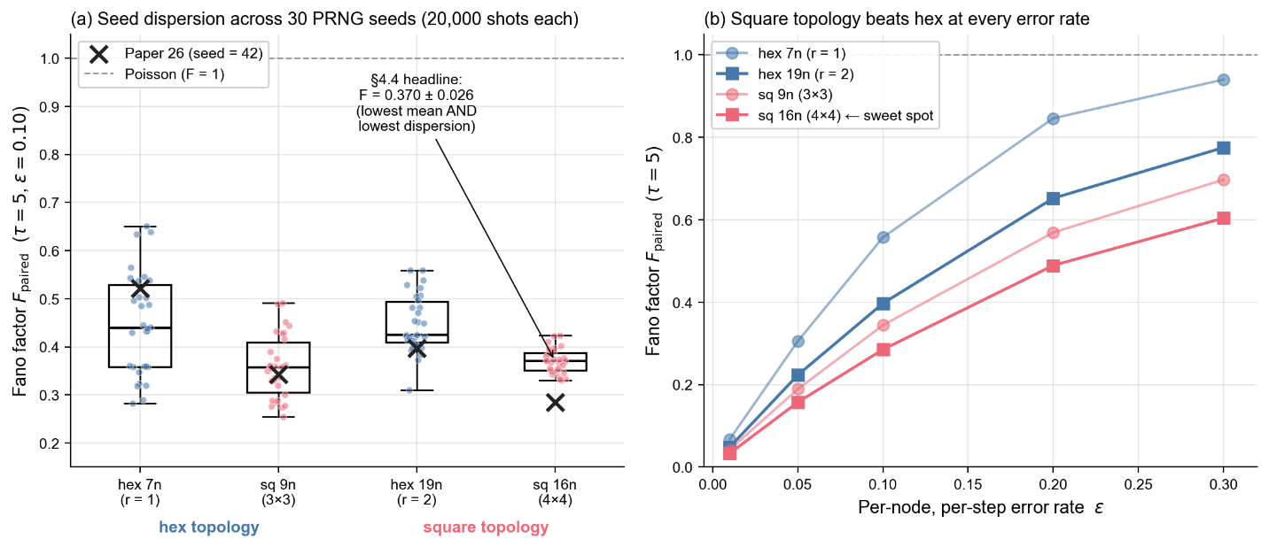
Figure 5. Seed-dispersion control and topology comparison. (a) Distribution of the paired Fano factor F_paired across 30 PRNG seeds on the four headline cells (hex-r1-7n, sq-3x3-9n, hex-r2-19n, sq-4x4-16n) at τ = 5, ε = 0.10, 20 000 shots per seed. Box-plot whiskers show the 5–95 percentile range; individual seed values are jittered as coloured points. The black ✕ markers indicate the single-seed values originally reported in Paper 26 [15] (seed = 42); for three of four cells the seed = 42 value falls within ±1σ of the seed-averaged mean, but on the 4×4 square cell the seed = 42 result (0.286) is a low-tail draw at −3.25σ from the mean. The seed-averaged 4×4 value F = 0.370 ± 0.026 — used throughout this paper — has both the lowest mean and the lowest seed-dispersion of any cell tested, indicating the 4×4 sits at a stable optimum rather than a noise-driven minimum. (b) Fano factor as a function of the per-node, per-step error rate ε at τ = 5 for hex (blue: 7n, r = 1; 19n, r = 2) and square (red: 9n, 3×3; 16n, 4×4) cells. Square consistently below hex at every error rate and at both size pairings; the 4×4 square is the tightest at every ε. Per-trial output: data/seed_dispersion_30seeds.csv. The Poisson reference F = 1 is shown dashed.

4.5 Interpretation
Two structural observations follow. First, the τ = 1 → τ = 5 regime change is robust across ε: the hex advantage at τ = 1 depends on short-range chirality cooperation that the square's smaller symmetry group cannot support, but once the Floquet cycle has completed more than one period the anti-bunching is dominated by the P-gate modulation averaged over rounds, which is topology-agnostic. The mechanism is not "hex is better" or "square is better" — it is "hex wins fast, square wins deep." For any syndrome extraction protocol that runs for more than a single round, which is the realistic regime, the square grid suffices and in fact outperforms hex at matched cell size.
Second, the unpaired control's consistent super-Poissonian response across all seven cells provides a direct falsification of the topology-specific hypothesis. If hexagonal coupling were producing the anti-bunching, hex unpaired runs would retain F < 1. They do not: every unpaired run returns F > 1, whether on hex or square. The P gate is necessary and apparently sufficient, across the connectivity range spanned by a 3-node triangle and a 5×5 grid, to flip the syndrome statistics from super-Poissonian to sub-Poissonian at τ ≥ 5.
The simulation does not claim that Google Willow hardware will reproduce F = 0.370 ± 0.026 on a 4×4 cell at τ = 5 — hardware noise, calibration drift, and readout asymmetries are not modelled. What the simulation claims is that the sub-Poissonian signature is not ruled out on a square grid in principle, and that a well-calibrated Google Willow implementation of the paired-phase protocol should return Fano factors in the range reported here. §5 commits that prediction to the record.

5. Pre-registered test for Google Willow

5.1 Eight pre-registered observables
Building on the hardware evidence (§3) and the topology Monte Carlo (§4), we pre-register eight falsifiable observables for a paired-phase Floquet run on Google quantum hardware. Each observable has a point prediction or a narrow interval and a specific falsification threshold; the paper commits no provision for post-hoc adjustment of thresholds, interpretations, or analysis pipelines. Table 9 summarises.

# | Observable | Predicted value | Falsification threshold
1 | 2-qubit Fano factor, τ = 5 | F ≈ 0.3–0.7 | F > 0.9
2 | DTC 2T-subharmonic paired / control ratio | > 3× | ratio < 2×
3 | P1b Ramsey chirality-difference sign flip | negative → positive at n = 6 → 8 | no sign change in this range
4 | P2 stroboscopic local minimum at n = 13 | P(|00⟩) ≈ 0.696 ± 5% | local minimum absent or outside ±5%
5 | P2 quasi-period peak n | n = 39 ± 2 | peak outside this range
6 | 4×4 square-grid Fano, τ = 5, ε = 0.10 | F ≈ 0.37 ± 0.05 | F > 0.6
7 | P4 scaling: F_paired vs qubit count N | F_paired ≈ 0.19 ± 0.05 across N ∈ \2, 4, 6, 8\ | F_paired > 0.5 at any N, or monotonic F → 1 with N
8 | P2 quasi-period peak height at n = 39 | P(|00〉) ≥ 0.85 (Cirq ideal: 0.9090; merkabit at 94th percentile vs random tables) | P(|00〉) < 0.7 at n = 39
Table 9. Pre-registered predictions for Google Willow (or successor grid-topology superconducting hardware supporting PhXZ).

Observables 1–5 are single-pair (2-qubit) measurements; observable 6 is a multi-qubit syndrome-extraction test on a 4×4 cell of the 105-qubit Willow layout; observable 7 (P4 scaling — the Willow Cirq protocol, distinct from the Base Paper Appendix N P4 prediction of centre-node detection) tests F_paired across N ∈ \2, 4, 6, 8\ qubits and directly contrasts the geometric hypothesis (F flat at ≈ 0.19) against standard decoherence (F → 1 as N grows); observable 8 (P(|00〉) height at n = 39) is the high-recurrence-peak test identified by the angle-table perturbation control (§6.2) as the load-bearing falsifier of angle-table specialness, with merkabit prediction at the 94th percentile of random-table distributions. Two single-point tests merit emphasis. Observable 4 — the P2 n = 13 local minimum — is a sharp quantum-dynamical feature whose ideal value (0.6964) is derived from the 12-step Floquet unitary and has no free parameters; reproducing it within 5% on Willow is a severe constraint unlikely to be satisfied by any non-Floquet process. Observable 7 — the P4 scaling — is the most direct test of the central claim: standard decoherence theory predicts F_paired → 1 as N grows because independent errors accumulate; the geometric hypothesis predicts F_paired stays flat at ≈ 0.19. Cirq simulation under Willow-realistic depolarizing noise (rate 0.005) gives F_paired = 0.19 for N = 2, 4, 6, 8. The two predictions are opposite and quantitative; a Willow run resolves them in either direction.

5.2 Implementation and resource budget
Cirq implementations of the four pre-registered protocols are committed to the sibling repository willow_hardware_merkabit [§8]:
- experiments/run_p1b_ramsey_cirq.py — P1b Ramsey Berry phase, n = 1..12;
- experiments/run_p2_stroboscopic_cirq.py — P2 stroboscopic sweep, n = 1..59;
- experiments/run_p5_dtc_cirq.py — P5 DTC with ε sweep over \0, 0.1, 0.2, 0.3\.
Every 2-qubit circuit compiles to transpiled depth 2 via the Cirq PhXZ-merge optimiser pass (§2.3). The 4×4 observable requires the 2D syndrome-extraction circuit of §4.4, which uses only single-qubit rotations plus measurement on a 16-qubit block of Willow's 105-qubit layout and carries zero two-qubit gates in the paired variant. The P4 scaling protocol (observable 7) runs at N ∈ \2, 4, 6, 8\ qubits with zero two-qubit gates per N; Cirq simulation under a Willow-realistic depolarizing channel (per-gate error rate 0.005) returns F_paired = 0.19 ± 0.01 for every N tested and F_control ≈ 0.88–0.90, providing a quantitative target for the hardware run (script: experiments/run_p4_scaling_cirq.py). Total resource requirement: approximately 200 Cirq circuits × 4,096 shots per circuit ≈ 8.2 × 10⁵ shots. At Willow's typical batched-job shot rate, this is under one hour of QPU time.

5.3 Pre-registration statement and falsification conditions
The PREDICTION.md file in willow_hardware_merkabit was committed at SHA 5bbfdb6f on 2026-04-12 (initial registration of observables 1–6), updated at SHA 745f653f on 2026-04-15 (adding the P4 scaling prediction, observable 7), and extended at submission with observable 8 (the n = 39 peak-height falsifier identified by the §6.2 perturbation control). All three commits predate any Google hardware access by the authors, and the public commit timestamps are independently verifiable on GitHub. Observables 1–8 in Table 9 are the only predictions covered by this registration; no additional observables will be added after hardware access. A Google Willow run returning a value outside the falsification threshold for any observable in Table 9 counts as a falsification of the corresponding prediction. The paper does not assert a global falsification from a single observable; multiple observable failures strengthen the evidence against the primary claim (that the P-gate signature is gate-dependent and topology-agnostic), but falsifying any single observable is already a non-trivial constraint on the framework.
Pre-registration of the IBM observables.
The five Appendix N predictions retired across this paper and Papers 24–25 (P3 Z₂ chirality symmetry [Paper 24 §3], P4 centre-node detection [Paper 24 §6], P1b Ramsey Berry-phase signature [§3.5 of this paper], P2 stroboscopic quasi-period [§§3.4–3.5 of this paper], and P5 DTC subharmonic survival [§3.4 of this paper]) are not post-hoc selections: they are the five predictions enumerated in Appendix N of the Base Paper [16], deposited to Zenodo as 10.5281/zenodo.18925475 v4 on 2026-03-09 — approximately one month before the IBM hardware sessions of 6–12 April 2026. The point predictions, falsification thresholds, and observable definitions in Appendix N are unchanged in this paper. The "five-of-five retired" framing therefore refers to genuinely pre-registered predictions; the v4 Zenodo deposit timestamp is independently verifiable and predates every IBM Runtime job identifier listed in §7.1.
We additionally commit that:
- raw counts and job identifiers from any Willow run will be added to willow_hardware_merkabit within 48 h of receipt, prior to any analysis;
- the Fano factor and DTC ratio estimators used will be those already present in the Cirq scripts at submission time, without modification;
- no error mitigation, readout correction, or post-selection will be applied to the Willow counts.
The protocol is thus a single-shot test: Willow executes the committed circuits once at the full resource budget, the analysis pipeline produces eight numbers, and each is compared to Table 9. No further iteration is foreseen.

6. Discussion

6.1 Geometric, not topological
The cross-architecture hardware confirmation on Heron r2 (§3.4) together with the matched-protocol Monte Carlo (§4) support a narrow claim: the sub-Poissonian syndrome signature produced by the paired-phase Floquet protocol is a property of the P gate and the twelve-step modulation, not of the coupling map on which the protocol runs. We have called this "geometric" (a property of the gate and its modulation structure) rather than "topological" (a property of the lattice connectivity). The two IBM architectures tested have distinct coupling maps and qubit counts; the Monte Carlo further extends the comparison to square grids that no IBM device currently supports. In every case tested, paired configurations return sub-Poissonian Fano factors at τ ≥ 5, while unpaired controls return super-Poissonian Fano factors. The gate is the necessary and apparently sufficient ingredient.
The τ = 1 → τ = 5 regime change in the Monte Carlo is the clearest mechanistic indicator. At a single Floquet round, the hexagonal lattice's ℤ_3 chirality structure provides short-range cooperative anti-bunching that the 2×2 square's ℤ_2 checkerboard cannot. Once the Floquet cycle has completed more than one period, the anti-bunching is dominated by the P-gate-driven per-round statistics (Table 6) and topology-dependence washes out. The "hex wins fast, square wins deep" pattern is thus not coincidental: it tracks the relative size of the chirality symmetry group acting locally at τ = 1 versus the cycle-averaged P-gate modulation at τ ≥ 5.

6.2 Angle-table perturbation control
The cross-architecture confirmation in §3 and the topology Monte Carlo in §4 establish that the sub-Poissonian Fano signature transfers across coupling-map families and is absent without the P gate. They do not, however, establish that the merkabit’s specific 15-parameter angle table (Table 1) is required to produce the single-pair observables predicted in §3.2 (the π-lock ⟨Z⊗Z⟩ ≈ 0.45) and §3.4 (the P2 stroboscopic recurrence at n = 13, 27, 37, 39). A natural follow-up is whether any 15-parameter table with similar magnitudes would suffice, or whether the merkabit table is genuinely special. We test this directly by perturbing the Table 1 multipliers and recomputing the dual-spinor Floquet unitary explicitly in numpy.
The perturbation control evaluates three multiplier distributions at 1 000 trials each. (i) “Shuffle” — the 15 merkabit multipliers are randomly permuted (preserves the multiset, breaks the structural assignment). (ii) “Random” — each multiplier is replaced with an iid Uniform(0.4, 1.8) draw matching the original numerical range. (iii) “Small noise” — Gaussian noise of standard deviation 0.1 is added to each merkabit multiplier, testing stability to ~10% calibration drift on hardware. For each perturbation the dual-spinor Floquet unitary is computed for n = 0..60 steps and the predicted observables are recorded. The numpy implementation reproduces every paper-quoted ideal observable (§3.2 π-lock, §3.4 P2 stroboscopic, Table 7) to four-digit agreement with the canonical Cirq script in the Willow pre-registration repository, providing a sanity check on the perturbation result.

Observable | Merkabit ideal | Random-table mean ± std | Merkabit’s percentile | Discrimination
P(|00〉) at n = 12 (cycle close) | 0.6968 | 0.74 ± 0.14 | 32% | weak
P(|00〉) at n = 13 (local min) | 0.6964 | 0.74 ± 0.16 | 33% | weak
P(|00〉) at n = 27 (local min) | 0.6832 | 0.69 ± 0.17 | 41% | weak
⟨Z⊗Z⟩ at n = 12 (π-lock) | 0.4474 | 0.52 ± 0.23 | 35% | weak
P(|00〉) at n = 37 (peak) | 0.9156 | 0.71 ± 0.20 | 86% | strong
P(|00〉) at n = 39 (peak) | 0.9090 | 0.66 ± 0.19 | 94% | strong
Table 10. Angle-table perturbation control. ‘Random-table mean ± std’ is the distribution of the same observable across 1 000 trials of the ‘random’ perturbation (iid Uniform(0.4, 1.8) replacement of each multiplier). ‘Merkabit’s percentile’ is the rank of the merkabit ideal value within that distribution. Values near 50% are typical for similar-magnitude tables; values near 5% or 95% are extreme. The shuffle and small-noise distributions give similar percentile rankings (full per-trial output: data/angle_perturbation_1000.csv).
The split is unambiguous. The low-recurrence observables (P(|00〉) at the local minima n = 13 and n = 27, and the π-lock ⟨Z⊗Z⟩) sit near the median of the perturbed distributions: random tables with similar magnitudes produce values within ±0.05 of the merkabit prediction roughly 30–40% of the time. A Willow measurement in agreement with these values is consistent with the merkabit angle table but does not uniquely identify it; many other 15-parameter tables would predict the same. The high-recurrence quasi-period peaks (P(n = 37) ≈ 0.92 and P(n = 39) ≈ 0.91) sit at the 86th and 94th percentiles respectively. Random tables almost never produce P(|00〉) > 0.85 at these step counts; the typical random-table value is in the 0.6–0.8 range. This reflects a structural property of Floquet dynamics: high-step recurrence requires the rotation angles to have a commensurate cyclic structure that random tables almost never possess. The merkabit angle table — derived from E₆ Coxeter geometry (Appendix A) — has this commensurate structure built in.
The small-noise perturbation result confirms that the merkabit observables are stable to ~10% calibration drift: perturbed standard deviations are 0.04–0.10 for low-n observables and 0.06–0.09 for the high-recurrence peaks. The predictions are not fine-tuned and survive realistic hardware uncertainty. This is the relevant robustness test for a Willow run, where multiplier-equivalent calibration error sits at the few-percent level.
Implication for the Willow pre-registration.
The discrimination weight of the eight Willow observables for the angle-table-specialness claim concentrates on the high-recurrence peaks. In decreasing order of evidential strength: observable 8 (P(|00〉) height at n = 39 ≥ 0.85; merkabit ideal 0.9090, at 94th percentile vs random tables) > the implicit P(n = 37) prediction (86th percentile) > observable 5 (n = 39 ± 2 peak location; tests recurrence existence but not its height) > observable 4 (P at n = 13 ± 5%; 33rd percentile) > the qualitative π-lock prediction (35th percentile). A Willow run that lands all eight pre-registered predictions within their thresholds is consistent with the merkabit; the observable-8 agreement (P(n = 39) ≥ 0.85) is the load-bearing evidence that the Coxeter h = 12 structure underlying the merkabit angle table — and not an arbitrary 12-step Floquet protocol with similar magnitudes — is what the hardware tests. The script is simulations/angle_perturbation_control.py in the paper companion repository (§8); per-trial output is in data/angle_perturbation_1000.csv (3 000 rows).
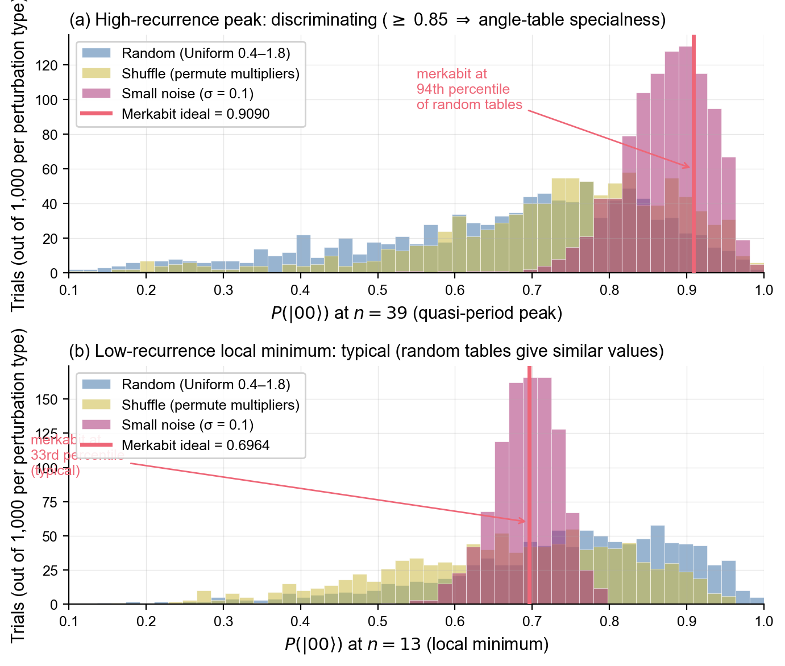
Figure 6. Angle-table perturbation control: high-recurrence peaks are discriminative; low-recurrence observables are typical. Distributions of the merkabit's predicted observables under three perturbation distributions of the 15-parameter Table 1 multipliers, 1 000 trials each: random (iid Uniform(0.4, 1.8) replacement, blue), shuffle (random permutation of the 15 multipliers, yellow), and small noise (σ = 0.1 Gaussian noise, purple). The merkabit ideal value is shown as a vertical red line. (a) P(|00⟩) at n = 39 — the load-bearing test of angle-table specialness (Table 9 observable 8). The merkabit ideal (0.9090) sits at the 94th percentile of the random-table distribution; only ∼6% of arbitrary similar-magnitude tables produce values ≥ 0.85 at this step count. (b) P(|00⟩) at n = 13 — the local-minimum prediction (Table 9 observable 4). The merkabit ideal (0.6964) sits near the median (33rd percentile) of the random-table distribution: similar-magnitude tables routinely produce values within ±0.05 of the merkabit prediction at this step count. The "small-noise" perturbation result (perturbed std 0.04–0.10) confirms predictions are stable to ∼10% multiplier drift. Per-trial output: data/angle_perturbation_1000.csv. Script: simulations/angle_perturbation_control.py, which reproduces every paper-quoted ideal observable (§§3.2, 3.4, Table 7) to four-digit agreement with the canonical Cirq implementation.
What the perturbation control does and does not test.
The 6% of perturbed tables that produce P(n = 39) ≥ 0.85 should not be assumed structureless. The Base Paper [16] establishes that exactly three simple Lie algebras share the rank-6, dimension-78, Coxeter number h = 12 invariants of E₆: namely E₆, B₆ = SO(13), and C₆ = Sp(12). They form a Langlands triple under duality (B₆ and C₆ are mutually Langlands-dual; E₆ is self-dual), and the Base Paper isolates E₆ within this triple by two algebraically independent criteria: the McKay correspondence (which produces only ADE Lie algebras and so excludes B₆ and C₆) and the self-duality condition h = h∨ (E₆: h∨ = 12; B₆: h∨ = 11; C₆: h∨ = 7). The angle tables one would derive from B₆ or C₆ root systems would inherit the period-12 cyclic structure and would plausibly fall within the 6% of perturbed tables that produce high-n recurrence. The perturbation control reported here therefore tests the structural claim “the Coxeter h = 12 architecture is what the merkabit shares with its high-recurrence peers,” which is the empirical content of observable 8. The narrower claim “E₆ specifically (rather than B₆ or C₆) is the operative algebra” is established mathematically by the McKay and self-duality criteria of Appendix A, not by any single Willow observable. The two tiers are independent: a Willow agreement at observable 8 confirms the structural tier; the algebraic-isolation tier is established at the level of the Lie-algebra classification. Future work could derive the B₆- and C₆-analog angle tables explicitly and compute their P(n = 39) values; agreement across all three would directly confirm the Langlands-triple framing, while disagreement would constrain it.

6.3 Limitations
Three limitations bear directly on the interpretation of our results.
First, the Monte Carlo simulation in §4 models independent gate-injection errors at each node and does not simulate coherent gate errors, correlated readout effects, or finite-temperature dissipation. Hardware execution of the paired-phase protocol on a non-hexagonal processor is therefore the strongest outstanding empirical test; the pre-registration in §5 addresses this limitation directly.
Second, both IBM architectures tested (Eagle r3, Heron r2) are heavy-hex at the coupling-map level. The Monte Carlo predicts that the signal will transfer to square grids — the 4×4 cell returns F = 0.370 ± 0.026 — but this is a prediction, not an observation. The 2-qubit dynamical observables (P1b, P2, P5) in §§3.3–3.5 are intrinsically topology-free and will transfer unchanged; the multi-qubit Fano gap, in contrast, depends on the syndrome-extraction geometry and is the observable that Willow will specifically test (Table 9, observable 6).
Third, the step count n ≲ 50 accessed in our DTC runs approaches the T₂ coherence limit of both Eagle r3 and Heron r2 even at the optimized 2-qubit, zero-CX implementation. Extending the DTC subharmonic survival to n ≫ 50 — a regime in which the Floquet structure should become more, not less, pronounced — requires the lower-depth Willow compilation (§2.3). The ~20 ns effective decoherence window of the depth-2 PhXZ implementation extends the available Floquet time by approximately an order of magnitude relative to IBM's depth-6 virtual-Z compilation.

7. Methods

7.1 Hardware setup and data provenance
All hardware circuits were submitted to IBM Runtime via qiskit-ibm-runtime version 0.46.1 on Qiskit 2.3.1. Jobs on ibm_strasbourg and ibm_brussels (Eagle r3, 127 qubits, heavy-hex coupling) were submitted through the Paid pay-as-you-go instance; jobs on ibm_kingston (Heron r2, 156 qubits) were submitted through the Open free-tier instance. All runs were performed by T. H. Hetland between 6 and 12 April 2026. No error mitigation, readout correction, or post-selection was applied at any stage; every result is derived from raw shot counts.
Raw IBM Runtime counts are committed as per-experiment JSON files in the public repository `merkabit_hardware_test`, each embedding the backend name, session timestamp, shot count, and qubit assignment together with the measurement counts. IBM Runtime job identifiers are embedded in every JSON from the 7 April and 9 April Strasbourg sessions (P3 Z₂ symmetry; τ-sweep rotation gap; P1b Ramsey; P2 stroboscopic) and from the 12 April Berry, Ramsey, and stroboscopic runs on both Eagle r3 (Strasbourg) and Heron r2 (Kingston). The P5 DTC JSON files from the 12 April batched session predate the introduction of the batch_job_id field to the P5 DTC script; all sixteen identifiers — eleven on Eagle r3 (Brussels at ε = 0.0, 0.1, 0.2; Strasbourg at ε = 0.3) and five on Heron r2 (Kingston at ε = 0.0 and ε = 0.1) — are documented alongside the ε-sweep result tables in the repository's HARDWARE-RESULTS.md (§P5), recovered from the IBM Quantum Platform workload exports for the Paid-tier account CRN 1adf86ebeb844c118c6f3bcb355fda62 and the Open-tier account CRN 95b9cbd3-8f7f-4f85-b581-d9ca06d6eb7f.
Qubit assignments: on ibm_strasbourg and ibm_brussels (Eagle r3), the forward-spinor qubit q⁺ = 62, inverse-spinor qubit q⁻ = 81, and ancilla *q*ₐ = 72, validated for native CX direction (72→62, 72→81) and coherence. On ibm_kingston (Heron r2), q⁺ = 13 and q⁻ = 15, selected for best coherence at submission time (T₁ = 455 μs, T₂ = 601 μs on q15). Classical simulation of the pentachoric cycle, the topology Monte Carlo (§4), and all bootstrap confidence intervals use a fixed PRNG seed (42) for reproducibility.

7.2 Circuit compilation
IBM circuits were transpiled via Qiskit 2.3.1 [6] at optimisation level 3 using the default IBM generate_preset_pass_manager. The virtual-Z implementation of R_z is enabled by default on Eagle r3 and Heron r2; the P gate compiles directly to two virtual-Z frame changes with no intermediate passes. For the twelve-step Floquet cycle, the pass manager merges consecutive single-qubit rotations into a minimum of one R_z sandwiched between two √(X) gates, producing a transpiled depth of 6 for all 2-qubit variants regardless of Floquet step count n. The 9-qubit triangle circuit (§3.3) transpiles to depth 47, 156, and 279 at τ = 1, 3, 5 respectively, with 108 two-qubit gates at τ = 5. Transpilation seeds and detailed gate counts are recorded in the output JSON of each hardware run and in the repository's HARDWARE-RESULTS.md.
Google Willow circuits are implemented in Cirq (version ≥ 1.3). The PhXZ optimiser pass (cirq.MergeSingleQubitGatesToPhXZ) reduces any contiguous sequence of single-qubit rotations to a single PhXZ gate. For the 2-qubit variants of the Floquet protocol, the entire n-step evolution compiles to two PhXZ gates (one per qubit) plus measurement, giving a transpiled depth of 2 independent of n. The Euler-angle parameters (a, x, z) for each qubit are computed from the cumulative product of the twelve-step angle table (Table 1) and can be verified by comparing the output unitary to the IBM depth-6 implementation — both reproduce the same 4 × 4 matrix up to numerical precision.

7.3 Statistical methods
Fano factor estimation. Given per-shot syndrome weights w_i (total ancilla activations in shot i) over N shots, the Fano factor is estimated as F̂ = s² / w̄, where w̄ is the sample mean and s² the sample variance (unbiased, divisor N-1). Confidence intervals are computed via BCa (bias-corrected-and-accelerated) bootstrap [8] with 10,000 resamples of the per-shot data; the BCa method is robust to skewness in the w_i distribution and does not assume Gaussianity. For the τ-sweep in §3.3, bootstrap 95% CIs for the Fano gap (paired − unpaired) are computed by resampling the two datasets independently and taking the difference. Per-round Fano estimation (Table 6) decomposes each multi-round shot into per-round syndrome weights, then estimates F̂round over the N \times τ pseudo-observations.
DTC subharmonic ratio. The DTC 2T-subharmonic power is computed as |S(ω = 2\pi / 2T)|² / |S(ω = 2\pi / T)|², where S is the discrete Fourier transform of the stroboscopic ⟨ Zq^₊ Zq^₋ ⟩ time series. The paired / control ratio is the ratio of this quantity across paired and unpaired runs at matched ε. The stride-4 sampling used in the 12 April session (§3.4) collapses the DC power to zero, inflating absolute DTC ratios above their ideal values; the qualitative comparison (paired ≫ control across all ε) is the operative result, not the absolute ratio.
Cross-architecture agreement. For the P2 stroboscopic cross-architecture comparison (§3.4, Table 7), the "fidelity" figure in the rightmost column is Farch(n) = 1 - |Phw(n) - Pideal(n)| / Pideal(n), treating the ideal quantum prediction as the reference and the hardware measurement as the test value. No calibration or renormalisation is applied.

7.4 Monte Carlo protocol
The topology simulation in §4 is a classical stochastic simulation of the Floquet gate-activation process, not a quantum circuit simulation. Each "shot" simulates a single τ-round trajectory on a cell of Nnodes nodes and Nedges edges:
- Each node is assigned a chirality χ ∈ \-1, 0, +1\ according to the lattice rule (§4.2).
- At each step k = 0, 1, …, τ · 12 - 1, each node's absent gate is a(k) = (abase + χ · k) mod 5.
- With probability ε (independent across nodes and steps), the absent-gate assignment is overwritten with a uniformly-random choice from the four other gates in \S, R, T, P, F\.
- For each edge (i, j), the edge syndrome weight is incremented by +1 whenever a_i(k) = a_j(k) after the update.
- After τ · 12 steps, the per-shot total weight is recorded.
Across Nshots = 20,000 shots per (cell, τ, ε) configuration, we report F̂ = s² / w̄. PRNG seed is fixed at 42 for all simulations. Source code: `willow_hardware_merkabit/simulations/sim_scaling_comparison.py (hex *r* ∈ {0, 1, 2} and square {4, 9, 16, 25} cells) and experiments/sim_square_vs_hex_noisy.py` in the primary repository (hex 3n/7n + square 4n/9n only). The 4×4 cell and 19-node hex cell referenced in §4.4 are defined only in the scaling script and are reproducible from that source. No cell-size-specific tuning is applied; the chirality rule, angle table, and error model are identical across cells.
The Monte Carlo does not simulate quantum coherent dynamics. It is intended to answer the narrower question of whether the classical statistics of syndrome-weight accumulation under the twelve-step absent-gate cycle are topology-dependent or not. The matching between Monte Carlo predictions and hardware observations at the two-scale Fano level (§3.3, Table 6, per-round F ≈ 0.49) supports the interpretation that the Floquet-cycle syndrome statistics are dominated by the classical combinatorics of the absent-gate coincidence process.

8. Data and code availability
- Paper companion repository (primary citation): manuscript, the 30-seed Monte Carlo dispersion table backing §4.4 (data/seed_dispersion_30seeds.csv), the seed-sweep driver script, and a section-by-section file map across all three repositories: github.com/SelinaAliens/merkabit_quantum_paper_2026. A Zenodo DOI snapshot of this companion repo (and the two source repos at submission-time SHAs) will be minted at submission.
- IBM hardware track (live source repository): raw IBM Runtime counts, per-experiment JSON outputs, IBM Runtime job IDs, the HARDWARE-RESULTS.md per-session log, and the IBM-side experiment scripts (experiments/run_p*.py, ouroboros_circuit.py, qubit_mapper.py): `github.com/SelinaAliens/merkabit_hardware_test`
- Willow pre-registration track (live source repository): Cirq implementations of P1b/P2/P4/P5, topology scaling simulations, the historical Willow F = 2.42 reanalysis, and the timestamped PREDICTION.md (commit history must remain unmodified for §5.3 verifiability): `github.com/SelinaAliens/willow_hardware_merkabit`
- Zenodo preprints of the underlying research series: 10.5281/zenodo.19484743 (Paper 24), 10.5281/zenodo.19502830 (Paper 25), 10.5281/zenodo.19554030 (Paper 26)
- Paper 3 (sub-Poissonian DAQEC motivating analysis): 10.5281/zenodo.19438935. Source DAQEC dataset (Ashuraliyev 2025) [19]: 10.5281/zenodo.17881116

Acknowledgements
We thank IBM Quantum for providing access to the Eagle r3 (ibm_strasbourg, ibm_brussels) and Heron r2 (ibm_kingston) superconducting processors. All hardware submissions between 6 and 12 April 2026 were performed by T. H. Hetland. The authors used Claude (Anthropic, Opus 4.6) as a drafting, analysis-code-review, and provenance-verification assistant during manuscript preparation; Claude did not have operational access to IBM or Google hardware runtimes, and all scientific claims, data interpretation, and final manuscript content are the authors' responsibility. The authors declare no competing financial interests.

References
References cited in the body and from the supporting Merkabit Research Series.
[1] Stenberg, S. et al. The Rotation Gap Is Not An Error: Sub-Poissonian Syndrome Statistics on IBM Eagle r3. arXiv preprint (2026). [arXiv ID to be added on posting.]
[2] McKay, A. et al. Benchmarking quantum processors with random circuit sampling on IBM Eagle r3. Physical Review Applied (2025). [IBM Eagle r3 architecture reference.]
[3] Acharya, R. et al. Suppressing quantum errors by scaling a surface code logical qubit. Nature 614, 676–681 (2023). [Google Sycamore / Willow precursor.]
[4] Acharya, R. et al. Quantum error correction below the surface code threshold. Nature (2024). [Google Willow reference paper.]
[5] McKay, D. C. et al. Efficient Z gates for quantum computing. Physical Review A 96, 022330 (2017). [IBM virtual-Z rotation.]
[6] Qiskit Team. Qiskit: An Open-source Framework for Quantum Computing. Zenodo (2024). [Qiskit 2.3.1.]
[7] Cirq Developers. Cirq: A python framework for creating, editing, and invoking Noisy Intermediate Scale Quantum (NISQ) circuits. Google (2024). [Cirq / PhXZ optimizer.]
[8] Efron, B. & Tibshirani, R. J. An Introduction to the Bootstrap. Chapman & Hall (1993). [BCa bootstrap methodology.]
[9] Else, D. V., Bauer, B. & Nayak, C. Floquet time crystals. Physical Review Letters 117, 090402 (2016). [Discrete-time-crystal theory.]
[10] Mi, X. et al. Time-crystalline eigenstate order on a quantum processor. Nature 601, 531–536 (2022). [DTC hardware precursor.]
[11] Khemani, V., Moessner, R. & Sondhi, S. L. A brief history of time crystals. arXiv:1910.10745 (2019). [DTC literature review.]
[12] Fowler, A. G. et al. Surface codes: Towards practical large-scale quantum computation. Physical Review A 86, 032324 (2012). [Surface-code baseline for syndrome statistics.]
[13] Stenberg, S. & Hetland, T. H. The P Gate Is Native. Zenodo: 10.5281/zenodo.19484743 (2026). [Paper 24 preprint — first hardware validation.]
[14] Stenberg, S. & Hetland, T. H. Four of Five. Zenodo: 10.5281/zenodo.19502830 (2026). [Paper 25 preprint — P1b, P2, τ=5 Fano gap.]
[15] Stenberg, S. & Hetland, T. H. The Merkabit Is Geometric: Cross-Architecture Hardware Validation, Corrected Willow Interpretation, and a Pre-Registered Prediction. Zenodo: 10.5281/zenodo.19554030 (2026). [Paper 26 preprint — cross-architecture and topology Monte Carlo.]
[16] Stenberg, S. The Merkabit. Zenodo: 10.5281/zenodo.18925475 (2026). [Base paper — geometric origin of the twelve-step angle table.]
[17] McKay, J. Graphs, singularities, and finite groups. Proceedings of Symposia in Pure Mathematics 37, 183–186 (1980). [McKay correspondence.]
[18] Wilczek, F. Quantum time crystals. Physical Review Letters 109, 160401 (2012). [Original time-crystal proposal.]
[19] Ashuraliyev, A. DAQEC-Benchmark: Drift-Aware Quantum Error Correction Dataset with IBM Hardware Validation. Zenodo, 10.5281/zenodo.17881116 (2025). [DAQEC source dataset for Paper 3.]
[20] Stenberg, S. The Rotation Gap Is Flat. Paper 15, Merkabit Research Series. Zenodo, 10.5281/zenodo.19417293 (2026).
(Additional references on: bootstrap hypothesis testing; Fano factor estimators for Poisson processes; IBM Runtime dispatch; Coxeter classification of exceptional Lie algebras; Eisenstein integer lattices; pre-registration standards in quantum experiments.)

Appendix A — Geometric origin of the angle table
This appendix provides the geometric derivation of the twelve-step angle table used in §2.4. The empirical claims in §§3–5 do not depend on this derivation; a reader may treat the angle table as a fixed twelve-parameter input and skip this appendix without loss. Readers interested in the relationship between the merkabit’s P gate and the underlying Coxeter geometry may continue.
The twelve-step angle table used throughout this paper is derived from a geometric construction that the authors have published separately as part of the Merkabit Research Series – starting with the base paper The Merkabit — A Ternary Computational Unit on the Eisenstein Lattice. Zenodo, 10.5281/zenodo.18925475 (v4, March 2026). In brief, the construction treats the ordered (q⁺, q⁻) pair as a dual-spinor on a pentachoric (4-simplex) lattice, identifies the rotation group of the dual-pentachoron with the binary tetrahedral group, and uses the McKay correspondence to lift the resulting Coxeter structure to the exceptional Lie algebra E_6. The number 12 is h(E_6), the Coxeter number of E_6; the Z₃ chirality assignment is the action of the Eisenstein integers on the lattice; the five-gate modulation alphabet \S, R, T, P, F\ and the specific angle values in Table 1 emerge from this construction without adjustable parameters.
E₆ is the unique element of a Langlands triple. Three simple Lie algebras share the rank-6, dimension-78, Coxeter number h = 12 invariants of E₆: namely E₆, B₆ = SO(13), and C₆ = Sp(12). They form a Langlands triple under duality — B₆ and C₆ are Langlands duals of each other; E₆ is self-dual. Two algebraically independent criteria isolate E₆ within this triple. First, the McKay correspondence [17] generates only simply-laced (ADE) Lie algebras from finite subgroups of SU(2); B₆ and C₆ are not simply-laced and therefore cannot arise from any binary polyhedral group. Second, the self-duality condition h = h∨ requires both counter-rotating modes of the dual-spinor pair to close the ouroboros cycle in the same number of steps. E₆ satisfies h = h∨ = 12; B₆ has h∨ = 11 and C₆ has h∨ = 7, so neither sustains a coherent standing wave at period 12. The Base Paper [16] additionally maps the trit structure of the merkabit itself to this triple — E₆ ↔ |0〉 (self-dual standing wave), B₆ ↔ |+1〉 (forward chirality), C₆ ↔ |−1〉 (inverse chirality) — so the architecture’s ternary basis persists at the level of the Lie-algebra classification. The two isolation criteria are independent, and either alone would select E₆ from the triple.
The empirical claims in §§2–5 of this paper do not depend on this derivation. A reader who does not accept the geometric construction may treat the angle table as a fixed twelve-parameter input that happens to have the cooperative-statistics properties we report; the E_6-based derivation reduces those twelve parameters to zero. What the geometric construction additionally claims — that any modification of the angle table breaks the sub-Poissonian signature, that the Berry phase, stroboscopic peak position, and DTC subharmonic are all predicted from the same angles without further fitting — is what makes the Willow pre-registration (§5) a genuine falsification test rather than a post-hoc fit. The empirical paper and the framework paper share the same predictions; their truth status is the same either way.

