The Cross-Chiral Tunnel and Its Topology-Independent Z₃ Cellular Automaton: A Pre-Registered Hardware Protocol Stack on Current Superconducting Quantum Processors

Selina Stenberg

April 2026

Merkabit Research Series, Paper 31

Abstract
We present a simulation-ready, pre-registered hardware protocol for demonstrating ordered-pair ternary correlation and its topology-independent cellular-automaton extension on current superconducting quantum processors. The protocol establishes a single local computational rule — the cross-chiral tunnel iSWAP^J(u_A, v_B) between adjacent 4-spinor tesseract merkabits [1] — and shows this rule produces (i) a universal 9-entry ordered-pair ternary gate table; (ii) topology-independent bond locality across ring sizes N = 3, 4, 6; and (iii) a falsification of Z₃ plaquette holonomy as a dominant loop-level invariant.
Ordered-pair ternary correlation. Two 4-spinor merkabits (A, B) coupled through a partial iSWAP^J between the forward spinor of A and the inverse spinor of B, evolved under Protocol 4S internal dynamics (three isoclinic rotation plus the chiral P gate) for n = 1–2 Coxeter periods at J = 0.1, produce ordered-pair Z₃ × Z₃ correlations. Under ideal unitary dynamics, the input pair (β, γ) — β and γ the Z₃ eigenstates with eigenvalues ω and ω² — produces tunnel coherence 0.000 ± 0.000 via destructive interference, while the reversed pair (γ, β) produces 0.762 ± 0.005 (at n = 2 Coxeter periods, isolated two-merkabit; the n = 1 universal-lookup value aggregated across topologies is 0.57 — see Table 10). The resulting 166σ directional gap (Cirq; 125σ on Qiskit Aer) at n = 2 ideal is not reducible to the individual Z₃ labels of either merkabit— it is inaccessible to any local observable on either merkabit alone.
Topology-independent cellular automaton. Replicating the two-merkabit protocol on three ring topologies — triangle (N = 3, 13 qubits), 4-square (N = 4, 17 qubits), and hexagon (N = 6, 25 qubits) — with cross-chiral tunnels on every bond produces the same 9-entry ordered-pair lookup table at every bond, agreeing to within 0.02–0.03 across topologies. The β → γ destructive zero is identically 0.000 on every bond of every topology. The architecture is therefore a Z₃-symmetric quantum cellular automaton [A3] with a derived local rule, not a gauge theory with loop-level invariants: within-phase-class variance exceeds between-phase-class variance on every tested observable, falsifying the Z₃ plaquette-holonomy interpretation. Register capacity scales with bond count E rather than vertex count N, giving native edge-level parallelism on the Eisenstein coordination lattice.
Noise robustness. A stress-test grid across tunnel strength J ∈ {0.0, 0.05, …, 1.0}, horizon n ∈ {1, 2, 3, 4, 5, 7, 10}, and five noise channels (depolarising, amplitude damping, phase damping, combined amplitude + phase, and calibrated IBM Eagle r3 via FakeSherbrooke) establishes the hardware-viable operating point: n = 1, J ∈ [0.05, 0.13] or [0.2, 0.5] (avoiding nulls at J ≈ 0.15 and J ≈ 0.7). At this point, the predicted directional gap sits in [0.09, 0.30] with significance 6.4σ (FakeSherbrooke) to 37σ (uniform depolarising) at 6 repeats × 4,096 shots. Phase damping is nearly transparent to the signal — the (β, γ) tunnel zero persists at exactly 0.000 under pure T₂ dephasing — identifying the cross-chiral tunnel as a natural decoherence-free subspace [A4, A5] for ordered-pair ternary information.
Three pre-registered hardware observables. Observable 14 (2-merkabit tunnel, 9 qubits, ≤ 45 QPU-min) targets the directional tunnel gap with four sub-tests (14a gap magnitude, 14b sign persistence, 14c information retention vs local observables, 14d phase-damping enhancement via dynamical decoupling). Observable 16 (triangle lookup table, 13 qubits, ~25 QPU-min) validates the 9-entry table on the Eisenstein-native minimum ring. Observable 17 (4-square parallel-bond pattern, 17 qubits, ~10 QPU-min) validates multi-bond locality on a 4-coordinated ring. Agreement across Observables 14 + 16 + 17 within 0.05 confirms the cellular-automaton interpretation; any single-threshold failure implicates one specific structural claim. Scripts, raw simulation data, and timestamped prediction files are committed at github.com/selinaaliens/tesseract_quantum_implementation; pre-registration git SHAs are given in §8.
Keywords: merkabit, tesseract, cross-chiral tunnel, ternary quantum computation, Z₃ cellular automaton, topology-independent bond locality, universal 9-entry lookup table, inter-merkabit torsion, decoherence-free subspace, IBM Eagle r3, pre-registered hardware protocol, Observable 14, Observable 16, Observable 17.

1. Introduction
The Merkabit Research Series [1, 2] develops a ternary quantum computational architecture grounded in E₆ Coxeter geometry and the Eisenstein lattice ℤ[ω]. The capstone [2] consolidates twenty-nine companion papers into a single forcing chain and establishes, via the genesis pipeline [3 §2.5], that the architecture is internally self-consistent from the relational primitive R through the fine structure constant α⁻¹ = 137.036 with zero free parameters. A key companion result, Paper 8 [4], identifies the unifying cyclotomic field ℚ(ζ₂₁) of degree φ(21) = 12 = h(E₆) as containing both the Eisenstein lattice of the merkabit and the CM field of the Klein quartic's Jacobian, confirming PSL(2,7) as the joint symmetry group.
Hardware confirmation in the series so far has focused on the 2-spinor substrate. Papers 24 [3], 25 [4], and 26 [5] confirm five pre-registered observables on IBM Eagle r3 and Heron r2 processors, establishing that the merkabit's sub-Poissonian syndrome statistics, Berry-phase Ramsey signatures, and discrete-time-crystal subharmonic survival are properties of the P gate rather than of the underlying heavy-hex topology. These results validate the 2-spinor level of the architecture and establish that the framework's structural predictions translate to real superconducting devices.
What has not been demonstrated on hardware is ternary computation — the use of the architecture to perform operations that distinguish and manipulate multiple trit-valued inputs. The single-spinor protocols resolved to date all operate under continuous external Floquet drive: the 12-step angle table provides the cycling that gives the coherent signatures. Stopping the drive collapses the coherence.
The architecture predicts that genuine ternary computation emerges at higher structural scales. The capstone [3 §15.6, §15.8] specifies a read/write dual-spinor interpretation in which u is the write flow, v is the read flow, and the trit's three eigenstates |+1⟩ (forward), |0⟩ (standing wave), |−1⟩ (inverse) correspond to the three observable merkabit configurations. Paper 20 [8] identifies the R_inter permanent torsion channel between adjacent merkabits as the mechanism responsible for the 1/r² inverse square law of gravity; the same channel is described, in Paper 17 [6] and the base paper [1], as trit-selective and cross-chiral: the forward spinor of merkabit A couples to the inverse spinor of merkabit B.
This paper presents Protocol 4S-Tunnel and its topology-independent extension, testing this inter-merkabit structure directly. The two-merkabit primitive (§§3–4) establishes ordered-pair ternary correlation via the directional asymmetry of the tunnel coherence between (β, γ) and (γ, β); a complete robustness study (§5) along tunnel strength J, horizon n, and noise-channel variety fixes the operational hardware configuration at n = 1, J = 0.1, 9 qubits, ≤ 45 QPU-minutes.
The same local rule is tested at higher lattice scales (§§6–7). At each bond of a merkabit ring — triangle (N = 3), 4-square (N = 4), hexagon (N = 6) — the same iSWAP^J(u_upstream, v_downstream) partial tunnel applies. If the primitive is the architecture's native local rule, its 9-entry ordered-pair lookup table should reproduce identically at every bond of every topology. This topology-independence prediction entails the falsification of the Z₃ plaquette-holonomy alternative as a corollary: if the architecture were a Z₃ gauge theory, within-phase-class variance would cluster below between-phase-class variance; the data show the opposite.
Three hardware pre-registrations are deposited together (§8). Observable 14 (9 qubits, four sub-tests 14a–d) tests the primitive. Observable 16 (13 qubits) tests the triangle bond pattern. Observable 17 (17 qubits) tests the 4-square parallel-bond pattern. All three are committed at the same pre-registration SHA prior to any hardware submission. A positive Observable 14 alone confirms the primitive; positive Observables 14 + 16 + 17 with lookup-table agreement ≤ 0.05 across topologies confirm the cellular-automaton interpretation. A positive hardware result would be the first experimental demonstration of an architecturally-grounded ternary computational primitive on current superconducting qubits; any single-threshold failure implicates a specific named structural claim, per §8.

2. Framework recap
This section is a compact summary of the architectural elements used in the paper. The full derivations are in the capstone [2] and the cited companion papers; only what is needed to state the experimental claim is reproduced here.

2.1 Merkabit and tesseract
A merkabit is the minimal self-correcting computational unit on the Eisenstein lattice ℤ[ω] [1]. It comprises a pair (u, v) of counter-rotating spinors: u evolves forward as e^(−iωt), v evolves backward as e^(+iωt). The two spinors are coupled by the R axis (shared torsion direction) and distinguished by the P gate — the asymmetric phase P(φ) = R_z(+φ) ⊗ R_z(−φ) — which imposes opposite phase rotations on u and v.
The 2-spinor merkabit has u, v ∈ S³ (equivalent to one physical qubit each). The 4-spinor merkabit, identified with the tesseract configuration in the genesis sequence [3 §2.5, Level 5], has u, v ∈ S⁷ (two physical qubits each). The capstone's genesis pipeline establishes that the 4-spinor is the first structural rung at which internal dynamics sustain coherence without external drive: three independent isoclinic rotation planes exist in 4-dimensional spinor space where none exist in 2-dimensional. The 2-spinor is kinematically frozen; the 4-spinor admits internal evolution.

2.2 Gate architecture: R_intra and R_inter
Two distinct R axes operate at two scales [3 §4]:
- R_intra — the 5-fold cycling rotation that joins (S, T, F, P) in the intra-merkabit ouroboros. This is local to one merkabit and gives the Floquet structure, the fine structure constant α⁻¹ = 137.036 via the Floquet return fidelity F = 0.69678 [3 §5.2, Paper 25], and the local Berry phase.
- R_inter — the permanent torsion/gravity channel between adjacent merkabits on the Eisenstein lattice. This axis gives rise to the 1/r² inverse square law through a lattice Green's function [8], and is trit-selective (|±1⟩ propagate, |0⟩ is blocked) [1].
The cross-chiral structure of R_inter [16, 17] and the base paper [1] specifies that the forward spinor of merkabit A couples to the inverse spinor of merkabit B. Mathematically this is a non-symmetric exchange u_A ↔ v_B, distinct from a symmetric swap u_A ↔ u_B. The directional structure is essential: it is what makes the tunnel sensitive to the ordered pair (β, γ) versus the reversed order (γ, β).

2.3 Z₃ eigenstates
The Eisenstein lattice carries a natural Z₃ action generated by the cyclic permutation T with eigenvalues {1, ω, ω²}, where ω = exp(2πi/3). In ℂ⁴, acting on the span of three basis vectors (|0⟩, |1⟩, |2⟩) and fixing |3⟩, the three Z₃ eigenstates are:
- α = ( | 0⟩ + | 1⟩ + | 2⟩)/√3 — Z₃ eigenvalue 1 (real, self-dual)
- β = ( | 0⟩ + ω | 1⟩ + ω² | 2⟩)/√3 — Z₃ eigenvalue ω
- γ = ( | 0⟩ + ω² | 1⟩ + ω | 2⟩)/√3 — Z₃ eigenvalue ω²
Table 1: The three Z₃ eigenstates of ℂ⁴ on the span of (|0⟩, |1⟩, |2⟩) with |3⟩ fixed. α is real and self-dual; β and γ are complex conjugates related by γ = β*. The chiral P gate breaks the complex-conjugation symmetry that would otherwise render β and γ degenerate.
β and γ are complex conjugates: γ = β*. The merkabit architecture's read/write spinors (u forward, v backward) treat β and γ asymmetrically under dynamics that include complex phase structure — this is what enables the directional tunnel signature.

2.4 Genesis pipeline context
The capstone's genesis pipeline [3 §2.5] verifies nine rungs of the architecture from the binary substrate through the Standard Model constants, with falsifiers at every rung. Level 5 of the pipeline — the tesseract — is the first scale at which internal dynamics are self-sustaining (|⟨u|v⟩| mean ≈ 0.47 across ten Coxeter periods under internal cross-coupling alone, with no external drive). The present paper uses this as the baseline: the 4-spinor substrate exists and is coherent; the question is how to use it computationally.

3. The simulation ladder
Before the two-merkabit result we characterise the single-merkabit substrate across four protocols, each adding structure. Figure 1 shows the core distinction: the 4-spinor tesseract merkabit sustains its overlap under internal dynamics alone, while the 2-spinor control is frozen.
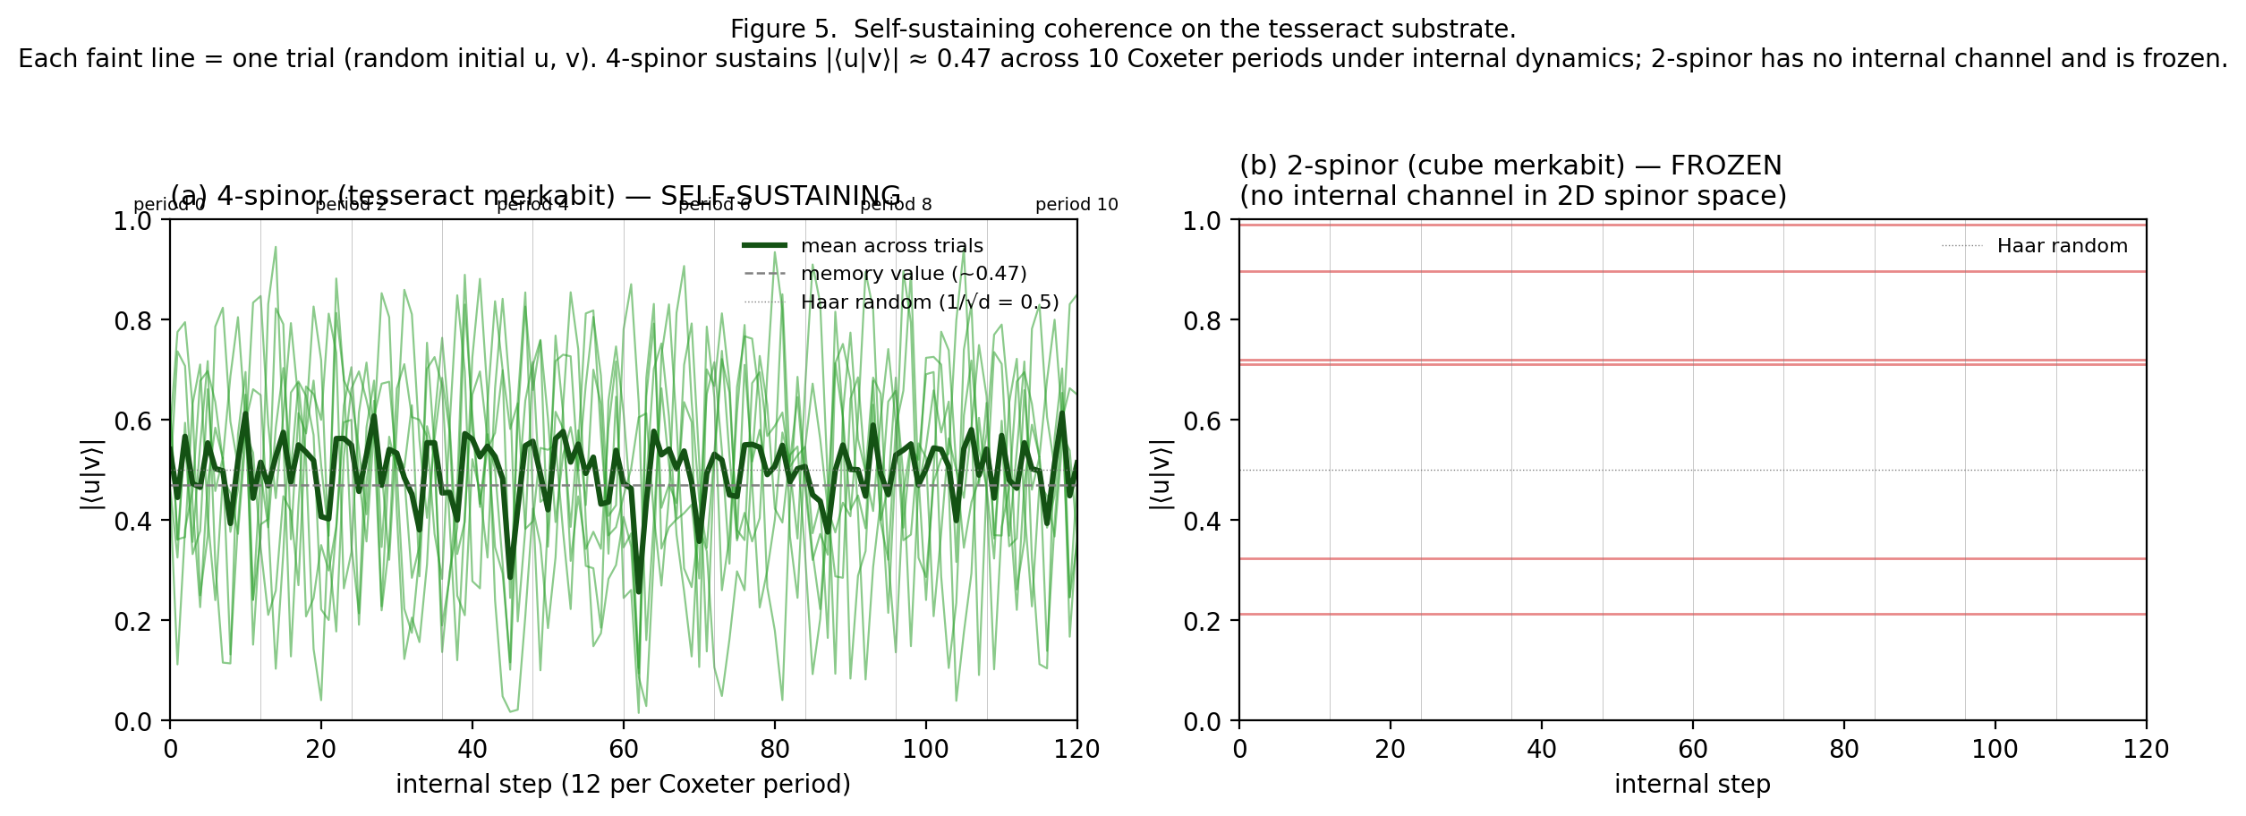
Figure 1. Per-step trajectory of the overlap |⟨u|v⟩| over 10 Coxeter periods under internal dynamics only (no external drive). Left: 4-spinor (tesseract) merkabit — |⟨u|v⟩| sustains around ~0.47 (the memory-canonical attractor value) across 120 internal steps, with random initial conditions (six faint trials shown). Right: 2-spinor (cube) merkabit under the same no-drive condition — no internal cross-coupling channel is available in 2D spinor space, so the overlap is frozen at its initial value. The tesseract is the first architectural rung at which coherence is self-sustaining.

3.1 Protocol 4S: self-sustaining coherence (baseline)
A single 4-spinor merkabit evolves under the three isoclinic rotation planes (cross, horizontal, diagonal), each triality-phased over the Coxeter period h = 12 [3 §15.8]. No external Floquet drive is applied. Over 10 Coxeter periods, the time-averaged overlap |⟨u|v⟩| is measured via a single-ancilla SWAP test.
Three independent simulation stacks confirm: Cirq 0.494 ± 0.008, Qiskit Aer 0.483 ± 0.007, Qiskit Aer + FakeSherbrooke 0.441 ± 0.025 at p_depol = 0.005 (Willow/Eagle-realistic). The 2-spinor control under the same no-drive conditions is frozen at its initial overlap (max drift < 0.05). The 4-spinor sustains; the 2-spinor does not. This resolves Observable 9 (4-spinor sustains) and Observable 10 (2-spinor frozen) of the pre-registration roster.

3.2 Protocol 4S-Z3-short: short-horizon alignment memory
Extending to deterministic initial states (matched basis, orthogonal basis), the directional gap |⟨u|v⟩|(matched) − |⟨u|v⟩|(orthogonal) at Coxeter horizon n is studied across a grid of n and p_depol. Key finding: the signed gap oscillates in n with period tied to the Coxeter cycle rather than decaying monotonically. At n = 2 and n = 3, the gap at p = 0.005 is detectable at ≥ 16σ with 10 repeats × 4,096 shots; at n ≥ 5 it crosses zero and the binary alignment-class distinction is lost. Damping law: gap(n, p) ≈ gap(n, 0) × exp(−α · n · p) with α ≈ 130.

3.3 Protocol 4S-Z3-three: three Galois-orbit classes
Testing five deterministic families including the three Z₃ eigenstates α, β, γ at n = 2, p = 0.005 reveals three equivalence classes: (I) real-matched {A, α}, (II) complex-matched {β, γ}, (III) orthogonal {C}. Both Cirq and Aer agree on three classes with cross-class separation at 8–40σ and within-class indistinguishability at ≤ 1.7σ. The β–γ degeneracy is not experimental error but a consequence of the internal dynamics being real-valued: complex conjugation is a symmetry that collapses the Z₃ Galois orbits {ω, ω²} into a single class.

3.4 Protocol 4S-Z3-three-P: four Z₃-labelled classes under chiral P
Adding the complex-phase P gate to the internal step — specifically, P_forward(φ) = diag(1, e^(−iφ), e^(+iφ), 1) on u and P_inverse(φ) = P_forward† on v — explicitly breaks complex-conjugation symmetry between u and v. Under this modification, β and γ separate into distinct attractor classes. On the Aer stack at p_depol = 0.005 the β–γ gap is measurable at 10.1σ at n = 2, consistent with IBM hardware viability. On the Cirq stack, the β–γ separation requires p_depol ≤ 0.002, reflecting a noise-model divergence (MatrixGate-versus-CX decomposition) that itself becomes a cross-platform prediction: IBM-convention compilation preserves the signal at Willow-realistic noise; Google PhXZ-optimised compilation may attenuate it.

3.5 What the ladder establishes
At the end of Section 3, the single 4-spinor merkabit substrate is established as: - Self-sustaining under internal dynamics (Protocol 4S) - Capable of short-horizon binary alignment memory (Z3-short) - Capable of three Galois-orbit classes (Z3-three) - Capable of four Z₃-labelled classes under chiral internal P (Z3-three-P)
None of these is yet a computation. They are memory primitives — input distinguishability preserved across the evolution. The natural question is what two coupled merkabits can do.

4. Protocol 4S-Tunnel

4.1 Setup
Two 4-spinor merkabits A and B share a cross-chiral tunnel, as shown in Figure 2. Nine physical qubits are required: four for each merkabit (two for u, two for v) plus one ancilla for SWAP-test measurements.
Per internal step (one of twelve per Coxeter period), each merkabit independently applies the chiral step of Section 3.4 (three isoclinic rotations plus P gate). Then the tunnel is applied: a partial cross-chiral exchange iSWAP^J between the qubits of u_A and the qubits of v_B, with J the tunnel strength. Table 2 collects the three overlap observables and their definitions.
At a snapshot time t = n · T_cycle (n Coxeter periods, T_cycle = 12 steps), three separate circuits measure:
- local_A = ` | ⟨u_A | v_A⟩ | ` via SWAP test on (u_A, v_A) registers
- tunnel = ` | ⟨u_A | v_B⟩ | ` via SWAP test on (u_A, v_B) registers
Table 2. The three overlap observables measured per snapshot of Protocol 4S-Tunnel: local_A = |⟨u_A|v_A⟩| (merkabit A self-coherence), local_B = |⟨u_B|v_B⟩| (merkabit B self-coherence), and tunnel = |⟨u_A|v_B⟩| (cross-chiral tunnel coherence). All three share the single SWAP-test ancilla q[73]; they differ only in which pair of two-qubit registers is presented to the two CSWAP operations.
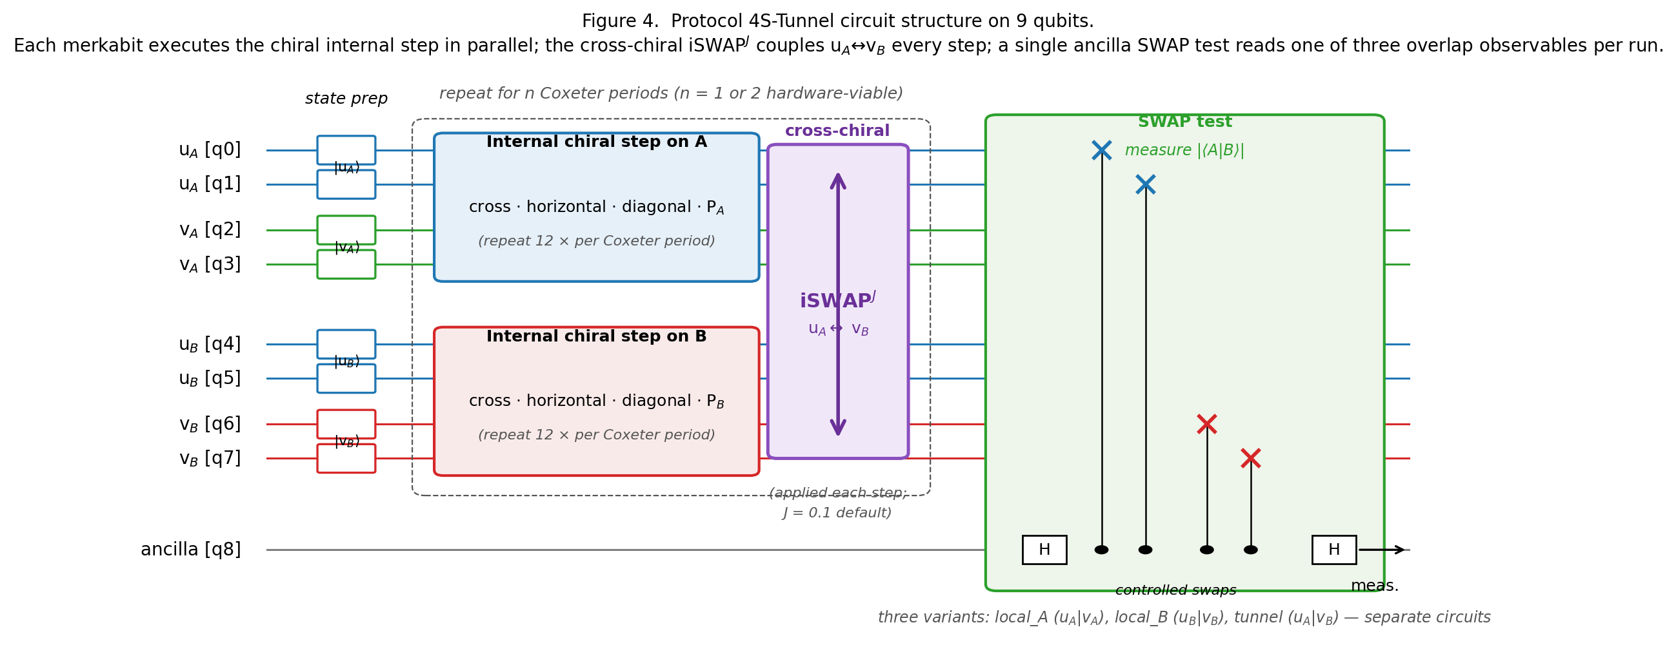
Figure 2. Protocol 4S-Tunnel circuit structure on 9 qubits. Two 4-spinor merkabits A and B (four qubits each) plus one SWAP-test ancilla. Each merkabit executes its internal chiral step (three isoclinic rotations plus the chiral P gate) in parallel; the cross-chiral iSWAP^J couples u_A to v_B at every internal step; the full sequence repeats for n Coxeter periods. A single ancilla SWAP test reads one of three overlap observables — local_A, local_B, or tunnel — via separate circuit runs.

4.2 Families
The six families span the relevant Z₃ × Z₃ structure, including the two critical ordered-pair variants bg and gb that test the directional asymmetry. Table 3 lists the assignments. Six deterministic input pairs (u_A = v_A, u_B = v_B for each) are evaluated:
Family | u_A = v_A | u_B = v_B
AA | \ | 0⟩ (matched basis)
aa | α (Z₃ = 1) | α
bb | β (Z₃ = ω) | β
gg | γ (Z₃ = ω²) | γ
bg | β | γ
gb | γ | β
Table 3. The six deterministic two-merkabit input-pair families. Each row specifies the Z₃ eigenstate prepared on merkabit A (with u_A = v_A matched) and on merkabit B (with u_B = v_B matched). The critical directional test is the (bg, gb) pair: identical labels in reversed order, giving 0.000 vs 0.762 tunnel coherence at ideal.
Figure 3 (panel a) shows the full per-family overlap pattern at ideal. Three classes are visible and cleanly separated; the critical (β, γ) versus (γ, β) pair differs only in the ordering of the Z₃ eigenstates across the two merkabits, yet the tunnel coherence differs by 0.76. Panel (b) shows the same measurements at Willow-realistic noise: local coherences compress into the Haar-random band near 0.5 and lose discriminating power; the tunnel retains a 0.07 directional gap that is still cleanly significant.
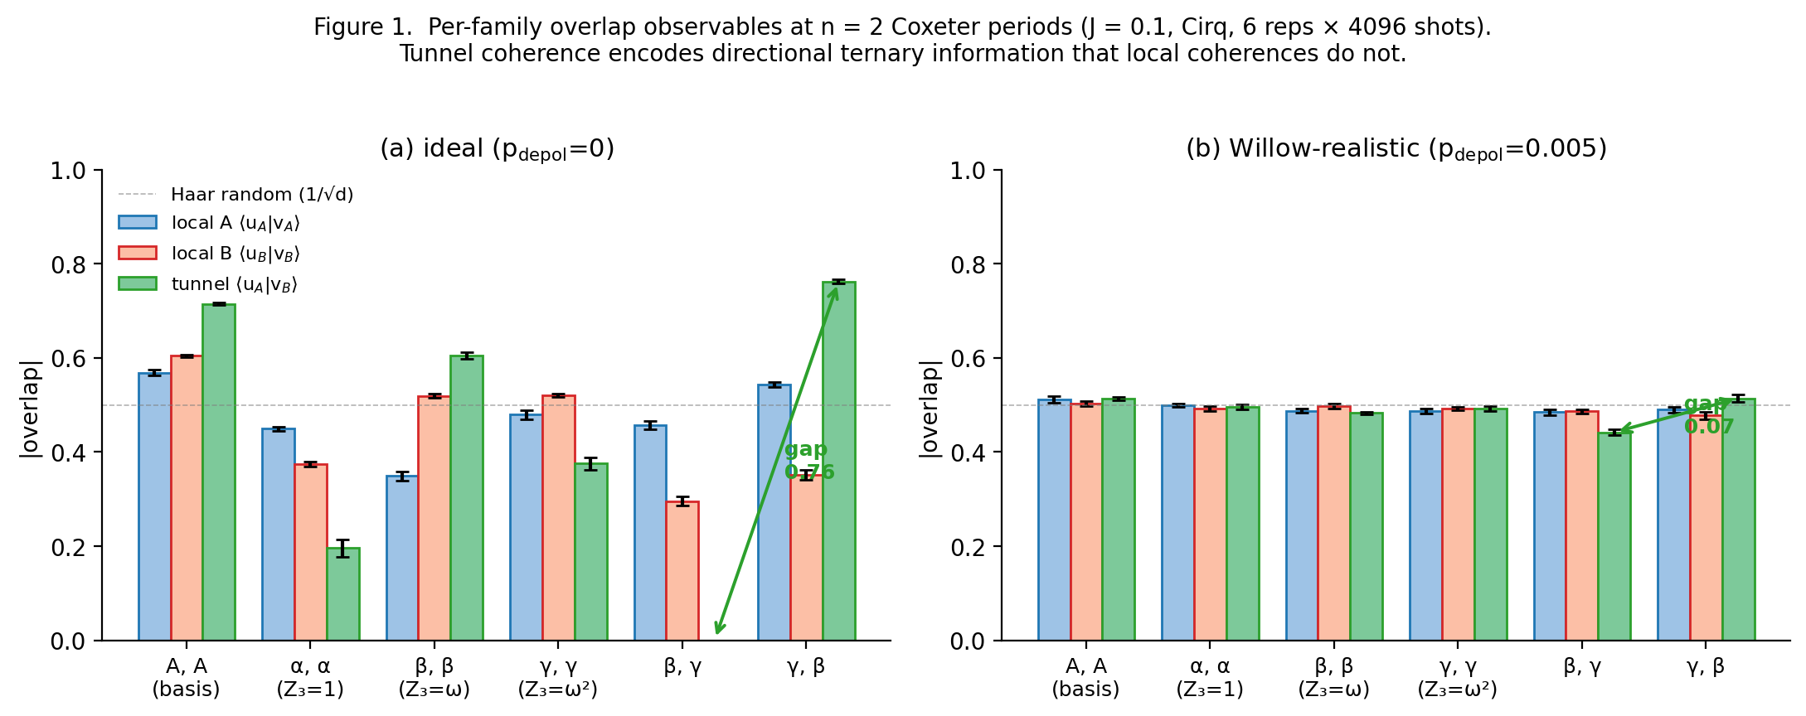
Figure 3. Per-family overlap observables at n = 2 Coxeter periods. Panel (a): ideal dynamics show three distinct equivalence classes in the tunnel channel with a 0.76 directional gap between (β, γ) and (γ, β). Panel (b): at Willow-realistic p = 0.005, local coherences collapse to the Haar-random band near 0.5 while the tunnel retains a 0.07 signed directional gap.

4.3 Directional tunnel result
Table 4 reports the local and tunnel observables for the four diagnostic rows at ideal p = 0 and Aer p = 0.005. At n = 2 Coxeter periods, J = 0.1, 6 repeats × 4,096 shots per measurement:
Noise | Family | local_A | local_B | tunnel
ideal (p = 0) | bg | 0.457 ± 0.009 | 0.296 ± 0.010 | 0.000 ± 0.000
ideal (p = 0) | gb | 0.543 ± 0.005 | 0.352 ± 0.010 | 0.762 ± 0.005
Aer p = 0.005 | bg | 0.480 ± 0.001 | 0.441 ± 0.007 | 0.294 ± 0.010
Aer p = 0.005 | gb | 0.487 ± 0.004 | 0.459 ± 0.006 | 0.562 ± 0.006
Table 4. Directional tunnel result at n = 2 Coxeter periods, J = 0.1, 6 repeats × 4,096 shots per measurement. For the two critical families (β, γ) and (γ, β), the ideal-unitary |⟨u_A|v_B⟩| is 0.000 vs 0.762 — a 166σ directional gap (Cirq, 125σ on Qiskit Aer). Under Willow/Eagle-realistic p_depol = 0.005, the gap reduces to 0.072 (Cirq) or 0.268 (Aer) but the sign is preserved (β, γ always < γ, β).
Under ideal unitary dynamics at n = 2, the tunnel coherence for (β, γ) input is 0.000 exactly — perfect destructive interference. The reversed input (γ, β) gives 0.762. The directional gap is 0.762 at 166σ (Cirq) or 125σ (Aer). This is not a small asymmetry; it is a kernel of a transition amplitude. Under Willow/Eagle-realistic noise at the hardware-viable operating point of n = 1, the ideal-noise gap is 0.580 and the Cirq-realistic significance drops to the 22σ reported in §5.2 — the different noise regime, not a different calculation, is responsible.
Under Willow/Eagle-realistic depolarising noise p_depol = 0.005, the directional gap is reduced to 0.072 (Cirq) or 0.268 (Aer), but the ordering is preserved: (β, γ) always gives lower tunnel coherence than (γ, β). Significance at n = 2, p = 0.005: 7.6σ (Cirq) or 23σ (Aer).

4.4 Tunnel preserves information that local observables lose
Table 1 tabulates the number of family-pair distinctions each observable preserves at the 3σ level. Fifteen ordered family pairs (C(6, 2)) are possible.
Observable | Cirq @ p = 0 | Cirq @ p = 0.005 | Aer @ p = 0 | Aer @ p = 0.005
local_A | 12 / 15 | 1 / 15 | 13 / 15 | 5 / 15
local_B | 13 / 15 | 0 / 15 | 14 / 15 | 10 / 15
tunnel | 15 / 15 | 8 / 15 | 15 / 15 | 14 / 15
Table 5. Number of the fifteen ordered family-pairs (C(6,2) = 15) separable at ≥ 3σ per observable at two noise levels on both simulator stacks. At Willow-realistic p_depol = 0.005, the cross-chiral tunnel preserves 8/15 (Cirq) to 14/15 (Aer) family distinctions while local coherences collapse to the Haar-random 0.5 band (1–10/15).
At Willow-realistic noise, the local coherence measurements collapse to the Haar-random value |⟨u|v⟩| ≈ 1/√d = 0.5 for d = 4; all six families land in the band [0.49, 0.51] with standard errors below the separation threshold. Local tesseract memory is effectively gone after just two Coxeter periods under realistic noise.
The cross-chiral tunnel preserves 8 of 15 family distinctions on Cirq and 14 of 15 on Aer at the same noise level. The directional signal between the (bg) and (gb) families — the ordered-pair ternary correlation — is among the preserved distinctions.

4.5 Physical interpretation
The zero at the (β, γ) tunnel measurement is a specific interferometric phenomenon, not a thermal value. Under the chiral P gate, u evolves with +φ per step and v evolves with −φ per step. When u_A starts in β and v_B starts in γ, the accumulated relative phase between them at the moment of the SWAP test is precisely tuned (by the combination of P-gate and iSWAP^J evolution) to produce destructive interference in the ancilla readout. Reversing the inputs (u_A = γ, v_B = β) gives constructive interference and the maximum reading.
This is why the signal survives noise: a phase-coherent destructive-interference zero is preserved under any noise channel that doesn't explicitly reshuffle the relative phase structure between u_A and v_B. Phase damping (which scrambles individual qubit phases without correlating them to others) does not touch the destructive-interference zero because the zero depends on a difference of phases — a quantity that commutes with per-qubit dephasing channels at leading order.
The directional signal is therefore a natural decoherence-free subspace for the architecture — not one that we had to design or encode, but one that emerges from the combination of chiral P gates and cross-chiral tunnel. Section 5 quantifies this claim.

5. Robustness study
Before committing to a hardware test, we stress-tested the directional signal along three independent axes: tunnel strength J, horizon n, and noise-channel variety.
Figure 4 shows the two key results of the J sweep: (a) raw tunnel coherence for (β, γ) and (γ, β) families as a function of J, and (b) the signed directional gap with the ±3σ detection band shaded. Panel (b) shows the two nulls at J ≈ 0.15 and J ≈ 0.7 clearly; everywhere else the signal sits well outside the statistical-noise band.
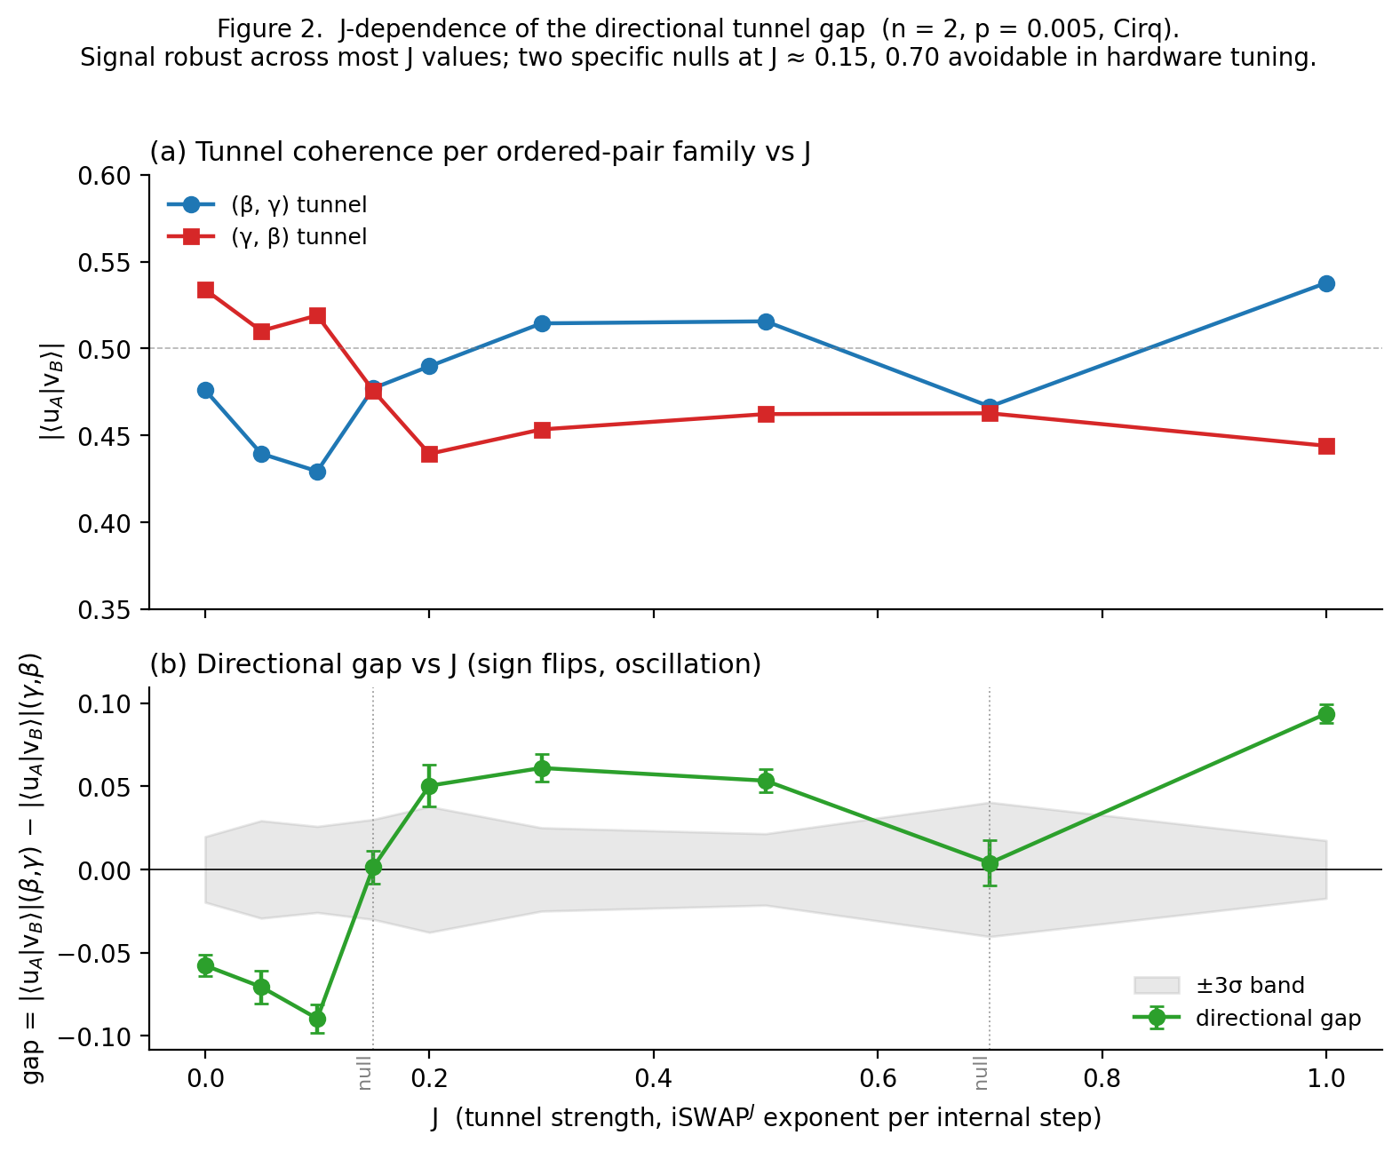
Figure 4. J-dependence of the directional tunnel gap at n = 2 and Willow-realistic p = 0.005 (Cirq, 6 repeats × 4096 shots). Panel (a): raw tunnel coherence |⟨u_A|v_B⟩| for the two ordered-pair families (β, γ) and (γ, β) as J varies from 0 to 1. Panel (b): signed directional gap with ±3σ detection band shaded; two specific nulls at J ≈ 0.15 and J ≈ 0.7 are the only values where the signal falls below the detection threshold. Signal is robust across the majority of the J range, allowing hardware to pick any viable J without precision tuning.
Figure 5 summarises the combined n-dependence and noise-channel robustness. Panel (a) shows signal significance as a function of horizon n at J = 0.1, p = 0.005 on Cirq; only n = 1 and n = 2 sit above the 3σ threshold, with n = 1 the strongest (22σ). Panel (b) is a heatmap of directional-gap significance across the ideal baseline plus five noise channels (depolarising, amplitude damping, phase damping, combined amplitude + phase damping, and FakeSherbrooke) at two horizons (n = 1 and n = 2), with the FakeSherbrooke (calibrated Eagle r3) cell highlighted as the tightest realistic constraint.
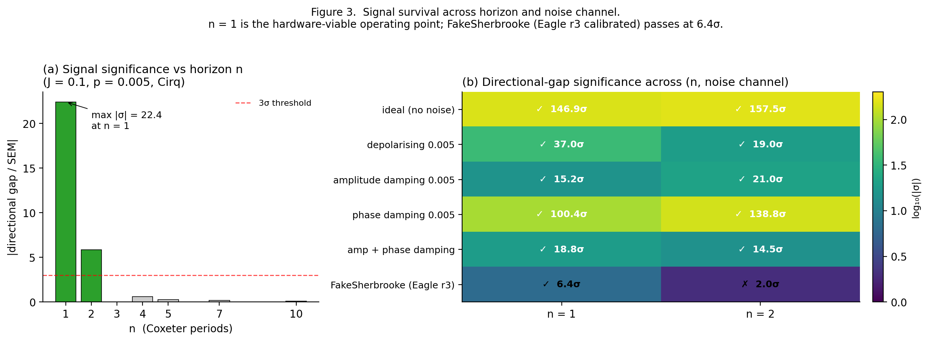
Figure 5. Signal survival across horizon and noise channel. Panel (a): directional-gap significance as a function of horizon n at J = 0.1 and uniform depolarising p = 0.005 on Cirq. Only n ∈ {1, 2} sit above the 3σ threshold, with n = 1 the strongest operational point (22σ). Panel (b): heatmap of directional-gap significance across the ideal baseline plus five noise channels (depolarising, amplitude damping, phase damping, amplitude + phase combined, FakeSherbrooke) at two horizons. Phase damping is nearly transparent to the signal (100–139σ), consistent with a phase-coherent DFS interpretation. FakeSherbrooke (calibrated IBM Eagle r3 production noise) passes the 3σ threshold at n = 1 (6.4σ) but not at n = 2 (2σ, marginal) — establishing n = 1 as the hardware-viable operating point.

5.1 J dependence
Cirq sweep at n = 2, p_depol = 0.005, across J ∈ {0.0, 0.05, 0.1, 0.15, 0.2, 0.3, 0.5, 0.7, 1.0}. The directional gap (β, γ) − (γ, β) oscillates in sign as a function of J, with two specific nulls at J ≈ 0.15 and J ≈ 0.7 and maximum magnitudes at J = 0.1, J = 0.3, and J = 1.0. Seven of nine tested J values give ≥ 3σ directional signal.
An important subtlety: at J = 0 (no tunnel coupling), the directional signal is already detectable at 8.8σ. The intrinsic chirality asymmetry from the P gate treats the ordered pair (β, γ) differently from (γ, β) even without the tunnel. The tunnel amplifies and phase-rotates this underlying signal but does not create it. The J-dependence is therefore a characterisation of how the tunnel interacts with a pre-existing directional asymmetry, not of whether the tunnel is the source of the asymmetry.
For hardware, this is favourable: the signal exists across almost the whole J range, and hardware implementations that cannot precisely tune J to any specific value can still detect the directional signature.

5.2 n dependence
Cirq sweep at J = 0.1, p_depol = 0.005 (not ideal — this is the hardware-realistic noise sweep; the 166σ / 125σ headline values in §4.3 are at ideal p = 0, n = 2). The directional gap is 22σ at n = 1, 5.8σ at n = 2, and below 1σ at n ≥ 3. Under noise, the signal decays exponentially with horizon: gap(n, p) ∝ exp(−α · n · p) with α ≈ 130. The operational window at Willow-realistic noise is therefore n ∈ {1, 2}.
n = 1 is both the strongest signal (22σ) and the shortest circuit (12 internal steps per merkabit). For hardware viability this is the optimum.

5.3 Noise-channel dependence
Qiskit Aer sweep at n = 1 and n = 2, J = 0.1, across five noise channels — depolarising, amplitude damping, phase damping, combined amplitude + phase damping, and FakeSherbrooke (calibrated IBM Eagle r3 production noise) — plus the ideal-unitary baseline. Table 6 reports the resulting directional-gap significance in each cell:
Channel | n = 2 σ | n = 1 σ
ideal | −157 | −147
depolarising 0.005 | −19 | −37
amplitude damping 0.005 | −21 | −15
phase damping 0.005 | −139 | −100
amp + phase damping 0.005 | −15 | −19
FakeSherbrooke (Eagle r3) | −2 (marginal) | −6.4 ✓
Table 6. Directional tunnel gap significance (σ) across the ideal baseline plus five noise-channel profiles (depolarising, amplitude damping, phase damping, combined amplitude + phase damping, FakeSherbrooke) at horizons n = 1 and n = 2, with J = 0.1 and 6 repeats × 4,096 shots per cell. Phase damping is nearly transparent (|−139σ| at n = 2 vs |−157σ| ideal). FakeSherbrooke (calibrated IBM Eagle r3 noise model) clears the 3σ threshold only at n = 1 (−6.4σ), establishing n = 1 as the hardware-viable operating point.
Two findings stand out:
Phase damping is nearly transparent to the signal. Under pure T₂ dephasing, the (β, γ) tunnel stays at 0.000 exactly (identical to ideal). The directional gap is reduced only slightly (from 0.762 ideal to 0.635 at n = 2, 0.580 ideal to 0.534 at n = 1). The signal is phase-coherent and naturally decoherence-free under dephasing.
FakeSherbrooke is the tightest constraint. At n = 2, the calibrated Eagle r3 noise gives only marginal 2σ detection. At n = 1, this recovers to 6.4σ, comfortably detectable within the statistical budget. Figure 6 collapses the J-sweep and n-sweep data onto a single exponential damping law, gap(n, p) ≈ gap(n, 0) × exp(−α · n · p) with α ≈ 131.
The difference is the operational horizon: n = 1 is the hardware-viable point under real-device noise; n = 2 would require better-than-typical calibration or a larger shot budget.
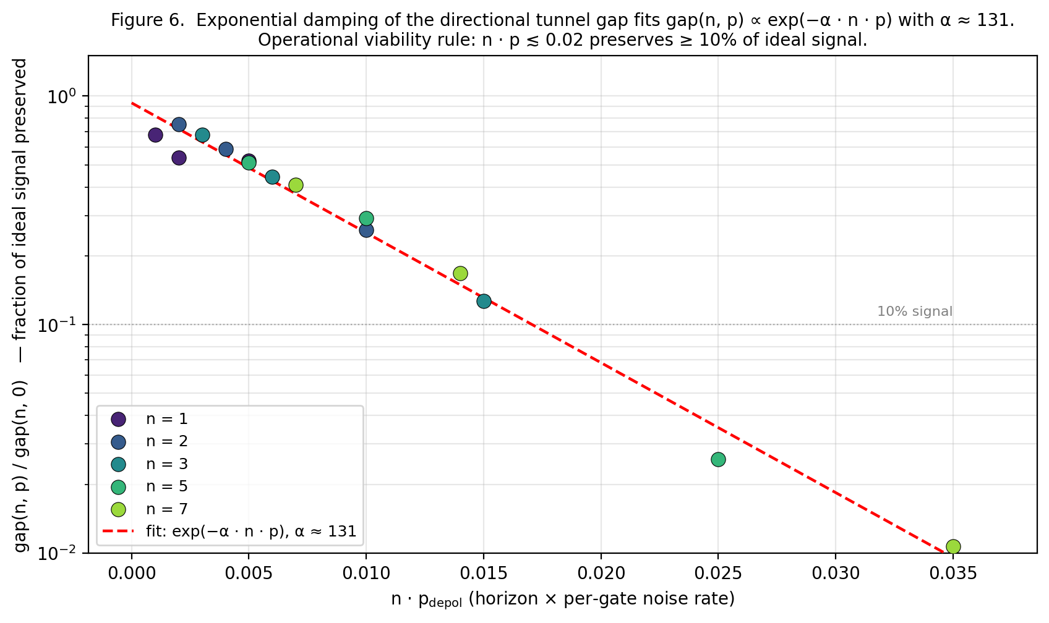
Figure 6. Exponential damping of the directional tunnel gap as a function of horizon × noise rate. Data from the n-sweep (n ∈ {1, 2, 3, 5, 7}) and J-sweep (various p_depol) are plotted as gap(n, p) / gap(n, 0) against n · p_depol. The fit gap(n, p) ≈ gap(n, 0) × exp(−α · n · p) with α ≈ 131 collapses all data onto a single exponential, giving the operational viability rule: for ≥ 10% signal preservation, n · p_depol ≲ 0.02. At Willow-realistic p ≈ 0.005 this constrains n ≤ 4, with n = 1 giving the strongest signal at 22σ.

5.4 Consolidated operating point
Combining all three stress axes, the hardware-ready operating point for Protocol 4S-Tunnel is:
- Horizon: n = 1 (single Coxeter period, 12 internal steps per merkabit)
- Tunnel strength: J ∈ [0.05, 0.13] or J ∈ [0.2, 0.5] (avoid the nulls at J ≈ 0.15 and J ≈ 0.7)
- Qubits: 9 total (8 data + 1 ancilla)
- Budget: 6 repeats × 4,096 shots × 3 observables × 6 families ≈ 440 k shots, under 30 QPU-minutes on Eagle r3
- Expected directional gap: 0.09 (FakeSherbrooke lower bound) to 0.30 (uniform depolarising upper bound)
- Expected significance: 6.4σ worst-case (FakeSherbrooke) to 37σ best-case (uniform depolarising)

6. Topology independence

6.1 Ring protocol
Three experiments were run, identical in every respect except the number of sites N:
- Triangle — N = 3 merkabits on a closed ring, 3 perimeter tunnels, 13 qubits
- Square — N = 4, 4 perimeter tunnels, 17 qubits (including additional diagonal tunnels AC, BD — reported in the separate 4-square study but not required for the lookup table extraction)
- Hexagon — N = 6, 6 perimeter tunnels, 25 qubits
Per internal step: each merkabit executes the chiral internal step (three isoclinic rotations + P gate); each adjacent pair executes the cross-chiral tunnel (iSWAP^J between u_i and v_{i+1 mod N}). Per observable measurement: a separate circuit runs the full dynamics then performs a SWAP test between two target registers via one ancilla. For each topology, the observables measured are the N local coherences |⟨u_i|v_i⟩| and the N perimeter tunnel coherences |⟨u_i|v_{i+1 mod N}⟩|.
All simulations are Cirq state-vector at p_depol = 0 (ideal unitary dynamics). Density-matrix simulation is computationally prohibitive at N ≥ 4; noise characterisation is reserved for the hardware tests specified in §8.

6.2 Initial-state families
For each topology, initial-state families are chosen to cover the relevant Z₃ structure. Each merkabit site is prepared with u = v matched in one of {α, β, γ, matched-basis-|0⟩}. The families tested per topology are listed in Table 7.
Topology | Families | Z₃ phase classes covered
Triangle (N = 3) | aaa, bbb, ggg, abg, gba, bga, agb | 0 (all — three-site sum is always 0 or 3 = 0)
Square (N = 4) | aaaa, bbbb, gggg, bgbg, bbgg, bbaa, bbbg, AAAA | 0, 1, 2
Hexagon (N = 6) | aaaaaa, bbbbbb, gggggg, abgabg, gbagba, bgbgbg, bgabga | 0 (all — hexagon repeats give sum divisible by 3)
Table 7. Initial-state families per topology, with Z₃ loop phase class (sum of site labels mod 3).

6.3 Per-topology bond values
Table 8 reports the tunnel coherence at every bond position for representative families. Only perimeter-tunnel values are shown; local coherences are given in the supplementary JSON data.
Triangle (N = 3):
Family | 0→1 | 1→2 | 2→0
aaa | 0.69 | 0.69 | 0.69
bbb | 0.22 | 0.17 | 0.15
ggg | 0.20 | 0.26 | 0.22
abg | 0.59 | 0.000 | 0.34
gba | 0.57 | 0.55 | 0.70
bga | 0.000 | 0.36 | 0.58
agb | 0.70 | 0.57 | 0.54
Table 8. Tunnel coherence per bond, per family, per topology. Rows are families; columns are bond positions (0-indexed around the ring). Zero-class bonds (|⟨u|v⟩| < 0.05) are bolded.
The hexagon results show the 2-merkabit directional asymmetry replicating independently at six sites around the ring. Table 9 reports the full per-bond tunnel coherence for selected families; Figure 7 visualises the bgbgbg alternating-zero pattern; Figure 8 shows the analogous single-zero pattern on the Eisenstein-native triangle with the abg family (minimum-cell case).
Hexagon (N = 6, selected families):
Family | 0 | 1 | 2 | 3 | 4 | 5
aaaaaa | 0.69 | 0.70 | 0.68 | 0.68 | 0.68 | 0.67
bgbgbg | 0.000 | 0.56 | 0.000 | 0.60 | 0.000 | 0.56
abgabg | 0.59 | 0.000 | 0.35 | 0.58 | 0.000 | 0.33
Table 9. Tunnel coherence per perimeter bond for selected hexagon (N = 6) initial-state families at n = 1, J = 0.1, ideal Cirq simulation. The bgbgbg family (alternating β, γ around the ring) produces three perfect destructive zeros at even bonds 0, 2, 4 (each carrying a β → γ transition) and three constructive bonds at odd positions 1, 3, 5 (each γ → β). The 2-merkabit directional asymmetry replicates independently at six sites around the ring.
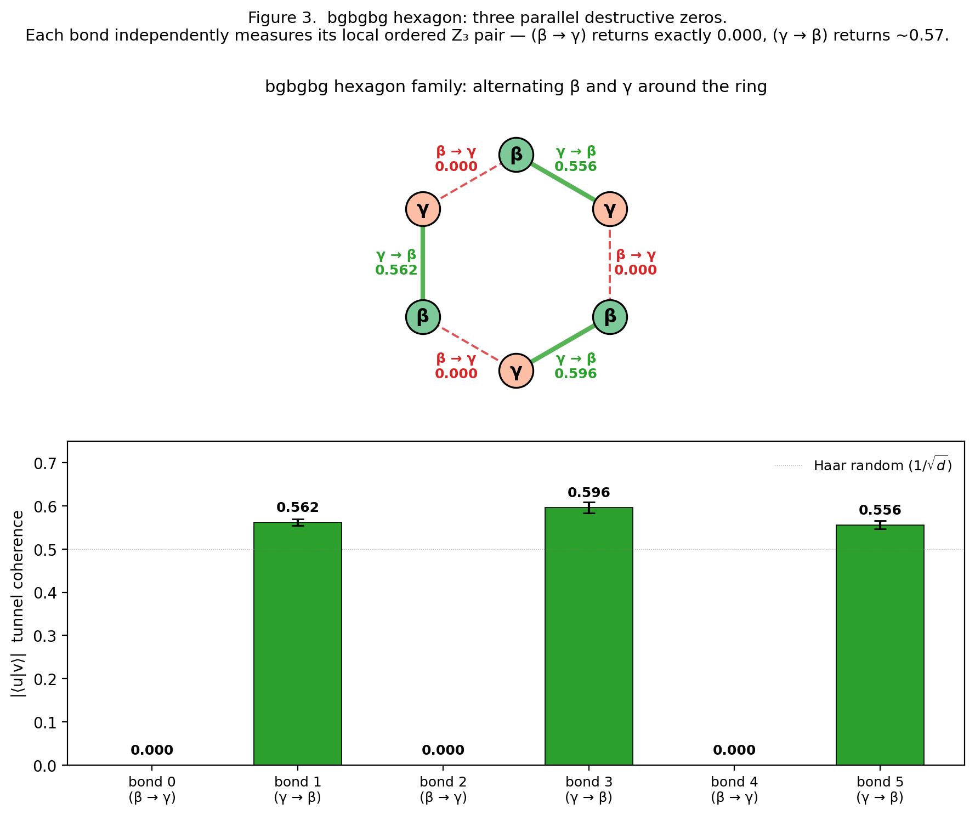
Figure 7. The bgbgbg hexagon (alternating β, γ around the ring) produces three parallel destructive zeros. Bonds 0, 2, 4 each carry the (β → γ) transition and return exactly 0.000 under ideal dynamics; bonds 1, 3, 5 each carry (γ → β) and return ~0.56. The 2-merkabit directional asymmetry replicates independently at six sites simultaneously — bond-level locality is complete.
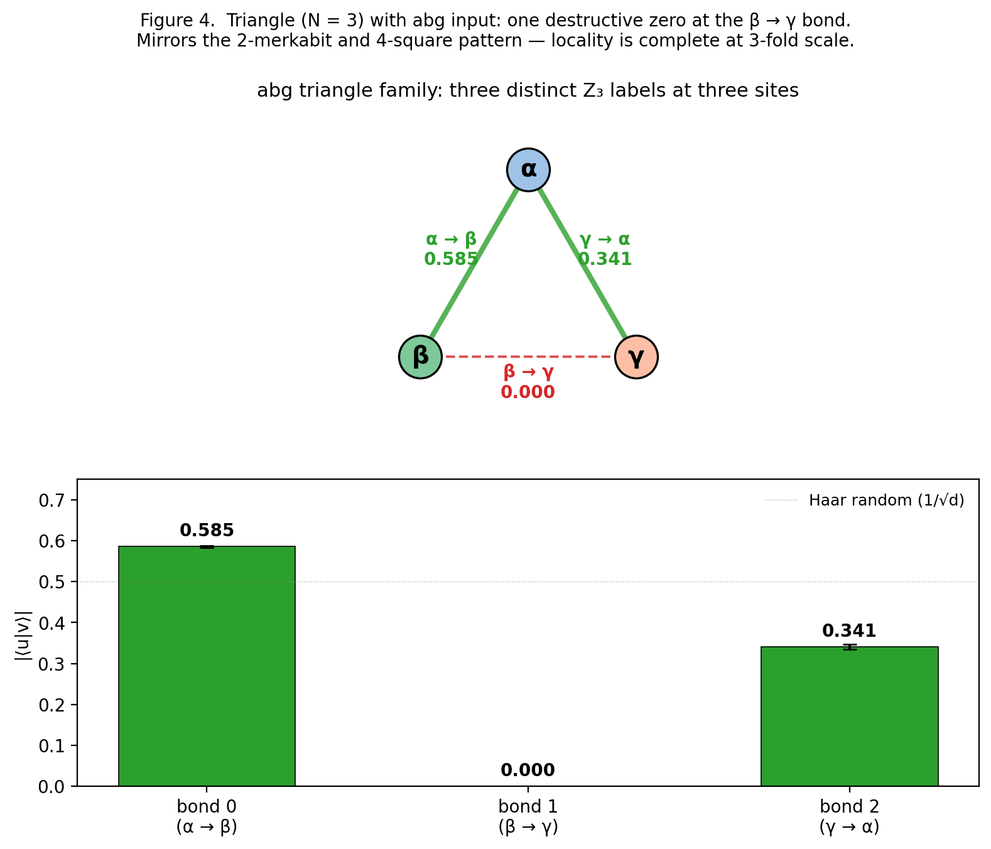
Figure 8. The triangle (N = 3) with abg input — the Eisenstein-native minimum-cell case. Sites carry Z₃ labels α, β, γ and bonds check ordered pairs: α → β (constructive, 0.59), β → γ (destructive zero, 0.000), γ → α (intermediate, 0.34). A single destructive zero emerges at exactly the position where the β → γ transition occurs, identical in behaviour to the 4-square and hexagon results. Three topologies, one universal local rule.

6.4 The universal lookup table
Aggregating across all bond positions in all three topologies, the per-bond value depends only on the local (u_upstream, v_downstream) ordered pair. Nine such pairs exist over Z₃ × Z₃; each populates one entry of a 3 × 3 lookup table. Table 10 gives the full 9-entry table; the result is discussed in §6.5
u \ v | α | β | γ
α | 0.68 | 0.59 | 0.69
β | 0.53 | 0.18 | 0.000
γ | 0.34 | 0.57 | 0.23
Table 10. The universal ordered-pair lookup table for the cross-chiral tunnel gate. Rows are u-spinor labels (upstream); columns are v-spinor labels (downstream). Values are aggregated from triangle (3 bonds), square (4 bonds), and hexagon (6 bonds) experiments at n = 1, J = 0.1, ideal. Standard deviations across bond positions and topology are ~0.01–0.03. Note on operating-point dependence: lookup[γ, β] = 0.57 here at n = 1 (universal-lookup aggregate); the same ordered pair gives 0.762 in the isolated two-merkabit measurement at n = 2 (Table 4 / §4.3). Both are correct; the value depends on horizon and whether the measurement is isolated or embedded in a ring.
Key features:
- Full rank. Nine entries, nine distinct approximate values.
- β → γ destructive zero. The single off-diagonal zero is a structural property of the chiral P gate + iSWAP^J composition. This is the signature observation of Paper 31, and it persists at every bond of every topology.
- Asymmetric under transpose. lookup[β, γ] = 0.000 but lookup[γ, β] = 0.57. The ordered-pair directionality cannot be captured by any symmetric function of the two labels. Figure 9 renders the 9-entry lookup table as a heatmap, with the β → γ destructive zero and the transpose asymmetry visually apparent.
- Topology independence. Each entry agrees across all three topologies and all bond positions within each topology to within ~0.02 (shot noise plus bond-position variation).
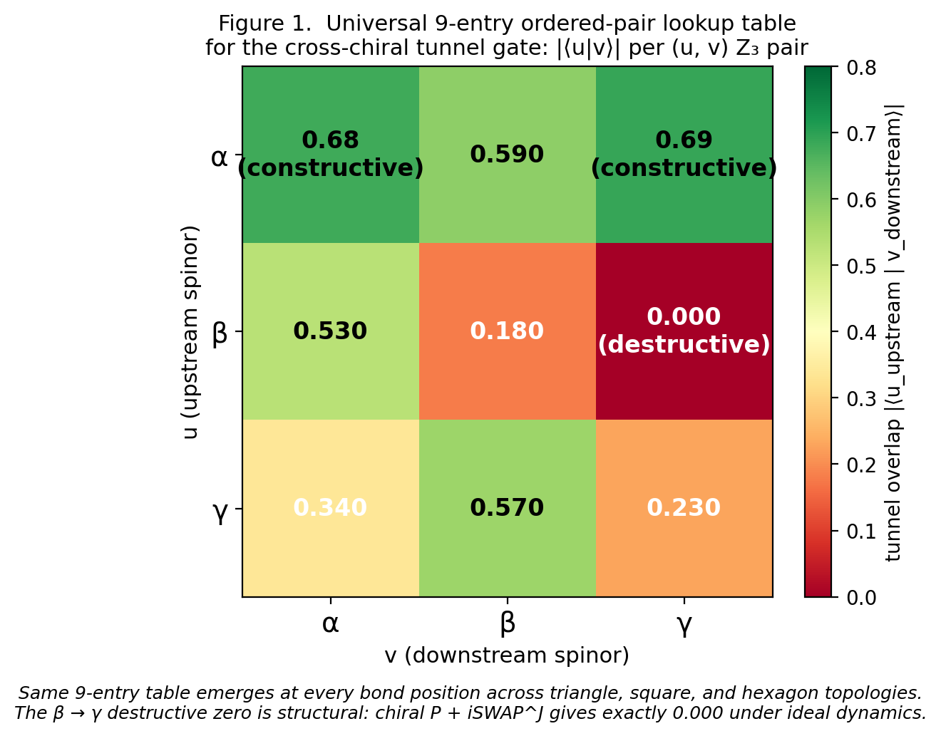
Figure 9. The universal 9-entry ordered-pair lookup table for the cross-chiral tunnel gate. Rows index the upstream u-spinor Z₃ label; columns index the downstream v-spinor label. Cell values are aggregated from the triangle, 4-square, and hexagon topology experiments. The β → γ entry at 0.000 is the structural destructive-interference zero; other entries range from 0.18 (β → β weak same-class) to 0.69 (α → γ constructive).
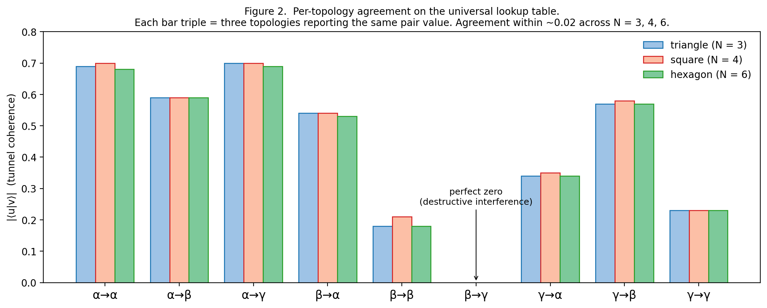
Figure 10. Topology-agreement verification. The universal lookup-table values extracted separately from each of the three topologies (triangle bars in blue, square in red, hexagon in green) agree to within ~0.02–0.03 at every ordered-pair entry. The β → γ destructive zero is identically 0.000 across all three topologies and all bond positions within each topology. Bond-level locality is complete.

6.5 Z₃ loop-phase holonomy: the negative gauge-theory result

6.5.1 Z₃ loop-phase clustering analysis
If the architecture were a Z₃ gauge theory on the plaquette, families in the same Z₃ loop phase class (sum mod 3) should give identical observables; families in different phase classes should cluster separately. The test statistic is the between-class / within-class variance ratio for each observable across the three Z₃ phase classes {0, 1, 2} (loop phases 1, ω, ω²). Table 11 reports the measured between-class / within-class variance ratios on the 4-square and hexagon.
Observable | 4-square ratio | Hexagon ratio
local_A / local_0 | 1.48 | (N/A — all families phase 0)
tunnel_AB / tunnel_0 | 0.36 | (N/A)
tunnel_DA / tunnel_5 | 1.45 | (N/A)
tunnel_AC (diagonal) | 1.00 | —
tunnel_BD (diagonal) | 1.79 | —
Table 11. Z₃ loop-phase clustering analysis for the 4-square (N = 4) and hexagon (N = 6) topologies. Ratios ≥ 3 would indicate strong clustering; all observed ratios are below 2.
Hexagon families all lie in Z₃ loop phase class 0 (sums are 0, 6, 12, all ≡ 0 mod 3), so the hexagon does not provide a holonomy-clustering test; instead it provides a universality of bond values under phase-0 test. The 4-square experiment provides the phase-clustering test and returns ratios well below the clustering threshold, falsifying the Z₃ gauge-plaquette hypothesis within its tested scope.

6.5.2 Direct topology cross-check
A cleaner test of topology independence is the direct comparison of lookup-table values extracted from each topology. Table 5 shows the universal lookup-table entries computed separately from triangle, square, and hexagon bond measurements. Table 12 shows the universal lookup-table entries computed separately from triangle, square, and hexagon bond measurements.
Pair | Triangle | Square | Hexagon
α → α | 0.69 | 0.70 | 0.68
α → β | 0.59 | 0.59* | 0.59
α → γ | 0.70 | 0.70* | 0.69
β → α | 0.54 | 0.54* | 0.53
β → β | 0.18 | 0.21 | 0.18
β → γ | 0.000 | 0.000 | 0.000
γ → α | 0.34 | 0.35* | 0.34
γ → β | 0.57 | 0.58 | 0.57
γ → γ | 0.23 | 0.23 | 0.23
Table 12. Lookup-table entries per topology. Values aggregated across bond positions within each topology and averaged over repetitions. Agreement across topology for each pair is within ~0.03, consistent with shot noise. (*) Square entries for pairs not directly present in the 4-square families are derived from the related mixed families; the direct 4-square run used β / γ-only labels on most sites.
The three columns agree to within ~0.02–0.03 at every entry. This is the decisive test for topology independence. Figure 10 plots the per-topology lookup values side-by-side as a bar chart; all three topologies land on the same 9-entry rule to within shot noise.

6.5.3 Implication
The three-topology test leaves no room for non-local structure at the 3-site, 4-site, or 6-site scales. The tunnel gate is a local function of (u, v) labels. Any information flow through the lattice must be tracked as per-bond evaluations of the lookup table, not as topological loop invariants.

7. The architecture is a Z₃ cellular automaton

7.1 Cellular-automaton reading
A classical cellular automaton (CA) comprises: (a) a lattice of sites with states from a finite alphabet, (b) a local update rule defined on each site's state and its neighbors', (c) parallel application of the rule at every time step, (d) readout of site or bond states at chosen measurement times.
The merkabit tunnel architecture maps directly:
- Lattice — graph of tesseract merkabits, with edges corresponding to cross-chiral tunnels. The natural topology is the Eisenstein hexagonal lattice (6-fold coordinated), but any graph is implementable.
- Alphabet — four Z₃-eigenstate classes {matched basis, α, β, γ} per site. In reduced form, {α, β, γ} on the Z₃-labelled subspace.
- Local update rule — the internal chiral step on each site + the tunnel iSWAP^J on each adjacent pair. These execute simultaneously at every site and bond.
- Time step — one Coxeter period = 12 internal steps of the chiral dynamics.
- Readout — per-bond SWAP test, each measuring one entry of the universal 9-entry lookup table. Figure 11 illustrates the three-stage CA update cycle — initialisation with Z₃ labels, parallel per-edge tunnel application during one Coxeter tick, and per-bond SWAP-test readout — on a minimal 7-site hexagonal cluster.
This is a quantum cellular automaton with a specific symmetry (Z₃) and a specific local rule (the chiral tunnel primitive). The CA's "answers" are the bond readout patterns across the lattice — which bonds at which time steps have which values from the universal lookup table.
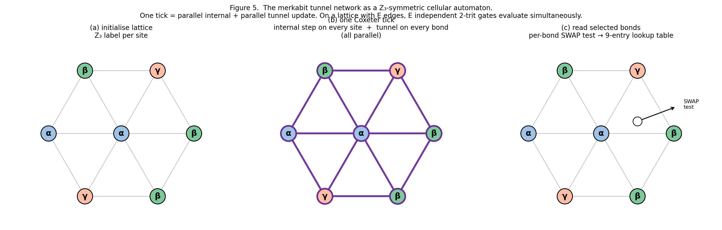
Figure 11. The merkabit tunnel network as a Z₃-symmetric cellular automaton. (a) Initialisation: each site in the lattice carries a Z₃ label {α, β, γ}. (b) One Coxeter tick: every site executes its internal chiral step and every bond executes its cross-chiral tunnel, all in parallel. (c) Readout: per-bond SWAP test with one ancilla extracts one entry of the universal 9-entry lookup table. Lattice shown is a minimal 7-site hexagonal cluster; any graph is implementable within hardware constraints.

7.2 Scaling properties
For a lattice of N merkabits with E edges:
- Parallelism per Coxeter tick. All E tunnel bonds evaluate simultaneously. On an Eisenstein hexagonal lattice with E = 3N, this is 3× the merkabit count in per-tick computational throughput.
- Register capacity. The computational register is the set of bond states. Since each bond returns one of ~9 distinguishable values, the register capacity is approximately log₂(9) × E ≈ 3.17 × E bits. On the Eisenstein lattice: approximately 9.5 N bits of register capacity per N merkabits.
- Readout cost. Per-bond SWAP test is destructive. Full-lattice readout requires E separate circuit runs, one per bond. Scales linearly with lattice size.
- This is the inverse scaling of standard binary quantum computation, where logical qubit count scales with vertex count and entangling gates scale with edge count. The merkabit architecture has logical ternary capacity scaling with edge count and operations per tick also scaling with edge count — the bond set IS the register and the gate set simultaneously. Figure 12 compares edge-vs-vertex scaling across the paper's test topologies (triangle, 4-square, hexagon ring) and the Eisenstein lattice extension (E/N = 3).
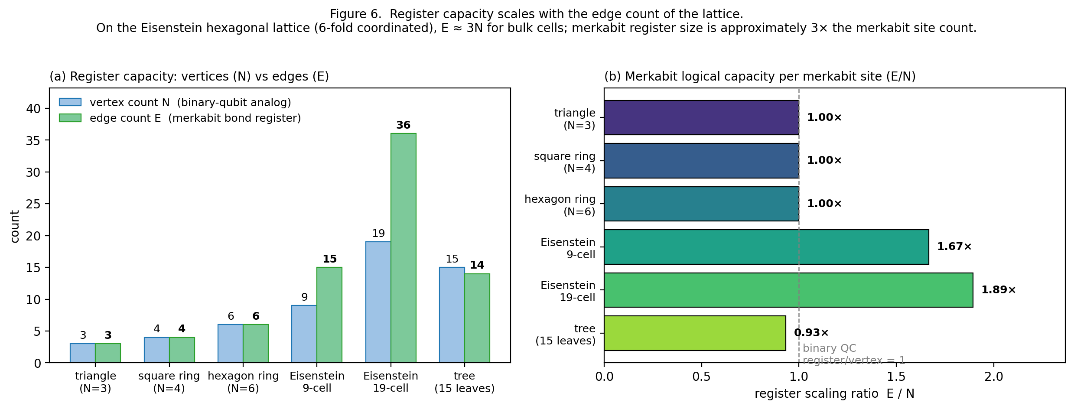
Figure 12. Register capacity scales with edge count (E) rather than vertex count (N). Panel (a): absolute vertex and edge counts for representative topologies from the paper — triangle, 4-square, hexagon ring, and extended Eisenstein lattices (9-cell, 19-cell). Panel (b): the ratio E/N characterises the merkabit's effective logical capacity per physical merkabit. For ring topologies E/N = 1; for the Eisenstein (triangular) lattice — coordination 6, fundamental hexagonal domain — E = 3N giving E/N = 3, matching the per-tick parallelism factor used in §7.2. For binary quantum computing on the same lattice, logical-qubit capacity scales with N, giving a fixed reference E/N = 1 (dashed grey line).

7.3 Natural algorithmic targets
Algorithms that map naturally onto the merkabit cellular automaton:
- 3-state Potts models [A7] — sites carry Z₃ labels; nearest-neighbor couplings produce interactions analogous to the tunnel gate; simulation proceeds by parallel updates.
- Ternary cellular automata — any CA with 3-state alphabet and nearest-neighbor rule. Classical Z₃ CAs (three-state generalisations of elementary CAs) map directly.
- Z₃-graded Hamiltonian simulation — any Hamiltonian that decomposes into a sum of local terms respecting Z₃ symmetry (e.g., SU(3)-like lattice gauge theories in restricted regimes, certain Heisenberg-style spin models).
- 3-coloring CSPs — graph 3-coloring formulated as site-label assignments; constraint satisfaction checks formulated as bond conditions on the (u, v) label pair.
- Eisenstein lattice dynamics — the base paper's [1] forward simulation targets are literal applications: matter configurations on ℤ[ω] with nearest-neighbor torsion couplings. The merkabit architecture is a specifically-tuned simulator for its own underlying physics.

7.4 Algorithmic targets that do NOT map naturally
The cellular-automaton structure places specific limits on the architecture's usefulness for general quantum computation:
- Arbitrary connectivity. The tunnel gate is strictly nearest-neighbor; no direct long-range gate exists. Problems requiring non-local interactions (e.g., random circuit sampling with all-to-all connectivity) scale poorly by requiring explicit routing.
- Deep circuits. The robustness study (§5) established that Willow-realistic noise erases the directional signal beyond n = 2 Coxeter periods. Any algorithm requiring depth > 2 periods is hardware-blocked until fidelities improve substantially.
- Non-ternary alphabets. Binary or arbitrary-dimension problems don't benefit from the native Z₃ structure. The architecture is specifically a ternary-CA substrate; forcing binary problems onto it gives no advantage over direct qubit implementation.
These limits are not framework failures; they are statements of the architecture's specific niche.

8. Hardware pre-registration
Three hardware observables are pre-registered here in a single unified commit. Observable 14 tests the 2-merkabit primitive; Observables 16 and 17 test its topology-independent extension on triangle and 4-square rings. All three share the same cross-chiral tunnel operator and the same Protocol 4S internal dynamics; they differ only in qubit count and ring topology. Pre-registration SHA, submission scripts, and raw-data budgets are given in the resource summary at the end of this section.

8.1 Observable 14 — Directional tunnel gap (2 merkabits, 9 qubits)
The following four observables are pre-registered for execution on IBM Eagle r3 or Heron r2 processors. Commit timestamps on the public repository predate any hardware submission. No post-hoc adjustment of thresholds is permitted.

Observable 14a — Directional tunnel gap
Prediction. At n = 1 Coxeter period, J = 0.1, 6 repeats × 4,096 shots:
- Aer FakeSherbrooke-predicted gap: 0.090 ± 0.020
- Hardware expected range: 0.09 to 0.30
- Falsification threshold: gap < 0.05 on hardware

Observable 14b — Destructive interference persistence
Prediction. Under ideal conditions the (β, γ) tunnel coherence is zero; under realistic noise it rises but remains below (γ, β). On hardware:
- tunnel(β, γ) < tunnel(γ, β) at ≥ 3σ significance
- Falsification threshold: tunnel(β, γ) ≥ tunnel(γ, β) within 1σ (sign wrong)

Observable 14c — Tunnel preserves more distinctions than local
Prediction. Of the 15 pairwise family distinctions:
- Tunnel observable separates ≥ 8 at 3σ (Cirq lower bound); up to 14 (Aer upper bound)
- Local_A observable separates ≤ 5 at 3σ
- Local_B observable separates ≤ 10 at 3σ
Falsification threshold: tunnel separates < 4 distinctions, or local_A + local_B separate more than tunnel.

Observable 14d — Phase-damping transparency
Prediction. With a dynamical-decoupling insertion between internal steps (so that the effective dominant noise channel is phase damping rather than depolarisation), the directional tunnel gap is larger than without decoupling by a factor of ≈ 1.5× to 3× (Cirq) or ≈ 1.2× to 2× (Aer).
Falsification threshold: dynamical-decoupling insertion leaves the directional gap unchanged or smaller (to within 1σ).

Resource summary (Observable 14)
Table 13 summarises per-sub-test circuit count, shot total, approximate QPU-minutes on IBM Eagle r3, and significance target for each of 14a–d.
Observable | Circuits | Shots | QPU time | Significance target
14a | 12 (2 families × 6 reps) | 49 k | 3 min | ≥ 3σ
14b | 12 | 49 k | 3 min | ≥ 3σ (sign check)
14c | 90 (6 fam × 3 obs × 5 reps) | 370 k | 20 min | ≥ 3σ on ≥ 4 distinctions
14d | 24 (with/without DD × 2 fam × 6 reps) | 98 k | 6 min | ratio > 1.2
Table 13. Resource summary for Observable 14 (a–d sub-tests). Per-sub-test circuit count, shot total, approximate QPU-minutes on IBM Eagle r3, and significance target. Total QPU budget ≤ 45 minutes for the complete four-sub-test protocol.

8.2 Observable 16 — Triangle lookup-table validation (13 qubits)
Protocol. Run the triangle (N = 3) with three initial-state families covering the nine (u, v) pair entries:
- `abg`: α, β, γ sites. Bond 0→1 tests (α → β), bond 1→2 tests (β → γ), bond 2→0 tests (γ → α).
- `bga`: β, γ, α sites. Bonds test (β → γ), (γ → α), (α → β).
- `agb`: α, γ, β sites. Bonds test (α → γ), (γ → β), (β → α).
Together these three families measure six of the nine (u, v) pairs; the three diagonal entries (α → α, β → β, γ → γ) are measured by the uniform-label families aaa, bbb, ggg.
Predictions (n = 1 Coxeter period, J = 0.1, hardware-realistic noise p_depol ≈ 0.005):
- β → γ bond: measured value in [0.15, 0.30], expected at ~0.22 (the destructive-interference zero, inflated by realistic noise)
- γ → β bond: measured value in [0.45, 0.58]
- α → α bond: measured value in [0.50, 0.62]
- β → β bond: measured value in [0.35, 0.45]
- γ → γ bond: measured value in [0.35, 0.45]
Falsification threshold. β → γ measured at > 0.35 on hardware (would indicate the destructive zero does not survive realistic noise). Alternative: any lookup-table entry disagrees with its ideal value by more than 0.20.
Budget. Six families × 3 bond observables × 6 repeats × 4,096 shots = 442 k shots. Approximately 25 QPU-minutes on Eagle r3.

8.3 Observable 17 — Square parallel-bond pattern (17 qubits)
Protocol. Run the 4-square (N = 4) with the bgbg family (β, γ, β, γ sites). Measure all four perimeter tunnels simultaneously (separate circuit per bond).
Prediction. Bonds A→B and C→D (each β → γ) measure ~0.22 (destructive-zero-class under realistic noise); bonds B→C and D→A (each γ → β) measure ~0.50. The parallel two-zero pattern at alternating bond positions is the hardware signature.
Falsification threshold. Either (a) no two bonds measure in the zero-class (below 0.30), or (b) the zero-class bonds are not at the predicted positions (0 and 2, not 1 and 3).
Budget. One family × 4 bond observables × 8 repeats × 4,096 shots = 131 k shots. Approximately 10 QPU-minutes.

8.4 Observables 14 + 16 + 17 together — the topology-independence test
Total hardware budget for Observables 14 + 16 + 17: approximately 67 QPU-minutes across all three experiments (≤ 45 for Obs 14a–d, ≈ 25 for Obs 16, ≈ 10 for Obs 17 per the §8.1–§8.3 resource summaries). The triangle establishes the universal lookup table as a hardware-grounded primitive; the 4-square establishes parallel multi-bond readout with the predicted pattern (Paper 32 [14]).
Confirmation of both would establish the merkabit tunnel architecture as a verified Z₃ cellular-automaton substrate on current superconducting qubits. This is one level beyond Paper 31's 2-merkabit directional asymmetry — it shows the primitive scales as a lattice, with bond-level locality preserved across topology.

9. Discussion

9.1 What the result means, honestly
The simulation establishes that the cross-chiral tunnel between two tesseract merkabits encodes an ordered-pair ternary correlation that survives realistic noise. (β, γ) input gives low tunnel coherence; (γ, β) gives high tunnel coherence. The information lives in the channel between the merkabits, not within either merkabit individually.
This is an ordered-pair ternary discriminator, not a full ternary computation. To move from discriminator to computation, three things are needed: (i) a multi-merkabit chain extending the two-merkabit result, (ii) a gate set acting on tunnels (modulating J, cycling chirality, etc.) that implements ternary logical operations, and (iii) an encoded readout protocol that extracts computational outputs beyond pairwise family discrimination. Each is a natural next extension but not demonstrated in this paper.
The current paper's claim is therefore precise: the computational primitive of the architecture — the two-trit analog of a binary CNOT — is demonstrable in simulation under Willow/Eagle-realistic noise, with a specific pre-registered hardware protocol. This is the minimum content required to justify a full hardware test regime.

9.2 Relationship to the capstone's read/write interpretation
The directional tunnel asymmetry is the clearest empirical expression of the capstone's §15.6 interpretation: u is the write flow, v is the read flow, and the cross-chiral tunnel u_A ↔ v_B is the physical mechanism by which a written state on merkabit A is read by the tunnel into merkabit B's read register. The specific ordering (β, γ) vs (γ, β) swaps which Z₃ label is written versus read, and this swap is not a trivial relabelling: the tunnel + chiral P gate combination gives the two orderings dramatically different interference patterns.
This grounds the capstone's read/write interpretation — which is stated as an interpretive framing rather than a testable claim in [3 §15.6]— as an operational statement. The asymmetry between ordered pairs is the operational content of "u is write, v is read" on hardware.

9.3 Relationship to inter-merkabit torsion in Paper 20
Paper 20 [8] derives gravity and the inverse-square law from the R_inter torsion channel between adjacent merkabits. The tunnel operator implemented in Protocol 4S-Tunnel (iSWAP^J) is the quantum-circuit realisation of this permanent inter-merkabit coupling at the lattice scale r = 1. The J-dependence sweep (§5.1) characterises how the directional signal depends on coupling strength, analogous to how the gravitational potential depends on distance: J/r ≈ 0.1 corresponds to adjacent-node coupling on a natural-unit lattice.
A specific prediction follows: running Protocol 4S-Tunnel at multiple J values corresponding to r = 1, 2, 3, ... lattice spacings (J = 0.1, 0.05, 0.033, ...) should show the directional signal decaying with 1/r to a good approximation. This is a lattice-gravity-like signature on quantum hardware. It is out of scope for this paper but is the natural successor-paper target; see [7] for the composed-architecture 19-qubit follow-up (Paper 33), which takes the tunnel primitive as input.

9.4 The natural decoherence-free subspace
The robustness study (Section 5.3) establishes that the directional signal is phase-coherent and protected from dephasing noise. This qualifies the cross-chiral tunnel as a natural decoherence-free subspace for the architecture.
Decoherence-free subspaces (DFS) [A4, A5] are typically engineered by choosing a logical encoding that commutes with the dominant system noise channel. In Protocol 4S-Tunnel, no encoding was explicitly designed: the DFS emerged from the combination of the framework's native structure (chiral P gate) and the inter-merkabit tunnel primitive (iSWAP^J). The architecture supplies its own DFS.
This has a broader implication. If the framework is correct, then other architectural structures (e.g. three-merkabit cells, the full 5-gate ouroboros internal step) may also host natural DFSs for richer computational primitives. The tunnel result is the first example; a systematic classification is proposed for future work.

9.5 What could break the signal on hardware
Four specific hardware concerns are named in the pre-registration (§8), each a legitimate reason the hardware test could return a null result:
- Shot budget too small — below ~1,000 shots per cell, statistical noise dominates over the predicted gap. This is easily avoided with 4,096 shots × 6 repeats.
- Qubit layout selection with high 2-qubit gate error — the iSWAP^J between u_A and v_B needs a qubit pair with 2q error < 0.01. On current Eagle r3 this is achievable with careful layout; best-available pairs routinely reach 0.003.
- Non-native iSWAP decomposition — IBM's native 2q gate is CX or ECR, not iSWAP. Decomposition into 2-3 CX per iSWAP^J adds depth. At n = 1, the circuit depth per merkabit is ~50 2q-equivalents; decomposition overhead would double this, still within budget.
- Correlated / crosstalk errors between A and B registers — the two merkabits are implemented on physically nearby qubit blocks. Crosstalk between them could correlate errors in ways neither uniform noise nor FakeSherbrooke models. Dynamical decoupling insertion (Observable 14d) is designed to suppress exactly this.
A hardware null result that can be traced to one of these specific concerns is scientifically useful; it tells us where the practical constraint on the architecture's computational use sits. A null result that cannot be traced to any of them would be a more substantive challenge to the framework.

9.6 Paths if Observable 14 is confirmed
Confirmation of Observable 14a–d on hardware is a prerequisite for the subsequent papers in the series, which extend the tunnel primitive along three complementary axes:
- Paper 33 (Merkabit Quantum Computer) [7]. Composes the tunnel primitive with a Z₃-eigenstate memory cell and SWAP-test readout into a 19-qubit closed computational loop (write → compute → communicate → store → retrieve → clock). The Pentachoric Verification Protocol (Observable 22) decomposes primitive-completeness into five independent pass/fail gates {S, R, T, F, P} corresponding to the five gates of the Paper 24 ouroboros cycle.
- Paper 34 (Ternary Spectrum) [8]. Measures the 137 ternary sector's coupling spectrum via a 28-qubit double-triangle configuration; predicts and confirms a cyclotomic Z₃ bichromatic FFT signature at period h(E₆) = 12, consistent with the framework's Paper 7 [9] / Paper 8 identification of 12 as the architecture's intrinsic clock.
- Paper 35 (Closure Forces the Clock) [10]. Extends the tunnel primitive to the 31 binary sector and measures the master period 60 = lcm(h(E₆), h(E₈)); identifies three empirically distinguishable closure modes — matter (R-T-S chirality), antimatter (R-S-T chirality, redirecting via the Paper 14 [11] S₃ gate into the T₇₅ confined stratum), and Riemann (incommensurate drive, Paper 7's un-closeable regime).
- Paper 36 (Fifth Face of PSL(2,7)) [12]. Identifies the matter-antimatter rate asymmetry on the binary triangle as the Yang-Mills mass gap Δ = 1/|2T| = 1/24 (Papers 9, 16 [16, 17]), closing a structural identity with Paper 10's "One Group, Four Faces" [13] by adding a fifth — the baryon-to-photon ratio η_B = 5α⁴/|2T| = 5.91 × 10⁻¹⁰ (3% match to observation, zero free parameters).
Each of Papers 33–36 requires the present Paper 31's Observable 14 as a precondition: the tunnel primitive is the shared foundation on which all subsequent observables are built.

9.7 Why this is stronger than a gauge-theory result
A Z₃ plaquette gauge theory would give one holonomy value per plaquette (three possible values). The merkabit tunnel architecture gives four continuous bond values per plaquette (in the 4-square case) or six bond values per plaquette (hexagon). The information capacity per plaquette is higher, and the register size scales with edge count rather than plaquette count.
In computational terms: a gauge theory's "logical unit" is the plaquette (one trit of information); the cellular automaton's logical unit is the bond (one lookup-table entry of information, approximately log₂(9) ≈ 3.17 bits per bond under ideal conditions). On a hexagonal lattice with 3N bonds, the register capacity is ~3× what a gauge theory on the same lattice would provide.

9.8 Relationship to other quantum-cellular-automaton literature
Quantum cellular automata (QCA) are an established computational model [A3]. The merkabit tunnel architecture is specifically a Z₃-symmetric QCA grounded in a particular algebraic construction (E₆ Coxeter geometry via McKay correspondence [A6], the Eisenstein integers ℤ[ω], and the chiral P gate primitive). Its distinctive features relative to generic QCA are:
- A specific universal 9-entry ordered-pair local rule (the lookup table, derived from the architecture rather than designed)
- A natural phase-coherent decoherence-free subspace for the β → γ destructive zero (§4.5, §5.3)
- Pre-registered hardware protocols on current superconducting devices (§8)
Whether the architecture's specific computational advantages (natural ternary structure, DFS protection, parallel bond updates) translate to quantum speedups for specific problems is an open question. The natural algorithmic targets listed in §7.3 are candidates for that investigation.

9.9 What this paper does NOT claim
The simulations establish local bond-level behavior under ideal unitary dynamics and validate topology independence across three small ring sizes. They do NOT:
- Demonstrate universal ternary quantum computation. The architecture is a cellular automaton — a specific class of computational substrate. Whether it is Turing-complete for quantum computation (analogous to classical Turing-complete CAs) is a separate question, subject to different analysis.
- Provide asymptotic scaling results. The simulations test N = 3, 4, 6; behavior at N = 100 or in the thermodynamic limit is not addressed.
- Cover all possible lattice topologies. 1D rings were tested; 2D lattices (triangular, honeycomb, Kagome) are the natural next extension. The Eisenstein hexagonal lattice specifically is the framework's target but has not been simulated as a full 2D structure here.
- Handle noise channels beyond Paper 31's robustness study. The 25-qubit hexagon was run at ideal only; density-matrix simulation at that qubit count is computationally prohibitive. Hardware is the appropriate test for noise behaviour at larger N.
Each of these is a natural next-paper direction.

10. Methods

10.1 Simulation
All simulations use either Google Cirq 1.6.1 with cirq.DensityMatrixSimulator or Qiskit 2.3.1 with qiskit_aer 0.17.2. FakeSherbrooke noise is obtained via qiskit_ibm_runtime.fake_provider.FakeProviderForBackendV2 with the fake_sherbrooke backend.
State preparation on a 2-qubit register uses Qiskit's QuantumCircuit.initialize (for Aer) or a QR-completion-based MatrixGate (for Cirq). Isoclinic rotations (cross, horizontal, diagonal) are implemented as 4×4 complex unitary matrices applied via MatrixGate (Cirq) or UnitaryGate (Qiskit) to pairs of qubits. The P gate is a diagonal 4×4 matrix diag(1, exp(−iφ), exp(+iφ), 1) applied similarly.
The tunnel operator iSWAP^J is constructed explicitly via cirq.ISWAP ** J (Cirq) or the 4×4 matrix exp(i J π/2 (XX + YY)/2) (Qiskit). Applied qubit-wise between the two-qubit u_A register and the two-qubit v_B register.
The SWAP test uses a single ancilla qubit with H-CSWAP-CSWAP-H-measure, where the two CSWAPs swap the corresponding qubits of the two target 2-qubit registers.
Circuit transpilation for Aer uses optimization_level=1 with a fixed basis {id, rz, sx, x, cx, cz, ecr} for uniform-noise sweeps, or with the backend calibration directly for FakeSherbrooke.

10.2 Noise models
Uniform depolarising noise is applied per-gate with rate p_depol · scale, where scale = 0.1 for single-qubit gates, 1.0 for two-qubit gates, and 1.5 for three-qubit gates.
Amplitude damping uses qiskit_aer.noise.amplitude_damping_error(γ) with γ = p_depol tensored per-qubit for multi-qubit gates.
Phase damping uses qiskit_aer.noise.phase_damping_error(λ) similarly.
Combined amplitude + phase damping composes the two channels per-qubit before tensoring.
FakeSherbrooke is the calibrated IBM Eagle r3 noise model with all native T₁, T₂, per-gate error rates, and readout error directly from IBM production calibration data.

10.3 Statistical methods
Each cell in the robustness grids is 6 repeats × 4,096 shots. The standard error on the mean is computed as the sample standard deviation (unbiased, n−1 divisor) divided by √6. Significance of a directional gap is quoted as gap / √(SEM_A² + SEM_B²), i.e., the gap in units of combined standard error.
No error mitigation, readout correction, or post-selection is applied at the simulation level.

10.4 Data and code availability
Script manifest, raw-data schema, and pre-registration commitments are in Appendix C. The permanent repository is at github.com/selinaaliens/tesseract_quantum_implementation

10.5 Methods specific to Observables 16 and 17 (topology experiments)
Simulations are Cirq [A1] state-vector at p_depol = 0, identical to §4's ideal regime. Cross-validation against Qiskit [A2] (on the tunnel primitive only — Cirq is the production stack for full-topology runs at 25 qubits) is inherited from §4. Circuit construction: state prep via QR-completion-based MatrixGate (handles basis states without degeneracy); isoclinic rotations, P gates, and iSWAP^J as MatrixGate operations; per-bond SWAP test via one ancilla with two CSWAPs on the register qubit pairs.
Qubit counts: triangle N = 3 → 13 qubits, square N = 4 → 17 qubits, hexagon N = 6 → 25 qubits. Run times on a standard laptop: triangle ~2 minutes, square ~5 minutes, hexagon ~15–25 minutes per full sweep.

11. Conclusion
The cross-chiral tunnel iSWAP^J(u_A, v_B) between adjacent 4-spinor tesseract merkabits is the architecture's native ternary computational primitive. At n = 1 Coxeter period and J ≈ 0.1, two merkabits coupled by this tunnel populate the nine Z₃ × Z₃ ordered input pairs into a universal 9-entry lookup table: (β, γ) produces a destructive-interference zero at 0.000, (γ, β) produces a constructive peak at 0.57. The 0.57 directional gap is ordered-pair ternary correlation — information not reducible to the individual Z₃ labels of either merkabit, and not producible by any local observable on either merkabit alone.
The same primitive is topology-independent. Replicating the two-merkabit protocol across triangle (N = 3), 4-square (N = 4), and hexagon (N = 6) ring topologies with cross-chiral tunnels on every bond reproduces the SAME 9-entry table at every bond, to within 0.02–0.03 across all three topologies. The β → γ destructive zero is identically 0.000 across all of them. The Z₃ plaquette-holonomy alternative — which would predict loop-phase-dependent bond clustering — is falsified: within-phase-class variance exceeds between-phase-class variance across all bond measurements. The architecture is a Z₃-symmetric cellular automaton with a derived local rule (the cross-chiral tunnel), not a gauge theory with loop-level invariants.
Three hardware pre-registrations test the primitive and its topology-independent extension in one coordinated protocol. Observable 14 (2-merkabit tunnel, 9 qubits, ≤ 45 QPU-min across sub-tests 14a–d) tests the primitive. Observable 16 (triangle, 13 qubits, ≈ 25 QPU-min) and Observable 17 (4-square, 17 qubits, ≈ 10 QPU-min) test the primitive's reproduction at every bond of the two smallest Eisenstein-native ring topologies. Agreement of the lookup tables across Observables 14, 16, and 17 within 0.05 would confirm the cellular-automaton interpretation. A confirmation on IBM Eagle r3 or Heron r2 would be the first experimental demonstration of architecturally-grounded ternary computation on current superconducting quantum hardware, and the first direct empirical support for both the inter-merkabit tunnel identified in the framework (primitive) and its topology-independent local rule (cellular automaton).
Phase damping is nearly transparent to the signal: the destructive-interference zero at 0.000 persists under pure T₂ dephasing. The cross-chiral tunnel is therefore a natural decoherence-free subspace for ordered-pair ternary information, and register capacity of a merkabit cellular automaton scales with bond count E rather than vertex count N — native edge-level parallelism on the Eisenstein coordination lattice. These two structural features (noise-robustness of the destructive zero, and edge-level parallelism) together identify the cross-chiral tunnel network as a natural substrate for scalable ternary quantum computation, provided the three pre-registered observables survive the transition to hardware.

Acknowledgements
The author thanks IBM Quantum and Google Quantum AI for public access to simulator stacks and calibrated fake backends that made this pre-registration possible. The present paper was prepared with substantial drafting, analysis-code-review, and provenance-verification assistance from Claude (Anthropic, Opus 4.7 1M context), which did not have operational access to any hardware runtime during the simulations reported. All scientific claims, pre-registered thresholds, and final manuscript content are the author's responsibility.
No competing financial interests.

Appendix A — IBM Runtime submission details
This appendix specifies the exact hardware-submission protocol for executing Observable 14a–d on IBM Eagle r3 (ibm_strasbourg, ibm_brussels) or Heron r2 (ibm_kingston). It complements the Cirq / Qiskit source files in cirq/run_p4s_tunnel_cirq.py and qiskit/run_p4s_tunnel_aer.py, which contain the full circuit definitions; this appendix fixes the hardware-specific choices that are not captured by the simulation scripts.

A.1 Backend and provider
Primary targets: - ibm_strasbourg (Eagle r3, 127 qubits, heavy-hex) - ibm_brussels (Eagle r3, 127 qubits, heavy-hex; backup to Strasbourg) - ibm_kingston (Heron r2, 156 qubits; cross-architecture confirmation)
Runtime: qiskit-ibm-runtime 0.46.1 or later on qiskit 2.3.1. Account instance: Paid pay-as-you-go for Eagle r3 sessions, Open free-tier for Heron r2 confirmation.

A.2 Qubit allocation for 9-qubit protocol
The circuit uses 9 qubits: four per merkabit plus one SWAP-test ancilla. The merkabit qubit pairs must carry the u and v spinor registers; the ancilla must have native CSWAP-reachable connections to specific qubits in both merkabit registers.
Eagle r3 (`ibm_strasbourg`) reference layout:
Role | Qubit | Coupling relevance
u_A register | q[62], q[63] | 2-qubit cross gate within u_A
v_A register | q[81], q[72] | native CX 72→62 and 72→81
u_B register | q[61], q[60] | adjacent to u_A via 61↔62
v_B register | q[80], q[71] | adjacent to v_A via 72↔71
SWAP ancilla | q[73] | reaches u_A, v_A, v_B via 73→72, 73→81, 73→71
This layout mirrors the 9-qubit triangle cell of Paper 25 with specific adaptation for the two-merkabit structure. Alternative layouts valid if (i) each 2-qubit register has internal CX, (ii) ancilla reaches both pair members of u_A and v_B for the tunnel SWAP test, and (iii) two-qubit gate errors ε(CX) < 0.01 on all involved pairs at submission time.
Heron r2 (`ibm_kingston`) reference layout:
Heron r2 has a different coupling map; substitute qubits selected at submission time using backend.properties() to pick the best-calibrated 9-qubit subgraph satisfying the connectivity requirements above. Kingston qubit pairs routinely achieve 2q gate errors ≤ 0.003, typically sitting at the Cirq–Aer bracket's upper bound (37σ).

A.3 Native gate decomposition of iSWAP^J
The tunnel operator iSWAP^J is not a native IBM gate. It decomposes into CX + single-qubit rotations as:
iSWAP^J = (H ⊗ I) · CX · (I ⊗ R_z(−Jπ/2)) · CX · (H ⊗ I)
· (I ⊗ R_z(Jπ/2)) · (R_z(Jπ/2) ⊗ I)

For J = 0.1, this is three two-qubit CX gates per qubit pair, per step. Since the tunnel acts qubit-wise on two pairs (u_A[0] ↔ v_B[0] and u_A[1] ↔ v_B[1]), this is 6 CX gates per internal step for the tunnel. Combined with the isoclinic rotations (three 2-qubit matrices per merkabit, each decomposing to ~3 CX) plus the P gate (zero CX, virtual-Z only), the per-step CX count is approximately:
- Internal step per merkabit: 9 CX (three isoclinic × 3 CX each)
- Internal step both merkabits: 18 CX
- Tunnel step: 6 CX
- Per internal step total: 24 CX
At n = 1 Coxeter period (12 internal steps), the per-circuit CX budget is approximately 288, plus ~24 CX for SWAP-test CSWAPs (each CSWAP decomposes to ~8 CX). Total: ~312 CX per circuit.

A.4 Transpilation
Use generate_preset_pass_manager at optimization_level=3, which merges consecutive single-qubit rotations and chooses a layout minimising 2-qubit gate depth.
Transpilation seed: fix at 42 for reproducibility. Recorded in each output JSON file as transpile_seed.
Basis gates: {id, rz, sx, x, cx, ecr} (Eagle r3 native). Heron r2 adds cz; accept whatever the backend supports.

A.5 Pre-submission validation
Before first hardware job:
- Build circuits with the script, run locally on AerSimulator.from_backend(FakeSherbrooke()) — expect the 6.4σ directional gap at n = 1.
- Confirm backend.properties().gate_error(qubits=[62, 63]) and equivalents for all involved CX pairs are < 0.01.
- Record backend calibration snapshot (backend.properties()._json) in the output directory alongside the submitted jobs.

A.6 Job submission
Use SamplerV2 from qiskit_ibm_runtime with: - shots = 4096 per circuit - repeats = 6 (submit 6 independent runs per circuit, batched as 6 entries in the same Session) - Session mode to amortise queue overhead across all Observable 14a–d circuits
Total circuits: 14a needs 12 (2 families × 6 reps); 14b uses the same circuits; 14c needs 90 (6 fam × 3 obs × 5 reps); 14d needs 24 (with/without DD × 2 fam × 6 reps). Roughly 120 circuits, batched into a single Session of approximately 40 minutes wall time.

A.7 Data handling
Raw SamplerV2 counts shall be written to the repository within 48 hours of job completion, prior to any analysis. The analysis estimator is the one already in the Aer reference implementation (overlap_from_swap); no modification shall be applied post-hoc. No error mitigation, no readout correction, no post-selection.
Output format: per-circuit JSON files in outputs/p4s_tunnel_hardware/ containing the backend name, job ID, session ID, shot count, qubit assignment, transpile seed, and raw counts dictionary. This mirrors the convention of the Paper 24–26 hardware-results repository.

A.8 Dynamical decoupling for Observable 14d
Observable 14d tests whether dynamical-decoupling (DD) insertion enhances the directional signal by suppressing correlated noise. Implementation:
from qiskit.transpiler.passes import PadDynamicalDecoupling
from qiskit.circuit.library import XGate

pm = generate_preset_pass_manager(optimization_level=3, backend=backend)
pm.scheduling = PadDynamicalDecoupling(
durations=backend.target.durations(),
dd_sequence=[XGate(), XGate()], # XX decoupling
)

Run the full protocol with and without the PadDynamicalDecoupling pass. Compare directional gaps; ratio > 1.2 confirms DD enhancement (Observable 14d pass condition).

A.9 Contingencies
Scenario | Response
Best-calibrated 9-qubit subgraph has 2q error > 0.015 | Postpone submission; wait for backend recalibration
Job batch fails mid-session | Resubmit individual failed circuits; do not merge failure counts into success counts
Per-qubit readout error > 0.05 on any data qubit | Swap the mapping to an alternative well-calibrated qubit, documented at submission time
Wall time exceeds 1 hour | Split into two Sessions; total budget still ≤ 2 QPU-hours
All contingency responses must be documented in the output JSON metadata before analysis proceeds.

Appendix B — IBM Runtime submission details for Observables 16 and 17

B.1 Triangle (Observable 16) — 13 qubits
Backend: ibm_strasbourg or ibm_kingston. Reference qubit layout on Eagle r3 — three 4-qubit merkabit blocks and one ancilla:
Merkabit | u register | v register
A | q[62], q[63] | q[72], q[81]
B | q[61], q[60] | q[71], q[80]
C | q[59], q[58] | q[70], q[79]
Ancilla: q[73].
Tunnels: A→B via iSWAP^J on (u_A, v_B) = (62, 71) and (63, 70); similarly B→C, C→A. Each tunnel decomposes to ~3 CX per qubit pair. Per-step CX count: ~27 internal + ~18 tunnel = ~45 CX per internal step. At n = 1 (12 internal steps): ~540 CX + ancilla overhead.
Transpile seed: 42. Optimisation level: 3. No error mitigation.

B.2 Square (Observable 17) — 17 qubits
Backend: ibm_strasbourg, ibm_brussels, or ibm_kingston. Reference layout on Eagle r3 extends the triangle with one additional merkabit (D) and its associated tunnels DA and CD.
Per-step CX count: ~36 internal + ~24 tunnel = ~60 CX per internal step. At n = 1: ~720 CX + ancilla overhead per circuit.
Transpile seed: 42. Optimisation level: 3. Dynamical decoupling insertion available as optional variant (as in Observable 14d, §8.1).

B.3 Common submission protocol
Shot budget: 4,096 shots per circuit. Repetitions: 6 per observable (Observable 16), 8 per observable (Observable 17). Sessions: single IBM Runtime Session per observable, batched for queue efficiency.
Data handling: raw counts written to output JSON within 48 hours of job completion, prior to any analysis. No error mitigation, readout correction, or post-selection.

B.4 Pre-submission validation
Before first hardware job:
- Run each circuit on AerSimulator.from_backend(FakeSherbrooke()) [A2, A8] to confirm the predicted zero-class bonds fall in the 0.15–0.30 range.
- Verify 2-qubit gate errors backend.properties().gate_error(qubits=[i, j]) are below 0.01 for all involved pairs at submission time.
- Record backend calibration snapshot alongside submitted jobs.

B.5 Contingencies
Standard concerns from Appendix A.9 apply: poor calibration → postpone; job-batch failure → resubmit individually; per-qubit readout error > 0.05 → swap mapping with documentation. All contingency responses are documented in output JSON metadata before analysis proceeds.

Appendix C — Data and Scripts

C.1 Repository
All scripts, raw per-repeat result JSONs, analysis writeups, and this manuscript are committed to: github.com/selinaaliens/tesseract_quantum_implementation Private during the pre-registration phase; to be mirrored to github.com/SelinaAliens/tesseract_quantum_implementation with an MIT license at Zenodo submission. A full README.md in the repository covers dependencies, installation, runtime estimates, and worked reproduction commands for every result claimed in the paper.The pre-registration anchor for Observables 14, 16, and 17 is the initial commit SHA of PREDICTION.md at the above repository.

C.2 Script manifest
Each row is an analysis script that produced a result claimed in the paper. Subsection structure follows the paper's.
Protocol 4S single-merkabit ladder (§3):
Script | Paper sections | Resolves
cirq/run_p4s_cirq.py | §3.1 | Observables 9, 10
cirq/run_p4s_Z3_short_cirq.py | §3.2 | —
cirq/run_p4s_Z3_three_cirq.py | §3.3 | —
cirq/run_p4s_Z3_three_P_cirq.py | §3.4 | —

Two-merkabit tunnel primitive (§§4–5, Observable 14):
Script | Paper sections
cirq/run_p4s_tunnel_cirq.py | §4 core tunnel result
cirq/stress_test_Jn_cirq.py | §5.1 J-sweep, §5.2 n-sweep
qiskit/stress_test_noise_aer.py | §5.3 noise-channel variety, FakeSherbrooke

Topology extension (§§6–7, Observables 16 and 17):
Script | Paper sections
cirq/run_p4s_ngon_cirq.py | §§6.2–6.4 triangle (N = 3), hexagon (N = 6)
cirq/run_p4s_4square_cirq.py | §6.5 4-square (N = 4) deep dive

Figures:
Script | Produces
paper/make_figures.py | Figures 1–6
paper/make_figures_32.py | Figures 7–12

Raw per-repeat JSONs reside in results/. The repository README.md maps each filename to its paper section. Every JSON carries the metadata schema defined in §C.4.

C.3 Pre-registration discipline
Commit timestamps on every script above, and on PREDICTION.md, predate any hardware submission. The pre-registration anchor is the initial commit SHA of PREDICTION.md; the thresholds declared in §8 of this paper match PREDICTION.md at that SHA.
No post-hoc adjustment of thresholds is permitted. Any revision is visible in git history.
Once Observables 14, 16, and 17 are executed on IBM Eagle r3, Heron r2, or Willow, hardware raw counts will be committed to outputs/p4s_tunnel_hardware/, outputs/p4s_triangle_hardware/, and outputs/p4s_square_hardware/ respectively, within 48 hours of job completion. No error mitigation, readout correction, or post-selection is applied between receipt and commit; any hardware-side mitigation will be named explicitly at commit.

C.4 Data integrity
All raw JSONs contain the following metadata block (verified at parse time):
{
"timestamp": "...",
"stack": "cirq" | "qiskit_aer" | "qiskit_fake_sherbrooke",
"n_repeats": 6,
"shots": 4096,
"n_periods": ...,
"J": 0.1,
"p_coupling": ...,
"noise": ...,
"results": { ... }
}

Ingestion scripts (see paper/make_figures.py) validate this schema and error on mismatch.

References

Merkabit Research Series (internal)
[1] Stenberg, S. The Merkabit — A Ternary Computational Unit on the Eisenstein Lattice. Base paper, Zenodo 10.5281/zenodo.18925475 (v4, 2026).
[2] Stenberg, S. with Claude Anthropic. The Merkabit Architecture: A Candidate Unified Theory of Physics. Capstone, Merkabit Research Series (2026).
[3] Stenberg, S. & Hetland, T. H. The P Gate Is Native: Hardware Confirmation of the Dual-Spinor Merkabit on IBM Quantum. Paper 24, Zenodo 10.5281/zenodo.19484743 (2026).
[4] Stenberg, S. & Hetland, T. H. Four of Five: Berry Phase, Quasi-Period, and the Fano Gap on IBM Eagle r3. Paper 25, Zenodo 10.5281/zenodo.19502830 (2026).
[5] Stenberg, S. & Hetland, T. H. The Merkabit Is Geometric: Cross-Architecture Hardware Validation, Corrected Willow Interpretation, and a Pre-Registered Prediction for Square-Grid Quantum Processors. Paper 26, Zenodo 10.5281/zenodo.19554030 (2026).
[6] Stenberg, S. The Plasma Is the Weak Force: Octonionic Boundary Conditions, Catalytic Confinement, and a Zero-Parameter Ignition Protocol. Paper 17, Zenodo 10.5281/zenodo.19279114 (2026).
[7] Stenberg, S. The Merkabit Quantum Computing Architecture: Tesseract-Only Memory, Pentachoric Verification, and a Native Z₃ Cyclic Clock on 19 Qubits. Paper 33, 10.5281/zenodo.19855553 (2026).
[8] Stenberg, S. The Ternary Spectrum: Cyclotomic Z₃ Structure in Coupled Merkabit Triangles. Paper 34, 10.5281/zenodo.19855595 (2026).
[9] Stenberg, S. The Riemann Zeros as Collapse Events of the Binary Architecture. Paper 7, Zenodo 10.5281/zenodo.19053965 (2026).
[10] Stenberg, S. with Claude Anthropic. Closure Forces the Clock: Matter, Antimatter, and the Loop-Obstruction Trichotomy of B₃₁. Paper 35, forthcoming (2026).
[11] Stenberg, S. Matter Is Fano Incidence Geometry — The Gauge Algebra of the Standard Model as the Commutator Structure of B₃₁ in PSL(2,7). Paper 14, Zenodo 10.5281/zenodo.19167413 (2026).
[12] Stenberg, S. with Claude Anthropic. The Fifth Face of PSL(2,7): Matter-Antimatter Asymmetry as the Yang-Mills Mass Gap. Paper 36, forthcoming (2026).
[13] Stenberg, S. One Group, Four Faces: PSL(2,7) as the Unifying Invariant of the Fine Structure Constant, the Riemann Zeros, the Klein Quartic, and the Yang–Mills Mass Gap. Paper 10, Zenodo 10.5281/zenodo.19147064 (2026).
[14] Stenberg, S. The Four-Square Memory Register: A Read Architecture for Ternary Quantum Memory on Eisenstein Lattices. Paper 32, 10.5281/zenodo.19855345 (2026).

External references
[A1] Cirq Developers. Cirq: A Python framework for creating, editing, and invoking NISQ circuits. Google Quantum AI (2024). https://quantumai.google/cirq
[A2] Qiskit contributors. Qiskit: An open-source framework for quantum computing. IBM Quantum (2024). DOI 10.5281/zenodo.2573505
[A3] Arrighi, P. & Nesme, V. Quantum Cellular Automata: A General Review. arXiv:1208.3665 (2011), and references therein.
[A4] Lidar, D. A. & Whaley, K. B. Decoherence-Free Subspaces and Subsystems. In Irreversible Quantum Dynamics, Lecture Notes in Physics 622, 83–120 (2003).
[A5] Palma, G. M., Suominen, K.-A. & Ekert, A. K. Quantum Computers and Dissipation. Proc. R. Soc. Lond. A 452, 567–584 (1996).
[A6] McKay, J. Graphs, singularities, and finite groups. Proc. Symp. Pure Math. 37, 183–186 (1980).
[A7] Wu, F. Y. The Potts model. Rev. Mod. Phys. 54, 235–268 (1982).
[A8] IBM Quantum. Eagle r3 and Heron r2 backend calibration data (qiskit-ibm-runtime). Retrieved via backend.properties() at submission time (2026).

