GHANA-INDIA KOFI ANAN CENTERE OF EXECELLENCE IN ICT (GI-KACE)
PROJECT WORK
TOPIC: CONTROLLING COMPUTER IN A LAB FROM A SINGL MACHINE!ALL
NAME OF THE STUDEN: AZOYA SELINA

INTRODUCTION
Computer laboratories require effective monitoring and management to ensure that computers are properly used and maintained. PanCafe Pro provides a centralized platform that allows an administrator to monitor and manage multiple computers from a single machine.

PROBLEM STATEMENT
Managing computers individually in a laboratory can require considerable time and effort. An administrator may have to physically move NBBN from one computer to another to perform administrative tasks, monitor users, transfer files, or apply restrictions. There was therefore a need to investigate a centralized approach that could allow an administrator to monitor and manage multiple computers through one central system. The project therefore focused on using PanCafe Server and PanCafe Client software to investigate centralized computer management over a network.

Aim of the project
To install, configure, test, and demonstrate PanCafe Server and PanCafe Client software for centralized monitoring and management of computers connected to a network.

- Objectives
- Install PanCafe Server on the administrator's computer.
- Install PanCafe Client on computers to be managed.
- Establish communication between the server and client computers.
- Configure computers on the same network.
- Understand IP configuration
- Test communication using the ping command.
- Monitor connected and disconnected client computers.
- Apply restrictions to client computers.
- Transfer files between the server and clients.
- Investigate remote administration.
- Investigate remote shutdown and restart.
- Configure and test a wireless router.

Significance
The project is significant because it provides practical experience in network administration and centralized computer management. It also demonstrates how a network administrator can use a central management system to monitor and administer several computers. The project helped develop practical knowledge in:
- Computer networking
- IP addressing
- Router configuration
- Client-server architecture
- Network troubleshooting
- Remote administration
- Computer laboratory management
- Basic network security

Network Set-Up
- Installed Server computer
- Client installed computer
- Local area network or wireless router
- Network connection
- Command Prompt
- Network configuration tools
- Checked the client from the server
- Connected the server computer to the router.
- Connected the client computer to the same network.
- Checked the IP addresses.
- Tested communication

THE STRUCTURE OR THE ARCHITECTURE OF CONTROLLING ALL COMPUTER IN A LAB FROM A SINGL MACHINE!

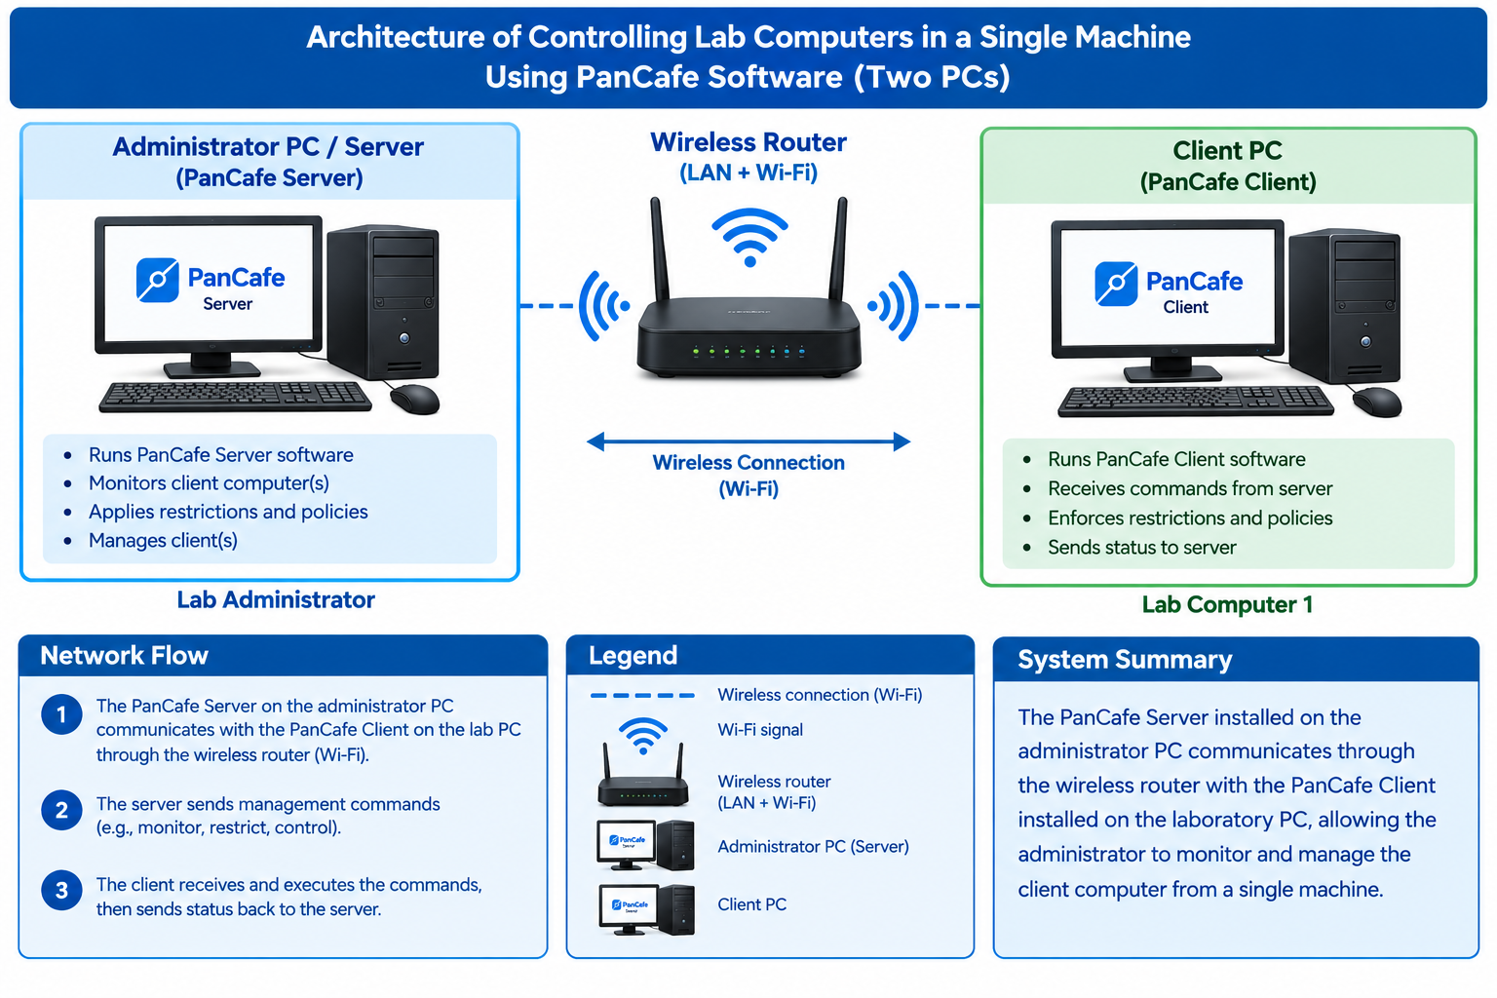

TECHNICAL BACKGROUND

This chapter explains the technical concepts related to the PanCafe project. These concepts include computer laboratory management, client-server architecture, IP addressing, DHCP, routers, network testing, and centralized network administration.
COMPUTER LABORATORY MANAGEMENT

Computer laboratory management involves controlling, monitoring, maintaining, and administering computers within a laboratory. An administrator may need to monitor computers, restrict certain activities, install software, transfer files, assist users, restart or shut down computers, and troubleshoot network problems. Centralized management can make these activities easier when several computers are involved

CLIENT-SERVER ARCHITECTURE
Client-server architecture is a network model in which one computer or system provides services or management functions while other computers communicate with it as clients. In the PanCafe project, the server is the administrator's computer and the clients are the computers being managed. The server communicates with the clients through the network.

PANCAFE SERVER
PanCafe Server is the central management software used by the administrator. It provides an interface through which the administrator can interact with connected client computers. The functions investigated during the project included client identification, client monitoring, restrictions, file transfer, remote administration, remote shutdown, remote restart, and computer management.

PANCAFE CLIENT
PanCafe Client is installed on computers that are managed by the PanCafe Server. The client communicates with the server over the network and receives management commands from the server. For successful communication, the client must be correctly installed, configured, and connected to the appropriate network.

IP ADDRESSING
An IP address is a numerical address used to identify a device on a network. For example, 192.168.10.10. Each device on the same network should have an appropriate IP configuration so that communication can occur. IP addressing became an important part of the project because PanCafe Server and PanCafe Client depend on network communication.

STATIC IP ADDRESS
A static IP address is manually assigned to a device and normally remains unchanged. For example: Server: 192.168.10.1; Client 1: 192.168.10.10; Client 2: 192.168.10.11. Static or predictable addressing can make it easier to identify specific computers in a laboratory.

DHCP
DHCP stands for Dynamic Host Configuration Protocol. DHCP automatically assigns IP addresses and other network information to devices connected to a network. A wireless router commonly provides DHCP services.
ROUTER
A router is a networking device that connects devices and manages network communication. In this project, the wireless router provided the network through which the PanCafe Server and client computers communicated

PING AND NETWORK TESTING
The ping command is a basic network troubleshooting tool. For example: ping 192.168.10.10. A successful response indicates that the destination device is reachable. Ping was useful when investigating whether the server and client computers could communicate.

CENTRALIZED NETWORK MANAGEMENT
Centralized network management involves managing multiple computers or devices from a central location. The PanCafe project demonstrated this concept by using one PanCafe Server to monitor and manage client computers.

APPLYING RESTRICTIONS
Restrictions were tested from the PanCafe Server. The purpose was to control certain activities on client computers

FILE TRANSFER
File transfer was tested between the PanCafe Server and PanCafe Client. The purpose was to investigate how an administrator could send files to client computers without physically moving from computer to computer. This was successfully demonstrated during the practical work.

REMOTE ADMINISTRATION
Remote administration was investigated using the PanCafe Server. The activities considered included monitoring clients, applying restrictions, file transfer, remote control, remote shutdown, and remote restart. This demonstrated the potential of centralized administration.

REMOTE SHUTDOWN AND RESTART
Remote shutdown and restart were investigated as part of the project. I also investigated whether the server could power on a computer after the computer had been completely turned off. I learned that remote power-on is different from remote shutdown and may require Wake-on-LAN support, appropriate BIOS/UEFI settings, network hardware support, and suitable configuration

WIRELESS ROUTER CONFIGURATION
The wireless router was configured and used to connect the server and clients. The configuration involved checking network settings, IP addressing, DHCP, wireless connectivity, and client connectivity. The router provided the network through which the PanCafe computers communicated.

EXPANSION TO MULTIPLE COMPUTERS
After testing the system with a small number of computers, the project was expanded to investigate multiple clients. At one stage, approximately five computers were monitored. The current objective is to investigate the management of approximately 21 client computers from one PanCafe Server.

FINDING
- Files can be transferred from the server to clients without physically moving to each computer.
- Remote functions work properly only when the required network connectivty is available.
- Some features require licensing Some PanCafe features, particularly certain time-management functions, may require a paid version.
- Restriction must be applied carefully incorrect restriction can affect the access to important window function.
- The administrator can observe client connection status from the server
RESULT OBTAINED
- PanCafe Server was installed successfully on the administrator computer.
- PanCafe Client was installed and tested on client computers.
- Communication between server and client computers was established.
- Client connection status could be observed.
- Remote administration functions were successfully used to monitor and manage client computers from the PanCafe Server.
- Remote shutdown and restart Client computers were shut down and restarted remotely from the PanCafe Server.
- Wireless router configuration the wireless router was configured to provide network connectivity between the server and client computers.
- Multiple client computers multiple client computers were connected and tested with the PanCafe Server.
- 21 client computers The project established a suitable network foundation for connecting and managing 21client computers from the server computer

PROBLEMS ENCOUNTERED
- Client disconnection: Client disconnection occurred due to possible network or IP configuration issues. The problem was addressed by checking the network connection, verifying IP settings, restarting the PanCafe Client, and reconnecting and testing the client.

- Incorrect restriction: An incorrect restriction was applied to a client computer, limiting access to certain system functions. The issue was resolved by reviewing the restriction settings and removing the unintended restriction.
- Pancafe installation and shut down problem: During the installation of the PanCafe Client software, the computer unexpectedly shut down, which interrupted the installation process. The possible causes included issues like, system management and power resources. Troubleshooting was required to identify and resolve the cause of the shutdown.
AREAS WHERE CONTROLLING ALL COMPUTER IN A LAB FROM A SINGL MACHINE
- Schools and Universities For managing computers in ICT and computer laboratories.
- ICT Training Centre’s for monitoring and controlling computers used by trainees.
- Libraries For controlling and monitoring public-access computers.
- Examination Centre’s for managing computers during computer-based examinations.
- Business Offices For centralized management of computers within an organization.
- Research Laboratories For monitoring and administering computers used for research activities.
- Government Institutions For managing computers across departments or computer laboratories.
- Technical and Vocational Institutions For practical computer training and laboratory management.
CONCLUSION
The PanCafe Server and PanCafe Client project provided valuable practical experience in computer networking and centralized computer laboratory management.
The project began with a basic server-client connection and gradually progressed to client monitoring, IP configuration, restrictions, file transfer, remote administration, remote shutdown and restart, and wireless router configuration.
One of the major lessons learned was that successful PanCafe operation depends heavily on proper network configuration. Understanding IP configuration, routers, and connectivity testing was therefore an important part of the project.
The practical work also demonstrated the usefulness of centralized computer management because the administrator can perform several management activities from one central computer instead of physically visiting every workstation.

Thank you

