|  |
| --- |
| sdmd games |
| Sky Birds |
| **Assignment 01** |
| Version 4.0  All work Copyright © 2015 by SDMD Games.  All rights reserved. |
| **Selina-Dionne Mohini Daley** |
|  |



|  |
| --- |
| October 5th 2015 |

**Table of Contents**

Version history…………………………………………………………………………………………………………………………. 3

Game description………………………………………………….……………………………………………………………….… 4

Controls……………………………………………………………………………………………………………………………………. 4

Interface sketch……………………………………………………………………………………………………………………….. 4

Screen description……………………………………………………………………………………………………………………. 5

Character…………………………………………………………………………………………………………………………………. 5

Enemies…………………………………………………………………………………………………………………………………… 6

Weapons…………………………………………………………………………………………………………………………………. 6

Items……………………………………………………………………………………………………………………………………….. 7

Bonus………………………………………………………………………………………………………………………………………. 7

Sound index…………………………………………………………………………………………………………………………….. 7

Art/multimedia index………………………………………………………………………………………………………………. 7

**Version History**

Version 1

- Character movement: Game Object for the character and a movement script

- Alien enemy bird: Game Object for the enemy and a movement script

- Character bullet: Player is able to kill enemies

- Background: The game background loops

Version 2

- Score: Player is able to accumulate points when killing an enemy

- Lives: Player is able to die multiple times before the game ends

- Time: Player is now able to see how long they stayed alive for

- Life orb: Player can now gain lives

Version 3

- The dark enemy: New enemy added

- The horn enemy: New enemy added

- The bomb enemy: New enemy added

- Player bombs: Player is able to drop bombs on enemies

Version 4

- Start screen: A screen to begin gameplay

- Background music: Music for the main menu, main game, and game over was added

- Sound effects: Explosion and life object sounds added

- Player animation: Player animation and player death animation

- Enemy animations: Enemy animations and enemy death animations

- Object animations: Animations for bomb explosion and shot explosions

1. **Game Overview**

**Summary**

The player controls an eagle and has to avoid being hit by the enemy characters flying towards them. The player is able to move in eight directions and can shot and bomb the enemy. At the start of the game the player has three lives and will lose on each time they are hit. Once the life counter reaches zero the game will end and the player has the option to play again.

**Gameplay**

The goal of this game is to stay alive as long as you can while killing enemies to rack up points to get a high score.

1. **Controls**

Player movement

* Move Up: W or up arrow
* Move Down: S or down arrow
* Move Left: A or left arrow
* Move Right: D or right arrow

Player weapons

* Fire Bullet: Spacebar
* Drop Bombs: B

User Interface

* Restart Game: R

1. **Interface Sketch**

|  |  |  |
| --- | --- | --- |
| Start Screen | Game Play | Game over |
| Collision  Start | Score: 0 Life: 3 Time: 6 | Game Over  Press R to restart |

1. **Menu and Screen Descriptions**

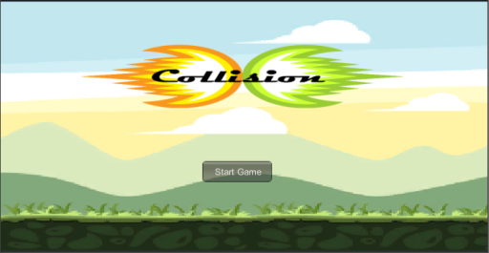**Screens**

Start Game Screen

* Start button
* Logo
* Background image

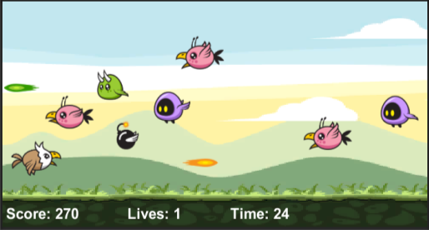 Game Play Screen

* Score
* Life
* Player
* Enemies
* Power ups

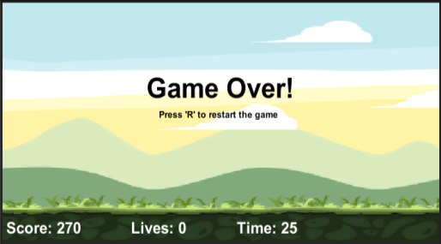Game Over Screen

* Game over
* Restart
* Score

1. **Characters**

 Player

* Flying: Is able to move in 8 directions
* Dying: An angel is created when the player dies
* Is able to file bullets and drop bombs

1. **Enemies**

 Enemy 1 (Alien)

* Flying: Flies in a linear motion towards the left side of the screen
* Dying : An angel is created when this enemy dies
* Points: Kill this enemy to earn 10 points

Enemy 2 (The Dark)

* Flying: Flies in a sinusoidal motion towards the left side of the screen
* Dying: An angel is created when this enemy dies
* Points: kill this enemy to earn 20 points

Enemy 3 (The Horn)

* Flying: Flies at a decreased pace in a linear motion towards the left side of the screen while shooting bullets
* Dying : An angel is created when this enemy dies
* Points: Kill this enemy to earn 70 points

Enemy 4 (Bomb)

* Flying: Flies at an accelerated pace in a linear motion towards the left side of the screen
* Dying: Explodes on contact with the player, players bullet, and/or players bomb
* Points: Kill this enemy to earn 50 points

1. **Weapons**

Player Bullet

* Hero Bullet AShot: Moves in a linear motion towards the right side of the screen
* Explosion: Explodes on contact with enemies

Player Bomb

* Bomb: Falls in a linear motion towards the ground
* Explosion: Explodes on contact with enemies and the ground

1. **Items**

Enemy Bullet

* Villain Bullet AShot: Moves in a linear motion towards the left side of the screen
* Explosion: Explodes on contact with player

Item Orbs

* Life: An orb that can be found randomly throughout the game.
* Getting one increases the players remaining lives by 1

1. **Bonuses**

Bonus Marks

* player fires bullets
* player drops bombs
* enemy fires bullets

1. **Sound Index**

Explosion: [www.shockwave-sound.com/sound-effects/explosion_sounds.html](http://www.shockwave-sound.com/sound-effects/explosion_sounds.html)

Main game music: <http://www.playonloop.com/2015-music-loops/starry-night>

Main menu/ game over music: <http://www.orangefreesounds.com/8-bit-music/>

Item sound : <http://opengameart.org/content/10-8bit-coin-sounds>

1. **Art / Multimedia Index**

All game graphics

* http://graphicriver.net/item/sky-birds-game-assets/7127737?ref=telyva
* http://graphicriver.net/user/bevouliin