|  |
| --- |
| SDMD GAMES |
| Slot Machine |
| **Assignment 01** |
| Version 2.0  All work Copyright © 2016 by SDMD Games.  All rights reserved. |
| **Selina-Dionne Mohini Daley** |
|  |



|  |
| --- |
| February 23rd 2016 |

**Table of Contents**

Version history…………………………………………………………………………………………………………………………. 3

Game description………………………………………………….……………………………………………………………….… 4

Game play mechanics..………………………………………….……………………………………………………………….… 4

Controls……………………………………………………………………………………………………………………………………. 4

Interface sketch……………………………………………………………………………………………………………………….. 4

Screen description……………………………………………………………………………………………………………………. 5

Scoring….…………………………………………………………………………………………………………………………………. 5

Art/multimedia index………………………………………………………………………………………………………………. 6

**Version History**

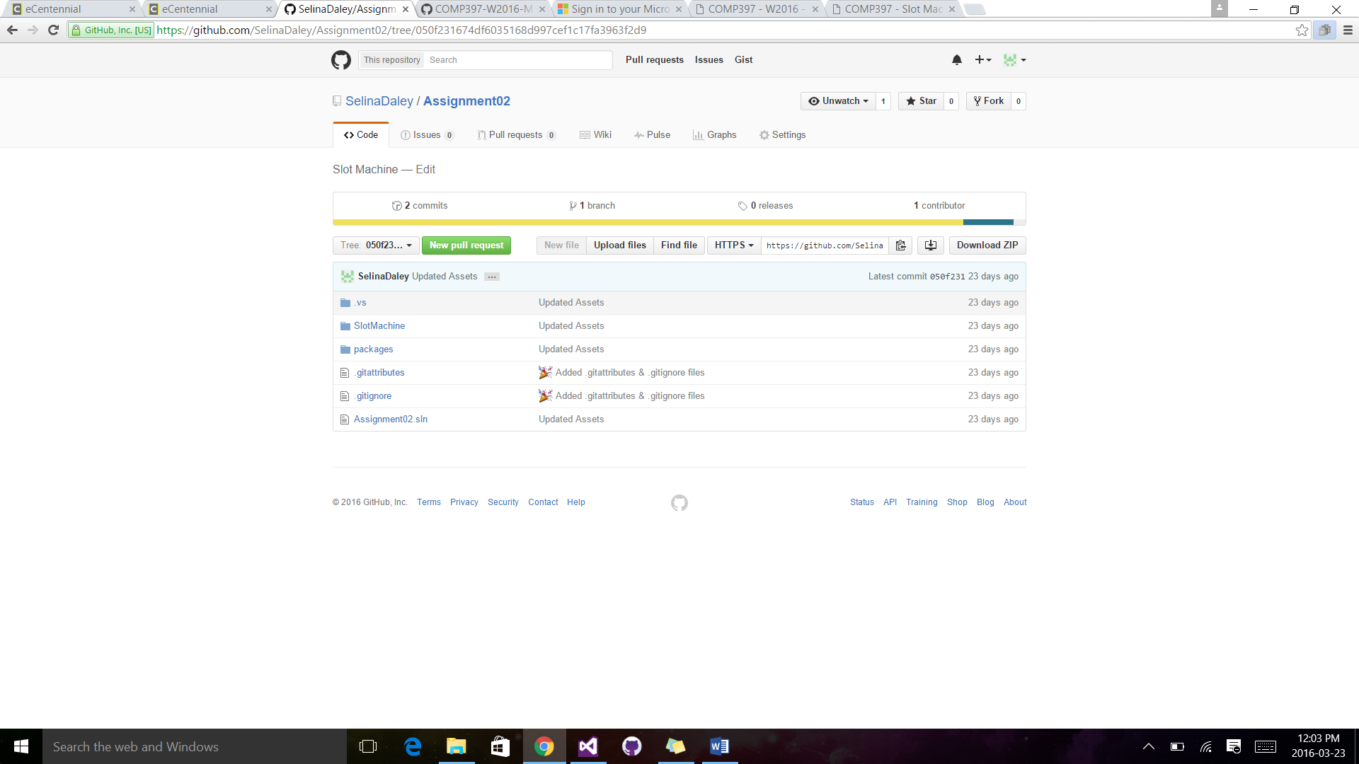

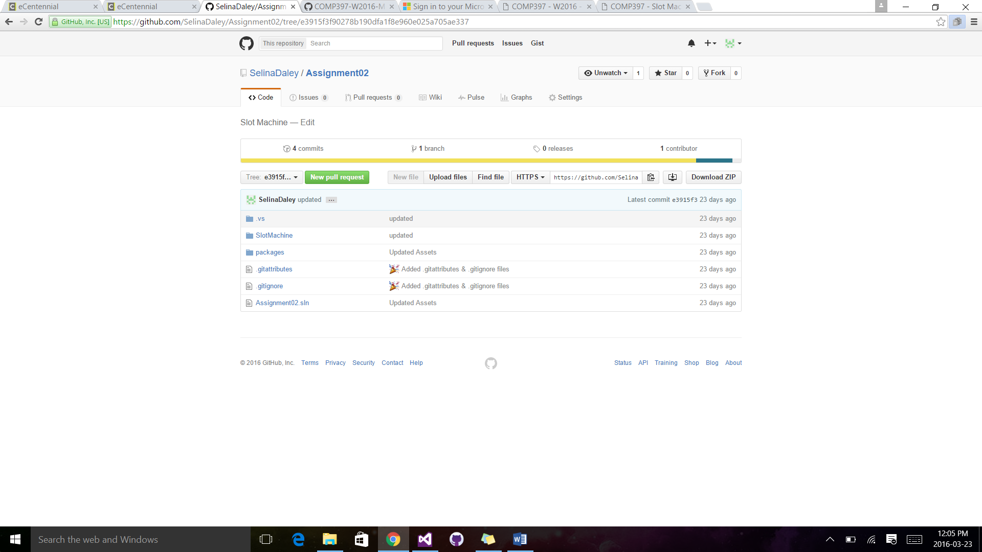

1. **Game Overview**

The player is brought to a scene with a slot machine and is able to interact with multiple buttons on the slot machine. The goal of the game is to win as much money as you can (maybe even hit the jackpot). The player is able to make bets in increments of 1, 10, and 100. If the player runs out of money, then they will not be able to play anymore and have the option of quitting or restarting the game.

1. **Game Play Mechanics**

The game works based on what the player chooses to do. They are able to place a bet, restart the game and quit the game. They are able to bet in increments of 1, 10, and 100 and once the desired amount to bet is reached the spin button is pressed to roll the reels and determine is they win money or if they get nothing back.

1. **Controls**

This game uses a mouse (also works with fingers/styles if using a touchscreen device) to interact with the GUI.

1. **Interface Sketch**

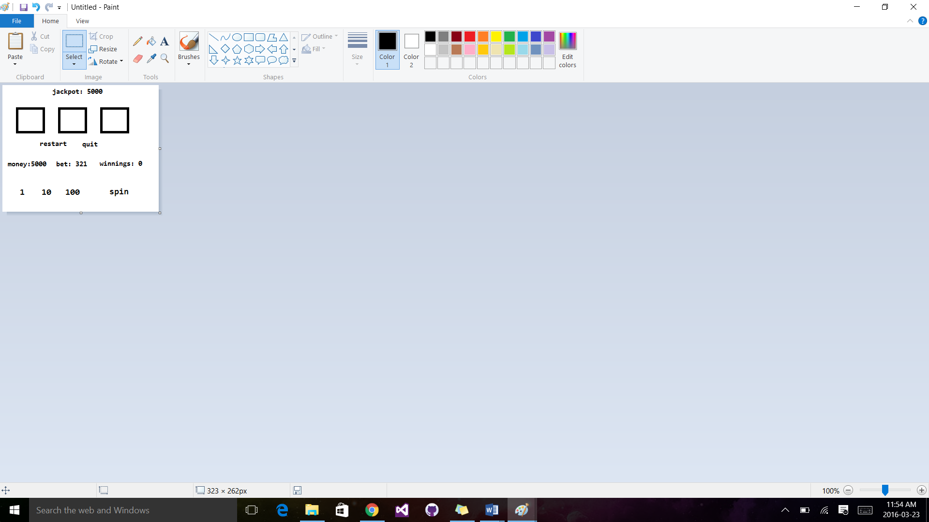

1. **Screen Descriptions**

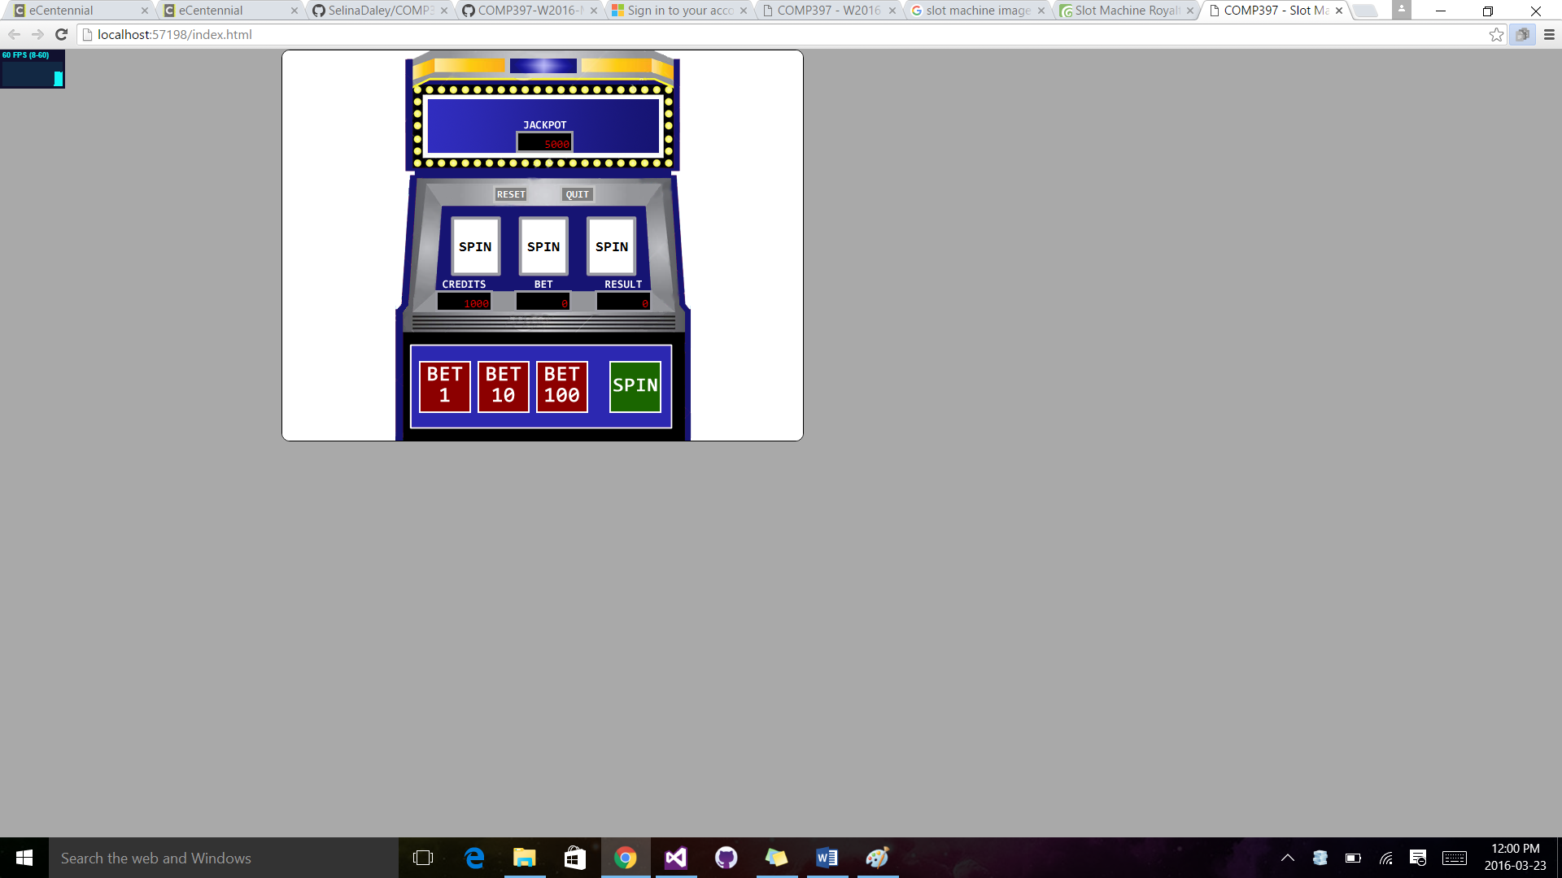

1. **Scoring**

Any blanks = bet * 0;

3 grapes = bet * 10;

3 bananas = bet * 20;

3 oranges = bet * 30;

3 cherries = bet * 40;

3 bars = bet * 50;

3 bells = bet * 75;

3 sevens = bet * 100;

2 grapes = bet * 2;

2 bananas = bet * 2;

2 oranges = bet * 3;

2 cherries = bet * 4;

2 bars = bet * 5;

2 bells = bet * 10;

2 sevens = bet * 20;

1 seven = bet * 5;

1 anything = bet * 1;

1. **Art / Multimedia Index**

Slot Machine Image

* <http://www.dreamstime.com/royalty-free-stock-photography-slot-machine-image12270117>

Slot Machine Symbol Images

* <http://www.dreamstime.com/stock-photography-vector-slot-machine-symbols-set-image27642442>
* <http://www.shutterstock.com/cat.mhtml?country_code=US&safesearch=1&search_language=en&search_type=similar&similar_photo_id=49070956&tracking_id=sMhm4yMjlrL8pefJiGMFbg&page=1>