|  |
| --- |
| sdmd games |
| Coin Collector |
| **Assignment 02** |
| Version 4.0  All work Copyright © 2015 by SDMD Games.  All rights reserved. |
| **Selina-Dionne Mohini Daley** |
|  |

****

|  |
| --- |
| October 26th 2015 |

**Table of Contents**

Version history…………………………………………………………………………………………………………………………. 3

Game description………………………………………………….……………………………………………………………….… 4

Controls……………………………………………………………………………………………………………………………………. 4

Interface sketch……………………………………………………………………………………………………………………….. 4

Screen description……………………………………………………………………………………………………………………. 5

Character…………………………………………………………………………………………………………………………………. 5

Enemies…………………………………………………………………………………………………………………………………… 6

Weapons…………………………………………………………………………………………………………………………………. 6

Items……………………………………………………………………………………………………………………………………….. 6

Bonus………………………………………………………………………………………………………………………………………. 6

Sound index…………………………………………………………………………………………………………………………….. 7

Art/multimedia index………………………………………………………………………………………………………………. 7

**Version History**

Version 1

- Character movement: Game Object for the character and a movement script

- Land tile: Game Object for the enemy and a movement script

- Water tile: Player is able to kill enemies

- Bridge tile: Bridge that falls 1 second after player steps on it

- Background: The game background builds as the player moves right

Version 2

- Coins: Player is able to accumulate coins when coins are picked up

- Lives: Player is able to take multiple hits before the game ends

- Time: Player is now able to see how long they stayed alive for

- Block tile: When hit the player has a chance to get coins

Version 3

- Spike tile: Player can now lose 10% each time they step on a spike

- Life orb: Player can now gain 10% for each life orb picked up

- The bomb enemy: New enemy added

- Player bombs: Player is able to lose 10% each time they are hit by a bomb

Version 4

- Start screen: A screen to begin gameplay

- Background music: Music for the main menu, main game, and game over was added

- Sound effects: Explosion and life object sounds added

- Player animation: Player animation

- Enemy animations: Enemy animations and enemy weapon animations

1. **Game Overview**

**Summary**

The player controls an alien and has to avoid being hit by enemy and obstacles throughout the game. The player is able to move left and right and has the ability to jump on certain terrain and objects. The player is also able to shoot fire balls at the enemy. At the start of the game the player has a full life bar and will lose a certain percent each time they are hit. Once the life bar reaches zero the game will end and the player has the option to play again, if the player falls in the water it is an automatic game over.

**Gameplay**

The goal of this game is to reach the end of the game with as high a score and with as many coins as you can without dying..

1. **Controls**

Player movement

* Jump: W or up arrow
* Move Left: A or left arrow
* Move Right: D or right arrow

Player weapons

* Fire Bullet: B

User Interface

* Restart Game: R

1. **Interface Sketch**

|  |  |  |
| --- | --- | --- |
| Start Screen | Game Play | Game over |
| Collision  Start | Life: 100% Coins: 0 Time: 0 | Game Over  Press R to restart |

1. **Menu and Screen Descriptions**

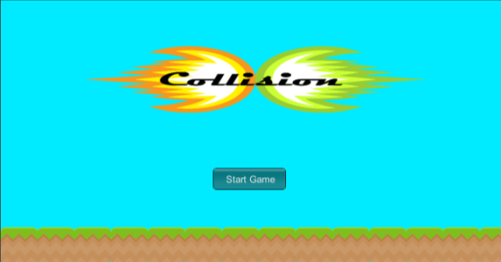**Screens**

Start Game Screen

* Start button
* Logo
* Background image

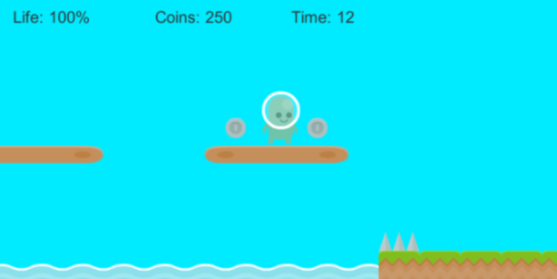 Game Play Screen

* Life
* Coins
* Player
* Enemies
* Power ups

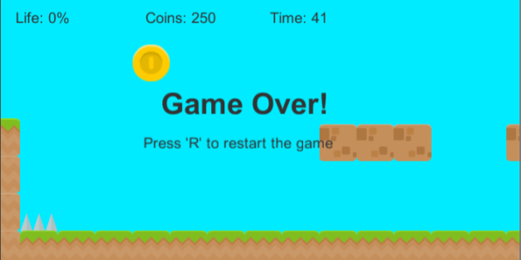Game Over Screen

* Game over
* Restart
* Coins
* Time
* Life

1. **Characters**

Player

* Idle: When the player is not moving the idle animation is played



* Jump: When the player jumps the jumping animation is played
* Walk: When the player is moving left or right the walking animation is played

1. **Enemies**

Bomb

* Flying: Flies in a linear motion towards the left side of the screen
* Dying: Explodes on contact with the player
* Bombs: Drops bombs in an attempt to decrease the players life bar

1. **Weapons**

Enemy Bomb Item

* Bomb: Falls in a linear motion towards the ground
* Explosion: Explodes on contact with the player and the ground

1. **Items**

Item Orbs

* Life: An orb that can be found randomly throughout the game.
* Getting one increases the players life bar by 10%

1. **Bonuses**

Bonus Marks

* enemy drops bombs
* life orbs to increase players life

1. **Sound Index**

Explosion: [www.shockwave-sound.com/sound-effects/explosion\_sounds.html](http://www.shockwave-sound.com/sound-effects/explosion_sounds.html)

Main game music: <http://www.playonloop.com/2015-music-loops/starry-night>

Main menu/ game over music: <http://www.orangefreesounds.com/8-bit-music/>

Item sound : <http://opengameart.org/content/10-8bit-coin-sounds>

1. **Art / Multimedia Index**

All game graphics

* <http://opengameart.org/content/platformer-tiles>
* [www.kenney.nl](http://www.kenney.nl)

**** **** **** **** **C:\Users\Selina2.Selina-HP\AppData\Local\Microsoft\Windows\INetCache\Content.Word\water.png** **C:\Users\Selina2.Selina-HP\AppData\Local\Microsoft\Windows\INetCache\Content.Word\switch_green_off.png**

**C:\Users\Selina2.Selina-HP\AppData\Local\Microsoft\Windows\INetCache\Content.Word\spikes.png** **C:\Users\Selina2.Selina-HP\AppData\Local\Microsoft\Windows\INetCache\Content.Word\plank.png** **C:\Users\Selina2.Selina-HP\AppData\Local\Microsoft\Windows\INetCache\Content.Word\bridge.png** **C:\Users\Selina2.Selina-HP\AppData\Local\Microsoft\Windows\INetCache\Content.Word\coin_bronze.png** **C:\Users\Selina2.Selina-HP\AppData\Local\Microsoft\Windows\INetCache\Content.Word\coin_silver.png** **C:\Users\Selina2.Selina-HP\AppData\Local\Microsoft\Windows\INetCache\Content.Word\coin_gold.png**





* <http://graphicriver.net/item/sky-birds-game-assets/7127737?ref=telyva>
* <http://graphicriver.net/user/bevouliin>

