|  |
| --- |
| sdmd games |
| Target Practice |
| **Final Project** |
| Version 1.3  All work Copyright © 2015 by SDMD Games.  All rights reserved. |
| **Selina-Dionne Mohini Daley** |
|  |



|  |
| --- |
| December 4, 2015 |

**Table of Contents**

Version history…………………………………………………………………………………………………………………………. 3

Game description………………………………………………….……………………………………………………………….… 4

Controls……………………………………………………………………………………………………………………………………. 4

Interface sketch……………………………………………………………………………………………………………………….. 5

Screen description……………………………………………………………………………………………………………………. 5

Character…………………………………………………………………………………………………………………………………. 6

Enemies…………………………………………………………………………………………………………………………………… 6

Weapons…………………………………………………………………………………………………………………………………. 6

Items……………………………………………………………………………………………………………………………………….. 6

Sound index…………………………………………………………………………………………………………………………….. 7

Art/multimedia index………………………………………………………………………………………………………………. 7

**Version History**

Version 1

- Character movement: Game Object for the character and a movement script

- Maze: Game Object for the maze area

- Gun: Player is able to kill enemies

- Gun Animations: Gun can be aimed and has a recoil animation

- Effects and Sound: Gun has a muzzle flash and makes noise when fired

- Targets: Three different coloured target Game Objects

1. **Game Overview**

**Summary**

The player controls a character in a first person perspective and has to destroy targets to advance through the game. The player is able to move freely and has the ability to jump. The player is able to shoot a gun at the targets to destroy them. At the start of the game the player has timer counting down and once the timer runs out it is an automatic game over.

**Gameplay**

The goal of this game is to destroy all the targets and gain as many points in as little time as you can while reaching the end of the maze before the time runs out.

1. **Controls**

Player movement

* Jump: W or up arrow
* Move Left: A or left arrow
* Move Right: D or right arrow
* Move Forward: W or up arrow
* Move Backwards: S or down Arrow
* Turn Left: Move mouse pointer left
* Turn Right: Move mouse pointer right
* Run: Hold left shift

Player weapons

* Fire Bullet: Left mouse button
* Aim Gun: Right mouse button

User Interface

* Restart Game: R

1. **Interface Sketch**

|  |  |  |
| --- | --- | --- |
| Start Screen | Game Play | Game over |
| N/A | Life: 100% Score: 0 Time: 0 | Game Over  Press R to restart |

1. **Menu and Screen Descriptions**

**Screens**

Start Game Screen

* Start button
* Logo
* Background image

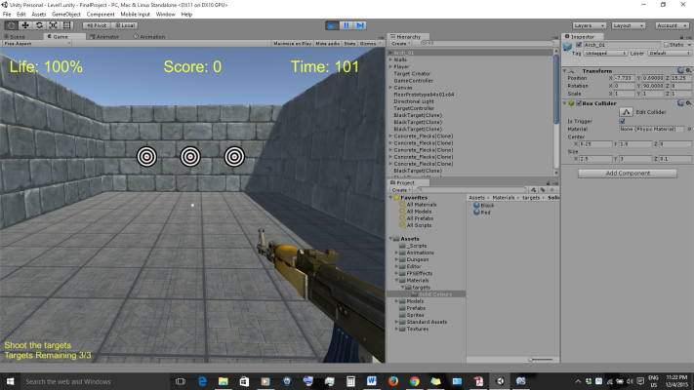 Game Play Screen

* Life
* Score
* Time
* Player
* Enemies
* Items

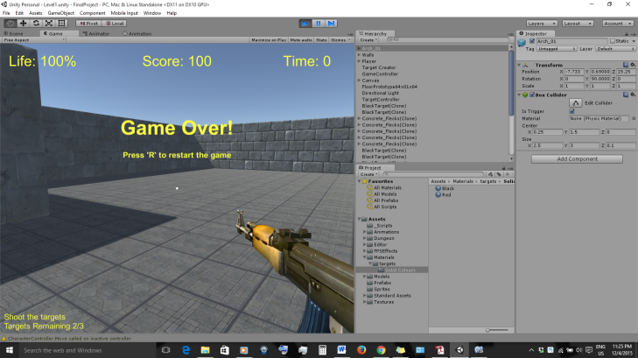Game Over Screen

* Game over
* Restart
* Score
* Time
* Life

1. **Game World**

Level 1

The first level takes place in a maze. The maze walls are made of bricks and the floor is made out of tiles. There are targets scattered throughout the maze.

1. **Levels**

Level 1

For the first level the player needs to shoot targets to advance to different sections of the maze. Once all of the targets are destroyed the player is able to make it to the end of the maze to exit the level.

1. **Characters**

Player

* Walk: Use W, A, S, D or Up, Left, Down, Right to move the character
* Run: Press and hold the left shift key and a directions key to run in the selected direction
* View: Use the mouse to look to the left or to the right

1. **Enemies**

Target

* Points: Player gains 100 points for every target that is successfully destroyed up using the gun

1. **Weapons**

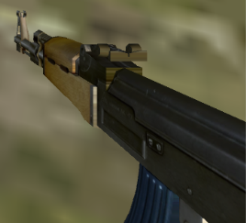Gun

* Fire: Press the left mouse gun to fire a shot
* Aim: Press and hold right mouse button to aim the gun

1. **Sound Index**

Unity Standard Asset Packages

* Characters
* Cross Platform Input
* Environment
* Physics Materials
* Utility

Assets from my teacher

* FPS Effects
* Terrain

1. **Art / Multimedia Index**

Unity Standard Asset Packages

* Characters
* Cross Platform Input
* Environment
* Physics Materials
* Utility

Assets from my teacher

* FPS Effects
* Terrain

Dungeon Level Kit

* Arch
* Floor
* Wall
* <https://www.assetstore.unity3d.com/en/?gclid=Cj0KEQiAkIWzBRDK1ayo-Yjt38wBEiQAi7NnP6t9UsQI6KB3rEJcd-o1Pn1bcByzeTtlrD10yB8AL5gaAjdM8P8HAQ#!/content/35681>