|  |
| --- |
| sdmd games |
| Sky Birds 2 |
| **Assignment 03** |
| Version 4.0  All work Copyright © 2015 by SDMD Games.  All rights reserved. |
| **Selina-Dionne Mohini Daley** |
|  |



|  |
| --- |
| March 25th 2016 |

**Table of Contents**

Version history…………………………………………………………………………………………………………………………. 3

Game description………………………………………………….……………………………………………………………….… 4

Controls……………………………………………………………………………………………………………………………………. 4

Interface sketch……………………………………………………………………………………………………………………….. 4

Screen description……………………………………………………………………………………………………………………. 5

Character…………………………………………………………………………………………………………………………………. 5

Enemies…………………………………………………………………………………………………………………………………… 6

Sound index…………………………………………………………………………………………………………………………….. 6

Art/multimedia index………………………………………………………………………………………………………………. 6

**Version History**

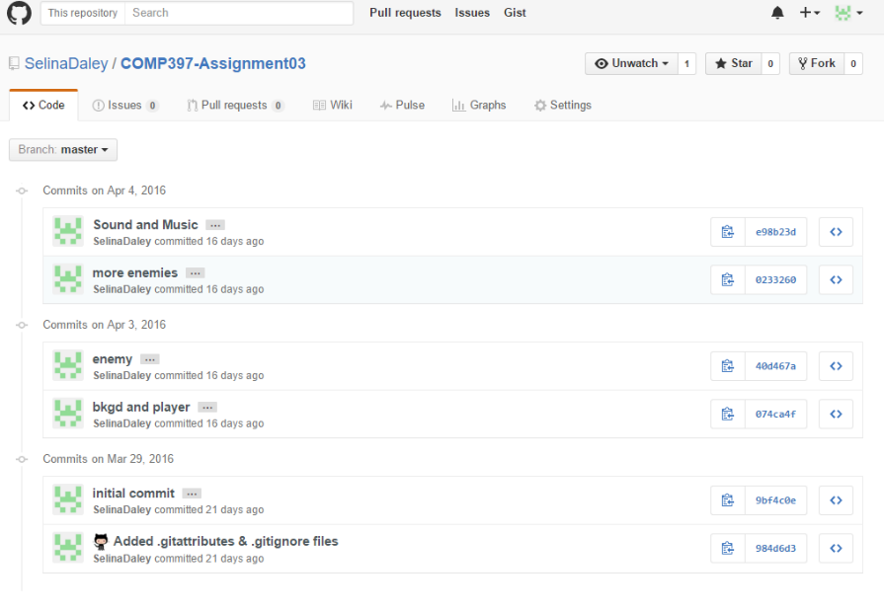



1. **Game Overview**

**Summary**

The player controls an eagle and has to avoid being hit by the enemy characters flying towards them. The player is able to move in all directions. At the start of the game the player has five lives and will lose one each time they are hit. Once the life counter reaches zero the game will end and the player has the option to play again.

**Gameplay**

The goal of this game is to stay alive as long as you can while dodging enemies to rack up points to get a high score.

1. **Controls**

Player movement

* Move Up: Move the mouse up
* Move Down: Move the mouse down
* Move Left: Move the mouse left
* Move Right: Move the mouse right

1. **Interface Sketch**

|  |  |  |
| --- | --- | --- |
| Start Screen | Game Play | Game over |
| Collision  [Start] | Score: 0 Life: 5 Time: 6 | Game Over  [Restart] |

1. **Menu and Screen Descriptions**

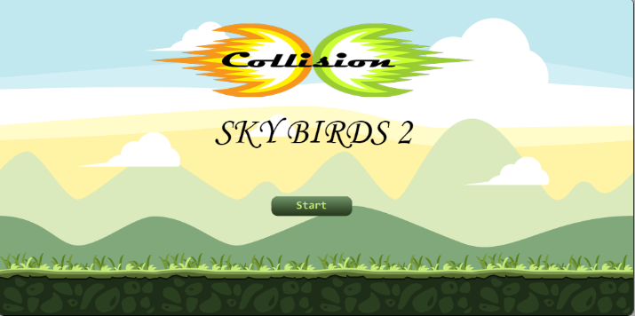**Screens**

Start Game Screen

* Start button
* Logo
* Background image

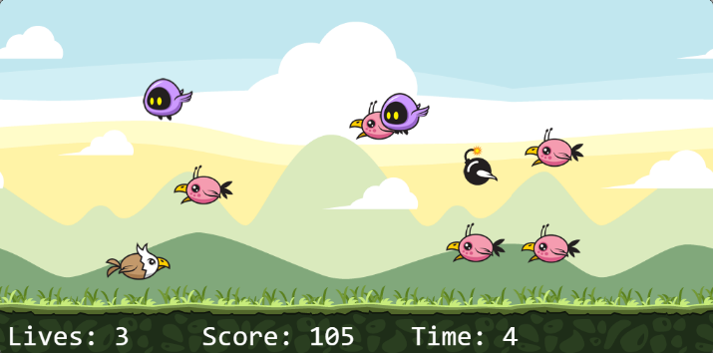 Game Play Screen

* Score
* Life
* Player
* Enemies
* Power ups

Game Over Screen

* Game over
* Restart
* Score

1. **Characters**

 Player

* Flying: Is able to move in any directions

1. **Enemies**

Enemy 1 (Alien)

* Flying: Flies in a linear motion towards the left side of the screen
* Points: Dodge this enemy to earn 10 points

Enemy 2 (The Dark)

* Flying: Flies in a sinusoidal motion towards the left side of the screen
* Points: Dodge this enemy to earn 20 points

Enemy 4 (Bomb)

* Flying: Flies at an accelerated pace in a linear motion towards the left side of the screen
* Points: Dodge this enemy to earn 25 points

1. **Sound Index**

Explosion: [www.shockwave-sound.com/sound-effects/explosion_sounds.html](http://www.shockwave-sound.com/sound-effects/explosion_sounds.html)

Main game music: <http://www.playonloop.com/2015-music-loops/starry-night>

Main menu/ game over music: <http://www.orangefreesounds.com/8-bit-music/>

Item sound : <http://opengameart.org/content/10-8bit-coin-sounds>

1. **Art / Multimedia Index**

All game graphics

* http://graphicriver.net/item/sky-birds-game-assets/7127737?ref=telyva
* http://graphicriver.net/user/bevouliin