|  |
| --- |
| sdmd games |
| Sky Birds 2 |
| **Final Project** |
| Version 3.0  All work Copyright © 2016 by SDMD Games.  All rights reserved. |
| **Selina-Dionne Mohini Daley** |
|  |



|  |
| --- |
| April 4th 2016 |

**Table of Contents**

Version history…………………………………………………………………………………………………………………………. 3

Game description………………………………………………….……………………………………………………………….… 4

Controls……………………………………………………………………………………………………………………………………. 4

Interface sketch……………………………………………………………………………………………………………………….. 4

Screen description………………………………………………………………………………………………………………... 5-6

Character…………………………………………………………………………………………………………………………………. 7

Enemies…………………………………………………………………………………………………………………………………… 7

Weapons…………………………………………………………………………………………………………………………………. 8

Items……………………………………………………………………………………………………………………………………….. 8

Bonus………………………………………………………………………………………………………………………………………. 8

Sound index…………………………………………………………………………………………………………………………….. 9

Art/multimedia index………………………………………………………………………………………………………………. 9

**Version History**

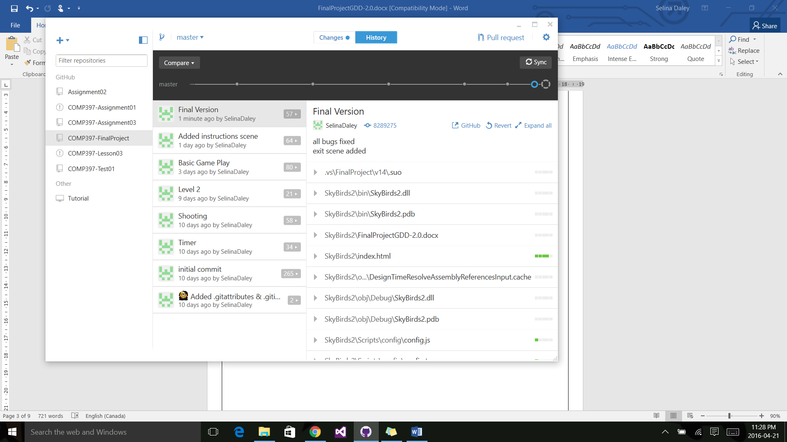

1. **Game Overview**

**Summary**

The player controls an eagle and has to avoid being hit by the enemy characters flying towards them. The player is able to move in all directions and can shoot the enemy. At the start of the game the player has five lives and will lose one each time they are hit. Once the life counter reaches zero the game will end and the player has the option to play again.

**Gameplay**

The goal of this game is to stay alive as long as you can while killing enemies to rack up points, advance to new levels and to get the highest score.

1. **Controls**

Player movement

* Move Up: Move the mouse up
* Move Down: Move the mouse down
* Move Left: Move the mouse left
* Move Right: Move the mouse right

Player weapons

* Fire Bullet: Automatic

1. 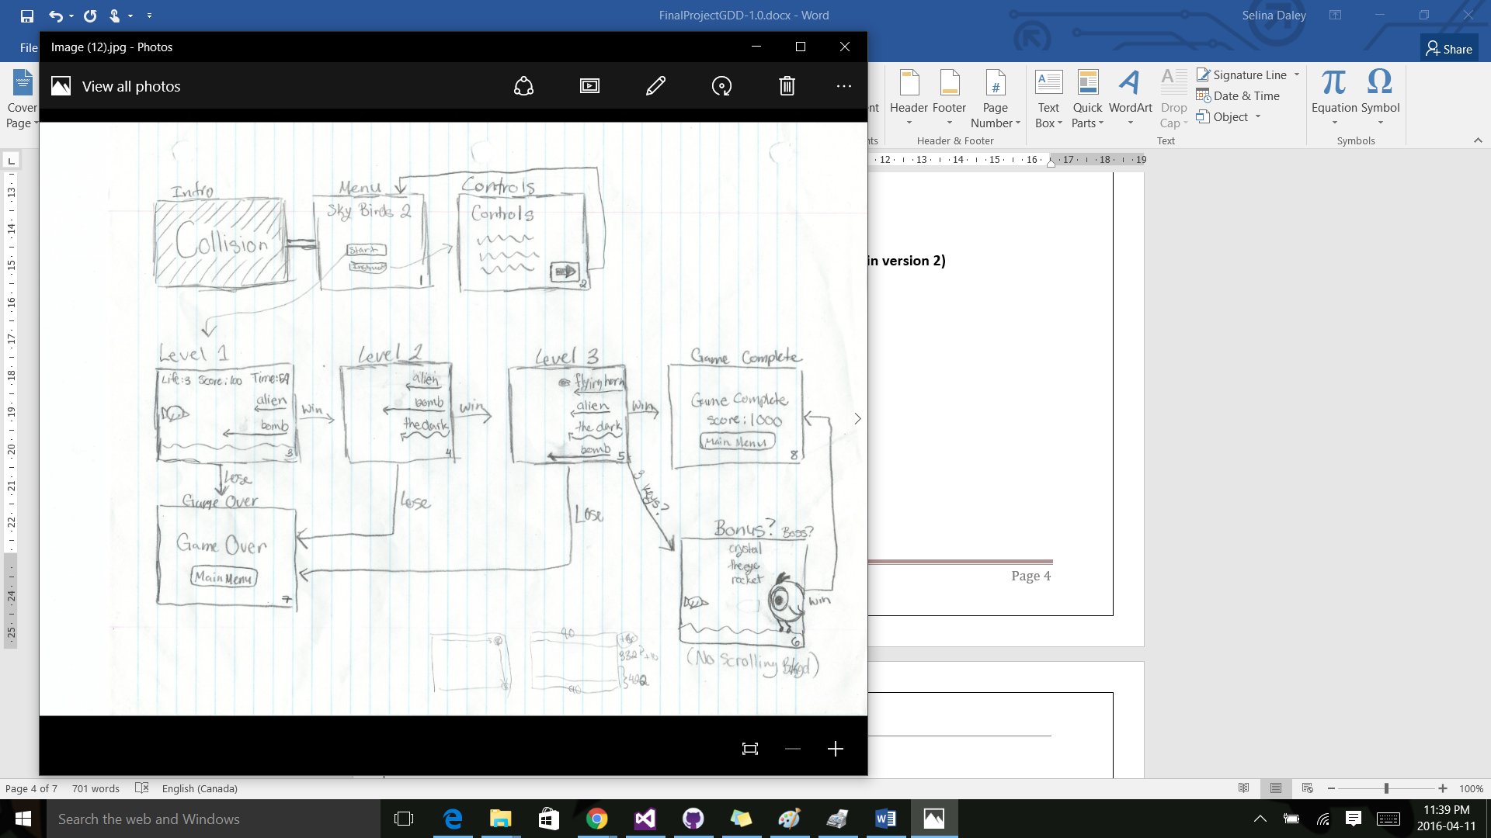**Interface Sketch**
2. **Menu and Screen Descriptions**

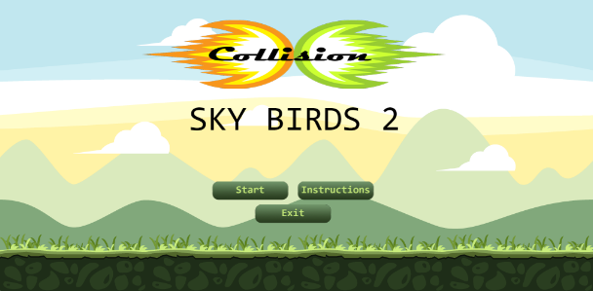**Screens**

Start Game Screen

* Start button
* Instructions Button
* Exit Button
* Logo
* Background image

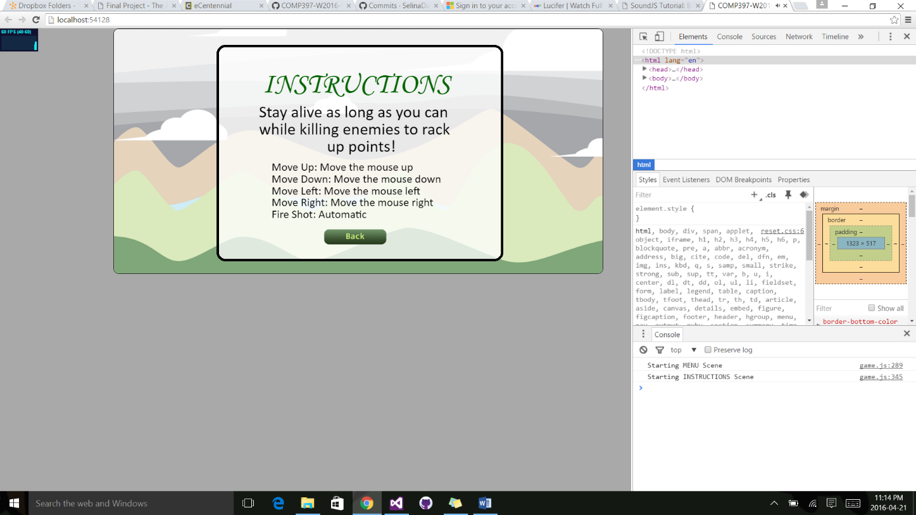 Instructions Screen

* Instructions Title
* Game Instructions
* Movement Instructions
* Back Button
* Background image

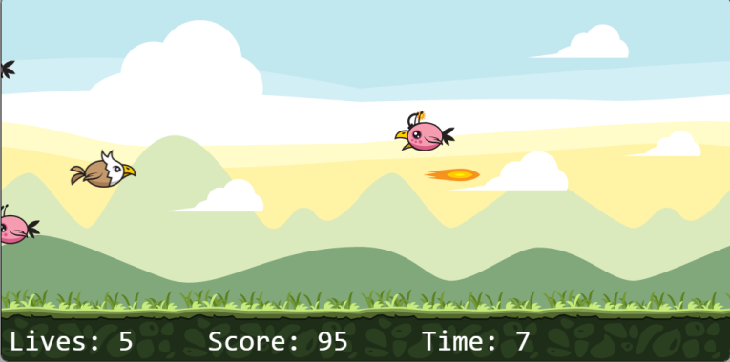Level 1 Screen

* Lives
* Score
* Time
* Player
* Enemies
* Power ups
* Background Image

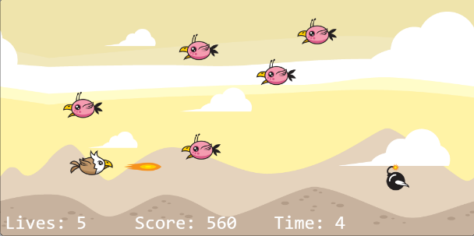Level 2 Screen

* Lives
* Score
* Time
* Player
* Enemies
* Power ups
* Background Image

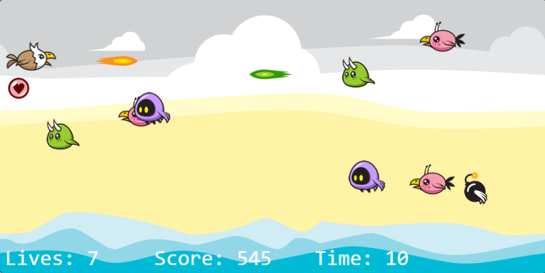Level 3 Screen

* Lives
* Score
* Time
* Player
* Enemies
* Power ups
* Background Image

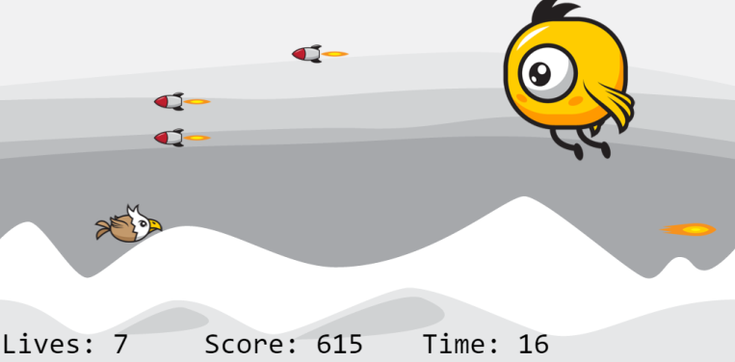Bonus Level

* Lives
* Score
* Time
* Player
* Boss
* Power ups
* Background Image

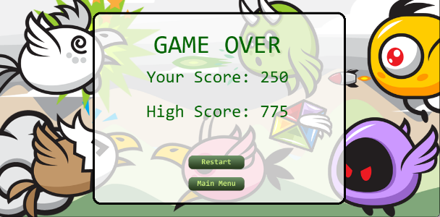Game Over Screen

* Game Over Title
* Score and Time Bonus
* Your Score
* High Score
* Restart Button
* Main Menu Button
* Background Image

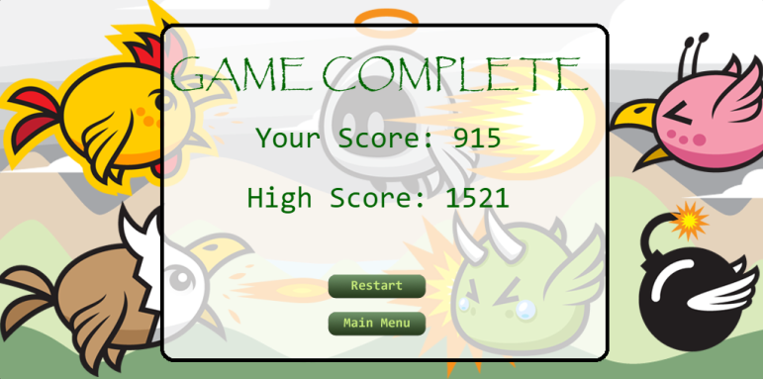Game Complete Screen

* Game Complete Title
* Score and Time Bonus
* Your Score
* High Score
* Restart Button
* Main Menu Button
* Background Image

1. **Characters**

 Player

* Flying: Is able to move in any direction
* Automatically fires shots

Assist

* Flying: Is controlled by the computer
* Automatically fires shots

1. **Enemies**

 Enemy 1 (Alien)

* Flying: Flies in a linear motion towards the left side of the screen
* Points: Kill this enemy to earn 10 points

Enemy 2 (The Dark)

* Flying: Flies in a sinusoidal motion towards the left side of the screen
* Points: kill this enemy to earn 20 points

Enemy 3 (The Horn)

* Flying: Flies at a decreased pace in a linear motion towards the left side of the screen while shooting bullets
* Points: Kill this enemy to earn 30 points



Enemy 4 (Bomb)

* Flying: Flies at an accelerated pace in a linear motion towards the left side of the screen
* Points: Kill this enemy to earn 25 points



Boss Enemy (The Eye)

* Flying: Hovers up and down at a normal speed and shots rockets at the player
* Points: Kill the boss enemy to earn 300 points

1. **Weapons**

Player Bullet

* Hero Bullet AShot: Moves in a linear motion towards the right side of the screen
* Explosion: Explodes on contact with enemies

Enemy Bullet

* Villain Bullet AShot: Moves in a linear motion towards the left side of the screen
* Explosion: Explodes on contact with player

Rocket



* Shot: Moves in a linear motion towards the left side of the screen
* Explosion: Explodes on contact with player

1. **Items**

Item Orbs

* Life: An orb that can be found randomly throughout the game.
* Getting one increases the players remaining lives by 1

Ally Orbs



* Ally: An orb that can be found randomly throughout the game.
* Getting one summons an ally for 8 seconds

1. **Bonuses**

Bonus Marks

* npc ally
* boss enemy
* power ups

1. **Sound Index**

Explosion: [www.shockwave-sound.com/sound-effects/explosion_sounds.html](http://www.shockwave-sound.com/sound-effects/explosion_sounds.html)

Main game music: <http://www.playonloop.com/2015-music-loops/starry-night>

Main menu/ game over music: <http://www.orangefreesounds.com/8-bit-music/>

Item sound : <http://opengameart.org/content/10-8bit-coin-sounds>

1. **Art / Multimedia Index**

All game graphics

* http://graphicriver.net/item/sky-birds-game-assets/7127737?ref=telyva
* http://graphicriver.net/user/bevouliin