Task-Free Online LoRA for Continual Instruction Tuning
Advisor Experiment Report v4 | InstrDialog seed=123 | Generated on 2026-06-13

Abstract
This report is written in a paper-style structure for advisor discussion. It studies task-free online continual instruction tuning with LoRA. The proposed method maintains a drift-triggered LoRA bank, trains a prototype router through self-consistency pseudo-labels, and regularizes branch overlap. The current best run is v8_sota_5, which reaches seen=0.353 and task-aware=0.404 on InstrDialog seed=123. Although it is still below the target SOTA thresholds, it substantially outperforms the true-fair baselines implemented in baselines/.
Keywords: continual instruction tuning; LoRA; task-free learning; drift detection; prototype routing; anti-overlap regularization.

1 Introduction
Real LLM systems receive non-stationary instruction data: product policies change, user intent distributions drift, and formats evolve. A naive sequential LoRA adapter can quickly overfit the current segment and forget previous ones. The central research question is how to adapt online without task IDs, while retaining earlier capabilities under a small memory and compute budget.
The report follows the structure of the earlier RP(Lora)_v2 proposal, but removes planning-only sections and replaces them with completed implementation details, current experimental evidence, and failure analysis. The writing target is a CCF-A style research report: problem, gap, method, theory, experiments, results, and discussion.

2 Related Work and Research Gap
- LoRA and PEFT reduce training cost by updating low-rank adapters while freezing the base model.
- Continual instruction tuning benchmarks show that sequential fine-tuning suffers from catastrophic forgetting under non-stationary streams.
- Existing LoRA continual learning methods often assume task boundaries or fixed adapter allocation policies.
- Routing-based methods can select experts, but task-free routing is unstable when adapter branches overlap or drift allocation is poor.
The gap addressed here is not only to add more adapters, but to close the loop among drift detection, capacity allocation, branch specialization, and task-free inference-time routing.

3 Method: Task-Free Online LoRA Bank with Prototype Routing
本方法面向 task-free continual instruction tuning: 输入流按 segment 到达, 训练时不使用任务 ID, 推理时也不提供任务边界。核心思想是保持冻结的 base LLM, 动态维护 LoRA bank, 用漂移检测决定何时扩容, 用原型路由器在推理时选择或混合分支, 并用 anti-overlap 约束减少分支冗余。

3.1 Problem formulation
Eq. 1: D = {S_1, S_2, ..., S_T}, S_t = {(x_i, y_i)}
每个 S_t 是在线到达的指令 segment。模型在处理 S_t 后需要在所有已见 segment 上保持性能, 同时不能依赖 task ID。
Eq. 2: Score_t = (1 / t) * sum_{j=1..t} Acc_j(theta_t)
报告中的 seen_avg_score 与 task-aware score 分别对应严格匹配和按任务类型感知的已见任务平均分。

3.2 LoRA branch parameterization
Eq. 3: W'_b = W + Delta W_b, Delta W_b = B_b A_b, rank(A_b, B_b) = r
base 权重 W 冻结, 每个分支 b 只训练低秩 LoRA 参数 A_b 和 B_b。v8_sota_5 使用 r=16, alpha=32, target modules 为 q_proj 和 v_proj。

3.3 Drift-triggered LoRA bank
系统维护 bank B = {b_1, ..., b_m}。当 anchor NLL 统计显示分布发生持续变化时, 冻结旧分支并 spawn 新分支。v8_sota_5 使用 train-split anchor, anchor_size=64, easy_core_hard_probe curriculum, threshold=0.025, 并关闭基于 segment 边界的 oracle spawn。
Eq. 4: C_t = max(0, C_{t-1} + (s_t - s_ref) - kappa)
这里 s_t 是 probe 或 core anchor 的平均 answer NLL, kappa 是 slack。若 probe CUSUM 超过阈值, 则触发 drift 事件。
Eq. 5: if C_t >= tau: freeze(b_m), spawn(b_{m+1}), trainable = b_{m+1}
冻结旧分支保证已有能力不再被覆盖, 新分支负责吸收新的分布。

3.4 Self-consistency prototype routing
v8 系列的关键实现从传统 learned head 转向 prototype router。每个分支维护一个归一化特征原型 p_b。训练后用 teacher-forced NLL 在已有分支上做自一致伪标签, 再用 EMA 更新原型。v8_sota_5 的贡献点是 spawn-sync prototype init + 每 segment 三遍 prototype update, 在不增加 LoRA 训练 epoch 的情况下提高分支原型拟合。
Eq. 6: b_i* = argmin_b NLL(y_i | x_i, W + Delta W_b)
伪标签不使用任务 ID, 只使用哪个 LoRA 分支对样本的 teacher-forced loss 最低。
Eq. 7: p_b <- normalize(ema * p_b + (1 - ema) * mean(z_i | b_i* = b))
v8_sota_5 中 ema=0.8, prototype_update_steps=3。z_i 是冻结 base model 的 pooled hidden feature。
Eq. 8: q_b(x) = softmax(cos(z(x), p_b) / T), T = 0.08
推理时按原型余弦相似度得到路由分布。配置中同时开启 hard_routing 和 soft top-3 routing。

3.5 Anti-overlap regularization
LoRA bank 扩大后, 不同分支可能学习到高度重叠的行为, 造成路由不稳定。v8_sota_5 保留 anti-overlap, 总权重 beta=0.05, activation:weight = 0.6:0.4。
Eq. 9: L_total = L_NLL + beta_a * L_activation_overlap + beta_w * L_weight_overlap
其中 activation overlap 直接约束不同分支在同一 batch 上的 hidden representation cosine similarity, weight overlap 约束 LoRA 权重方向冗余。

3.6 Implementation summary of v8_sota_5
Module | Configuration or implementation
Backbone | Llama-3.1-8B-Instruct, bf16, max_seq_len=512
LoRA | r=16, alpha=32, dropout=0.05, q_proj/v_proj
Training budget | 1 epoch per segment, batch_size=2, lr=2e-4
Bank | max_branches=15, spawn_on_drift=true, freeze_old_branches=true
Router | prototype backend, soft top-3, temperature=0.08, warmup=1
v8_sota_5 novelty | spawn-sync prototype initialization plus 3-pass prototype EMA per segment
Overlap | beta=0.05, activation_beta=0.03, weight_beta=0.02
Logging | save every segment, W&B group v8_sota, full per-segment metrics

4 Experimental Setup
Item | Setting
Benchmark | CITB InstrDialog, 19 segments, seed=123
Data per segment | 50 train examples and 10 eval examples after processed stream preparation
Protocol | Task-free online continual instruction tuning
Baselines | Sequential LoRA, Replay(50), PeriodicLatest, BankNoRouter, RouterOnly
Baseline budget | true_fair protocol: 5 epochs, batch_size=1, around 250 batches per segment
Ours budget | v8_sota_5: 1 epoch, batch_size=2, around 25 batches per segment
Main targets | seen>=0.600, task-aware>=0.600, forgetting<=0.0333, TA forgetting<=0.077, token_f1>=0.600, lcs>=0.600

5 Results
本节报告两类结果: 第一, 与 baselines/ 中对应方法在 true_fair 协议下的终局对比; 第二, ours SOTA 路线中离目标最近的一次实验。

5.1 Main comparison against true-fair baselines
Method | Seen | Task-aware | Forgetting | TA forgetting | Token F1 | LCS | Oracle agree
Sequential | 0.000 | 0.232 | 0.050 | 0.127 | 0.078 | 0.247 | 0.000
Replay(50) | 0.000 | 0.110 | 0.061 | 0.213 | 0.065 | 0.230 | 0.000
PeriodicLatest | 0.037 | 0.326 | 0.399 | 0.116 | 0.146 | 0.169 | 0.000
BankNoRouter | 0.016 | 0.225 | 0.117 | 0.128 | 0.101 | 0.223 | 0.000
RouterOnly | 0.000 | 0.227 | 0.156 | 0.181 | 0.072 | 0.191 | 0.531
Ours v8_sota_5 | 0.353 | 0.404 | 0.049 | 0.017 | 0.419 | 0.431 | 0.417

v8_sota_5 在 seen, task-aware, token_f1, lcs 上均显著高于 baselines。最强 baseline 是 PeriodicLatest: task-aware=0.326, 但 forgetting=0.399, 说明固定周期分支容量不能稳定保留早期任务。RouterOnly 的 oracle agreement=0.531, 但 task-aware 只有 0.227, 表明没有 drift-triggered capacity allocation 时, 单纯路由不足以形成可靠持续学习系统。
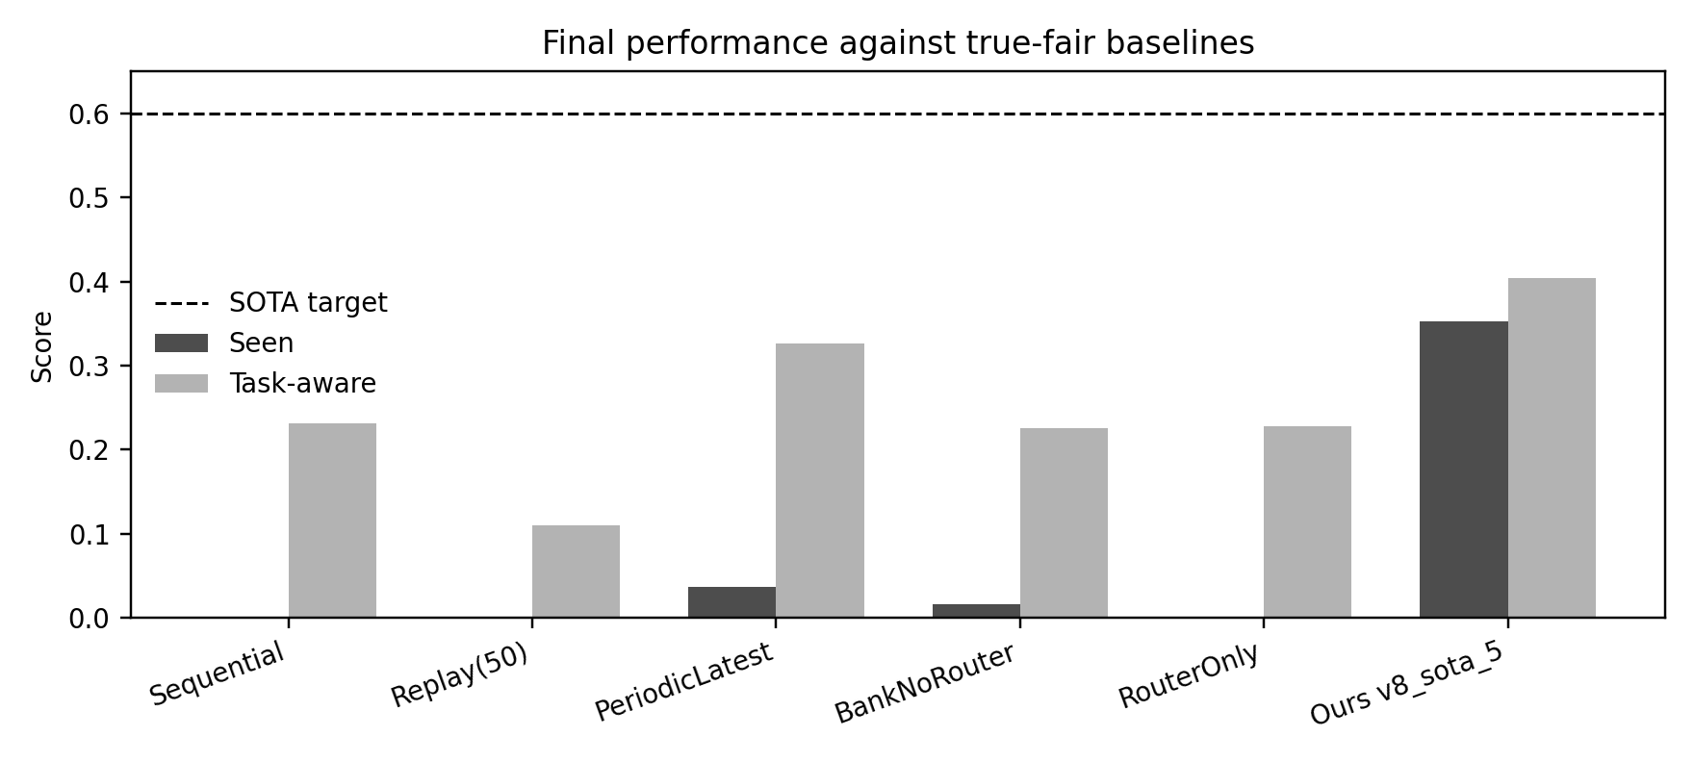
Figure 1. Final seen and task-aware scores against true-fair baselines. All text is rendered in black.

5.2 Closest run to SOTA target: v8_sota_5
Metric | Target | v8_sota_5 | Margin | Met
eval.seen_avg_score | >= 0.6000 | 0.3526 | -0.2474 | No
eval.seen_avg_task_aware_score | >= 0.6000 | 0.4044 | -0.1956 | No
eval.forgetting | <= 0.0333 | 0.0491 | -0.0158 | No
eval.task_aware_forgetting | <= 0.0770 | 0.0167 | 0.0603 | Yes
eval.token_f1_mean | >= 0.6000 | 0.4191 | -0.1809 | No
eval.lcs_overlap_mean | >= 0.6000 | 0.4310 | -0.1690 | No

v8_sota_5 是当前综合冠军: seen=0.353, task-aware=0.404, forgetting=0.049, TA forgetting=0.017, token_f1=0.419, lcs=0.431。它只满足 6 个 SOTA 目标中的 TA forgetting, 但在 seen 与 task-aware 上是当前最高。

5.3 Ours internal SOTA trajectory
Run | Seen | Task-aware | Forgetting | TA forgetting | Token F1 | LCS | Oracle agree
Ours v4_sota_39 | 0.352 | 0.383 | 0.050 | 0.039 | 0.435 | 0.475 | 0.488
Ours v6_sota_2 | 0.350 | 0.386 | 0.057 | 0.042 | 0.422 | 0.445 | 0.374
Ours v8_sota_5 | 0.353 | 0.404 | 0.049 | 0.017 | 0.419 | 0.431 | 0.417
Ours v8_sota_8 | 0.352 | 0.404 | 0.044 | 0.011 | 0.428 | 0.438 | 0.441

v4_sota_39 的 token_f1 和 lcs 更高, v8_sota_8 的 forgetting 更低, 但 v8_sota_5 在 primary strict seen 上最高, 因此被记录为综合冠军。v8_sota_8 将 prototype_update_steps 从 3 增至 4, 中段更强, 但终局 seen 略低于 v8_sota_5。
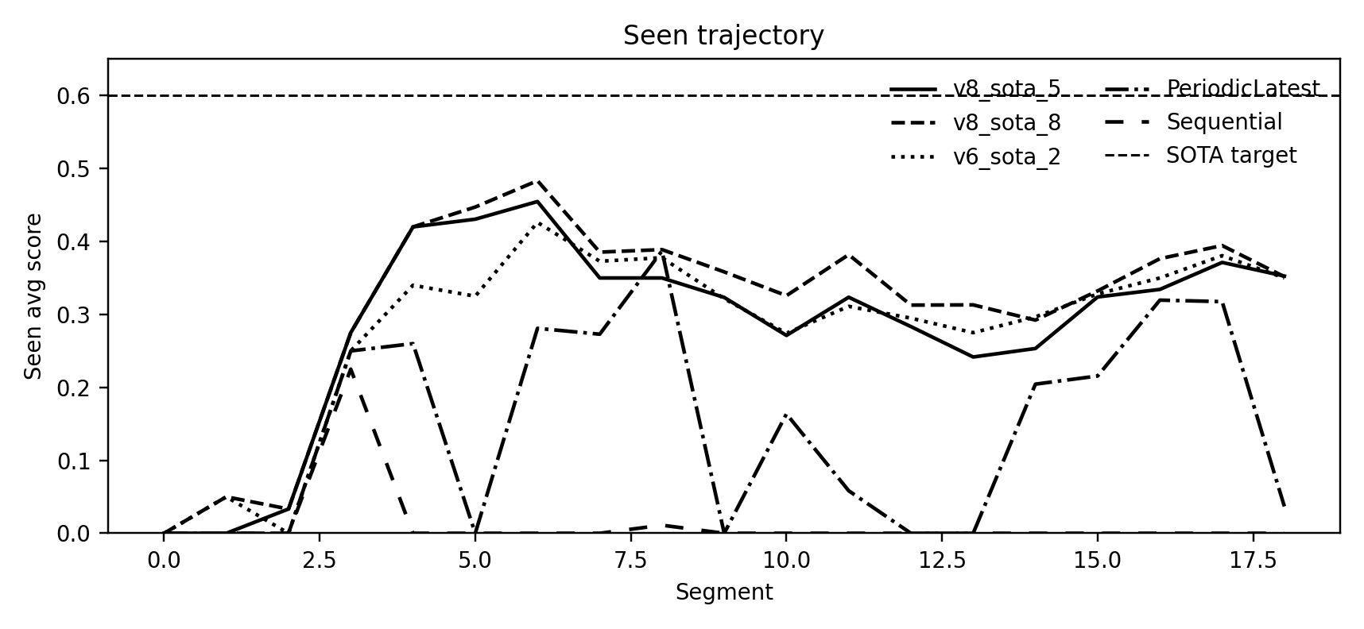
Figure 2. Seen trajectory across representative ours and baseline runs.

6 Analysis and Discussion

6.1 Why v8_sota_5 is the current champion
- Spawn-sync prototype init fixes cold-start: new branches receive a meaningful initial prototype when spawned, avoiding early routing collapse.
- Three-pass prototype EMA improves pseudo-label fitting without increasing LoRA training epochs, preserving a low compute budget.
- Soft top-3 routing keeps useful mixtures when the best branch is uncertain, while warmup=1 prevents unstable early routing.
- Anti-overlap keeps branch specialization pressure active as branch count grows to around 10.

6.2 Remaining bottlenecks
- Absolute SOTA gap is still large: seen needs +0.247 and task-aware needs +0.196 to reach 0.600.
- Drift detector has miss_rate=0.5 in v8_sota_5, so half of true shifts are not detected promptly.
- Overlap remains high: final overlap_mean_cosine is around 0.880, suggesting specialization is incomplete.
- Router agreement is moderate: oracle agreement is 0.417 for v8_sota_5, below v4_sota_39 and below RouterOnly, although RouterOnly has much worse task performance.

6.3 Lessons from negative runs
Run | Change | Outcome | Interpretation
v8_sota_8 | prototype_update_steps=4 | seen=0.352, forgetting improves | More prototype passes help stability but do not improve primary seen.
v8_sota_11 | router_warmup_segments=2 | early stop at seg4, seen=0.220 | Longer latest-branch warmup causes catastrophic forgetting.
v8_sota_13 | router lr=0.006 | seen=0.341 | Conservative router learning slows peak segment recovery.
v8_sota_14 | router lr=0.010 | early stop at seg7, seen=0.321 | Aggressive router learning increases late trajectory instability.

7 Conclusion and Next Steps
本阶段的主要结论是: 相比 baselines/ 中的 sequential, replay, periodic, and router-only baselines, ours 的 drift-triggered LoRA bank + prototype routing 在核心性能上已经形成显著优势; 但相对预设 SOTA 目标仍未达标。
- 下一步应优先降低 drift miss_rate, 因为 missed shifts 直接影响 branch allocation 和早期任务保留。
- 第二优先级是降低 branch overlap, 让 prototype routing 的特征空间更可分。
- 第三优先级是改进 routing calibration, 目标是在保持 v8_sota_5 seen 的同时接近 v8_sota_8 的 forgetting 和 v4_sota_39 的 lcs/token_f1。

Appendix A Reproducibility Checklist
Artifact | Path or value
Champion config | configs/paper/v8_sota_5.yaml
Champion metrics | results/runs/paper_instrdialog_ours_full_s123_v8_sota_5/final_metrics.json
Segment metrics | results/tables/paper_instrdialog_ours_full_s123_v8_sota_5_segment_metrics.csv
Baseline metrics | results/runs/paper_instrdialog_*_s123_true_fair/final_metrics.json
W&B project | lora-citb-sota for SOTA runs; lora-citb-acl for baseline backfill
Seed | 123

Appendix B References Used in the Report
- Hu et al. LoRA: Low-Rank Adaptation of Large Language Models.
- Zhang et al. CITB: A Benchmark for Continual Instruction Tuning.
- Kirkpatrick et al. Overcoming Catastrophic Forgetting in Neural Networks.
- Online-LoRA and task-free continual learning literature for drift-driven adaptation.
- Mixture-of-experts and LoRA routing literature for inference-time branch selection.

