

COLLEGE OF COMPUTING AND INFORMATION SCIENCES
SCHOOL OF COMPUTING AND INFORMATICS TECHNOLOGY
DEPARTMENT OF NETWORKS

BSE4104 EMERGING TRENDS IN SOFTWARE ENGINEERING
AI-NATIVE & AGENTIC ENGINEERING CAPSTONE

System Architecture and Integration Specification of the Software-Engineering QA Agent
Group J
NAME | STUDENT NUMBER | REGISTRATION NUMBER
Karagwa Ann Treasure | 2300709034 | 23/U/09034/PS
Ayan Mustafa Abdirahman | 2300722948 | 23/X/22948/EVE
Wanyana Selina Masembe | 2300701529 | 23/U/1529
Amabe Junior Humphrey | 2300705942 | 23/U/05942/PS
Akanga Andrew | 2300705555 | 23/U/05555/PS

Table of Contents
1. Purpose and scope 4
1.1. What the system does 4
2. Architectural principles 4
3. System context 4
3.1. External systems 5
4. Container view and trust zones 7
5. Deliberately out of scope 11

List of Figures
Figure 3.1: System Context and Human-Decision Boundaries. Amber indicates a boundary that requires a human decision or an isolated execution environment. 5
Figure 4.1: Container View across Five Trust Zones. Zones 7

List of Tables
Table 2.1: Architectural Principles and Their Enforcement Points 4
Table 3.1: Primary Actor and Responsibilities 5
Table 3.2: External Systems, Trust Levels and Interface Contracts 5
Table 4.1: Trust Zones and Boundary Semantics 7

Purpose and scope
This document specifies the architecture of the Software-Engineering QA Agent: its context boundary, its containers, the trust zones they sit in, and the interfaces between them. It is the Week 1 architecture and context deliverable.
The full specification the team builds against container responsibilities, tool contracts, the interface register, the end-to-end request trace, the control-to-container mapping, assumptions and the build order is maintained separately in docs/architecture/full-spec.md. This document carries only the Week 1 architecture and context deliverable.

What the system does
A QA engineer asks the system to triage a failing or newly changed area of a repository. The system grounds itself in that repository's requirements, documentation and code, proposes tests, runs approved existing tests in a sandbox, explains what failed and why, and drafts an issue or pull-request note for a human to review and post.
The system diagnoses and drafts. It does not fix, merge or deploy.

Architectural principles
Five principles constrain the design. Each is testable, and each maps to a control that appears later in this document.
Table Architectural principles.1: Architectural Principles and Their Enforcement Points
S/N | Principle | How it shows up in the architecture
P1 | Model output is untrusted input | Every tool-call request returned by the model is validated against a schema, an allow-list and a permission rule before anything executes. The agent runtime holds no credentials and touches no store directly.
P2 | One choke point for every action | The orchestrator is the sole path to the tool layer. There is no second route from the agent runtime to the filesystem, the sandbox, the network or the stores.
P3 | Side effects are gated, not merely logged | Test execution and any external write pass through an approval gate that blocks on a human decision. There is no timeout that auto-approves.
P4 | The corpus is read-only and frozen | The target repository is cloned at a fixed tag. Nothing in the system writes to it. This makes the evaluation set reproducible.
P5 | Observability is built first, not last | The trace store and prompt registry land in Week 2 alongside the first model call, so Week 7 has a history to analyse rather than a reconstruction to attempt.

System context
One primary user, one system in scope, four external dependencies at three different trust levels.
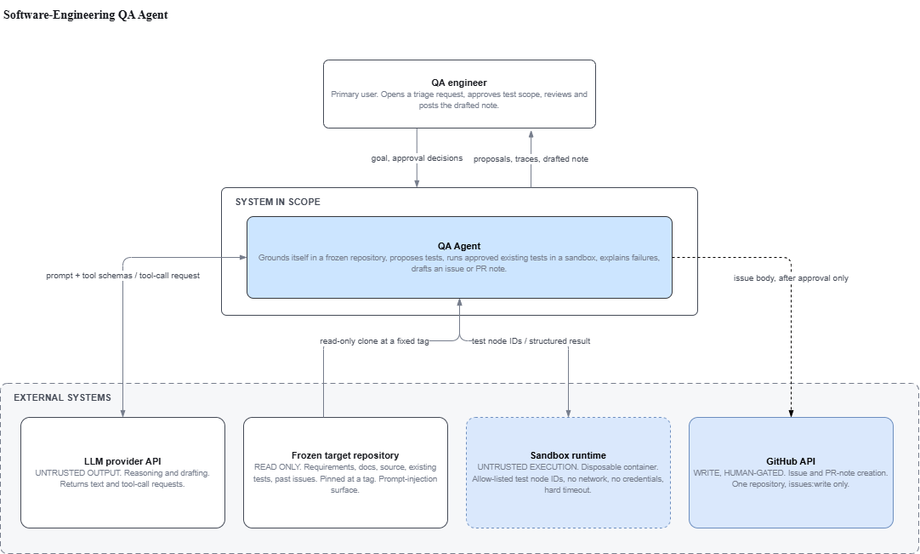
Figure System context.1: System Context and Human-Decision Boundaries.
Table System context.2: Primary Actor and Responsibilities
Actor | Responsibility
QA engineer | Opens a triage request. Approves or rejects the scope of test execution. Reviews the drafted issue and decides whether it is posted. The only human role in scope; no reviewer or administrator persona is modelled.

External systems
Table System context.3: External Systems, Trust Levels and Interface Contracts
System | Trust level | Contract
LLM provider API | Untrusted output | Receives a versioned prompt, the retrieved context bundle and the declared tool schemas. Returns text and tool-call requests. Nothing it returns is executed without validation.
Frozen target repository | Read only, untrusted text | Source of requirements, README, testing conventions, source code, the existing test suite and past issue text. Cloned at a fixed tag. Also the system's prompt-injection surface, since a docstring or comment can carry instructions.
Sandbox runtime | Untrusted execution | Runs allow-listed test node IDs in a disposable container with no network access, no credentials in the environment and a hard timeout.
GitHub API | Write, human-gated | Issue and pull-request-note creation against one repository, with an issues:write-scoped token. Reachable only after an explicit human approval.

Container view and trust zones
The container diagram is organised by trust boundary rather than by component type. This is deliberate: the boundaries are what the design has to defend, and they stay correct when the technology stack changes.
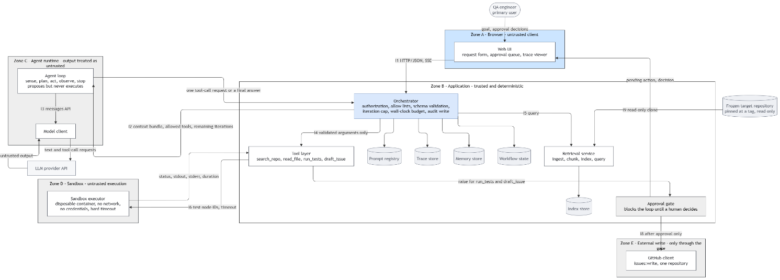
Figure Container view and trust zones.2: Container View across Five Trust Zones. Zones
Table Container view and trust zones.4: Trust Zones and Boundary Semantics
Zone | Name | What the boundary means
A | Browser | Untrusted client. Holds no credentials, calls nothing but the orchestrator.
B | Application | Trusted and deterministic. Every control that must not be an LLM decision lives here: authorization, allow-lists, validation, limits, audit.
C | Agent runtime | The model's output is treated as untrusted. The runtime proposes actions and never executes them, holds no credentials, and cannot widen its own permissions or raise its own iteration cap.
D | Sandbox | Untrusted execution, and the highest-risk boundary in the system. Disposable, network-disabled, credential-free.
E | External write | Reachable only through the approval gate. The only place the system affects anything outside itself.

Deliberately out of scope
Recorded here so scope creep has to be an explicit decision rather than a drift.
- Patch or fix generation. The system diagnoses and drafts; it does not propose code changes.
- Automatic execution of agent-written tests.
- Free-form shell access. Only test node IDs drawn from a manifest.
- Any second target repository, and any second user persona.
- Network access from inside the sandbox.
- Automatic merge, deployment or release of any kind.
- Training or fine-tuning a model.

