
COLLEGE OF COMPUTING AND INFORMATION SCIENCES
SCHOOL OF COMPUTING AND INFORMATICS TECHNOLOGY
DEPARTMENT OF NETWORKS
BSE4104 EMERGING TRENDS IN SOFTWARE ENGINEERING
AI-NATIVE & AGENTIC ENGINEERING CAPSTONE
AGENT LOOP ORCHESTRATION AND CITATION SAFETY
OF THE SOFTWARE-ENGINEERING QA AGENT
WEEK 5 — MEMBER 2 DELIVERABLE
GROUP J
NAME | REGISTRATION NUMBER | STUDENT NUMBER
Karagwa Ann Treasure | 2300709034 | 23/U/09034/PS
Ayan Mustafa Abdirahman | 2300722948 | 23/X/22948/EVE
Wanyana Selina Masembe | 2300701529 | 23/U/1529
Amabe Junior Humphrey | 2300705942 | 23/U/05942/PS
Akanga Andrew | 2300705555 | 23/U/05555/PS

CONTENTS
1 Purpose and Scope ....................................................... 3
2 Ownership and Integration Boundaries .................................... 3
3 Agent Loop Architecture ................................................. 4
4 Execution Lifecycle ..................................................... 5
5 Citation Validator Change ............................................... 6
6 Dependency Contracts .................................................... 7
7 Files Implemented ....................................................... 7
8 Verification ............................................................ 8
9 Limitations and Handoffs ................................................ 9
10 Conclusion ............................................................. 9

1 Purpose and Scope
This report records Member 2's Week 5 contribution to the Software-Engineering QA Agent. The deliverable is a bounded agent loop that coordinates the existing retrieval, model, citation-validation, dispatcher, stop-policy and tracing boundaries without re-implementing those components. One iteration senses context, plans exactly one proposal, validates its citations, acts through the established dispatcher when required, records a safe observation, and either stops, pauses or begins another iteration.
The loop accepts a validated runtime AgentTask. It does not parse task_contract.yaml, define the stop policy, implement production tools, decide human approval, or persist trace records. These limits preserve the intended team structure and keep the Week 5 work focused on orchestration.

2 Ownership and Integration Boundaries
Component | Responsibility in this deliverable | Boundary
AgentLoop | Member 2 implementation | Coordinates one bounded session and returns a stable LoopResult.
ContextSensor and RAG | Injected dependency | Returns AssembledContext and the exact citation allow-list.
Planner and model client | Injected dependency | Returns one ProposalSet for the current turn.
Citation validator | Reused and narrowly updated | Rejects missing or fabricated evidence before dispatch.
ToolDispatcher and approval gate | Existing Week 4 boundary | Authorizes, approves and invokes at most one tool.
StopEvaluator and TraceSink | Injected team dependencies | Own stop decisions and trace persistence.
Table 1: Week 5 Member 2 ownership and integration boundaries.

3 Agent Loop Architecture
Figure 1 records the L5 application-layer lifecycle. Solid outlines inside AgentLoop identify Member 2 stages. Dashed boxes are injected dependencies owned elsewhere in the team structure. The loop cannot widen tool permissions, bypass approval, change citation sources, or override a stop decision.
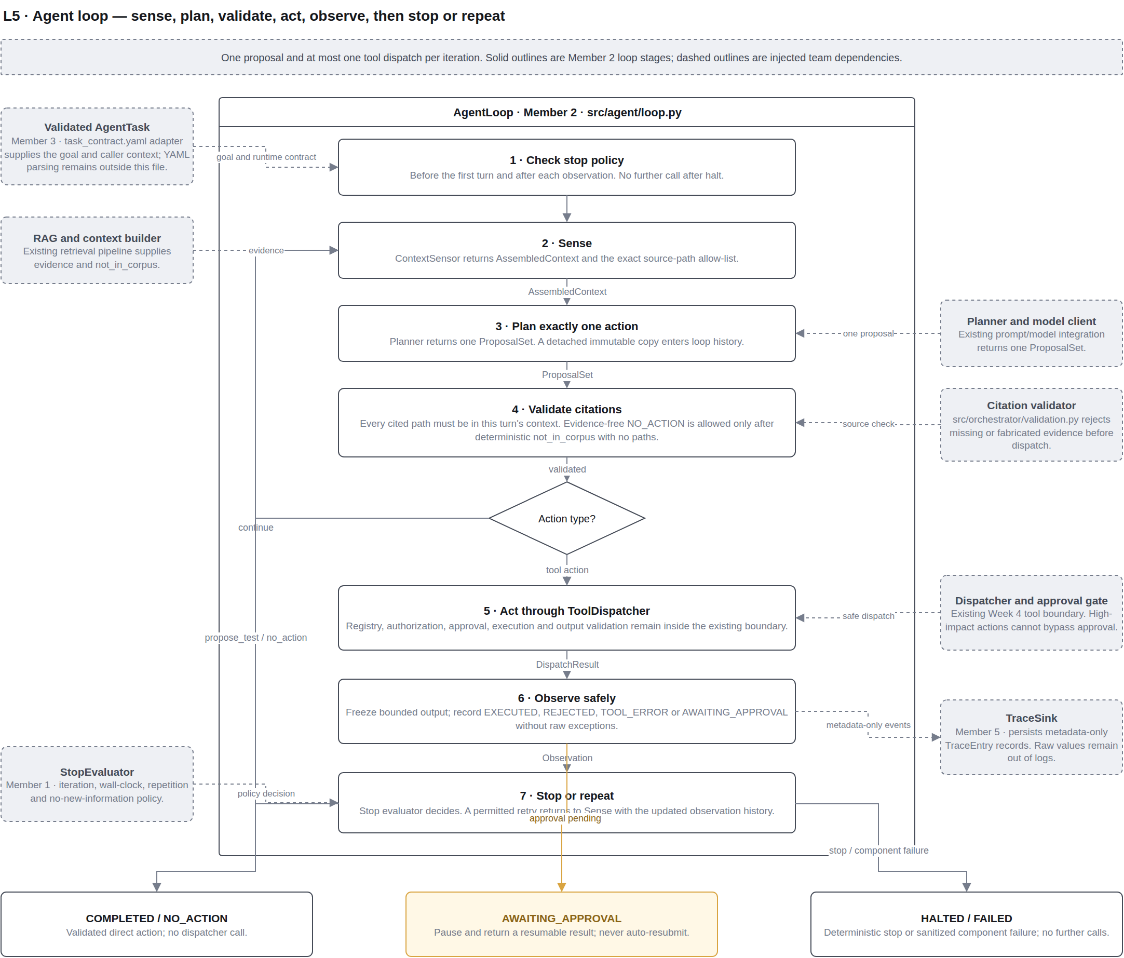
Figure 1: L5 agent-loop architecture — solid stages are Member 2; dashed boxes are injected team dependencies.
The action branch is deliberate: PROPOSE_TEST and NO_ACTION complete directly after citation validation; only actions in TOOL_ACTIONS reach ToolDispatcher. Every tool iteration therefore contains one proposal and no more than one dispatch.

4 Execution Lifecycle
Stage | Implemented behaviour
1. Stop check | Runs before the first turn and after each recorded observation; a decision halts without another model or tool call.
2. Sense | Snapshots AssembledContext and its allowed_source_paths before planning.
3. Plan | Accepts exactly one ProposalSet and stores a detached, immutable PlannedAction.
4. Validate | Checks every citation against this turn's allow-list before any dispatch.
5. Act | Completes direct actions or sends one tool action through ToolDispatcher.
6. Observe | Records a bounded, immutable and sanitized outcome without raw exception text.
7. Stop or repeat | Halts, pauses for approval, completes, fails safely, or begins the next turn.
Table 2: Sense–plan–validate–act–observe lifecycle.
Outcome | Meaning and dispatch effect
COMPLETED | A grounded PROPOSE_TEST is ready for human review; no dispatcher call.
NO_ACTION | A grounded or deterministically justified no-action result; no dispatcher call.
AWAITING_APPROVAL | The request is paused and resumable; the loop never auto-resubmits it.
HALTED | The injected stop evaluator ended the session; no further calls occur.
FAILED | A required dependency failed; the result uses a fixed LoopFailure value.
Tool rejection or error | A safe observation is added, then the stop evaluator decides whether another turn is permitted.
Table 3: Loop outcomes and dispatch effects.

4.1 Safety Invariants
- Exactly one planned proposal enters each iteration.
- At most one dispatcher call can occur in each iteration.
- Citation validation always occurs before direct completion or tool dispatch.
- Approval-pending results pause rather than retry or auto-approve.

5 Citation Validator Change
The existing citation validator originally required evidence for every proposal. That rule conflicts with the propose_action failure behaviour when deterministic retrieval confirms that the requested information is not in the corpus: NO_ACTION is the only honest response, and there is no source path available to cite. Forcing evidence in that case would encourage a fabricated citation.
The validator now accepts a keyword-only confirmed_not_in_corpus flag. Evidence-free NO_ACTION passes only when that value is exactly true and the allowed source-path set is empty. The flag is derived from AssembledContext.not_in_corpus, not from model output. All other evidence-free proposals remain rejected, and every supplied citation must still occur in the current turn's exact allow-list.
validate_citations(
proposal,
allowed_source_paths,
*,
confirmed_not_in_corpus=False,
)
Listing 1: Citation-validation interface with the narrow Week 5 flag.
Proposal state | Validator decision
Evidence matches the current allow-list | Accept.
Evidence is missing for any tool action or PROPOSE_TEST | Reject before dispatch.
Evidence cites a path outside the current allow-list | Reject as fabricated or untraceable.
NO_ACTION, no evidence, retrieval confirmed empty, allow-list empty | Accept the narrow exception.
NO_ACTION uses the flag but supplies a citation | Reject if that citation is not traceable; the flag never validates a path.
Table 4: Citation-validator decisions.
The module docstring and inline comments document the prompt failure behaviour, the deterministic source of the flag, and why a truthy non-boolean value must not open the exception.

6 Dependency Contracts
Contract | Expected value | Failure classification
ContextSensor.sense | AssembledContext | SENSE_FAILED
Planner.plan | One structurally valid ProposalSet | PLAN_FAILED
Citation validation | Traceable proposal or narrow NO_ACTION | Expected rejection is observed; validator fault is VALIDATION_FAILED
Dispatcher.dispatch | DispatchResult for a tool action | DISPATCH_FAILED
StopEvaluator.evaluate | StopReason or None | STOP_CHECK_FAILED
TraceSink.record | Successful metadata-only recording | TRACE_FAILED
Table 5: Injected contracts and sanitized failure mapping.

7 Files Implemented
File | Purpose
src/agent/loop.py | Implements AgentLoop, immutable state/result types, dependency protocols and safe lifecycle handling.
src/agent/__init__.py | Exports the public Week 5 agent-loop boundary.
src/orchestrator/validation.py | Adds and documents the narrow evidence-free NO_ACTION exception.
tests/integration/test_agent_loop.py | Covers lifecycle, outcomes, invariants, failures, pause/resume and safe tracing.
tests/test_validation.py | Covers accepted, missing, fabricated and confirmed-empty citation cases.
docs/architecture/qa-agent-architecture (1).drawio | Adds the editable L5 · Agent loop page.
docs/architecture/l5-agent-loop.png | Provides the rendered architecture image used in Figure 1.
Table 6: Week 5 Member 2 implementation and evidence files.

8 Verification
The focused Member 2 unit suite completed 40 tests successfully. A broader integration selection completed 74 tests and 116 subtests successfully. Python compilation, whitespace validation and the repository sensitive-data check also passed for the changed source and test files.
Verification area | Evidence covered
Normal lifecycle | Sense, plan, validate, dispatch, observe, re-plan and complete.
Direct outcomes | PROPOSE_TEST and NO_ACTION complete with zero dispatcher calls.
Citation safety | Missing and fabricated evidence never reaches the dispatcher; the confirmed-empty exception is narrow.
Approval | Pending approval pauses, is marked resumable and never auto-resubmits.
Failures | Sensor, planner, validator, dispatcher, stop evaluator and trace sink failures are sanitized.
Data boundaries | Proposals and outputs are copied, frozen, JSON-checked and size-bounded.
Table 7: Focused verification coverage.
PYTHONDONTWRITEBYTECODE=1 PYTHONPATH=src .venv/bin/python -m unittest \
tests.integration.test_agent_loop tests.test_validation -v
PYTHONDONTWRITEBYTECODE=1 PYTHONPATH=src .venv/bin/python -m pytest -q \
tests/integration/test_agent_loop.py tests/test_validation.py \
tests/integration/test_router.py tests/test_tool_auth.py

8.1 Repository-Wide Baseline
The repository-wide suite is not claimed as fully passing. The tests directory currently has a pre-existing RAG manifest-count failure, and unscoped root discovery also collects test modules stored under the example knowledge corpus. These issues are outside the Week 5 agent-loop boundary and are recorded rather than hidden.

9 Limitations and Handoffs
- The loop receives an already validated AgentTask; task_contract.yaml parsing and validation remain outside src/agent/loop.py.
- StopEvaluator is injected. The loop enforces its decision but does not define iteration, wall-clock, repetition or no-new-information policy.
- TraceSink is injected. The loop emits metadata-only TraceEntry values but does not persist them.
- Tool authentication, authorization, approval and output-schema checks remain inside the established dispatcher and tool boundaries.
- A caller resumes an approval-pending result explicitly; the loop does not poll, replay or auto-approve the pending request.
- The architecture records intended adapters and handoffs without claiming they are implemented by Member 2.

9.1 Team Integration Actions
Owner | Required handoff
Task-contract owner | Parse and validate task_contract.yaml, then construct AgentTask with the goal and ExecutionContext.
RAG/context owner | Provide AssembledContext with exact allowed_source_paths and deterministic not_in_corpus.
Stop-policy owner | Supply StopEvaluator.evaluate using the agreed bounded-stop rules.
Tracing owner | Persist TraceEntry metadata without introducing raw arguments, outputs or exception text.
Integration/test owner | Run the full scenario and failure matrix once all adapters are connected.
Table 8: Remaining team integration actions.

10 Conclusion
The Week 5 Member 2 deliverable provides a bounded, dependency-injected agent loop that preserves citation, authorization, approval, stopping and trace boundaries. Its one-proposal and at-most-one-dispatch rules make each turn auditable, while safe pause, halt and failure results prevent uncontrolled continuation. The citation exception resolves the empty-corpus prompt case without weakening evidence checks for any actionable proposal.

