
COLLEGE OF COMPUTING AND INFORMATION SCIENCES
SCHOOL OF COMPUTING AND INFORMATICS TECHNOLOGY
DEPARTMENT OF NETWORKS
BSE4104 EMERGING TRENDS IN SOFTWARE ENGINEERING
AI-NATIVE & AGENTIC ENGINEERING CAPSTONE
TOOL-CALLING ORCHESTRATION AND ARCHITECTURE UPDATE
OF THE SOFTWARE-ENGINEERING QA AGENT
WEEK 4 — MEMBER 2 DELIVERABLE
GROUP J
NAME | REGISTRATION NUMBER | STUDENT NUMBER
Karagwa Ann Treasure | 2300709034 | 23/U/09034/PS
Ayan Mustafa Abdirahman | 2300722948 | 23/X/22948/EVE
Wanyana Selina Masembe | 2300701529 | 23/U/1529
Amabe Junior Humphrey | 2300705942 | 23/U/05942/PS
Akanga Andrew | 2300705555 | 23/U/05555/PS

CONTENTS
1 Purpose and Deliverable ................................................. 3
2 Scope of Work ........................................................... 3
3 Tool-Calling Flow ....................................................... 4
4 Design Decisions ........................................................ 5
4.1 Fixed Registry and Single-Turn Scope ........................ 5
4.2 Fail-Closed Authorization and Approval ...................... 5
4.3 Validation and Safe Result Boundaries ....................... 5
5 Files Implemented ....................................................... 6
6 Interface Contracts and Handoffs ........................................ 7
7 Verification ............................................................ 8
8 Architecture Changes Recorded ........................................... 9
9 Evidence and Limitations ................................................ 9
10 Open Items for the Team ................................................ 9

1 Purpose and Deliverable
This report records Member 2's Week 4 contribution to the Software-Engineering QA Agent. The deliverable is a safe, single-turn orchestration boundary that receives one structured model proposal, performs ordered checks, invokes at most one registered tool, and returns one stable, JSON-ready DispatchResult. The contribution also includes focused tests, a deterministic offline demonstration, and the L4 tool-calling architecture view.
The implementation does not provide the production tools, define the human approval policy, authenticate the caller, or implement the Week 5 agent loop. Those boundaries remain explicit so that each team member can integrate through a small public contract without duplicating another member's contribution.

2 Scope of Work
Work item | Owner | Integration boundary
Router, registry, results, statuses and codes | Member 2 | Implemented in src/orchestrator/router.py.
ProposalSet, Action and structural parsing | Member 1 | Reused through the shared model types.
Citation validation | Member 1 | src/orchestrator/validation.py runs before dispatch().
Four tools, schemas and role metadata | Member 3 | src/tools/*.py implementations use the Tool protocol.
Failure and authorization evidence suite | Member 4 | tests/test_tool_auth.py runs against the real tools.
Approval policy and human gate | Member 5 | src/orchestrator/approval_gate.py supplies the gate.
Week 4 progress report | Member 5 | Receives Member 2's evidence and architecture.
Table 1: Week 4 ownership and integration boundaries.

3 Tool-Calling Flow
Figure 1 shows the application-layer path from a raw model response to a validated result. Solid blue outlines identify Member 2 components. Dashed outlines identify dependencies owned by Members 1, 3 and 5. Planned Member 3 tool modules shown in the diagram are integration targets and are not claimed as implemented by Member 2.
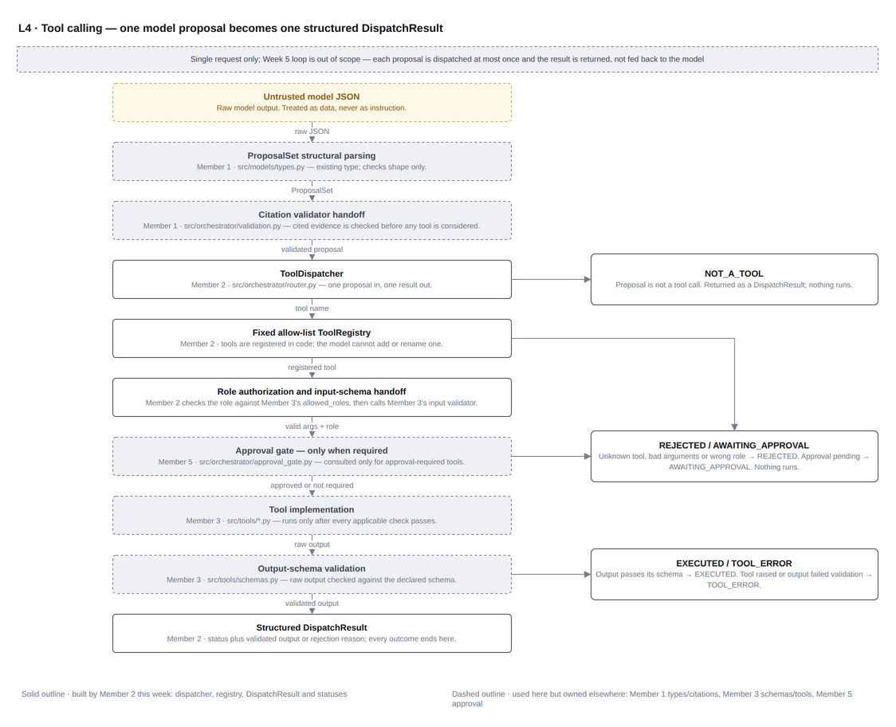
Figure 1: L4 tool-calling architecture — solid outlines are Member 2; dashed outlines are integration dependencies.
The production path is parse → citation validation → dispatch. The convenience method dispatch_raw() combines parsing and dispatch for isolated tests and the offline demonstration; it must not be used to bypass the citation-validation handoff.

4 Design Decisions

4.1 Fixed Registry and Single-Turn Scope
ToolRegistry is a code-defined allow-list. Model output cannot add, rename or dynamically import a tool. One dispatch call handles one ProposalSet and returns; it does not plan another action or continue an autonomous loop.

4.2 Fail-Closed Authorization and Approval
The dispatcher checks the caller-supplied ExecutionContext.role against the concrete tool's declared allowed_roles before validating arguments or executing. This is an authorization check, not authentication. Approval is requested only for tools marked REQUIRES_APPROVAL. A missing gate, gate exception, malformed verdict, denial or pending decision results in non-execution. The current boundary does not impose a timeout on a hanging gate or tool.

4.3 Validation and Safe Result Boundaries
The concrete tool owns argument and output-schema validation. Member 2 additionally requires a mapping result, strict JSON serialization and a maximum encoded output size of 64,000 bytes by default. Arguments and outputs are deep-copied across boundaries. Exception text is excluded from result messages; the retained ProposalSet is also excluded from DispatchResult.to_dict().

4.4 Stable Outcomes
Every non-successful path uses a stable DispatchStatus and, where applicable, a machine-readable DispatchCode. A valid tool action that is absent from the registry produces unknown_tool. An action outside the shared Action enum fails structural parsing and produces malformed_request.
Status | Representative codes | Execution
executed | none | Tool ran once; output passed checks.
not_a_tool | none | Proposal required no tool.
rejected | malformed_request, unknown_tool, unauthorized, invalid_arguments | Tool did not run.
rejected | approval_gate_missing, approval_unavailable, approval_denied | Approval-required tool did not run.
awaiting_approval | approval_pending | Tool did not run.
tool_error | execution_failed, invalid_output | No validated output was returned.
Table 2: Stable dispatcher outcomes.

5 Files Implemented
File | Purpose
src/orchestrator/router.py | Implements the fixed registry, execution context, protocols, ordered safety checks and structured results.
src/orchestrator/__init__.py | Re-exports the public orchestration contracts for stable imports.
src/models/__init__.py | Removes a circular package re-export so fresh RAG pipeline imports succeed.
tests/integration/test_router.py | Contains 16 fake-based checks for the Member 2 router; it does not replace Member 4's test_tool_auth.py.
scripts/member2_tool_dispatch_demo.py | Runs four deterministic scenarios with clearly labelled canned adapters.
docs/architecture/qa-agent-architecture (1).drawio | Adds the editable fifth page, L4 · Tool calling.
docs/architecture/l4-tool-calling.png | Provides the verified image embedded as Figure 1.
docs/ai-assistance credit/week4/member2-tool-calling.md | Records AI assistance, accepted decisions and verification responsibility.
Table 3: Member 2 implementation and evidence files.

5.1 Demonstration Boundary
DemoSearchRepoTool, DemoRunTestsTool and DemoApprovingGate are demonstration adapters only. They return canned data, execute no tests, read no repository files and implement no real approval policy. They must not be registered in the production application.

5.2 Import Repair
The package-level model re-export created a circular import when rag.pipeline was imported in a fresh process. The re-export was removed while direct imports from models.client and models.types remain available. This repair is recorded separately from the dispatcher implementation in commit 6209aa3.

6 Interface Contracts and Handoffs

6.1 Tool Contract — Member 3
Each concrete tool declares its action name, risk level and allowed roles, and owns its argument and output schemas. The dispatcher owns the order of checks and guarantees at most one run invocation.
class Tool(Protocol):
name: str
risk: ToolRisk
allowed_roles: Collection[str]
def validate_arguments(self, arguments) -> dict: ...
def run(self, arguments, context) -> Mapping: ...
def validate_output(self, output) -> dict: ...

6.2 Approval Gate Contract — Member 5
The gate is called only for REQUIRES_APPROVAL tools and only after role and argument checks. It returns APPROVED, DENIED or PENDING. No missing or invalid decision can cause execution.
class ApprovalGate(Protocol):
def check(
self, *, action: Action, arguments: Mapping,
context: ExecutionContext
) -> ApprovalVerdict: ...

6.3 Citation and Test Handoffs
Member 1's caller validates proposal citations before dispatch(). Member 4 can exercise the same public boundary with Member 3's real tools to build the broader failure and authorization evidence matrix. Member 5 incorporates the resulting evidence into the team progress report.
Handoff | Owner | Expected integration
Citation validation | Member 1 | Parse, validate cited sources, then call dispatch().
Production tool adapters | Member 3 | Register implementations through the Tool protocol.
Integrated negative tests | Member 4 | Exercise the dispatcher with the real tools.
Approval and reporting | Member 5 | Supply ApprovalGate and record team evidence.
Table 4: Integration handoffs from the Member 2 boundary.

7 Verification
The focused Member 2 suite completed 16 offline tests successfully. The tests use FakeTool and FakeGate stand-ins and therefore verify the dispatcher boundary rather than Member 3's production tools or Member 4's integrated failure matrix.
Verification area | Evidence
Registry and action handling | Allow-listed execution; duplicate, unsafe, unknown and non-tool handling.
Authorization and approval | Role rejection; missing, denied, pending, failing and malformed gate outcomes.
Execution and output | Exactly-once run; safe tool errors; mapping, schema, JSON and size enforcement.
Isolation | Deep-copy boundaries and detached JSON-ready results.
Table 5: Focused dispatcher test coverage.
Offline demo scenario | Recorded result
read_only_search_executes | executed
run_tests_without_gate_rejected | rejected / approval_gate_missing
run_tests_with_approving_gate_executes | executed with a canned approving gate
unknown_action_rejected | rejected / malformed_request
Table 6: Four deterministic offline demonstration scenarios.
PYTHONDONTWRITEBYTECODE=1 PYTHONPATH=src python3 -m unittest discover \
-s tests/integration -p "test_router.py" -v
PYTHONDONTWRITEBYTECODE=1 python3 scripts/member2_tool_dispatch_demo.py

7.1 Known Baseline Failure
The repository-wide suite is not claimed as fully passing. Commit 5c39b08 removed tests/fixtures/member2/corpus/logs/test_run_2026_09_15.log while earlier RAG and evaluation expectations still reference it. Those two failures occur outside the Week 4 Member 2 files and have been reported for team resolution.

8 Architecture Changes Recorded
The editable Draw.io source now contains five pages. The added L4 page records the parser and citation-validation handoff, the fixed registry, role and schema checks, the conditional approval gate, exactly-once execution, strict output checks, and the structured DispatchResult returned to the application.

9 Evidence and Limitations
- Incremental commits separate the import repair, dispatcher, tests, demo, architecture and documentation.
- The L4 XML was parsed, the PNG was exported and visually inspected, and the focused tests and demo were run offline.
- No performance claim is made; latency_ms is measured but deliberately normalized in demo output.
- The dispatcher does not authenticate callers, time out dependencies, implement tools, or make human approval decisions.
- AI assistance and the reviewed decisions are disclosed in docs/ai-assistance credit/week4/member2-tool-calling.md; responsibility for the submitted work remains with Member 2.

10 Open Items for the Team
- Member 3: implement and register the four real tools and their schemas, risks and allowed roles.
- Member 3: confirm that search_repo adapts RetrievalResult.to_search_repo_output().
- Member 5: implement ApprovalGate.check without timeout auto-approval.
- Member 1: confirm citation validation occurs before dispatch().
- Member 4: run the integrated failure and authorization matrix against the real tools.
- Member 5: include the test, demo and architecture evidence in the Week 4 progress report.

10.1 Member 2 Commit Record
6209aa3 Import repair · 658d3e8 Dispatcher · 93f9fb3 Tests · 3462003 Demo · 718efef Architecture · 13e8a64 Ownership clarification · cee8b4b Router move · 8294719 Test alignment · 707c136 Architecture path alignment.

