

COLLEGE OF COMPUTING AND INFORMATION SCIENCES
SCHOOL OF COMPUTING AND INFORMATICS TECHNOLOGY
DEPARTMENT OF NETWORKS

BSE4104 EMERGING TRENDS IN SOFTWARE ENGINEERING
AI-NATIVE & AGENTIC ENGINEERING CAPSTONE

Retrieval Pipeline and Architecture Update of the Software-Engineering QA Agent
Group J
NAME | STUDENT NUMBER | REGISTRATION NUMBER
Karagwa Ann Treasure | 2300709034 | 23/U/09034/PS
Ayan Mustafa Abdirahman | 2300722948 | 23/X/22948/EVE
Wanyana Selina Masembe | 2300701529 | 23/U/1529
Amabe Junior Humphrey | 2300705942 | 23/U/05942/PS
Akanga Andrew | 2300705555 | 23/U/05555/PS

Contents
Select this table and press F9, or right-click and choose Update Field, to build the table of contents.

Purpose and Deliverable
This document records the Week 3 contribution of Member 2, the Application and Integration Lead, to the Software-Engineering QA Agent. The assigned task was to build the pipeline that reads the project's documents, splits them into chunks, indexes them, and retrieves the relevant ones on request, and to update the architecture diagram to reflect the result.
Until this week the agent had no means of finding anything. The Week 2 deliverable established a working connection to the foundation model, but the evidence sent to that model had to be supplied by hand. The retrieval pipeline described here is the component that locates relevant evidence within the project corpus and returns it with the provenance needed to cite it.
The pipeline is deliberately narrow. It answers one question, which passages of the corpus relate to this query, and it answers a second question that matters just as much: whether the corpus contains anything relevant at all. That second decision is taken by ordinary program code rather than by the model, which is what architecture principle P1 requires.

Scope of Work
The completed scope covers the contracts, the chunking rules, the index and its scoring, the answerability policy, the offline test suite, and the architecture update. The work deliberately stops at the boundaries listed below, each of which belongs to another member in the same week or a later one.
Work | Owner | Relationship to this deliverable
Corpus collection and provenance tagging | Member 1 | Produces the SourceDocument records this pipeline consumes. The pipeline does not read the repository itself.
Grounding design and context building | Member 3 | Consumes RetrievalResult and decides what the model is shown, including the case where nothing was found.
Tool schemas and the search_repo tool | Member 3 | Wraps the pipeline in Week 4. The result object already exposes the tool's declared output shape.
Fifteen-case retrieval evaluation | Member 4 | Calls the pipeline once per evaluation question. A stable entry point is provided for that purpose.
Restricted-data commit check | Member 5 | Protects the repository at commit time. It is a separate control from anything in this pipeline.

Table 1: Work adjacent to this deliverable, its owner, and how it connects to the retrieval pipeline.
One control named in the Security and Risk Register has no owner in the task allocation plan. The mitigation recorded for R4 states that ingested content is scanned for credential-shaped strings before it reaches the model. That scan belongs at the ingestion boundary rather than at commit time, and it is raised here for the team to assign rather than absorbed into this deliverable.

Retrieval Flow
The implemented flow is shown below. Solid outlines mark the stages built as part of this deliverable; dashed outlines mark stages owned by another member or scheduled for a later week.
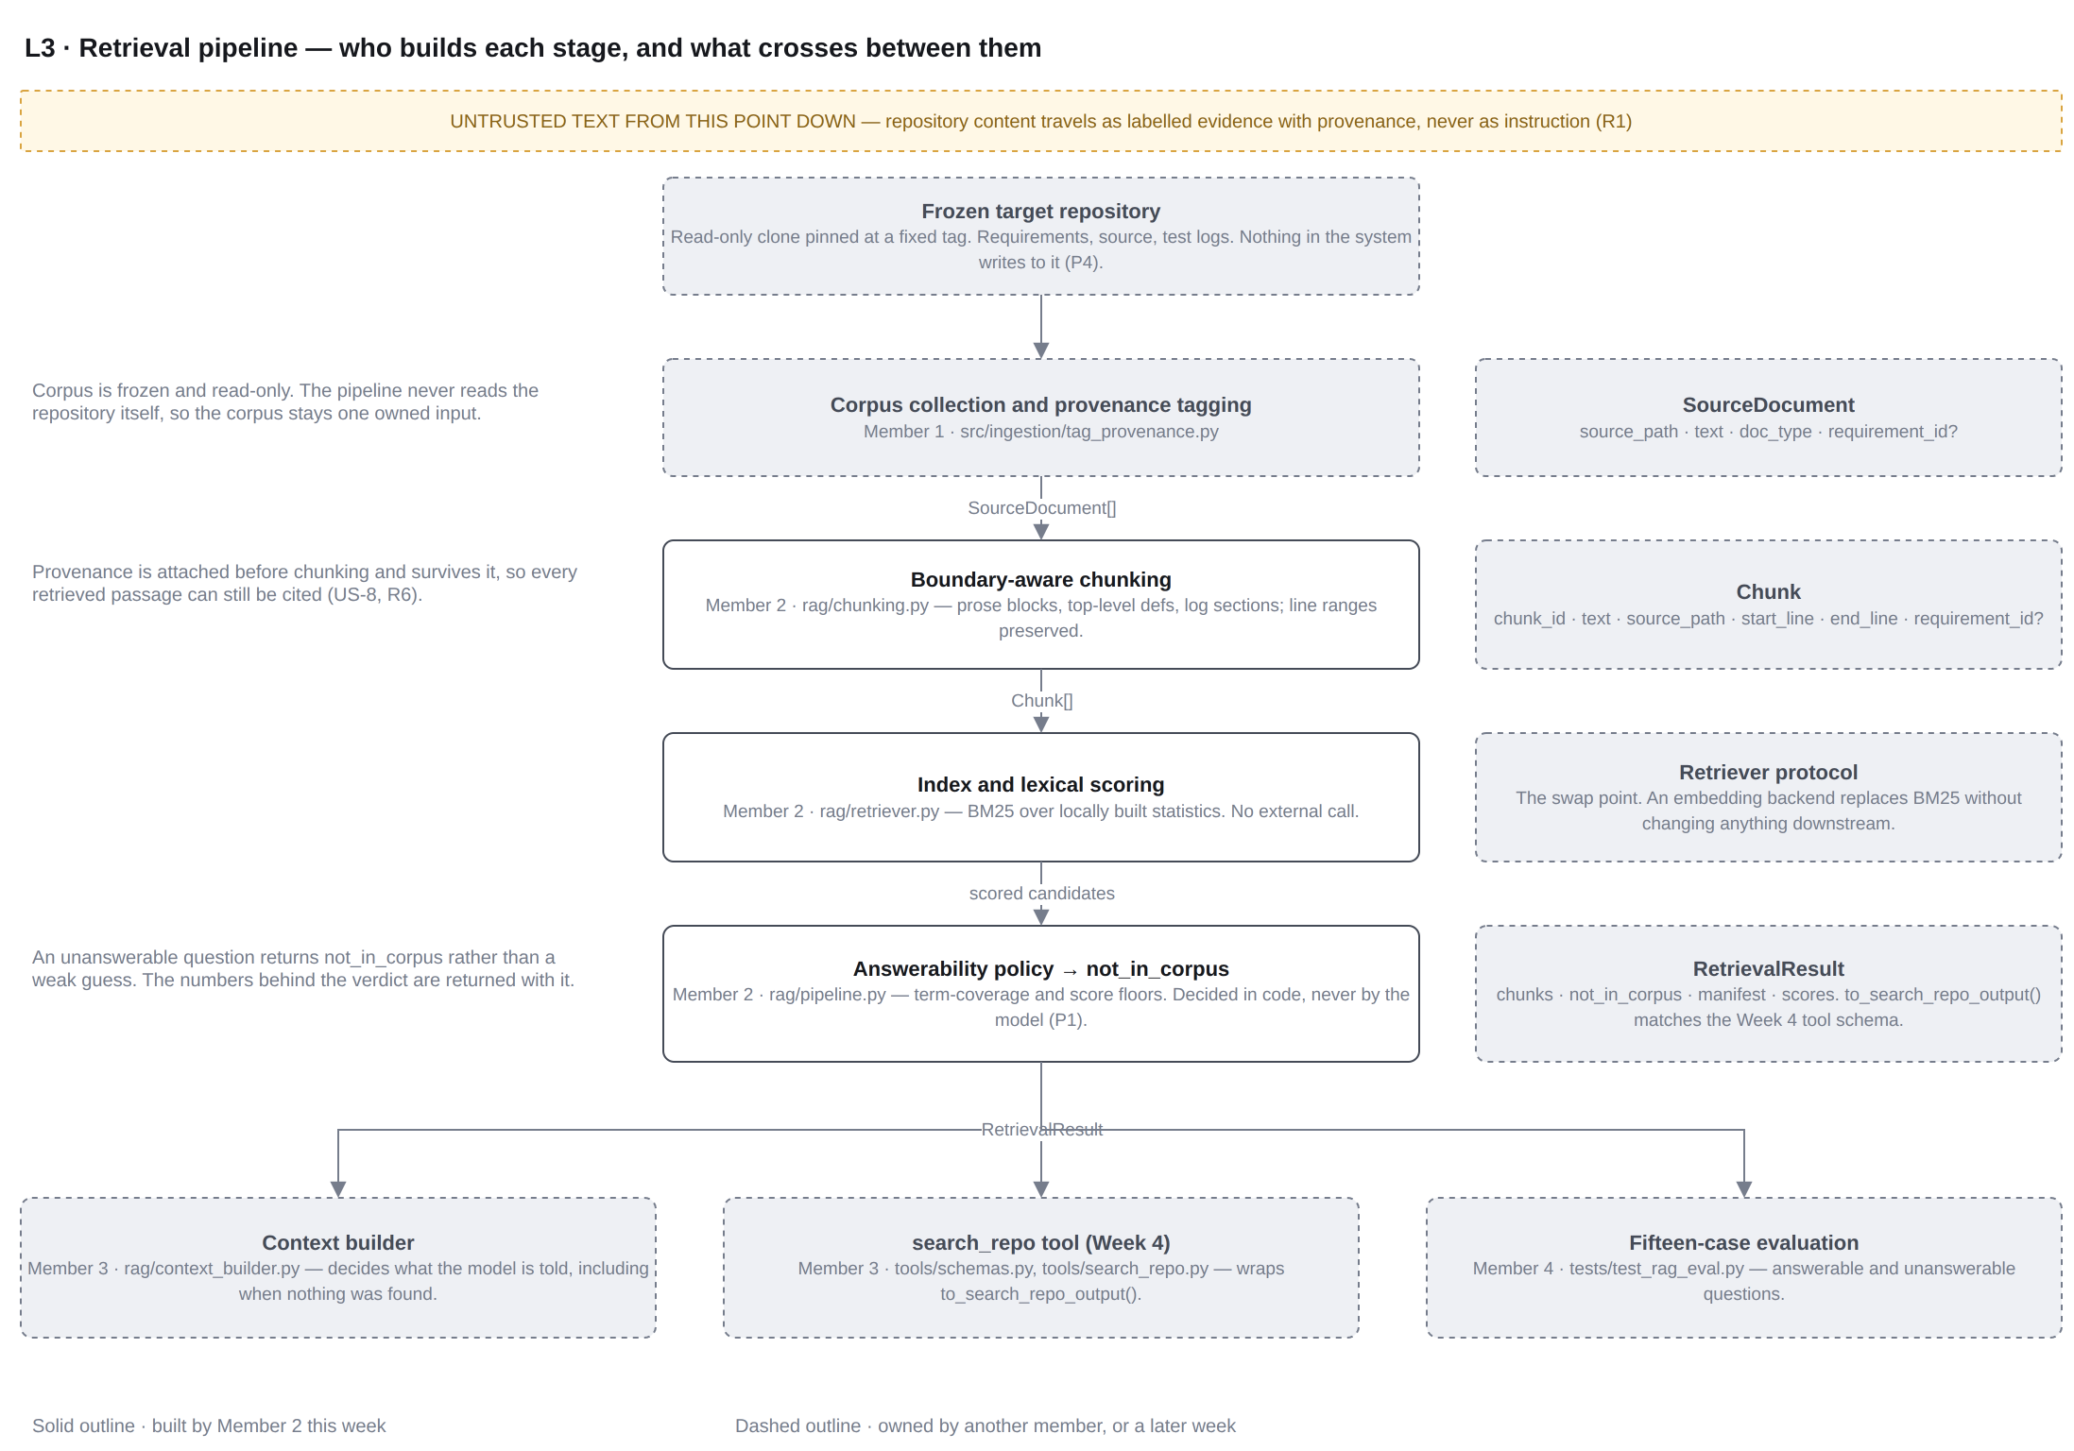
Figure 1: L3 retrieval pipeline, showing the stage each member builds and the contract that crosses between them. Added as a new page to the project architecture diagram.
A document enters as a provenance-tagged record, is split into passages that retain their source path and line range, and is indexed. A query is scored against that index, and the answerability policy decides whether the best passages are good enough to return. The result carries both the evidence and the measurements behind the decision.

Design Decisions

Lexical retrieval rather than embeddings
The Week 1 architecture described the index store as holding chunks, embeddings and provenance. Embeddings were assumed rather than decided, and they carry consequences the project has not accepted: a second external service with its own cost and rate limits, a dependency on network availability during evaluation, and repository text leaving the project, which is the concern recorded as R9.
For a corpus of ten to fifty files, lexical retrieval is sufficient and has properties the project actively needs. It runs offline, costs nothing, and returns identical rankings for identical inputs, which is what makes the fifteen-case evaluation reproducible and supports the frozen-corpus principle P4. Ranking uses BM25 over statistics built locally from the corpus itself.
The decision is recorded rather than hidden. Retrieval sits behind a declared protocol, so an embedding-backed implementation can replace the current one without altering the pipeline, the tool layer, or the evaluation harness. The index store label in the container view has been corrected to read chunks, term statistics and provenance, so the diagram no longer implies a decision the team has not made.

Boundary-aware chunking per document type
The Week 1 architecture called for boundary-aware chunking without stating which boundaries. The corpus holds three different shapes of text, and a single splitter serves none of them well.
Document type | Boundary used | Reason
Requirement | Blank-line blocks, with a single-line heading joined to the text beneath it | A requirement identifier usually sits on its own line above the behaviour it governs. Joining them keeps the identifier in the same passage as the text it describes.
Code | Unindented definition lines, with decorators and the comment block above them | A function or class is the unit a proposed test targets. A regular expression is used rather than a syntax tree so a file that does not parse still yields usable passages.
Log | Separator rules, then blank-line blocks within each section | Test output is already organised into sections and individual failures, and those divisions carry meaning.

Table 2: Chunking boundaries applied to each document type.
Any block longer than the configured maximum is divided into overlapping windows so no passage exceeds a usable size. Every passage records its source path and its first and last line, so a later proposal or failure summary can cite the exact evidence it rests on. This is the mechanism behind user story US-8 and the mitigation recorded for R6: traceability is enforced by the data structure rather than requested in a prompt.
No passage is discarded for being short. An earlier version of the implementation dropped passages below a character threshold, which silently removed short requirements from the corpus. The rule now discards only passages that contain no alphanumeric characters at all.

The answerability rule
The tool contract declares not_in_corpus as a boolean, and the request walkthrough states that an unsupported question must return it, but neither says what makes a question unsupported. That rule is defined here, because it is the difference between an agent that admits ignorance and one that produces a plausible answer from irrelevant text.
A passage is accepted when it clears two floors. The first is term coverage: the share of the question's meaningful terms that the passage actually contains. The second is an optional absolute score floor. A query is reported as not in corpus when fewer than the required number of passages clear both.
Term coverage is the primary control because it remains comparable between different corpora, whereas a raw relevance score does not. Both floors are configuration rather than constants, so the evaluation set can be tuned without editing the pipeline. The result also returns the measurements behind the verdict, so a rejected query can be examined rather than merely observed.

Files Implemented
File | Responsibility
src/qa_agent/rag/chunking.py | The SourceDocument and Chunk contracts, the document type enumeration, the retrieval error hierarchy, and the three chunking strategies.
src/qa_agent/rag/retriever.py | The Retriever protocol, the identifier-aware tokenizer, and the BM25 implementation with path scoping and a requirement-identifier boost.
src/qa_agent/rag/pipeline.py | The pipeline itself, the answerability policy, the index manifest, the result object, and a development-only corpus loader.
src/qa_agent/rag/__init__.py | The public surface of the package, so other members import from one stable location rather than from internal files.
tests/integration/test_rag_pipeline.py | Twenty-seven offline tests covering chunking, provenance, tokenizing, retrieval, the answerability decision, and the shape of the published result.
tests/fixtures/member2/corpus/ | Three synthetic files used only to exercise the pipeline before the project corpus is available.
docs/architecture/qa-agent-architecture.drawio | The project architecture diagram, with the new L3 retrieval page and corrections to the L2 container view.

Table 3: Files produced or modified by this deliverable.
The package is placed under src/qa_agent/rag/ rather than src/rag/ so that it sits beside the Week 2 integration code in one importable package. The task allocation plan describes its proposed layout as a suggestion rather than a requirement, and the module boundaries it specifies are preserved.

Interface Contracts and Handoffs
As the integration deliverable, the value of this work lies as much in the contracts it publishes as in the retrieval itself. Each contract is stated below so the members who depend on it can build against a fixed shape.

Member 1, corpus and provenance
The pipeline consumes a sequence of SourceDocument records and never reads the repository directly. The record carries a source path, the document text, a document type, and an optional requirement identifier. Where an identifier is supplied it is authoritative; where it is absent the chunker falls back to a pattern match on the text, which is a convenience and not a substitute for tagging.
SourceDocument(
source_path="requirements/authentication.md",
text=...,
doc_type=DocumentType.REQUIREMENT,
requirement_id="REQ-AUTH-01", # optional
)

Member 3, context building and the tool layer
The division of responsibility around an unanswerable query is the one place where these two deliverables meet directly. This pipeline decides whether a query is answerable and reports the verdict. The context builder decides what the model is told when the verdict is negative. The pipeline produces the fact; the context builder handles the consequence.
For Week 4, the result object already returns the declared output shape of the search_repo tool, so the tool becomes a thin wrapper rather than a reshaping layer.
result = pipeline.retrieve(query, path_scope=None, top_k=5)
result.to_search_repo_output()
# {"chunks": [{"text": ..., "source_path": ..., "requirement_id": ...}],
# "not_in_corpus": false}

Member 4, retrieval evaluation
A single stable entry point is provided for the fifteen-case evaluation. Each case calls retrieve once. In addition to the passages themselves, the result reports the number of candidates considered, the best score, the best term coverage, the measured latency, and the corpus fingerprint, so a result can be attributed to the exact corpus state that produced it. The policy floors are constructor arguments, so a threshold can be varied across runs without code changes.

Member 5, configuration and tracing
The pipeline holds no configuration of its own beyond the policy and chunking settings passed to it, and it reads no environment variables. The development corpus loader is tooling for this deliverable and is not a competing configuration loader. A sanitized trace record is available for the trace store when it is built; it reports identifiers, scores and the decision, and deliberately excludes passage text so corpus content is not copied into logs.

Verification
The suite runs offline, contacts no provider, and requires no API key. From the repository root:
PYTHONDONTWRITEBYTECODE=1 PYTHONPATH=src \
python3 -m unittest discover -s tests/integration -v

The recorded result is thirty-six tests passing, comprising the twenty-seven added by this deliverable and the nine from the Week 2 model integration, which continue to pass unchanged.
Two failures were found and corrected during development, and both are recorded here because each changed the implementation rather than the test. The first was the character threshold that silently discarded short passages, described in section 4.2. The second was an incorrect assertion of the author's own: a test asserted that a particular query could not achieve full term coverage, when a passage in the fixture corpus legitimately contained every term of it. The assertion was replaced with a query containing terms the corpus genuinely lacks, which tests the intended control rather than an accidental property of the fixtures.
A worked example over the fixture corpus, showing both outcomes:
Query | Verdict | Best passage | Score | Coverage
how should an incorrect password be handled | answerable | requirements/authentication.md, lines 3 to 7, REQ-AUTH-01 | 4.42 | 0.67
how do we rotate kubernetes ingress certificates | not in corpus | none returned | 0.00 | 0.00

Table 4: Retrieval over the fixture corpus, fingerprint a45c7babce2241c9, fourteen passages from three documents. The second query is rejected rather than answered from loosely related text.

Architecture Changes Recorded
Three changes were made to the project architecture diagram.
- A new page, L3 Retrieval pipeline, showing the stages of the pipeline, the member who owns each, and the contract that crosses between them.
- The retrieval service box in the L2 container view now names its three parts and their owners, and refers to the new page for detail.
- The index store label now reads chunks, term statistics and provenance, replacing the earlier reference to embeddings.
The new page also records something the trust zones alone did not express. The zones classify components, and the retrieval service sits inside the trusted application zone because its code is deterministic. The text flowing through it is not trusted: the frozen repository is identified in the Week 1 document as the prompt-injection surface, and R1 is the highest-rated risk in the register. Marking the point at which repository content enters the system, and showing that it travels onward as labelled evidence with provenance rather than as instruction, closes that gap in the drawing.

Evidence Collection
- The offline test output showing thirty-six tests passing.
- The worked retrieval example in Table 4, including the corpus fingerprint.
- The updated architecture diagram file and the exported image of the new page.
- The commit history for this deliverable, which separates the contracts, the retriever, the pipeline, the tests and the diagram.
- The pull request and the corresponding task record.

Open Items for the Team
- The credential-shaped-string scan recorded as the mitigation for R4 has no owner in the task allocation plan and needs one.
- The corpus location differs between documents: the repository provides knowledge/ while the allocation plan names docs/knowledge/. Member 1's collection work should settle it.
- The Week 1 architecture document refers to docs/architecture/full-spec.md, and the AI engineering notes cite a Table 4.3 of that document. Neither exists yet.
- The default policy floors are provisional. Member 4's fifteen cases are the first real evidence for what they should be, and they are configuration precisely so that evidence can change them.

