Error: No Such file or directory
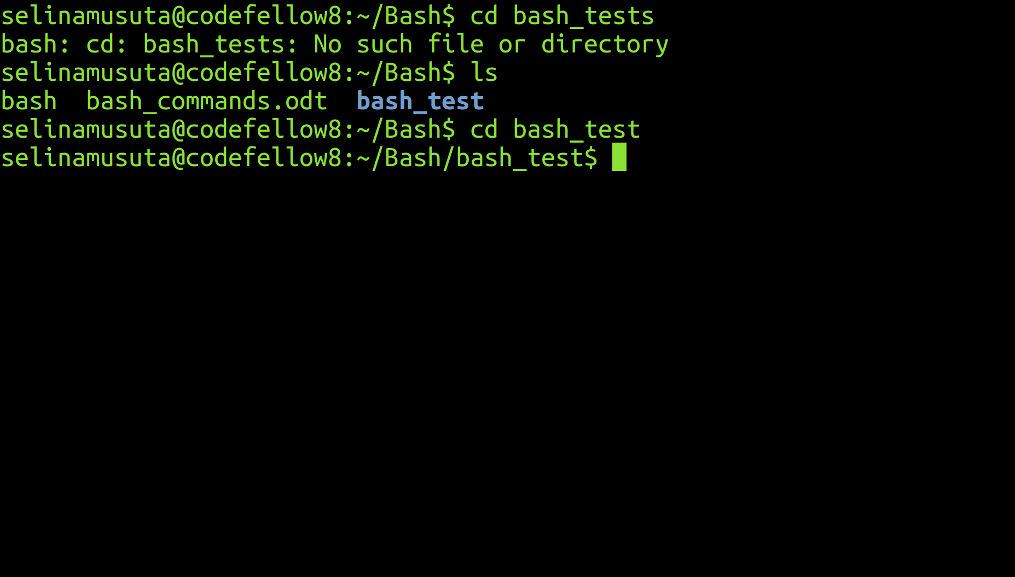
Oops! That's not bash_tests

What Happened?: I wanted to change my directory to bash_tests. But I was given the error above.

How did you solve it? I typed ls in my command line in order to see what directories and files were in my Bash directory. I saw that the listed directory that I wanted was spelled differently (bash_test without an 's') from the directory (bash_tests) that I had previously typed. The computer could not find that file. So now for the correct directory name with command:

cd bash_test

