Software Requirements Specification
(SRS) For E-receipt

Souraiya Rahman
Sanjib Barma Shuvo
Selina Akter Shila
Faisal Ahmed
Nabonita Das
Shishir Das

Innovative Software Limited
07/08/2017

Contents

1. Introduction 2
2. General Description 2
3. Functional Requirements 3
4. Interface Requirements 4
4.1 User Interfaces 4
4.2 Hardware Interfaces 4
4.3 Communications Interfaces 4
4.4 Software Interfaces 4
5. Performance Requirements 4
6. Other non-functional attributes 5
6.1 Security 5
6.2 Binary Compatibility 5
6.3 Reliability 5
6.4 Maintainability 5
6.5 Portability 5
6.6 Extensibility 5
6.7 Reusability 5
6.8 Application Affinity/Compatibility 5
6.9 Resource Utilization 6
6.10 Serviceability 6
7. Operational Scenarios 6
8. Preliminary Use Case Models and Sequence Diagrams 6
8.1 Use Case Model 1 7
8.1 Use Case Model 2………………………………………………………………………..8
9. Appendices 8
9.1 Definitions, Acronyms, Abbreviations 8

1. Introduction
  - Introduction
The purpose of this document is to define and describe the requirements of the project and to spell out the system’s functionality and its constraints.

  - Scope of this Document
The service clients for the system are the Govt.bodies,NGOs,Banks,Stock exchange,Restaurants,Hotels, Motels,Supershops and the developers of the system is the Innovative Software Team. Our constraints for this section includes our deadline for the document which is due 08/09/17

  - Overview
The service is provided through sending mail to the customer mail in pdf pattern that will hold information of items/services, items ID, item’s original value(+vat included), payment type, customer email.

  - Business Context
As it applies to this project, it can reduce the cost of paper and ink and also there is no risk of losing e-receipt unless deletes the mail.

2. General Description
2.1 Product Functions
Our product will input data from retailer shop, hospital or restaurants. Then give them their required receipts via email.

2.2Similar System Information
The product is being developed with PHP using its Laraval Framework. We searched in the internet for some similar products; we found nothing similar to this.

2.3 User Characteristics
The employees of the super shop will input data during the shopping of respective customers who have accounts in our system. For this system, the user is required to know the basic usability of Internet as well as a very base level understanding of electric communication, which hopefully will be facilitated by the software team through training.

2.4 User Problem Statement
The users system, currently, is based on paper receipt. Sometimes customers lost their receipt and then they cannot claim for product warranty. Using paper means cutting down more trees daily for making papers. This system will focus on these problems.

2.5 User Objectives
The user wants a system that will decrease bearing paper receipts in their pocket/bags. Also environmental issue of cutting trees for paper. Our main objective is to save trees and make the life much digitalized. Our product “E-Receipt” will also provide some additional services such as personal accountant; give him news of claiming extra bonuses so on.

2.6 General Constraints
Constraints include an easy to use interface for the program. People can use it in any platform like Windows, IOS and oviously in mobile phone platforms like android.

.

3. Functional Requirements
- Items provided to Mr. Anowarul Abedin shall be stored in the Access Database.
  - Items shall be stored on the laptop machine/PC and have complete fields.
  - Very high criticality
  - Limited network / wi-fi availability could present a technical challenge
  - The above stated factor is a risk we have encountered. Eliminate it by reducing the dependency of our program on these things.
  - This requirement is the basis of the project; all other aspects depend on it.
- The items shall be accessible via queries and reports.
  - Users of the database be able to run queries.
  - Admin users of the database should be able to run reports on the data that has been put into the database.
  - Very high criticality
  - We do not foresee any technical issues preventing the implementation of this.
  - Given the capabilities of Access, this requirement is able to be satisfied.
  - This requirement depends on requirement number one.
- The data stored should be able to be manipulated through forms.
  - Items and other data should be able to be added and updated through the use of forms.
  - Very high criticality
  - We do not foresee any technical risks involved in this requirement.
  - The only factor we can encounter here is the user of the system not being able to use it correctly. We will overcome this by training those who will be using it.
  - This requirement is dependent on requirement one.

4. Interface Requirements
4.1 User Interfaces
- 4.1.1 GUI
The user interface for this program is the interface provided by Laravel. Access includes forms and reports for the users to query and organize data to suit their needs. Forms and reports both have builders that let the user specify which fields they want to use and which constraints they want to define.
- 4.1.2 CLI
There is no command line interface
- 4.1.3 API
There is API developed in PHP for the product
4.2 Hardware Interfaces
The program uses the barcode reader for accessing the customer’s card.
4.3 Communications Interfaces
If we decide to implement an Ad Hoc network for a shared database, the operating system will handle those connections.
4.4 Software Interfaces
The Access system may be used to import and export data with MySQL database. This functionality is built in to the user interface.

5. Performance Requirements
HTML 5, PHP 7 supported web browser.

6. Other non-functional attributes

6.1 Security

Our software has a different level of security & the information is included in the database.After all, there is no obvious information that is of a high security level such as user information, that could be implemented are encrypting the database and/or making the database password-protected, by user’s request.

6.2 Binary Compatibility

Our software basically web based & it has cross platform compatibility .It will work any environment. User can use from anywhere.

6.3 Reliability

Reliability is one of the key attributes of this service. Back-ups will be made regularly so that restoration process will be fast in any sort of situation. The product will also tested by our software quality assurance team to ensure reliability.

6.4 Maintainability

The software shall be maintained by a managing team which is lead by a certain number of people.

6.5 Portability
Our software is designed in a way that allow user to use the software from multiple devices with any operating system.

6.6 Extensibility

The software shall be designed and documented in a user-friendly way that anybody can use it & can make the full benefit from it.

6.7 Reusability

The system designed in a way so that the database can be re-used in the future.

6.8 Application Affinity/Compatibility

This software requires the laravel & xamp for environment purpose.

6.9 Resource Utilization

The resourced used in the creation of this system include: The client(Anowarul Abedin), and the internet.

6.10 Serviceability

The maintenance of the system should be able to be sufficiently performed by any it people.

7. Operational Scenarios
Scenario A: Customer Check-out
The co-admin shall be able to enter information about the customer purchasing a particular item, and record the information. They will also send the e-receipt to the customer email.

Scenario B: Database Maintenance
The admin may alter/delete information if required.

8. Preliminary Use Case Models and Sequence Diagrams
This section presents a list of the fundamental use cases that satisfy the system’s requirements. The purpose is to provide an alternative, "structural" view of the requirements stated above and how they might be satisfied in the system.

8.1 Use Case Model

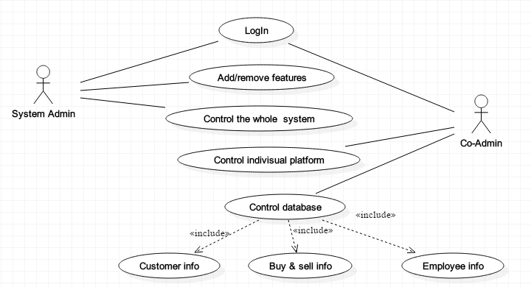

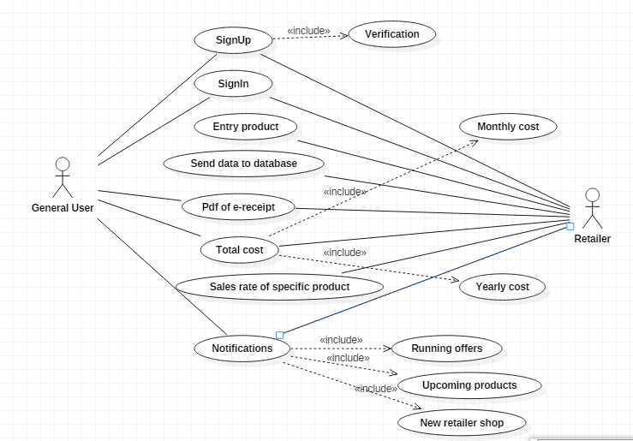

9. Appendices
9.1 Definitions, Acronyms, Abbreviations
ISL- Innovative Software Limited

